# Statistics for Files in D:/Documents/Unob_7/STC/STC_code/DB_Performance/_Test/Performance/Test_v5/yugabyte

## File: gql_event.txt

Number of queries: 100

Mean: 34.47

Median: 28.26

Max: 168.57

Min: 18.0

Variance: 423.7

Standard Deviation: 20.58

90th Percentile: 51.67

Is normal: No

Shapiro-Wilk test p-value: 8.747437148270195e-15

Is exponential: No

Kolmogorov-Smirnov test p-value: 2.0000000000223767e-200

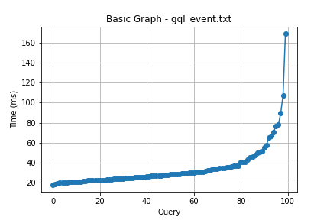

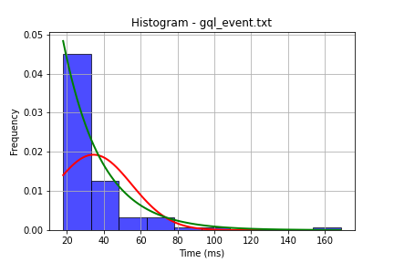

## File: gql_facilities.txt

Number of queries: 100

Mean: 17.93

Median: 14.75

Max: 53.0

Min: 8.0

Variance: 104.98

Standard Deviation: 10.25

90th Percentile: 32.6

Is normal: No

Shapiro-Wilk test p-value: 2.978186794400095e-11

Is exponential: No

Kolmogorov-Smirnov test p-value: 3.2140102745646212e-140

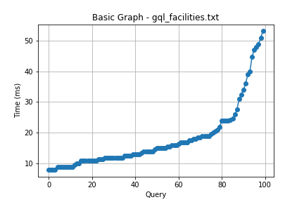

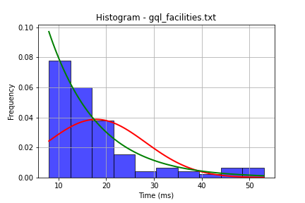

## File: gql_forms.txt

Number of queries: 100

Mean: 31.47

Median: 28.0

Max: 185.14

Min: 17.52

Variance: 331.14

Standard Deviation: 18.2

90th Percentile: 38.11

Is normal: No

Shapiro-Wilk test p-value: 4.391913394398769e-18

Is exponential: No

Kolmogorov-Smirnov test p-value: 2.0000000000001775e-200

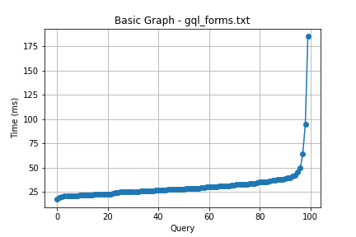

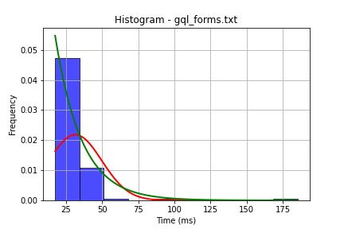

## File: gql_granting.txt

Number of queries: 100

Mean: 30.34

Median: 27.37

Max: 87.04

Min: 18.52

Variance: 110.44

Standard Deviation: 10.51

90th Percentile: 43.63

Is normal: No

Shapiro-Wilk test p-value: 7.111169986195875e-11

Is exponential: No

Kolmogorov-Smirnov test p-value: 2.01163497381884e-200

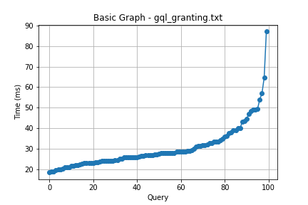

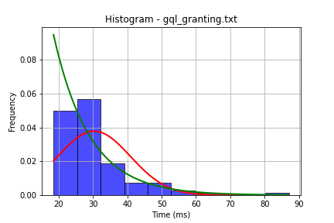

## File: gql_lessons.txt

Number of queries: 100

Mean: 31.9

Median: 25.99

Max: 145.52

Min: 16.99

Variance: 327.8

Standard Deviation: 18.11

90th Percentile: 48.32

Is normal: No

Shapiro-Wilk test p-value: 1.9072667978379393e-14

Is exponential: No

Kolmogorov-Smirnov test p-value: 2.000000000215556e-200

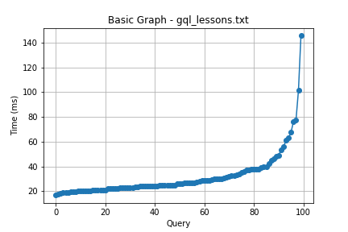

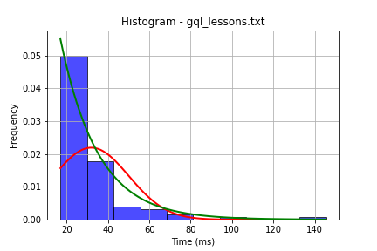

## File: gql_presences.txt

Number of queries: 100

Mean: 25.75

Median: 22.52

Max: 61.62

Min: 16.0

Variance: 83.55

Standard Deviation: 9.14

90th Percentile: 40.01

Is normal: No

Shapiro-Wilk test p-value: 6.293185417227676e-11

Is exponential: No

Kolmogorov-Smirnov test p-value: 2.535301290431561e-170

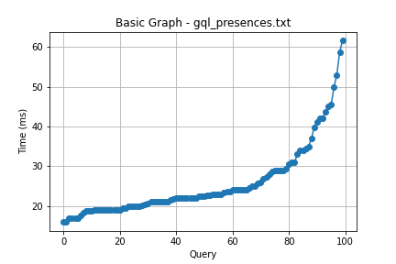

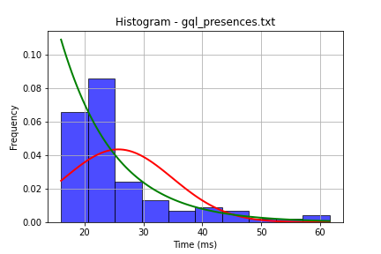

## File: gql_projects.txt

Number of queries: 100

Mean: 29.85

Median: 26.51

Max: 170.92

Min: 17.0

Variance: 310.87

Standard Deviation: 17.63

90th Percentile: 41.61

Is normal: No

Shapiro-Wilk test p-value: 1.486246493248656e-16

Is exponential: No

Kolmogorov-Smirnov test p-value: 2.5353012020540596e-170

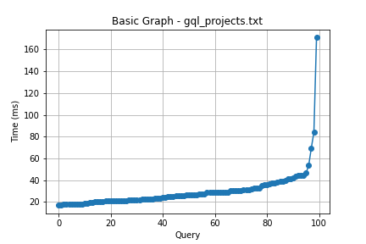

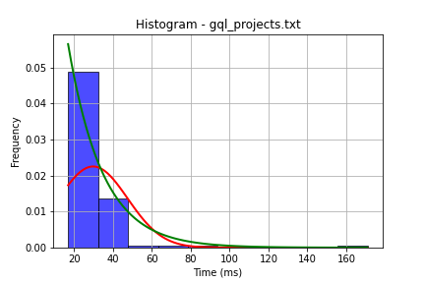

## File: gql_ug.txt

Number of queries: 100

Mean: 41.97

Median: 36.52

Max: 267.28

Min: 23.0

Variance: 803.75

Standard Deviation: 28.35

90th Percentile: 50.77

Is normal: No

Shapiro-Wilk test p-value: 1.1914072614142145e-17

Is exponential: No

Kolmogorov-Smirnov test p-value: 1.0307550414641235e-152

