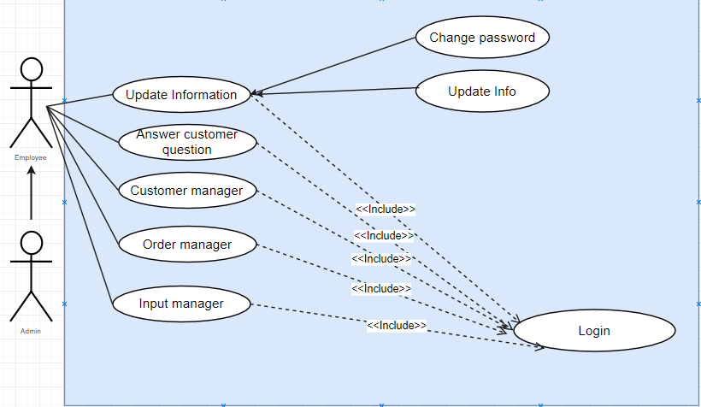

**Picture 1 . Admin – Employee Usecase.**

|  |  |  |  |
| --- | --- | --- | --- |
| **USE CASE SPECIFICATION** | | | |
| **Use-case No.** | UC001 | **Use-case Version** | 1.0 |
| **Use-case Name** | Login | | |
| **Actor:**  Admin, Employee  **Summary:**Login  **Goal:** Login to the system.  **Triggers**  **Preconditions:**  Admin and Employee must be the ones who have created UserName and Password  **Post Conditions:**  Based on logins that have different permissions, so the corresponding Admin and Employee accounts will appear different form and management functions.  **Alternative Scenario:**  **Exceptions:**  **Relationships:**  **:**  Employees  **Business Rules:** | | | |

|  |  |  |  |
| --- | --- | --- | --- |
| **USE CASE SPECIFICATION** | | | |
| **Use-case No.** | UC002 | **Use-case Version** | 1.0 |
| **Use-case Name** | Change password | | |
| **Actor:** Admin,Employee  **Summary:**  Change password.  **Goal:**  Change password.  **Triggers**  **Preconditions:**  Admin or Employee must login to the system  **Post Conditions:** Admin or Employee can change password.  **Main Success Scenario:**  1. Admin or Employee login to the system.  2. Change the password the Admin or Employee wants to change.  4. Checking for validity.  5. Update into the database.  **Alternative Scenario:**  **Exceptions:**  **Relationships:**  Employees  **Business Rules:** | | | |

|  |  |  |  |
| --- | --- | --- | --- |
| **USE CASE SPECIFICATION** | | | |
| **Use-case No.** | UC003 | **Use-case Version** | 1.0 |
| **Use-case Name** | Update Information | | |
| **Actor:** Admin,Employee  **Summary:**  Update Information .  **Goal:**  Update Information.  **Triggers**  **Preconditions:**  Admin or Employee must login to the system  **Post Conditions:** Admin or Employee can change info.  **Main Success Scenario:**  1.Admin or Employee edit personal information.  2. The system validates the data entered.  3. The system confirms the edit.  4. Update into the database.  **Alternative Scenario:**  **Exceptions:**  **Relationships:**  Employees  **Business Rules:** | | | |
|  | | | |

|  |  |  |  |
| --- | --- | --- | --- |
| **USE CASE SPECIFICATION** | | | |
| **Use-case No.** | UC004 | **Use-case Version** | 1.0 |
| **Use-case Name** | Search answer customer question | | |
| **Actor:** Admin,Employee  **Summary:**  Search answer customer question.  **Goal:**  Search answer customer question.  **Triggers**  **Preconditions:**  Admin or Employee must login to the system  **Post Conditions:** Admin or Employee can search answer customer question.  **Main Success Scenario:**   1. Admin or Employee enter keyword search. 2. The system validates the data entered.   3. Show an search information if exits.  4. If does not exits the current message and no all question.  **Alternative Scenario:**  **Exceptions:**  **Relationships:**  Employees  **Business Rules:** | | | |
|  | | | |

|  |  |  |  |
| --- | --- | --- | --- |
| **USE CASE SPECIFICATION** | | | |
| **Use-case No.** | UC005 | **Use-case Version** | 1.0 |
| **Use-case Name** | Viewlist answer customer question | | |
| **Actor:** Admin,Employee  **Summary:**  Viewlist answer customer question.  **Goal:**  Viewlist nswer customer question.  **Triggers**  **Preconditions:**  Admin or Employee must login to the system  **Post Conditions:** Admin or Employee can see all answer customer question.  **Main Success Scenario:**  1.Show all answer customer question.  **Alternative Scenario:**  **Exceptions:**  **Relationships:**  Employees  **Business Rules:** | | | |
|  | | | |

|  |  |  |  |
| --- | --- | --- | --- |
| **USE CASE SPECIFICATION** | | | |
| **Use-case No.** | UC006 | **Use-case Version** | 1.0 |
| **Use-case Name** | Reply question of customer | | |
| **Actor:** Admin,Employee  **Summary:**  Reply question of customer.  **Goal:**  Reply question of customer.  **Triggers**  **Preconditions:**  Admin or Employee must login to the system  **Post Conditions:** Admin or Employee can see all answer customer question and then reply question ò customer .  **Main Success Scenario:**   1. Show all answer customer question. 2. Admin or Employee can see question and reply question of customer.   **Alternative Scenario:**  **Exceptions:**  **Relationships:**  Employees  **Business Rules:** | | | |
|  | | | |

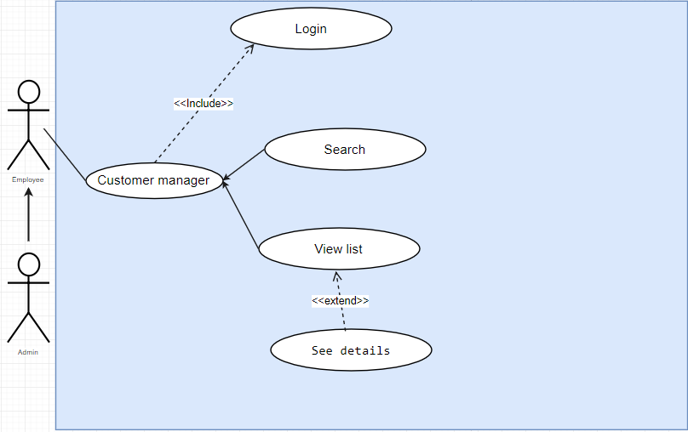

**Picture 2. Customer Manager.**

|  |  |  |  |
| --- | --- | --- | --- |
| **USE CASE SPECIFICATION** | | | |
| **Use-case No.** | UC007 | **Use-case Version** | 1.0 |
| **Use-case Name** | Customers Manager | | |
| **Actor:** Admin,Employee.  **Summary:**  Manager customers information.  **Goal:**  Manager customer information.  **Triggers**  **Preconditions:**  Admin or Employee must login to the system.  **Post Conditions:** Admin or Employee can view information of customers.  **Main Success Scenario:**  1.Admin or Employee search customer by name.  2. The system validates the data entered.  3. Admin or Employee can view list customer.  4. Admin or Employee can view details of a customer.  **Alternative Scenario:**  **Exceptions:**  **Relationships:**  **Business Rules:** | | | |
|  | | | |

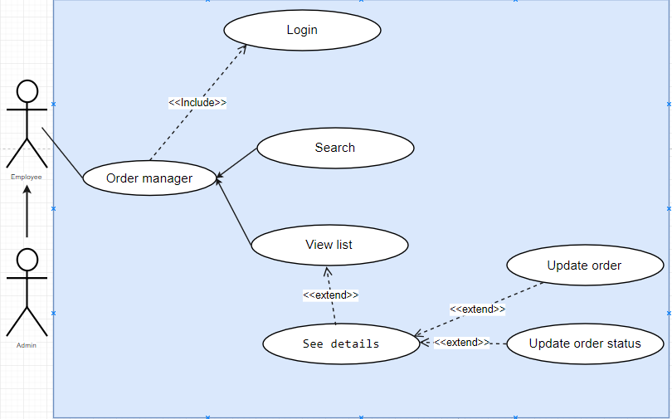

**Picture 3. Order Manager.**

|  |  |  |  |
| --- | --- | --- | --- |
| **USE CASE SPECIFICATION** | | | |
| **Use-case No.** | UC008 | **Use-case Version** | 1.0 |
| **Use-case Name** | Order Manager | | |
| **Actor:** Admin,Employee.  **Summary:** Process order from customers.  **Goal:**  Manager all order.  **Triggers**  **Preconditions:**  Admin or Employee must login to the system.  **Post Conditions:**  **Main Success Scenario:**  1.Admin or Employee search order list by code,customer name.  2. The system validates the data entered.  3. Admin or Employee can view order list.  4. Admin or Employee can view details of an order.  5. Admin or Employee can change information of order details.  **Alternative Scenario:**  **Exceptions:**  **Relationships:**  **Business Rules:** | | | |
|  | | | |

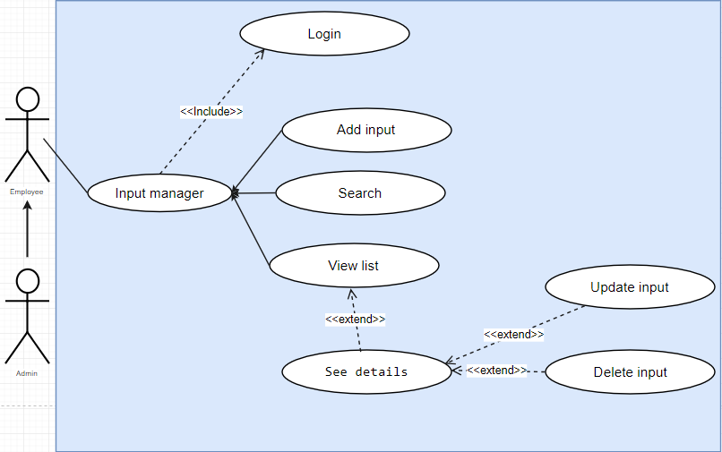

**Picture 4. Input Manager.**

|  |  |  |  |
| --- | --- | --- | --- |
| **USE CASE SPECIFICATION** | | | |
| **Use-case No.** | UC009 | **Use-case Version** | 1.0 |
| **Use-case Name** | Add input | | |
| **Actor:** Admin,Employee  **Summary:**  Add input.  **Goal:**  Add input.  **Triggers**  **Preconditions:**  Admin or Employee must login to the system  **Post Conditions:**  **Main Success Scenario:**   1. Admin or Employee login to the system. 2. Enter input information to add. 3. Check the validity of the data. 4. Update into the database.   **Alternative Scenario:**  **Exceptions:**  **Relationships:**  Employees  **Business Rules:** | | | |
|  | | | |

|  |  |  |  |
| --- | --- | --- | --- |
| **USE CASE SPECIFICATION** | | | |
| **Use-case No.** | UC0010 | **Use-case Version** | 1.0 |
| **Use-case Name** | Search input infomation | | |
| **Actor:** Admin,Employee  **Summary:**  Search input infomation.  **Goal:**  Search input infomation.  **Triggers**  **Preconditions:**  Admin or Employee must login to the system  **Post Conditions:** .  **Main Success Scenario:**   1. Admin or Employee enter keyword search. 2. The system validates the data entered.   3. Show an search information if exits.  4. If does not exits the current message and no all question.  **Alternative Scenario:**  **Exceptions:**  **Relationships:**  Employees  **Business Rules:** | | | |
|  | | | |

|  |  |  |  |
| --- | --- | --- | --- |
| **USE CASE SPECIFICATION** | | | |
| **Use-case No.** | UC0011 | **Use-case Version** | 1.0 |
| **Use-case Name** | Viewlist input | | |
| **Actor:** Admin,Employee  **Summary:**  Viewlis input.  **Goal:**  Viewlist input.  **Triggers**  **Preconditions:**  Admin or Employee must login to the system  **Post Conditions:**  **Main Success Scenario:**   1. Admin or Employee login to the system. 2. Show all input information.   **Alternative Scenario:**  **Exceptions:**  **Relationships:**  Employees  **Business Rules:** | | | |
|  | | | |

|  |  |  |  |
| --- | --- | --- | --- |
| **USE CASE SPECIFICATION** | | | |
| **Use-case No.** | UC0012 | **Use-case Version** | 1.0 |
| **Use-case Name** | Update input | | |
| **Actor:** Admin,Employee  **Summary:**  Update input.  **Goal:**  Update input.  **Triggers**  **Preconditions:**  Admin or Employee must login to the system  **Post Conditions:**  **Main Success Scenario:**   1. Admin or Employee login to the system. 2. Looking for input to edit. 3. Admin or Employee changed the information. 4. Check the validity of the data. 5. Update into the database.   **Alternative Scenario:**  **Exceptions:**  **Relationships:**  Employees  **Business Rules:** | | | |
|  | | | |

|  |  |  |  |
| --- | --- | --- | --- |
| **USE CASE SPECIFICATION** | | | |
| **Use-case No.** | UC0013 | **Use-case Version** | 1.0 |
| **Use-case Name** | Delete input | | |
| **Actor:** Admin,Employee  **Summary:**  Delete input.  **Goal:**  Delete input.  **Triggers**  **Preconditions:**  Admin or Employee must login to the system  **Post Conditions:**  **Main Success Scenario:**   1. Admin or Employee login to the system. 2. Looking for input to delete. 3. Delete. 4. Update into the database.   **Alternative Scenario:**  **Exceptions:**  **Relationships:**  Employees  **Business Rules:** | | | |
|  | | | |

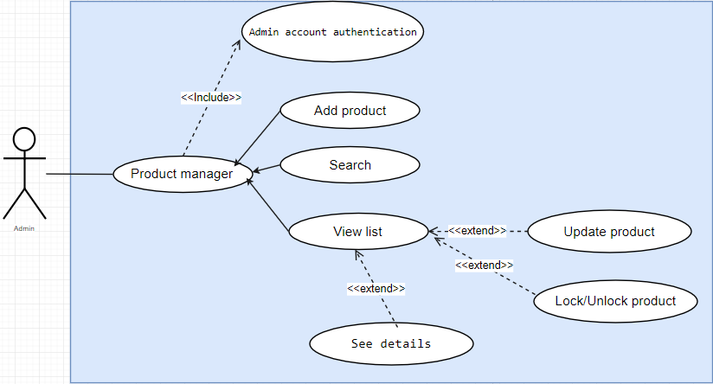

**Picture 5. Product Manager.**

|  |  |  |  |
| --- | --- | --- | --- |
| **USE CASE SPECIFICATION** | | | |
| **Use-case No.** | UC0014 | **Use-case Version** | 1.0 |
| **Use-case Name** | Product Manager | | |
| **Actor:** Admin  **Summary:** Manager all product.  **Goal:**  Manager all product.  **Triggers**  **Preconditions:**  Admin must login to the system with admin account.  **Post Conditions:**  **Main Success Scenario:**  1.Admin search product by name.  2. Admin add information of new product.  3. Admin can view list product.  4. Admin can update product details.  5. Admin can lock or unlock product.  6. The system validates the data entered when add or update product.  **Alternative Scenario:**  **Exceptions:**  **Relationships:**  **Business Rules:** | | | |
|  | | | |

|  |  |  |  |
| --- | --- | --- | --- |
| **USE CASE SPECIFICATION** | | | |
| **Use-case No.** | UC0015 | **Use-case Version** | 1.0 |
| **Use-case Name** | Search product | | |
| **Actor:** User  **Summary:** Users can find product they want.  **Goal:**  User search product.  **Triggers**  **Preconditions:**  Website main page is loaded.  **Post Condition :**  **Main Success Scenario:**  1.User click on search box.  2. System validates data entered.  3. System show list product by keyword. If not, the “Not found” page displays.  **Alternative Scenario:**  **Exceptions:**  **Relationships:**  **Business Rules:** | | | |
|  | | | |

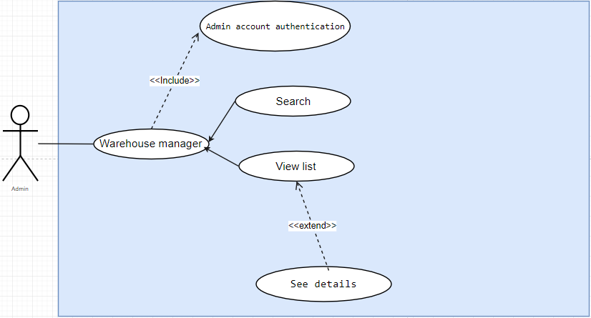

**Picture 6. Warehouse Manager.**

|  |  |  |  |
| --- | --- | --- | --- |
| **USE CASE SPECIFICATION** | | | |
| **Use-case No.** | UC0016 | **Use-case Version** | 1.0 |
| **Use-case Name** | Search warehouse manager. | | |
| **Actor:** Admin  **Summary:**  Search warehouse manager.  **Goal:**  Search warehouse manager.  **Triggers**  **Preconditions:**  Admin must login to the system  **Post Conditions:** .  **Main Success Scenario:**   1. Admin enter keyword search. 2. The system validates the data entered.   3. Show an search information if exits.  4. If does not exits the current message and no all question.  **Alternative Scenario:**  **Exceptions:**  **Relationships:**  Employees  **Business Rules:** | | | |
|  | | | |

|  |  |  |  |
| --- | --- | --- | --- |
| **USE CASE SPECIFICATION** | | | |
| **Use-case No.** | UC0017 | **Use-case Version** | 1.0 |
| **Use-case Name** | Viewlist warehouse manager | | |
| **Actor:** Admin  **Summary:**  Viewlis warehouse.  **Goal:**  Viewlist warehouse.  **Triggers**  **Preconditions:**  Admin must login to the system  **Post Conditions:**  **Main Success Scenario:**   1. Admin login to the system. 2. Show all warehouse information.   **Alternative Scenario:**  **Exceptions:**  **Relationships:**  Employees  **Business Rules:** | | | |
|  | | | |

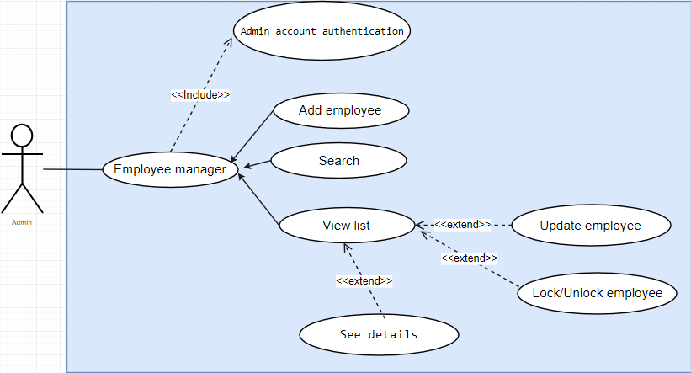

**Picture 7. Employee Manager.**

|  |  |  |  |
| --- | --- | --- | --- |
| **USE CASE SPECIFICATION** | | | |
| **Use-case No.** | UC0018 | **Use-case Version** | 1.0 |
| **Use-case Name** | Add Employee | | |
| **Actor:** Admin  **Summary:**  Add Employee.  **Goal:**  Add Employee.  **Triggers**  **Preconditions:**  Admin must login to the system  **Post Conditions:**  **Main Success Scenario:**   1. Admin login to the system. 2. Enter input information to add. 3. Check the validity of the data. 4. Update into the database.   **Alternative Scenario:**  **Exceptions:**  **Relationships:**  Employees  **Business Rules:** | | | |
|  | | | |

|  |  |  |  |
| --- | --- | --- | --- |
| **USE CASE SPECIFICATION** | | | |
| **Use-case No.** | UC0019 | **Use-case Version** | 1.0 |
| **Use-case Name** | Search Employee. | | |
| **Actor:** Admin  **Summary:**  Search employee.  **Goal:**  Search employee.  **Triggers**  **Preconditions:**  Admin must login to the system  **Post Conditions:** .  **Main Success Scenario:**   1. Admin enter keyword search. 2. The system validates the data entered.   3. Show an search information if exits.  4. If does not exits the current message and no all question.  **Alternative Scenario:**  **Exceptions:**  **Relationships:**  Employees  **Business Rules:** | | | |
|  | | | |

|  |  |  |  |
| --- | --- | --- | --- |
| **USE CASE SPECIFICATION** | | | |
| **Use-case No.** | UC0020 | **Use-case Version** | 1.0 |
| **Use-case Name** | Viewlist employee | | |
| **Actor:** Admin  **Summary:**  Viewlis employee.  **Goal:**  Viewlist employee.  **Triggers**  **Preconditions:**  Admin must login to the system  **Post Conditions:**  **Main Success Scenario:**   1. Admin login to the system. 2. Show all employee information.   **Alternative Scenario:**  **Exceptions:**  **Relationships:**  Employees  **Business Rules:** | | | |
|  | | | |

|  |  |  |  |
| --- | --- | --- | --- |
| **USE CASE SPECIFICATION** | | | |
| **Use-case No.** | UC0021 | **Use-case Version** | 1.0 |
| **Use-case Name** | Update employee | | |
| **Actor:** Admin  **Summary:**  Update employee.  **Goal:**  Update employee.  **Triggers**  **Preconditions:**  Admin must login to the system  **Post Conditions:**  **Main Success Scenario:**   1. Admin login to the system. 2. Looking for employee to edit. 3. Admin changed the information. 4. Check the validity of the data. 5. Update into the database.   **Alternative Scenario:**  **Exceptions:**  **Relationships:**  Employees  **Business Rules:** | | | |
|  | | | |

|  |  |  |  |
| --- | --- | --- | --- |
| **USE CASE SPECIFICATION** | | | |
| **Use-case No.** | UC0022 | **Use-case Version** | 1.0 |
| **Use-case Name** | Update employee | | |
| **Actor:** Admin  **Summary:**  Update employee.  **Goal:**  Update employee.  **Triggers**  **Preconditions:**  Admin must login to the system  **Post Conditions:**  **Main Success Scenario:**   1. Admin login to the system. 2. Looking for employee to edit. 3. Admin changed the information. 4. Check the validity of the data. 5. Update into the database.   **Alternative Scenario:**  **Exceptions:**  **Relationships:**  Employees  **Business Rules:** | | | |
|  | | | |

|  |  |  |  |
| --- | --- | --- | --- |
| **USE CASE SPECIFICATION** | | | |
| **Use-case No.** | UC0023 | **Use-case Version** | 1.0 |
| **Use-case Name** | Lock/Unlock employee | | |
| **Actor:** Admin  **Summary:**  Lock/unlock employee.  **Goal:**  Lock/Unlock employee.  **Triggers**  **Preconditions:**  Admin must login to the system  **Post Conditions:**  **Main Success Scenario:**   1. Admin login to the system. 2. Looking for employee to lock/unlock. 3. Lock/unlock. 4. Update into the database.   **Alternative Scenario:**  **Exceptions:**  **Relationships:**  Employees  **Business Rules:** | | | |
|  | | | |

|  |  |  |  |
| --- | --- | --- | --- |
| **USE CASE SPECIFICATION** | | | |
| **Use-case No.** | UC0024 | **Use-case Version** | 1.0 |
| **Use-case Name** | Statistics employee | | |
| **Actor:** Admin  **Summary:**  Statistics employee.  **Goal:**  Statistics employee.  **Triggers**  **Preconditions:**  Admin must login to the system  **Post Conditions:**  **Main Success Scenario:**   1. Admin login to the system. 2. Show all employee sells product that total money from high level.   **Alternative Scenario:**  **Exceptions:**  **Relationships:**  Employees  **Business Rules:** | | | |
|  | | | |

|  |  |  |  |
| --- | --- | --- | --- |
| **USE CASE SPECIFICATION** | | | |
| **Use-case No.** | UC0025 | **Use-case Version** | 1.0 |
| **Use-case Name** | Statistics customer | | |
| **Actor:** Admin  **Summary:**  Statistics customer.  **Goal:**  Statistics customer.  **Triggers**  **Preconditions:**  Admin must login to the system  **Post Conditions:**  **Main Success Scenario:**   1. Admin login to the system. 2. Show all customer purchase product that total money from high level.   **Alternative Scenario:**  **Exceptions:**  **Relationships:**  Employees  **Business Rules:** | | | |

|  |  |  |  |
| --- | --- | --- | --- |
| **USE CASE SPECIFICATION** | | | |
| **Use-case No.** | UC0026 | **Use-case Version** | 1.0 |
| **Use-case Name** | Statistics employee | | |
| **Actor:** Admin  **Summary:**  Statistics employee.  **Goal:**  Statistics employee.  **Triggers**  **Preconditions:**  Admin must login to the system  **Post Conditions:**  **Main Success Scenario:**   1. Admin login to the system. 2. Show all employee sells product that total money from high level.   **Alternative Scenario:**  **Exceptions:**  **Relationships:**  Employees  **Business Rules:** | | | |
|  | | | |

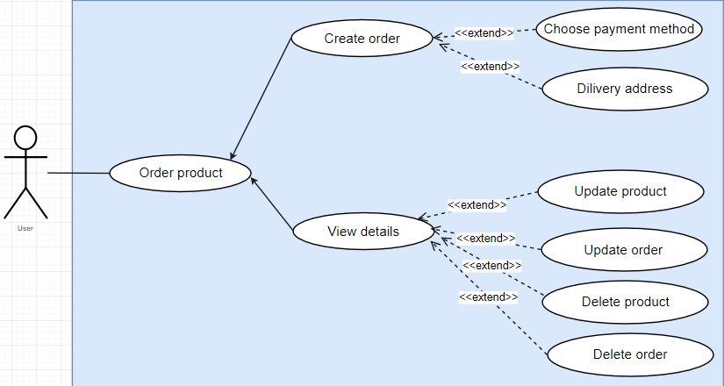

**Picture 8. Customer Order.**

|  |  |  |  |
| --- | --- | --- | --- |
| **USE CASE SPECIFICATION** | | | |
| **Use-case No.** | UC0027 | **Use-case Version** | 1.0 |
| **Use-case Name** | Order product (create) | | |
| **Actor:** Admin  **Summary:**  Order product(create).  **Goal:**  Order product(create).  **Triggers**  **Preconditions:**    **Post Conditions:**  **Main Success Scenario:**   1. Customer view all product. 2. View details product 3. Choose buy to push to cart 4. Create an order 5. Can add or change a product 6. Purchase. 7. Enter the buyer information (if not already login) 8. Enter the recipient information if the buyer and recevice are different. 9. Confirmation 10. Update data in temporary order table.   **Alternative Scenario:**  **Exceptions:**  **Relationships:**  Employees  **Business Rules:** | | | |
|  | | | |

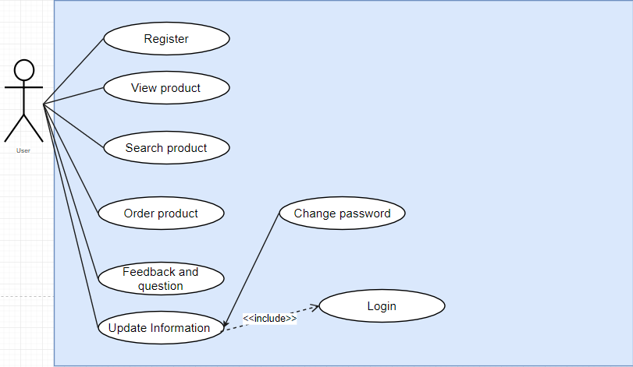

**Picture 9. Customer Usecase.**

|  |  |  |  |
| --- | --- | --- | --- |
| **USE CASE SPECIFICATION** | | | |
| **Use-case No.** | UC0029 | **Use-case Version** | 1.0 |
| **Use-case Name** | Update user information | | |
| **Actor:** User  **Summary:** Users can modify their information.  **Goal:**  Update user information.  **Triggers**  **Preconditions:**  User must login to the system.  **Post Condition :**  **Main Success Scenario:**  1.User click on “Update profile” link.  2. System validates data entered.  3. System show “Successfully” page. If not, the “Error” page displays.  **Alternative Scenario:**  **Exceptions:**  **Relationships:**  **Business Rules:** | | | |
|  | | | |

|  |  |  |  |
| --- | --- | --- | --- |
| **USE CASE SPECIFICATION** | | | |
| **Use-case No.** | UC0030 | **Use-case Version** | 1.0 |
| **Use-case Name** | Change user password | | |
| **Actor:** User  **Summary:** Users can modify their password.  **Goal:**  Change user password.  **Triggers**  **Preconditions:**  User must login to the system.  **Post Condition :**  **Main Success Scenario:**  1.User click on “Change password” link.  2. System validates data entered.  3. System show “Successfully” page. If not, the “Error” page displays.  **Alternative Scenario:**  **Exceptions:**  **Relationships:**  **Business Rules:** | | | |
|  | | | |

|  |  |  |  |
| --- | --- | --- | --- |
| **USE CASE SPECIFICATION** | | | |
| **Use-case No.** | UC0031 | **Use-case Version** | 1.0 |
| **Use-case Name** | Feedback and question | | |
| **Actor:** User  **Summary:** Users can feedback or ask question.  **Goal:**  User feedback to the system.  **Triggers**  **Preconditions:**  User must login to the system.  **Post Condition :**  **Main Success Scenario:**  1.User click on “Feedback” link.  2. System validates data entered.  3. System show “Successfully” page. If not, the “Error” page displays.  **Alternative Scenario:**  **Exceptions:**  **Relationships:**  **Business Rules:** | | | |
|  | | | |