**SEESAW**

* ESRB Index: E (Everyone)
* Target Audience: children
* The game depicts a play of folk games in Vietnam. With fun 2D graphics, promises to bring high entertainment to players.
* Unique point of the game:
  + Beautiful graphics.
  + Fun stories.
  + Educational nature: This is a folk game of Viet Nam, associated with the childhood of many people.

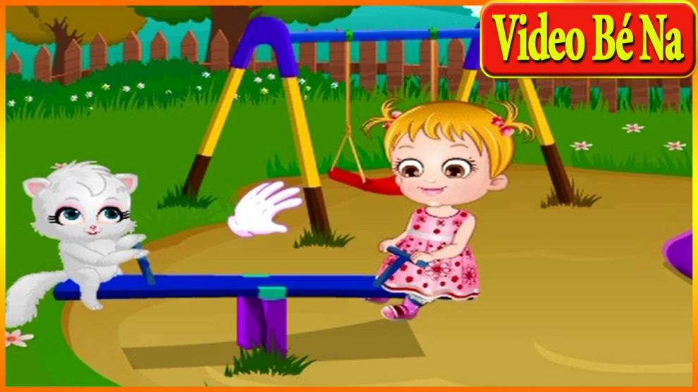

Image 1: Balance Bridg

I. **Game Concept**

1. Character

- The game has 2 main characters: Tom and Jerry standing at the two ends of the balance bridge.This is 2 famous characters in the cartoon movie.

- Characters’s personalities: Fun, Jaunty, giddy. Every time they jumped up and landed safe, the characters had funny saying, crunching laughter.

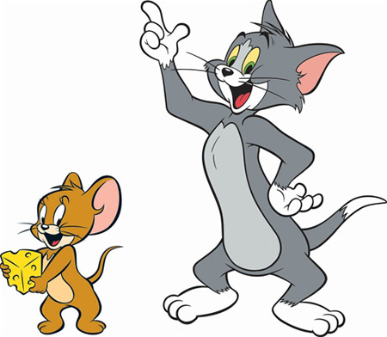

Image 2: Tom and Jerry

1. Camera

* Static Camera: The camera hold a fixed angle, not moving.
* Feature: Don’t change position and stay fixed on the screen.

Advantage:

* + Easily express the mode of play.
  + Easily setup events in the game.
* View angle in the game: third angle view

Players have a better view of the game world, the activities of the characters.

- When players moves the bridge, the camera remain unchanged.

Because the distance players can move the bridge is limited, only 1 screen.

1. Control

The players touches the character when want it to jump up. After the character jumps, the player must control the left or the right side to steer the bridge to the character landing position.

The player moves the bridge by holding onto it to move. The bridge is just a symbol that connect the characters, creating logic: 1 person fall, the other person can’t continue playing, give the player a bit of responsibility with the others.

If players doesn’t bring the bridge to the correct location, the characters will fall to the ground and end game.

Game will defined : When the character on the bridge players can touch and can not move the bridge. Opposite, when the character jumps, the player can only hold to move the bridge.

[Tung] Is player can jump whenever they want?

So, the control is : Click to jump and hold to move the bridge. How to define click/hold? I mean how long do you have to hold to let system know that it’s a “hold”.

1. Challenge

- Clock will count down. Each level will have 1 minute. In that 1 minute, let’s try to jump successfully many times.

When touch button start the game, the player has not played, the game is start normal. So the clock to limit the playing time, freeing up machine memory when not needed and also it creates challenges for players.

- When the players gives the character a jump up, the height and the drop point are random. I think it is a challenge for the players.

- Character can’t jump over the screen. To increase difficulty, when the characters jump up, the speed of jumping and falling will increase.

[Tung] The height and drop point are random. I wonder can character jump over 1 screen height?

- Each time you jump up and land safely, you will earn scores and money. The cumulative amount can be used to purchase new items such as new balance bridge, Tom & Jerry food, etc.

[Tung] How to increase/decrease the difficulty? Overall, is there any solution to increase fun factor?

**II. Pitch Document**

1. **Target Audience**

The children and their parents.

To day, with the emergence of smart devices. Children no longer play folk game. Gradually, they don’t know the games. They won’t understand the excitement of the game, not understanding what their parents experienced at a young age. That is the weakness of smart devices for childern. So, combining mobile gaming platform and folk game story, the game “Seesaw ” was born to introduced children knew that Vietnam has such good games, inspire them to learn other folk types.

1. **Competitive Analysis**

**-** Game Mechanics is very easy. There are only two ways to control: one is touch, the other is hold. Anyone looking for the first time can understand how to play. However, there will still be tutorials for players to get know faster.

- Target Audience is very popular. The number of children owning smartphone is increasing.

- Platform: develop on the Android and IOS, is two platform popular at the present.

-Subject: The folk game. Vietnamese game, friendly with people Vietnamese.

-Publishing time: This is mini game. Publishing time about 1 week.

At the present time, the game on this topic is very little. When we produce, create a good user experience, user will come to us.

1. **Bussiness potential**

- With Game play easy, there are only two ways to control: one is touch, the other is hold.

- In the game, some items have to buy users such as character clothing, bridge, ... We can make money from it. Also, because of the free dowload of games, there will be ads.

- For interaction between players: after each turn will be turn scores. That score will show the player's skill.

- At pressent I watch not many folk games on the stores. While, the number of Vietnamese folk games a lot. The number of smartphone users has increased exponentially (Year 2017,The percentage of smartphone users compared to traditional phones is 84% while the age of use smartphone decreases). Game for Vietnamese is a very open market for VietNamese game companies.

- Seesaw game is considered to be a start. If the game receives a positive response from the user, the development team continues to target similar games and developed on multiple operating systems.