Daniel Gerald Gabriel

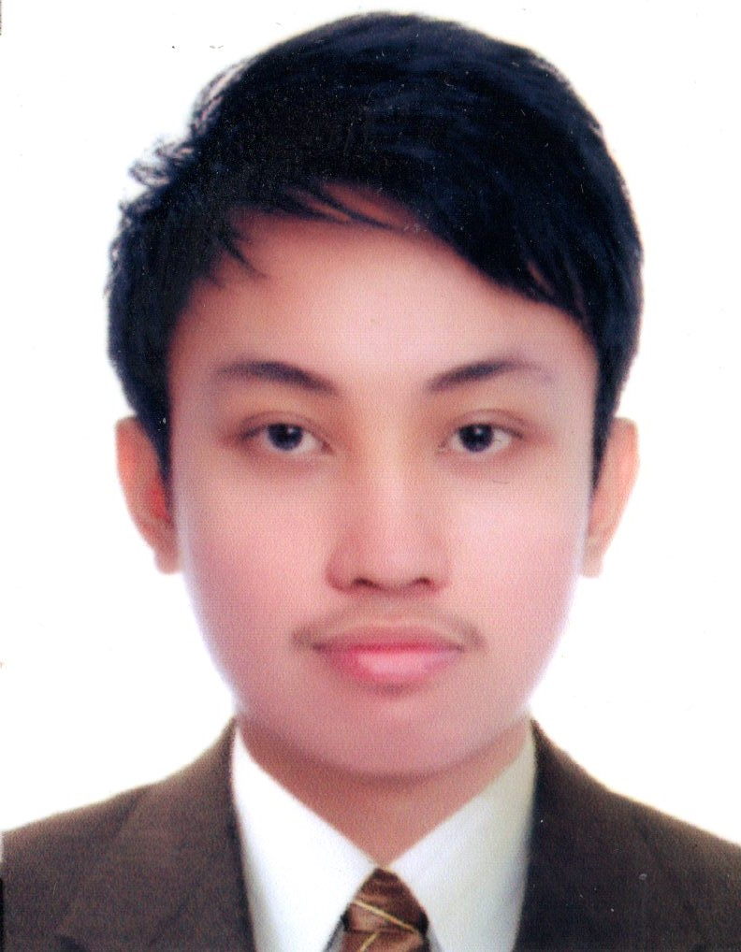

#236 Mabini St. Poblacion, Pulilan, Bulacan

0943-406-5099 ~ [danielgabriel08@hotmail.com](mailto:danielgabriel08@hotmail.com)

http://www.gabrieldaniel.me/

**Career Objective**

To obtain a challenging position of entry level programmer, and contribute positively to build a long term career with the company

**Technical** **Skills**

Microsoft Office · Windows XP/7/8 · PC Software installation, System Config And troubleshooting

Visual Basic .NET · JAVA· Android · Arduino · JavaScript· CSS· HTML · PHP · Wordpress

**Professional** **Experience**

**Android developer and Junior SEO**

Alchemy Business Center and Marketing consultancy

203, 2/F FBR Arcade Bldg, 317 Katipunan Avenue, Loyola Heights,

Quezon City, 1108 Metro Manila

*On-the-Job Training*

December 2014-March 2015

**PCOS TECHNICIAN**

2013 Election

Sto. Rosario Chapel

Lumbac, Pulilan, Bulacan

May 13, 2013

**ASSISTANT CLERK/DATA ENCODER**

Municipality of Pulilan

Pulilan, Bulacan

*On-the-Job Training*

June-November, 2012

**SEMINAR ATTENDED**

**Mobile App Launch Marketing**

Luna Room - 203, 2/F FBR Arcade Bldg, 317 Katipunan Avenue, Loyola Heights,

Quezon City, 1108 Metro Manila

March 6 , 2015

**1st Computer Technology SUMMIT**

Bulacan State Universty

Malolos City, Bulacan

June 27, 2013

**Visual C# Programming**

Bulacan State Universty

Malolos City, Bulacan

December 2, 2013

**ICT SYMPOSIUM**

Bulacan State Universty

Malolos City, Bulacan

March 20, 2012

**System Configuration Seminar**

Bulacan State Universty

Malolos City, Bulacan

December 4, 2012

**Education**

**BACHELOR OF INDUSTRIAL TECHNOLOGY**

Major in Computer Technology

Bulacan State University

Malolos City, Bulacan

March 2015

**ST. DOMINIC ACADEMYOF PULILAN**

Poblacion, Pulilan, Bulacan

March 2011

**PULILAN CENTRAL SCHOOL**

Poblacion, Pulilan, Bulacan

March 2007

**PERSONAL INFORMATION**

Date of Birth : March 08, 1994

Place of Birth : Baliuag, Bulacan

Civil Status : Single

Gender : Male

Age : 20 yrs. old

Weight : 95 lbs

Height : 5’7

Citizenship : Filipino

Father’s Name : Dante E. Gabriel

Mother’s Name : Aurea A. Gabriel

**CHARACTER REFERENCES**

**Mrs. Carina L. Advincula OJT Program Director**

Alchemy Business Center

Loyola Heights, Quezon City

**Mr.Rommel Pineda Programmer/System Support**

Abdul Rahman Saad Al Rashid

Sons and Co.King Fahad Road

Riyadh Kingdom of Saudi Arabia

*I hereby certify that the above information is true and correct to the best of my knowledge and belief.*

**DANIEL GERALD A. GABRIEL**

Applicant