Center Name: ACE-HCMC-2-FPT.
MEDIFLOW
Developer’s Guide
Supervisor: | Mr. HOANG DUC QUANG
Semester: | 4
Batch No: | T2.2410.E0
Group No: | 4
Order: | Full name | Roll No.
1. | Pham Dang Vinh | Student1614910
2. | Tran Hoang Anh | Student1614884
3. | Than The Loc | Student1571994
4. | Le Quang Huy | Student1394600
- This is to certify that
Mr. Pham Dang Vinh
Mr. Tran Hoang Anh
Mr. Than The Loc
Mr. Le Quang Huy
have successfully designed & developed:
eProject: MediFlow
- Submitted by:
Mr. Hoang Duc Quang
Date of issue: 08/11/2026
Authorized Signature:

Table of Contents
Table of Contents 2
I. Download Source Code (BE, FE & Mobile) 1
II. Install the Prerequisites 2
III. Configure the Environment 2
IV. Run the Project (Demo Data Auto-Import) 5
V. Run the Project Manually (Docker Compose & Maven) 9
VI. Run the Mobile App (Flutter) 12
VII. Architecture and Source Code Structure 13
VIII. Testing and Quality Checks 15
IX. Stop, Clean Up and Troubleshooting 16

Download Source Code (BE, FE & Mobile)
MediFlow is a single Git monorepo that contains the Spring Boot backend, the Next.js web client and the Flutter mobile client.

Clone the repository (or extract the submitted source archive):
git clone git@github.com:Dangvinh77/MediFlow.git
cd MediFlow

Open the backend in IntelliJ IDEA: File → Open → select the root pom.xml and choose Open as Project. IntelliJ imports all Maven modules of the reactor.

Open the frontend folder frontend/ in Visual Studio Code.

Open the mobile folder mobile/ in Visual Studio Code or Android Studio (Flutter plugin installed).

On a new clone, run the bootstrap once. It installs the Git hooks that enforce the commit-author policy:
powershell -ExecutionPolicy Bypass -File scripts/bootstrap.ps1
Repository layout
Folder | Content
backend/ | 13 Maven modules: eureka-server, gateway, common and the business services
frontend/ | Next.js 16 web client (App Router, TypeScript, Tailwind CSS v4, pnpm)
mobile/ | Flutter mobile client (Clean Architecture, Riverpod)
docs/ | Design documents, API contracts, coding standards (docs/ai) and acceptance evidence
scripts/ | Bootstrap, Git hooks, database init script and the Windows demo launcher (scripts/run)
docker-compose.yml | PostgreSQL, RabbitMQ and the containerised services
pom.xml | Root Maven reactor

Install the Prerequisites
Install the tools below and make sure each command is available in the PATH (open a new terminal after installing).
Tool | Version | Used for | Check command
JDK | 21 | Build and run the backend | java -version
Apache Maven | 3.9+ | Backend build and tests | mvn -v
Docker Desktop | Latest | PostgreSQL, RabbitMQ, Testcontainers and the demo launcher | docker info
Python | 3.x | Demo launcher (database restore and seeding) | python --version
Node.js + pnpm | Node 20+ | Web client | node -v, pnpm -v
Flutter | Stable (Dart ^3.13) | Mobile client | flutter doctor

Tip: Docker Desktop must be started and show Engine running before any backend command. Every bounded context owns its own PostgreSQL database inside Docker.

Configure the Environment

Email (SMTP) settings — smtp.local.env
MediFlow sends welcome emails, temporary passwords and password-reset links. SMTP settings are read from a gitignored file smtp.local.env in the repository root.

Copy the template smtp.env.example to smtp.local.env in the project root.

Fill in your Gmail sender and a Google App Password (not your normal password):
SPRING_MAIL_HOST=smtp.gmail.com
SPRING_MAIL_PORT=587
SPRING_MAIL_USERNAME=<your-email>
SPRING_MAIL_PASSWORD=<your-google-app-password>
MEDIFLOW_MAIL_FROM=<your-email>
MEDIFLOW_MAIL_FROM_NAME=MediFlow
MEDIFLOW_PUBLIC_WEB_URL=http://localhost:3000
MEDIFLOW_SECURITY_MAIL_KEY=<base64-encoded-32-byte-key>
MEDIFLOW_DEMO_MAILBOX_ENABLED=false

Generate the mail key once, for example in PowerShell:
[Convert]::ToBase64String((1..32 | ForEach-Object { Get-Random -Maximum 256 }))

Save the file. scripts/run/start-backend.bat loads it automatically. For IDE/Java startup, dot-source scripts/load-smtp-local.ps1 first.
Never commit smtp.local.env or put real credentials in smtp.env.example. Without SMTP the system still works; emails stay pending and the local demo mailbox (/demo-mailbox) can be used for seed accounts.

Backend variables (manual run only)
When services are started from the IDE or with java -jar, provide these environment variables (or a gitignored application-local.yml). The demo launcher sets them for you.
Variable | Meaning | Local example
MEDIFLOW_DB_USER / MEDIFLOW_DB_PASSWORD | PostgreSQL account used by every service | postgres / postgres
MEDIFLOW_RABBIT_HOST / _PORT | RabbitMQ broker | localhost / 5672
MEDIFLOW_RABBIT_USER / _PASSWORD | RabbitMQ account | guest / guest
MEDIFLOW_JWT_SECRET | Shared JWT signing secret — must be identical for Gateway and Core | a long random string
MEDIFLOW_PUBLIC_WEB_URL | Web origin used in email links | http://localhost:3000

Frontend variables — frontend/.env.local
Copy frontend/.env.example to frontend/.env.local. The web client only calls the Gateway through the same-origin /api/* proxy.
GATEWAY_URL=http://localhost:8080
MEDIFLOW_OUTPATIENT_UI_ENABLED=true
start-frontend.bat writes the right values automatically when the demo launcher is used (Gateway port 28080).

Run the Project (Demo Data Auto-Import)
The fastest way on Windows is the demo launcher in scripts/run/. It builds the backend, creates the PostgreSQL/RabbitMQ containers, restores the synthetic demo database automatically (departments, staff, accounts, patients, schedules, drugs, prices) and starts all eight applications. You do not need to import any data manually.

Start the backend

Open Docker Desktop and wait until the engine is running.

Double-click scripts\run\start-backend.bat, or run from a terminal:
cd scripts\run
.\start-backend.bat
Run it without the -Fast option. The launcher then builds every backend module from source and imports the demo data from scratch, so the result does not depend on an earlier build or on the Docker state. Add -LocalOnly to keep everything on 127.0.0.1, or -Rebuild to force a clean Maven build.

Wait for the console to print CALENDAR READY and then READY. Building from scratch takes several minutes (Maven build + data import). Keep the window open; the applications stop after two hours or when you press Ctrl + C.
Building the eight demo applications...
Gateway: http://127.0.0.1:28080.
eureka-server UP
...
CALENDAR READY
READY
Option | Effect
(none) — recommended | Build from source and import fresh demo data; applications stop after two hours
-Rebuild | Force a Maven rebuild
-ResetData | Recreate the retained demo data
-LanAddress <ip> | Serve on that LAN address so phones on the same Wi-Fi can connect
-LocalOnly | Bind to 127.0.0.1 only
-StartupParallelism 1 | Start applications one at a time on low-memory machines

Start the frontend

After the backend prints READY, double-click scripts\run\start-frontend.bat (it runs pnpm install and pnpm dev).
▲ Next.js 16.2.11 (Turbopack)
- Local: http://127.0.0.1:3000
✓ Ready

Press Ctrl + Click on the printed link, or open http://127.0.0.1:3000/login in the browser.
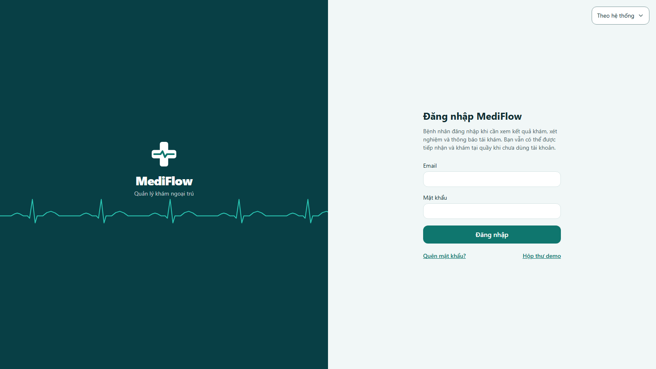
Figure 1. MediFlow login page served by the web client

Sign in with a demo account below. If everything is set up correctly, the role workspace opens.

Demo accounts
All seed accounts share the password MediFlowDemo@2026 (synthetic data only). Sign in with the email.
Role | Email | Name / department | Main use
ADMIN | demo.staff01@example.test | Nguyễn Quản Trị Demo | Organization, staff, accounts, department heads, reports
NURSE | demo.staff04@example.test | Phạm Điều Dưỡng Demo — Internal Medicine | Patient records, patient accounts, reception
DOCTOR | demo.staff03@example.test | Lê Bác Sĩ Demo — Internal Medicine (department head) | Examination, lab orders, prescriptions, department management
DOCTOR | demo.staff05@example.test | Nguyễn Minh Phúc Demo — Paediatrics | Second doctor, another department
LAB_TECH | demo.staff15@example.test | Dương Thanh Tâm Demo — Laboratory | Run tests and enter results
PHARMACIST | demo.staff17@example.test | Mai Thảo Vy Demo — Pharmacy | Drug catalogue, dispensing
CASHIER | demo.staff19@example.test | Phan Khánh Linh Demo — Finance | Exam, lab and prescription payments
PATIENT | demo.patient01@example.test | Nguyễn Văn An Demo | Own results and notifications
PATIENT | demo.patient02@example.test | Trần Thị Bình Demo | Follow-up patient

The complete list (with patient IDs and scenarios) is in scripts/run/TAI_KHOAN_DEMO.txt; the step-by-step demo script is scripts/demo_25_10/DEMO_UI_TUNG_BUOC.md.

Run the Project Manually (Docker Compose & Maven)
Use this path on macOS/Linux or when you want to debug individual services in the IDE.

Start the shared infrastructure. On first start PostgreSQL runs scripts/init-databases.sql, which creates one database per context:
docker compose up -d postgres rabbitmq

Build all backend modules:
mvn -q -DskipTests install

Start the applications in this order (each in its own terminal or IntelliJ run configuration). Flyway creates the schema of each database on startup:
java -jar backend/eureka-server/target/eureka-server-0.0.1-SNAPSHOT.jar
java -jar backend/gateway/target/gateway-0.0.1-SNAPSHOT.jar
java -jar backend/core-service/target/core-service-0.0.1-SNAPSHOT.jar
java -jar backend/clinical-service/target/clinical-service-0.0.1-SNAPSHOT.jar
java -jar backend/lab-service/target/lab-service-0.0.1-SNAPSHOT.jar
java -jar backend/pharmacy-service/target/pharmacy-service-0.0.1-SNAPSHOT.jar
java -jar backend/billing-service/target/billing-service-0.0.1-SNAPSHOT.jar
java -jar backend/support-service/target/support-service-0.0.1-SNAPSHOT.jar

Check the services in the Eureka dashboard http://localhost:8761 and the Gateway health endpoint http://localhost:8080/actuator/health.

Start the web client:
cd frontend
pnpm install
pnpm dev

Open http://localhost:3000. pnpm dev proxies /api/* to the Gateway on port 8080.
Module | Port | Role
eureka-server | 8761 | Service discovery
gateway | 8080 | /api/* entry point, login and route authorization
core-service | 8089 | Organization and Patient contexts (/api/v1/org, /api/v1/patients)
clinical-service | 8082 | Appointments and medical records (/api/v1/appointments, /api/v1/records)
lab-service | 8084 | Laboratory (/api/v1/lab)
pharmacy-service | 8085 | Pharmacy (/api/v1/pharmacy)
billing-service | 8086 | Billing (/api/v1/billing)
support-service | 8087 | Report and Notification (/api/v1/reports, /api/v1/notifications)
PostgreSQL / RabbitMQ | 5432 / 5672 (UI 15672) | Databases per context / event broker

There is no default administrator in a clean manual setup. Create accounts through a seeded environment, or use the demo launcher which provisions all demo accounts.

Run the Mobile App (Flutter)
The Flutter client talks to the real Gateway only (no mock data). From the mobile/ folder on Windows:

Fetch packages and run the web build with a same-origin proxy to the demo Gateway:
cd mobile
flutter pub get
./tool/run_web.ps1 -Demo -Gateway http://127.0.0.1:28080

Open http://localhost:4300, then use the browser device toolbar (F12 → Ctrl+Shift+M) to emulate a phone.
If Windows PowerShell 5.1 stops the script right after the message “Wasm dry run succeeded”, the web build has already finished: start the server directly with dart run tool/dev_server.dart 4300 http://127.0.0.1:28080. The first page load can take about ten seconds.

For hot reload on Chrome or an Android emulator:
./tool/run_dev.ps1
./tool/run_dev.ps1 -Target android -Demo -Gateway http://127.0.0.1:28080

For a real device on the same Wi-Fi, start the backend with -LanAddress <your-ip> and run:
flutter run -d <device-id> --dart-define=GATEWAY_URL=http://<your-ip>:28080/api \
--dart-define=ALLOW_INSECURE_HTTP=true --dart-define=MEDIFLOW_OUTPATIENT_UI_ENABLED=true \
--dart-define=PHARMACY_MODE=outpatient
GATEWAY_URL must end with /api. An Android emulator reaches the host machine through 10.0.2.2. Never point the app at a service port directly.

Architecture and Source Code Structure
MediFlow is a microservices-based outpatient hospital information system. Clients call one Spring Cloud Gateway; services register in Eureka, own a separate PostgreSQL database and exchange domain events through RabbitMQ (exchange mediflow.events). Contexts reference each other only by UUID — there is no cross-context database access.

Backend service layout (clean architecture)
src/main/java/com/mediflow/<context>/
├── domain/ pure Java model and business rules (no Spring/JPA)
├── application/ use cases with port/in and port/out
└── infrastructure/ web, persistence, messaging, clients, security, config
Dependencies point inward only: infrastructure → application → domain. Every endpoint declares roles with @PreAuthorize; the Gateway also checks routes. Money uses BigDecimal, identifiers UUID, dates LocalDate/Instant.

Web client layout
frontend/src/
├── app/ routes (App Router): login, appointments, records, lab, ...
├── features/ one folder per bounded context:
│ appointment, billing, lab, medical-record, notification,
│ organization, patient, pharmacy, report
├── components/ shared UI components
└── lib/ api.ts (the only HTTP client), shared types
Main business events
Action in UI | Service | Event published
Create / update patient | Core (Patient) | patient.created / patient.updated
Register visit and hold a slot | Clinical | outpatient.registration.changed
Pay a charge | Billing | payment.completed, financial.clearance.granted
Add diagnosis / complete record | Clinical | diagnosis.added / medicalrecord.completed
Create lab request / save result | Lab | lab.request.created / lab.result.created
Create prescription / dispense | Pharmacy | prescription.created / prescription.filled
Store in-app notification | Support (Notification) | notification.sent

Testing and Quality Checks
Part | Command | What it runs
Backend (all) | mvn test | Unit, web-slice, persistence and Testcontainers integration tests (Docker required)
Backend (one module) | mvn -pl backend/core-service -am test | Tests of one service and its dependencies
Web client | pnpm typecheck, pnpm lint, pnpm test | TypeScript, ESLint and Vitest
Mobile client | ./tool/check.ps1 | Format, analyze, tests and a web build

Stop, Clean Up and Troubleshooting

Stop the frontend: press Ctrl + C in its window.

Stop the backend with Ctrl + C in the backend window. The next start-backend.bat builds the modules and imports the demo data again from scratch.

Preview, then remove the project containers and images (volumes are kept):
.\clean-docker.bat -Preview
.\clean-docker.bat
Problem | Solution
Launcher fails with a Docker error | Start Docker Desktop and wait for the engine, then run the launcher again
Login says the credentials are wrong | Use the email (not the old username) and the demo password; a password changed during the session is kept
A page returns 404 right after a build | Stop only the frontend, move frontend/.next/dev aside and run start-frontend.bat again
Phone cannot reach the Gateway | Start with -LanAddress <ip> (run once as administrator to add the firewall rule) and open http://<ip>:28080/actuator/health on the phone
Low memory during startup | Use -StartupParallelism 1
Emails are not received | Check smtp.local.env and the Google App Password; seed accounts can use /demo-mailbox

