Center Name: ACE-HCMC-2-FPT.
MEDIFLOW
User’s Guide
Supervisor: | Mr. HOANG DUC QUANG
Semester: | 4
Batch No: | T2.2410.E0
Group No: | 4
Order: | Full name | Roll No.
1. | Pham Dang Vinh | Student1614910
2. | Tran Hoang Anh | Student1614884
3. | Than The Loc | Student1571994
4. | Le Quang Huy | Student1394600
- This is to certify that
Mr. Pham Dang Vinh
Mr. Tran Hoang Anh
Mr. Than The Loc
Mr. Le Quang Huy
have successfully designed & developed:
eProject: MediFlow
- Submitted by:
Mr. Hoang Duc Quang
Date of issue: 08/11/2026
Authorized Signature:

Table of Contents
Table of Contents 2
I. Home Page and Sign In 1
II. Roles and Navigation 5
III. Organization Management (Administrator) 7
IV. Patient Records (Nurse) 14
V. Reception and Visit Registration (Nurse) 19
VI. Exam Fee Payment (Cashier) 25
VII. Doctor Calendar and Examination (Doctor) 29
VIII. Laboratory Order and Payment 38
IX. Laboratory Processing (Laboratory Technician) 44
X. Prescription, Payment and Dispensing 51
XI. Completing the Visit and Follow-up (Doctor) 61
XII. Payment History and Refunds (Cashier) 65
XIII. Department Management (Department Head) 67
XIV. Patient Portal (Patient) 71
XV. Reports and Notifications (Administrator) 76

Home Page and Sign In

Web application
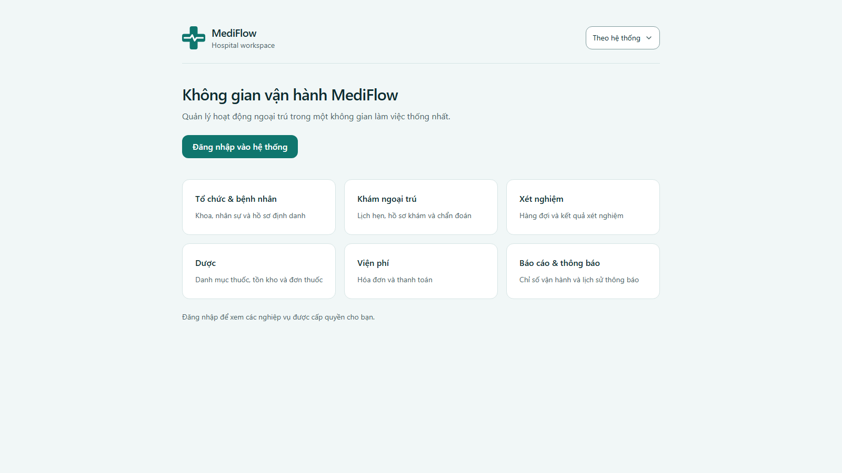
Figure 1. MediFlow home page
- Users open http://<server>:3000 to reach the MediFlow outpatient workspace. The interface is in Vietnamese.
- The home page introduces the six business areas: Organization & patients, Outpatient examination, Laboratory, Pharmacy, Billing and Reports & notifications.
- The theme switcher (Sáng / Tối / Theo hệ thống — Light / Dark / System) is available on every page.
- Click Đăng nhập vào hệ thống (Sign in) to open the login page.
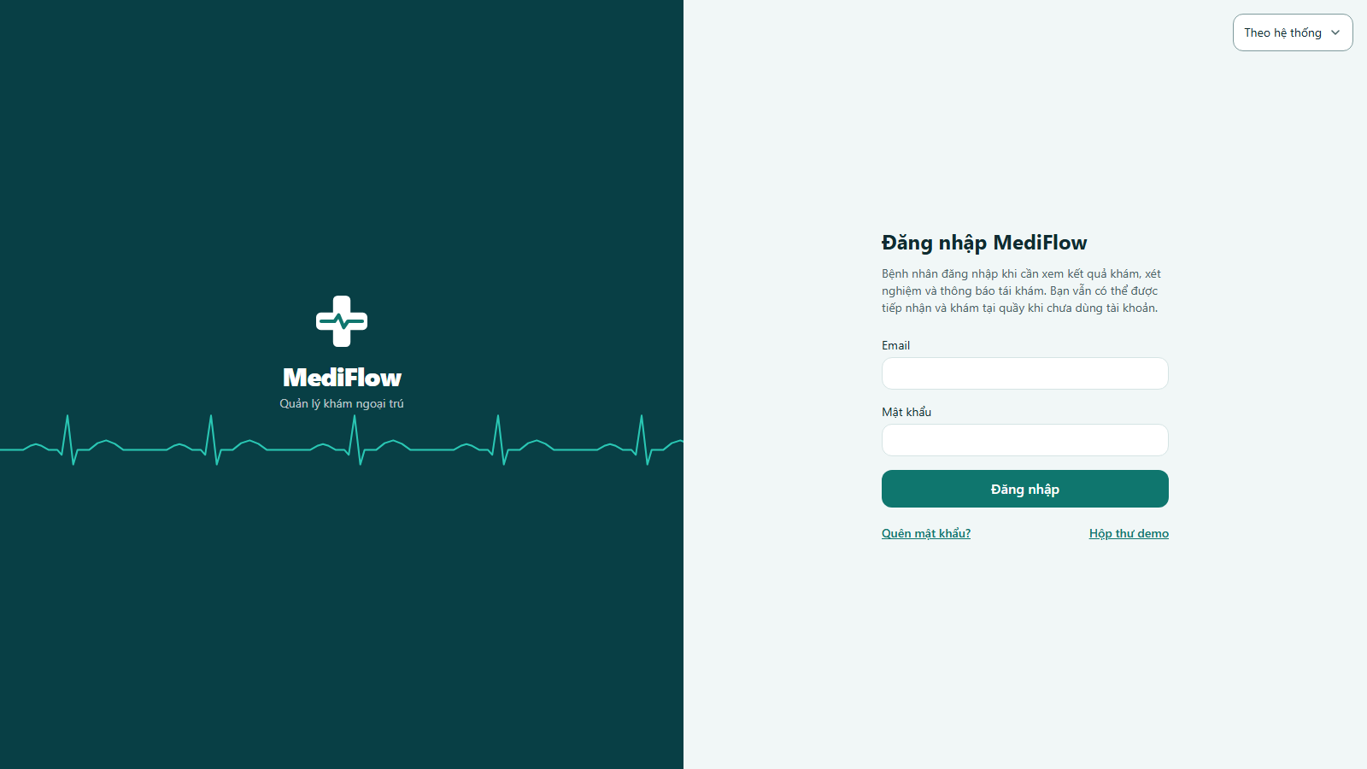
Figure 2. Login page
- Staff and patients sign in with their email (Email) and password (Mật khẩu), then click Đăng nhập.
- After signing in, MediFlow opens the workspace of the account role: Administrator, Nurse, Doctor, Laboratory technician, Pharmacist, Cashier or Patient.
- Patients do not need an account to be received and examined; the account is only used to view results and notifications.
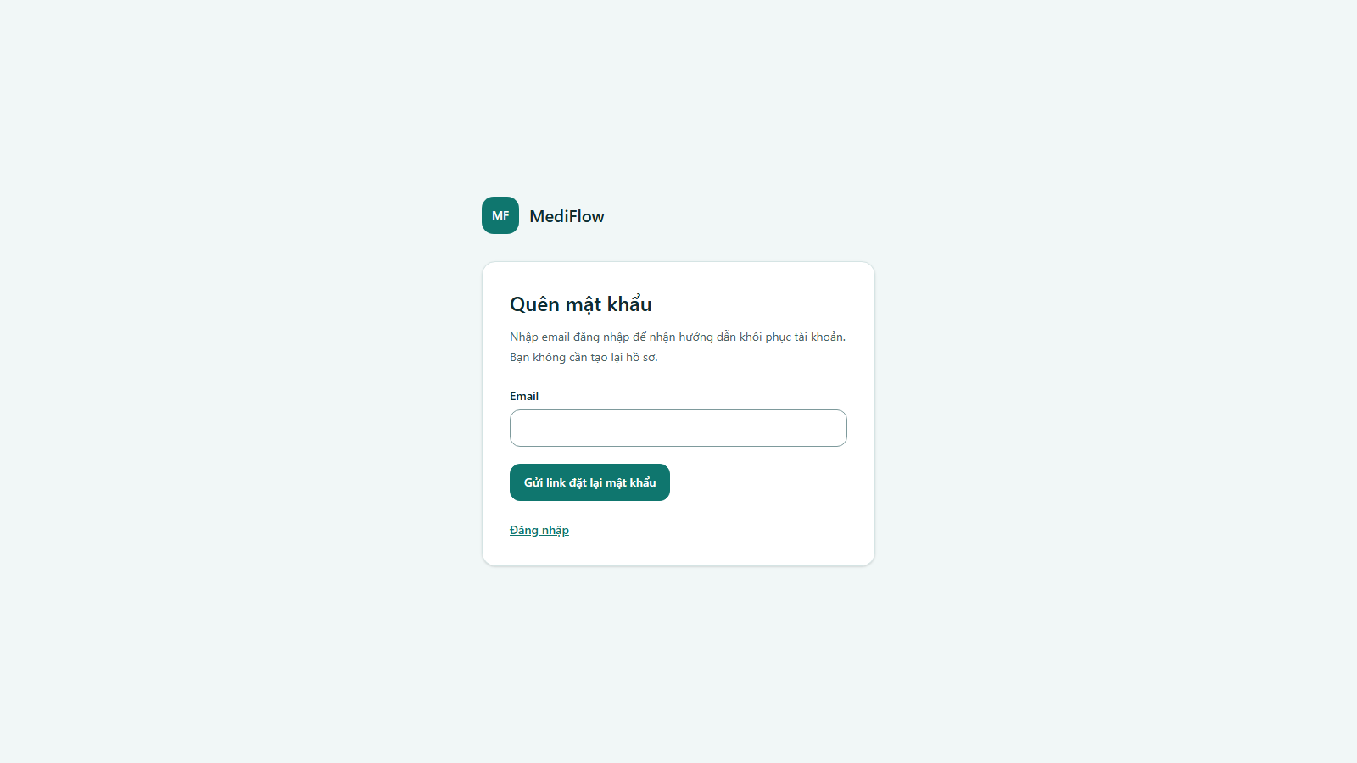
Figure 3. Forgot password page
- Quên mật khẩu? (Forgot password) sends a reset link to the account email. The user opens the link and sets a new password.
- A new account receives a temporary password by email and must change it at the first sign in.

Mobile app (Flutter)
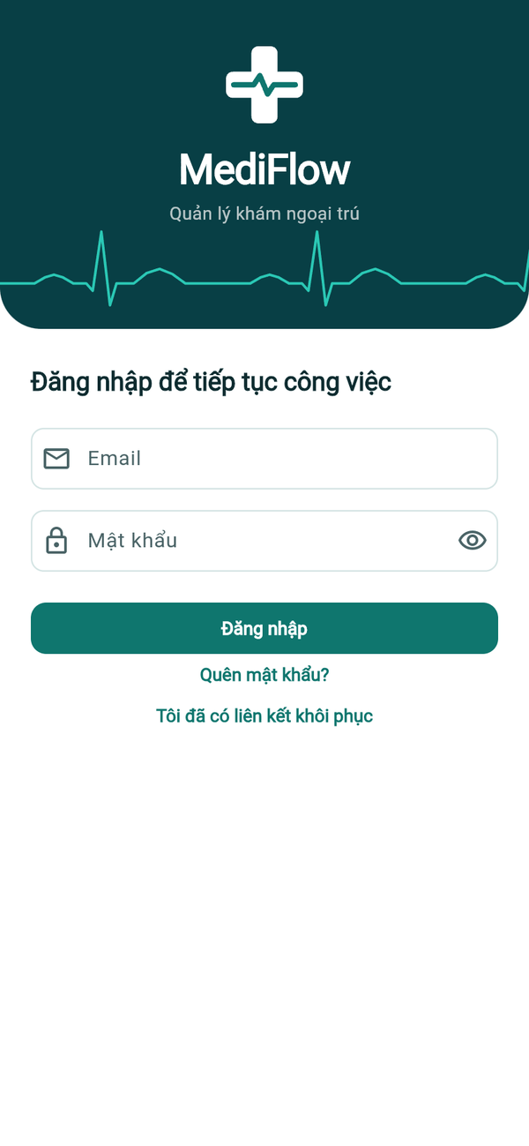  Sign in | 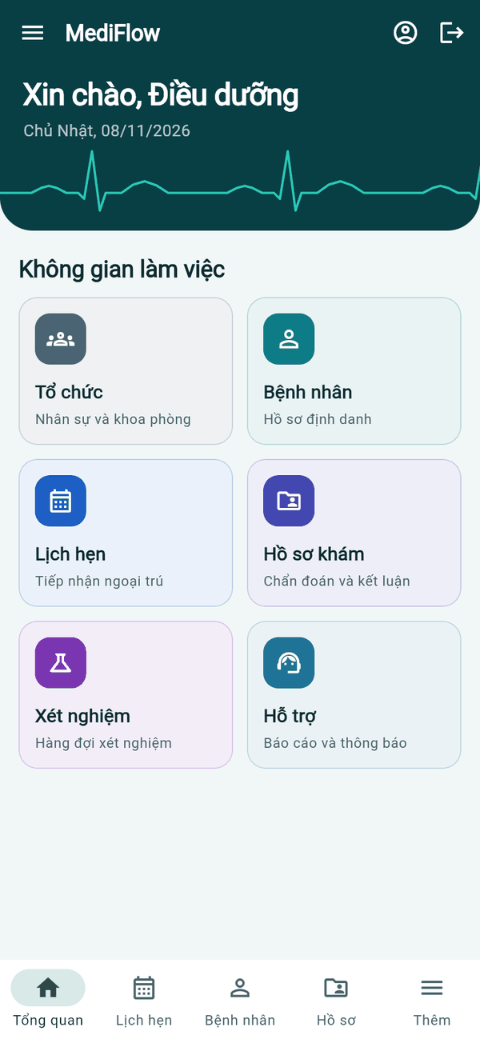  Home (nurse) | 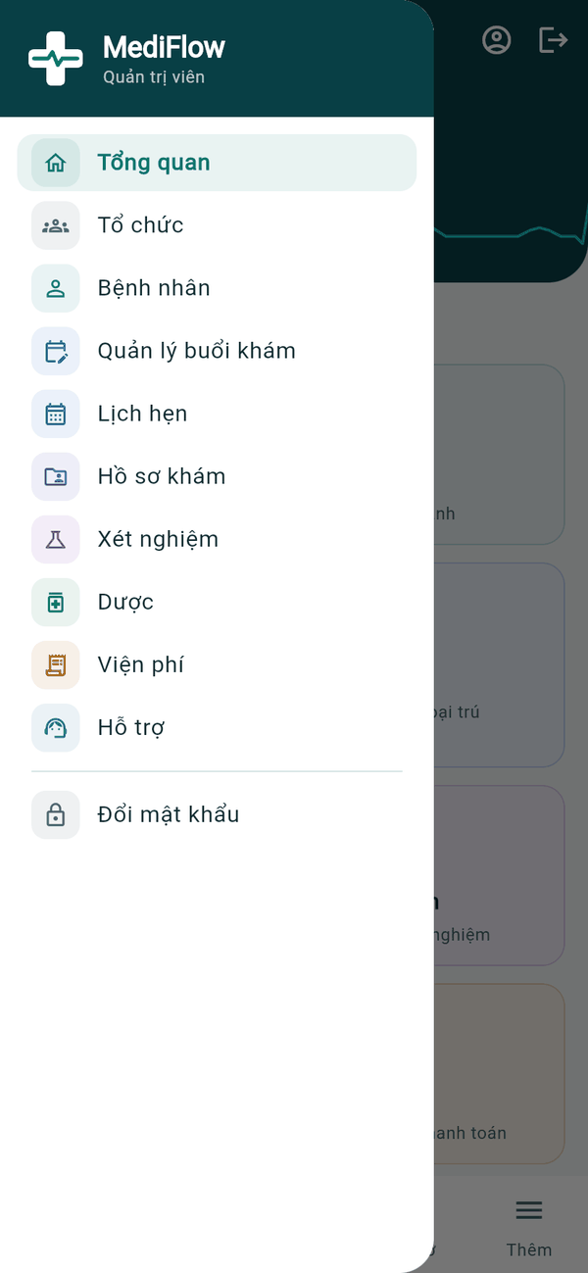  Navigation menu
Figure 4. Mobile app — sign in, home and menu
- The mobile app uses the same accounts as the web: enter Email and Mật khẩu, then tap Đăng nhập. The session is kept in the secure storage of the phone.
- After signing in, the home screen greets the user by role and shows the Không gian làm việc (workspace) tiles allowed for that role.
- Quên mật khẩu? and Tôi đã có liên kết khôi phục handle password recovery exactly as on the web.

Roles and Navigation

Web application
- The left sidebar only shows the functions allowed for the signed-in role. Hiding a menu is for convenience; the server checks every request again.
- The Tài khoản (Account) button at the top right opens the profile, password change and Đăng xuất (Sign out).
- On a narrow screen, use the three-line button to open the menu.
Role | Main screens
Administrator (Quản trị viên) | Organization, staff, accounts, rooms, department heads, reports, notifications
Nurse (Điều dưỡng) | Patient records, patient accounts, reception and visit registration
Doctor (Bác sĩ) | My calendar, examination, diagnosis, lab orders, prescriptions, follow-up
Department head (Trưởng khoa) | A doctor appointed by the administrator: department overview, doctor shifts, sessions and rooms
Cashier (Thu ngân) | Exam fees, lab and prescription payments, payment history, refunds
Laboratory technician (KTV xét nghiệm) | Lab queue, start test, enter results
Pharmacist (Dược sĩ) | Drug catalogue and stock, prescriptions, dispensing
Patient (Bệnh nhân) | My visits, my examination results, my lab results, notifications
The typical outpatient journey followed in this guide is: Nurse registers → Cashier collects the exam fee → Doctor examines and orders a test → Cashier collects the lab fee → Lab technician returns the result → Doctor prescribes → Cashier collects the drug fee → Pharmacist dispenses → Doctor completes the visit → Patient views the results.

Mobile app (Flutter)
- The bottom bar holds the main destinations of the role (for example Tổng quan, Lịch hẹn, Bệnh nhân, Hồ sơ, Thêm for a nurse). Thêm (More) and the three-line button open the full menu.
- The person icon at the top right opens Hồ sơ cá nhân (My profile); the arrow icon signs out.
- The mobile app talks to the same Gateway as the web, so roles and permissions are identical on both clients.

Organization Management (Administrator)

Web application
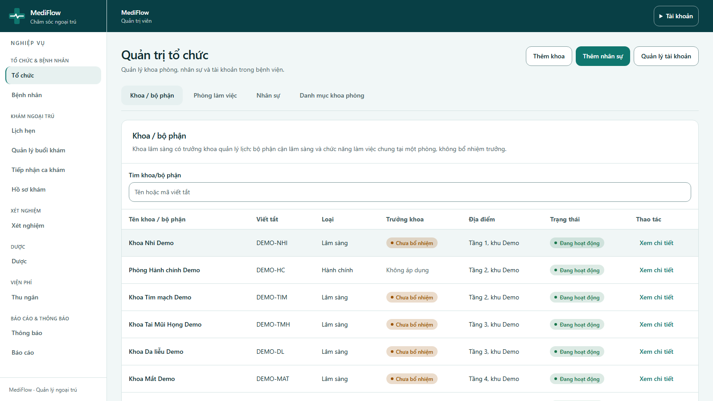
Figure 5. Organization administration — departments
- The administrator opens Tổ chức (Organization). The page has four tabs: Khoa / bộ phận (Departments), Phòng làm việc (Workplace rooms), Nhân sự (Staff) and Danh mục khoa phòng (Room type catalogue).
- The department list shows the name, short code, type (clinical, paraclinical, administrative), department head, location and status. Use Tìm khoa/bộ phận to search by name or code.
- Buttons Thêm khoa, Thêm nhân sự and Quản lý tài khoản create a department, add a staff member and manage accounts.
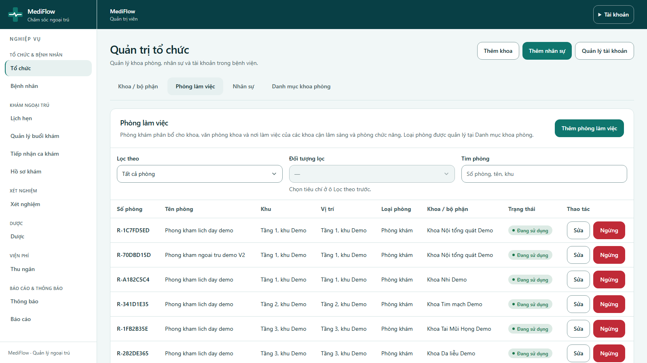
Figure 6. Workplace rooms
- Phòng làm việc lists consultation rooms of each clinical department, department offices and the single workplaces of laboratory, pharmacy, cashier and administration.
- Filter by Loại phòng (room type) or by department; Thêm phòng làm việc adds a room, Sửa edits it and Ngừng deactivates it.
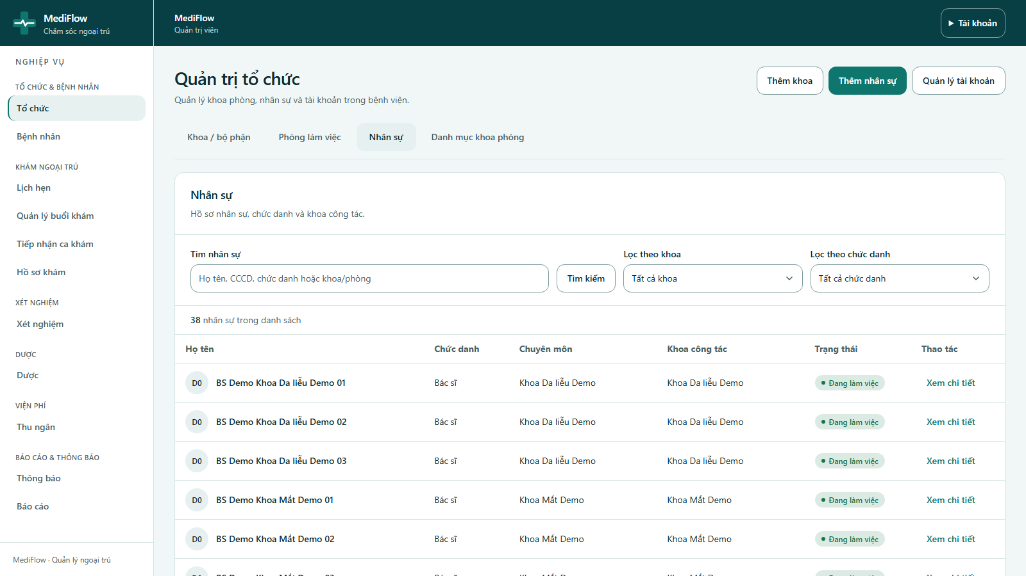
Figure 7. Staff directory
- Nhân sự shows staff with job title, specialty, department and status. Filter by department or job title, and open a record to edit it or move the staff member to another department.
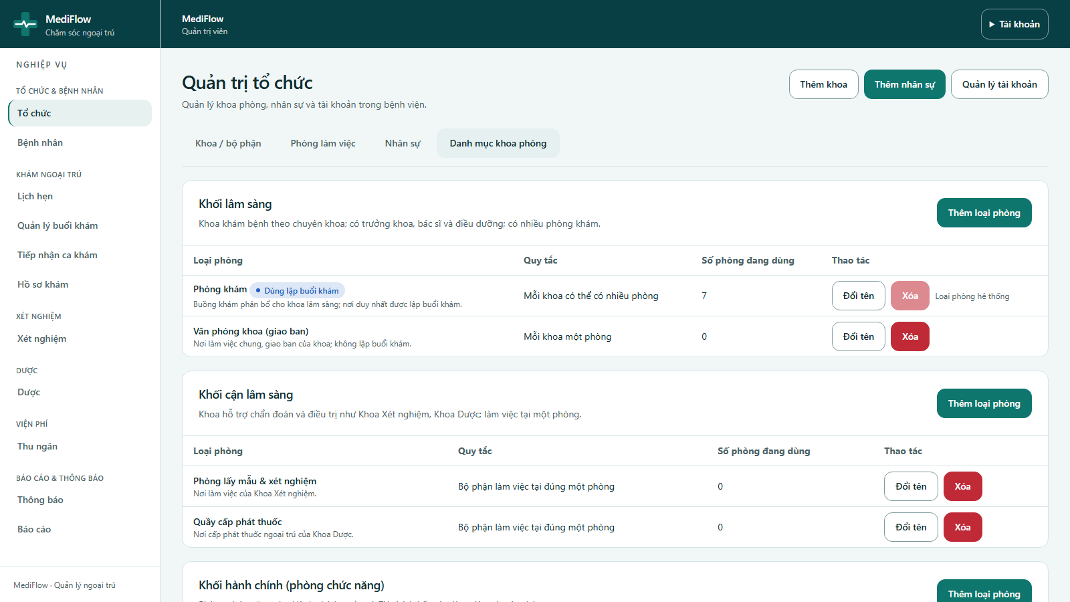
Figure 8. Room type catalogue
- Danh mục khoa phòng defines which room types each kind of department may use (consultation room, department office, laboratory, pharmacy, cashier ...).
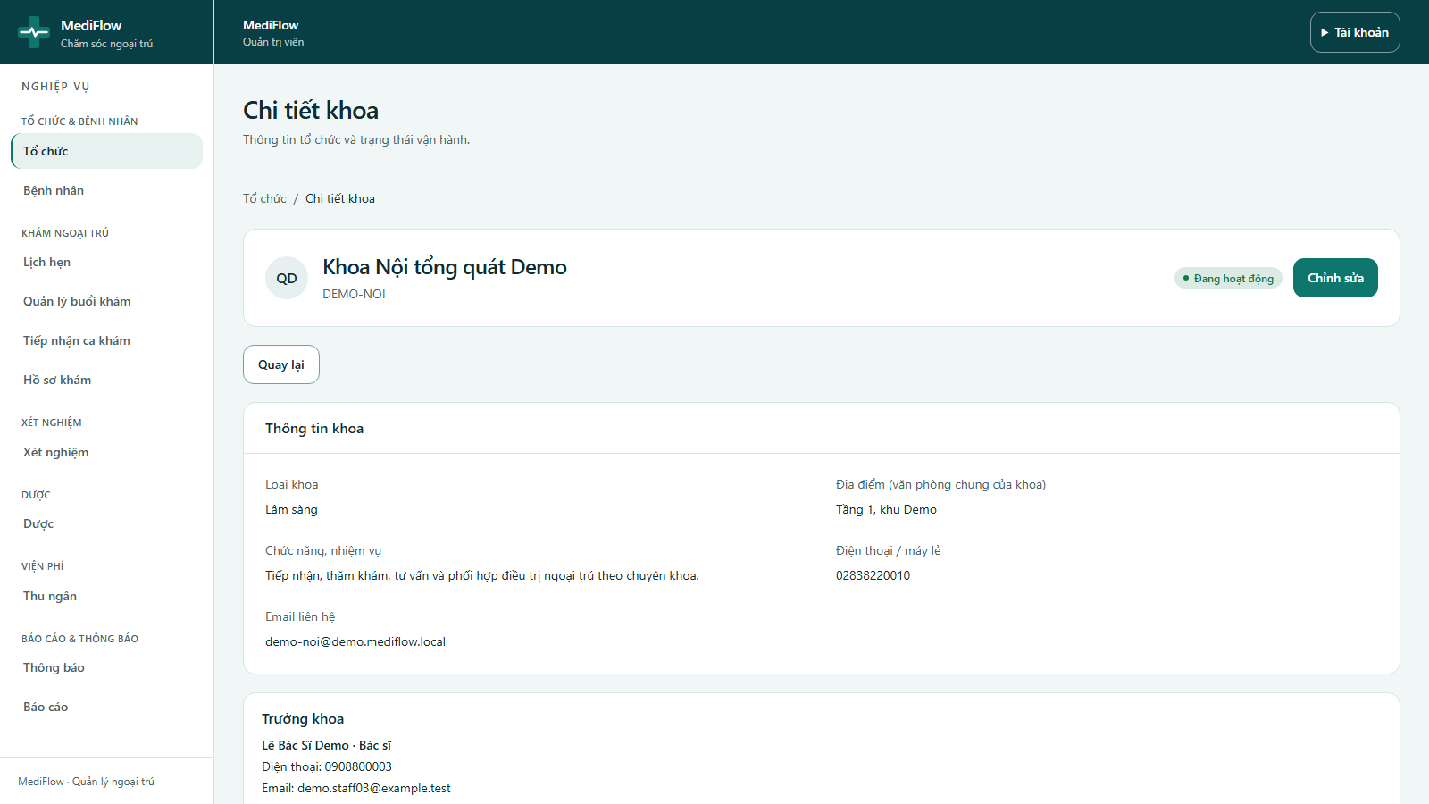
Figure 9. Department detail
- Xem chi tiết on a department shows its information, the current head, the staff of the unit and its rooms.
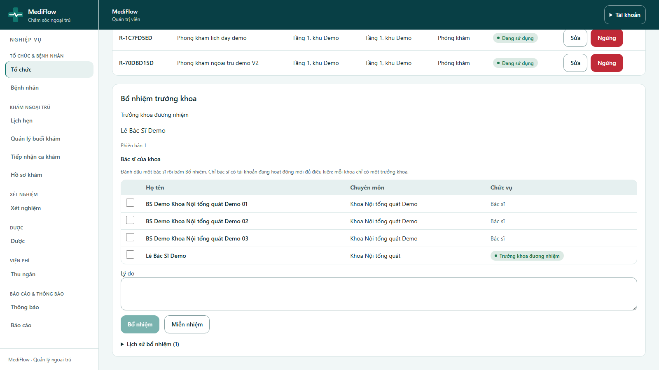
Figure 10. Appointing a department head
- In Bổ nhiệm trưởng khoa, the administrator ticks a doctor of the department, enters a Lý do (reason) and clicks Bổ nhiệm (Appoint) or Miễn nhiệm (Dismiss).
- Only a doctor with an active account is eligible and each clinical department has one head. Lịch sử bổ nhiệm keeps the appointment history.
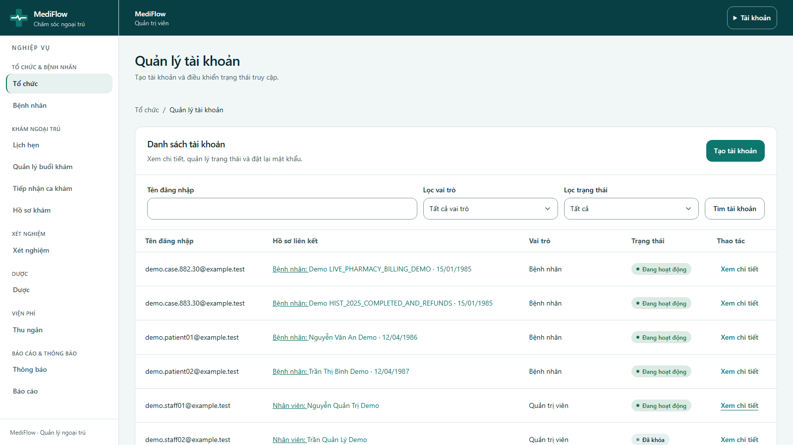
Figure 11. Account management
- Quản lý tài khoản lists all staff and patient accounts with the linked profile, role and status. Filter by role or status.
- Open an account to lock or unlock it or reset its password. Tạo tài khoản creates a staff account; the password is generated by the system and sent by email.

Mobile app (Flutter)
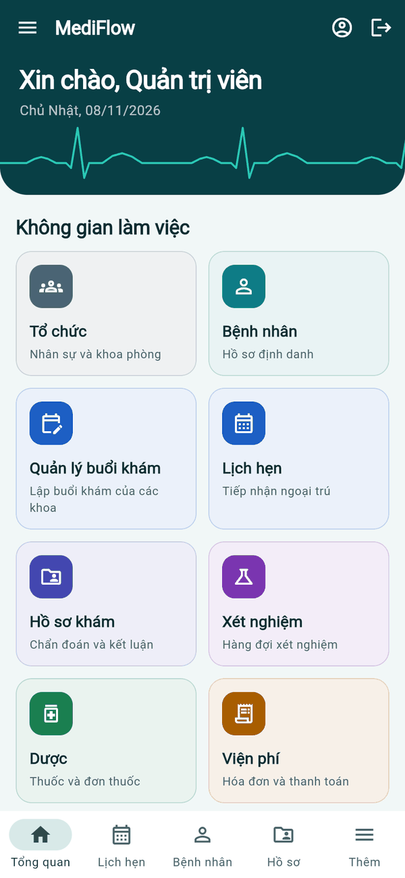  Admin home | 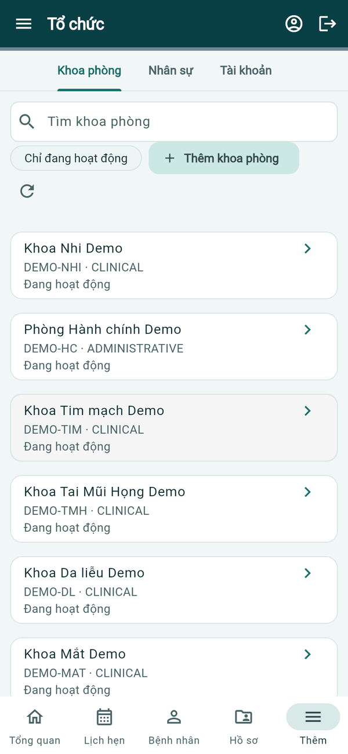  Departments | 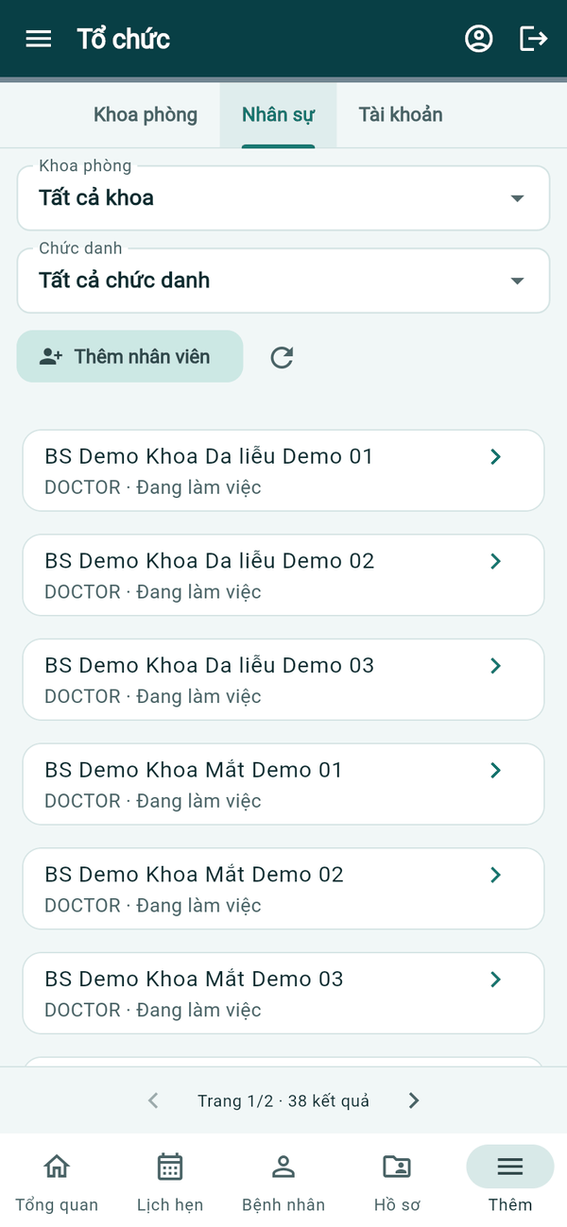  Staff
Figure 12. Mobile app — organization
- On the phone, Tổ chức has three tabs: Khoa phòng (departments), Nhân sự (staff) and Tài khoản (accounts).
- Departments can be searched, filtered to active ones and added with Thêm khoa phòng; staff can be filtered by department and job title and added with Thêm nhân viên.
- Tap a card to open its detail. Room catalogue maintenance and department head appointment are done on the web.

Patient Records (Nurse)

Web application
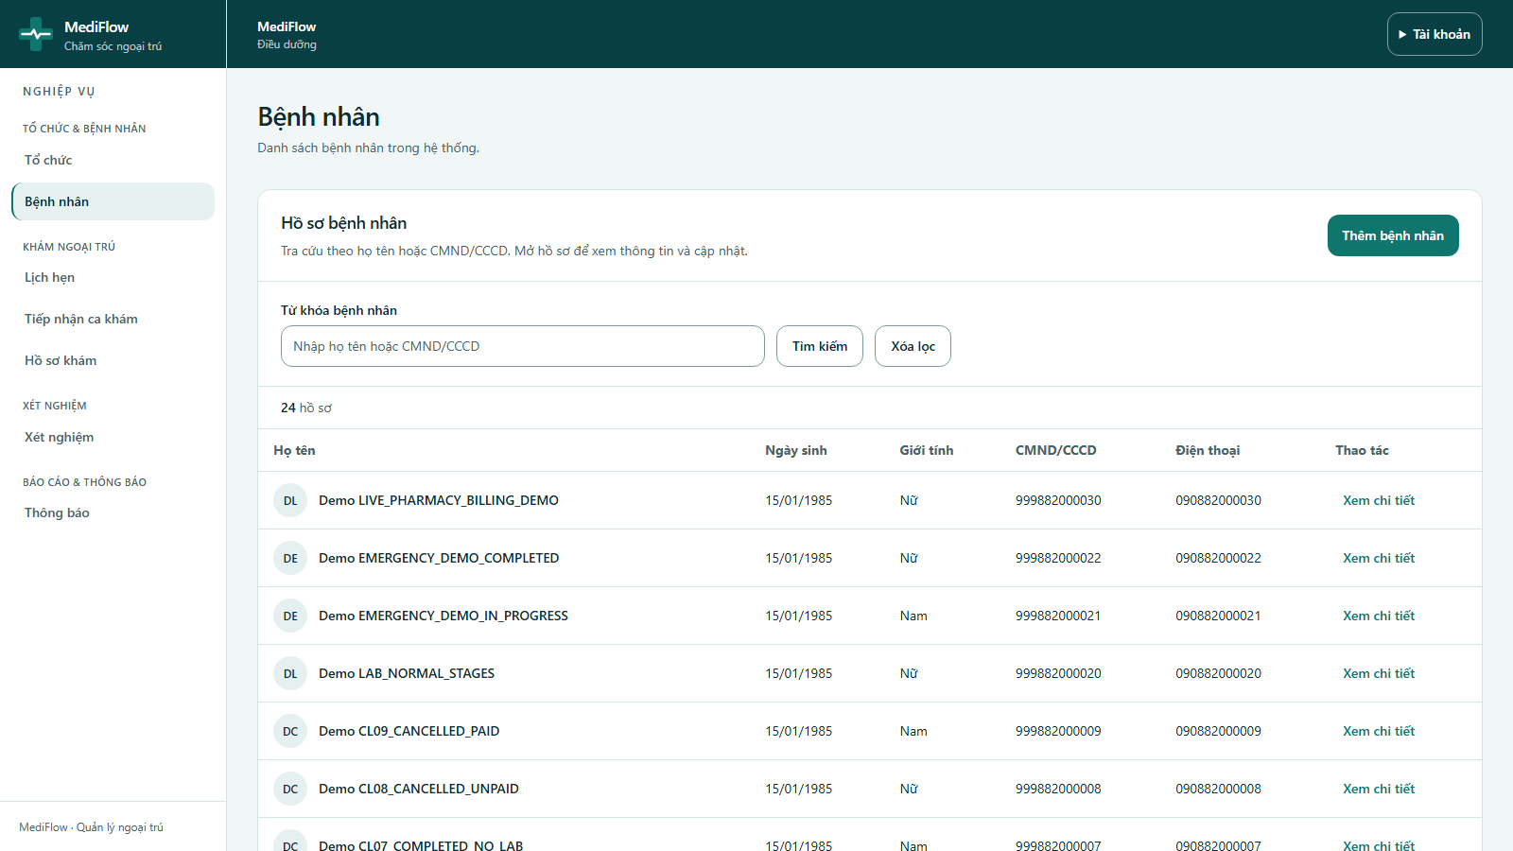
Figure 13. Patient list
- The nurse opens Bệnh nhân (Patients) to search by full name or ID card number (CMND/CCCD) and open a record with Xem chi tiết.
- Always search first; if the patient already has a record, reuse it instead of creating a duplicate.
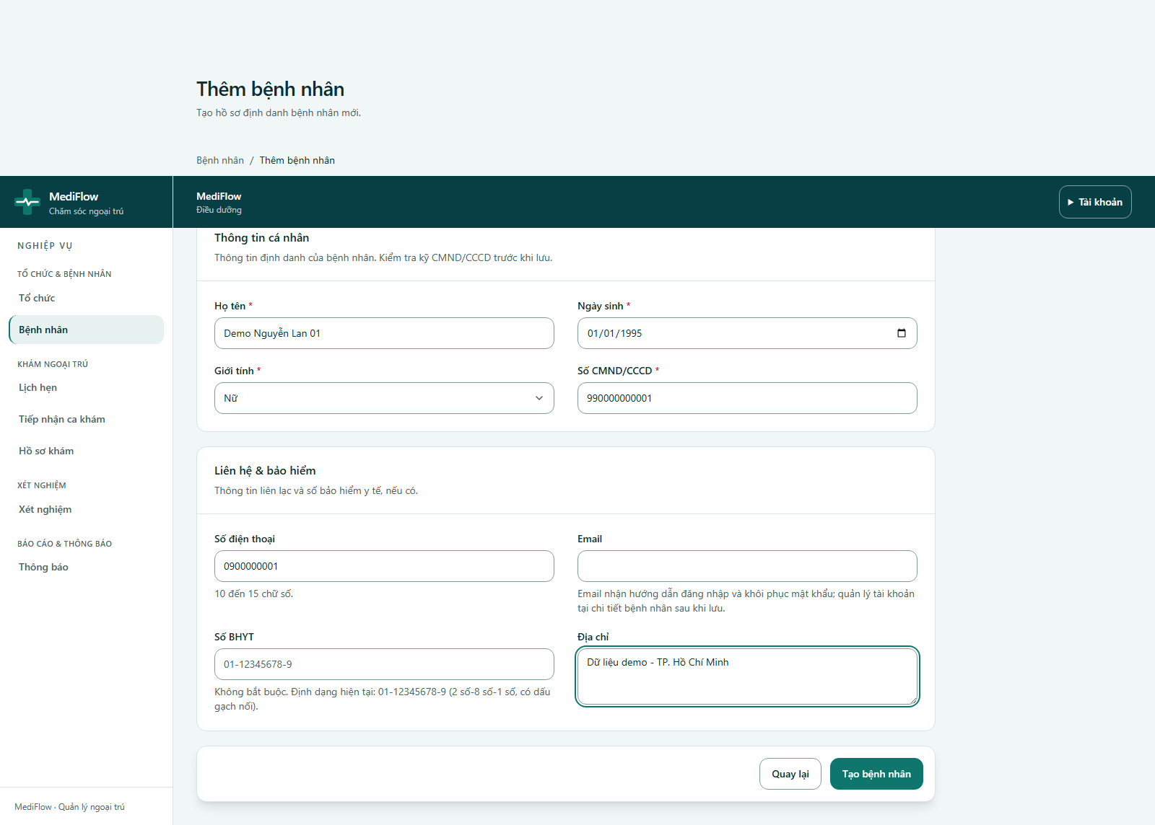
Figure 14. Creating a new patient
- Thêm bệnh nhân opens the form. Required fields: Họ tên (full name), Ngày sinh (date of birth), Giới tính (gender) and Số CMND/CCCD (ID number).
- Optional: phone number, email (used for the patient account), health insurance number (format 01-12345678-9) and address.
- Click Tạo bệnh nhân to save.
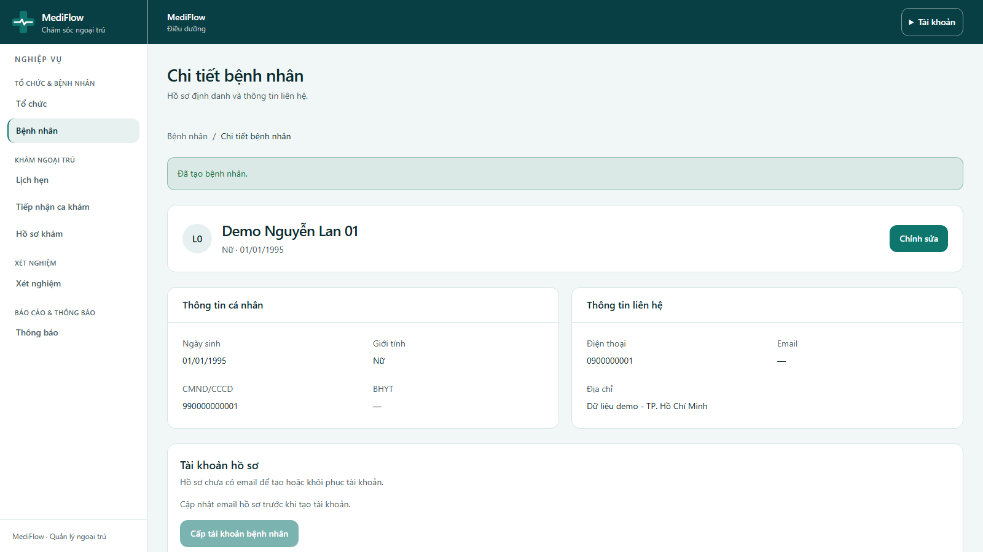
Figure 15. Patient detail
- The detail page shows identity and contact information. Chỉnh sửa edits the record.
- Cấp tài khoản bệnh nhân issues a patient account when the record has an email; the patient receives a temporary password by email.
- Tiếp tục đăng ký khám (Continue to registration) opens reception with this patient already selected.

Mobile app (Flutter)
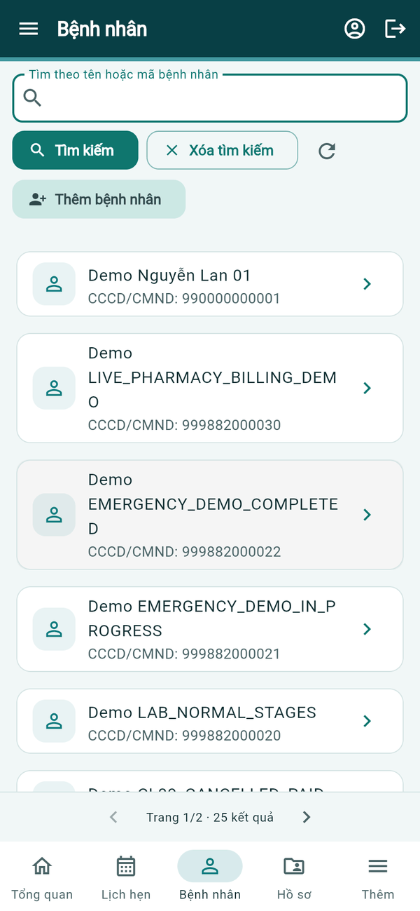  Patient list | 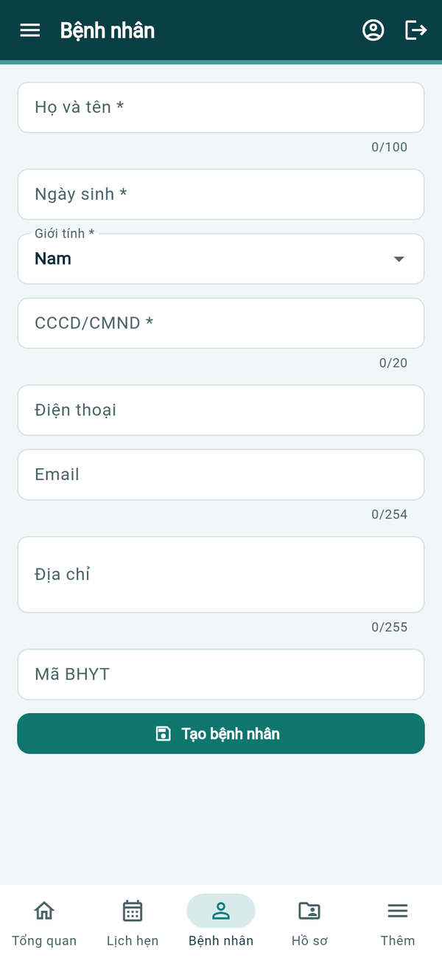  New patient | 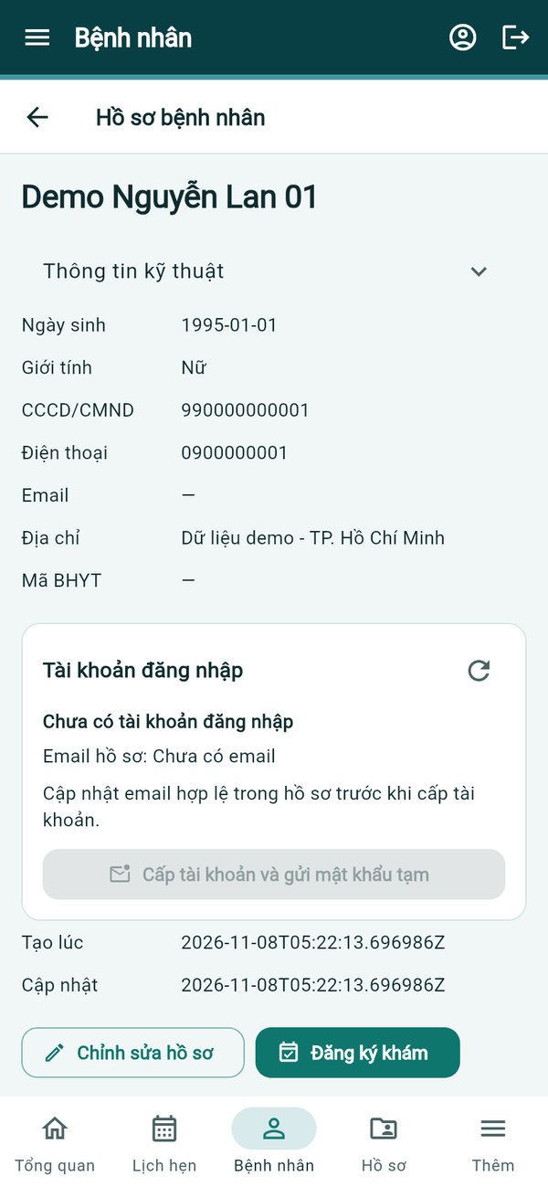  Patient detail
Figure 16. Mobile app — patient records
- Bệnh nhân searches by name or patient code. Thêm bệnh nhân opens the same form as the web (full name, date of birth, gender, ID number, phone, email, address, insurance number).
- The patient detail shows Thông tin kỹ thuật, the login account block (Cấp tài khoản và gửi mật khẩu tạm when the record has an email), Chỉnh sửa hồ sơ and Đăng ký khám.

Reception and Visit Registration (Nurse)

Web application
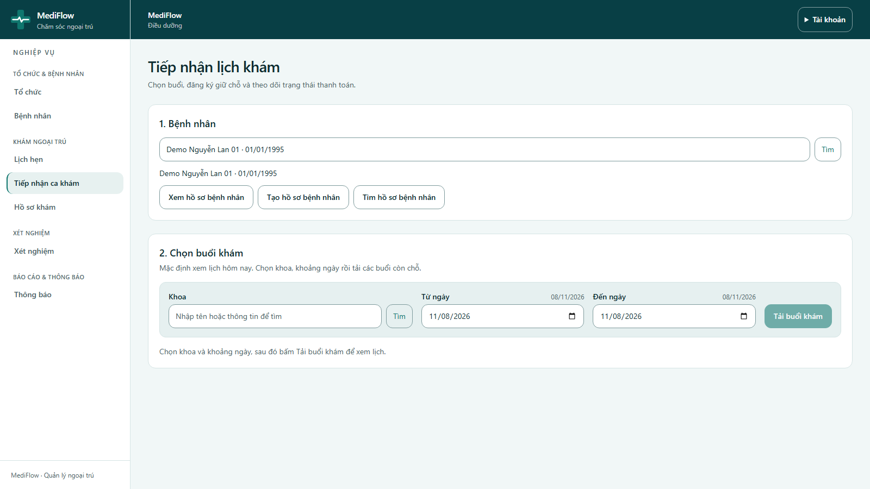
Figure 17. Reception — patient selected
- Tiếp nhận ca khám (Reception) has two steps: 1. Bệnh nhân — the selected patient, and 2. Chọn buổi khám — the consultation session.
- Type the department in Khoa, click Tìm and choose it from the results; set Từ ngày / Đến ngày (date range) and click Tải buổi khám.
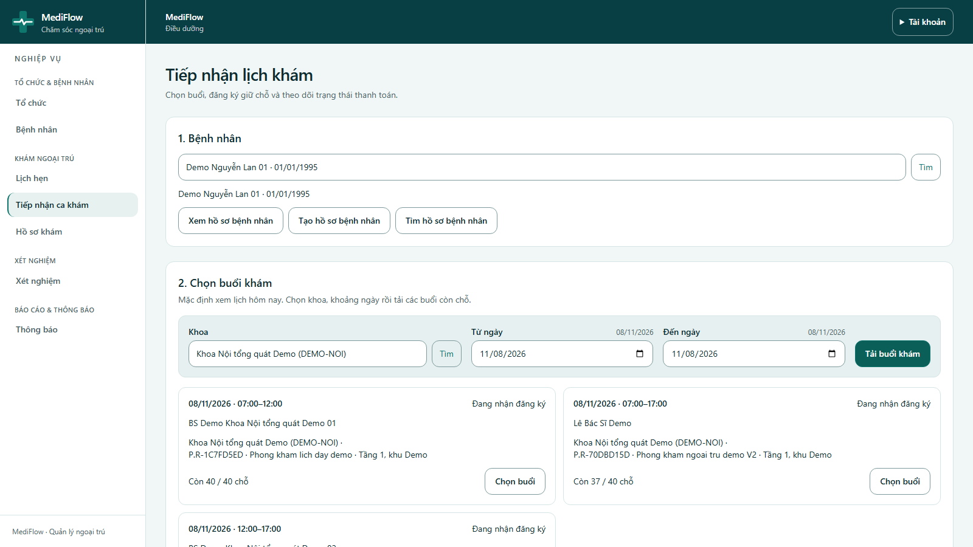
Figure 18. Available consultation sessions
- Each session card shows the date and time, doctor, department, room and remaining capacity (for example Còn 37 / 40 chỗ). Click Chọn buổi on the wanted session.
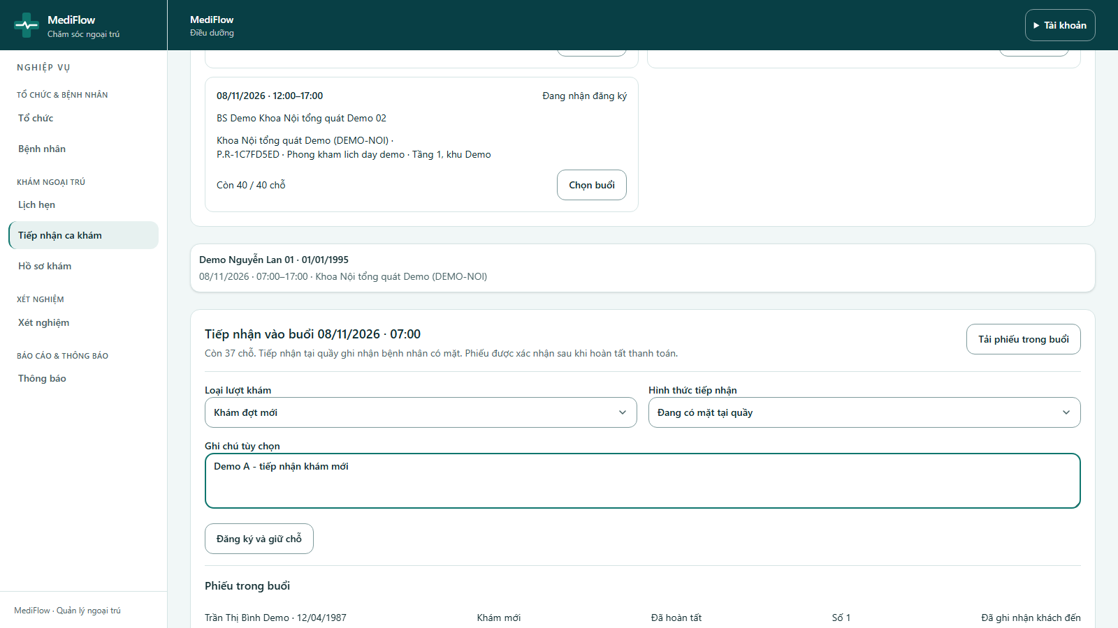
Figure 19. Registration form
- Choose Loại lượt khám (visit type): Khám đợt mới (new visit) or Tái khám từ lượt đã hoàn tất (follow-up of a completed visit).
- Choose Hình thức tiếp nhận: Đang có mặt tại quầy (patient is at the desk) or Đăng ký trước, sẽ đến sau (pre-registration). Add an optional note.
- Click Đăng ký và giữ chỗ (Register and hold the slot).
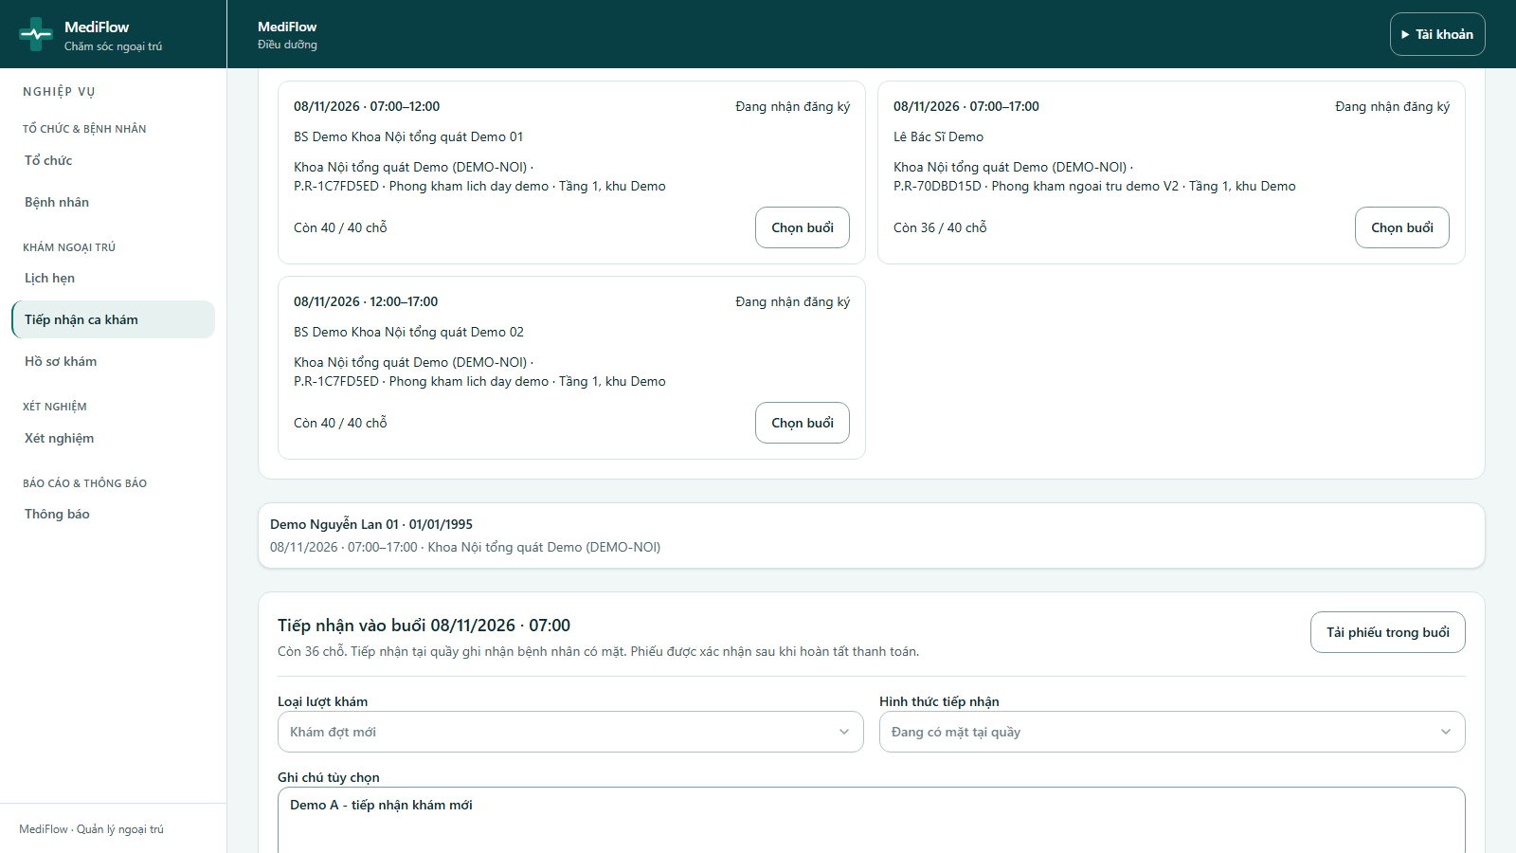
Figure 20. Registration waiting for payment
- The ticket is created with status Đang chờ thu tiền (waiting for payment) and a Hạn giữ chỗ (hold deadline). The queue number is issued after payment.
- Send the patient to the cashier before the deadline. Tiếp nhận bệnh nhân tiếp theo starts the next registration.

Mobile app (Flutter)
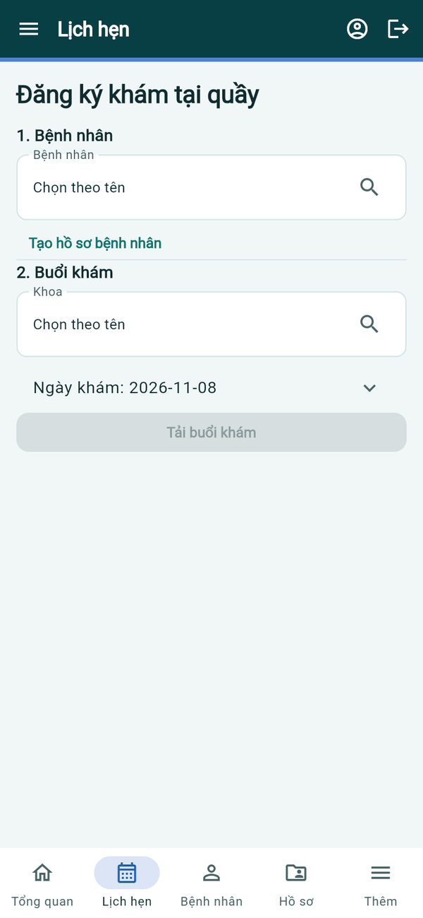  Reception | 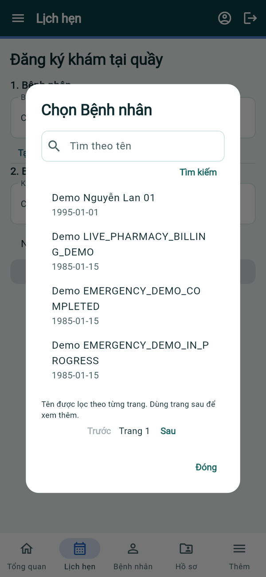  Choose patient | 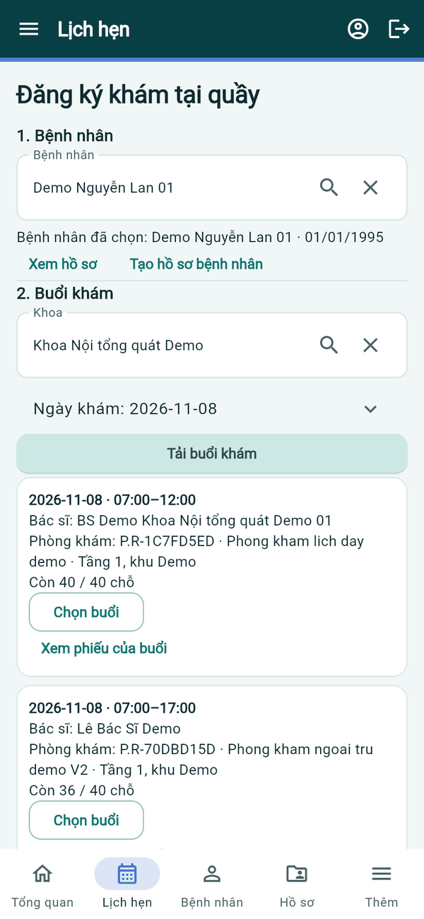  Sessions
Figure 21. Mobile app — reception
- Lịch hẹn → Đăng ký khám (Đăng ký khám tại quầy) follows the same two steps: 1. Bệnh nhân and 2. Buổi khám.
- Tap Chọn Bệnh nhân or Chọn Khoa to open a searchable picker, set Ngày khám and tap Tải buổi khám. Each session card shows doctor, room and remaining slots; tap Chọn buổi to register.
Mobile app (Flutter)
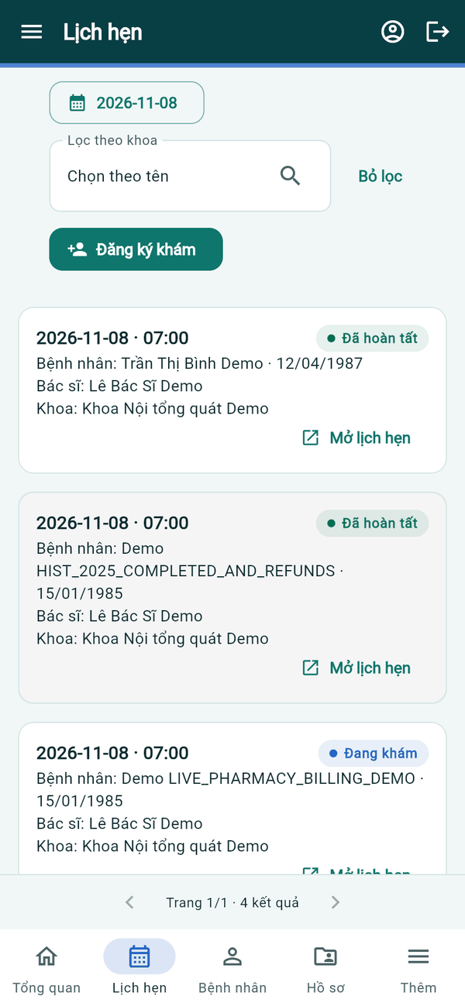  Appointments | 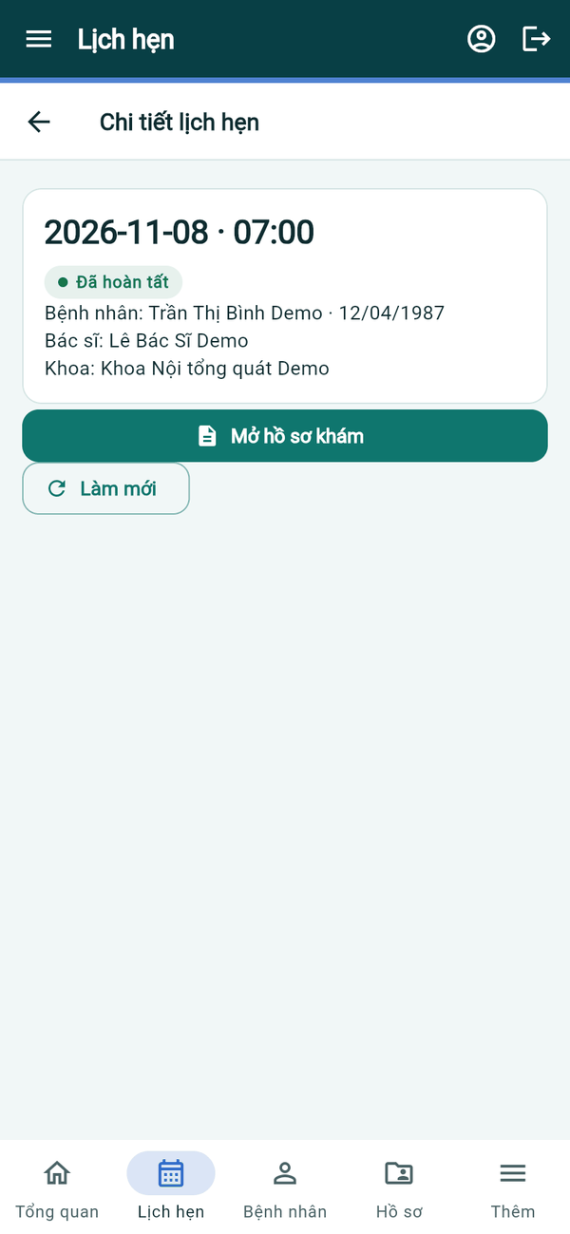  Appointment detail
Figure 22. Mobile app — appointment list
- Lịch hẹn lists the tickets of a day with status. Mở lịch hẹn shows the detail and Mở hồ sơ khám for a started visit.

Exam Fee Payment (Cashier)

Web application
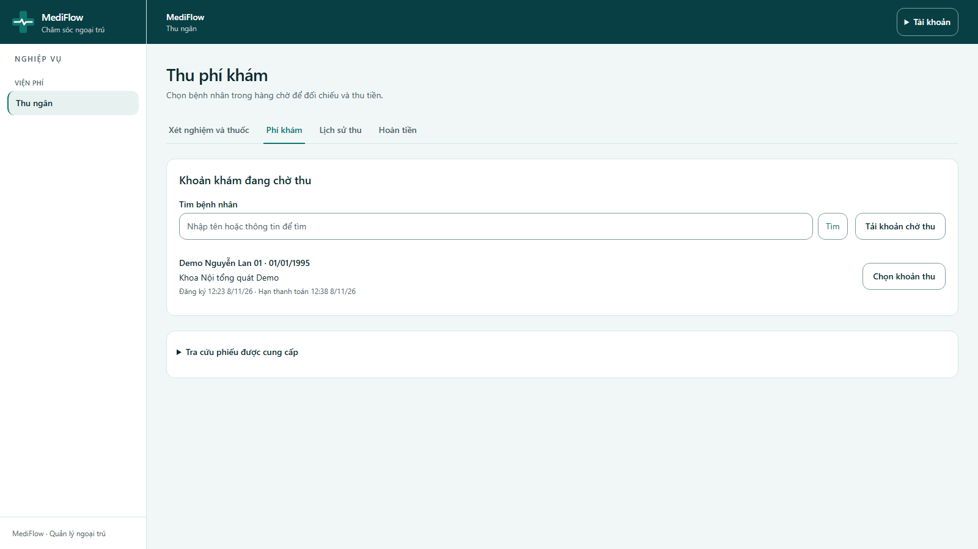
Figure 23. Exam fees waiting for payment
- The cashier opens Thu ngân → Phí khám. The queue lists registrations waiting for payment with patient, department, registration time and payment deadline.
- Search a patient by name if needed, then click Chọn khoản thu (Select charge).
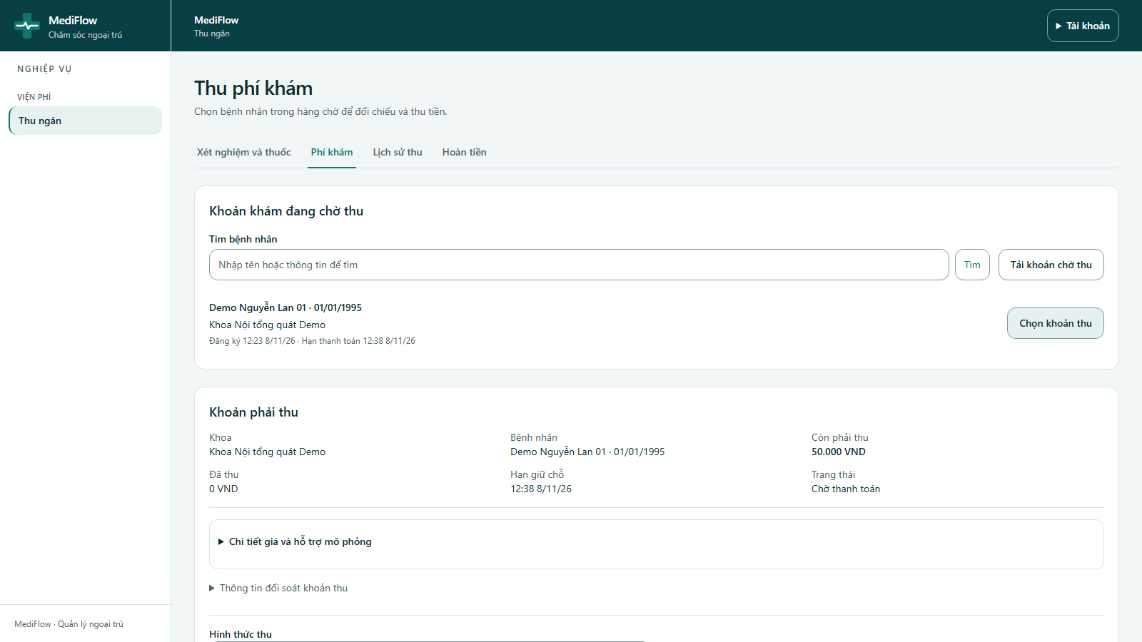
Figure 24. Charge detail
- The panel shows the department, patient, Còn phải thu (amount due) and status. Chi tiết giá và hỗ trợ mô phỏng explains the price and the simulated support.
- Select Hình thức thu (cash or bank transfer) and click Thu phí lịch khám. The amount is taken from the billing quote; it cannot be typed by hand.
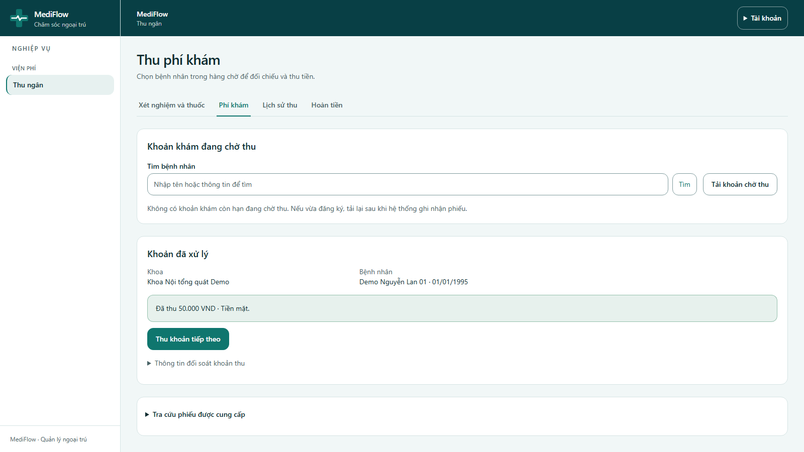
Figure 25. Exam fee collected
- A successful payment shows Đã thu ... VND. The registration is confirmed automatically and receives a queue number.
- If a transaction is pending, use Kiểm tra trạng thái giao dịch; never collect the same charge twice.

Mobile app (Flutter)
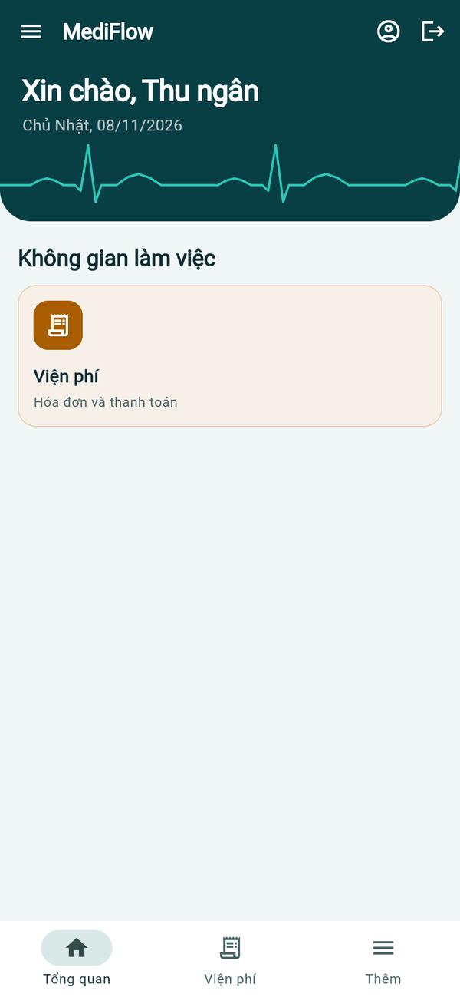  Cashier home | 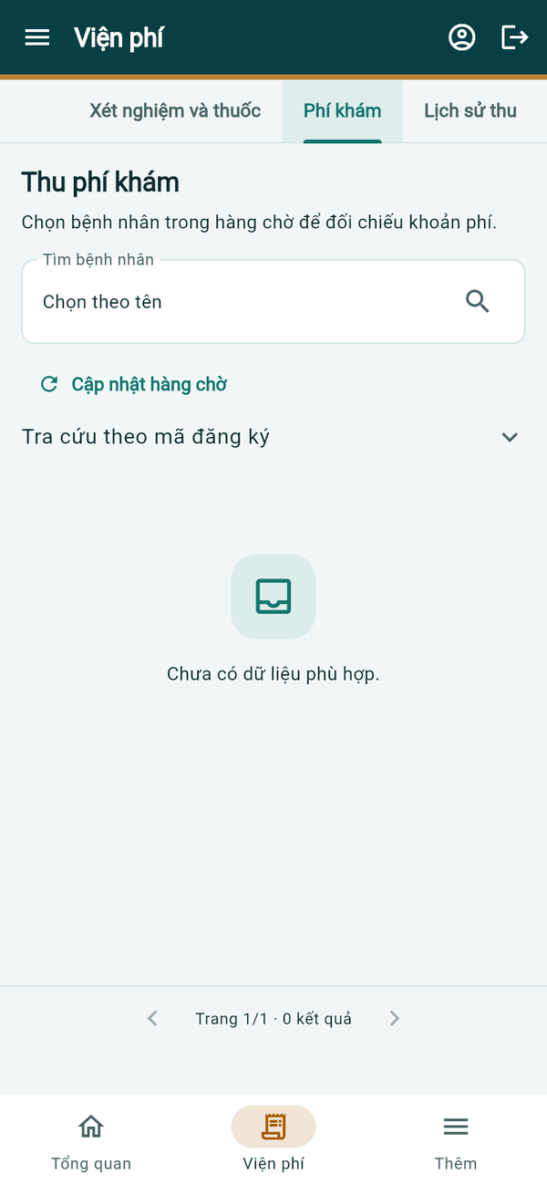  Exam fees
Figure 26. Mobile app — exam fee
- The cashier opens Viện phí → Phí khám, picks a patient from the waiting queue (Chọn Tìm bệnh nhân) or uses Tra cứu theo mã đăng ký, then collects the quoted amount as on the web.

Doctor Calendar and Examination (Doctor)

Web application
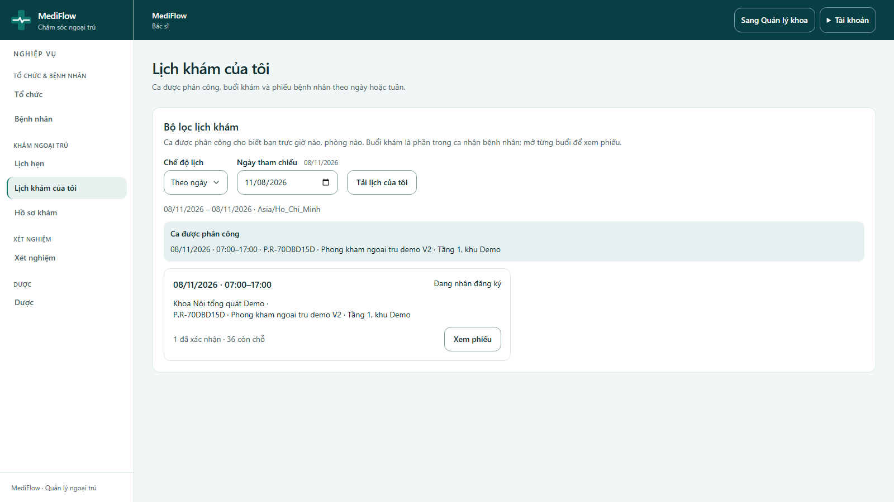
Figure 27. My calendar
- The doctor opens Lịch khám của tôi (My calendar), chooses Theo ngày / Theo tuần (by day / week) and a reference date, then clicks Tải lịch của tôi.
- The page shows assigned shifts and consultation sessions with the number of confirmed tickets and remaining slots.
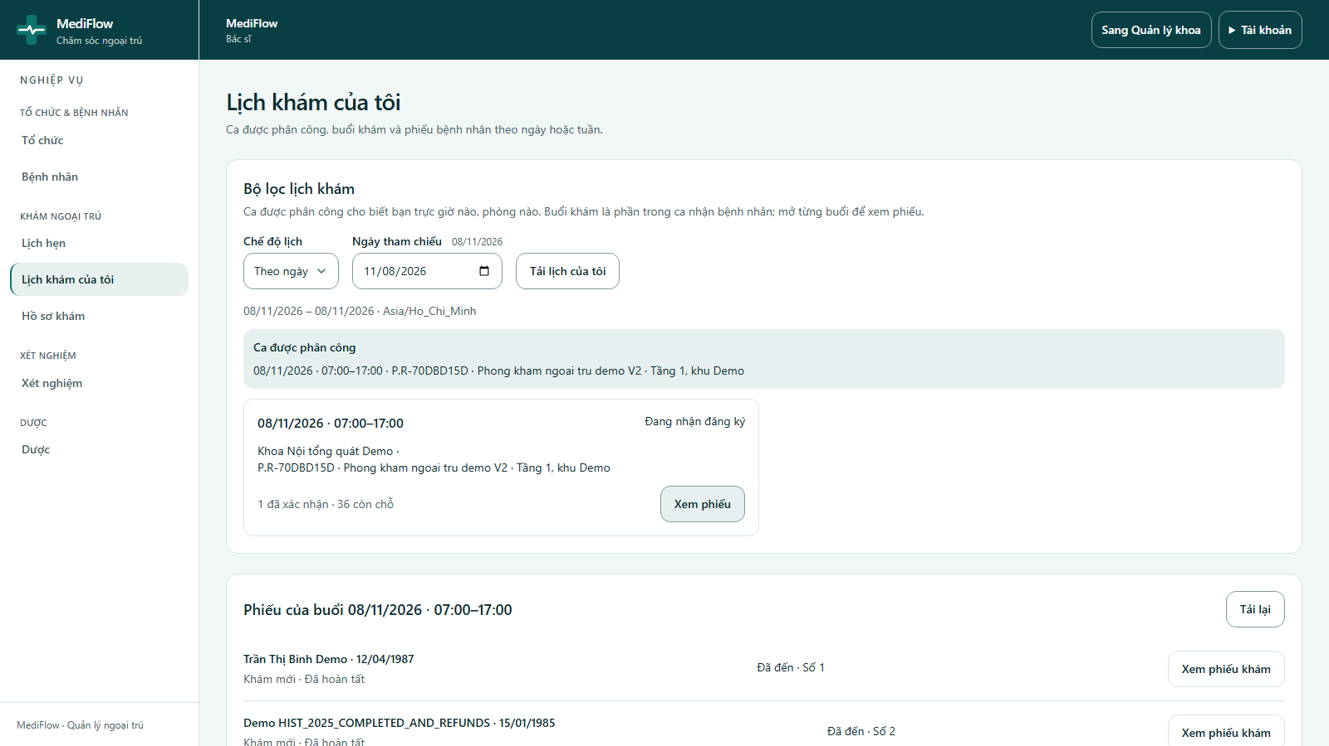
Figure 28. Tickets of a session
- Xem phiếu lists the tickets of the session with queue number and status. A paid ticket shows Đủ điều kiện khám (ready for examination). Click Xem phiếu khám.
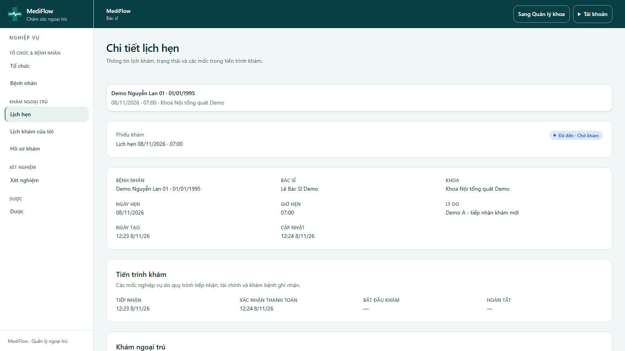
Figure 29. Appointment detail and timeline
- The ticket shows patient, doctor, department, date and time and the Tiến trình khám timeline: reception, payment confirmation, examination start and completion.
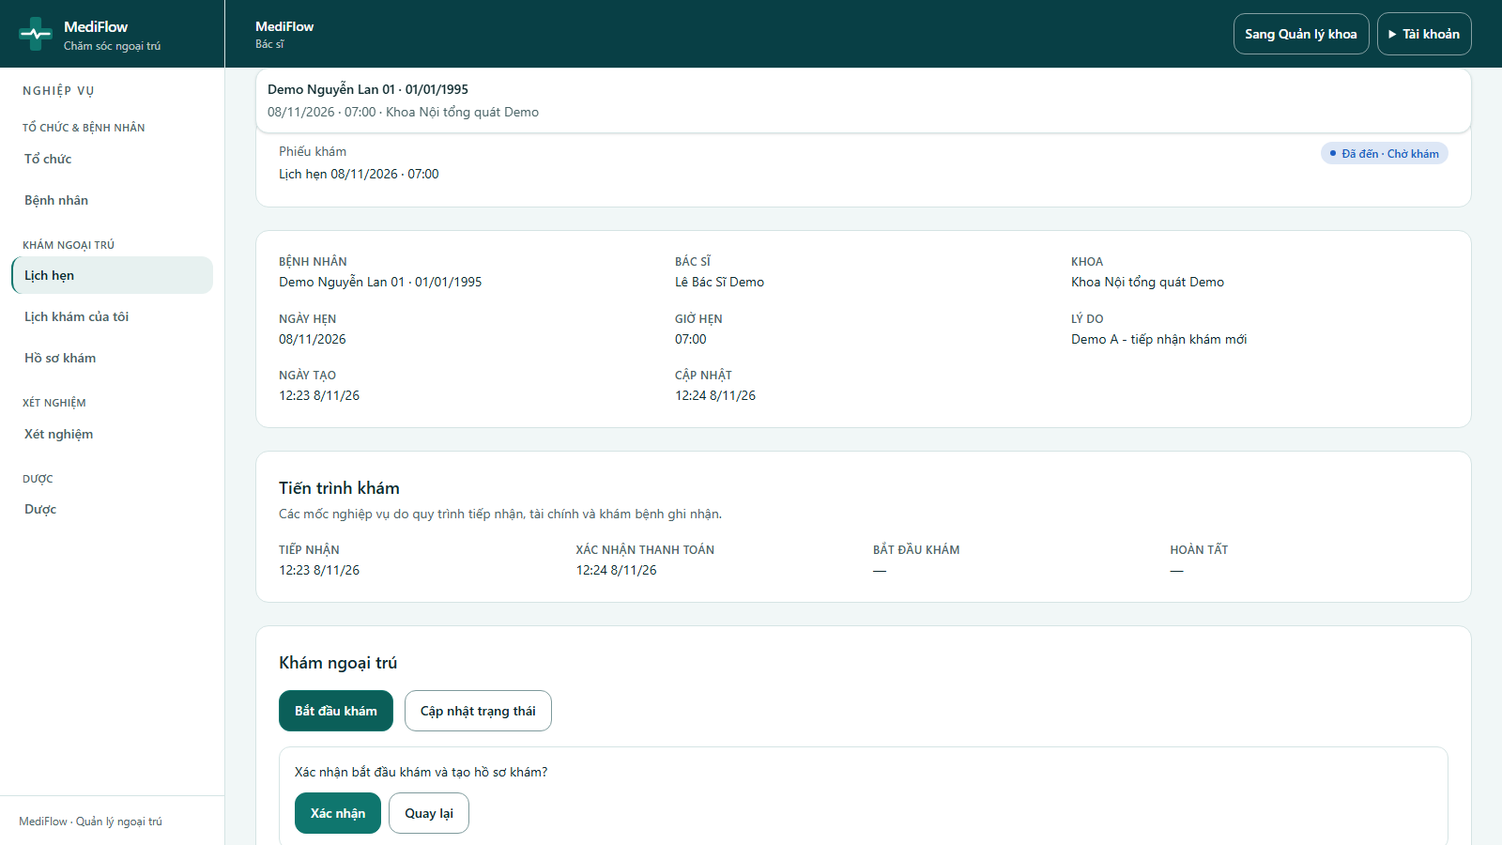
Figure 30. Starting the examination
- Click Bắt đầu khám (Start examination) and Xác nhận to confirm. The examination cannot start before the exam fee is paid.
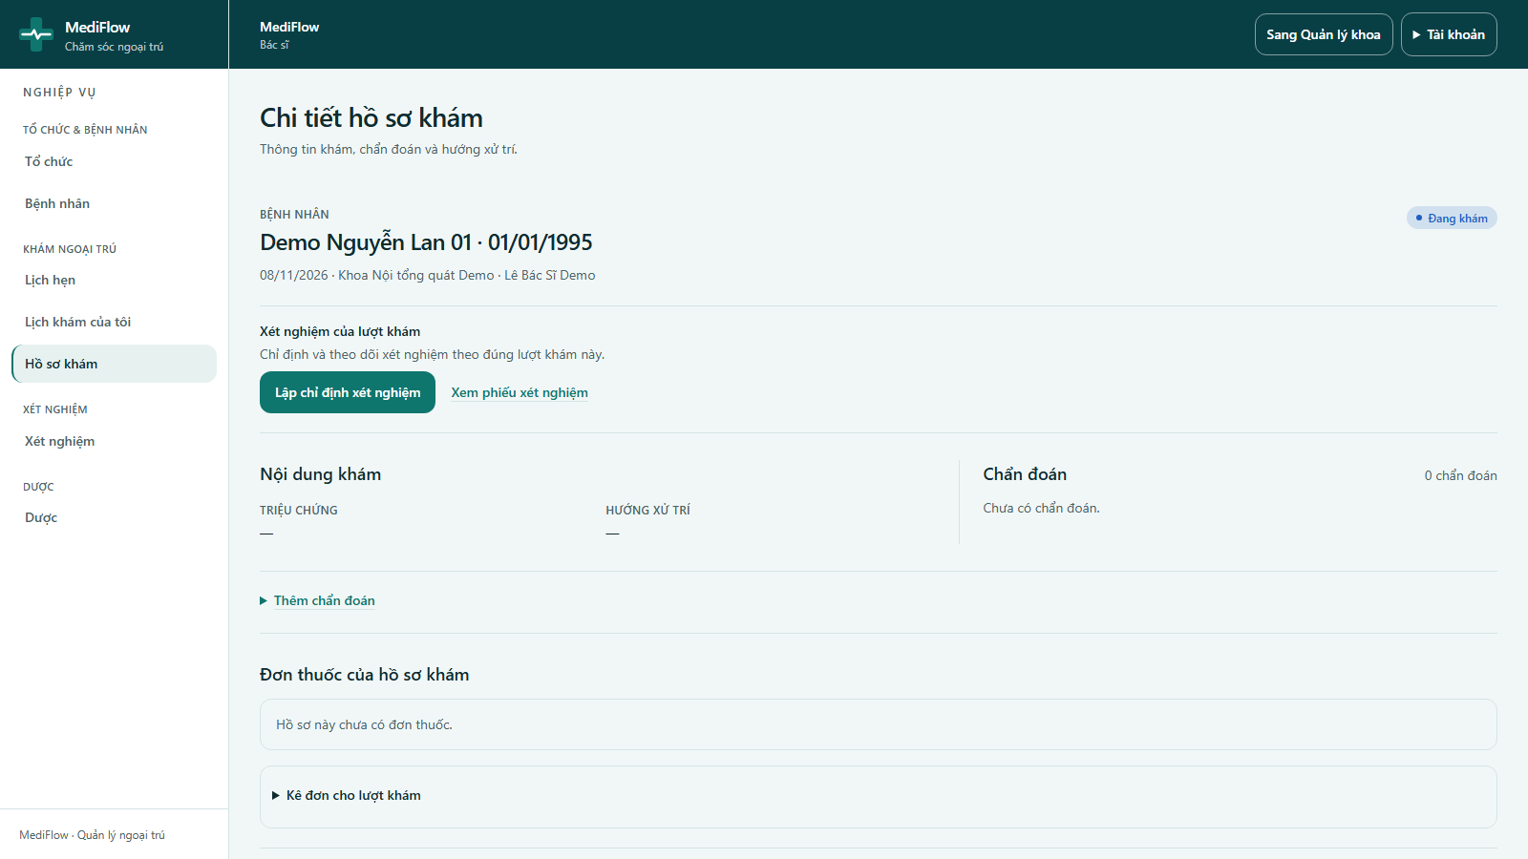
Figure 31. Medical record
- Mở hồ sơ khám opens the outpatient medical record with sections for lab tests, symptoms, diagnoses, prescriptions and completion.
- Tác vụ khác → Sửa triệu chứng records the symptoms.
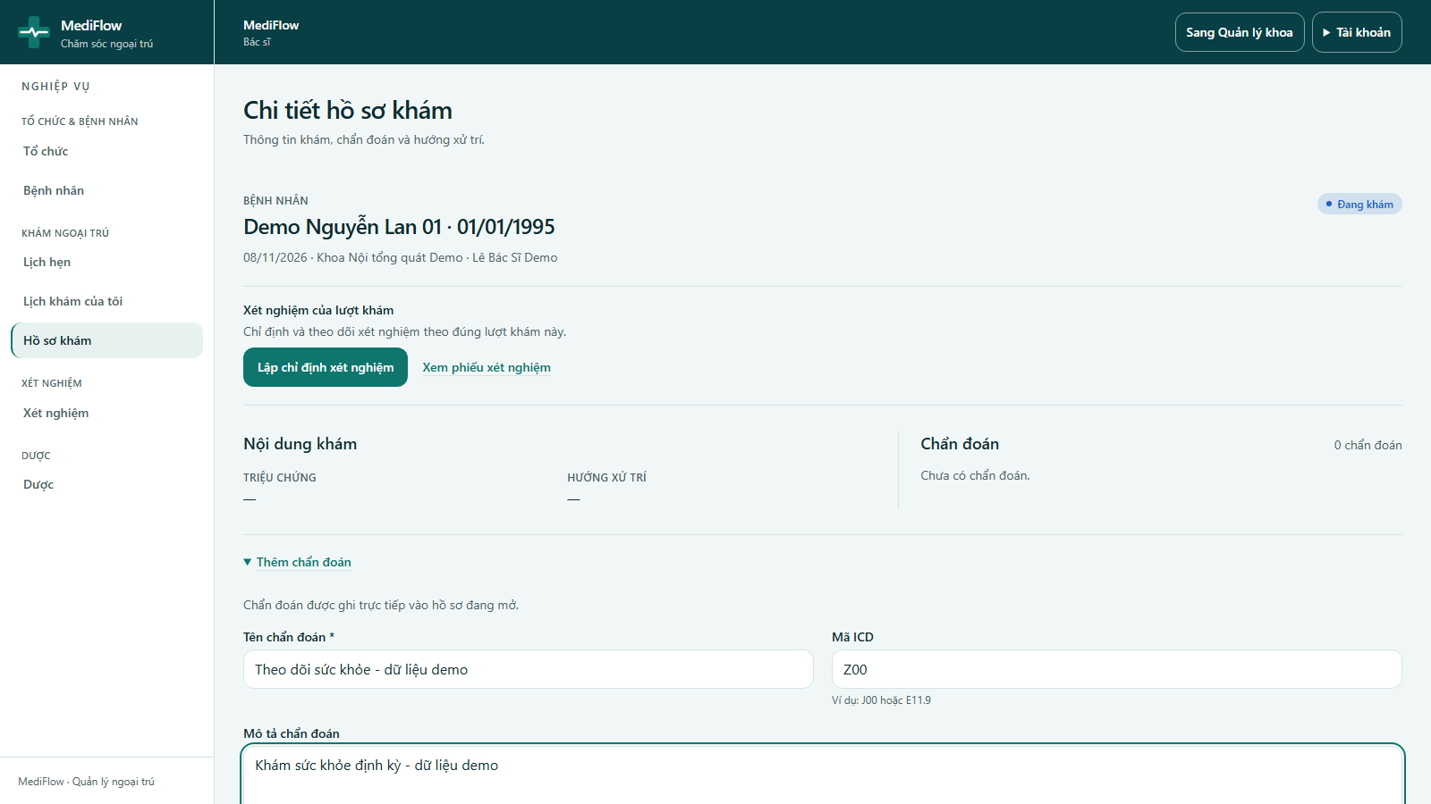
Figure 32. Adding a diagnosis
- In Thêm chẩn đoán, enter Tên chẩn đoán (diagnosis), Mã ICD (for example Z00) and a description, then save.
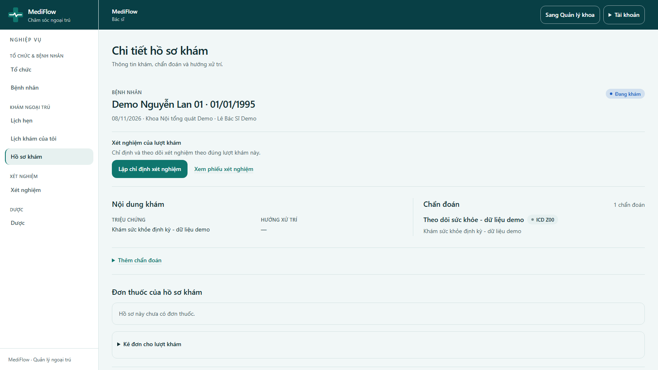
Figure 33. Record with symptoms and diagnosis
- The record now shows the symptoms and the diagnosis with its ICD code.

Mobile app (Flutter)
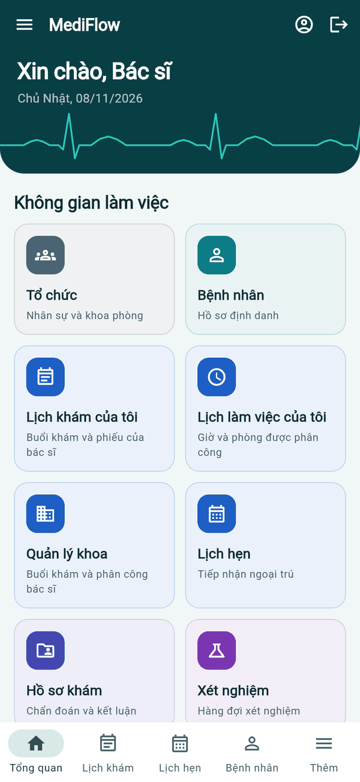  Doctor home | 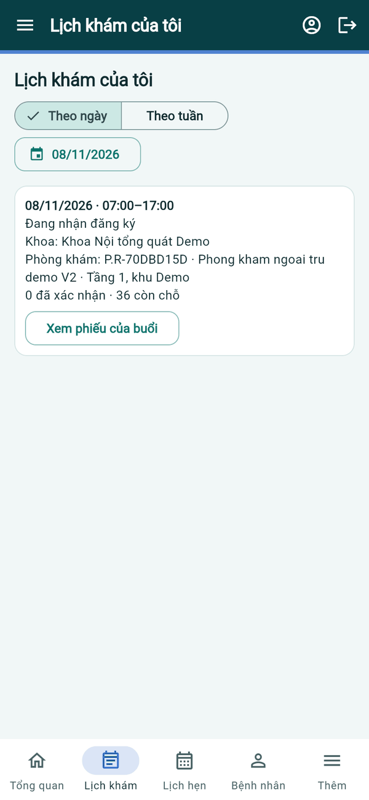  My calendar | 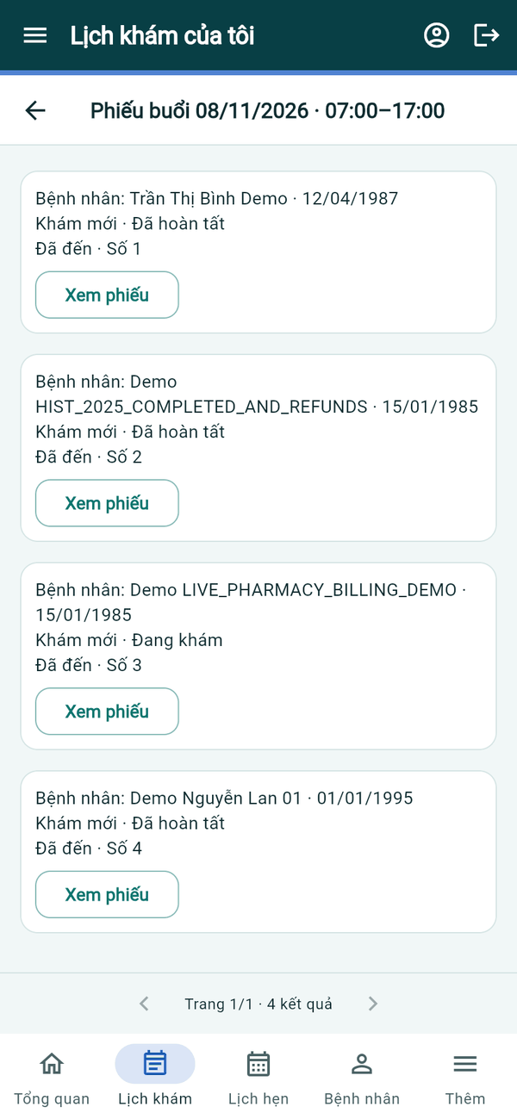  Session tickets
Figure 34. Mobile app — doctor calendar
- Lịch khám của tôi shows the sessions of a day or week; Xem phiếu của buổi lists the tickets with status and queue number, and Xem phiếu opens one.
Mobile app (Flutter)
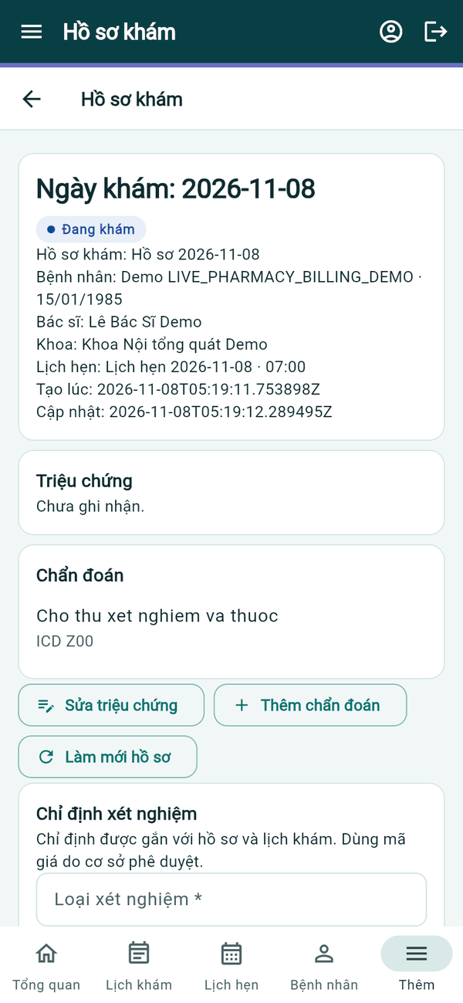  Record in progress | 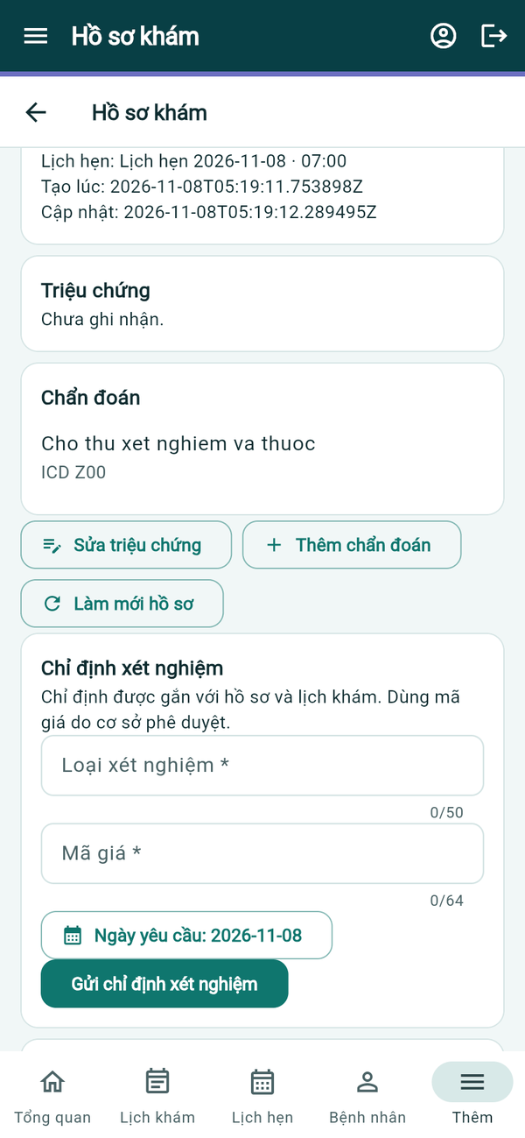  Symptoms and diagnosis
Figure 35. Mobile app — medical record
- The record shows the visit header, Triệu chứng and Chẩn đoán. Sửa triệu chứng and Thêm chẩn đoán open the same forms as the web.

Laboratory Order and Payment

Web application
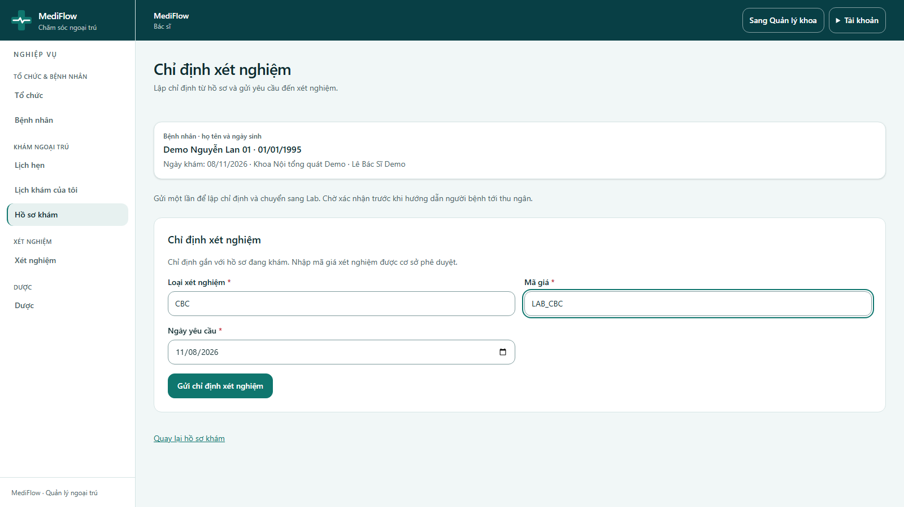
Figure 36. Laboratory order from the record
- From the record the doctor clicks Lập chỉ định xét nghiệm. Patient, visit date, department and doctor are filled from the record.
- Enter Loại xét nghiệm (test type, e.g. CBC), Mã giá (price code, e.g. LAB_CBC) and Ngày yêu cầu, then click Gửi chỉ định xét nghiệm.
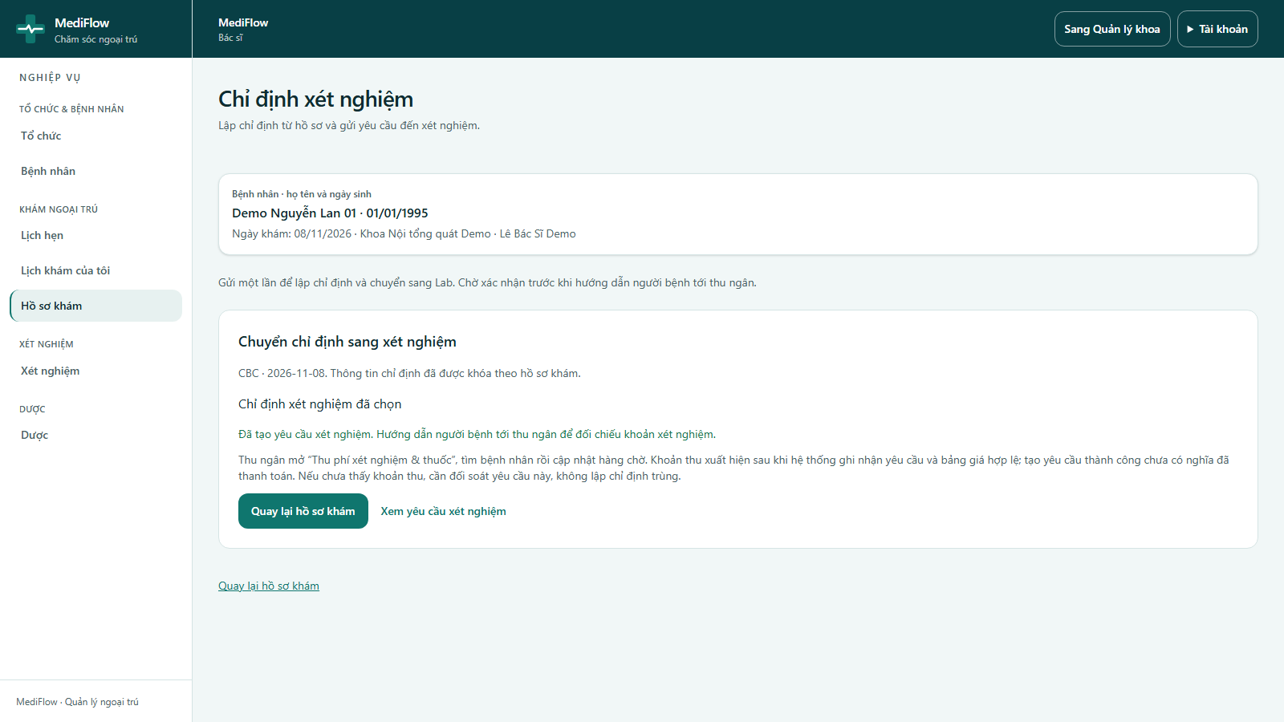
Figure 37. Laboratory request created
- The request is sent to the laboratory and the doctor asks the patient to go to the cashier. Xem yêu cầu xét nghiệm opens the request.
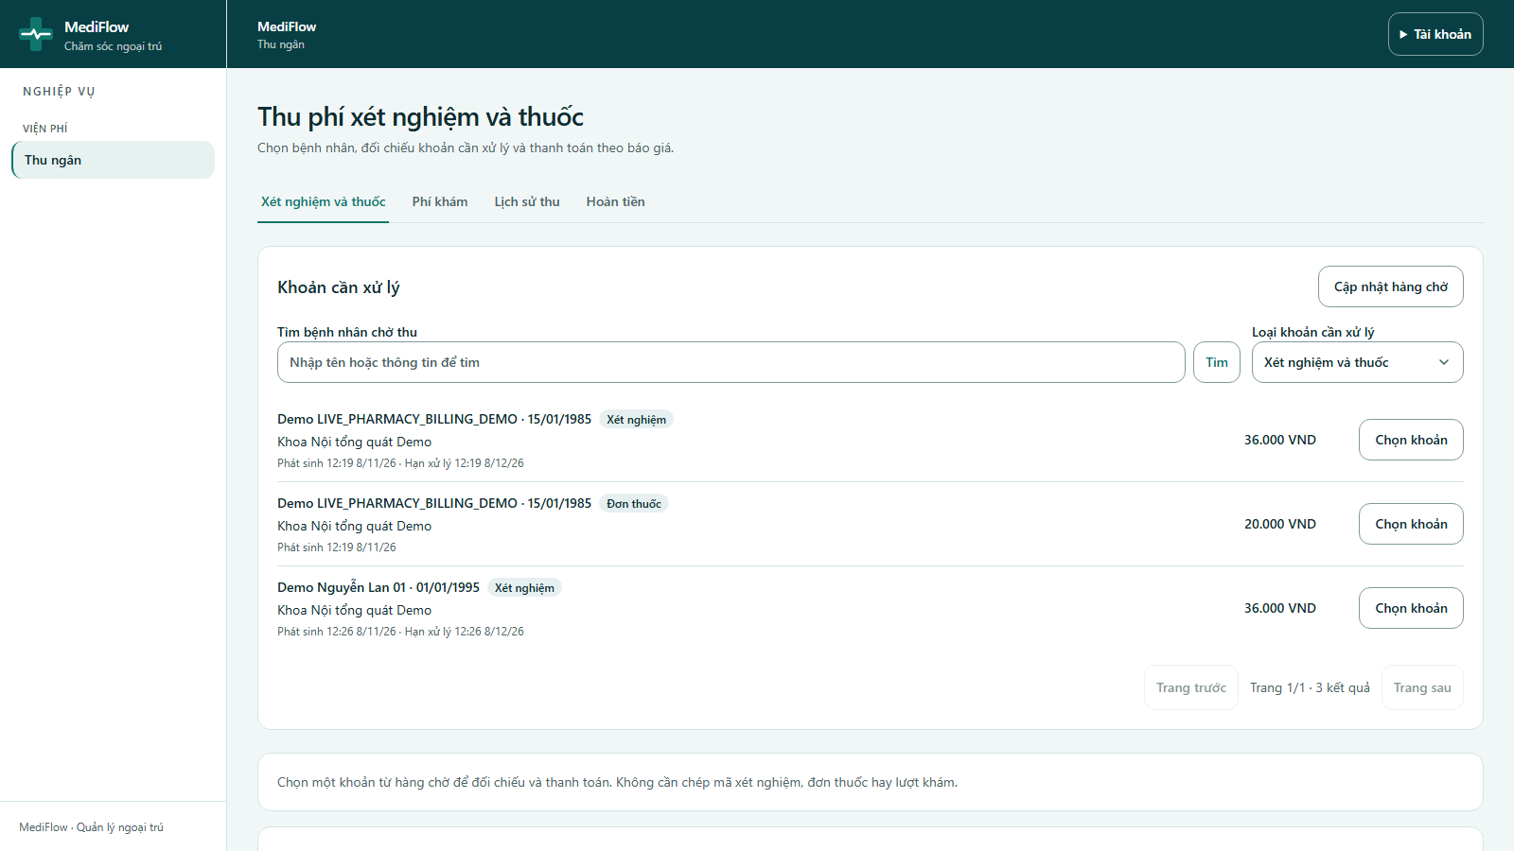
Figure 38. Lab and prescription payment queue
- The cashier opens Thu ngân → Xét nghiệm và thuốc. The queue lists pending charges with patient, type (Xét nghiệm / Đơn thuốc), department, time and amount.
- Search a patient, filter by Loại khoản cần xử lý, and click Chọn khoản. No code needs to be copied between counters.
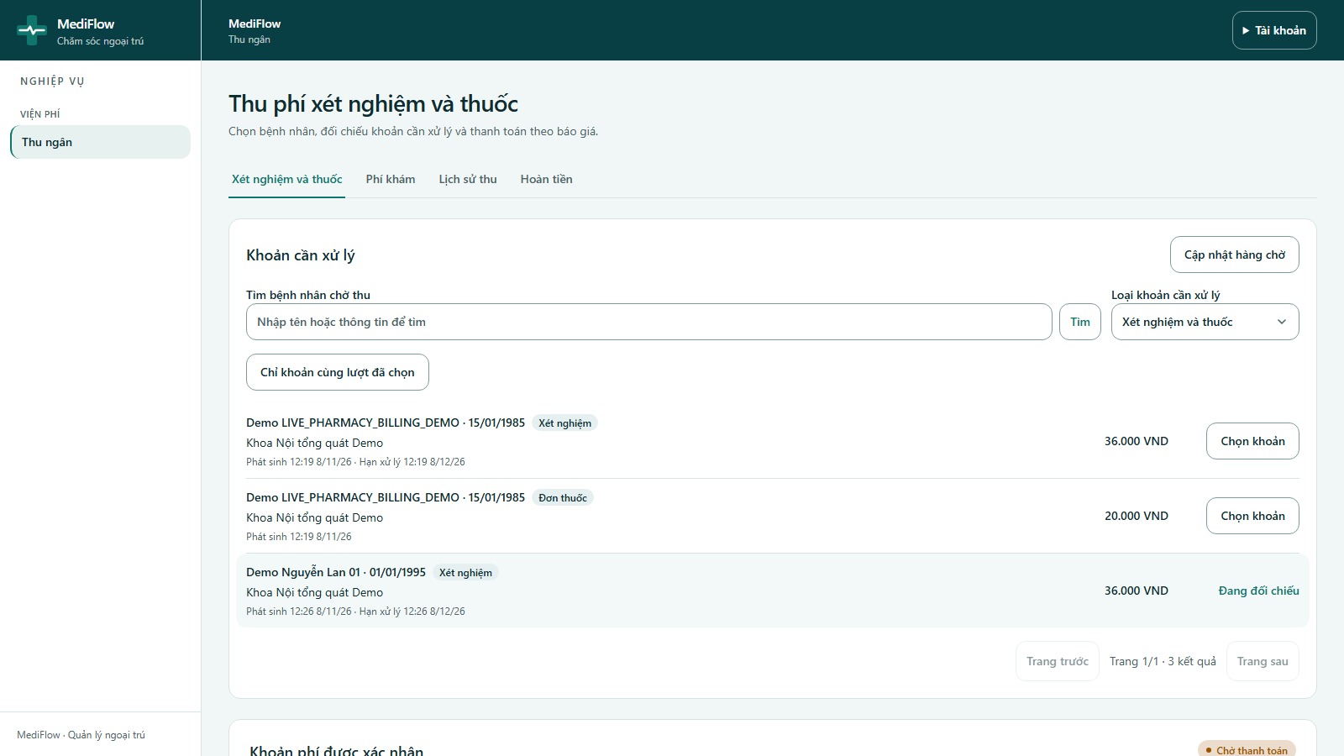
Figure 39. Laboratory charge selected
- The panel shows the requested amount, paid amount and balance. Choose the payment method and click Xác nhận thu theo báo giá.
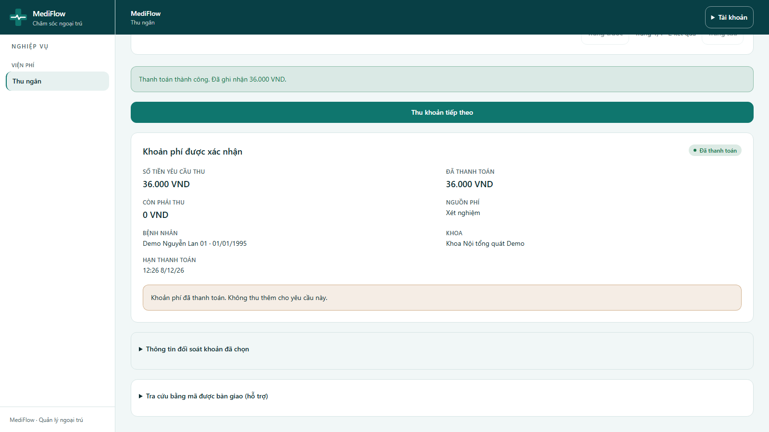
Figure 40. Laboratory charge paid
- The status becomes Đã thanh toán with a balance of 0 VND and the laboratory receives the financial clearance.

Mobile app (Flutter)
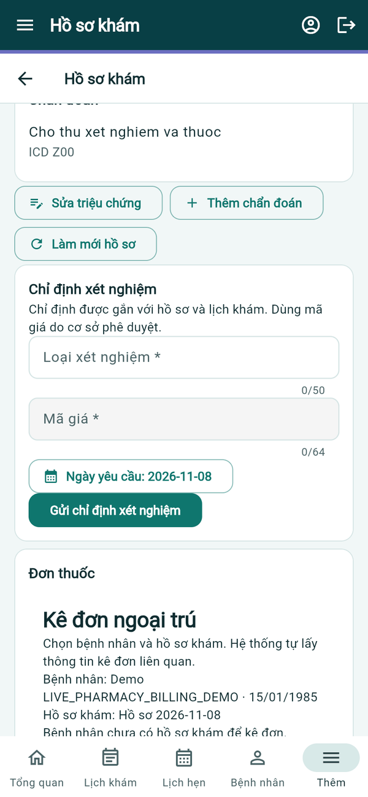  Lab order | 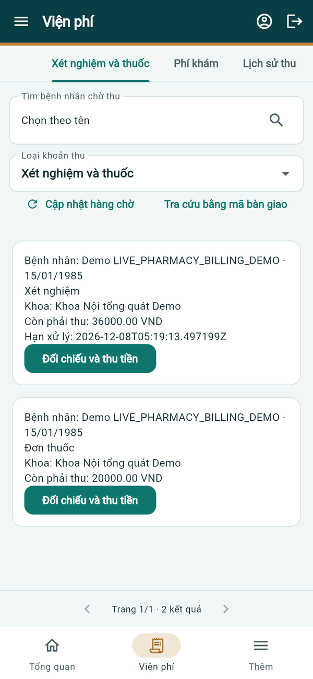  Lab & drug queue
Figure 41. Mobile app — lab order and payment
- In the record, Chỉ định xét nghiệm takes Loại xét nghiệm, Mã giá and Ngày yêu cầu; tap Gửi chỉ định xét nghiệm.
- The cashier opens Viện phí → Xét nghiệm và thuốc; each pending charge shows patient, type, department and balance. Tap Đối chiếu và thu tiền to collect it.

Laboratory Processing (Laboratory Technician)

Web application
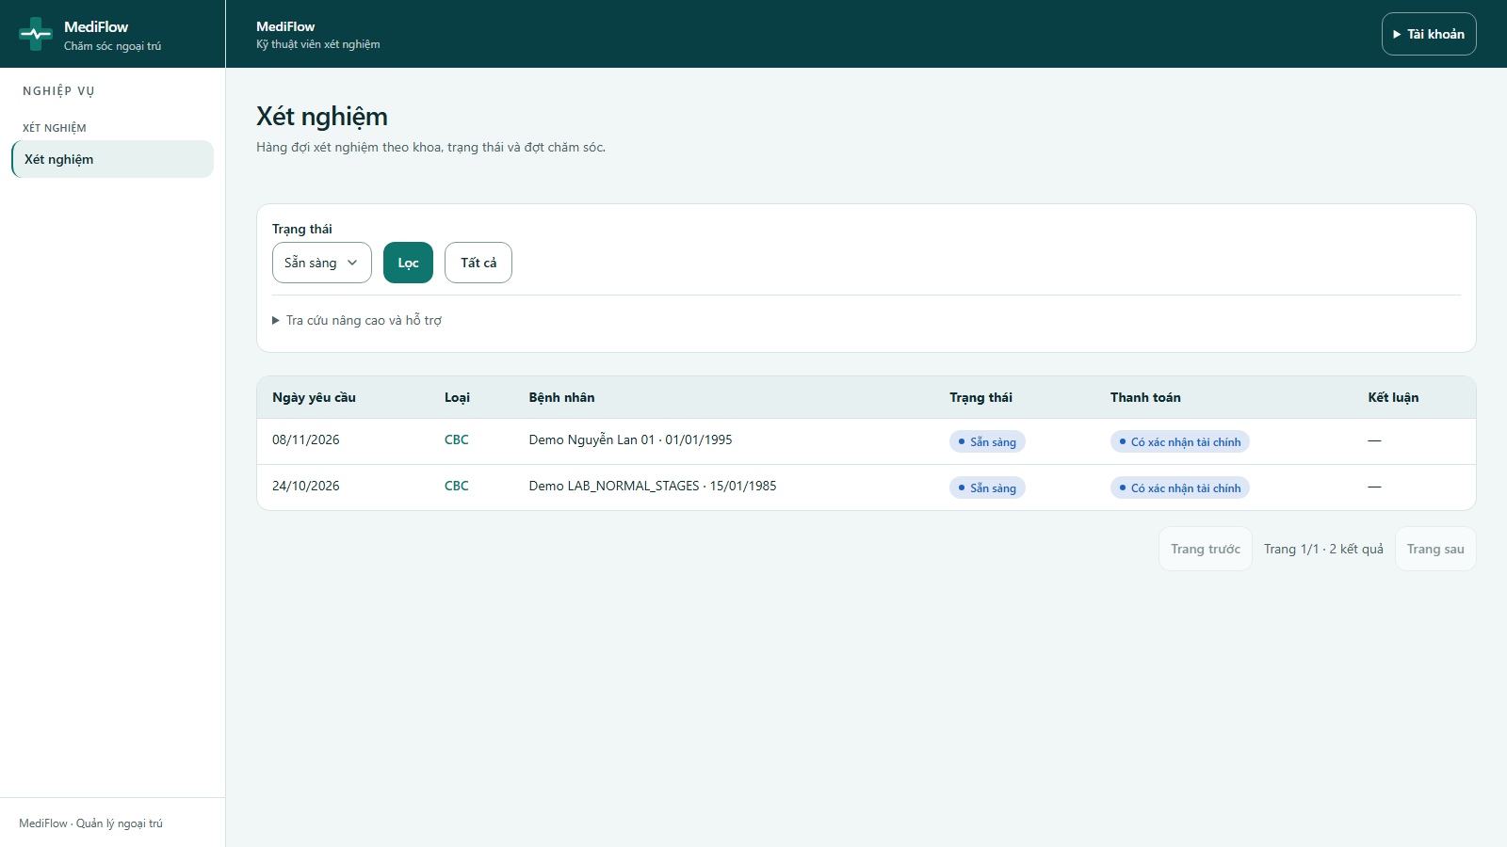
Figure 42. Laboratory queue
- The technician opens Xét nghiệm. The queue can be filtered by status: pending, waiting for payment, ready, in progress, completed or cancelled.
- The Thanh toán column shows whether the test has financial clearance.
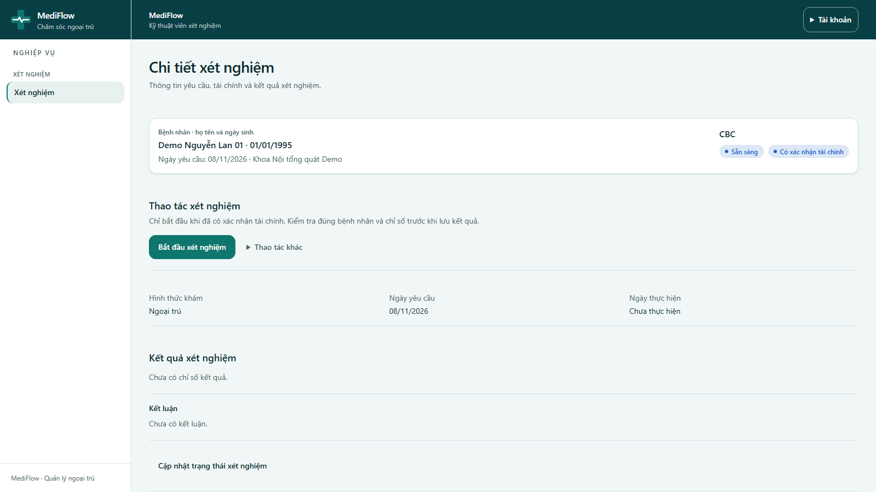
Figure 43. Laboratory request detail
- Open a request and check the patient name, date of birth and test type. Bắt đầu xét nghiệm is accepted only when the payment is confirmed.
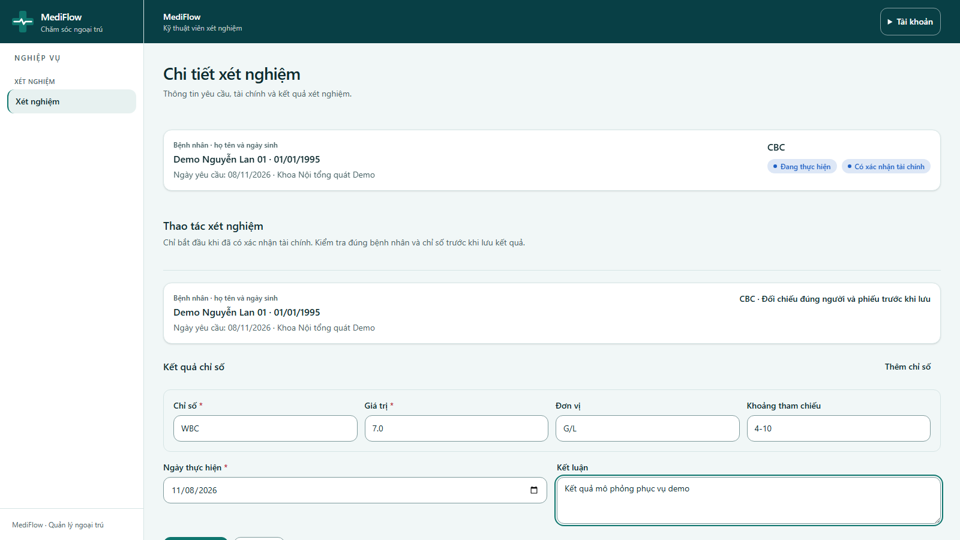
Figure 44. Entering results
- After starting, click Nhập kết quả. Enter one or more rows of Chỉ số (indicator), Giá trị (value), Đơn vị (unit) and Khoảng tham chiếu (reference range); Thêm chỉ số adds a row.
- Fill Ngày thực hiện (performed date) and Kết luận (conclusion), then click Lưu kết quả.
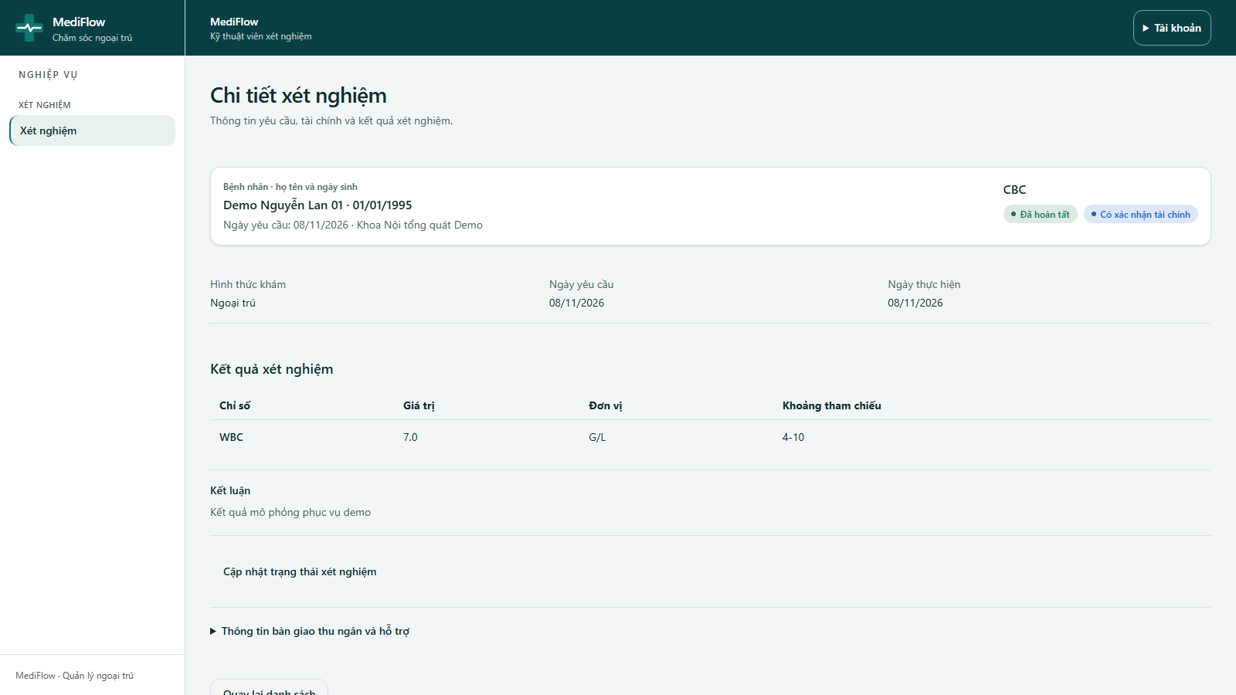
Figure 45. Completed laboratory result
- The test becomes Đã hoàn tất (completed). The doctor and the patient can now read the result.
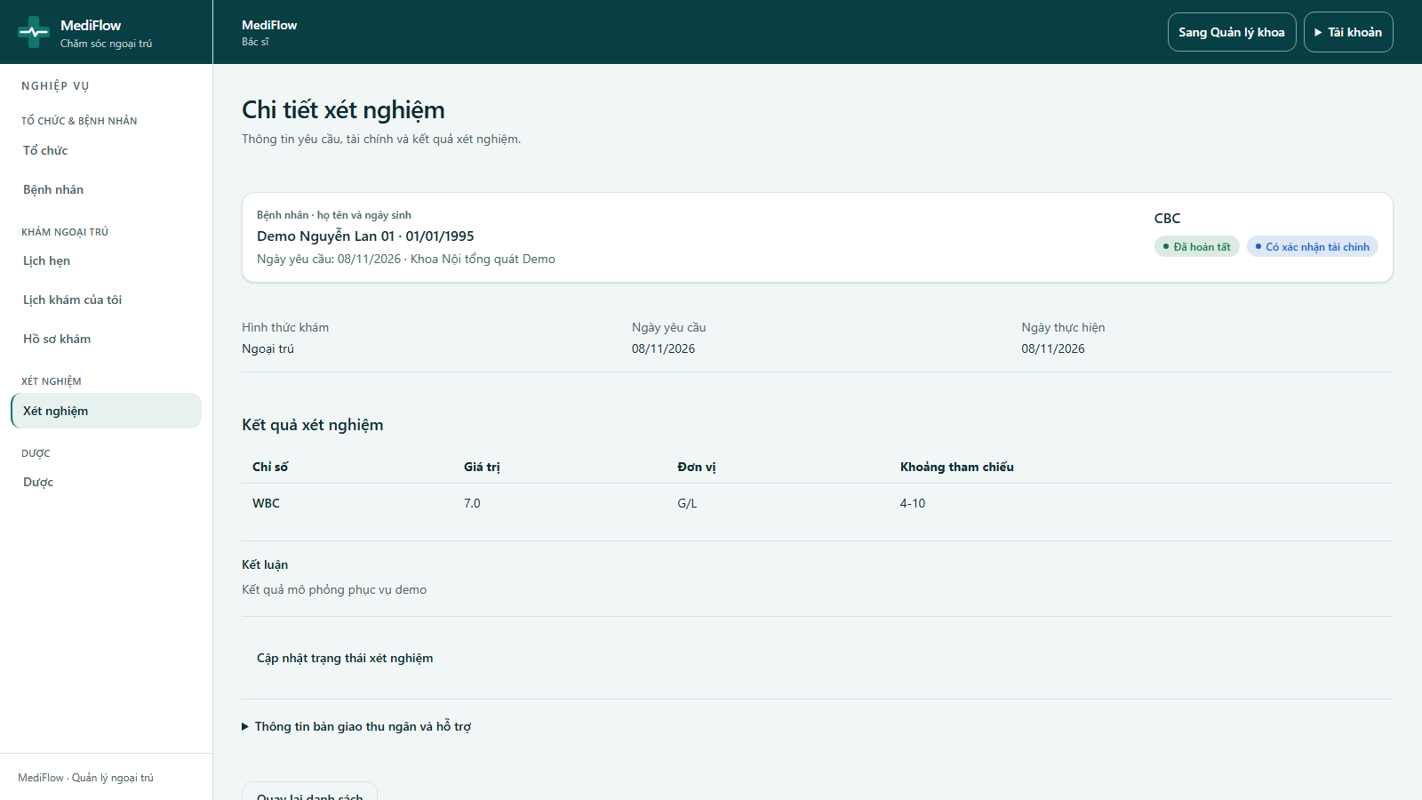
Figure 46. Doctor reads the result
- The doctor opens Xem phiếu xét nghiệm from the record to read the result of the same visit.

Mobile app (Flutter)
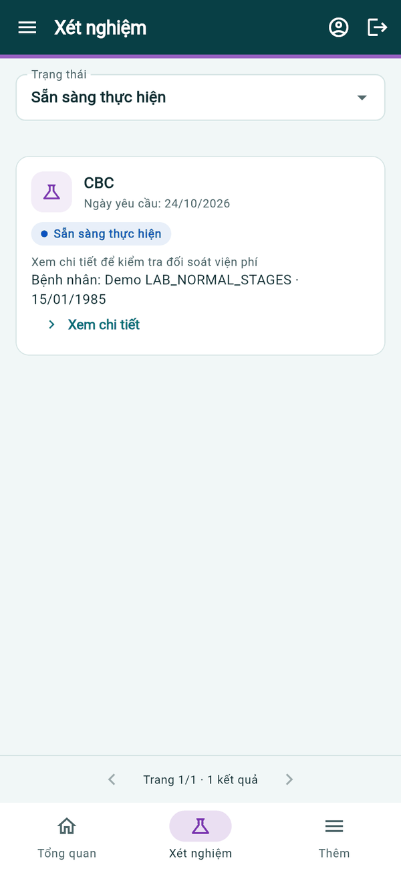  Lab queue | 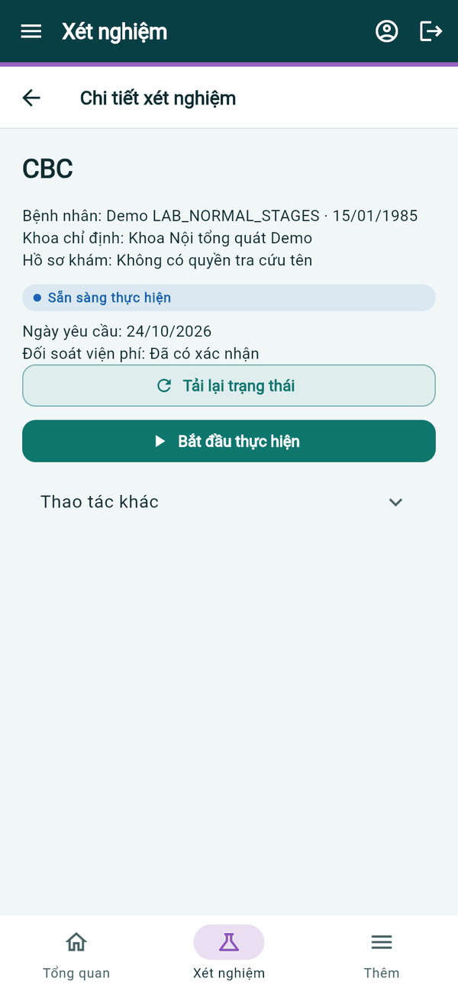  Request detail | 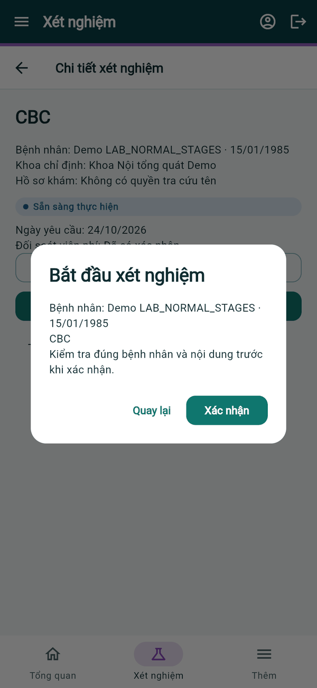  Start confirmation
Figure 47. Mobile app — laboratory request
- Xét nghiệm lists requests filtered by Trạng thái. Xem chi tiết shows patient, ordering department and payment clearance (Đối soát viện phí: Đã có xác nhận).
- Bắt đầu thực hiện asks for confirmation of the patient and test before starting.
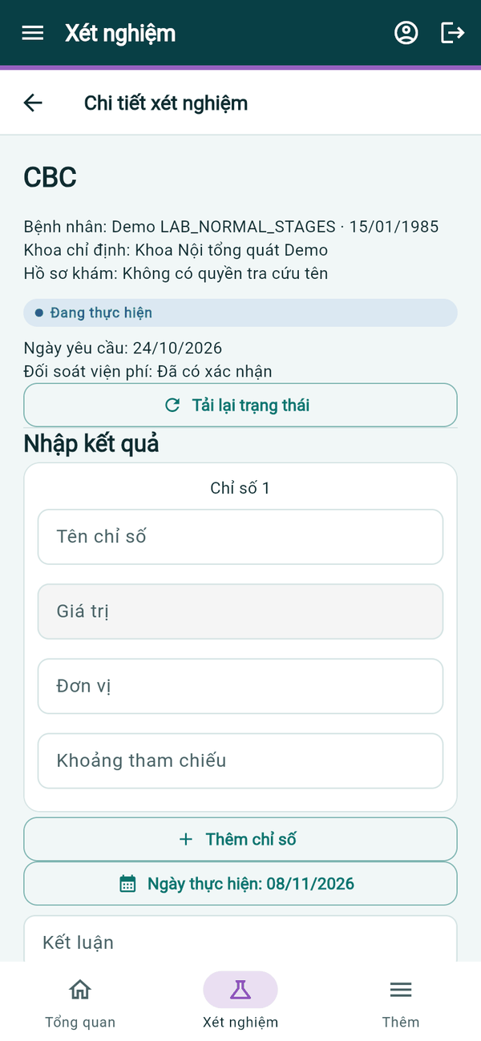  In progress | 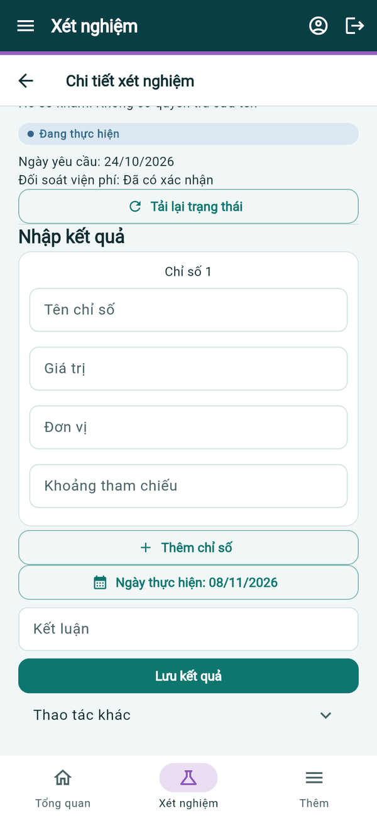  Entering results | 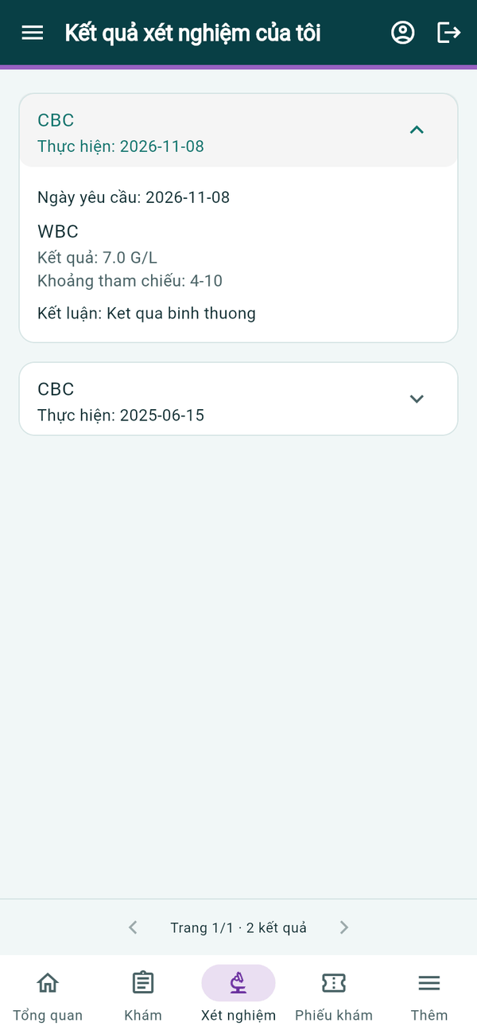  Result seen by patient
Figure 48. Mobile app — entering results
- Under Nhập kết quả, fill Tên chỉ số, Giá trị, Đơn vị, Khoảng tham chiếu (add rows with Thêm chỉ số), the performed date and Kết luận, then tap Lưu kết quả.

Prescription, Payment and Dispensing

Web application
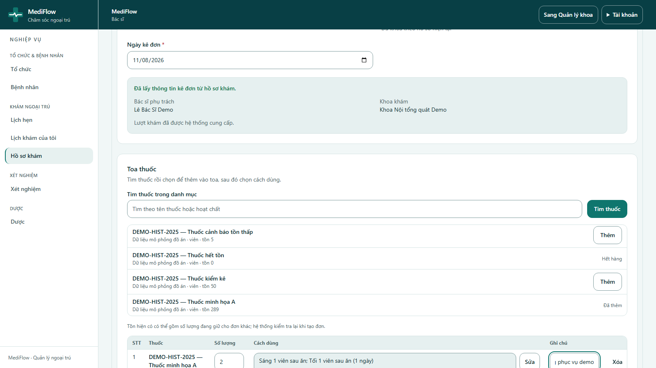
Figure 49. Prescribing from the medical record
- In the record, Kê đơn cho lượt khám opens the prescription form. Patient, record, doctor and department are taken from the record automatically.
- Search the drug catalogue with Tìm thuốc trong danh mục; each result shows unit and stock. Click Thêm to add the drug; out-of-stock drugs are disabled.
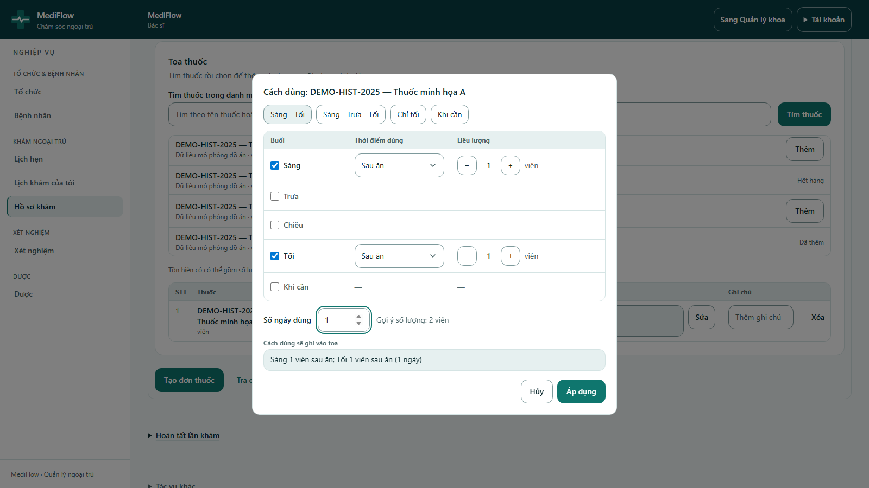
Figure 50. Dosage dialog
- The dosage dialog sets the times of day (morning, noon, afternoon, evening, as needed), when to take the drug and the dose, plus Số ngày dùng (number of days). Quick presets such as Sáng - Tối are available.
- Click Áp dụng, adjust Số lượng (quantity) and note, then click Tạo đơn thuốc.
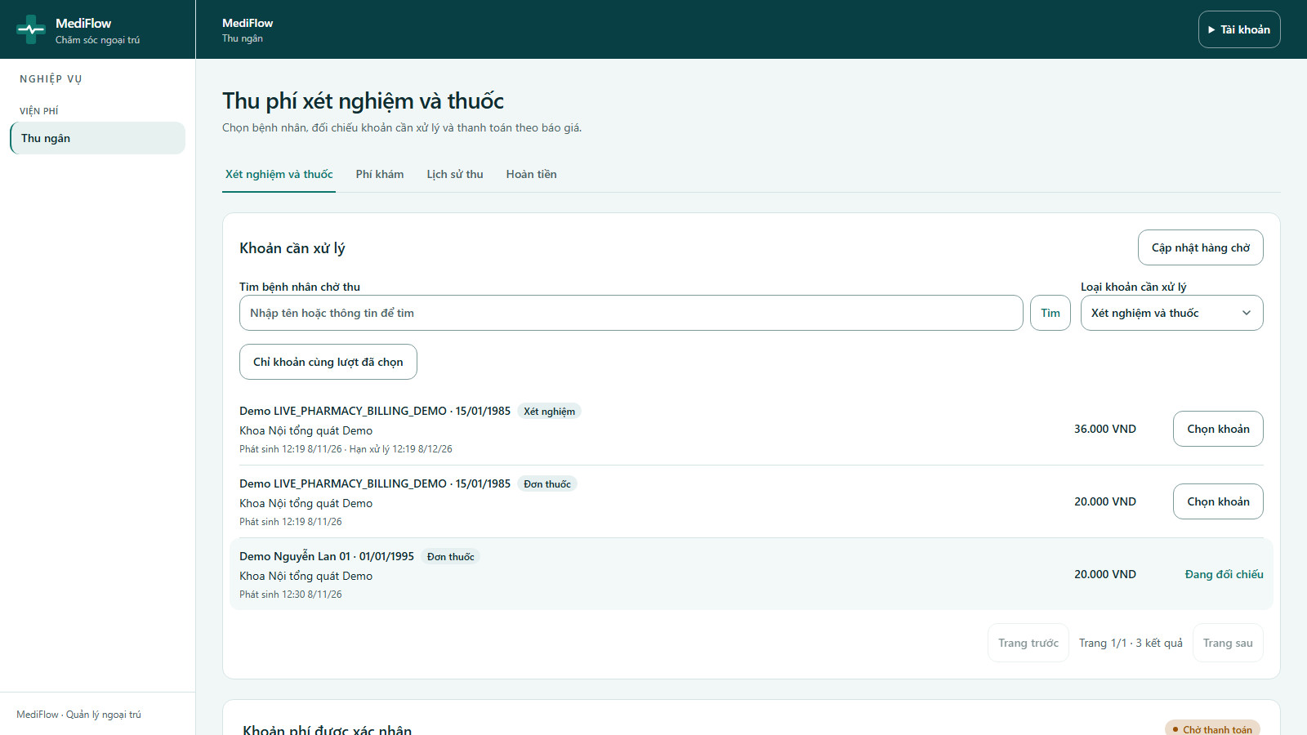
Figure 51. Prescription charge selected
- The cashier selects the Đơn thuốc charge in Xét nghiệm và thuốc, checks the amount, chooses the payment method and clicks Xác nhận thanh toán.
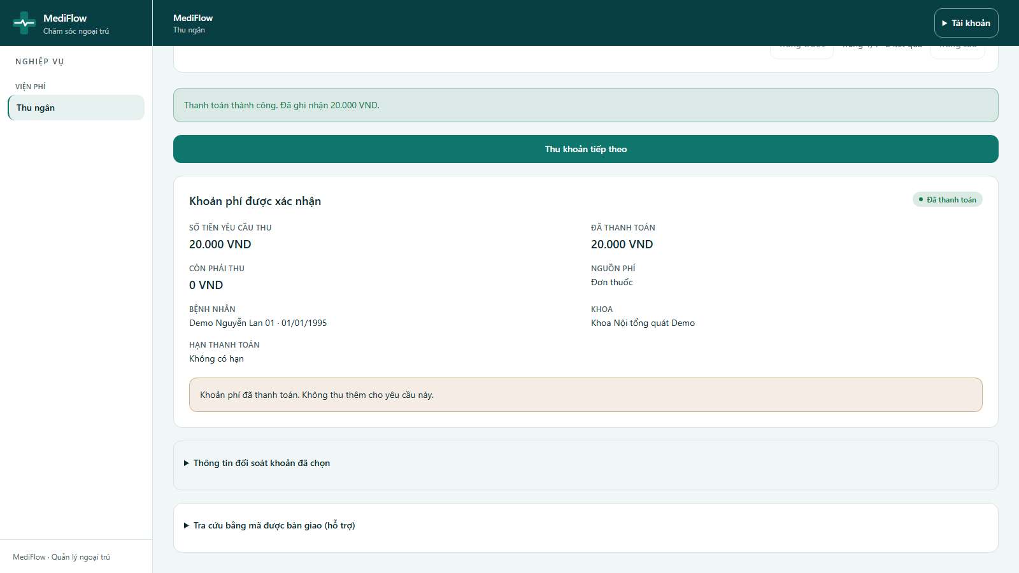
Figure 52. Prescription paid
- The charge becomes Đã thanh toán; the prescription can now be dispensed.
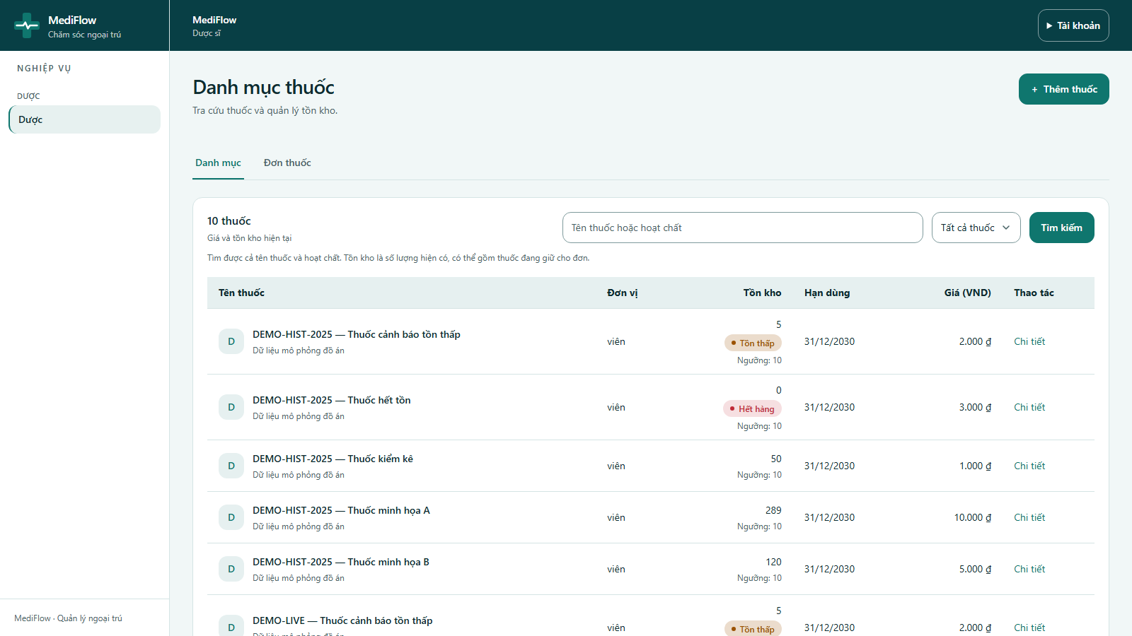
Figure 53. Drug catalogue
- The pharmacist opens Dược → Danh mục: unit, stock, low-stock threshold, expiry date and price. Filter by in stock, low stock, out of stock, expiring in 30 days or expired.
- Thêm thuốc adds a drug; Chi tiết shows a drug and its stock adjustment.
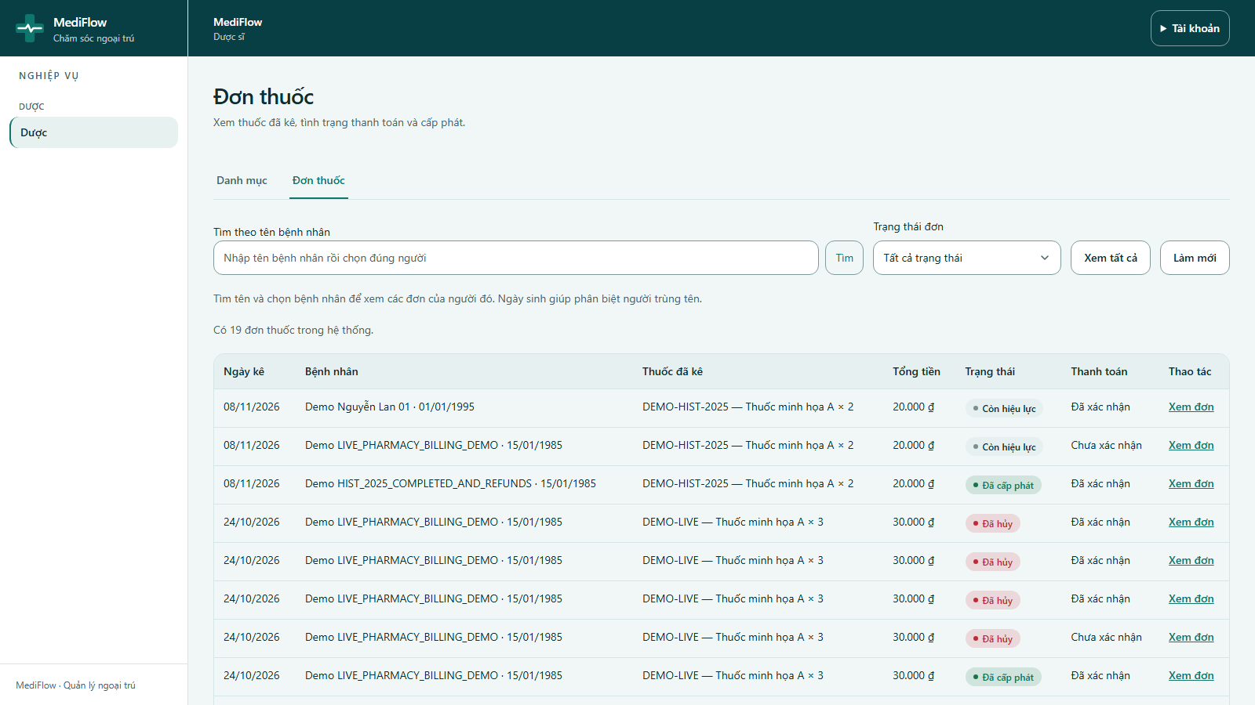
Figure 54. Prescriptions
- Đơn thuốc lists prescriptions with patient, drugs, total, status and payment. Search by patient name and click Xem đơn.
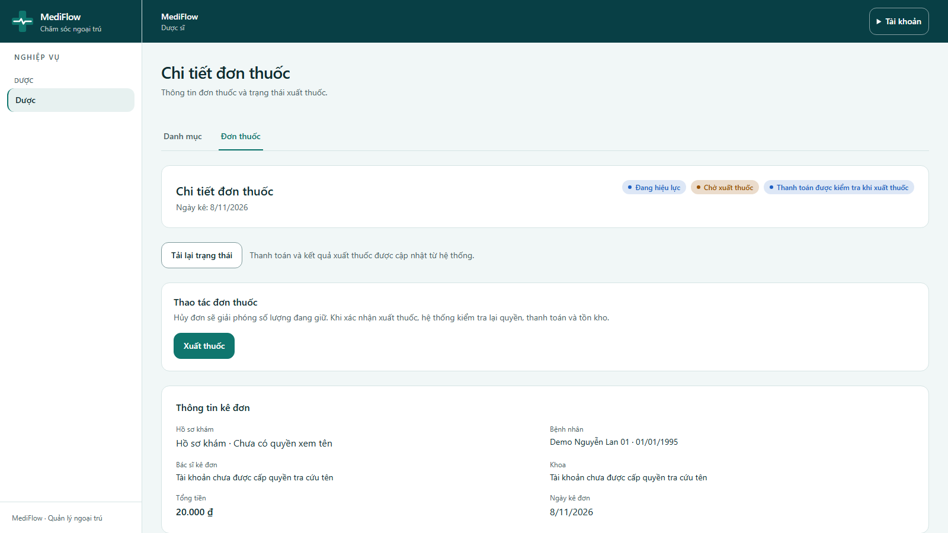
Figure 55. Prescription detail
- The detail shows the drug lines with quantity, unit price, dosage and total. Click Xuất thuốc (Dispense).
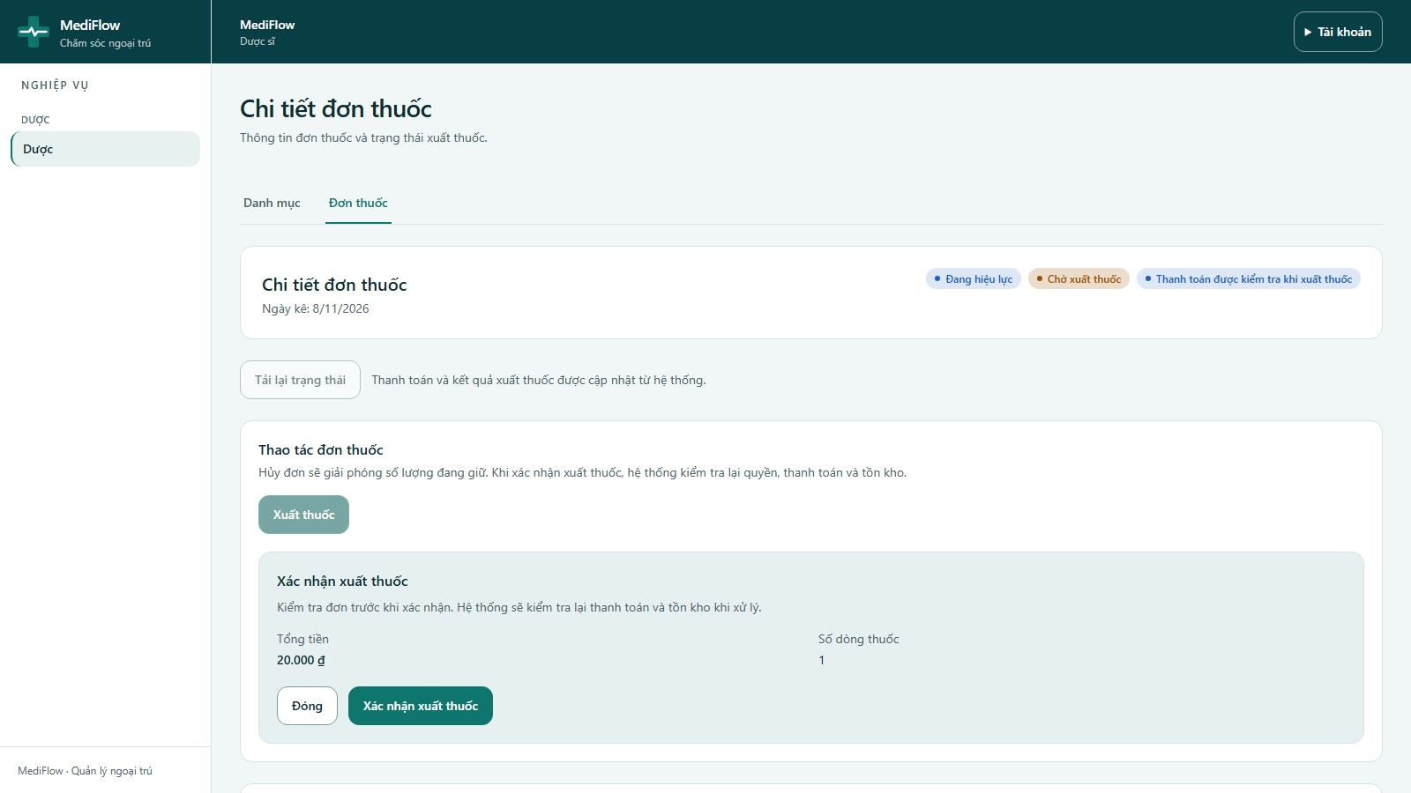
Figure 56. Dispense confirmation
- Confirm with Xác nhận xuất thuốc. The system checks permission, payment and stock again before dispensing.
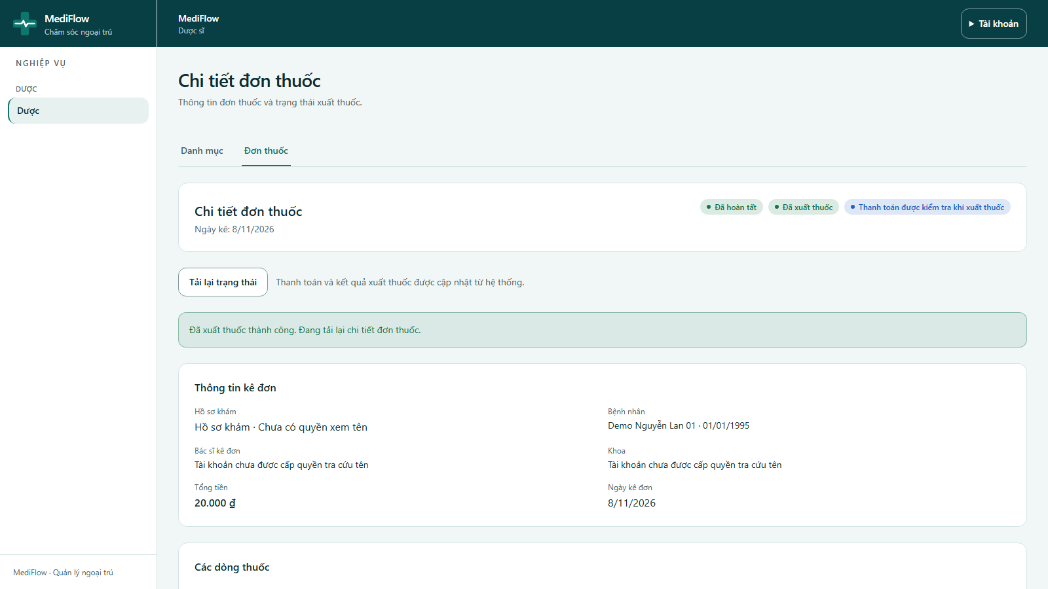
Figure 57. Prescription dispensed
- A successful dispense shows Đã xuất thuốc and the stock decreases. An unpaid prescription is refused.

Mobile app (Flutter)
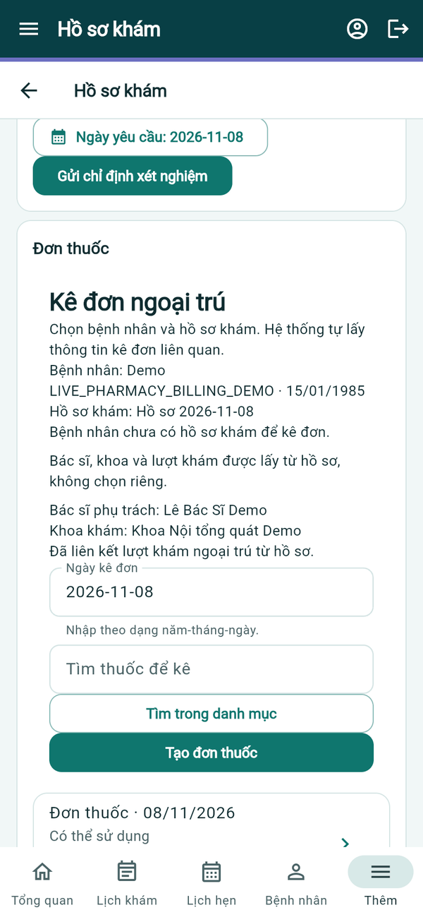  Prescribing | 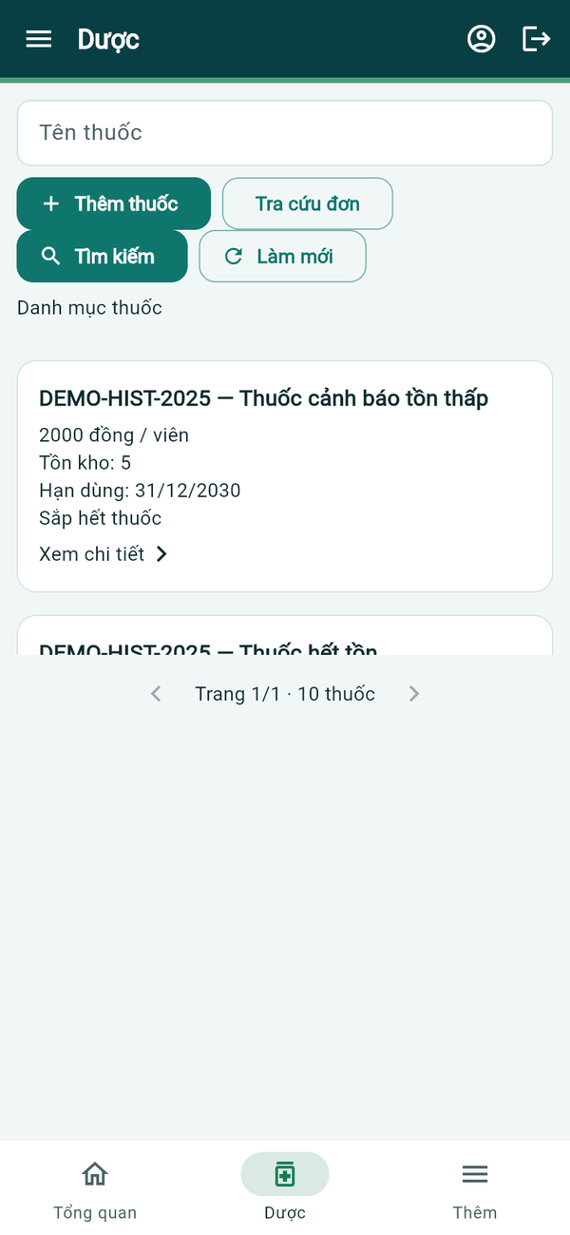  Drug catalogue | 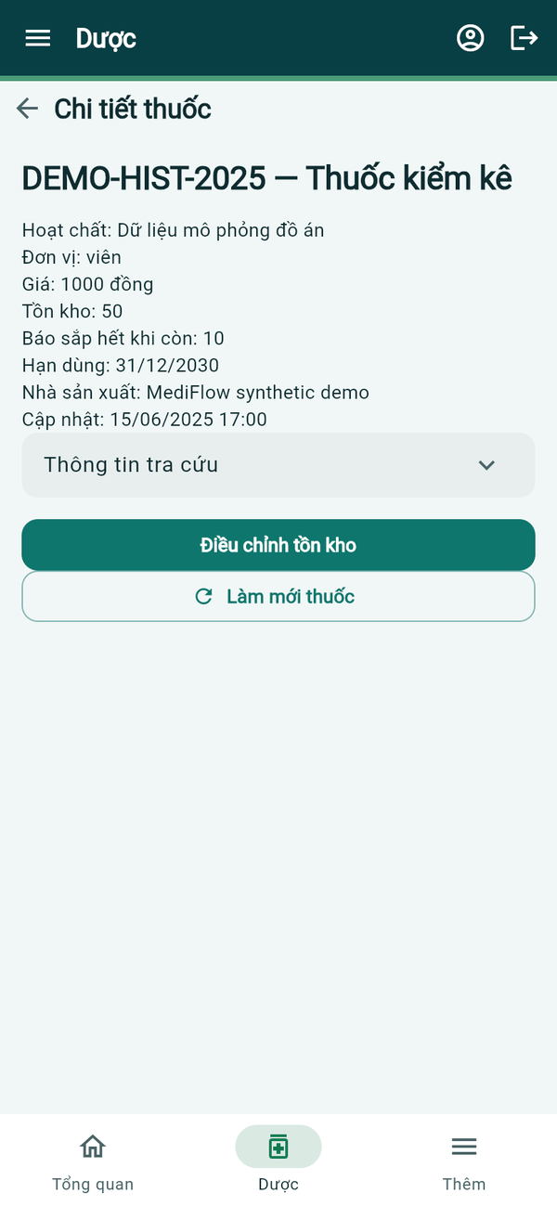  Drug detail
Figure 58. Mobile app — prescription and drugs
- In the record, Kê đơn ngoại trú takes the patient, record, doctor and department from the visit; search with Tìm thuốc để kê and tap Tạo đơn thuốc.
- The pharmacist opens Dược: search the catalogue, Thêm thuốc, and open a drug to see stock, threshold and expiry, or Điều chỉnh tồn kho.
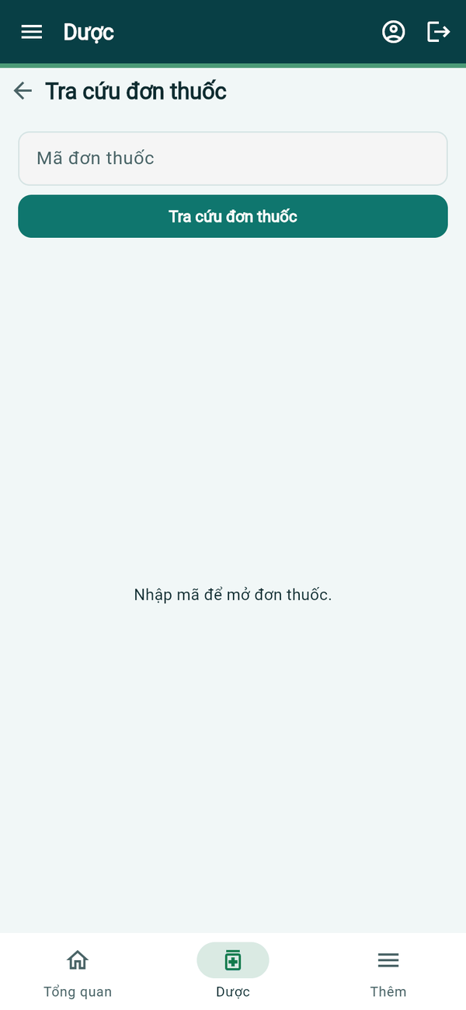  Prescription lookup | 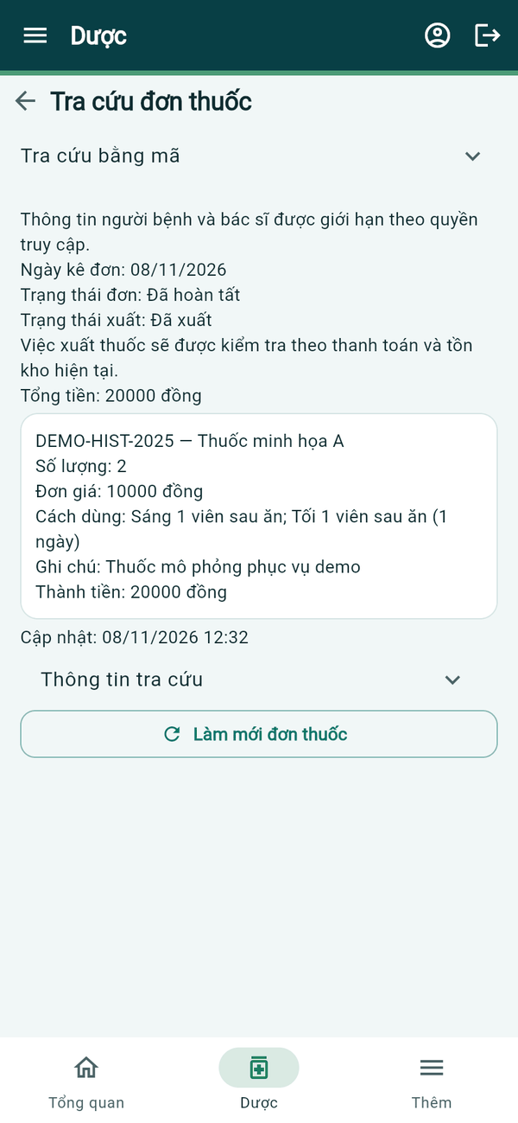  Prescription detail
Figure 59. Mobile app — prescription lookup
- Tra cứu đơn opens a prescription by its code and shows status, dispense status, total and each drug line with dosage. Dispensing is checked against payment and stock as on the web.

Completing the Visit and Follow-up (Doctor)

Web application
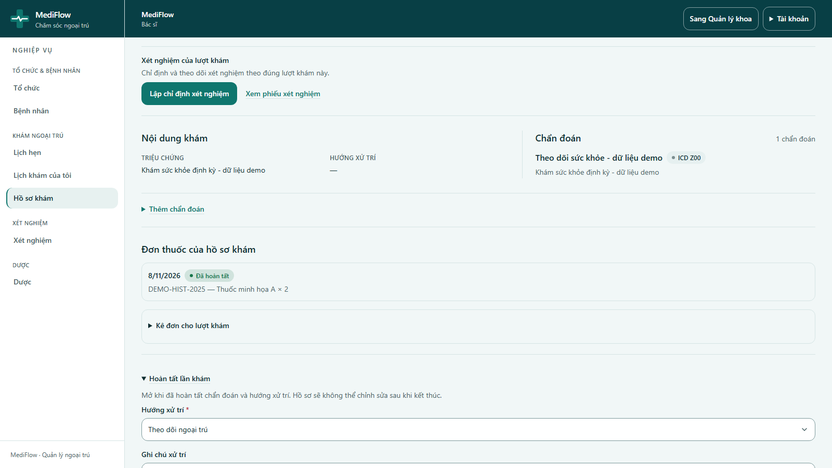
Figure 60. Completing the examination
- In Hoàn tất lần khám, the doctor chooses Hướng xử trí (disposition, e.g. Theo dõi ngoại trú), writes a note, ticks the confirmation box and clicks Hoàn tất hồ sơ khám.
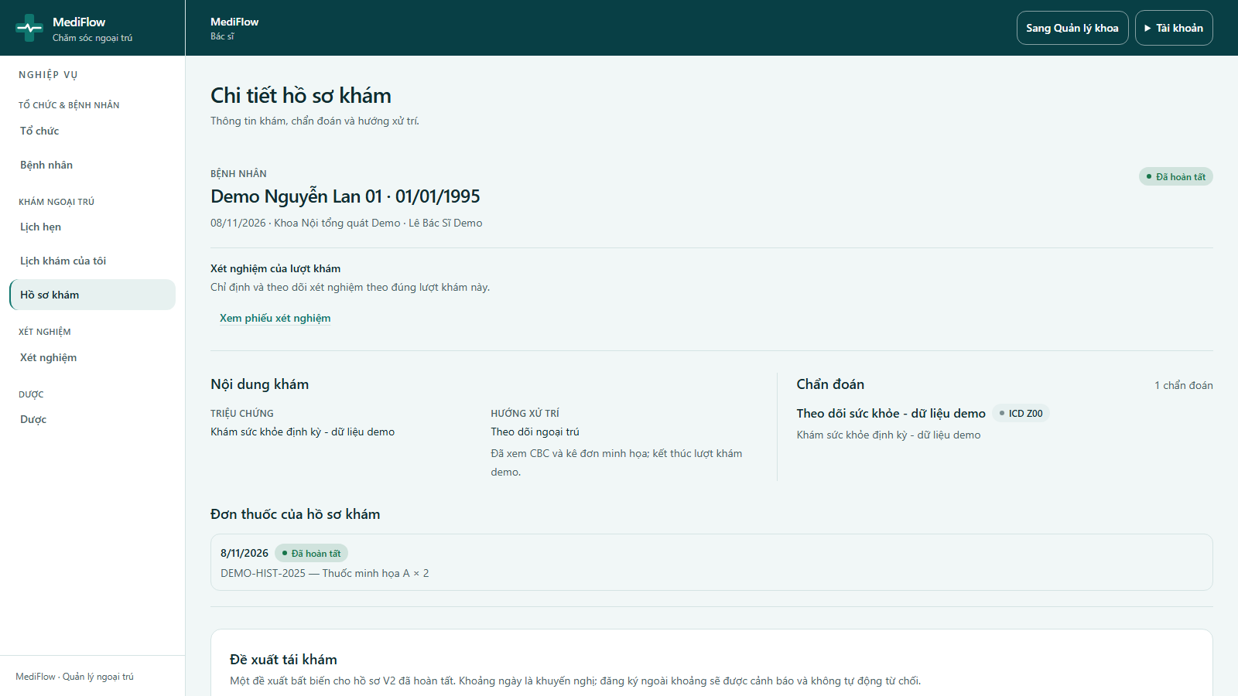
Figure 61. Completed medical record
- The record becomes Đã hoàn tất and shows symptoms, disposition, diagnosis, lab tests and the dispensed prescription.
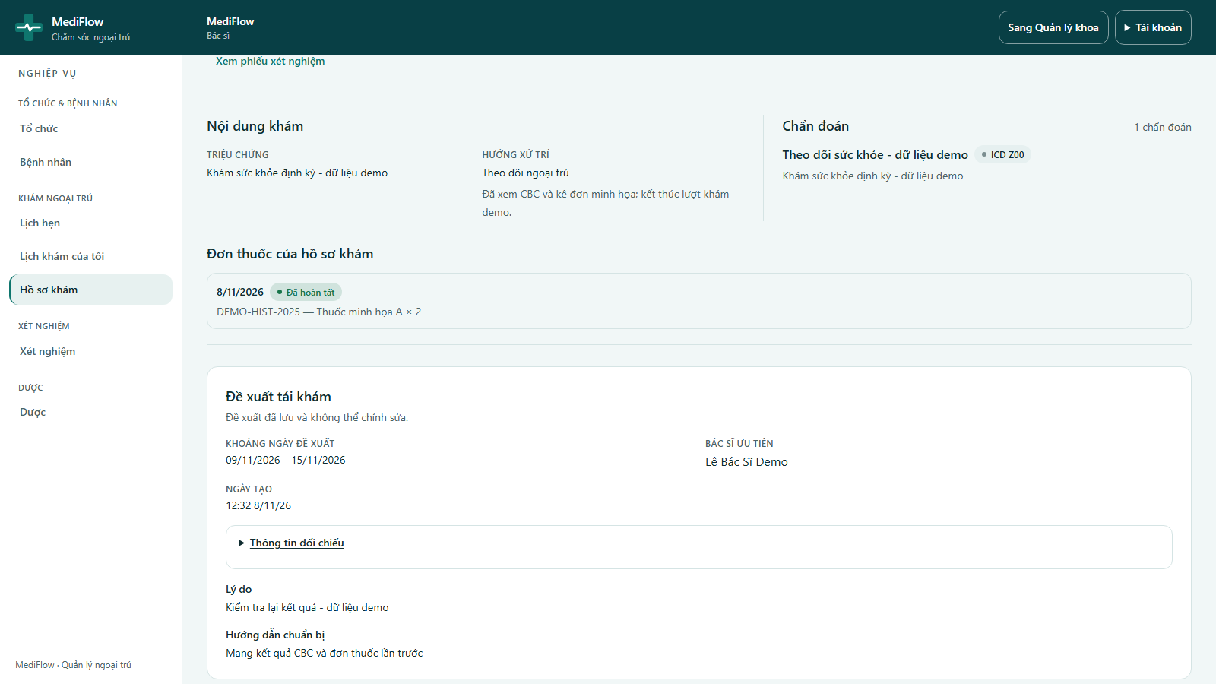
Figure 62. Follow-up recommendation
- Đề xuất tái khám records a recommended date range, the reason and preparation instructions. It is saved once and cannot be edited.
- A recommendation does not book a session; the nurse registers the follow-up visit later by choosing Tái khám từ lượt đã hoàn tất.

Mobile app (Flutter)
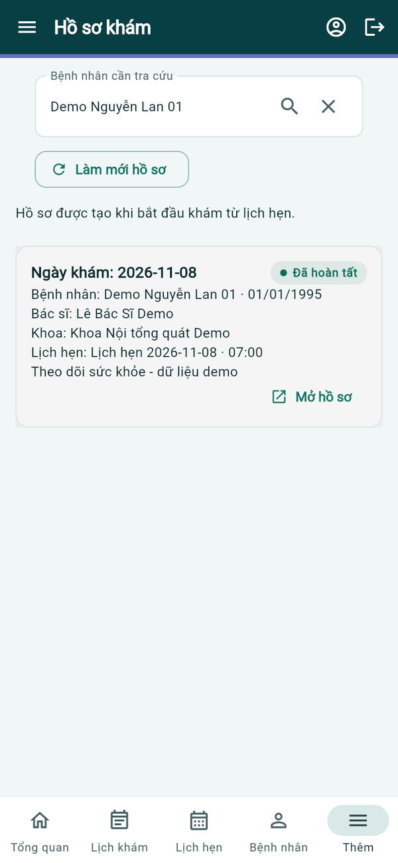  Records of a patient | 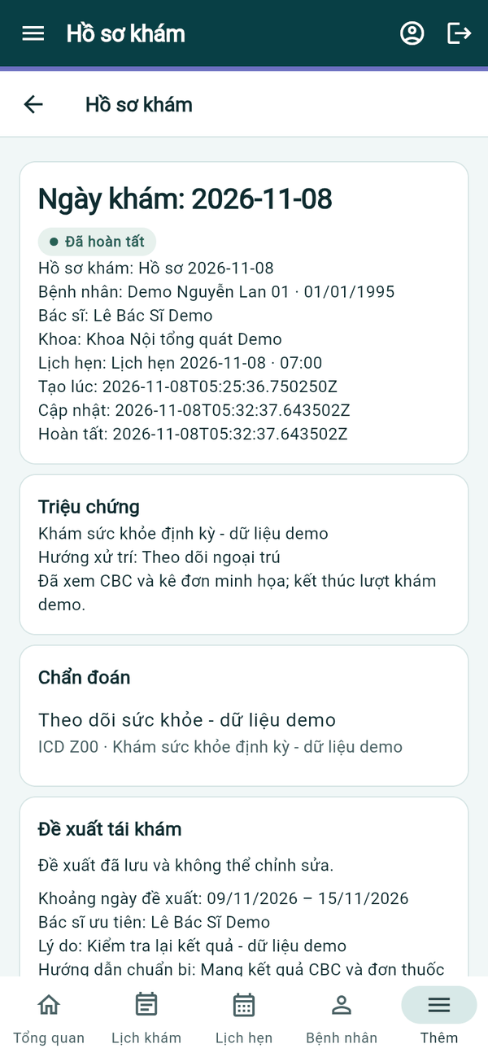  Completed record | 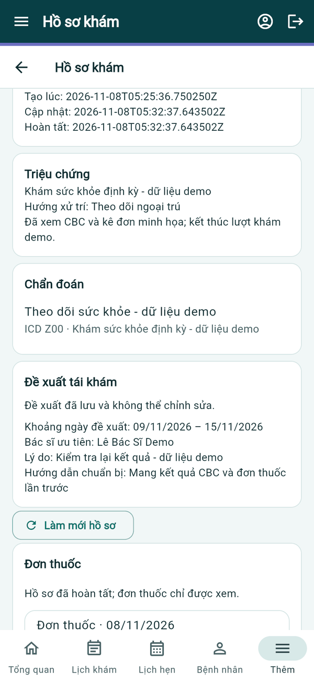  Follow-up
Figure 63. Mobile app — completed record
- Hồ sơ khám lets the doctor choose a patient and open any visit with Mở hồ sơ.
- A completed record shows symptoms, disposition, diagnosis, the saved Đề xuất tái khám and the read-only prescription.

Payment History and Refunds (Cashier)

Web application
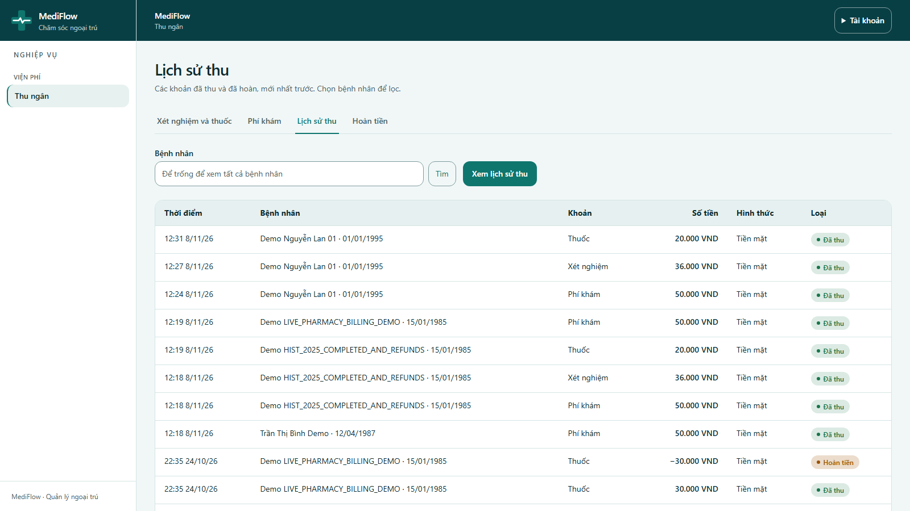
Figure 64. Payment history
- Lịch sử thu lists collected and refunded amounts, newest first, with time, patient, charge type, amount, method and type. Choose a patient to filter.
- The patient of this guide paid three separate charges: exam fee 50,000 VND, CBC 36,000 VND and drugs 20,000 VND (simulated demo prices).
- Hoàn tiền (Refunds) handles reconciliation and refund of an eligible charge.

Mobile app (Flutter)
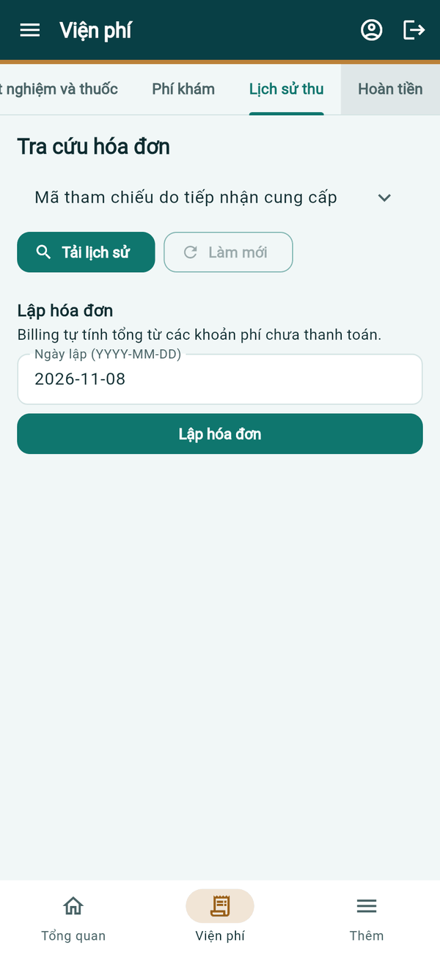  Payment history | 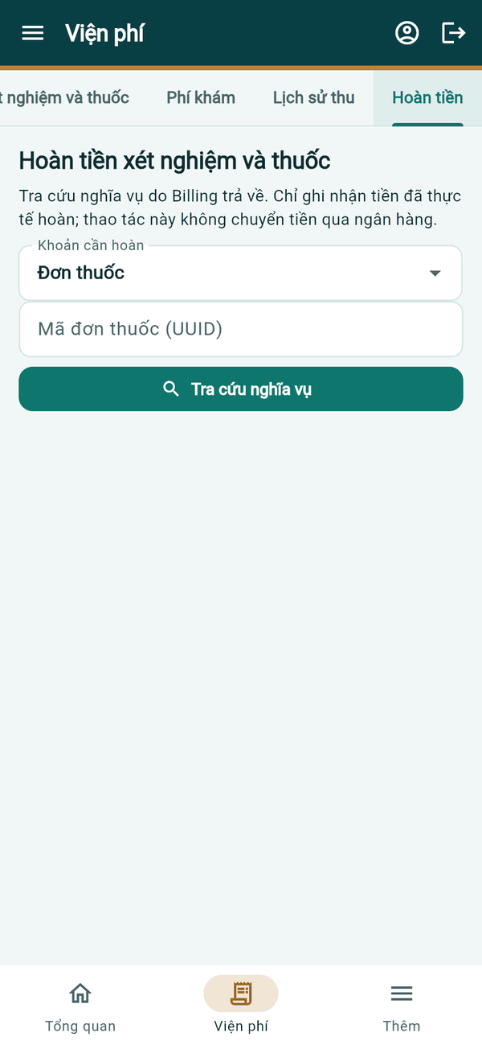  Refunds
Figure 65. Mobile app — history and refunds
- Lịch sử thu loads invoices by reference and can create an invoice for unpaid charges; Hoàn tiền looks up the refund obligation of a prescription or lab request and records the amount actually refunded.

Department Management (Department Head)

Web application
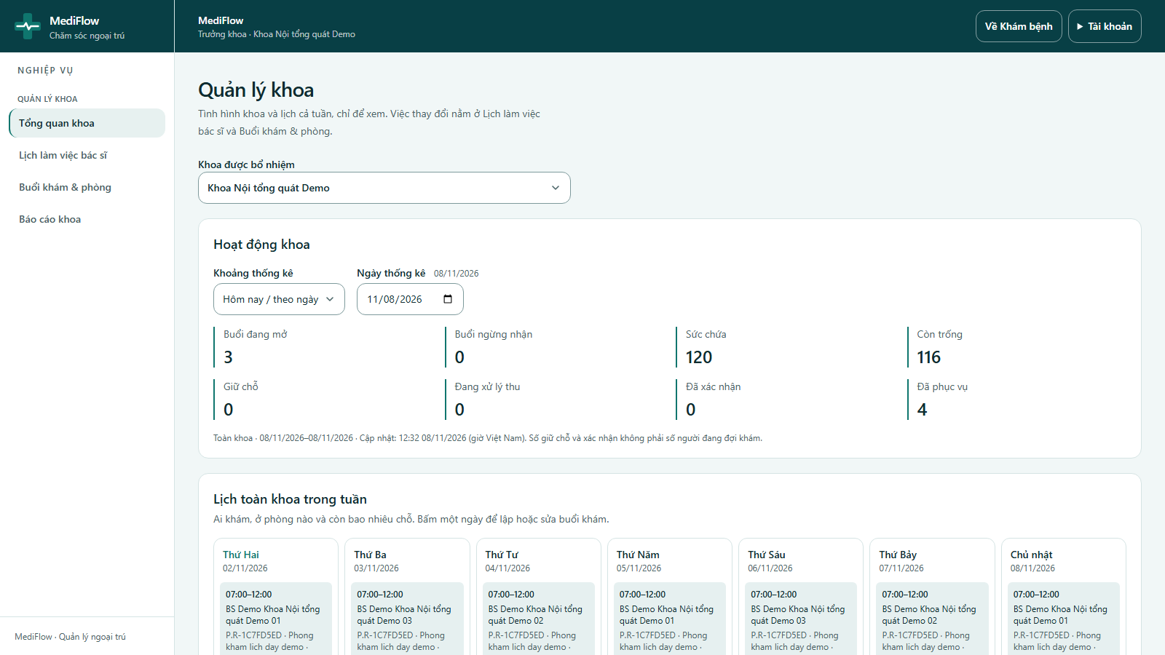
Figure 66. Department overview
- A doctor appointed as department head sees Sang Quản lý khoa (Go to department management). The overview shows open sessions, capacity, free slots, holds, confirmed and served tickets, and the weekly calendar of the whole department.
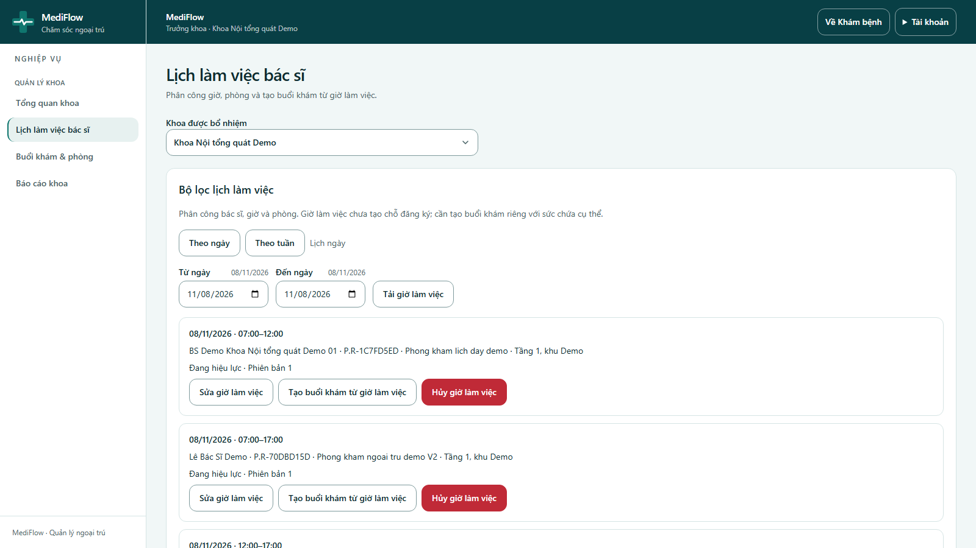
Figure 67. Doctor shifts
- Lịch làm việc bác sĩ assigns doctors to a room and time (07:00–17:00). Each shift can be edited, cancelled, or used to Tạo buổi khám từ giờ làm việc (create a consultation session).
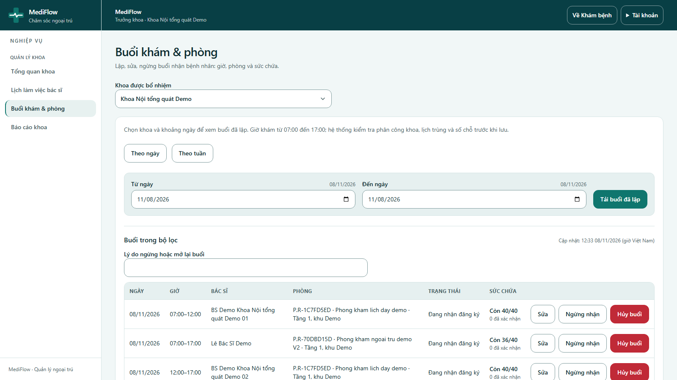
Figure 68. Sessions and rooms
- Buổi khám & phòng lists sessions with doctor, room, status and capacity. Sessions can be edited, closed for registration (Ngừng nhận) or cancelled; the system checks overlaps and booked slots.
- Về Khám bệnh returns to the personal doctor workspace with the same account.

Mobile app (Flutter)
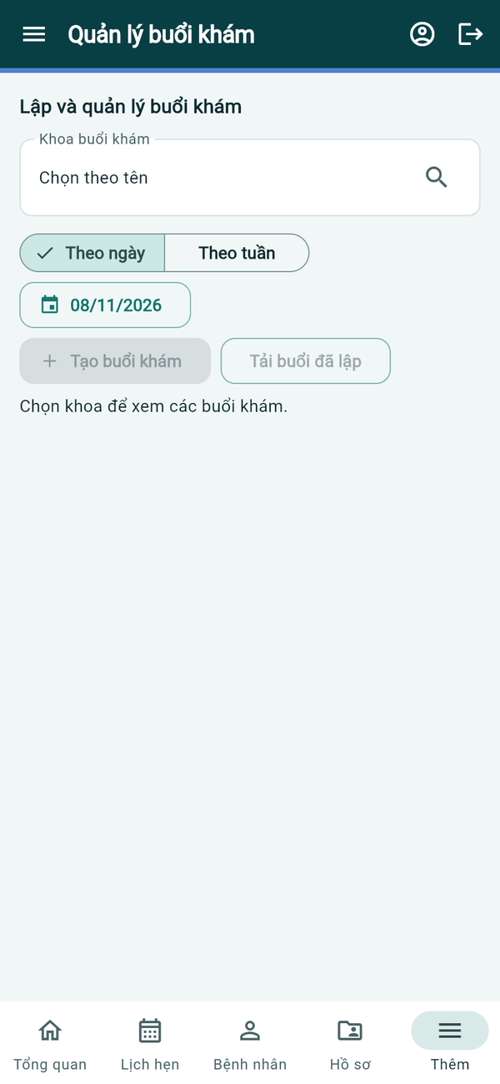
Session management
Figure 69. Mobile app — session management
- On the phone, Quản lý buổi khám lets the authorised user choose a department, view sessions by day or week and Tạo buổi khám. Doctor shift planning (Lịch làm việc của tôi) is also available from the doctor home screen.

Patient Portal (Patient)

Web application
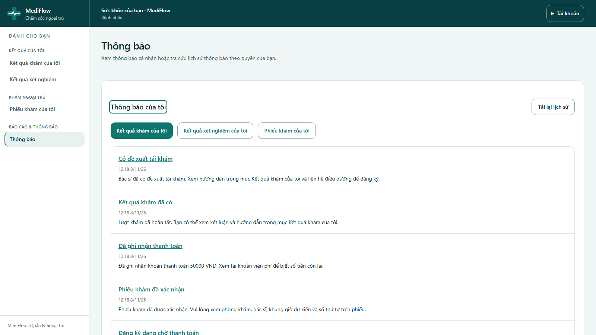
Figure 70. Patient notifications
- A patient signs in with the email of their account. Thông báo của tôi shows notifications such as registration waiting for payment, ticket confirmed, payment recorded, result available and follow-up recommendation.
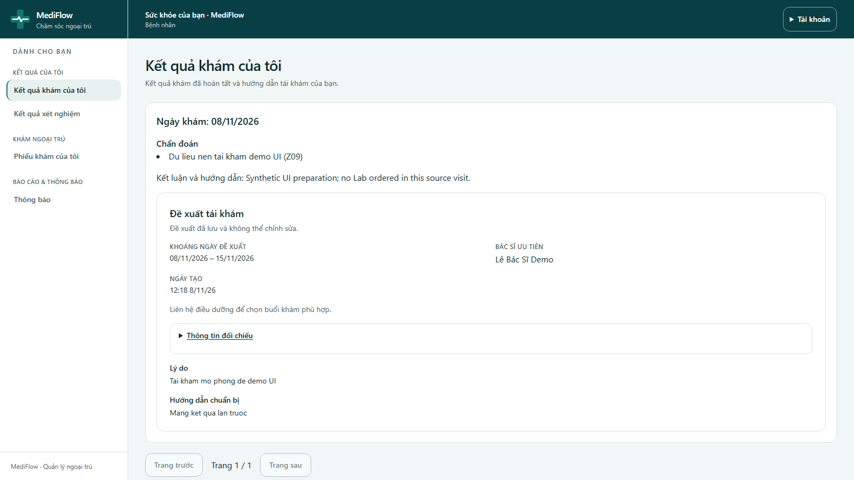
Figure 71. My examination results
- Kết quả khám của tôi shows completed visits with diagnosis, conclusion and follow-up recommendation.
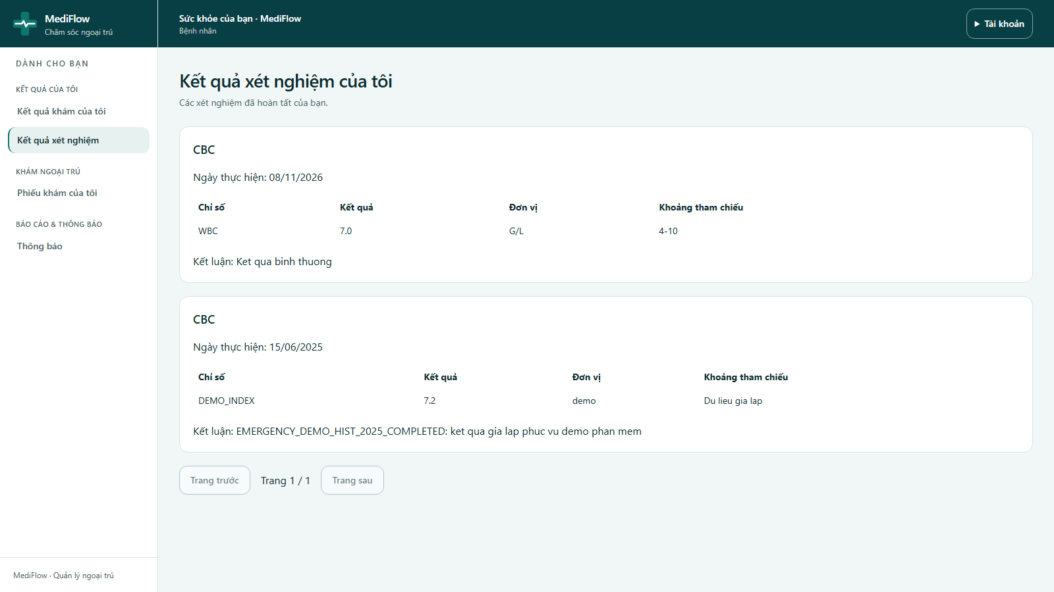
Figure 72. My laboratory results
- Kết quả xét nghiệm của tôi lists completed tests with indicators, values, units, reference ranges and the conclusion.
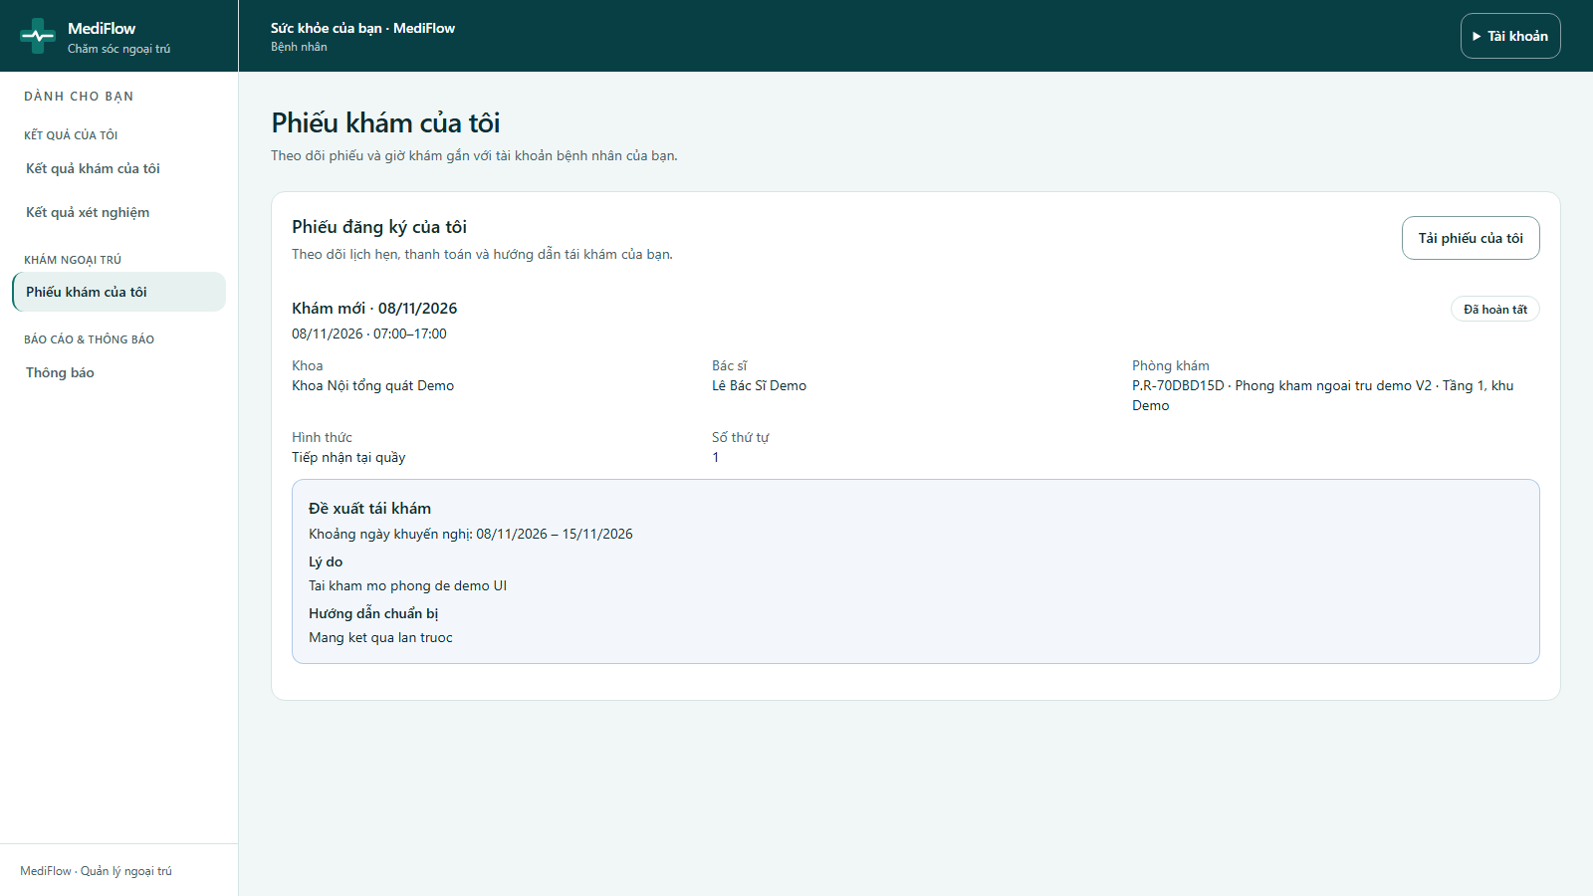
Figure 73. My visit tickets
- Phiếu khám của tôi tracks visit tickets: department, doctor, room, queue number, status and recommended follow-up.
- A patient can only see their own data.

Mobile app (Flutter)
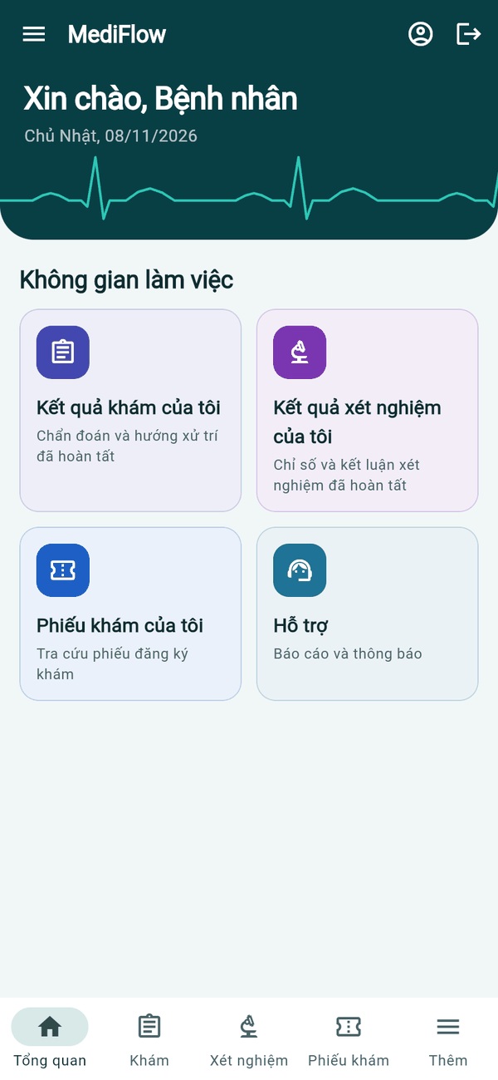  Patient home | 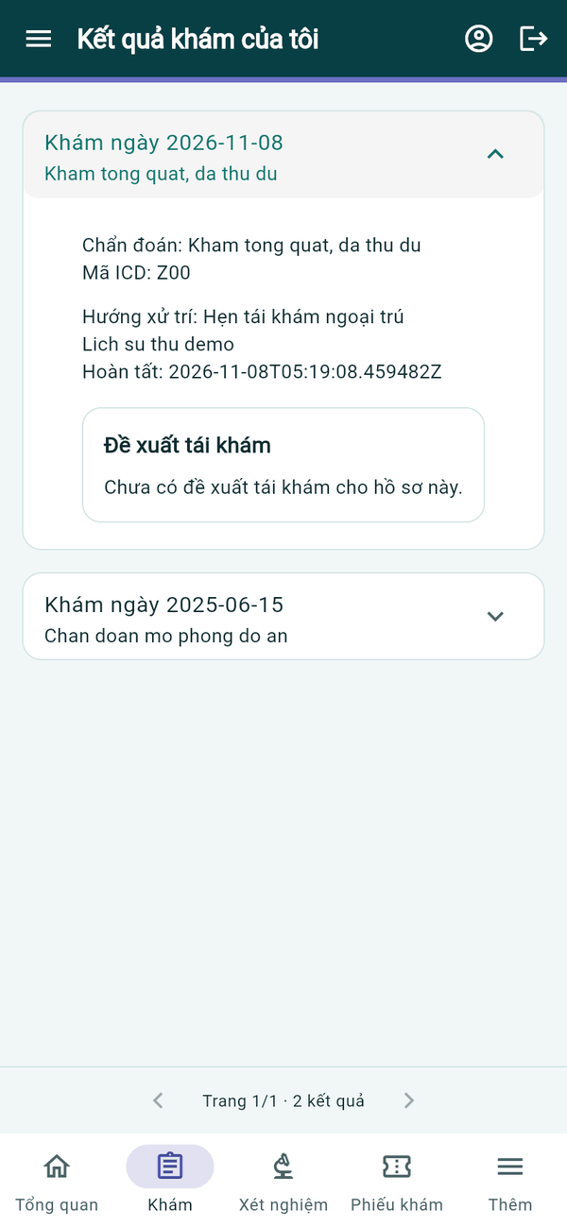  My examination | 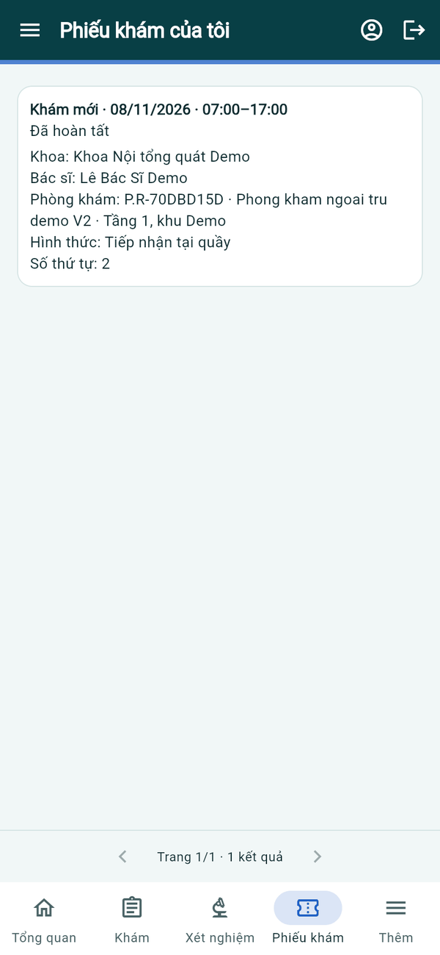  My tickets
Figure 74. Mobile app — patient portal
- Patients have three tabs: Khám (my examination results), Xét nghiệm (my lab results) and Phiếu khám (my visit tickets). Tap a visit or test to expand diagnosis, indicators and conclusion.

Reports and Notifications (Administrator)

Web application
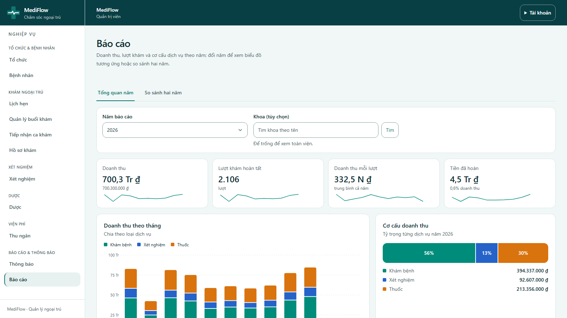
Figure 75. Annual report overview
- Báo cáo shows revenue, completed visits, revenue per visit and refunded amount for the selected Năm báo cáo (year), for the whole hospital or one department.
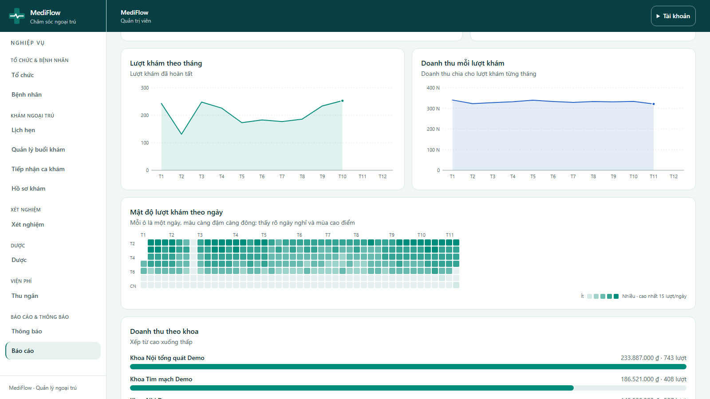
Figure 76. Report charts
- Charts show monthly revenue by service (examination, laboratory, drugs), revenue structure, visits per month, revenue per visit, a daily heat map and revenue by department, followed by a monthly detail table.
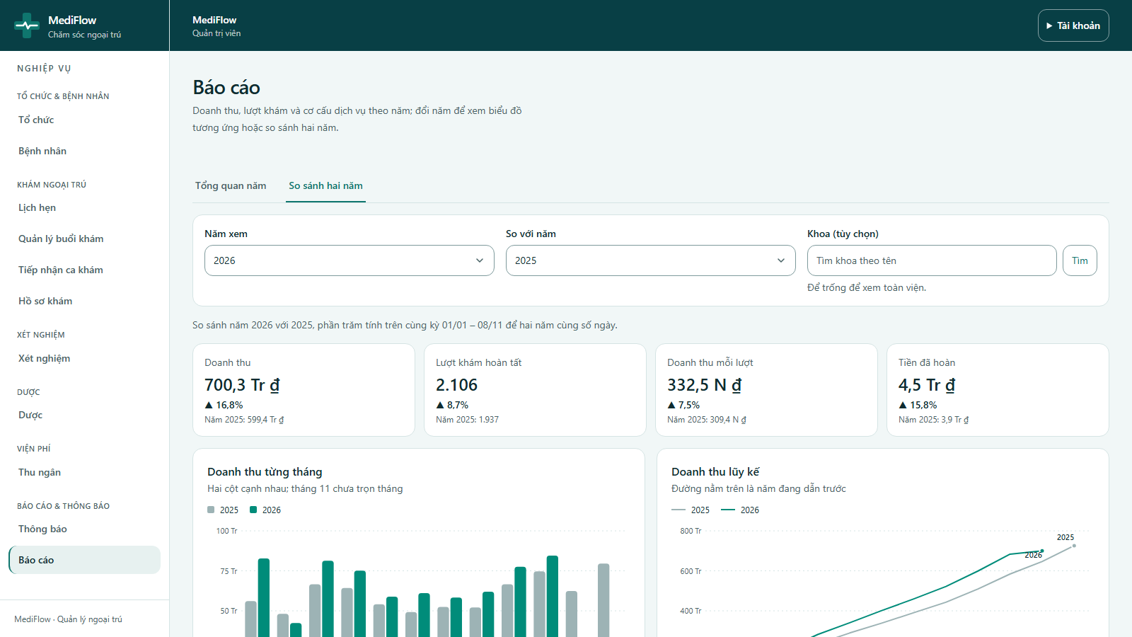
Figure 77. Comparing two years
- So sánh hai năm compares two years side by side. The demo database contains synthetic data only.
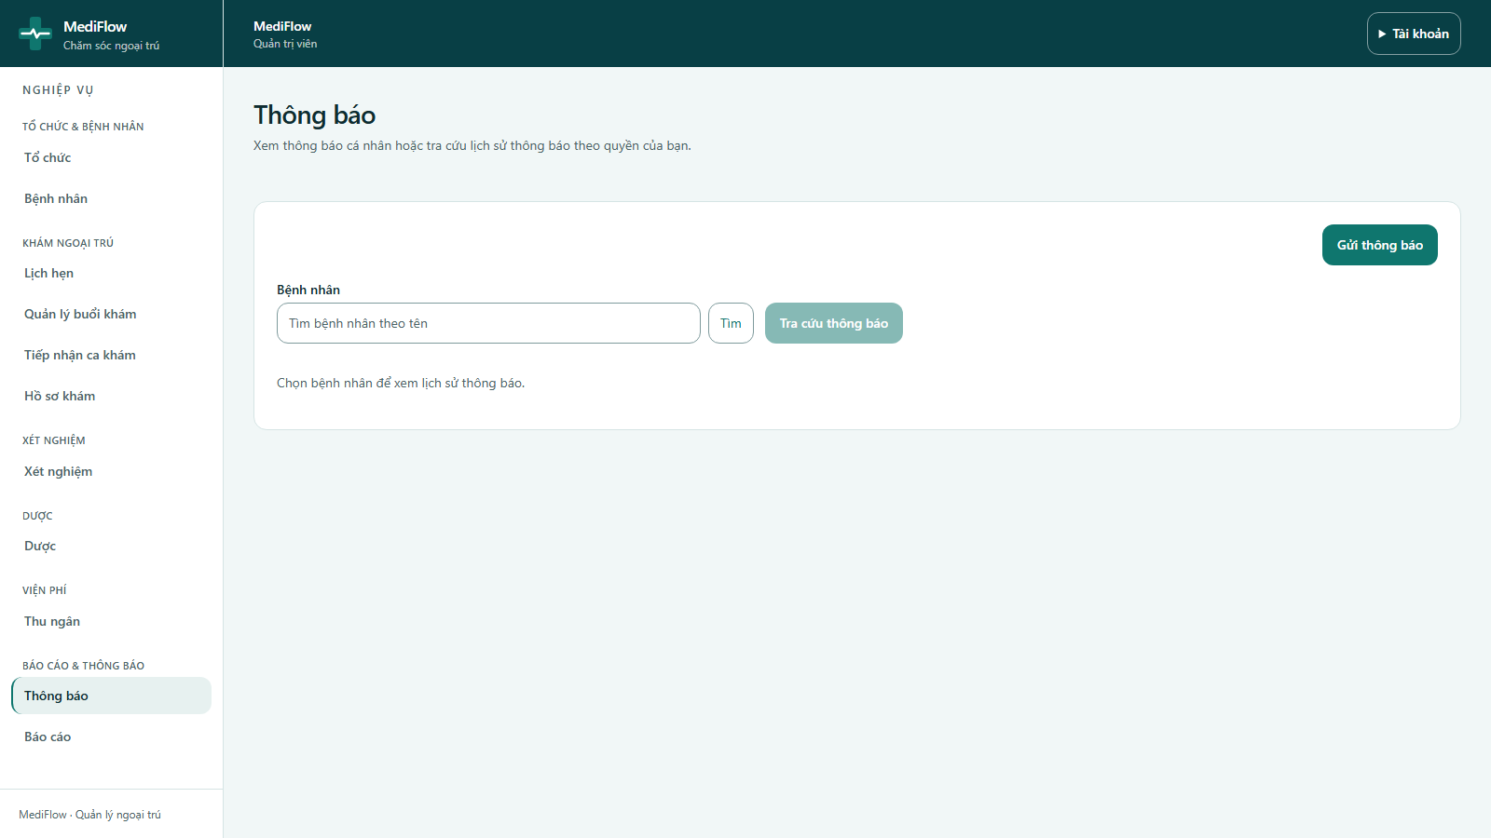
Figure 78. Notification history
- Thông báo lets authorised staff choose a patient and review their notification history.
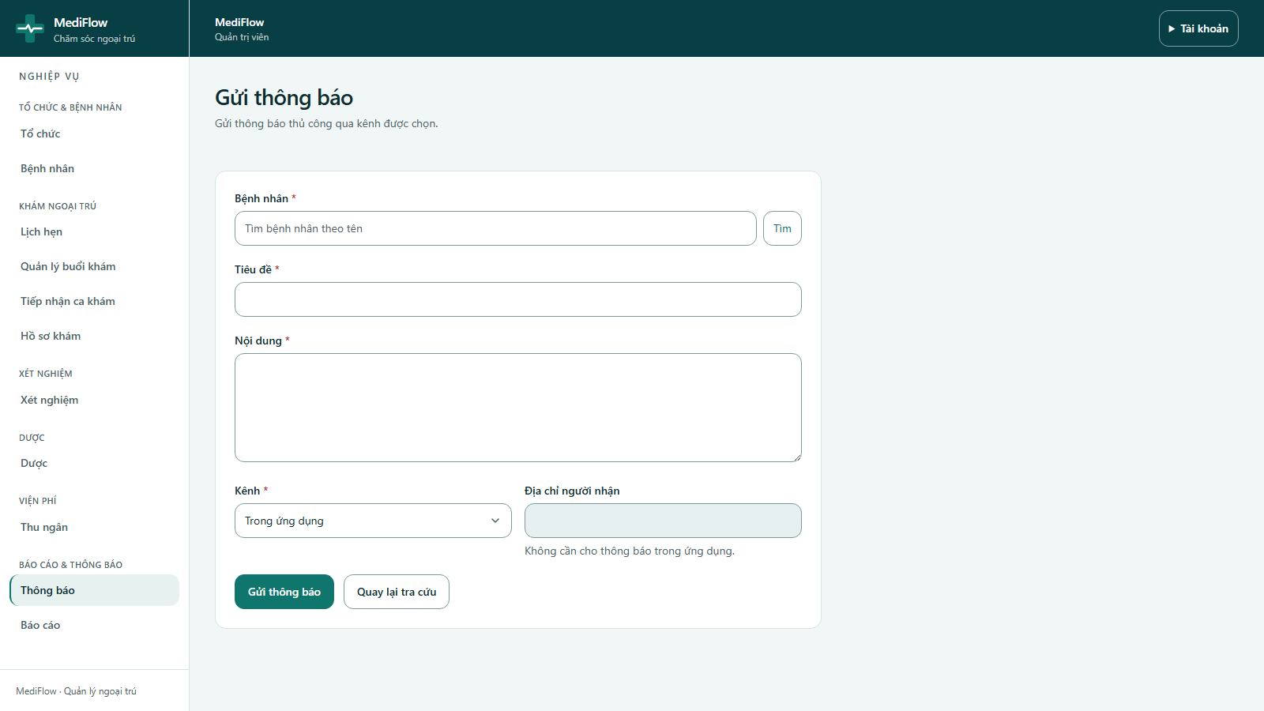
Figure 79. Sending a notification
- Gửi thông báo sends a manual message to a patient: title, content and channel (Trong ứng dụng, Email or SMS). The recipient address is only needed for email/SMS.

Mobile app (Flutter)
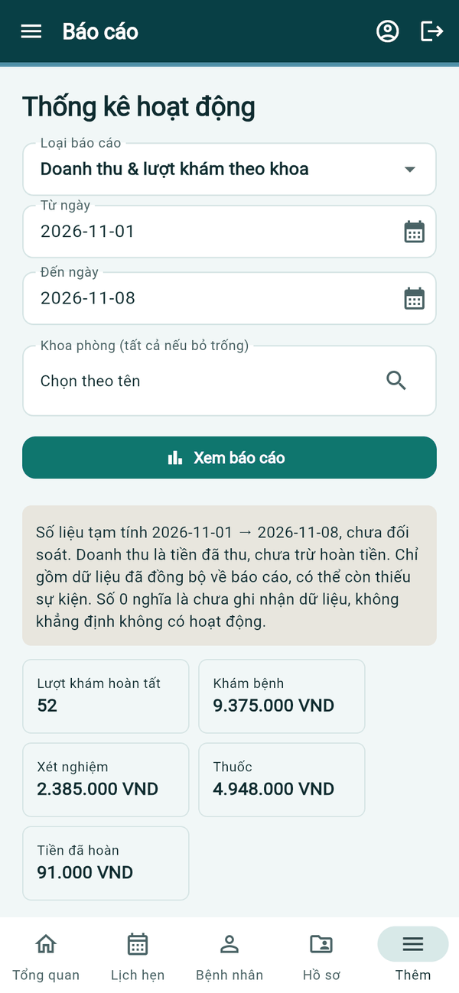  Activity report | 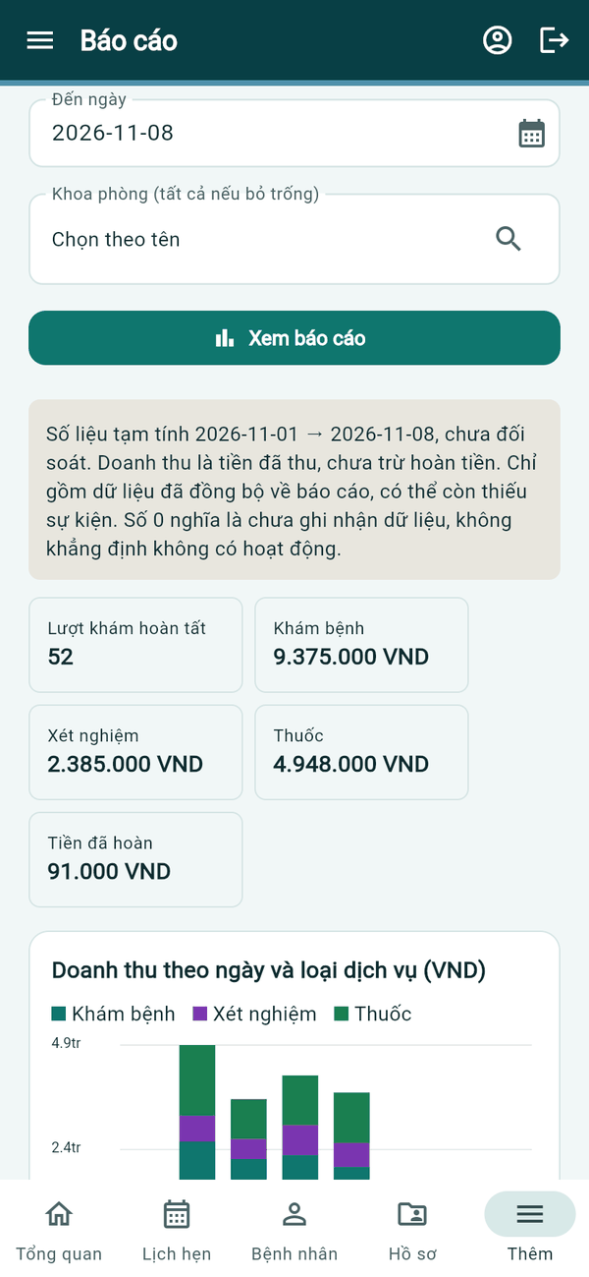  Report chart | 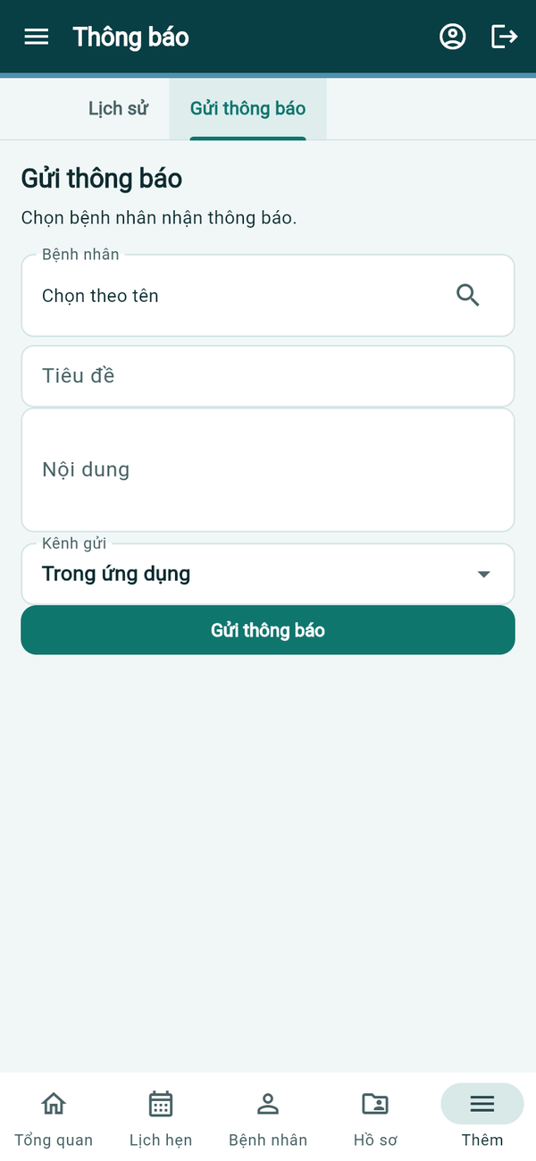  Send notification
Figure 80. Mobile app — reports and notifications
- Hỗ trợ → Báo cáo (Thống kê hoạt động) selects a report type, date range and department, then Xem báo cáo shows totals and a daily revenue chart.
- Thông báo has Lịch sử and Gửi thông báo tabs, the same as on the web.

