

MediFlow
A Microservices – Based Distributed Hospital Management System

Supervisor: | HOÀNG ĐỨC QUANG
Semester: | 04
Batch No: | T2.2410.E0
Group No: | 04
Order: | Full name | Roll No.
1. | Phạm Đăng Vinh | Student1614910
2. | Lê Quang Huy | Student1394600
3. | Trần Hoàng Anh | Student1614884
4. | Thân Thế Lộc | Student1571994

Month: 10 Year: 2026


This is to certify that
Mr. | PHAM DANG VINH
Mr. | LE QUANG HUY
Mr. | TRAN HOANG ANH
Mr. | THAN THE LOC

Have successfully Designed & Developed
MEDIFLOW
A MICROSERVICES – BASED DISTRIBUTED HOSPITAL MANAGEMENT SYSTEM

Submitted by:
Mr. HOANG DUC QUANG

Date Of Issue:

Authorized Signature:

Content

Content 3
Acknowledge 4
Synopsis 6
Review 01 7
Problem Definition 8
Customer Requirements Specifications 11
Review 02 24
Architecture Design 25
Data Flow Diagram 51
Entity Relationship Diagram 53
Table Design 59
SiteMap 93
Algorithm 95
Review 03 100
Screen shots 101
Testing document 183
Final checklist 194
Tasksheet 200
Acknowledgments and Declaration 206

Acknowledge

As we approach the completion of our MediFlow – Microservices-Based Distributed Hospital Management System project, we are filled with gratitude, pride, and a sense of accomplishment. This project has been a valuable opportunity to apply our academic knowledge, strengthen our technical skills, and gain practical experience in developing complex software systems.
Heartfelt Gratitude to Our Mentors
First and foremost, we would like to express our sincere gratitude to the Project Team at FPT Aptech for providing us with the knowledge, resources, and opportunity to undertake this meaningful project.
We are especially thankful to our lecturer, Mr. HOANG DUC QUANG, for his dedicated guidance, patience, and valuable feedback throughout the development process. His mentorship has helped us overcome technical challenges, improve our problem-solving abilities, and develop a more professional approach to software engineering.
Appreciation for Our Team and Families
We extend our heartfelt appreciation to every member of Team 04 for their dedication, teamwork, and perseverance. Through close collaboration, we have explored and developed a distributed healthcare platform encompassing ten business domains: Organization, Patient, Clinical, Laboratory, Pharmacy, Billing, Notification, Reporting, Inpatient, and Surgery.
We are equally grateful to our families, friends, and classmates for their continuous encouragement and understanding throughout this journey.
A Meaningful Learning Experience
The MediFlow Project has provided us with valuable experience in microservices architecture, distributed systems, database design, event-driven communication, and cross-platform application development. By working with technologies such as Spring Boot, Spring Cloud, RabbitMQ, PostgreSQL, Next.js, and Flutter, we have gained a deeper understanding of modern software engineering practices and the challenges of integrating independent healthcare services.
Beyond technical knowledge, this project has strengthened our communication, adaptability, responsibility, and collaborative problem-solving skills.
Looking Forward
As we conclude this important milestone, we believe the knowledge and experience gained from MediFlow will serve as a strong foundation for our future careers in information technology.
Once again, we sincerely thank everyone who has supported and contributed to our journey.
With heartfelt gratitude,
TEAM 04
MediFlow – Microservices-Based Distributed Hospital Management System

Synopsis
MediFlow – Microservices-Based Distributed Hospital Management System is a healthcare management project designed to address the fragmentation of patient information, hospital operations, and medical workflows across different departments. The system aims to improve coordination, streamline administrative processes, and support efficient healthcare service delivery through a distributed software architecture.
Built on a microservices-based and event-driven architecture, MediFlow encompasses ten business domains: Organization, Patient, Clinical, Laboratory, Pharmacy, Billing, Notification, Reporting, Inpatient, and Surgery. These services are designed to manage distinct healthcare responsibilities while enabling coordinated workflows, including patient registration, appointment scheduling, clinical examinations, laboratory testing, prescription management, payment processing, medication dispensing, inpatient care, and surgical procedures.
The project utilizes Java Spring Boot, Spring Cloud Gateway, Netflix Eureka, RabbitMQ, and PostgreSQL for backend development, service discovery, asynchronous communication, and data management. Next.js and Flutter are used to develop web and mobile applications, providing role-based interfaces for healthcare professionals and administrative personnel.
MediFlow follows essential software engineering principles, including Domain-Driven Design, Clean Architecture, database-per-service ownership, RESTful API communication, and event-driven integration. These approaches promote modularity, maintainability, scalability, and separation of responsibilities across independent services.
As an academic project under active development, MediFlow demonstrates the practical application of distributed systems and modern software engineering technologies in the healthcare domain. Beyond its functional scope, the project provides valuable experience in system architecture, collaborative development, integration testing, and solving complex real-world business problems.
Keywords: Hospital Management System, Healthcare Information System, Microservices, Distributed Systems, Event-Driven Architecture, Spring Boot, RabbitMQ, Next.js, Flutter.

Review 01

Problem Definition

Introduction and Context
MediFlow coordinates departments throughout an outpatient journey: reception, examination, laboratory tests, prescribing, payment, and dispensing. Records share a patient identity while each department remains responsible for its own data and business decisions. Users access the web application through the API Gateway.
The project focuses on an outpatient workflow that can be verified end to end, including message redelivery and temporary service outages

Problem Identification

Disconnected patient information, appointments, and clinical records cause repeated entry and make progress difficult to track.

Doctors, the laboratory, and the pharmacy lack consistent handoff status, increasing the risk of missed orders or results.

Payment status is not clearly tied to each visit, test, or prescription, making service authorization difficult to control.

Poor coordination of stock, reservations, and dispensing can cause duplicate dispensing or insufficient stock.

Successful payment followed by dispensing failure requires traceable compensation rather than a lost transaction.

Reports and notifications lag behind operations; users struggle to distinguish missing data from a measured zero.

Medical and financial information requires access restrictions based on role, work scope, and record ownership.

Project Objectives

Link identity, appointments, visits, tests, prescriptions, and payments through explicit references.

Enforce the relevant business and financial conditions before examination, test processing, and dispensing.

Prevent duplicate financial or stock effects when requests or events are processed again.

Update reports and notifications from events while preserving fault tracing and recovery.

Define acceptance criteria for successful workflows, access denial, redelivery, and partial failure.

Project Scope
Service | Responsibility
Core | Accounts, staff, departments, reference room data, and patient identity
Clinical | Appointments, check-in, records, diagnosis, orders, and outpatient completion
Lab | Accept test requests, track processing, and return results
Pharmacy | Drug catalogue, stock, prescriptions, reservations, and dispensing
Billing | Charges, invoices/payment requests, payments, service clearance, and compensation/refunds
Support | Reporting read models and in-app notifications
Gateway and Eureka are infrastructure; common is a shared library. Core and Support co-host modules while retaining each context's data and business boundaries. The design retains eight active context stores; six services do not imply six databases.

Users and Stakeholders
The eight human roles are ADMIN, DOCTOR, NURSE, PHARMACIST, CASHIER, LAB_TECH, MANAGER, and PATIENT. SYSTEM is a service identity for automated processing, not a human login account. Functions for each role are listed in B1.
Stakeholders include patients, reception staff, doctors, the laboratory, the pharmacy, cashiers, management, and the development team. Departments agree on requirements and verify outcomes within their authorized responsibilities.

Proposed Solutions
The Next.js/TypeScript/Tailwind web application accesses the backend through Gateway. The backend uses Java 21, Spring Boot, Maven, PostgreSQL, RabbitMQ, and Eureka. Each context owns its data; contexts do not query each other's databases. REST supplies information needed immediately; events support handoffs and asynchronous updates. Outbox delivery, duplicate protection, bounded retries, and dead-letter queues support recovery.
The main workflow is identity → check-in → examination payment → examination → tests if needed → prescription if needed → medication payment → dispensing → outpatient completion → report/notification updates. When tests are ordered, their fees and authorization are checked before protected laboratory actions.

Customer Requirements Specifications

Functional Requirements
The following functions are fucntional requirements. Each action must respect endpoint permissions, clinical authority, and record access boundaries. A role does not grant access to every record. This list neither adds APIs nor expands default permissions.

ADMIN — Administrator

Manage accounts, roles, active status, and account locking.

Manage departments, staff, and reference data required for outpatient care.

Link accounts to staff or patients using an authoritative identity source.

Inspect system status, history, and processing failures within permitted administration scope.

Perform authorized recovery operations with an audit trail, without bypassing financial or clinical conditions.

DOCTOR — Doctor

View appointments and patient records within the assigned scope.

Start an examination only with valid EXAM clearance for the exact visit; emergency exceptions use only the supported, audited mechanism.

Record examination findings, diagnosis, and outpatient disposition.

Create explicit laboratory orders and view results returned for the corresponding record.

Author prescription content; Pharmacy validates and owns prescriptions, prices, stock, and reservations.

Follow test results and dispensing status, and complete the outpatient record when its conditions are met.

NURSE — Nurse / Reception Support

Search, create, and update patient information within granted permissions.

Assist with appointment registration and departmental schedule tracking.

Perform check-in, update permitted reception status, and hand patients over to doctors.

View visit information and processing progress needed for care coordination.

Check-in does not itself authorize examination or replace financial verification.

LAB_TECH — Laboratory Technician

View valid existing test requests and permitted related information.

Start test processing only with unexpired LAB_TEST clearance matching the exact test.

Update processing status and cancel when the workflow permits.

Record a non-empty result with a valid performed date and complete the test.

Publish results to relevant departments through the Lab workflow.

PHARMACIST — Pharmacist

Manage and search the drug catalogue, stock, available quantities, and expiry information.

Receive doctor-authored prescription content and verify patient identity and outpatient clinical context.

Create/process permitted prescriptions using server catalogue prices and line-level reservations.

Check PRESCRIPTION clearance for the exact prescription, reservation validity, and stock before dispensing.

Confirm dispensing; apply the stock effect once only when all lines satisfy the conditions.

Cancel or expire prescriptions through the supported workflow, release reservations, and report failures to Billing when financial adjustment is required.

A payment receipt does not automatically replace dispensing authorization in the target workflow.

CASHIER — Cashier

Find charges belonging to the exact visit/patient within permitted service scope.

Create invoices or payment requests from valid charges in the same visit account.

Record payments and inspect transaction status and corresponding documents.

Track financial clearance for the exact examination, test, or prescription; do not manually grant access using a patient-wide paid flag.

Process compensation/refunds through Billing's workflow and authorization when cancellation or dispensing failure requires it.

Inspect transaction history for reconciliation; do not rewrite or delete history to force a balance match.

MANAGER — Manager

View reports on visits, tests, prescriptions, and dispensed quantities.

View cash received, refunds, and net cash from available authoritative sources.

Filter reports using criteria supported by the reporting contract.

Distinguish missing source coverage from zero, and cash received from earned revenue.

Track report freshness without modifying source business data from reporting screens.

PATIENT — Patient

Sign in and access information associated with their own patient identity.

View and update permitted personal information.

Request, view, and track their own appointments through supported workflows.

View their own examination information, test results, and prescriptions approved for patient access.

View their own charges, invoices, payment status, and dispensing status through available contracts.

View in-app notifications addressed to them; do not access another patient's records or notifications.

SYSTEM — Service Identity

Transfer valid outpatient events between contexts while preserving identifiers and traceability.

Automatically create charges/service clearance from valid business sources in the selected profile.

Handle redelivery, retries, and pending-work recovery without duplicate financial or stock effects.

Update reporting read models and create in-app notifications for the correct recipients.

Move messages that remain unprocessable after bounded retries to dead-letter handling for inspection.

Do not substitute service tokens for human accounts on operations requiring an authenticated human actor.

Hardware / Software requirements

Client requirements

Hardware
Client profile | Minimum | Recommended
Staff desktop/laptop | 64-bit dual-core CPU, 4 GB RAM, 1366×768 display, stable network | Modern 4-core CPU, 8 GB RAM, Full HD display, wired or reliable Wi-Fi
Patient browser device | Recent smartphone, tablet, or computer with at least 2 GB available memory | Device receiving current OS/browser security updates, 4 GB or more memory
Development workstation | 64-bit 4-core CPU, 16 GB RAM, 30 GB free storage | 8-core CPU, 32 GB RAM, SSD with 60 GB or more free storage
Shared reception/lab terminal | Keyboard, pointing device, 1366×768 display, reliable network | Full HD display, barcode-capable peripherals where locally required, UPS-backed power

Software
Item | Requirement
Browser | Current Chrome, Edge, Firefox, or Safari with JavaScript, cookies, and HTTPS enabled
Operating system | A vendor-supported Windows, macOS, Linux, Android, or iOS release
Network | Stable access to the deployed HTTPS endpoint through approved firewall/proxy rules
Document tools | Microsoft Word, LibreOffice Writer, or compatible tool for report conversion
Mobile status | Responsive browser access is assumed; a complete native mobile client is not currently delivered

Server requirements

Hardware
Environment | CPU | Memory | Storage | Intended use
Developer demonstration | 8 logical cores | 16 GB RAM | 40 GB free SSD | Local containers, selected services, frontend, and tests
Team integration | 16 logical cores | 32 GB RAM | 150 GB SSD | Concurrent services, shared testing, sample data, and monitoring
Initial production baseline | 24+ logical cores distributed across hosts | 64+ GB RAM distributed | 500+ GB resilient SSD plus backups | Starting point only; must be validated by performance and recovery tests

Software
Item | Source-aligned baseline
Java | 21
Spring Boot | 3.3.5
Spring Cloud | 2023.0.3
Backend build | Maven multi-module
Frontend | Next.js 16.2.11, React 19.2.4, TypeScript 5, Tailwind CSS 4, pnpm
Database | PostgreSQL 16-compatible, isolated logical database per service
Messaging | RabbitMQ 3-compatible with operational management support
Discovery | Eureka Server
Containers | Docker Engine and Docker Compose compatible with repository definitions
Production platform services | HTTPS certificate management, secret management, centralized logs/metrics/alerts, backups, time synchronization

Task Sheet Review 1
Project Ref. No |  | Project Title | Activity Plan Prepared By | Date of Preparation of Activity Plan
No. | Task | Project Title | Activity Plan Prepared By | Actual Start Date | Actuals Days | Teammate  Names | Status
1 | Problem Definition | Mediflow | Hoang Anh | 15/10/2026 | 2 | All members | Completed
2 | Requirement Specification | Mediflow | Hoang Anh | 15/10/2026 | 2 | All members | Completed
3 | Task sheet review | Mediflow | Hoang Anh | 15/10/2026 | 2 | All members | Completed

Review 02

Architecture Design

Architecture Design
Web calls same-origin /api/*, proxied to Gateway; Flutter calls Gateway through GATEWAY_URL. Gateway verifies JWT/route policy; downstream services enforce roles, ownership and business authority again. PostgreSQL 16 is one development container hosting separate context databases. RabbitMQ supplies per-consumer queues; cross-context SQL is prohibited.
Client side and Server side are explicit boundaries. Labelled request and response arrows show synchronous HTTP traffic; double-headed edges summarize a request and its return path. Dashed event edges are asynchronous messages, not HTTP responses. The Next.js server proxy runs on Server side even though its UI executes on the client. Deployment ports are intentionally omitted.
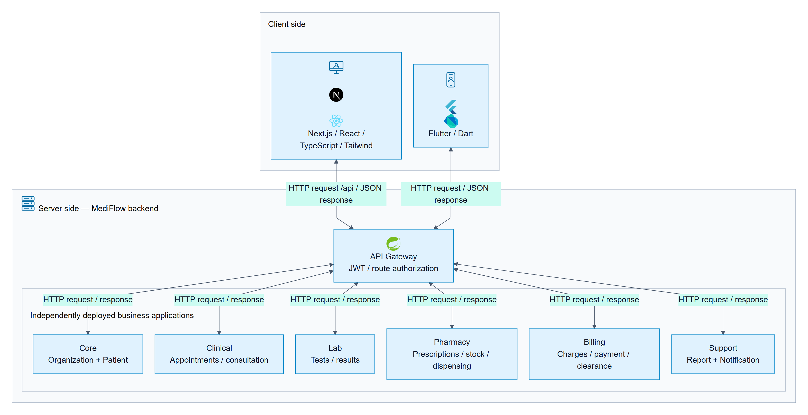
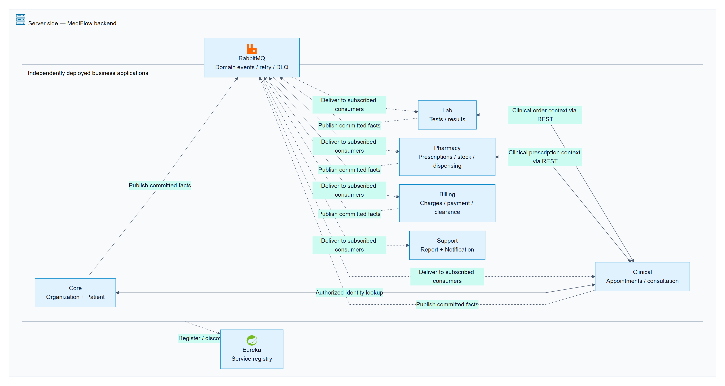
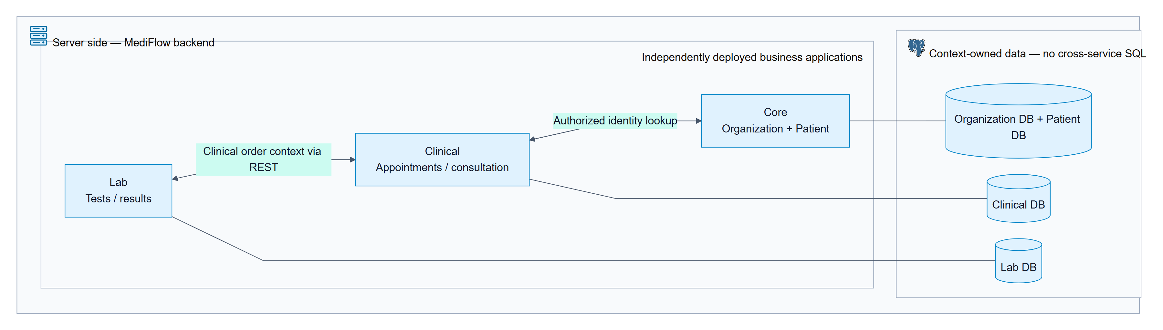
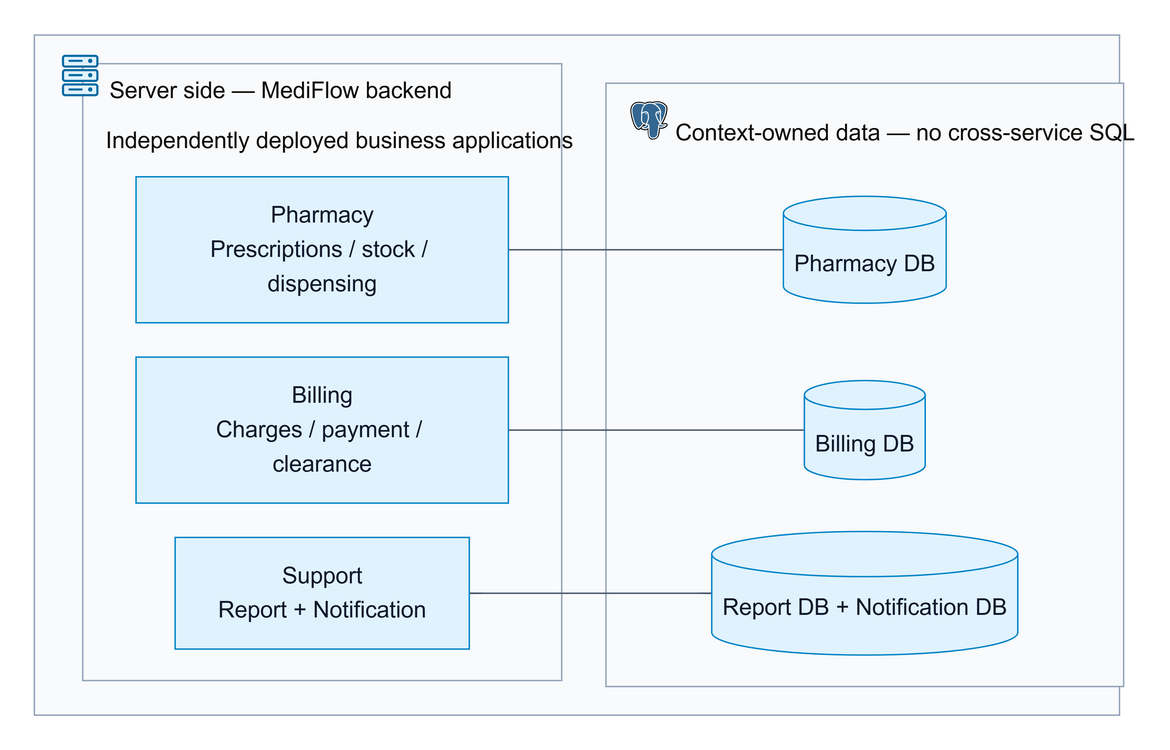

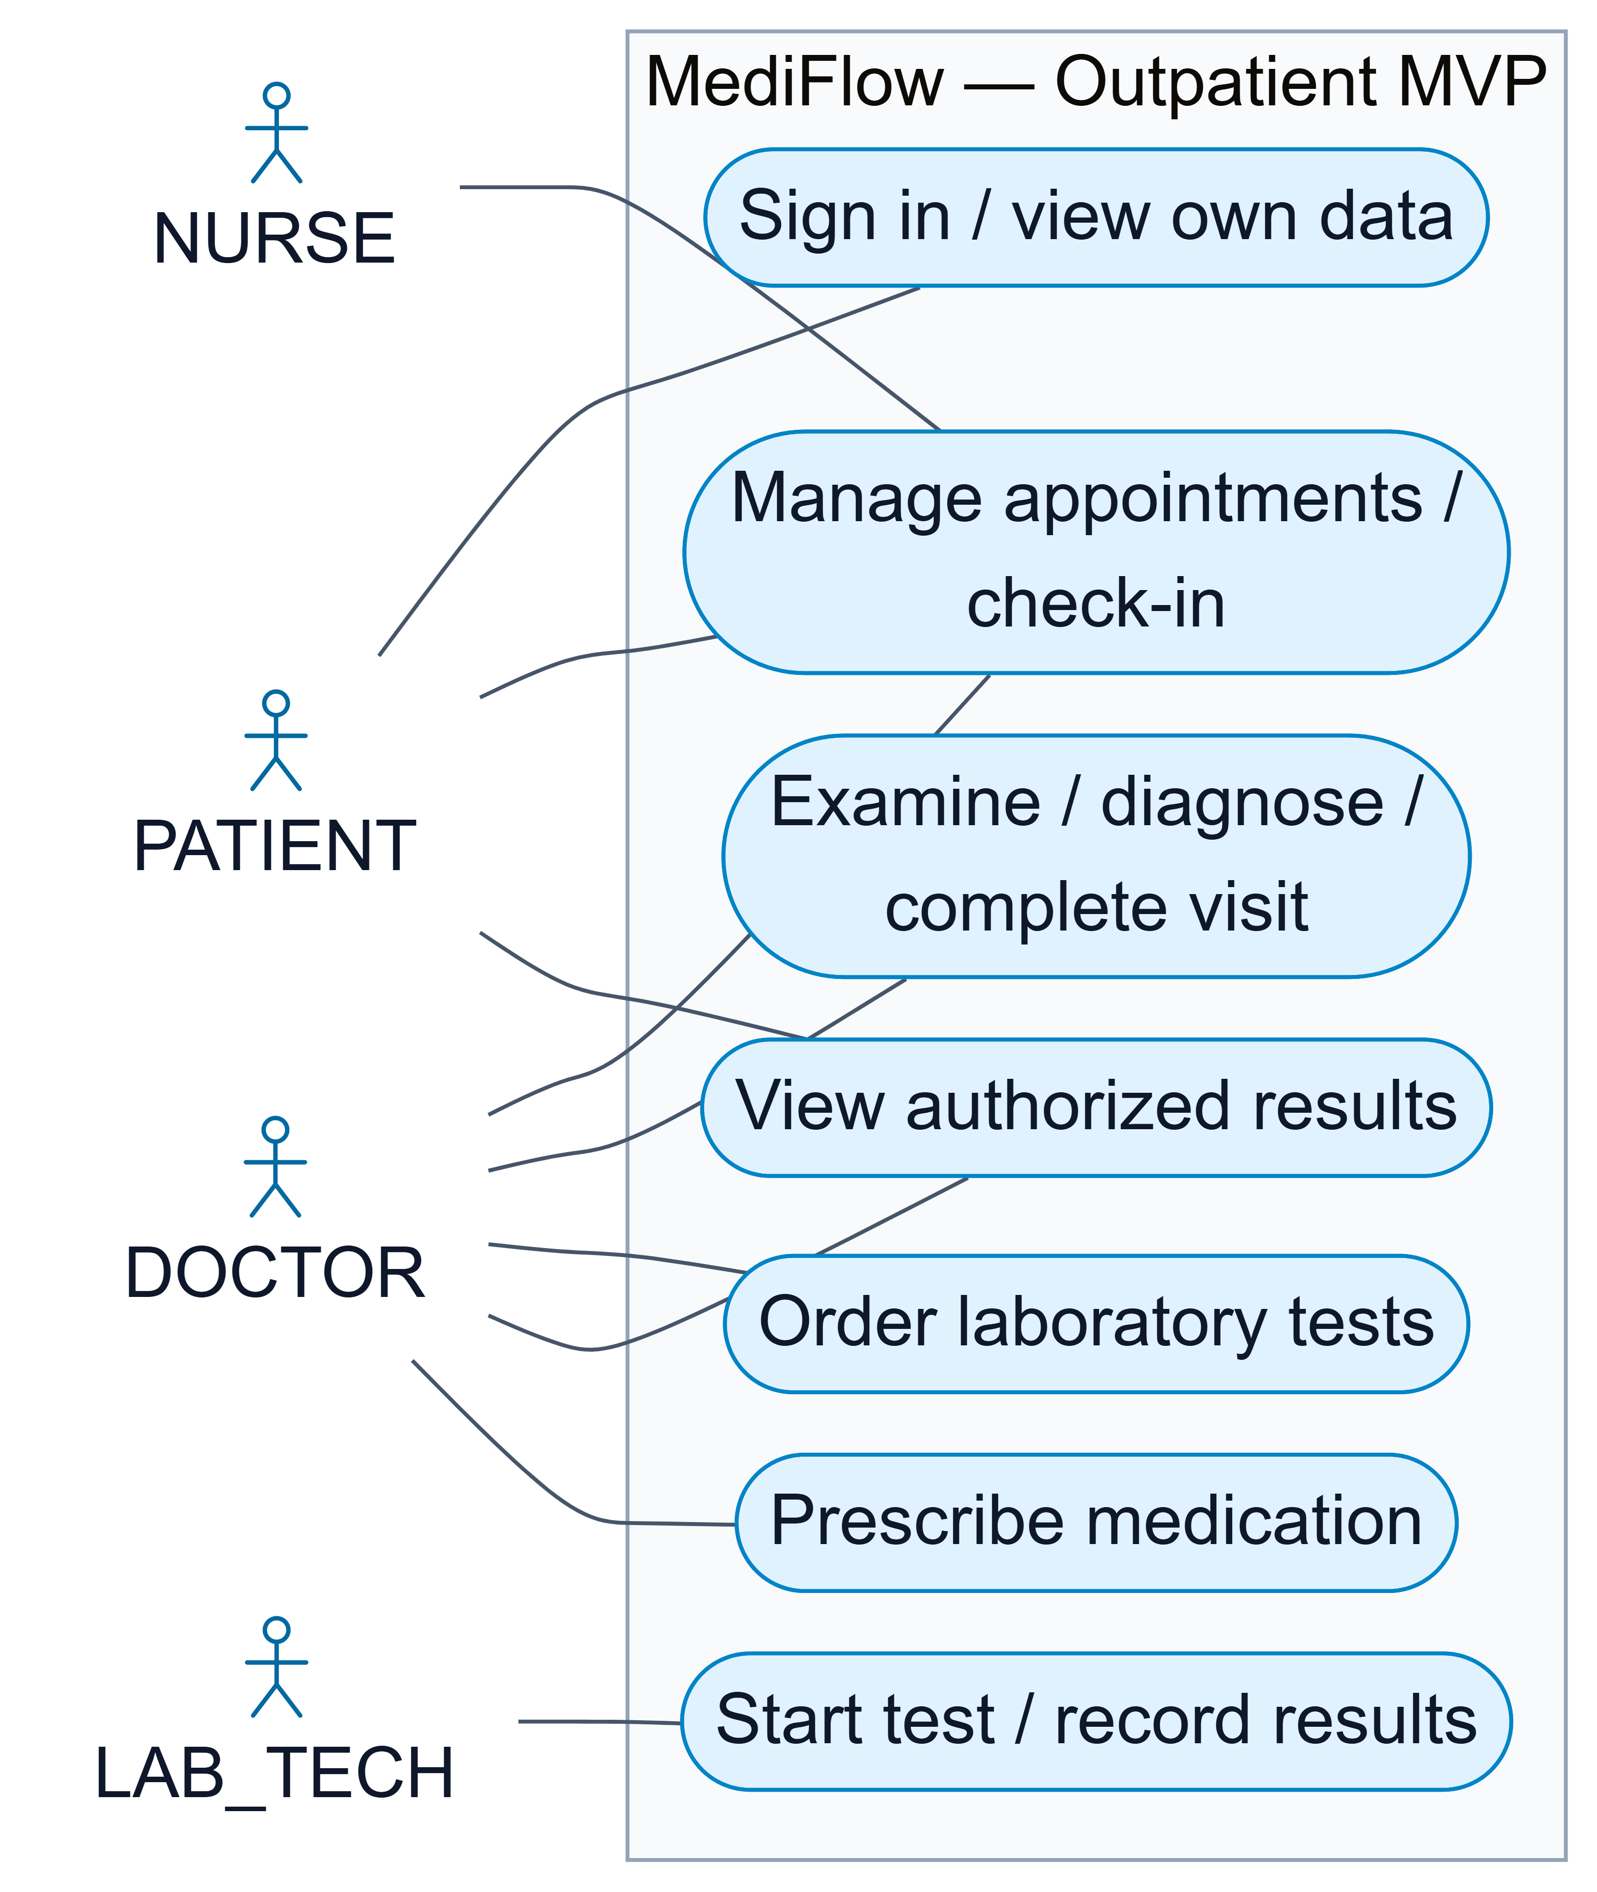

NURSE – Nurse tasks
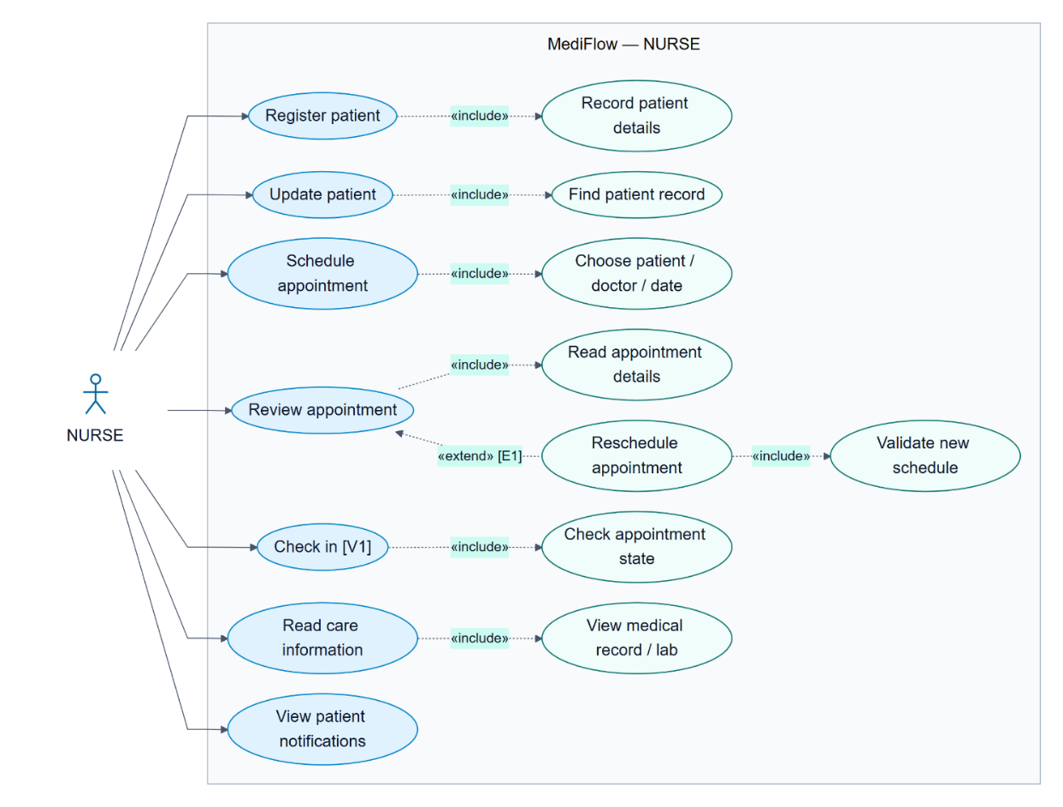

PATIENT
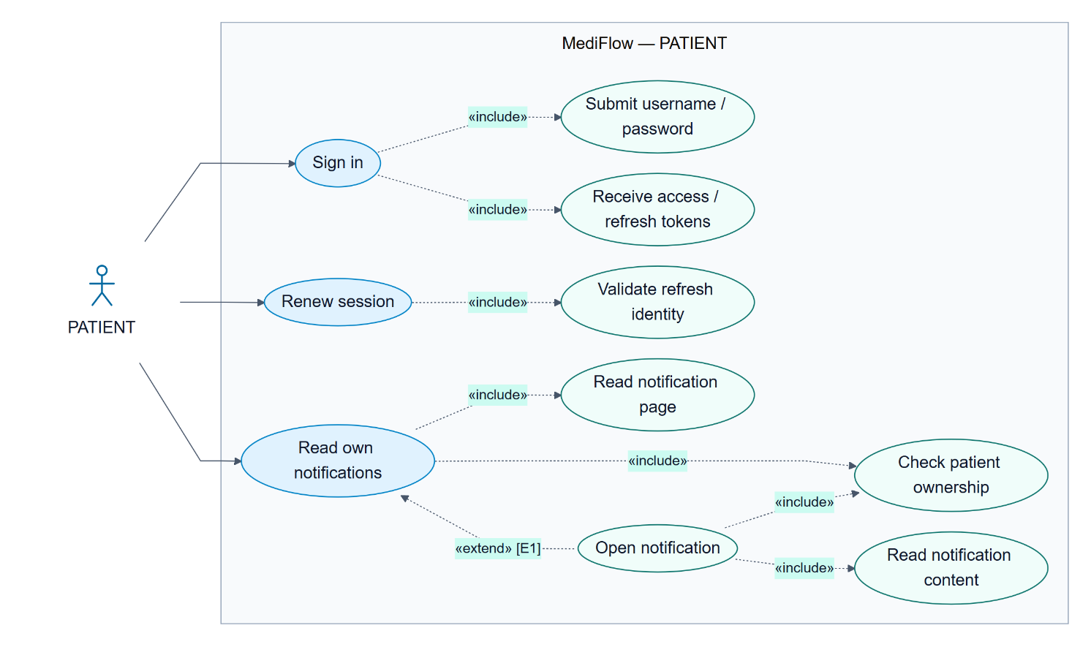

DOCTOR – Doctor tasks
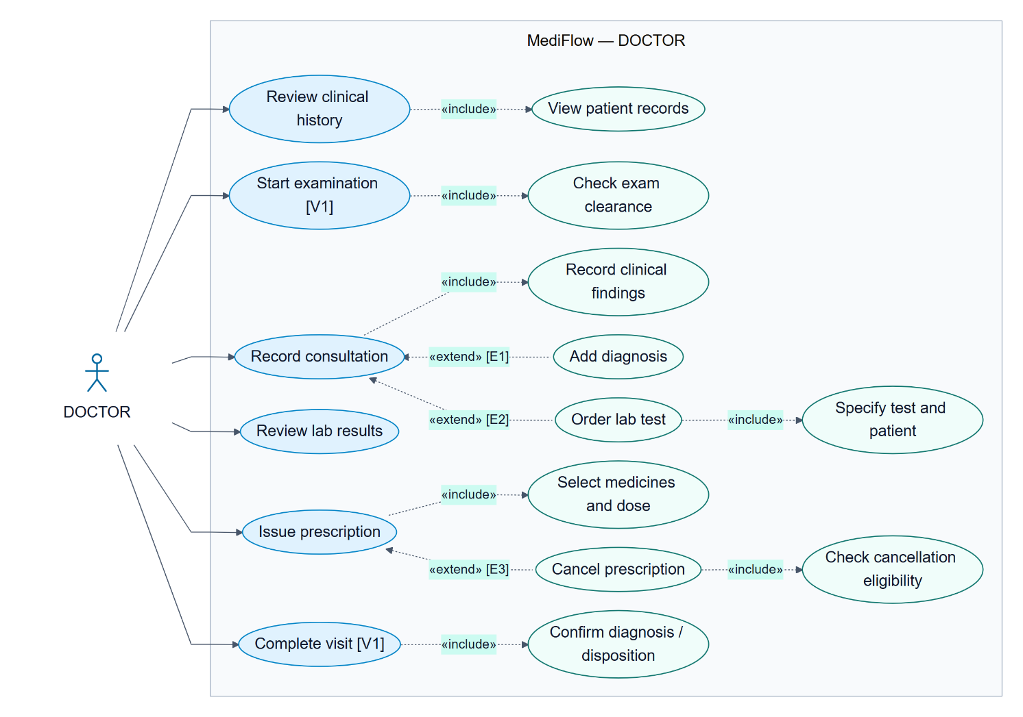

LAB_TECH – Laboratory technician tasks
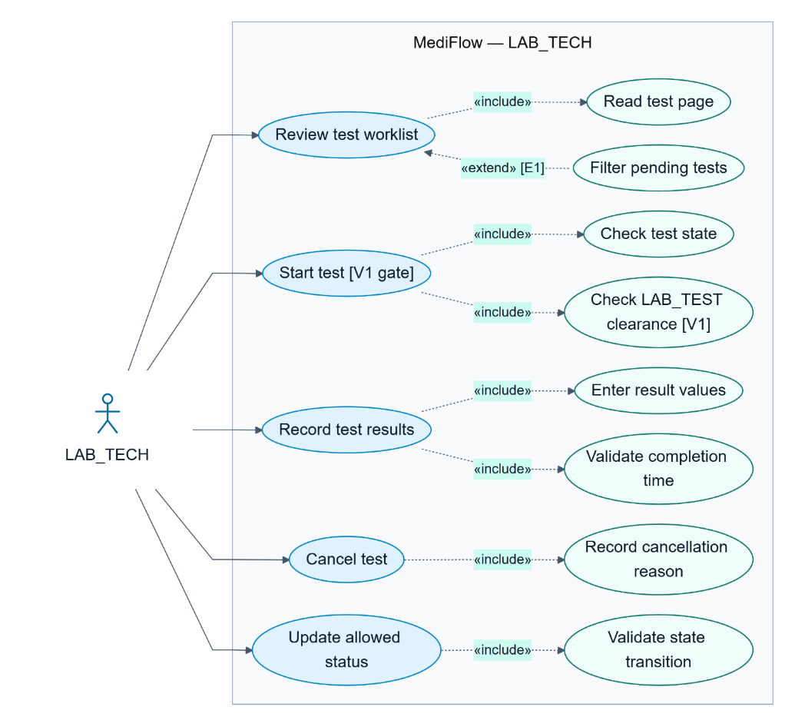

PHARMACIST
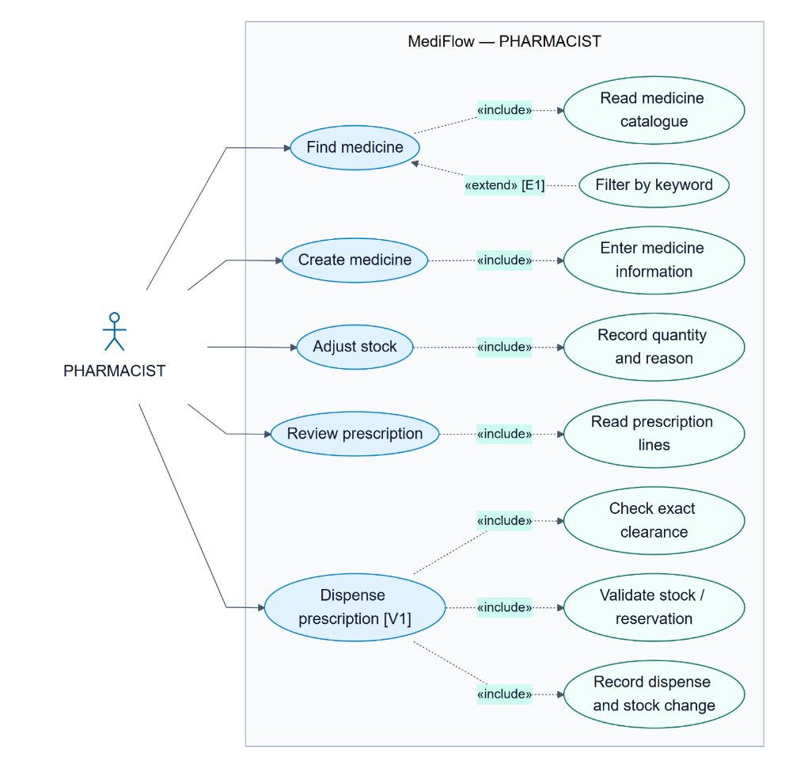

CASHIER
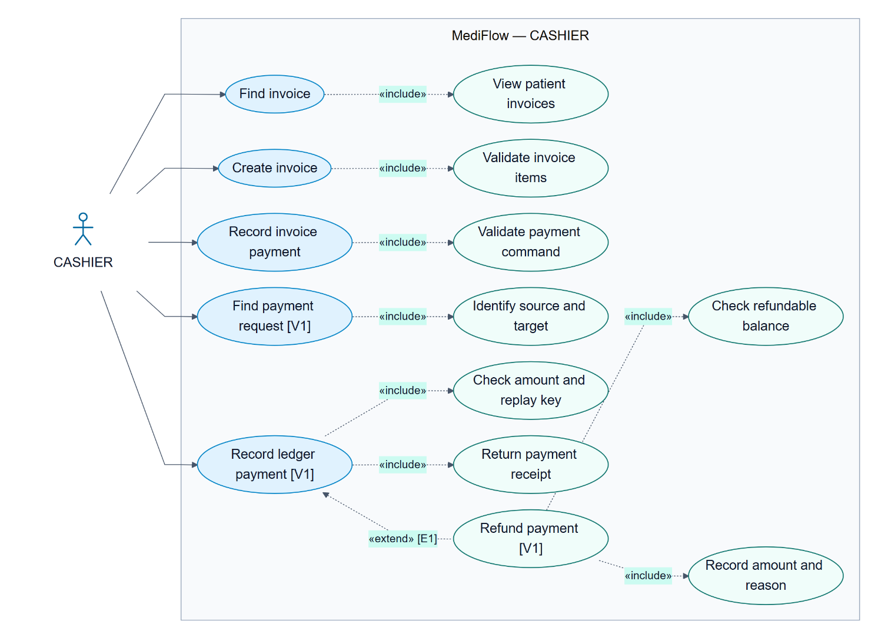

MANAGER – Manager tasks
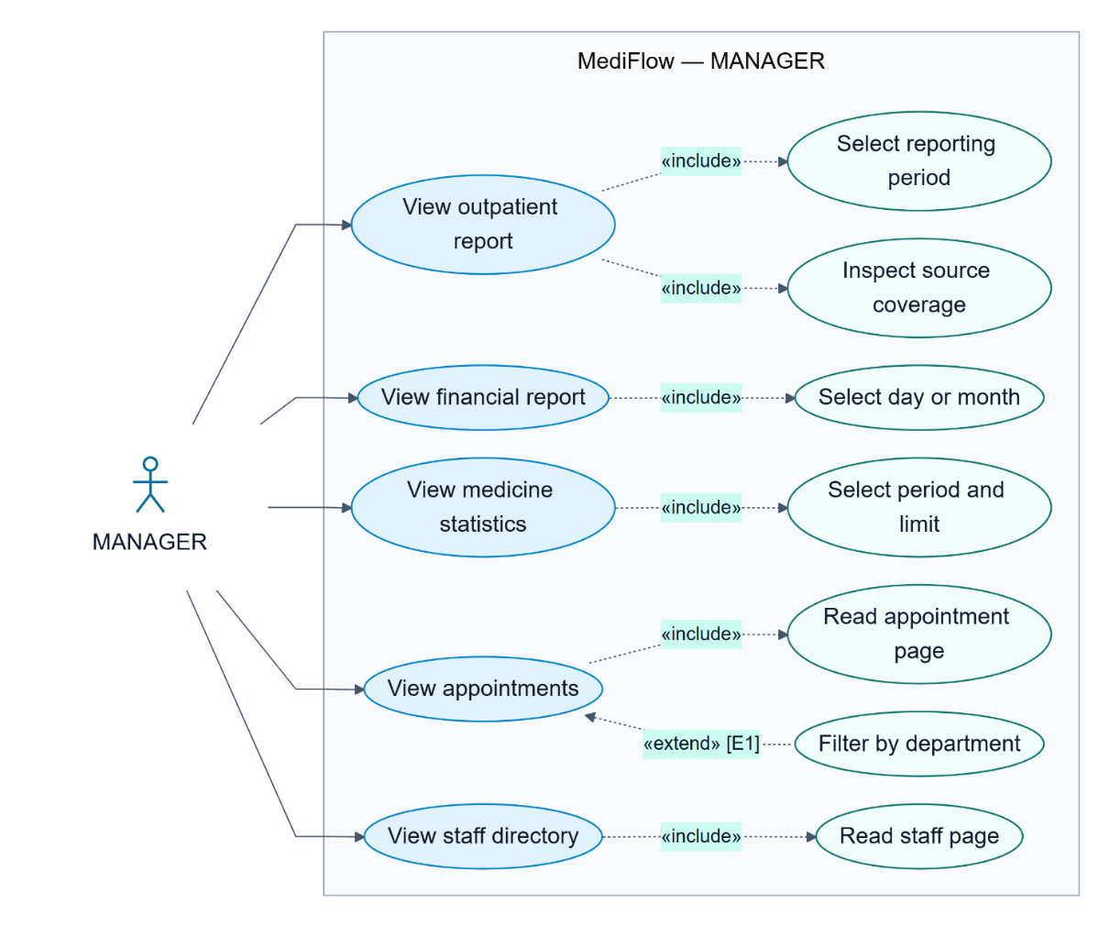

ADMIN – Administrator tasks
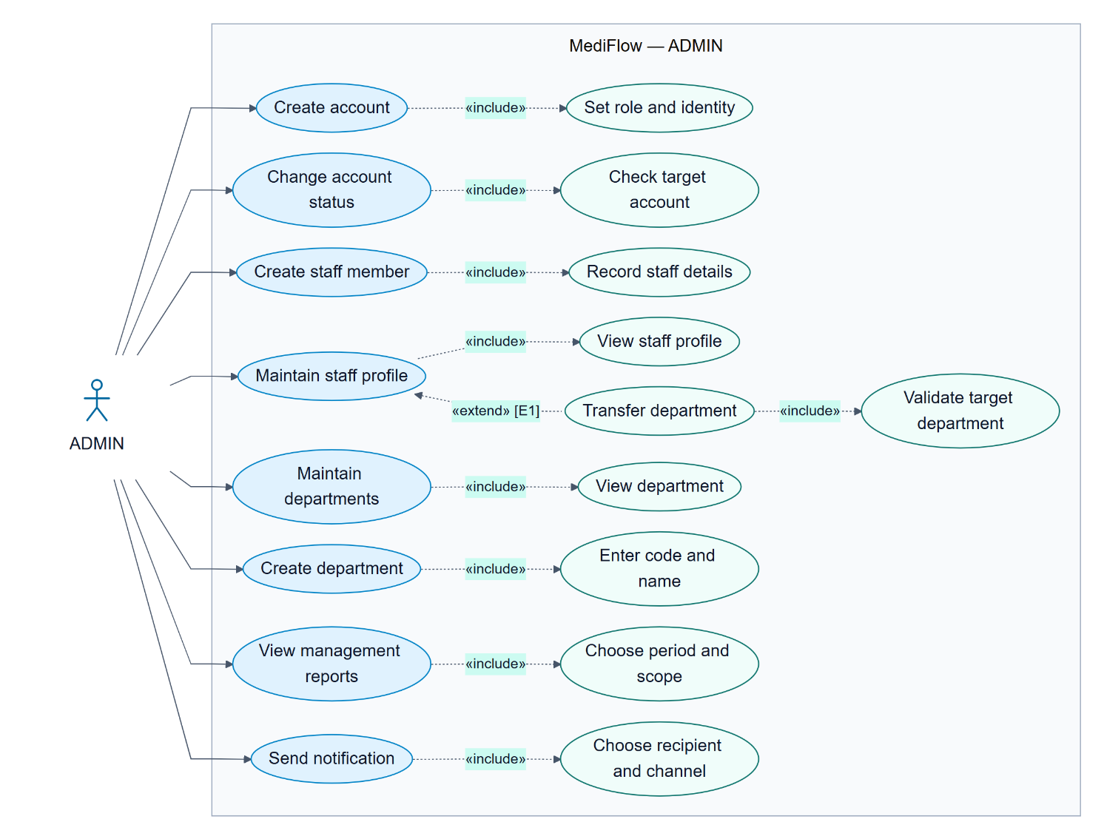

Sequences Diagrams

Sign in — validation, rejected credentials and recovery
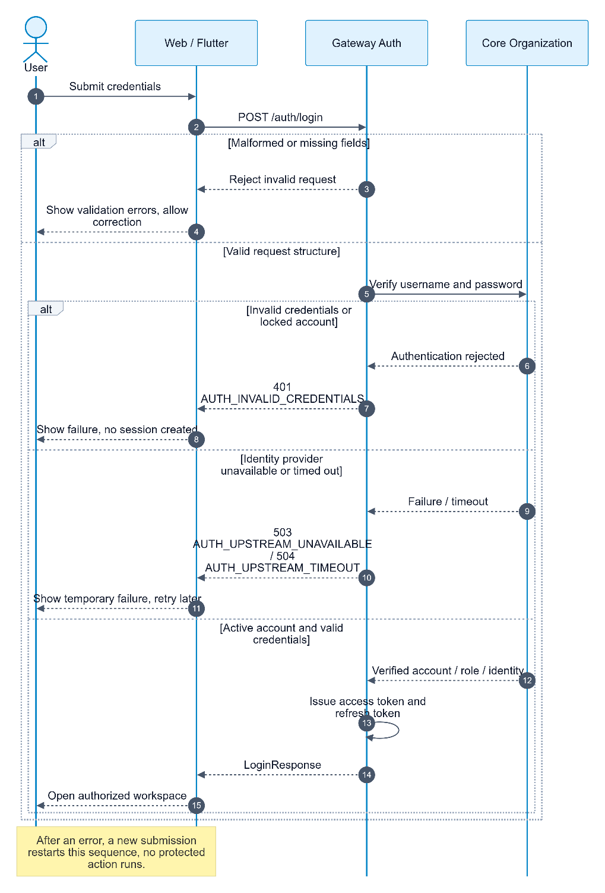

Renew session — a separate authentication use case
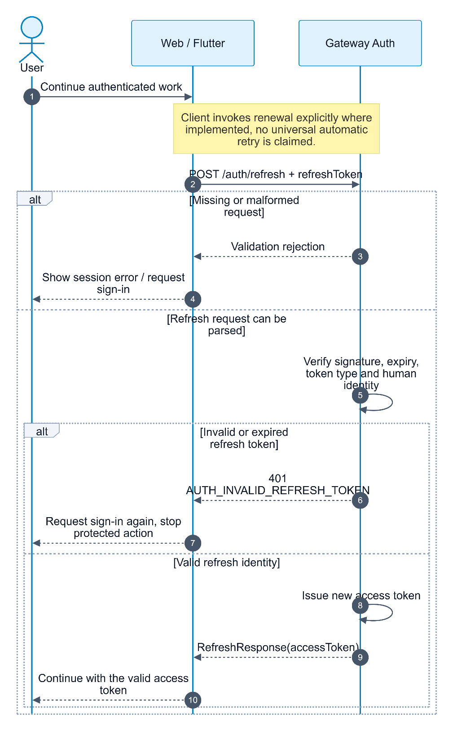

Schedule appointment before arrival
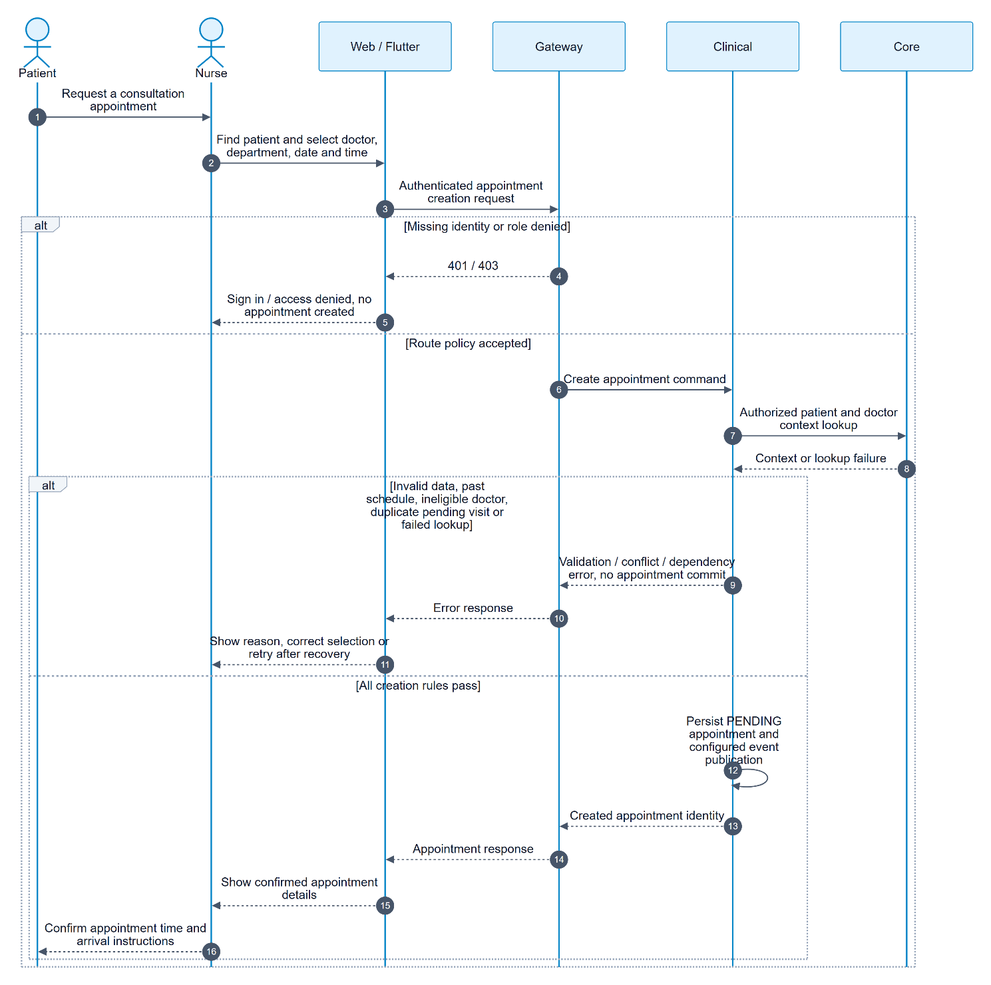

Arrival → exam payment → start consultation
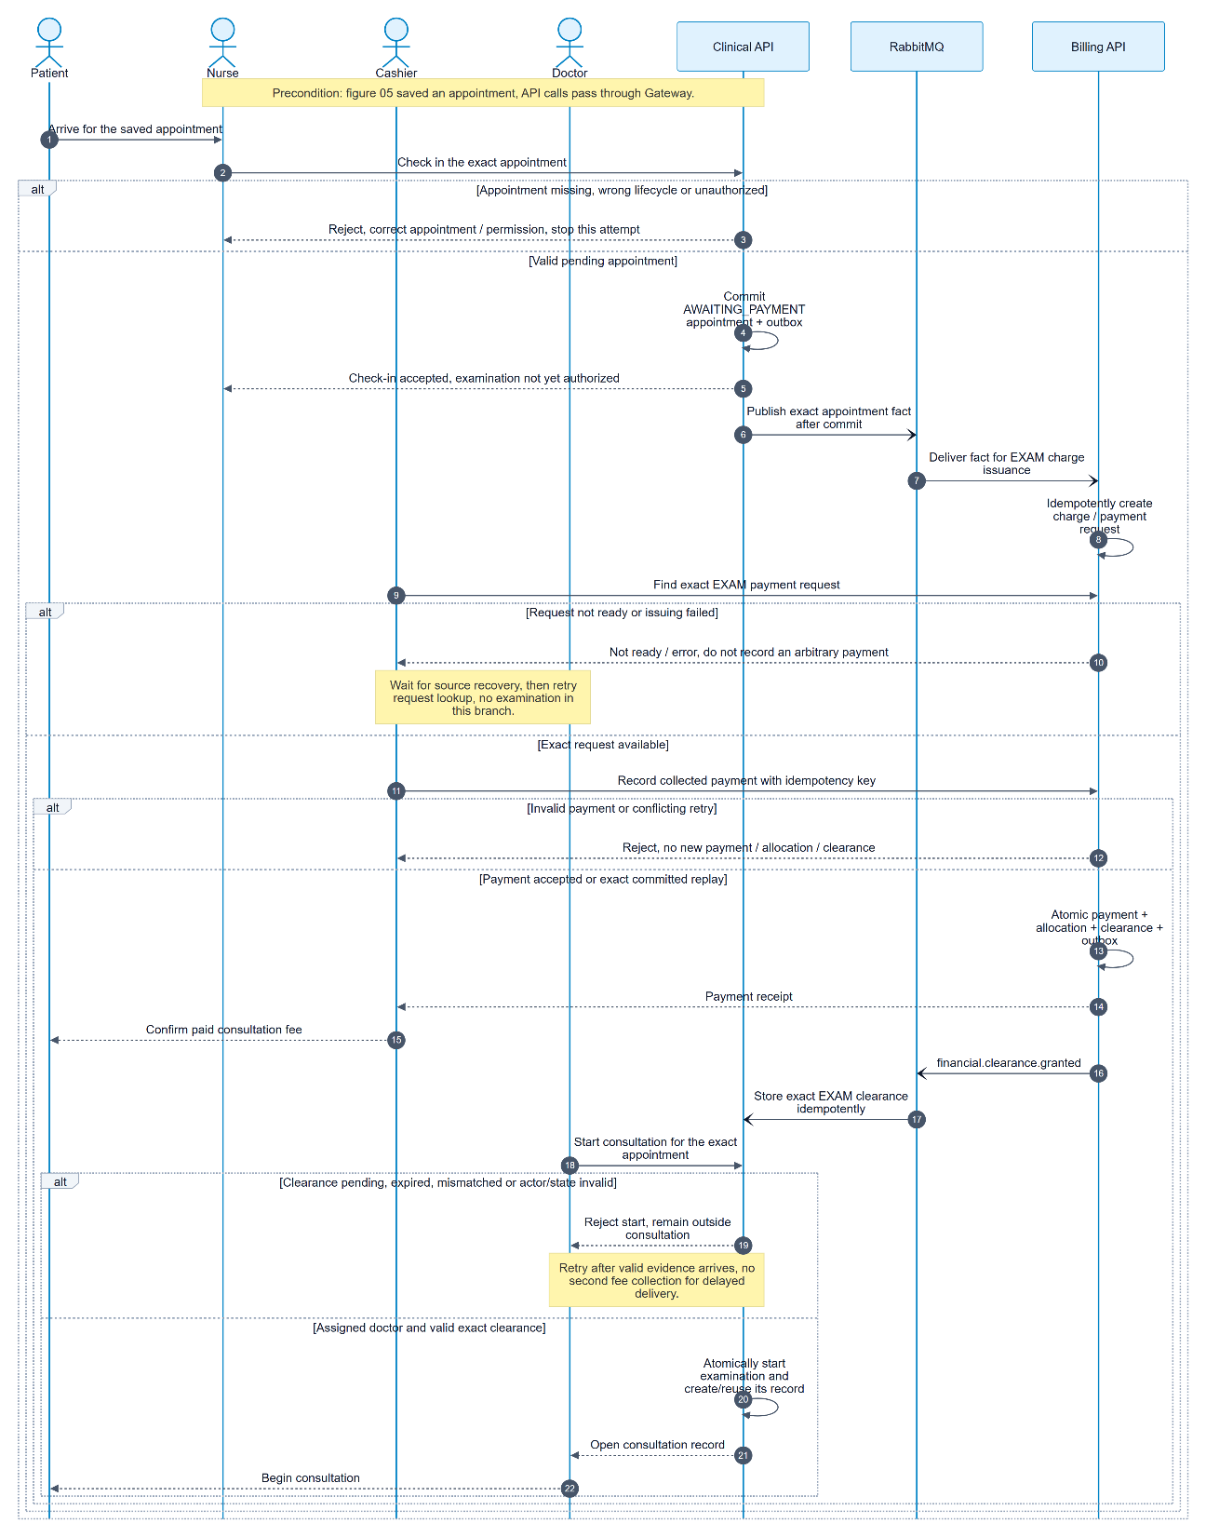

Lab order → payment → test → doctor reads results
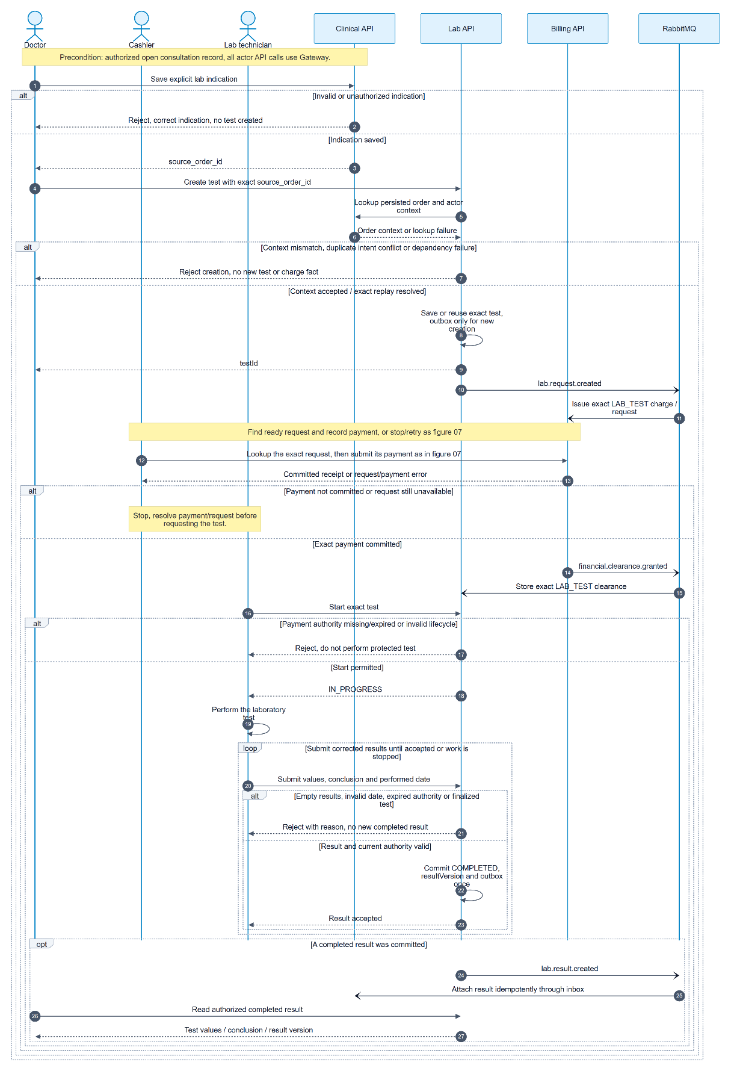

Doctor explains consultation outcome to patient
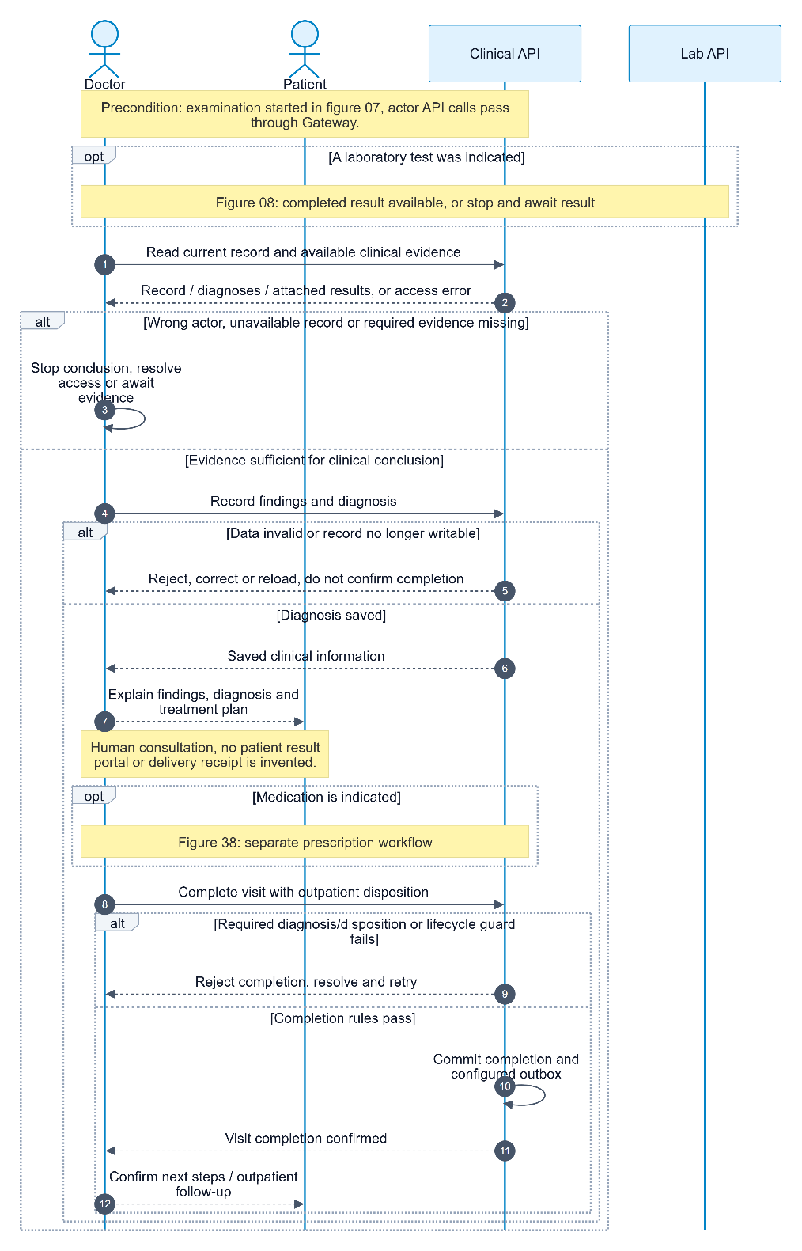

Create prescription — an optional separate workflow
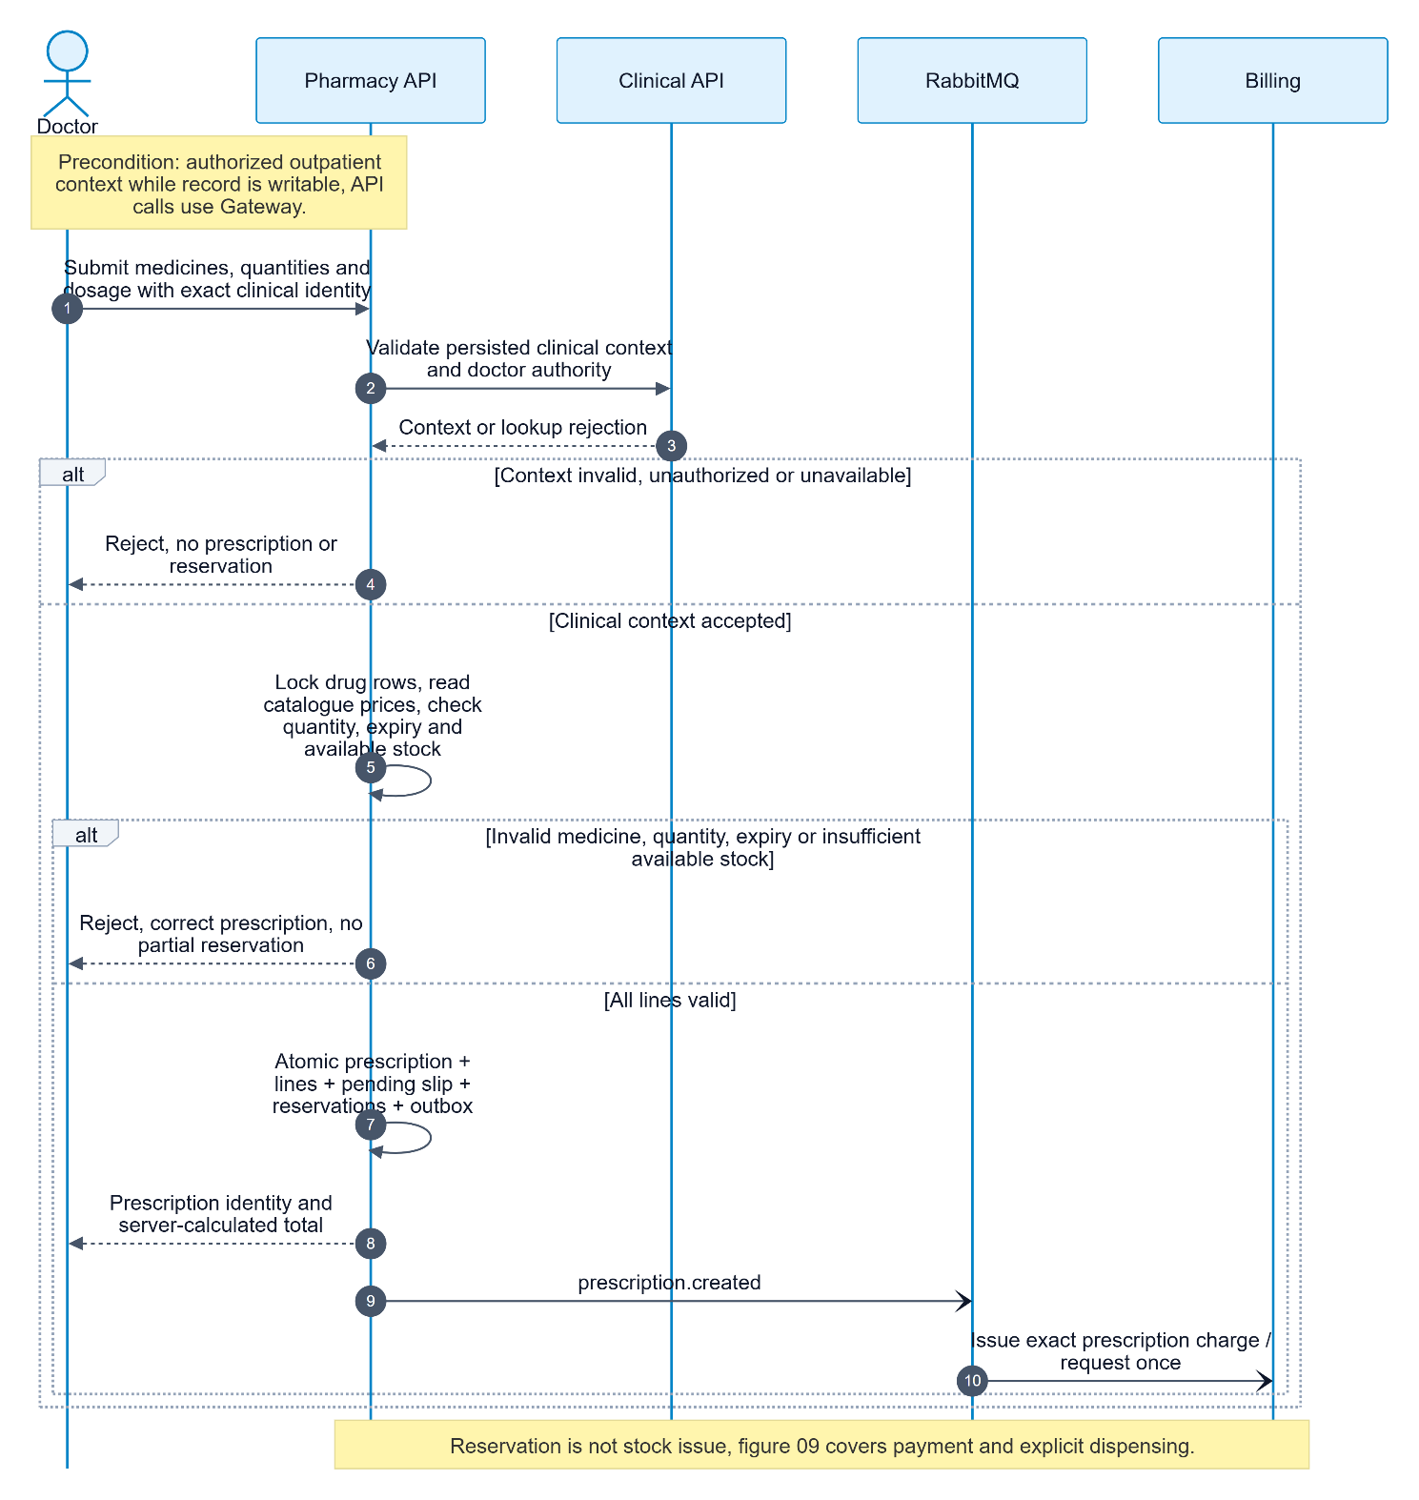

Prescription payment and explicit pharmacist dispensing
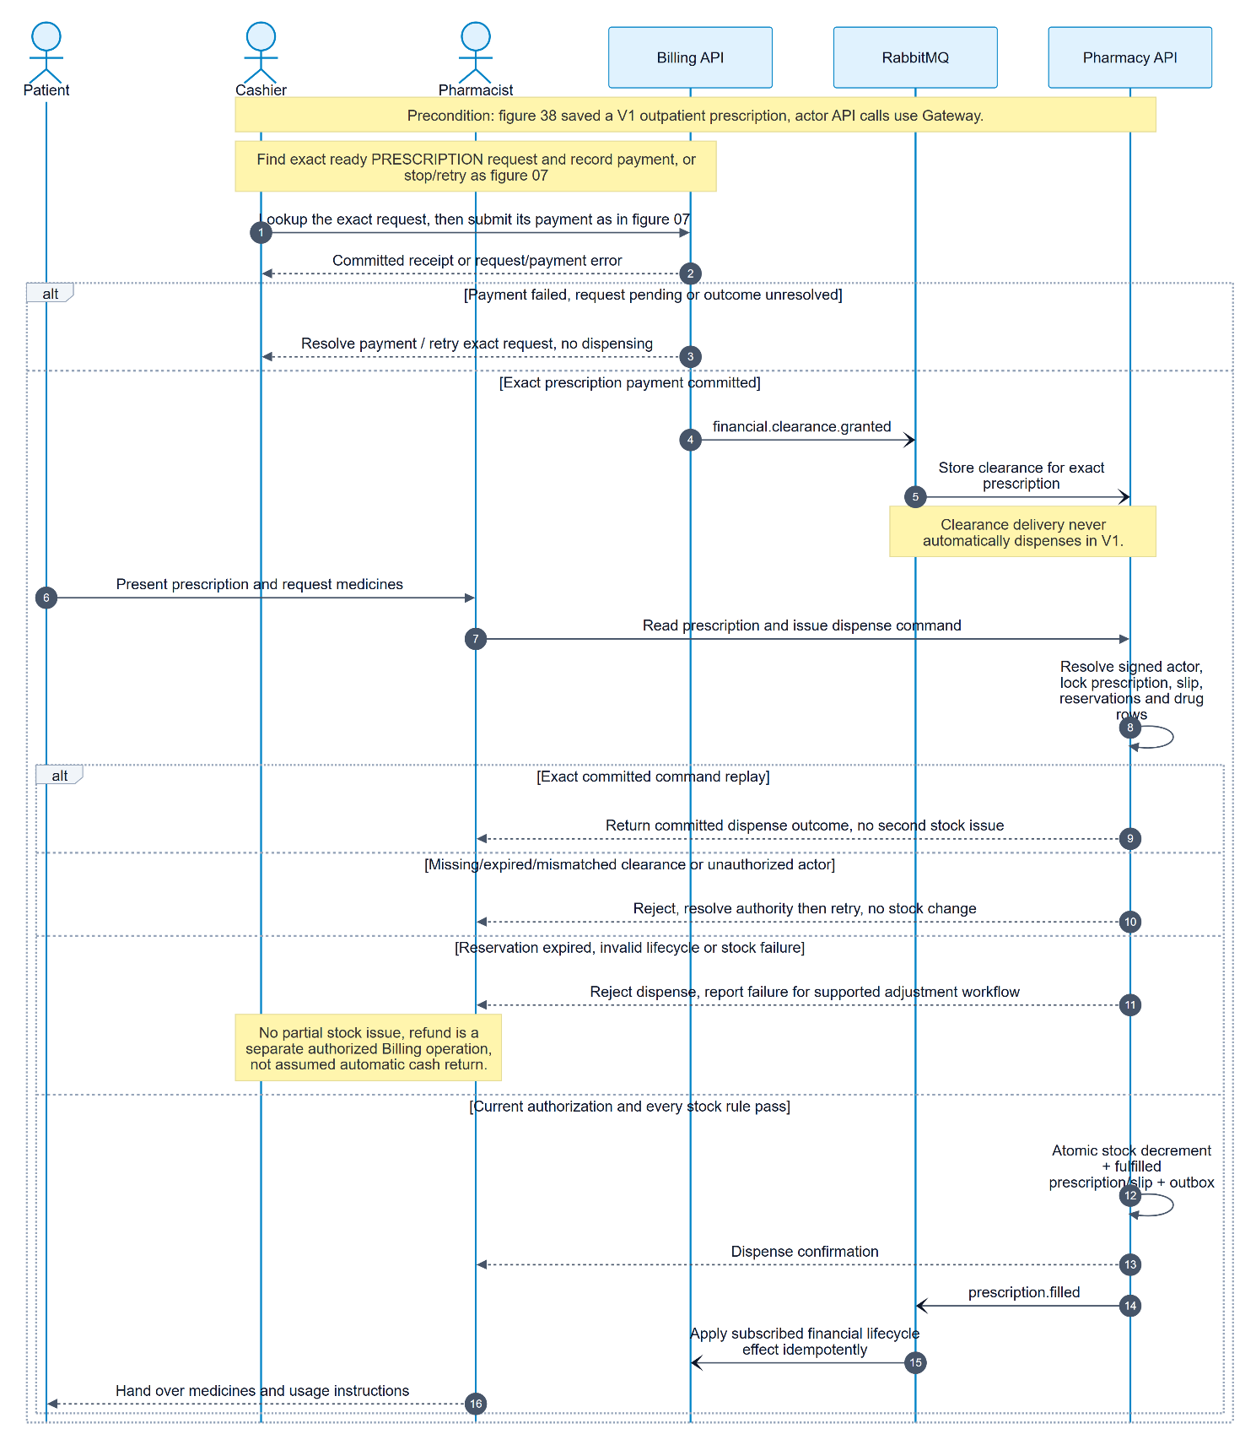

Class Diagrams

Core service — Organization and Patient modules
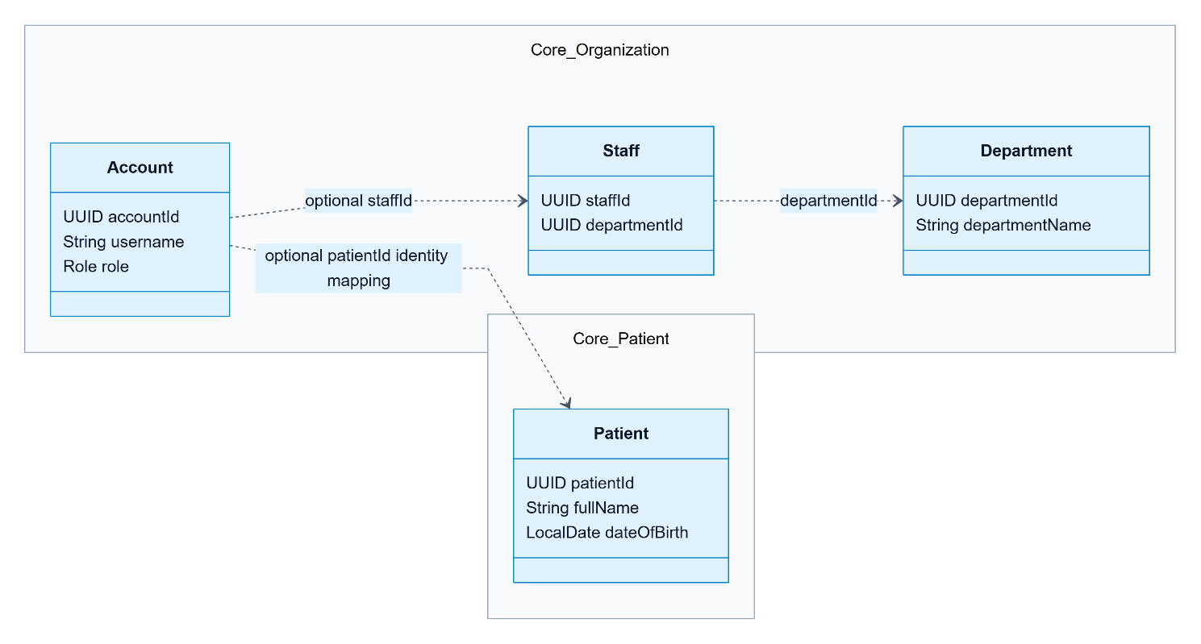

Clinical service — domain classes
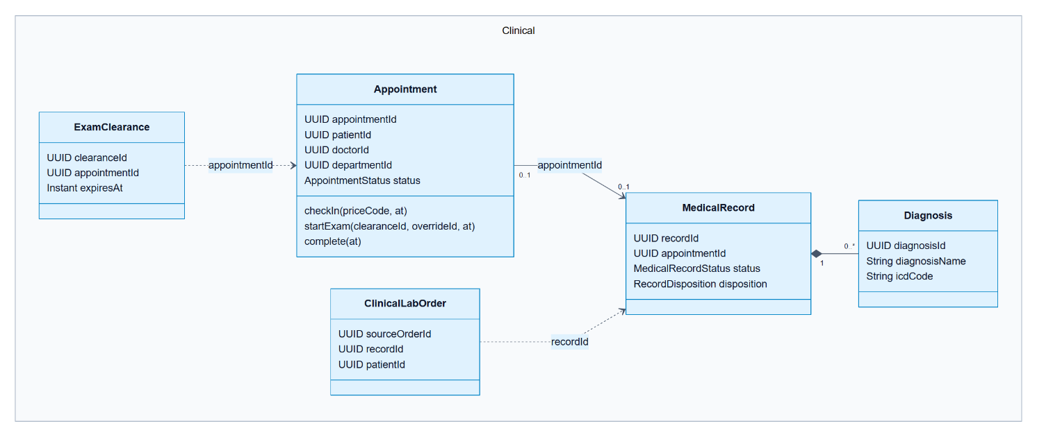

Lab service — tests, results and financial authority
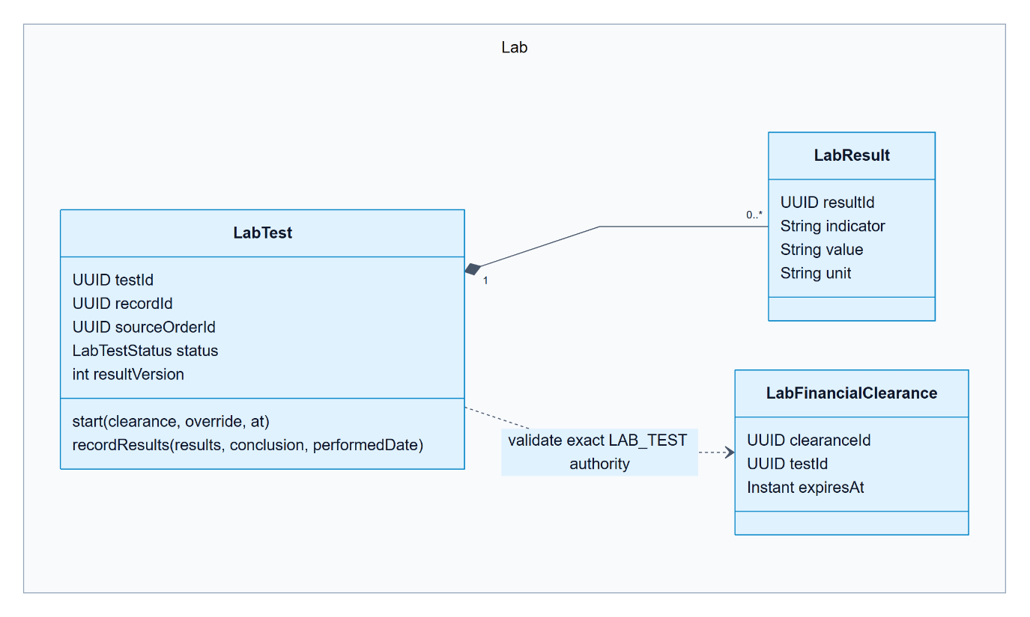

Pharmacy and Billing — separate services, explicit contracts

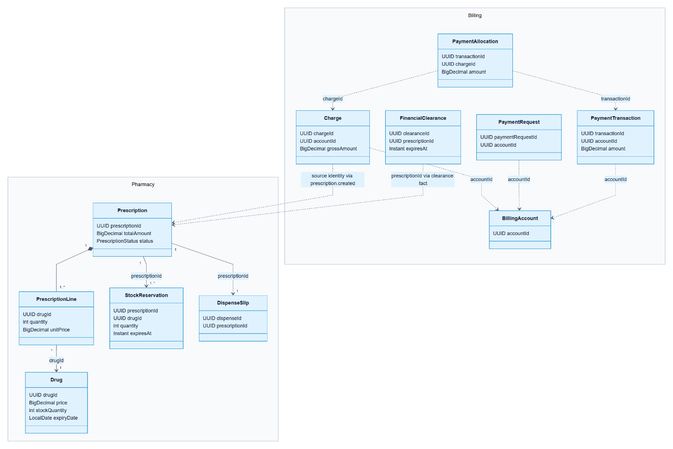

Support service — separate reporting and notification models
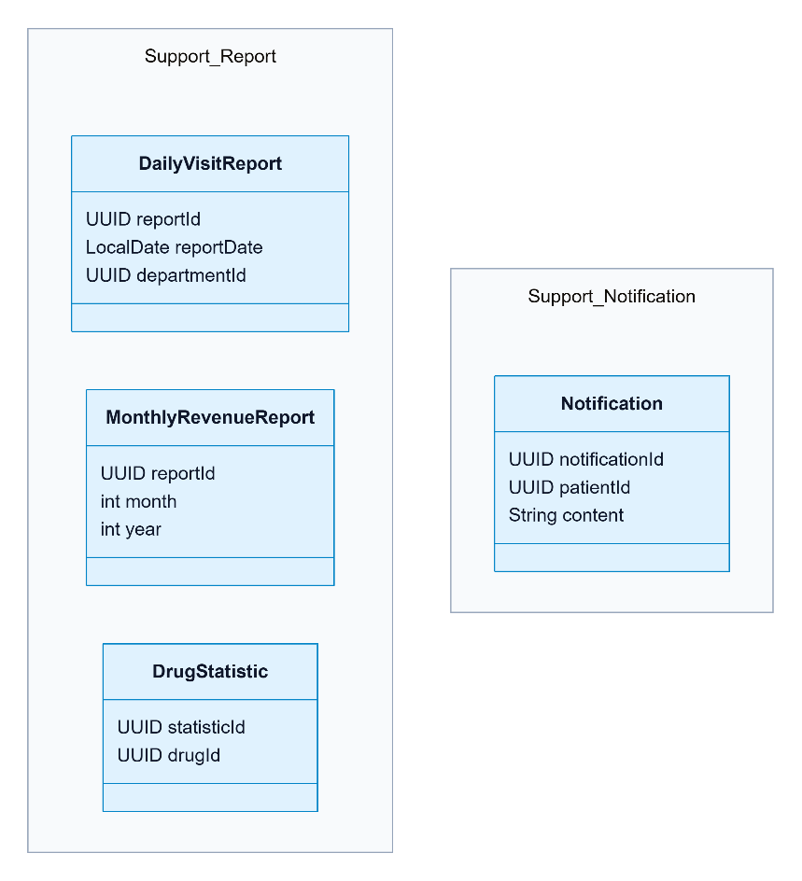

Data Flow Diagram

DFD Level 0 — system boundary
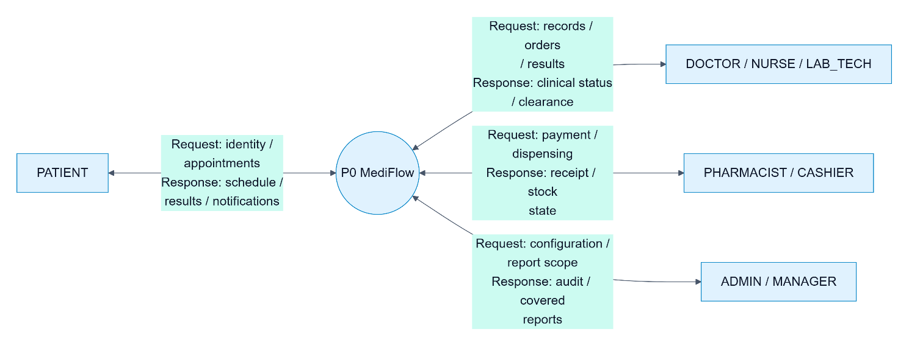

DFD Level 1 — six processes and eight stores
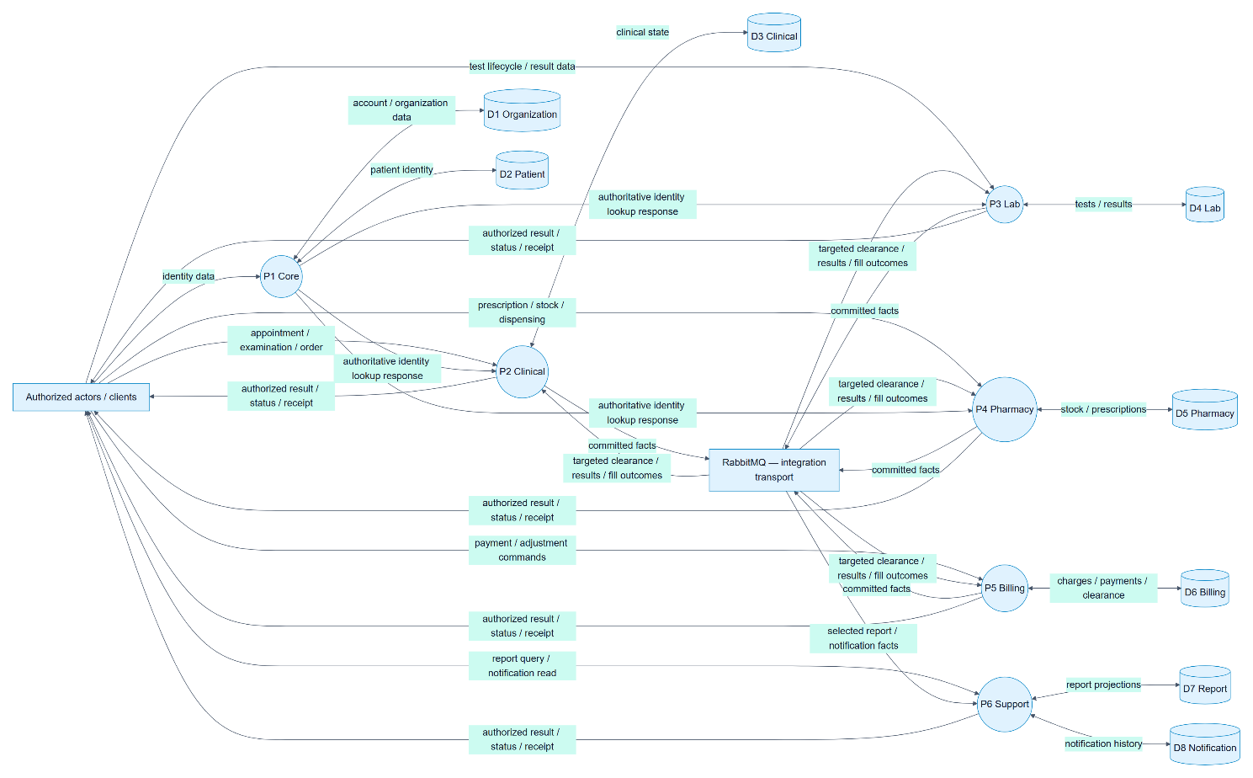

DFD Level 2 — V1 payment and service authorization
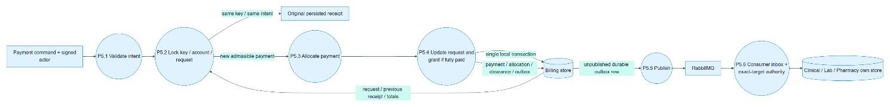

Entity Relationship Diagram

Organization
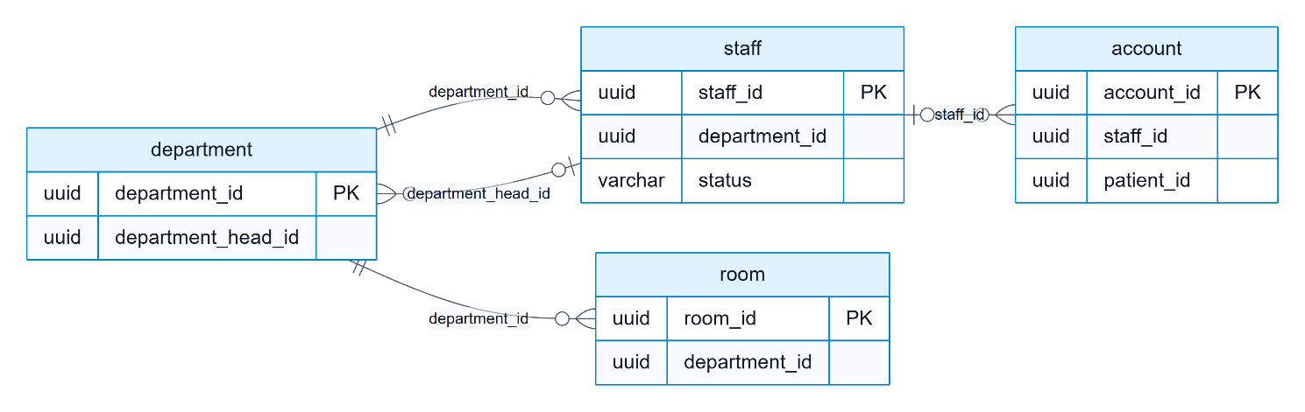

Patient
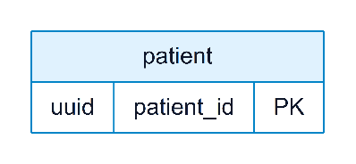

Clinical
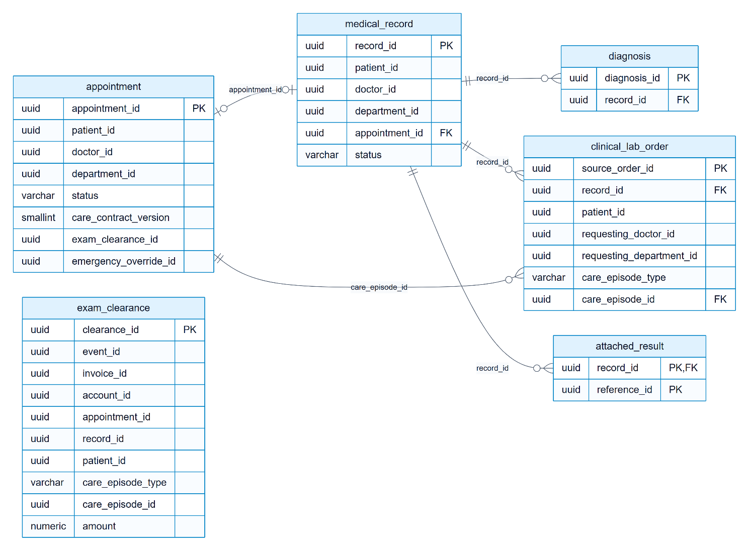

Lab
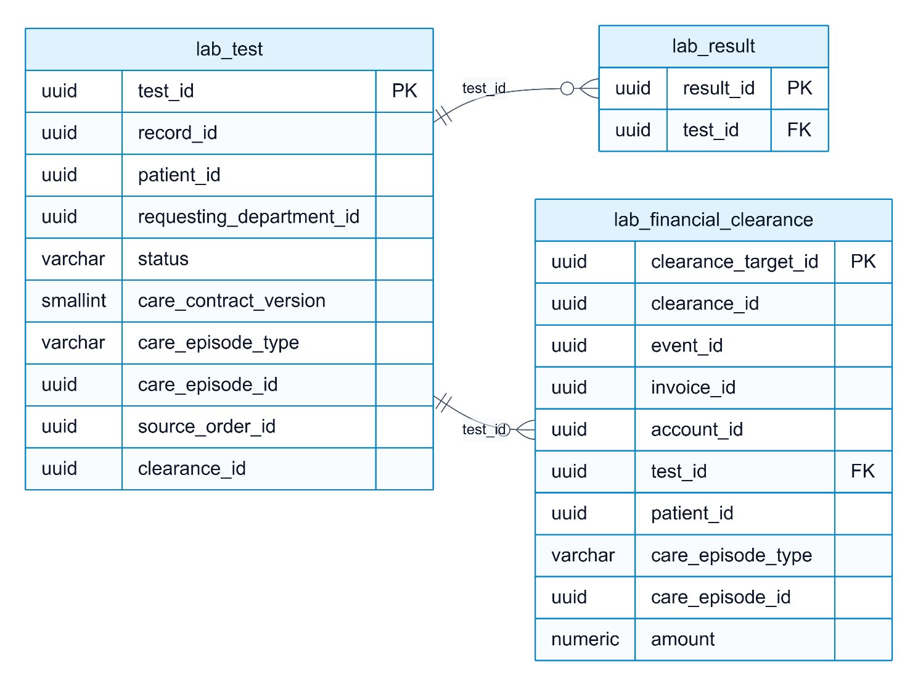

Pharmacy
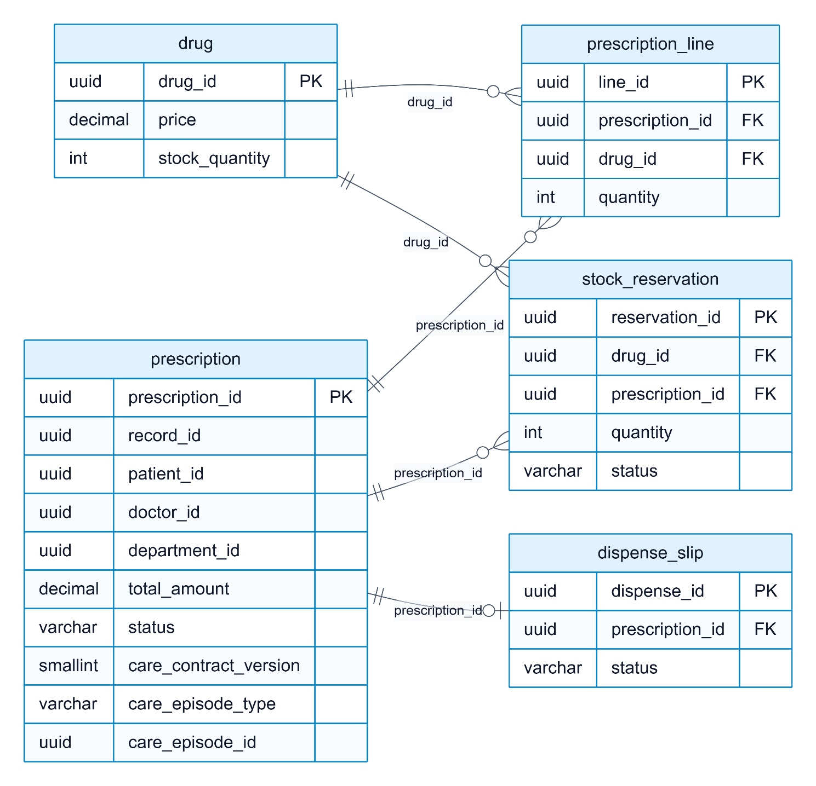

Billing
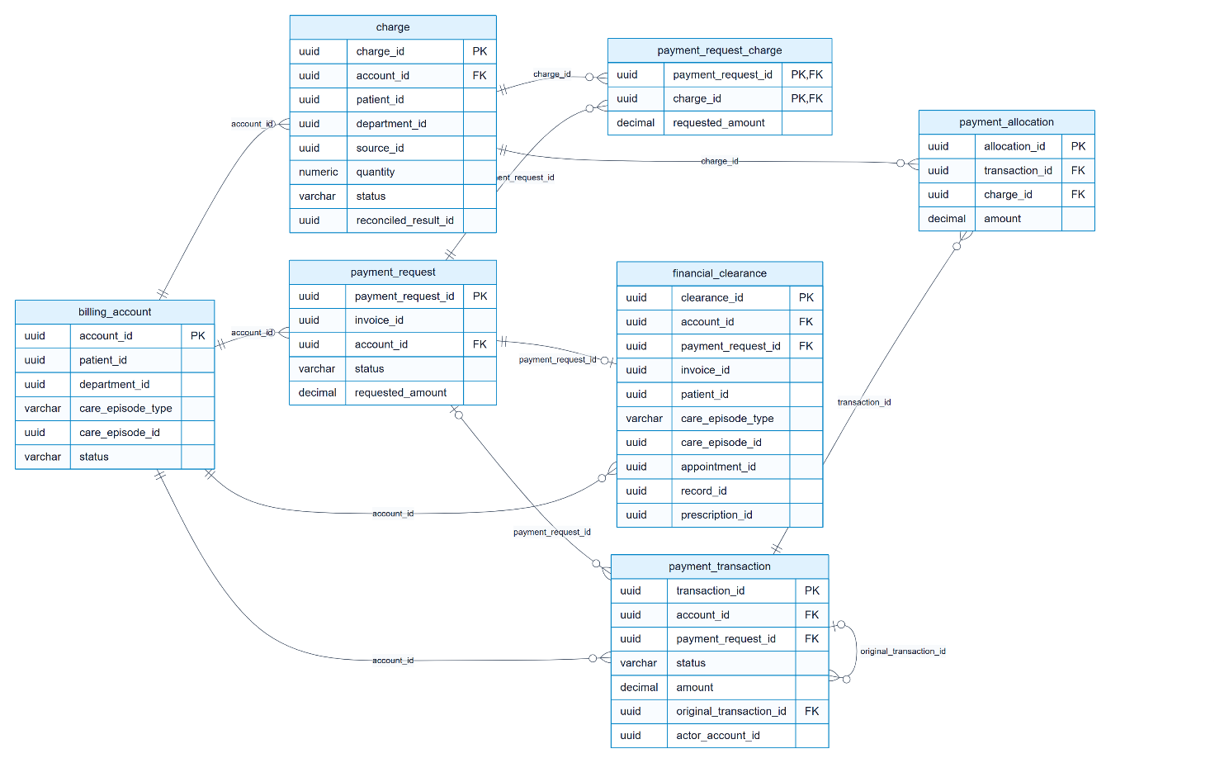

Notification
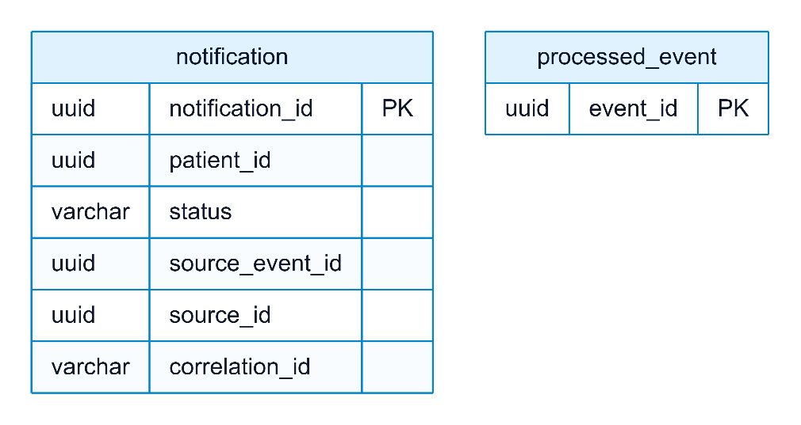

Report
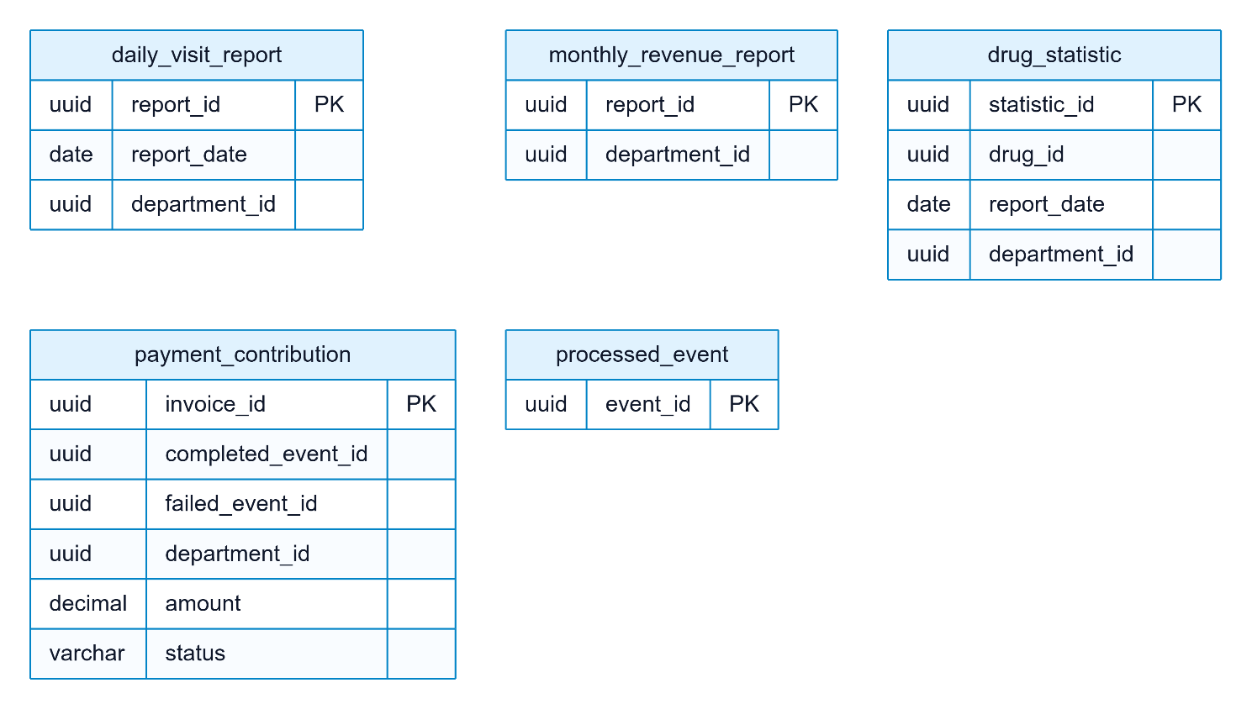

Table Design

Database Tables
Unquoted PostgreSQL identifiers fold to lowercase even when migrations use uppercase. This inventory reads migrations by V number and records each table’s creation and ALTER TABLE migrations. It inventories source, not a live DB: unapplied tables and inactive features may appear. Flyway’s automatically created flyway_schema_history is excluded from business table counts.
Service Context | Database | Declared tables | Migrations
Organization | mediflow_organization | 7 | 4
Patient | mediflow_patient | 1 | 1
Clinical | mediflow_clinical | 12 | 7
Lab | mediflow_lab | 8 | 3
Pharmacy | mediflow_pharmacy | 17 | 20
Billing | mediflow_billing | 42 | 23
Notification | mediflow_notification | 7 | 4
Report | mediflow_report | 58 | 24

Organization
Table | PK / identity
department | department_id
staff | staff_id
account | account_id
room | room_id
operating_room | room_id
surgical_capability | staff_id, team_role
surgery_authority_outbox | event_id

Patient
Table | PK / identity
patient | patient_id

Clinical
Table | PK / identity
appointment | appointment_id
medical_record | record_id
diagnosis | diagnosis_id
attached_result | record_id, type, reference_id
processed_event | event_id
exam_clearance | clearance_id
clinical_emergency_override | override_id
admission_referral | admission_request_id
clinical_outbox_event | event_id
clinical_lab_order | source_order_id
consumer_inbox_delivery | consumer_name, event_id
consumer_inbox_operation | consumer_name, operation_key

Lab
Table | PK / identity
lab_test | test_id
lab_result | result_id
processed_event | event_id
lab_financial_clearance | clearance_target_id
lab_emergency_override | override_id
lab_outbox_event | event_id
consumer_inbox_delivery | consumer_name, event_id
consumer_inbox_operation | consumer_name, operation_key

Pharmacy
Table | PK / identity
drug | drug_id
prescription | prescription_id
prescription_line | line_id
dispense_slip | dispense_id
processed_event | event_id
stock_reservation | reservation_id
pharmacy_event_outbox | event_id
payment_receipt | receipt_id
stock_adjustment | adjustment_id
pharmacy_scheduler_lease | job_name
admission_medication_context | admission_id
admission_medication_event | event_id
prescription_clearance_target | prescription_id
prescription_clearance | clearance_id
prescription_clearance_event | event_id
care_prescription_creation | command_id
pharmacy_outpatient_delivery_cohort | prescription_id

Billing
Table | PK / identity
fee | fee_id
invoice | invoice_id
processed_event | event_id
lab_test_type | lab_id
billing_event_outbox | event_id
billing_account | account_id
charge | charge_id
payment_request | payment_request_id
payment_request_charge | payment_request_id, charge_id
payment_transaction | transaction_id
payment_allocation | allocation_id
financial_clearance | clearance_id
insurance_adjustment | adjustment_id
settlement | settlement_id
payment_request_target | payment_request_id
ledger_refund_evidence | refund_transaction_id
surgery_charge_delivery | event_id
surgery_charge_source | surgery_case_id
surgery_charge_item | surgery_case_id,item_code
surgery_cancellation_source | surgery_case_id
surgery_cancellation_delivery | event_id
surgery_cancellation_refund_due | cancellation_id,original_transaction_id,charge_id
lab_test_charge_delivery | event_id
lab_test_charge_source | lab_id
admission_deposit_delivery | event_id
admission_deposit_source | admission_id
admission_reconciliation | settlement_id
admission_charge_close | admission_id
admission_charge_close_delivery | event_id
deposit_allocation_operation | allocation_operation_id
surgery_completion_source | surgery_case_id
surgery_completion_delivery | event_id
final_admission_settlement_operation | recognition_operation_id
prescription_charge_source | prescription_id
prescription_charge_item | prescription_id,drug_id
prescription_charge_delivery | event_id
prescription_terminal_source | prescription_id
prescription_terminal_delivery | event_id
prescription_terminal_refund_due | prescription_id, original_transaction_id, charge_id
exam_charge_delivery | event_id
exam_charge_source | appointment_id
billing_outpatient_publication_cohort | payment_request_id

Notification
Table | PK / identity
notification | notification_id
processed_event | event_id
notification_event_outbox | event_id
surgery_notice_case | surgery_case_id
surgery_notice_source | event_type,source_id
surgery_notice_snapshot | snapshot_id
care_notification_source | event_type,source_id

Report
Table | PK / identity
daily_visit_report | report_id
monthly_revenue_report | report_id
drug_statistic | statistic_id
processed_event | event_id
payment_contribution | invoice_id
financial_contribution | contribution_id
daily_financial_report | report_id
operational_contribution | contribution_id
daily_operational_report | report_id
operational_event_journal | event_id
operational_delivery | event_id, metric_type
operational_replay_generation | generation_id
operational_replay_input | generation_id, event_id
operational_replay_contribution | generation_id, source_type, source_id, source_revision, metric_type
operational_replay_scope | see DDL
report_admission_target | admission_id
report_admission_delivery | event_id
report_admission_fact | admission_id, fact_type
operational_report_publication | report_kind
operational_source_snapshot | source_type,source_id,source_revision,event_type
report_cash_receipt | transaction_id
report_cash_delivery | event_id
report_gross_cash_daily | scope_id
cash_replay_generation | generation_id
cash_replay_input | generation_id,transaction_id
cash_replay_receipt | generation_id,transaction_id
cash_replay_scope | see DDL
report_cash_refund | refund_transaction_id
report_cash_refund_delivery | event_id
report_refund_cash_daily | scope_id
prescription_fill_receipt | prescription_id
refund_replay_generation | generation_id
refund_replay_input | generation_id,refund_transaction_id
refund_replay_fact | generation_id,refund_transaction_id
refund_replay_scope | see DDL
report_settlement_snapshot | settlement_id
report_settlement_delivery | event_id
report_receivable_current | account_id
report_receivable_stock | see DDL
financial_report_generation | generation_id
financial_report_day | see DDL
financial_report_publication | currency,report_zone
report_medical_discharge | admission_id
report_medical_discharge_delivery | event_id
report_final_recognition | recognition_operation_id
report_final_recognition_delivery | event_id
report_final_recognition_contribution | see DDL
report_final_deposit_release | recognition_operation_id,original_transaction_id
report_final_recognition_daily | see DDL
financial_source_rebuild | generation_id
financial_source_rebuild_input | generation_id,source_kind,source_id
financial_source_rebuild_day | see DDL
financial_archive_restore | archive_fingerprint
financial_generation_acceptance | generation_id
financial_publication_audit | command_id
operational_generation_acceptance | generation_id
operational_publication_audit | command_id
report_outpatient_coverage | coverage_id

Core table column dictionary
The following tables represent the outpatient journey. Column definitions are extracted from CREATE and ADD COLUMN; dropped columns are removed. This is not a full SQL execution engine: ALTER TYPE/DEFAULT, constraints/indexes and conditional SQL must also be read in linked migrations; do not reconstruct production DDL from this summary. Removed fields such as invoice.dispense_id are excluded.

Organization

Organization.account
Column | Declared type and column constraints
account_id | UUID PRIMARY KEY
username | VARCHAR(50) NOT NULL
password_hash | VARCHAR(255) NOT NULL
staff_id | UUID
role | VARCHAR(20) NOT NULL
is_active | BOOLEAN NOT NULL DEFAULT TRUE
last_login_at | TIMESTAMPTZ
created_at | TIMESTAMPTZ NOT NULL DEFAULT now()
updated_at | TIMESTAMPTZ
patient_id | UUID

Organization.staff
Column | Declared type and column constraints
staff_id | UUID PRIMARY KEY
full_name | VARCHAR(100) NOT NULL
department_id | UUID NOT NULL
job_title | VARCHAR(20) NOT NULL
specialization | VARCHAR(100)
license_number | VARCHAR(50)
phone_number | VARCHAR(15)
email | VARCHAR(100)
status | VARCHAR(20) NOT NULL DEFAULT 'ACTIVE'
created_at | TIMESTAMPTZ NOT NULL DEFAULT now()
updated_at | TIMESTAMPTZ

Organization.department
Column | Declared type and column constraints
department_id | UUID PRIMARY KEY
department_name | VARCHAR(100) NOT NULL
abbreviation | VARCHAR(20) NOT NULL
department_type | VARCHAR(20) NOT NULL
department_head_id | UUID
location | VARCHAR(255)
is_active | BOOLEAN NOT NULL DEFAULT TRUE
created_at | TIMESTAMPTZ NOT NULL DEFAULT now()
updated_at | TIMESTAMPTZ

Patient

Patient.patient
Column | Declared type and column constraints
patient_id | UUID PRIMARY KEY
full_name | VARCHAR(100) NOT NULL
date_of_birth | DATE NOT NULL
gender | VARCHAR(1) NOT NULL
identity_number | VARCHAR(20) NOT NULL
address | VARCHAR(255)
phone_number | VARCHAR(15)
email | VARCHAR(100)
health_insurance_number | VARCHAR(20)
created_at | TIMESTAMPTZ NOT NULL DEFAULT now()
updated_at | TIMESTAMPTZ

Clinical

Clinical.appointment
Column | Declared type and column constraints
appointment_id | UUID PRIMARY KEY
patient_id | UUID NOT NULL
doctor_id | UUID NOT NULL
department_id | UUID NOT NULL
appointment_date | DATE NOT NULL
appointment_time | TIME NOT NULL
status | VARCHAR(20) NOT NULL DEFAULT 'PENDING'
reason | TEXT
created_at | TIMESTAMPTZ NOT NULL DEFAULT now()
updated_at | TIMESTAMPTZ
care_contract_version | SMALLINT NOT NULL DEFAULT 0
exam_clearance_id | UUID
exam_clearance_at | TIMESTAMPTZ
emergency_override_id | UUID
exam_price_code | VARCHAR(64)
checked_in_at | TIMESTAMPTZ
examination_started_at | TIMESTAMPTZ
completed_at | TIMESTAMPTZ

Clinical.medical_record
Column | Declared type and column constraints
record_id | UUID PRIMARY KEY
patient_id | UUID NOT NULL
doctor_id | UUID NOT NULL
department_id | UUID NOT NULL
examination_date | DATE NOT NULL
symptoms | TEXT
appointment_id | UUID REFERENCES appointment(appointment_id)
created_at | TIMESTAMPTZ NOT NULL DEFAULT now()
updated_at | TIMESTAMPTZ
status | VARCHAR(20) NOT NULL DEFAULT 'OPEN'
disposition | VARCHAR(32)
disposition_note | TEXT
completed_at | TIMESTAMPTZ

Clinical.diagnosis
Column | Declared type and column constraints
diagnosis_id | UUID PRIMARY KEY
record_id | UUID NOT NULL REFERENCES medical_record(record_id) ON DELETE CASCADE
diagnosis_name | VARCHAR(255) NOT NULL
description | TEXT
icd_code | VARCHAR(10)
created_at | TIMESTAMPTZ NOT NULL DEFAULT now()

Clinical.clinical_lab_order
Column | Declared type and column constraints
source_order_id | UUID PRIMARY KEY
record_id | UUID NOT NULL REFERENCES medical_record(record_id)
patient_id | UUID NOT NULL
requesting_doctor_id | UUID NOT NULL
requesting_department_id | UUID NOT NULL
care_episode_type | VARCHAR(32) NOT NULL CHECK (care_episode_type = 'OUTPATIENT_VISIT')
care_episode_id | UUID NOT NULL REFERENCES appointment(appointment_id)
lab_type | VARCHAR(50) NOT NULL CHECK (length(btrim(lab_type)) > 0)
requested_date | DATE NOT NULL
price_code | VARCHAR(64) NOT NULL CHECK (length(btrim(price_code)) > 0)
ordered_at | TIMESTAMPTZ NOT NULL

Lab

Lab.lab_test
Column | Declared type and column constraints
test_id | UUID PRIMARY KEY
record_id | UUID NOT NULL
patient_id | UUID NOT NULL
requesting_department_id | UUID NOT NULL
test_type | VARCHAR(50) NOT NULL
requested_date | DATE NOT NULL
performed_date | DATE
status | VARCHAR(20) NOT NULL DEFAULT 'PENDING'
conclusion | TEXT
is_paid | BOOLEAN NOT NULL DEFAULT false
created_at | TIMESTAMPTZ NOT NULL DEFAULT now()
updated_at | TIMESTAMPTZ
care_contract_version | SMALLINT NOT NULL DEFAULT 0
care_episode_type | VARCHAR(32)
care_episode_id | UUID
source_order_id | UUID
price_code | VARCHAR(64)
clearance_id | UUID
clearance_granted_at | TIMESTAMPTZ
emergency_override_id | UUID
result_version | INTEGER NOT NULL DEFAULT 0

Lab.lab_result
Column | Declared type and column constraints
result_id | UUID PRIMARY KEY
test_id | UUID NOT NULL REFERENCES lab_test(test_id) ON DELETE CASCADE
indicator | VARCHAR(100) NOT NULL
value | VARCHAR(50) NOT NULL
unit | VARCHAR(20)
reference_range | VARCHAR(50)
created_at | TIMESTAMPTZ NOT NULL DEFAULT now()

Pharmacy

Pharmacy.drug
Column | Declared type and column constraints
drug_id | UUID PRIMARY KEY
drug_name | VARCHAR(150) NOT NULL
active_ingredient | VARCHAR(150)
unit | VARCHAR(20) NOT NULL
price | DECIMAL(15,2) NOT NULL
stock_quantity | INT NOT NULL DEFAULT 0
expiry_date | DATE NOT NULL
manufacturer | VARCHAR(150)
low_stock_threshold | INT NOT NULL DEFAULT 10
created_at | TIMESTAMPTZ NOT NULL DEFAULT now()
updated_at | TIMESTAMPTZ

Pharmacy.prescription
Column | Declared type and column constraints
prescription_id | UUID PRIMARY KEY
record_id | UUID
patient_id | UUID NOT NULL
doctor_id | UUID NOT NULL
department_id | UUID NOT NULL
prescribed_date | DATE NOT NULL
total_amount | DECIMAL(15,2) NOT NULL DEFAULT 0
created_at | TIMESTAMPTZ NOT NULL DEFAULT now()
updated_at | TIMESTAMPTZ
status | VARCHAR(30) NOT NULL DEFAULT 'ACTIVE'
cancelled_at | TIMESTAMPTZ
cancelled_by | UUID
cancellation_reason | VARCHAR(500)
care_contract_version | SMALLINT NOT NULL DEFAULT 0
care_context | VARCHAR(20) NOT NULL DEFAULT 'OUTPATIENT'
care_episode_type | VARCHAR(32)
care_episode_id | UUID
admission_id | UUID
price_code | VARCHAR(64)
lifecycle_at_iso | VARCHAR(35)

Pharmacy.prescription_line
Column | Declared type and column constraints
line_id | UUID PRIMARY KEY
prescription_id | UUID NOT NULL REFERENCES PRESCRIPTION(prescription_id) ON DELETE CASCADE
drug_id | UUID NOT NULL REFERENCES DRUG(drug_id)
quantity | INT NOT NULL
unit_price | DECIMAL(15,2) NOT NULL
dosage | VARCHAR(255)
line_total | DECIMAL(15,2) NOT NULL
drug_name_snapshot | VARCHAR(150)

Pharmacy.stock_reservation
Column | Declared type and column constraints
reservation_id | UUID PRIMARY KEY
drug_id | UUID NOT NULL REFERENCES DRUG(drug_id)
prescription_id | UUID NOT NULL REFERENCES PRESCRIPTION(prescription_id)
quantity | INT NOT NULL
status | VARCHAR(20) NOT NULL DEFAULT 'RESERVED'
expires_at | TIMESTAMPTZ NOT NULL
created_at | TIMESTAMPTZ NOT NULL DEFAULT now()
updated_at | TIMESTAMPTZ
release_reason | VARCHAR(50)
released_at | TIMESTAMPTZ
released_by | UUID

Pharmacy.dispense_slip
Column | Declared type and column constraints
dispense_id | UUID PRIMARY KEY
prescription_id | UUID NOT NULL UNIQUE REFERENCES PRESCRIPTION(prescription_id)
status | VARCHAR(20) NOT NULL DEFAULT 'PENDING'
dispensed_at | TIMESTAMPTZ
dispensed_by | UUID
failure_reason | VARCHAR(500)
created_at | TIMESTAMPTZ NOT NULL DEFAULT now()
updated_at | TIMESTAMPTZ
dispensed_actor_type | VARCHAR(30)
lifecycle_at_iso | VARCHAR(35)

Billing

Billing.invoice
Column | Declared type and column constraints
invoice_id | UUID PRIMARY KEY
patient_id | UUID NOT NULL
created_date | DATE NOT NULL
total_amount | DECIMAL(15,2) NOT NULL
is_paid | BOOLEAN NOT NULL DEFAULT false
payment_method | VARCHAR(20)
prescription_id | UUID
saga_status | VARCHAR(20) NOT NULL DEFAULT 'NONE'
paid_at | TIMESTAMPTZ
created_at | TIMESTAMPTZ NOT NULL DEFAULT now()
updated_at | TIMESTAMPTZ

Billing.billing_account
Column | Declared type and column constraints
account_id | UUID PRIMARY KEY
patient_id | UUID NOT NULL
department_id | UUID NOT NULL
care_episode_type | VARCHAR(32) NOT NULL
care_episode_id | UUID NOT NULL
status | VARCHAR(32) NOT NULL DEFAULT 'OPEN'
currency | CHAR(3) NOT NULL DEFAULT 'VND'
version | BIGINT NOT NULL DEFAULT 0
opened_at | TIMESTAMPTZ NOT NULL
charge_closed_at | TIMESTAMPTZ
closed_at | TIMESTAMPTZ
created_at | TIMESTAMPTZ NOT NULL DEFAULT now()
updated_at | TIMESTAMPTZ NOT NULL DEFAULT now()

Billing.charge
Column | Declared type and column constraints
charge_id | UUID PRIMARY KEY
account_id | UUID NOT NULL REFERENCES BILLING_ACCOUNT(account_id)
patient_id | UUID NOT NULL
department_id | UUID NOT NULL
source_type | VARCHAR(32) NOT NULL
source_id | UUID NOT NULL
price_code | VARCHAR(64) NOT NULL
description | VARCHAR(255) NOT NULL
quantity | NUMERIC(19,4) NOT NULL DEFAULT 1 CHECK (quantity > 0)
unit_amount | DECIMAL(19,2) NOT NULL CHECK (unit_amount >= 0)
gross_amount | DECIMAL(19,2) NOT NULL CHECK (gross_amount >= 0)
status | VARCHAR(20) NOT NULL DEFAULT 'POSTED'
void_reason | VARCHAR(500)
incurred_at | TIMESTAMPTZ NOT NULL
created_at | TIMESTAMPTZ NOT NULL DEFAULT now()
reconciled_result_id | UUID

Billing.payment_request
Column | Declared type and column constraints
payment_request_id | UUID PRIMARY KEY
invoice_id | UUID NOT NULL UNIQUE
account_id | UUID NOT NULL REFERENCES BILLING_ACCOUNT(account_id)
purpose | VARCHAR(32) NOT NULL
status | VARCHAR(24) NOT NULL DEFAULT 'PENDING'
requested_amount | DECIMAL(19,2) NOT NULL CHECK (requested_amount >= 0)
currency | CHAR(3) NOT NULL DEFAULT 'VND'
expires_at | TIMESTAMPTZ
created_by | UUID
created_at | TIMESTAMPTZ NOT NULL DEFAULT now()
completed_at | TIMESTAMPTZ

Billing.payment_transaction
Column | Declared type and column constraints
transaction_id | UUID PRIMARY KEY
account_id | UUID NOT NULL REFERENCES BILLING_ACCOUNT(account_id)
payment_request_id | UUID REFERENCES PAYMENT_REQUEST(payment_request_id)
transaction_type | VARCHAR(20) NOT NULL
classification | VARCHAR(24) NOT NULL
status | VARCHAR(20) NOT NULL
amount | DECIMAL(19,2) NOT NULL CHECK (amount > 0)
currency | CHAR(3) NOT NULL DEFAULT 'VND'
payment_method | VARCHAR(20) NOT NULL
provider_reference | VARCHAR(120)
idempotency_key | VARCHAR(120) NOT NULL UNIQUE
original_transaction_id | UUID REFERENCES PAYMENT_TRANSACTION(transaction_id)
completed_at | TIMESTAMPTZ
created_at | TIMESTAMPTZ NOT NULL DEFAULT now()
actor_account_id | UUID

Billing.payment_allocation
Column | Declared type and column constraints
allocation_id | UUID PRIMARY KEY
transaction_id | UUID NOT NULL REFERENCES PAYMENT_TRANSACTION(transaction_id)
charge_id | UUID NOT NULL REFERENCES CHARGE(charge_id)
amount | DECIMAL(19,2) NOT NULL CHECK (amount > 0)
created_at | TIMESTAMPTZ NOT NULL DEFAULT now()

Billing.financial_clearance
Column | Declared type and column constraints
clearance_id | UUID PRIMARY KEY
account_id | UUID NOT NULL REFERENCES BILLING_ACCOUNT(account_id)
payment_request_id | UUID NOT NULL REFERENCES PAYMENT_REQUEST(payment_request_id)
invoice_id | UUID NOT NULL
patient_id | UUID NOT NULL
purpose | VARCHAR(32) NOT NULL
care_episode_type | VARCHAR(32) NOT NULL
care_episode_id | UUID NOT NULL
appointment_id | UUID
record_id | UUID
lab_test_ids | UUID[] NOT NULL DEFAULT '{}'
prescription_id | UUID
admission_id | UUID
surgery_case_id | UUID
amount | DECIMAL(19,2) NOT NULL CHECK (amount >= 0)
currency | CHAR(3) NOT NULL DEFAULT 'VND'
payment_method | VARCHAR(20) NOT NULL
emergency_override | BOOLEAN NOT NULL DEFAULT FALSE
expires_at | TIMESTAMPTZ
granted_at | TIMESTAMPTZ NOT NULL
revoked_at | TIMESTAMPTZ

Notification.notification
Column | Declared type and column constraints
notification_id | UUID PRIMARY KEY
patient_id | UUID NOT NULL
title | VARCHAR(255) NOT NULL
content | TEXT NOT NULL
channel | VARCHAR(10) NOT NULL
recipient_address | VARCHAR(150)
status | VARCHAR(10) NOT NULL DEFAULT 'PENDING'
failure_reason | VARCHAR(255)
retry_count | INT NOT NULL DEFAULT 0
created_at | TIMESTAMPTZ NOT NULL DEFAULT now()
sent_at | TIMESTAMPTZ
template_key | VARCHAR(64)
source_event_id | UUID
source_event_type | VARCHAR(100)
source_id | UUID
correlation_id | VARCHAR(120)
sensitivity | VARCHAR(32) NOT NULL DEFAULT 'STANDARD'

Report

Report.daily_visit_report
Column | Declared type and column constraints
report_id | UUID PRIMARY KEY
report_date | DATE NOT NULL
department_id | UUID
visit_count | INT NOT NULL DEFAULT 0
lab_count | INT NOT NULL DEFAULT 0
prescription_count | INT NOT NULL DEFAULT 0
revenue | DECIMAL(15,2) NOT NULL DEFAULT 0
created_at | TIMESTAMPTZ NOT NULL DEFAULT now()
updated_at | TIMESTAMPTZ

Report.monthly_revenue_report
Column | Declared type and column constraints
report_id | UUID PRIMARY KEY
month | INT NOT NULL
year | INT NOT NULL
department_id | UUID
total_revenue | DECIMAL(15,2) NOT NULL DEFAULT 0
invoice_count | INT NOT NULL DEFAULT 0
created_at | TIMESTAMPTZ NOT NULL DEFAULT now()
updated_at | TIMESTAMPTZ

Report.drug_statistic
Column | Declared type and column constraints
statistic_id | UUID PRIMARY KEY
drug_id | UUID NOT NULL
drug_name | VARCHAR(150) NOT NULL
report_date | DATE NOT NULL
department_id | UUID
dispensed_quantity | INT NOT NULL DEFAULT 0
updated_at | TIMESTAMPTZ

Constraints and persistence strategy

UUIDs are business identifiers; cross-context references have no JPA relationship/FK. Organization.account.patient_id remains a logical Patient reference even inside the Core JVM.

Money uses BigDecimal and DDL-specific NUMERIC/DECIMAL: V0 commonly (15,2), ledger (19,2). This report does not normalize all precision to one type.

Appointment has a patient/date PENDING uniqueness guard; medical_record has a unique appointment; prescription_line quantity > 0; stock/price are nonnegative; reservation has prescription/drug uniqueness.

Billing has unique charge (source_type, source_id, price_code) and payment_transaction.idempotency_key; FKs/allocations stay within Billing.

Business timestamps use TIMESTAMPTZ/Instant, dates use DATE/LocalDate. Lab result.value is VARCHAR, preserving textual results and reference_range.

Outbox commits with state; inbox/receipt commits with effects. Retries preserve eventId/bytes; poison messages reach DLQ after bounded retry; HELD rows are not automatically released.

Released Flyway migrations are append-only. Indexes and multi-column CHECKs live in the linked DDL, beyond the column summaries above.

Database Diagram

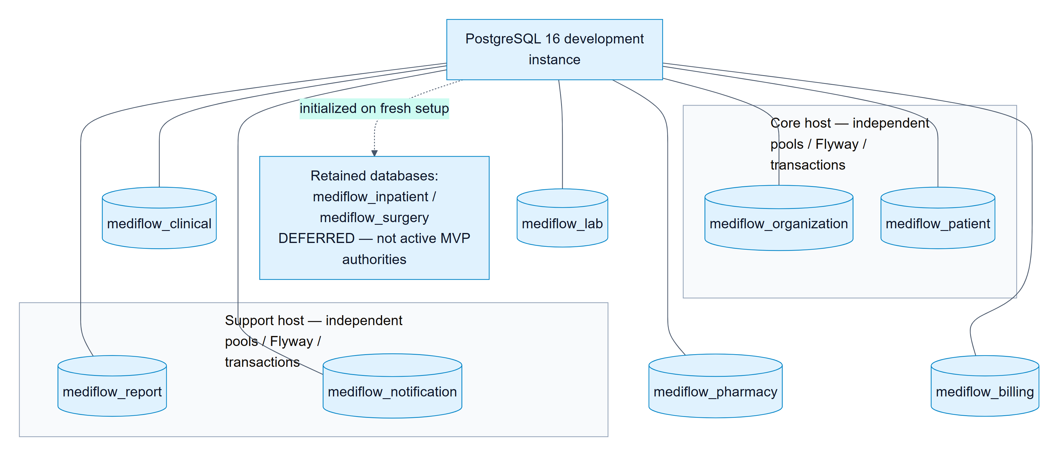

SiteMap

Web sitemap by route group
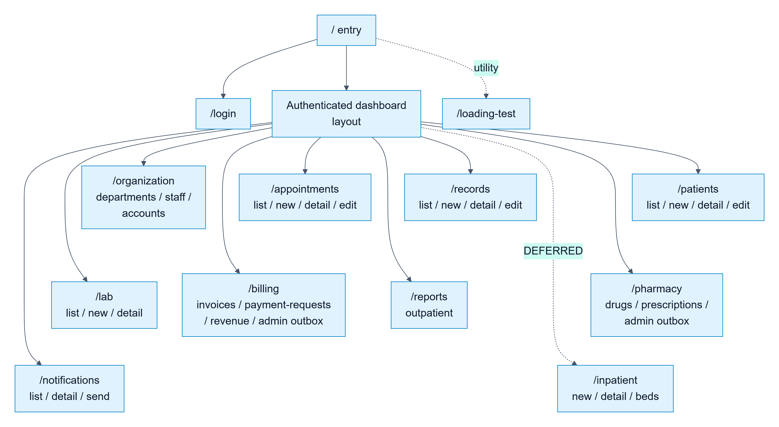

Mobile sitemap and implementation level
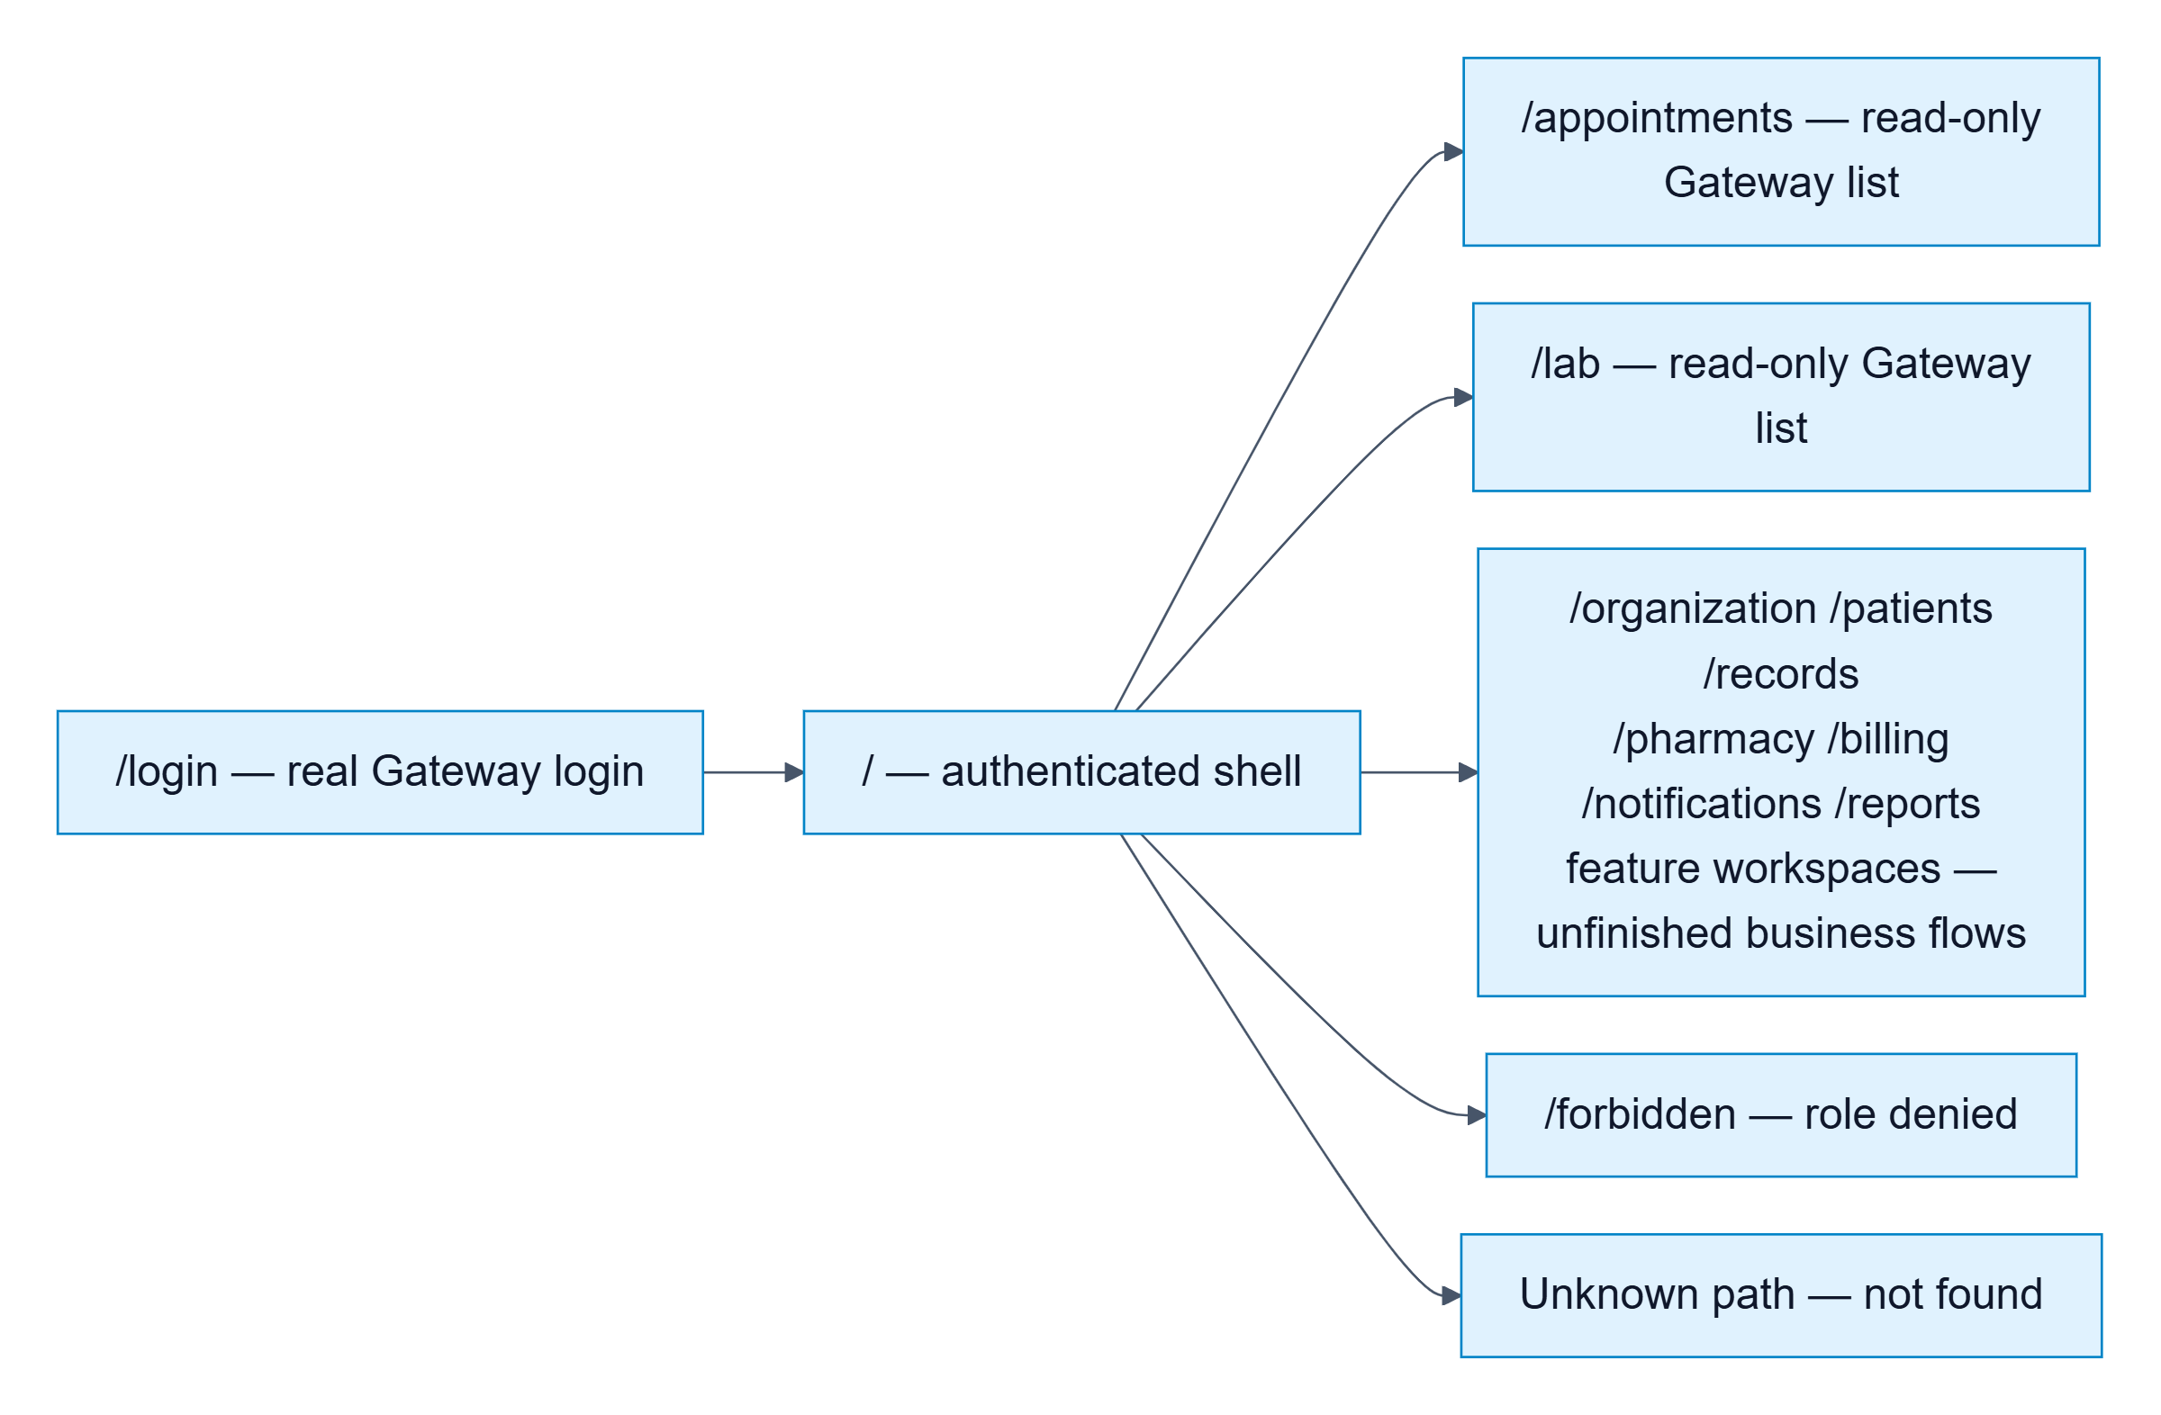

Algorithm

Prescription creation and stock reservation
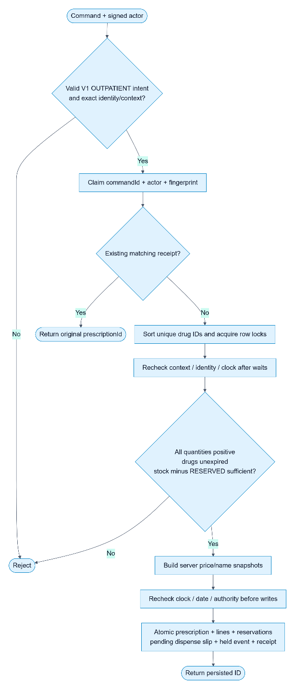

Idempotent payment recording

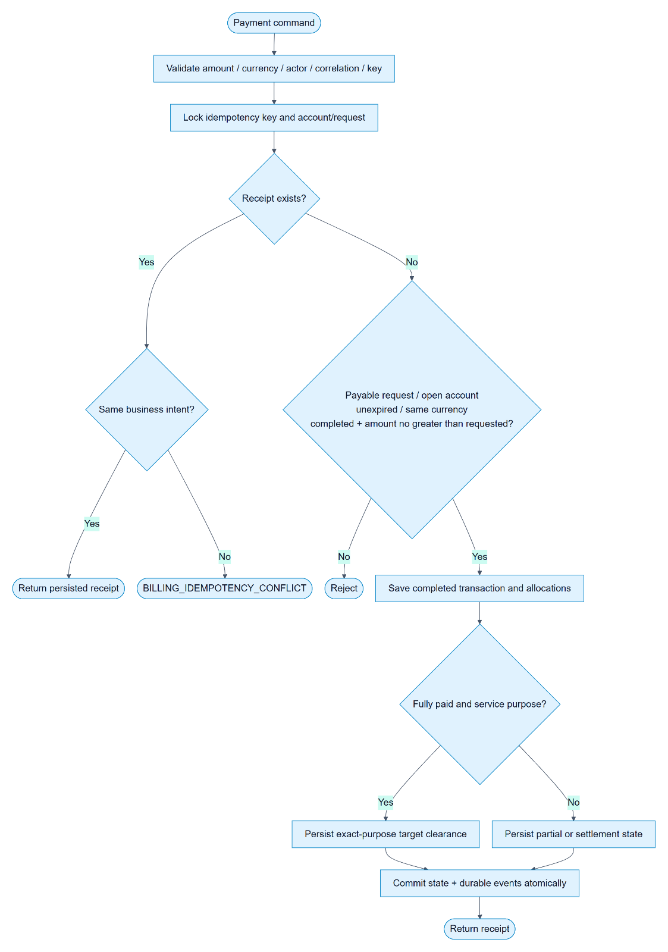

Event delivery, deduplication and recovery
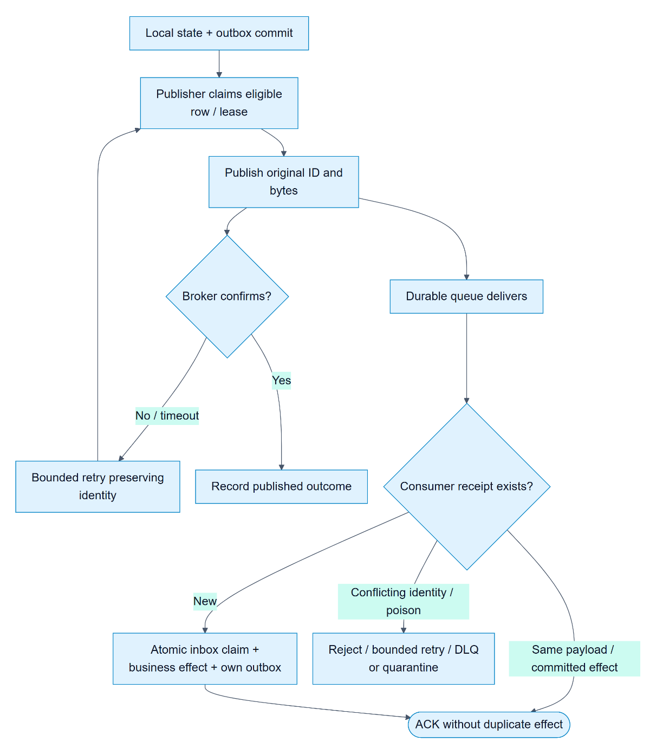

Tasksheet Review 2
Project Ref. No |  | Project Title | Activity Plan Prepared By | Date of Preparation of Activity Plan
No. | Task | Project Title | Activity Plan Prepared By | Actual Start Date | Actuals Days | Teammate  Names | Status
1 | Architecture Design | Mediflow | Dang Vinh | 18/10/2026 | 2 | All members | Completed
2 | Data Flow Diagram | Mediflow | Dang Vinh | 18/10/2026 | 2 | All members | Completed
3 | Entity Relationship Diagram | Mediflow | Dang Vinh | 18/10/2026 | 2 | All members | Completed

4 | Table Design | Mediflow | Dang Vinh | 18/10/2026 | 2 | All members | Completed
5 | SiteMap | Mediflow | Dang Vinh | 18/10/2026 | 2 | All members | Completed
6 | Algorithm | Mediflow | Dang Vinh | 18/10/2026 | 2 | All members | Completed
7 | Tasksheet review | Mediflow | Dang Vinh | 18/10/2026 | 2 | All members | Completed

Review 03

Screen shots
(Fill Content Here)

Testing document

No. | Feature Tested | Remarks
1 | Authentication — sign in with a valid username and password. | PASS
2 | Authentication — reject invalid credentials and validate required login fields. | PASS
3 | Authentication — reject locked or inactive accounts. | PASS
4 | Session management — sign out, clear the session and prevent access to protected pages after logout. | PASS
5 | Session management — handle expired or invalid tokens and require authentication again. | PASS
6 | Authorization — enforce access for Administrator, Manager, Doctor, Nurse, Laboratory Technician, Pharmacist, Cashier and Patient. | PASS
7 | Authorization — reject direct access to restricted routes and API operations, including manually entered URLs. | PASS
8 | Authorization — prevent a patient from reading another patient's protected information. | PASS
9 | Account management — create a staff-linked account and assign a permitted role. | PASS
10 | Account management — reject duplicate usernames and invalid identity references. | PASS
11 | Account management — update account status and verify the effect of role or account-status changes on authorization. | PASS
12 | Department management — list, search and view department details. | PASS
13 | Department management — create or update department information with required-field validation. | PASS
14 | Department management — validate department type, active status and department-head eligibility. | PASS
15 | Staff management — list, search and view staff details. | PASS
16 | Staff management — create or update staff information, including identity number, contact information and professional fields. | PASS
17 | Staff management — validate duplicate identity information and incompatible job titles or assignments. | PASS
18 | Staff management — transfer staff between departments while preserving a valid current assignment. | PASS
19 | Patient management — list, search, paginate and open patient records. | PASS
20 | Patient management — register a patient using valid demographic and contact information. | PASS
21 | Patient management — update patient information and reload the persisted values. | PASS
22 | Patient management — validate required fields, dates and identifiers, and handle duplicate identities according to the contract. | PASS
23 | Appointment management — list appointments and filter by supported date, status or department criteria. | PASS
24 | Appointment management — create an appointment with valid patient, doctor, department, date and time references. | PASS
25 | Appointment management — reject invalid references, invalid scheduling data and prohibited scheduling conflicts. | PASS
26 | Appointment management — view appointment details and its current care lifecycle. | PASS
27 | Appointment management — update or cancel an appointment only when its current state permits the operation. | PASS
28 | Reception — check in a patient and display the updated appointment state. | PASS
29 | Examination payment gate — prevent examination from starting before the exact examination charge is cleared. | PASS
30 | Examination payment gate — allow examination only after current Billing authorization for the correct patient and care episode. | PASS
31 | Examination — start an examination and create the associated medical record atomically. | PASS
32 | Examination — handle repeated or concurrent start requests without creating duplicate medical records. | PASS
33 | Medical records — list or search supported records and open the correct patient's record. | PASS
34 | Medical records — record clinical information, vital signs and diagnosis using the supported fields. | PASS
35 | Medical records — preserve changes after reload and reject invalid updates or unauthorized modifications. | PASS
36 | Medical records — complete an outpatient examination only when its business prerequisites are satisfied. | PASS
37 | Laboratory ordering — select a supported laboratory test and create an order from a valid clinical record. | PASS
38 | Laboratory ordering — preserve source order, patient, requesting department and care-episode references. | PASS
39 | Laboratory queue — list, paginate, filter and open laboratory requests. | PASS
40 | Laboratory payment gate — create one charge for a laboratory request despite duplicate event delivery. | PASS
41 | Laboratory payment gate — reject execution without valid, current authorization for the exact test. | PASS
42 | Laboratory execution — start an eligible paid test and persist the execution state. | PASS
43 | Laboratory results — enter indicators, values, units, reference ranges and a conclusion. | PASS
44 | Laboratory results — reject invalid result data and prohibited changes to terminal results. | PASS
45 | Laboratory results — publish completed results and expose them to the authorized clinical workflow. | PASS
46 | Laboratory cancellation — apply permitted cancellation without reopening the source or duplicating financial adjustments. | PASS
47 | Drug catalogue — list, search, paginate and view drug details. | PASS
48 | Drug catalogue — validate supported drug information and active availability for prescribing. | PASS
49 | Inventory — record a supported stock increase and reload the resulting stock balance. | PASS
50 | Inventory — reject invalid quantities and prevent negative available stock. | PASS
51 | Prescription management — create a prescription linked to the correct patient, clinical record and care episode. | PASS
52 | Prescription management — validate drug selection, quantity, dosage, frequency and usage instructions. | PASS
53 | Prescription pricing — use server-authoritative prices and retain the accepted price snapshot. | PASS
54 | Prescription reservation — handle insufficient stock for a multi-drug prescription without partial reservation effects. | PASS
55 | Prescription lookup — find a prescription by its supported identifier and display its lines and lifecycle state. | PASS
56 | Prescription payment gate — require current authorization for the exact prescription before dispensing. | PASS
57 | Dispensing — confirm an eligible prescription and record the fulfilled state and stock movement. | PASS
58 | Dispensing — handle repeated commands or duplicate payment events without double dispensing or double stock deduction. | PASS
59 | Prescription lifecycle — handle cancellation, expiry and late payment without reopening a terminal prescription. | PASS
60 | Billing discovery — locate examination, laboratory and prescription payment requests using the correct source and care-episode references. | PASS
61 | Billing calculation — display requested, paid and remaining amounts with the correct currency and decimal handling. | PASS
62 | Payment collection — record a valid supported payment and return the payment receipt. | PASS
63 | Payment collection — reject zero, negative, excessive or otherwise invalid payment amounts according to the contract. | PASS
64 | Payment idempotency — repeat the same payment intent without creating an additional financial effect. | PASS
65 | Billing refresh — reload the authoritative paid status and remaining amount after a successful payment. | PASS
66 | Billing separation — distinguish legacy invoices from outpatient payment requests and ledger records. | PASS
67 | Billing allocation — prevent over-allocation and allocation to the wrong patient or care account. | PASS
68 | Adjustments — apply a permitted cancellation or prescription adjustment with its original source and audit references. | PASS
69 | Refunds — calculate refundable amounts, record an authorized refund and prevent over-refunding or duplicate refund effects. | PASS
70 | Refund and execution concurrency — serialize examination or laboratory start with refund and cancellation decisions. | PASS
71 | Financial audit — preserve original payment links, histories and accepted writes through retries. | PASS
72 | Reports — open the supported report workspace and apply supported reporting-period and department filters. | PASS
73 | Reports — distinguish cash collection, earned revenue, adjustments and refunds according to the report contract. | PASS
74 | Reports — process repeated events without counting the same business contribution twice. | PASS
75 | Reports — distinguish an unavailable or uncovered report from a verified zero-value report. | PASS
76 | Reports — retain stable acceptance ordering and detect conflicting event content during replay. | PASS
77 | Notifications — list and open in-app notifications for the authenticated recipient. | PASS
78 | Notifications — display appointment reminders and supported care-related notification details. | PASS
79 | Notifications — prevent cross-recipient access and duplicate delivery effects during event replay. | PASS
80 | Identity presentation — display the correct patient, doctor and department names instead of using UUID as the only visible label. | PASS
81 | Identity presentation — retain the original identifiers in commands and show an honest fallback when a permitted name lookup fails. | PASS
82 | Web GUI — display shared landing, login, navigation and access-denied pages. | PASS
83 | Web GUI — provide role-appropriate menus, page links and visible actions. | PASS
84 | Web GUI — handle loading, empty, validation, not-found and request-error states with supported retry behavior. | PASS
85 | Web GUI — maintain readable forms, lists and dialogs at the supported desktop and narrow-screen sizes. | PASS
86 | Web GUI — preserve readable text, contrast, keyboard access and labels in supported themes. | PASS
87 | Mobile GUI — authenticate, retain the permitted session and sign out through the configured Gateway. | PASS
88 | Mobile GUI — display the navigation and workspace appropriate to each of the eight roles. | PASS
89 | Mobile GUI — browse supported department, staff and account screens. | PASS
90 | Mobile GUI — browse, search and view patients and use supported patient forms. | PASS
91 | Mobile GUI — browse appointments, change the supported date filter and open the available appointment workflow. | PASS
92 | Mobile GUI — browse laboratory requests and filter by the supported lifecycle status. | PASS
93 | Mobile GUI — integrate supported clinical-record, pharmacy and report workspaces with their actual repositories. | PASS
94 | Mobile GUI — discover a payment request, submit a valid payment and refresh its authoritative balance. | PASS
95 | Mobile GUI — list and open the authenticated patient's notifications. | PASS
96 | Mobile GUI — handle unavailable workspaces, connection failures and small-screen scrolling without presenting unfinished features as completed. | PASS
97 | Session isolation — discard stale responses and cached identity information after a record change, logout or account switch. | PASS
98 | Gateway integration — send web and mobile business requests through the Gateway with the required authentication. | PASS
99 | Gateway security — reject unsupported nested routes, wrong-role requests and invalid token types. | PASS
100 | Integration — propagate examination and laboratory charge requests and prescription payment events between the intended contexts. | PASS
101 | Event reliability — use durable outbox/inbox processing and preserve event identity during retry and redelivery. | PASS
102 | Event reliability — handle poison messages, bounded retry, dead-letter routing and unroutable publication. | PASS
103 | Recovery — resume pending pharmacy work after service interruption without losing or duplicating its business effect. | PASS
104 | Recovery — preserve accepted records and financial effects across database, broker and application restart. | PASS
105 | Transaction integrity — roll back failed multi-step operations without leaving partial clinical, stock or financial state. | PASS
106 | Core reliability — handle repeated staff-creation requests and event publication failures without duplicate identities. | PASS
107 | Deployment — start Core, Clinical, Lab, Pharmacy, Billing and Support with Gateway and Eureka. | PASS
108 | Data boundaries — retain separate context-owned stores and use supported API/event contracts for cross-context data. | PASS
109 | Backup and rollback — validate restoration or current-store rollback while retaining accepted writes and audit history. | PASS
110 | Scope control — keep deferred inpatient and surgery routes, jobs and business actions outside the outpatient MVP acceptance scope. | PASS

Final checklist
No. | Review 01 aspect tested | Suggestion / Remarks
1 | Project title and problem statement describe outpatient care management consistently. | PASS
2 | Project objectives identify the intended users and the operational problems addressed by MediFlow. | PASS
3 | Project scope includes the eight active business contexts and identifies inpatient care and surgery as deferred. | PASS
4 | Functional requirements cover the responsibilities and access boundaries of all eight user roles. | PASS
5 | Non-functional requirements address security, reliability, usability, maintainability and operational recovery. | PASS
6 | Use-case diagrams and descriptions match the active role workflows and business scope. | PASS
7 | The architecture distinguishes six business deployments, eight business contexts, infrastructure and shared libraries. | PASS
8 | Service boundaries, responsibilities and dependencies are consistent across the architecture and implementation documents. | PASS
9 | Sequence diagrams describe appointment, examination, laboratory, prescription, payment and dispensing interactions. | PASS
10 | Class and component diagrams reflect the intended responsibilities and dependency direction. | PASS
11 | Data-flow diagrams describe the main clinical, stock, financial, reporting and notification information flows. | PASS
12 | Entity relationship diagrams and table descriptions match context-owned persistence boundaries. | PASS
13 | Database identifiers, field types, constraints and migrations are documented consistently. | PASS
14 | No cross-context database relationship or direct database lookup is introduced to replace a public service contract. | PASS
15 | API contracts define supported request fields, response fields, validation rules and stable errors. | PASS
16 | Gateway routing, authentication, session handling and role authorization match the intended access model. | PASS
17 | Account, department, staff and patient management cover the required outpatient identity information. | PASS
18 | Appointment booking, reception, examination eligibility and clinical-record creation form a consistent care lifecycle. | PASS
19 | Laboratory ordering, payment authorization, execution, results and cancellation follow the documented lifecycle. | PASS
20 | Prescription pricing, reservation, payment authorization and dispensing preserve stock and financial consistency. | PASS
21 | Billing handles charge discovery, payments, balances, adjustments and refunds with the required audit links. | PASS
22 | Reports distinguish covered data, unavailable data, cash collection and earned activity according to the contract. | PASS
23 | In-app notifications are addressed to the correct recipients and preserve recipient-only access. | PASS
24 | Idempotency, concurrency control and transaction boundaries prevent duplicate or partial business effects. | PASS
25 | Event publication, delivery, replay and failure handling preserve durable business state. | PASS
26 | Web navigation and visible actions are appropriate for Administrator, Manager, Doctor, Nurse, Laboratory Technician, Pharmacist, Cashier and Patient. | PASS
27 | Shared web pages, forms, validation feedback and error states use consistent presentation. | PASS
28 | Patient, doctor and department references display readable names where lookup is available and authorized. | PASS
29 | Web GUI layouts remain readable at supported viewport sizes and in supported themes. | PASS
30 | Mobile architecture, Gateway access, session handling and navigation follow the Flutter project rules. | PASS
31 | Mobile role workspaces are evaluated individually, including supported screens and unfinished or unavailable areas. | PASS
32 | Mobile forms, lists, filters, details and feedback are usable at a phone-sized viewport. | PASS
33 | Native Android/iOS execution evidence is identified separately from Flutter web evidence. | PASS
34 | Demonstration data includes linked accounts, staff, departments, patients, appointments, clinical records, tests, prescriptions and charges. | PASS
35 | Seed data is confined to the isolated demo environment and does not fabricate medical results or financial authorization. | PASS
36 | Backend, web and mobile verification records identify the tested revision, commands, passed cases, failures and skips. | PASS
37 | Integration and recovery evidence uses the required real database and broker rather than relying only on mocked tests. | PASS
38 | Screenshots show common pages, role-specific pages and representative interactions for web and mobile. | PASS
39 | Screenshot captions, numbering and references match the corresponding role, platform and observed runtime state. | PASS
40 | Known issues and unfinished features are recorded in handoffs with owners and observable acceptance criteria. | PASS
41 | The Testing document covers valid, invalid, unauthorized, duplicate, concurrent and failure scenarios. | PASS
42 | The final checklist aligns the report with the approved MVP instead of claiming completion of deferred features. | PASS
43 | Build, configuration and startup instructions describe the environment needed to reproduce the demonstration. | PASS
44 | Database persistence, backup and restart instructions allow the demo data to be retained for later review. | PASS
45 | The final report uses consistent terminology, readable figures, section titles and page references. | PASS
46 | Personal credentials, access tokens and private runtime manifests are excluded from shared report assets and source control. | PASS
47 | Requirements, implementation, test evidence and screenshots can be traced to the same supported workflow. | PASS
48 | Actual acceptance decisions are reconciled against evidence before replacing this pre-filled template with a signed final result. | PASS

Tasksheet Review 3
Project Ref. No |  | Project Title | Activity Plan Prepared By | Date of Preparation of Activity Plan
No. | Task | Project Title | Activity Plan Prepared By | Actual Start Date | Actuals Days | Teammate  Names | Status
1 | Screenshots | Mediflow | Quang Huy | 20/10/2026 | 2 | Hoang Anh | Completed
2 | Testing document | Mediflow | Quang Huy | 20/10/2026 | 2 | Quang Huy | Completed
3 | Final checklist | Mediflow | Quang Huy | 20/10/2026 | 2 | Dang Vinh | Completed

4 | Tasksheet review |  |  | 20/10/2026 | 2 | The Loc | Completed
Project Detail Tasksheet
1 | Core: accounts, staff, departments/rooms, patients, authentication, and authorization. | MediFlow | Vinh | 14/10/2026 | 15 | Hoàng Anh | Completed
2 | Gateway: routing, JWT authentication, role-based access control, and lookup APIs. | MediFlow | Vinh | 02/10/2026 | 27 | Hoàng Anh | Completed
3 | Clinical: appointments, patient reception, medical records, diagnoses, and laboratory orders. | MediFlow | Vinh | 10/10/2026 | 15 | Vinh | Completed
4 | Lab: order reception, test results, laboratory workflow management, and payment eligibility checks. | MediFlow | Vinh | 02/10/2026 | 16 | Vinh | Completed
5 | Pharmacy: medicine catalogue, inventory, prescriptions, dispensing/cancellation, and dispensing eligibility checks. | MediFlow | Vinh | 02/10/2026 | 20 | Huy | Completed
6 | Report and Support: reporting, data coverage controls, service hosting consolidation, and separate data stores. | MediFlow | Vinh | 02/10/2026 | 15 | Huy | Completed
7 | Billing/Notification: foundational contributions to payment processing, payment request discovery, event publication/recovery, and notifications. | MediFlow | Vinh | 06/10/2026 | 10 | Lộc | Completed
8 | Billing/Notification: backend takeover, security improvements, event replay, preservation of original event bytes, and regression testing. | MediFlow | Vinh | 03/10/2026 | 20 | Vinh | Completed
9 | Shared Web: login, session management, role-based navigation, responsive layouts, and name-based lookups. | MediFlow | Vinh | 08/10/2026 | 20 | Vinh; Huy; Hoàng Anh | Completed
10 | Web Organization/Patient: lists, search, details, forms, and account management. | MediFlow | Vinh | 02/10/2026 | 20 | Hoàng Anh | Completed
11 | Web Clinical/Lab: appointments, patient reception, medical records/diagnoses, laboratory orders, and test results. | MediFlow | Vinh | 03/10/2026 | 15. | Vinh | Completed
12 | Web Pharmacy/Report: medicines, inventory, prescriptions/dispensing, filtering, and report queries. | MediFlow | Vinh | 14/10/2026 | 16. | Huy | Completed
13 | Web Billing/Notification: payments, revenue reports, refunds/adjustments, event outbox management, and notifications. | MediFlow | Vinh | 15/10/2026 | 7 | Lộc | Completed
14 | Shared Mobile and outpatient workspaces, including Organization/Patient and Billing/Notification features added under the handover scope. | MediFlow | Vinh | 17/10/2026 | 10 | Vinh | Completed
15 | Mobile Pharmacy/Report: medicine catalogue, prescriptions, dispensing actions, and report queries. | MediFlow | Vinh | 20/10/2026 | n.a. | Huy | Completed

Acknowledgments and Declaration
Project Documentation for Mediflow
Completed on 30/10/2025
The documentation for the Mediflow project was completed on November 30, 2026. Our team would like to express our gratitude to our supervisor, Mr. HOÀNG ĐỨC QUANG, for his guidance and valuable feedback throughout the project. We also appreciate the constructive input from our fellow students, which contributed to the refinement of our work.
We also thank Project Aptech for providing us with the opportunity to work on this real-world project, which helped us apply our academic knowledge in a practical scenario.
This document is the result of our team’s efforts, based on the knowledge we have gained during our studies and additional research. We confirm that the content is original and accurate, with no unauthorized copying or plagiarism. Our team is committed to maintaining academic integrity and ensuring the quality of this project.
This is a complete document that reflects the efforts and research of our team as students who are still learning and have not yet entered the professional workforce. We are grateful to our teacher for his support throughout this project. The content is based on the knowledge we have acquired during our studies and reliable sources.

