

MediFlow
A Microservices – Based Distributed Hospital Management System

Supervisor: | HOÀNG ĐỨC QUANG
Semester: | 04
Batch No: | T2.2410.E0
Group No: | 04
Order: | Full name | Roll No.
1. | Phạm Đăng Vinh | Student1614910
2. | Lê Quang Huy | Student1394600
3. | Trần Hoàng Anh | Student1614884
4. | Thân Thế Lộc | Student1571994

Month: 10 Year: 2026


This is to certify that
Mr. | PHAM DANG VINH
Mr. | LE QUANG HUY
Mr. | TRAN HOANG ANH
Mr. | THAN THE LOC

Have successfully Designed & Developed
MEDIFLOW
A MICROSERVICES – BASED DISTRIBUTED HOSPITAL MANAGEMENT SYSTEM

Submitted by:
Mr. HOANG DUC QUANG

Date Of Issue:

Authorized Signature:

Content

Content 3
Acknowledge 4
Synopsis 6
Review 01 7
Problem Definition 8
Customer Requirements Specifications 18
Review 02 36
Architecture Design 37
Data Flow Diagram 38
Entity Relationship Diagram 39
Table Design 40
SiteMap 41
Algorithm 42
Review 03 43
Screen shots 44
Testing document 61
Final checklist 74
Tasksheet 80
Acknowledgments and Declaration 97

Acknowledge

As we approach the completion of our MediFlow – Microservices-Based Distributed Hospital Management System project, we are filled with gratitude, pride, and a sense of accomplishment. This project has been a valuable opportunity to apply our academic knowledge, strengthen our technical skills, and gain practical experience in developing complex software systems.
Heartfelt Gratitude to Our Mentors
First and foremost, we would like to express our sincere gratitude to the Project Team at FPT Aptech for providing us with the knowledge, resources, and opportunity to undertake this meaningful project.
We are especially thankful to our lecturer, Mr. LE THANH NHAN, for his dedicated guidance, patience, and valuable feedback throughout the development process. His mentorship has helped us overcome technical challenges, improve our problem-solving abilities, and develop a more professional approach to software engineering.
Appreciation for Our Team and Families
We extend our heartfelt appreciation to every member of Team 04 for their dedication, teamwork, and perseverance. Through close collaboration, we have explored and developed a distributed healthcare platform encompassing ten business domains: Organization, Patient, Clinical, Laboratory, Pharmacy, Billing, Notification, Reporting, Inpatient, and Surgery.
We are equally grateful to our families, friends, and classmates for their continuous encouragement and understanding throughout this journey.
A Meaningful Learning Experience
The MediFlow Project has provided us with valuable experience in microservices architecture, distributed systems, database design, event-driven communication, and cross-platform application development. By working with technologies such as Spring Boot, Spring Cloud, RabbitMQ, PostgreSQL, Next.js, and Flutter, we have gained a deeper understanding of modern software engineering practices and the challenges of integrating independent healthcare services.
Beyond technical knowledge, this project has strengthened our communication, adaptability, responsibility, and collaborative problem-solving skills.
Looking Forward
As we conclude this important milestone, we believe the knowledge and experience gained from MediFlow will serve as a strong foundation for our future careers in information technology.
Once again, we sincerely thank everyone who has supported and contributed to our journey.
With heartfelt gratitude,
TEAM 04
MediFlow – Microservices-Based Distributed Hospital Management System

Synopsis
MediFlow – Microservices-Based Distributed Hospital Management System is a healthcare management project designed to address the fragmentation of patient information, hospital operations, and medical workflows across different departments. The system aims to improve coordination, streamline administrative processes, and support efficient healthcare service delivery through a distributed software architecture.
Built on a microservices-based and event-driven architecture, MediFlow encompasses ten business domains: Organization, Patient, Clinical, Laboratory, Pharmacy, Billing, Notification, Reporting, Inpatient, and Surgery. These services are designed to manage distinct healthcare responsibilities while enabling coordinated workflows, including patient registration, appointment scheduling, clinical examinations, laboratory testing, prescription management, payment processing, medication dispensing, inpatient care, and surgical procedures.
The project utilizes Java Spring Boot, Spring Cloud Gateway, Netflix Eureka, RabbitMQ, and PostgreSQL for backend development, service discovery, asynchronous communication, and data management. Next.js and Flutter are used to develop web and mobile applications, providing role-based interfaces for healthcare professionals and administrative personnel.
MediFlow follows essential software engineering principles, including Domain-Driven Design, Clean Architecture, database-per-service ownership, RESTful API communication, and event-driven integration. These approaches promote modularity, maintainability, scalability, and separation of responsibilities across independent services.
As an academic project under active development, MediFlow demonstrates the practical application of distributed systems and modern software engineering technologies in the healthcare domain. Beyond its functional scope, the project provides valuable experience in system architecture, collaborative development, integration testing, and solving complex real-world business problems.
Keywords: Hospital Management System, Healthcare Information System, Microservices, Distributed Systems, Event-Driven Architecture, Spring Boot, RabbitMQ, Next.js, Flutter.

Review 01

Problem Definition

Introduction and Context
MediFlow coordinates departments throughout an outpatient journey: reception, examination, laboratory tests, prescribing, payment, and dispensing. Records share a patient identity while each department remains responsible for its own data and business decisions. Users access the web application through the API Gateway.
The project focuses on an outpatient workflow that can be verified end to end, including message redelivery and temporary service outages

Problem Identification

Disconnected patient information, appointments, and clinical records cause repeated entry and make progress difficult to track.

Doctors, the laboratory, and the pharmacy lack consistent handoff status, increasing the risk of missed orders or results.

Payment status is not clearly tied to each visit, test, or prescription, making service authorization difficult to control.

Poor coordination of stock, reservations, and dispensing can cause duplicate dispensing or insufficient stock.

Successful payment followed by dispensing failure requires traceable compensation rather than a lost transaction.

Reports and notifications lag behind operations; users struggle to distinguish missing data from a measured zero.

Medical and financial information requires access restrictions based on role, work scope, and record ownership.

Project Objectives

Link identity, appointments, visits, tests, prescriptions, and payments through explicit references.

Enforce the relevant business and financial conditions before examination, test processing, and dispensing.

Prevent duplicate financial or stock effects when requests or events are processed again.

Update reports and notifications from events while preserving fault tracing and recovery.

Define acceptance criteria for successful workflows, access denial, redelivery, and partial failure.

Project Scope
Service | Responsibility
Core | Accounts, staff, departments, reference room data, and patient identity
Clinical | Appointments, check-in, records, diagnosis, orders, and outpatient completion
Lab | Accept test requests, track processing, and return results
Pharmacy | Drug catalogue, stock, prescriptions, reservations, and dispensing
Billing | Charges, invoices/payment requests, payments, service clearance, and compensation/refunds
Support | Reporting read models and in-app notifications
Gateway and Eureka are infrastructure; common is a shared library. Core and Support co-host modules while retaining each context's data and business boundaries. The design retains eight active context stores; six services do not imply six databases.

Users and Stakeholders
The eight human roles are ADMIN, DOCTOR, NURSE, PHARMACIST, CASHIER, LAB_TECH, MANAGER, and PATIENT. SYSTEM is a service identity for automated processing, not a human login account. Functions for each role are listed in B1.
Stakeholders include patients, reception staff, doctors, the laboratory, the pharmacy, cashiers, management, and the development team. Departments agree on requirements and verify outcomes within their authorized responsibilities.

Proposed Solutions
The Next.js/TypeScript/Tailwind web application accesses the backend through Gateway. The backend uses Java 21, Spring Boot, Maven, PostgreSQL, RabbitMQ, and Eureka. Each context owns its data; contexts do not query each other's databases. REST supplies information needed immediately; events support handoffs and asynchronous updates. Outbox delivery, duplicate protection, bounded retries, and dead-letter queues support recovery.
The main workflow is identity → check-in → examination payment → examination → tests if needed → prescription if needed → medication payment → dispensing → outpatient completion → report/notification updates. When tests are ordered, their fees and authorization are checked before protected laboratory actions.

Customer Requirements Specifications

Functional Requirements
The following functions are fucntional requirements. Each action must respect endpoint permissions, clinical authority, and record access boundaries. A role does not grant access to every record. This list neither adds APIs nor expands default permissions.

ADMIN — Administrator

Manage accounts, roles, active status, and account locking.

Manage departments, staff, and reference data required for outpatient care.

Link accounts to staff or patients using an authoritative identity source.

Inspect system status, history, and processing failures within permitted administration scope.

Perform authorized recovery operations with an audit trail, without bypassing financial or clinical conditions.

DOCTOR — Doctor

View appointments and patient records within the assigned scope.

Start an examination only with valid EXAM clearance for the exact visit; emergency exceptions use only the supported, audited mechanism.

Record examination findings, diagnosis, and outpatient disposition.

Create explicit laboratory orders and view results returned for the corresponding record.

Author prescription content; Pharmacy validates and owns prescriptions, prices, stock, and reservations.

Follow test results and dispensing status, and complete the outpatient record when its conditions are met.

NURSE — Nurse / Reception Support

Search, create, and update patient information within granted permissions.

Assist with appointment registration and departmental schedule tracking.

Perform check-in, update permitted reception status, and hand patients over to doctors.

View visit information and processing progress needed for care coordination.

Check-in does not itself authorize examination or replace financial verification.

LAB_TECH — Laboratory Technician

View valid existing test requests and permitted related information.

Start test processing only with unexpired LAB_TEST clearance matching the exact test.

Update processing status and cancel when the workflow permits.

Record a non-empty result with a valid performed date and complete the test.

Publish results to relevant departments through the Lab workflow.

PHARMACIST — Pharmacist

Manage and search the drug catalogue, stock, available quantities, and expiry information.

Receive doctor-authored prescription content and verify patient identity and outpatient clinical context.

Create/process permitted prescriptions using server catalogue prices and line-level reservations.

Check PRESCRIPTION clearance for the exact prescription, reservation validity, and stock before dispensing.

Confirm dispensing; apply the stock effect once only when all lines satisfy the conditions.

Cancel or expire prescriptions through the supported workflow, release reservations, and report failures to Billing when financial adjustment is required.

A payment receipt does not automatically replace dispensing authorization in the target workflow.

CASHIER — Cashier

Find charges belonging to the exact visit/patient within permitted service scope.

Create invoices or payment requests from valid charges in the same visit account.

Record payments and inspect transaction status and corresponding documents.

Track financial clearance for the exact examination, test, or prescription; do not manually grant access using a patient-wide paid flag.

Process compensation/refunds through Billing's workflow and authorization when cancellation or dispensing failure requires it.

Inspect transaction history for reconciliation; do not rewrite or delete history to force a balance match.

MANAGER — Manager

View reports on visits, tests, prescriptions, and dispensed quantities.

View cash received, refunds, and net cash from available authoritative sources.

Filter reports using criteria supported by the reporting contract.

Distinguish missing source coverage from zero, and cash received from earned revenue.

Track report freshness without modifying source business data from reporting screens.

PATIENT — Patient

Sign in and access information associated with their own patient identity.

View and update permitted personal information.

Request, view, and track their own appointments through supported workflows.

View their own examination information, test results, and prescriptions approved for patient access.

View their own charges, invoices, payment status, and dispensing status through available contracts.

View in-app notifications addressed to them; do not access another patient's records or notifications.

SYSTEM — Service Identity

Transfer valid outpatient events between contexts while preserving identifiers and traceability.

Automatically create charges/service clearance from valid business sources in the selected profile.

Handle redelivery, retries, and pending-work recovery without duplicate financial or stock effects.

Update reporting read models and create in-app notifications for the correct recipients.

Move messages that remain unprocessable after bounded retries to dead-letter handling for inspection.

Do not substitute service tokens for human accounts on operations requiring an authenticated human actor.

Hardware / Software requirements

Client requirements

Hardware
Client profile | Minimum | Recommended
Staff desktop/laptop | 64-bit dual-core CPU, 4 GB RAM, 1366×768 display, stable network | Modern 4-core CPU, 8 GB RAM, Full HD display, wired or reliable Wi-Fi
Patient browser device | Recent smartphone, tablet, or computer with at least 2 GB available memory | Device receiving current OS/browser security updates, 4 GB or more memory
Development workstation | 64-bit 4-core CPU, 16 GB RAM, 30 GB free storage | 8-core CPU, 32 GB RAM, SSD with 60 GB or more free storage
Shared reception/lab terminal | Keyboard, pointing device, 1366×768 display, reliable network | Full HD display, barcode-capable peripherals where locally required, UPS-backed power

Software
Item | Requirement
Browser | Current Chrome, Edge, Firefox, or Safari with JavaScript, cookies, and HTTPS enabled
Operating system | A vendor-supported Windows, macOS, Linux, Android, or iOS release
Network | Stable access to the deployed HTTPS endpoint through approved firewall/proxy rules
Document tools | Microsoft Word, LibreOffice Writer, or compatible tool for report conversion
Mobile status | Responsive browser access is assumed; a complete native mobile client is not currently delivered

Server requirements

Hardware
Environment | CPU | Memory | Storage | Intended use
Developer demonstration | 8 logical cores | 16 GB RAM | 40 GB free SSD | Local containers, selected services, frontend, and tests
Team integration | 16 logical cores | 32 GB RAM | 150 GB SSD | Concurrent services, shared testing, sample data, and monitoring
Initial production baseline | 24+ logical cores distributed across hosts | 64+ GB RAM distributed | 500+ GB resilient SSD plus backups | Starting point only; must be validated by performance and recovery tests

Acceptance Criteria

Verify login and reject locked accounts, wrong roles, wrong token types, and cross-patient access.

Register a patient and appointment and perform check-in; examination is blocked without clearance and permitted with the exact valid clearance.

Create a test request; missing, wrong, or expired clearance blocks processing; valid results reach Clinical.

Create a prescription with server prices and reservations; pay for the correct target; dispense once without negative stock or partial order effects.

Repeated payment requests/events do not duplicate payments, charges, or stock effects.

Stop/restart Pharmacy and simulate failure after commit; pending work resumes without lost or duplicate effects.

Cancellation, expiry, dispensing failure, and late payment preserve terminal states; Billing compensates once in the selected mode and does not claim a completed refund without evidence.

Reports and notifications update asynchronously for the correct recipients; report replay does not resend notifications.

Run the six-service profile with infrastructure and preserve accepted data/effects during rollback.

Software
Item | Source-aligned baseline
Java | 21
Spring Boot | 3.3.5
Spring Cloud | 2023.0.3
Backend build | Maven multi-module
Frontend | Next.js 16.2.11, React 19.2.4, TypeScript 5, Tailwind CSS 4, pnpm
Database | PostgreSQL 16-compatible, isolated logical database per service
Messaging | RabbitMQ 3-compatible with operational management support
Discovery | Eureka Server
Containers | Docker Engine and Docker Compose compatible with repository definitions
Production platform services | HTTPS certificate management, secret management, centralized logs/metrics/alerts, backups, time synchronization

Review 02

Architecture Design

Architecture Design
Web calls same-origin /api/*, proxied to Gateway; Flutter calls Gateway through GATEWAY_URL. Gateway verifies JWT/route policy; downstream services enforce roles, ownership and business authority again. PostgreSQL 16 is one development container hosting separate context databases. RabbitMQ supplies per-consumer queues; cross-context SQL is prohibited.
Client side and Server side are explicit boundaries. Labelled request and response arrows show synchronous HTTP traffic; double-headed edges summarize a request and its return path. Dashed event edges are asynchronous messages, not HTTP responses. The Next.js server proxy runs on Server side even though its UI executes on the client. Deployment ports are intentionally omitted.
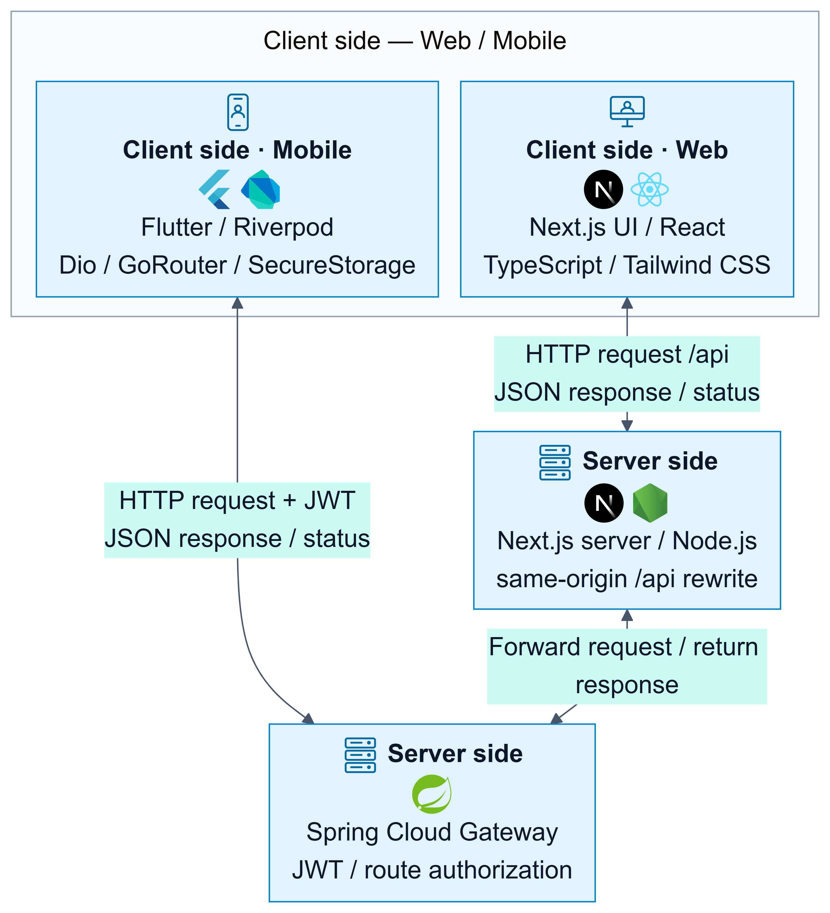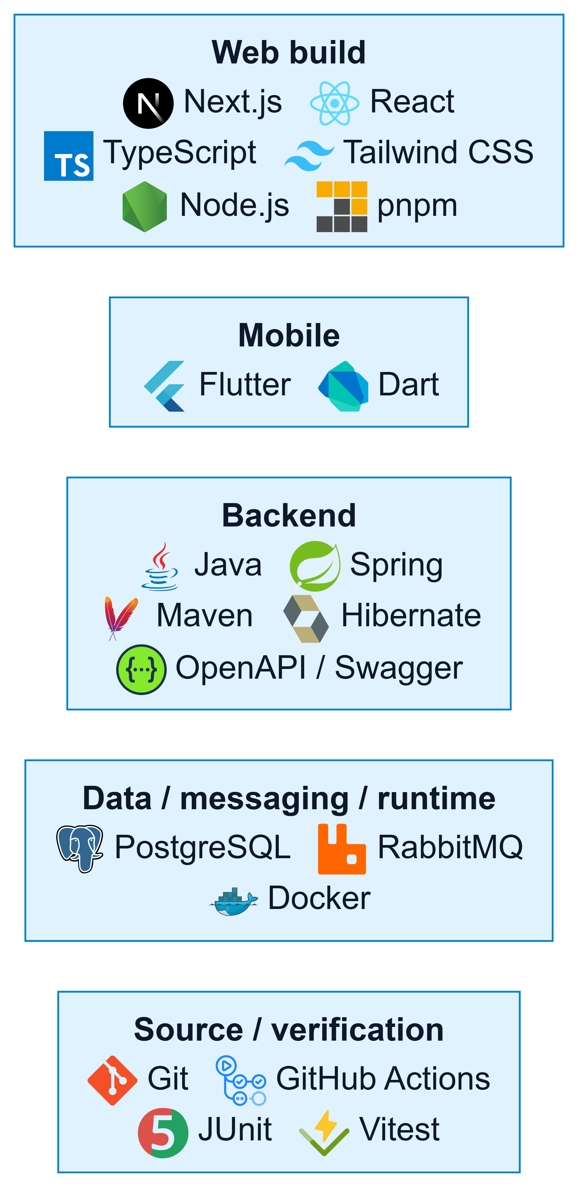
Figure 1.1. Application and Technology Architecture
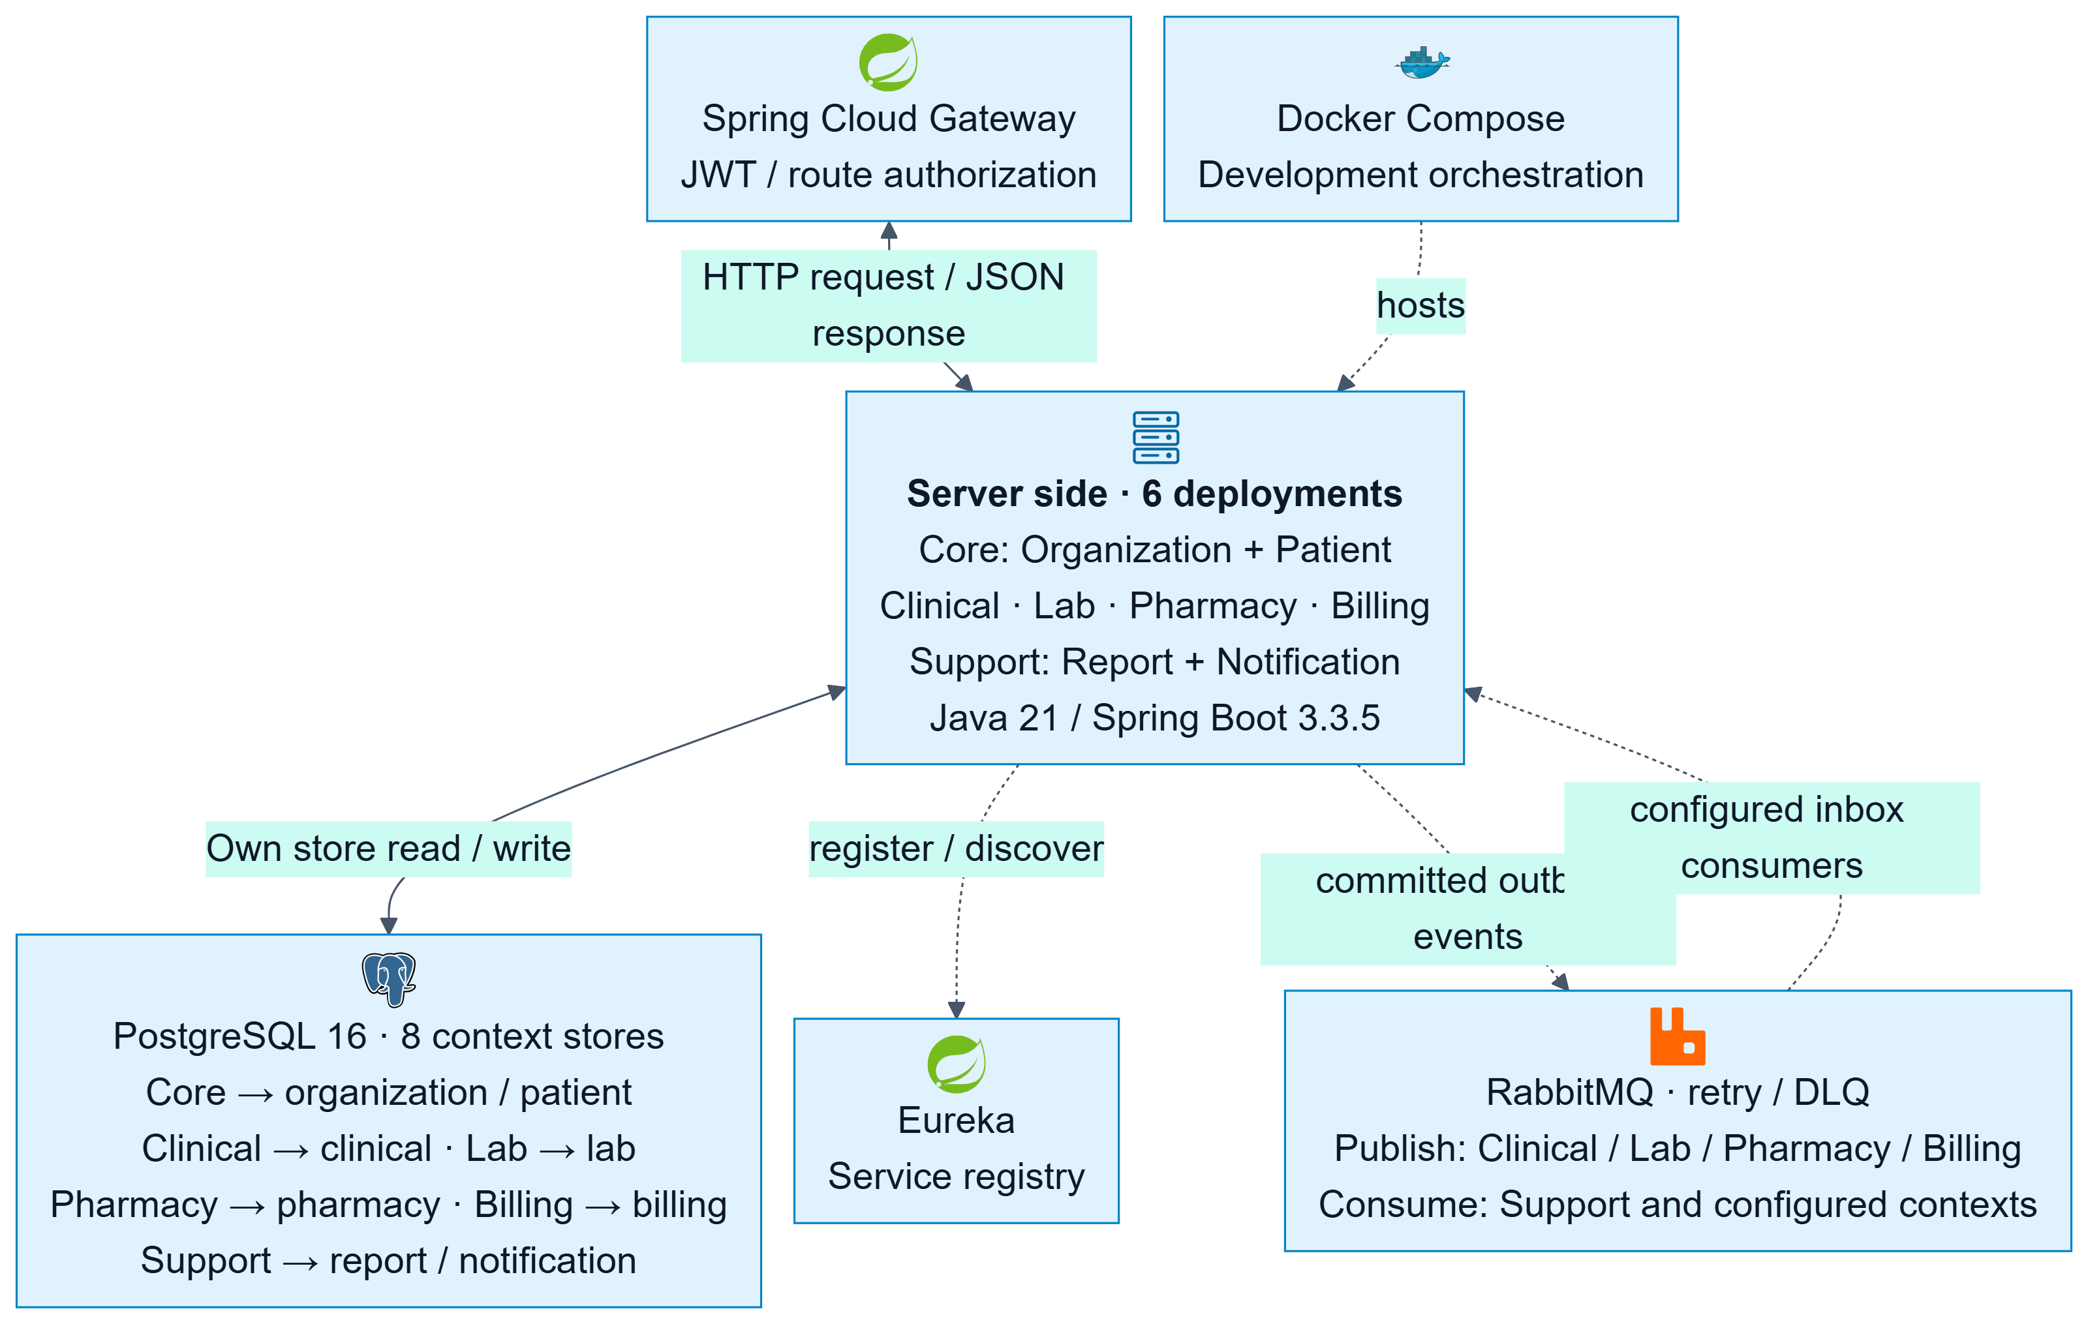
Figure 1.2. System Architecture

Use Cases Diagrams

Reception, clinical and laboratory use cases
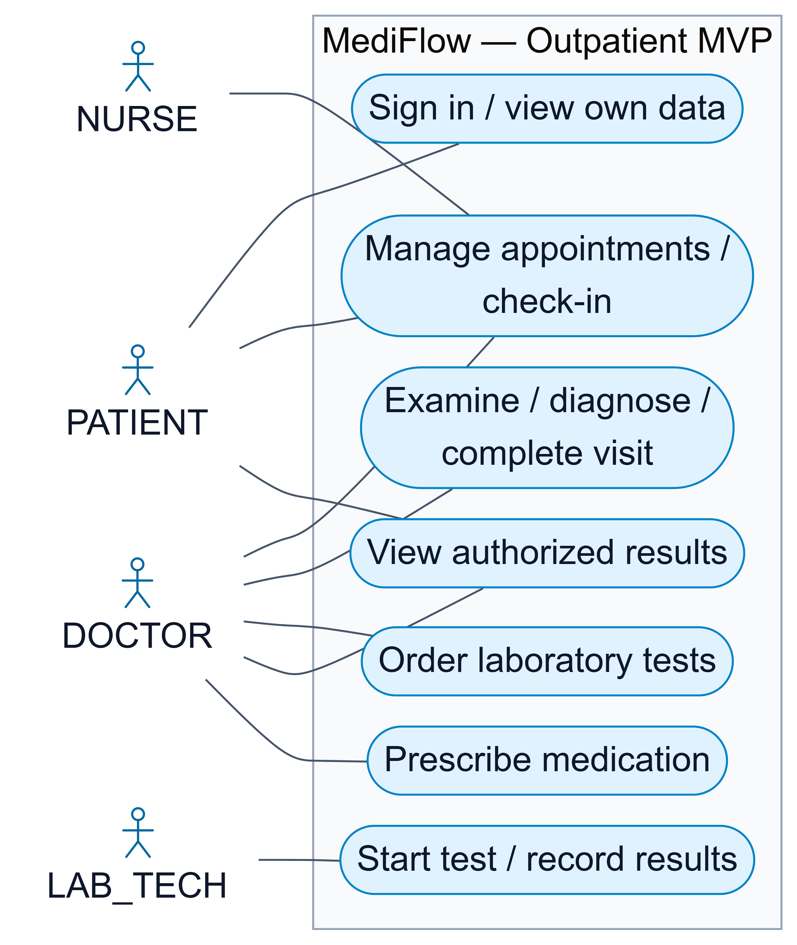

NURSE
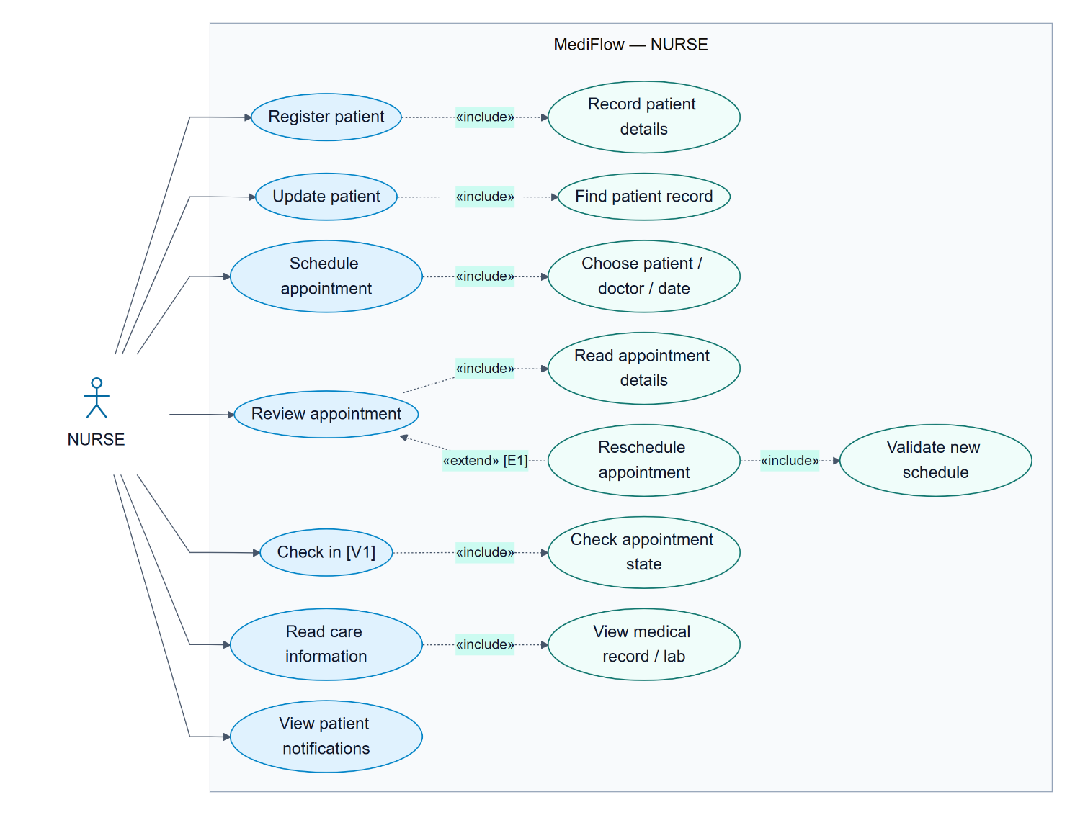

PATIENT
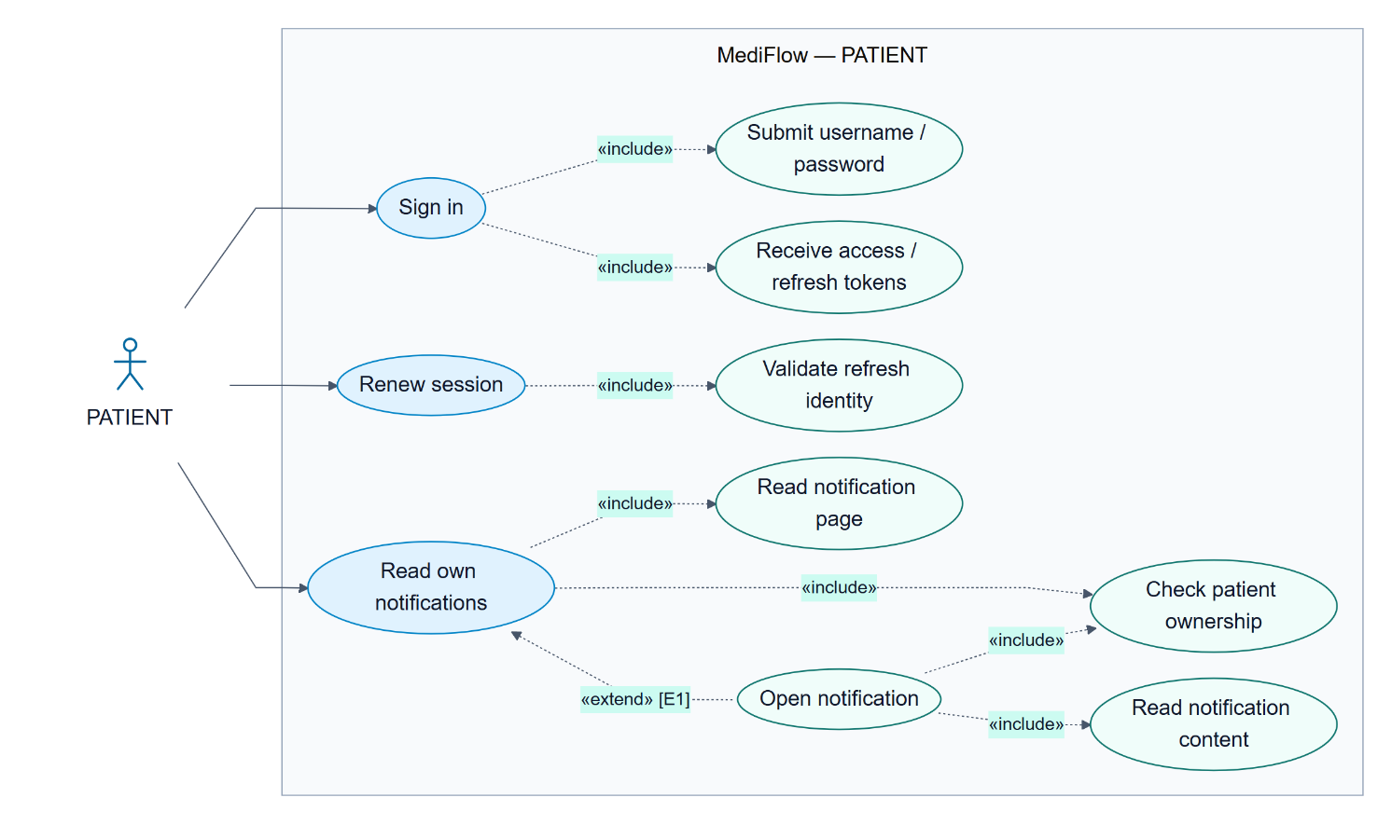

DOCTOR
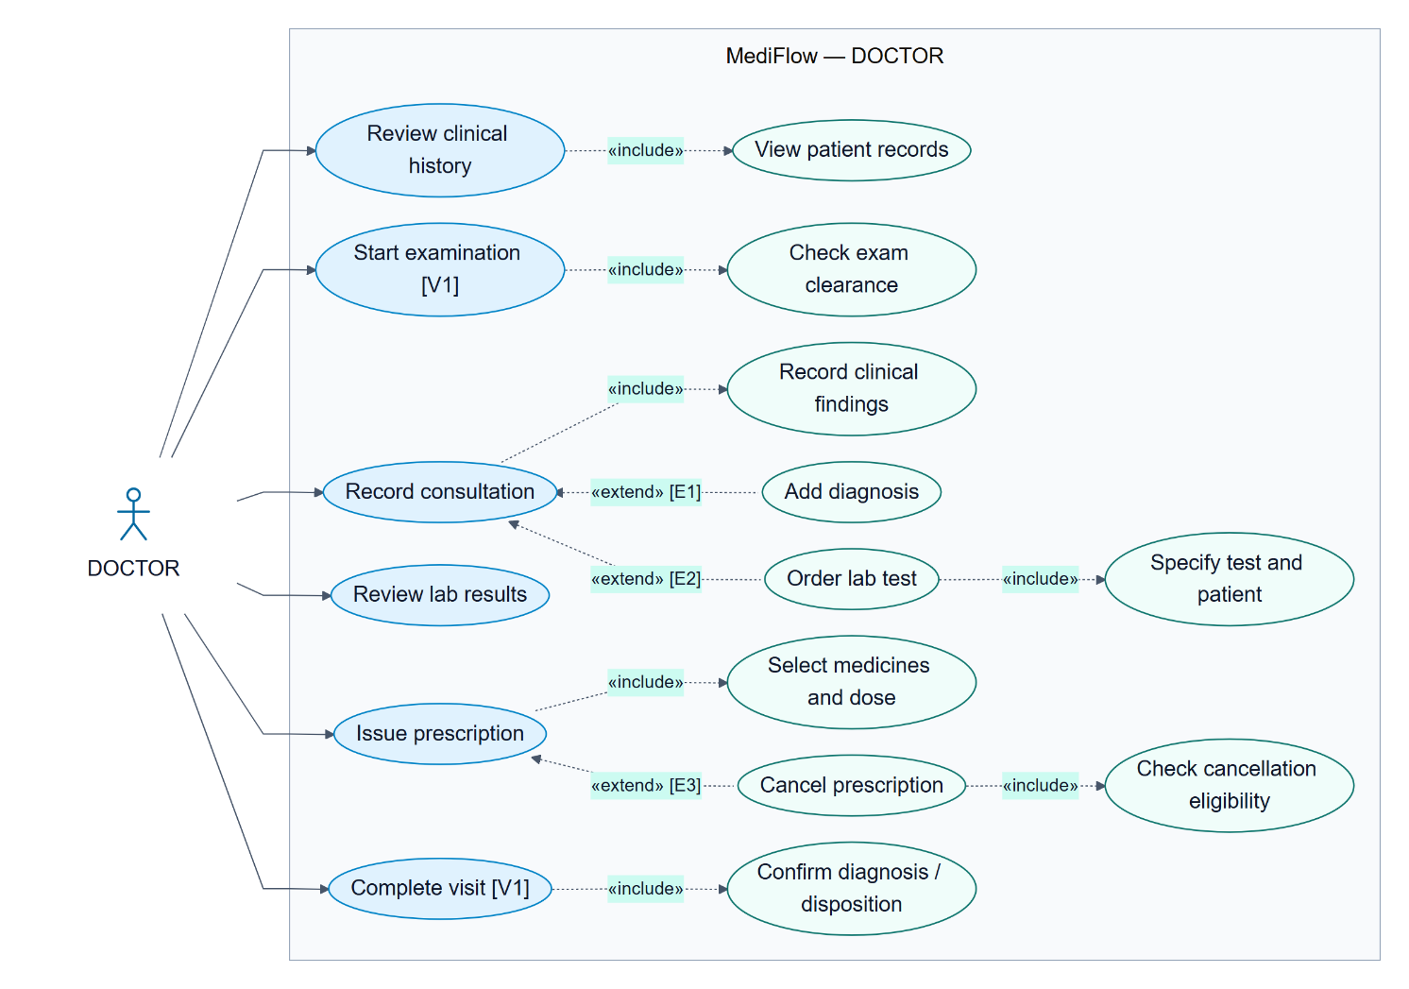

LAB_TECH
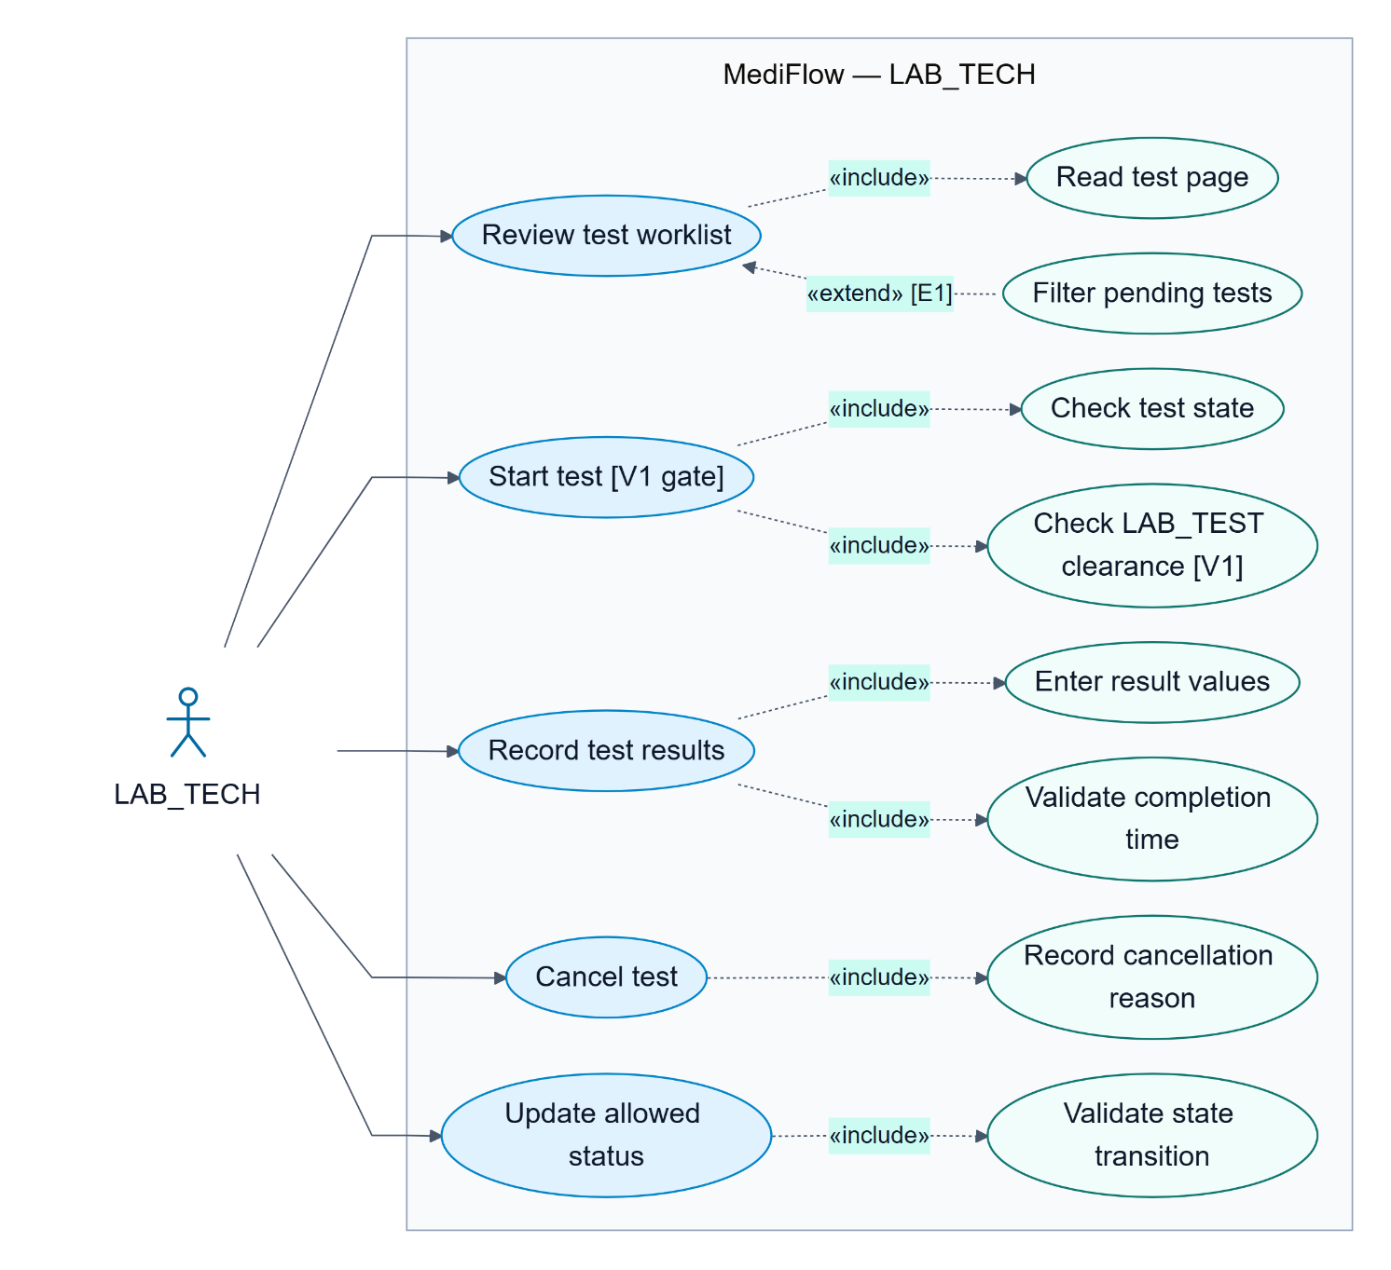

Pharmacy, billing and support use cases
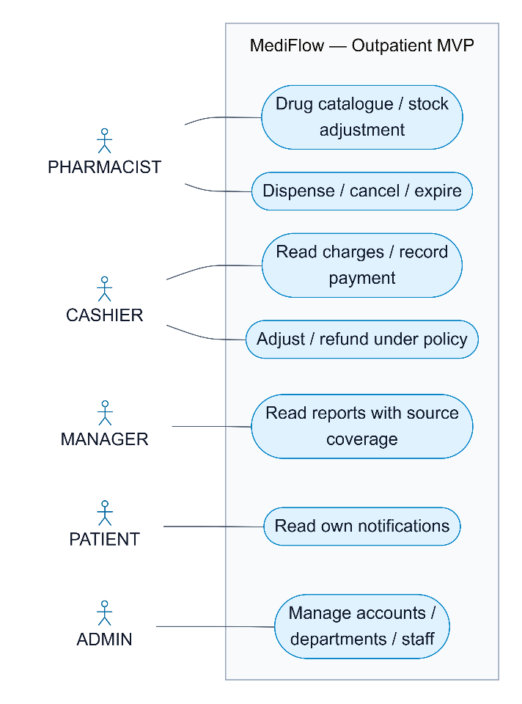

PHARMACIST
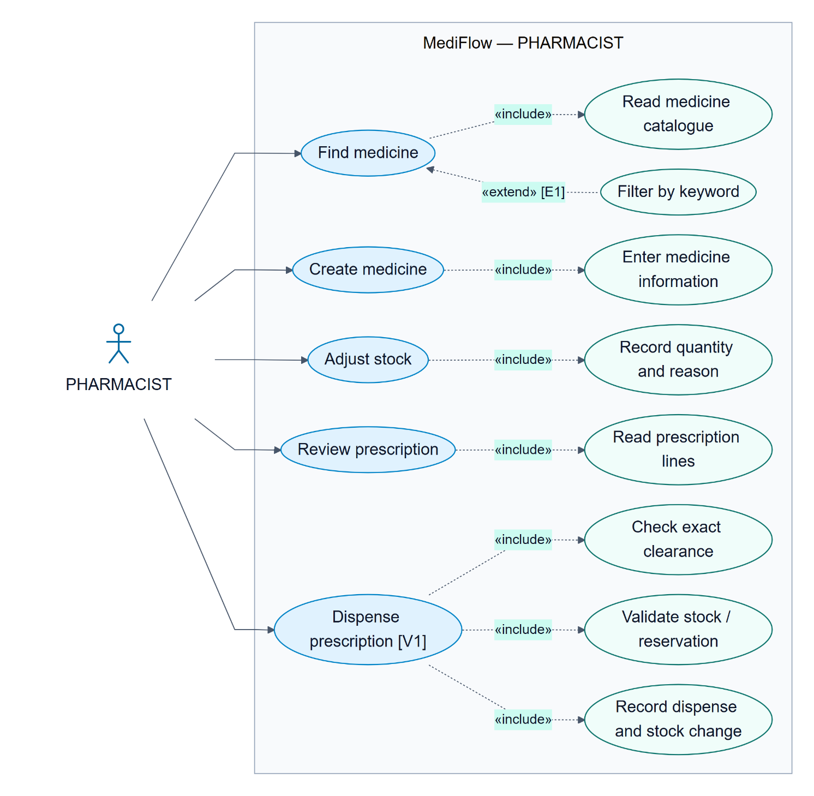

CASHIER
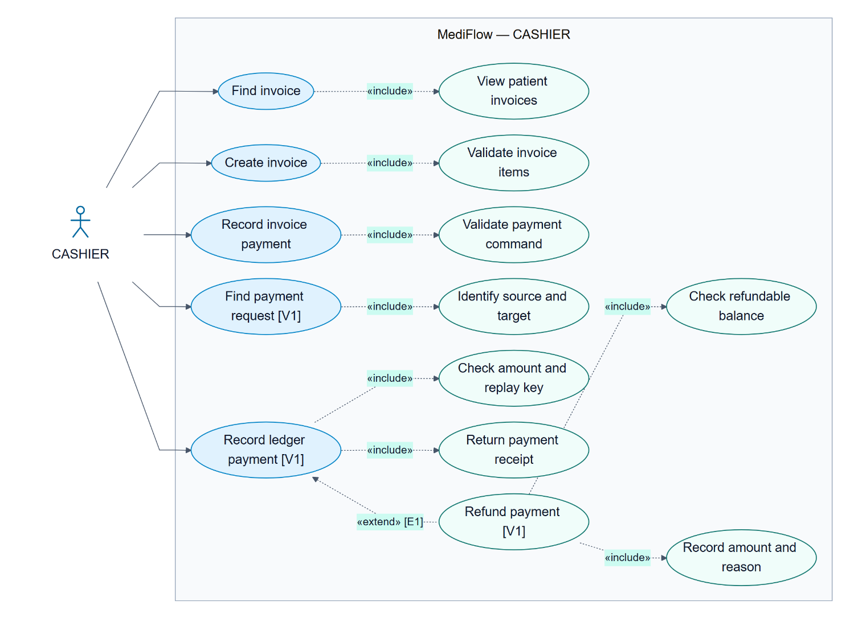

MANAGER
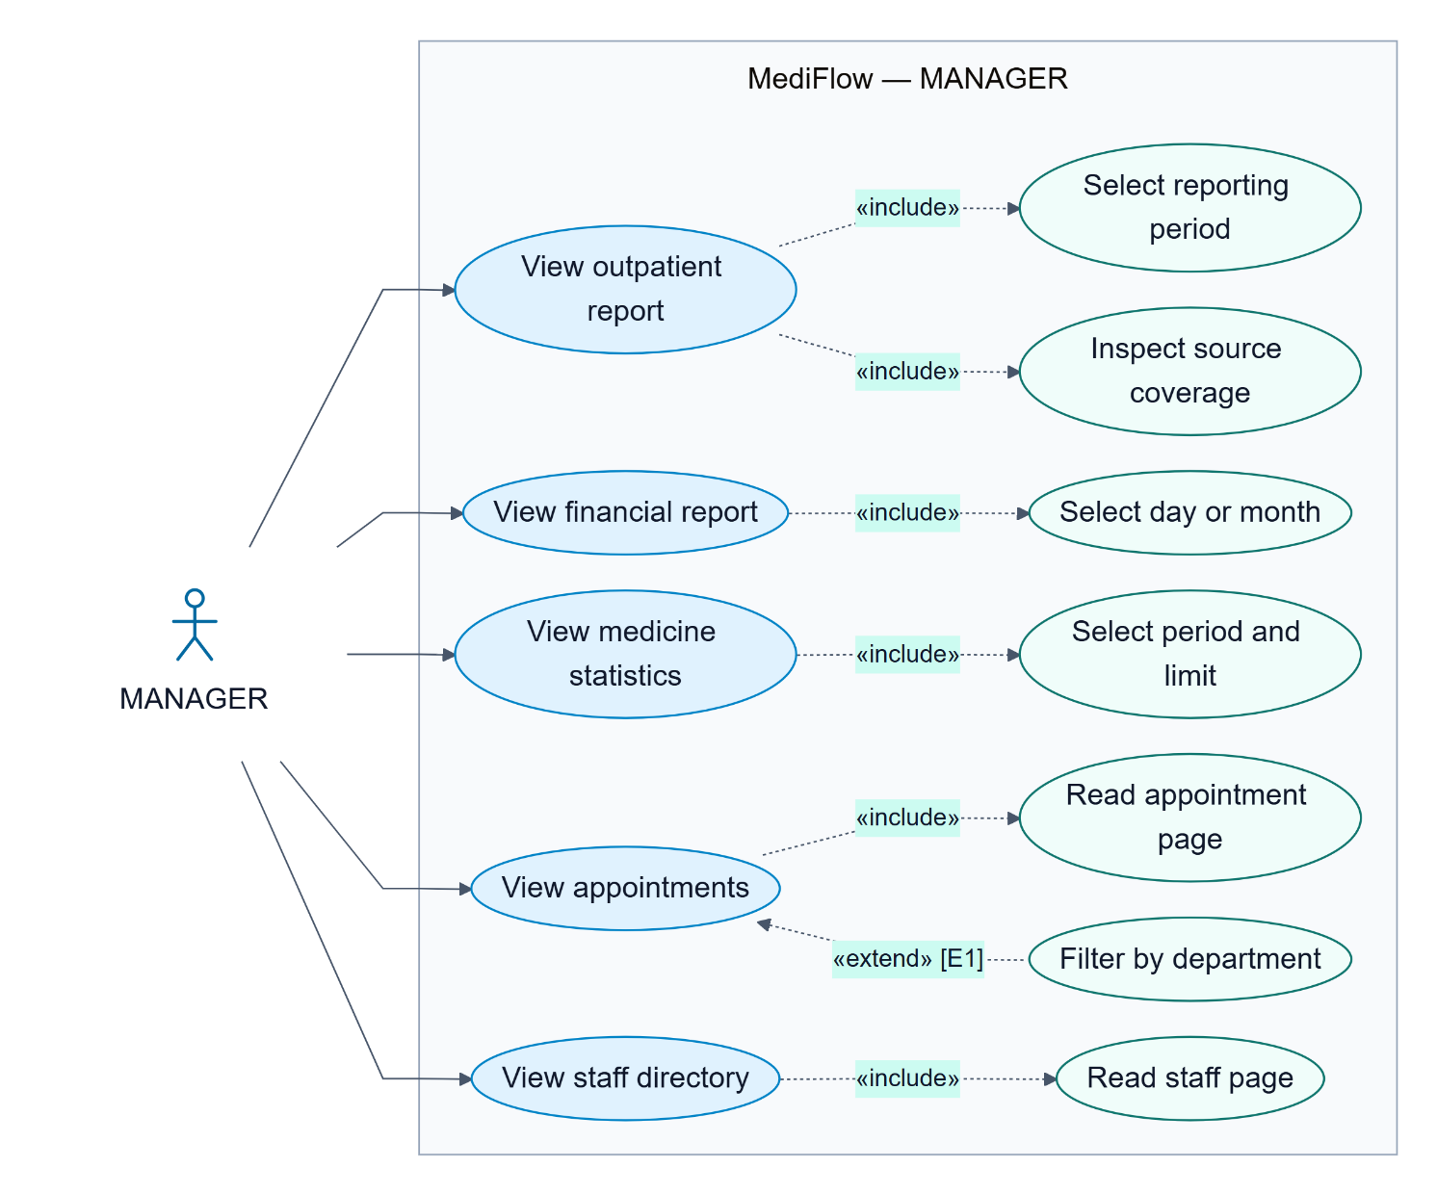

ADMIN
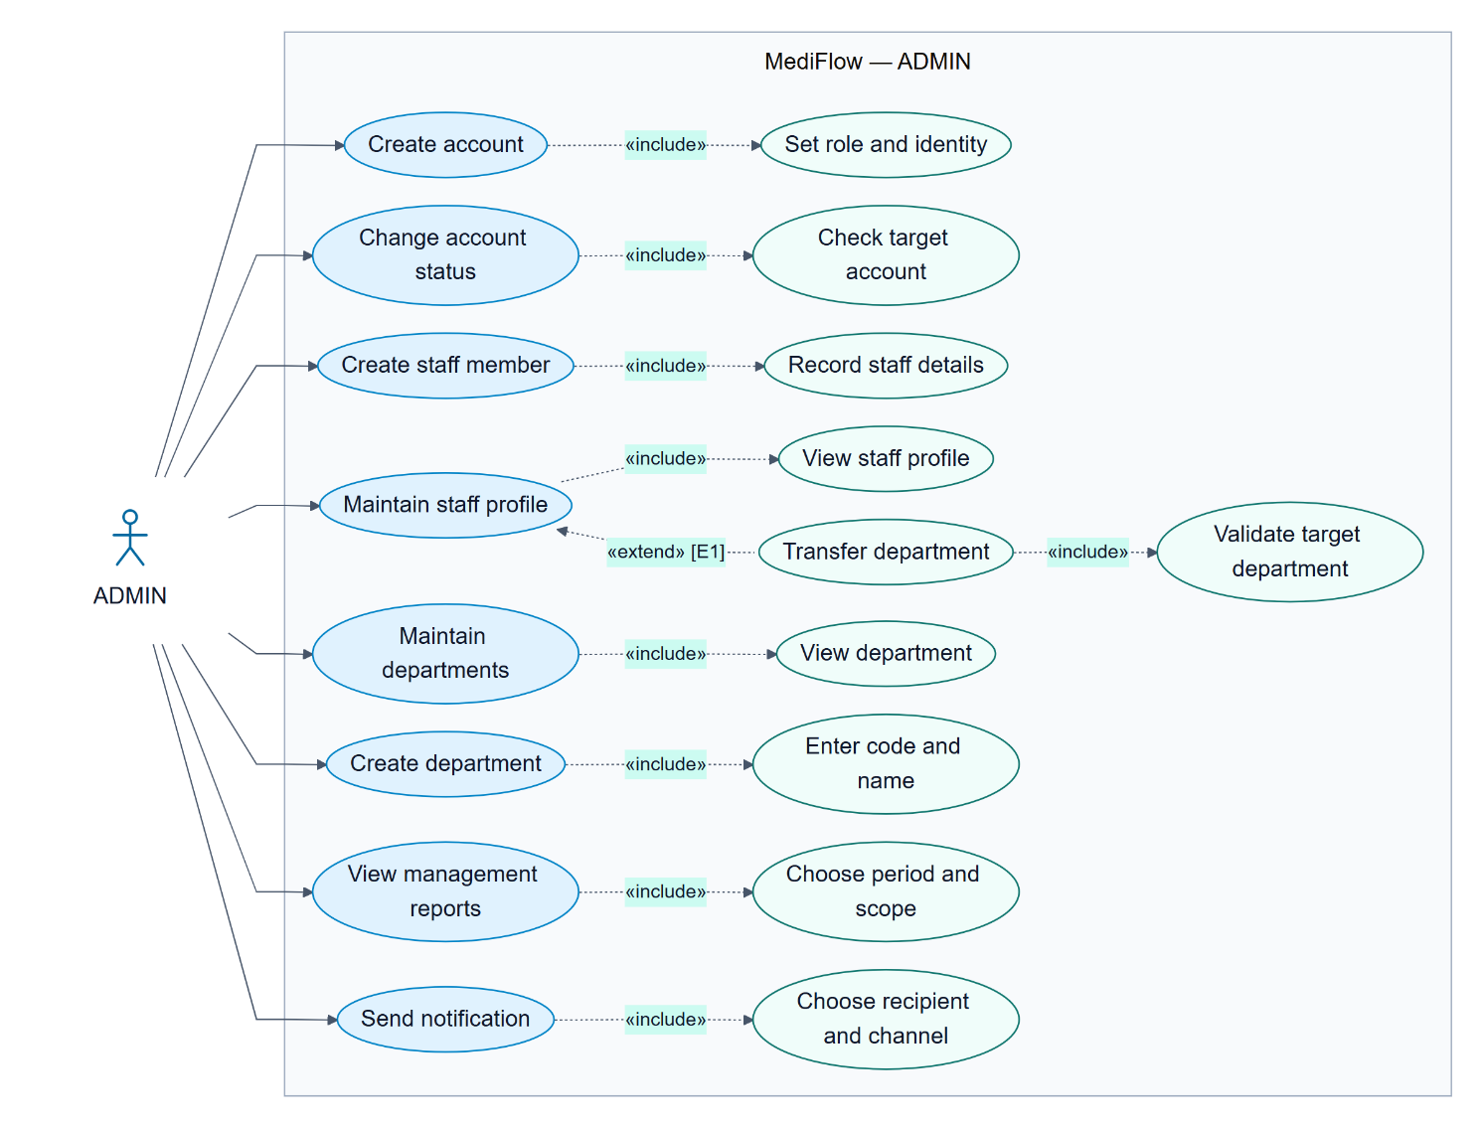

Sequences Diagrams

Login and authorized access
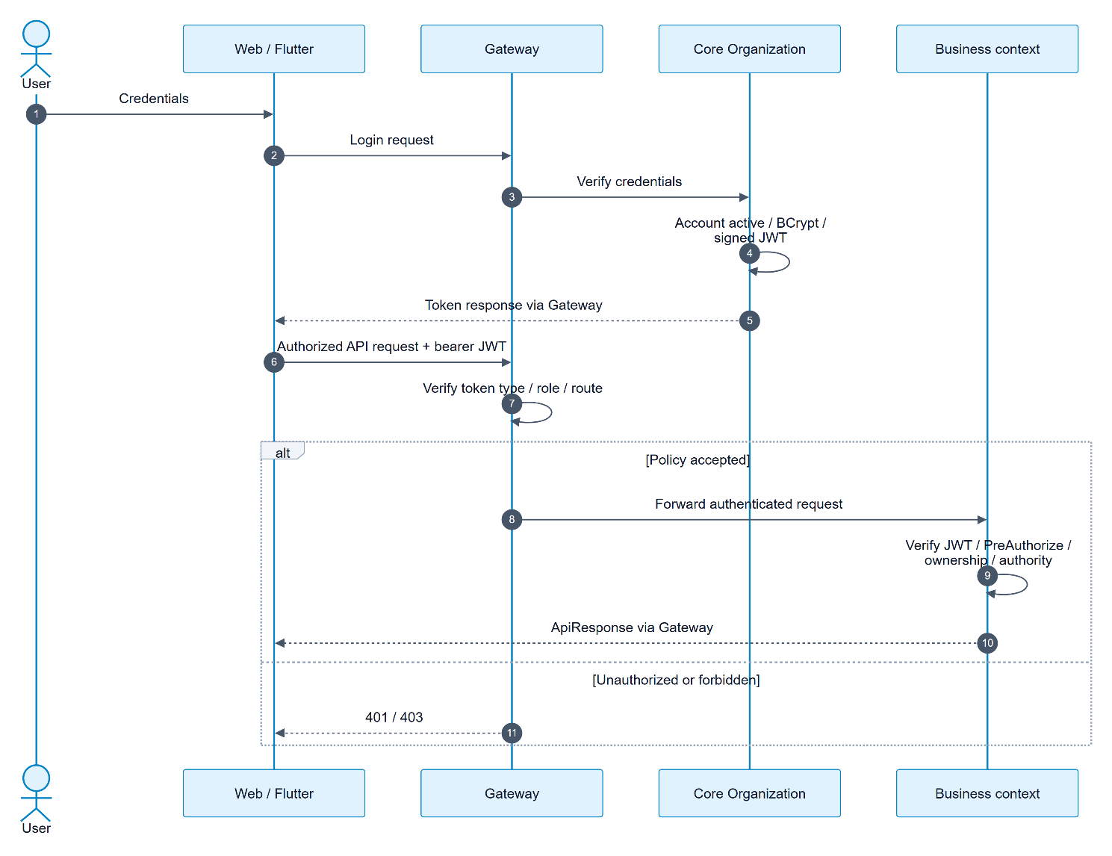

Check-in → EXAM payment → examination
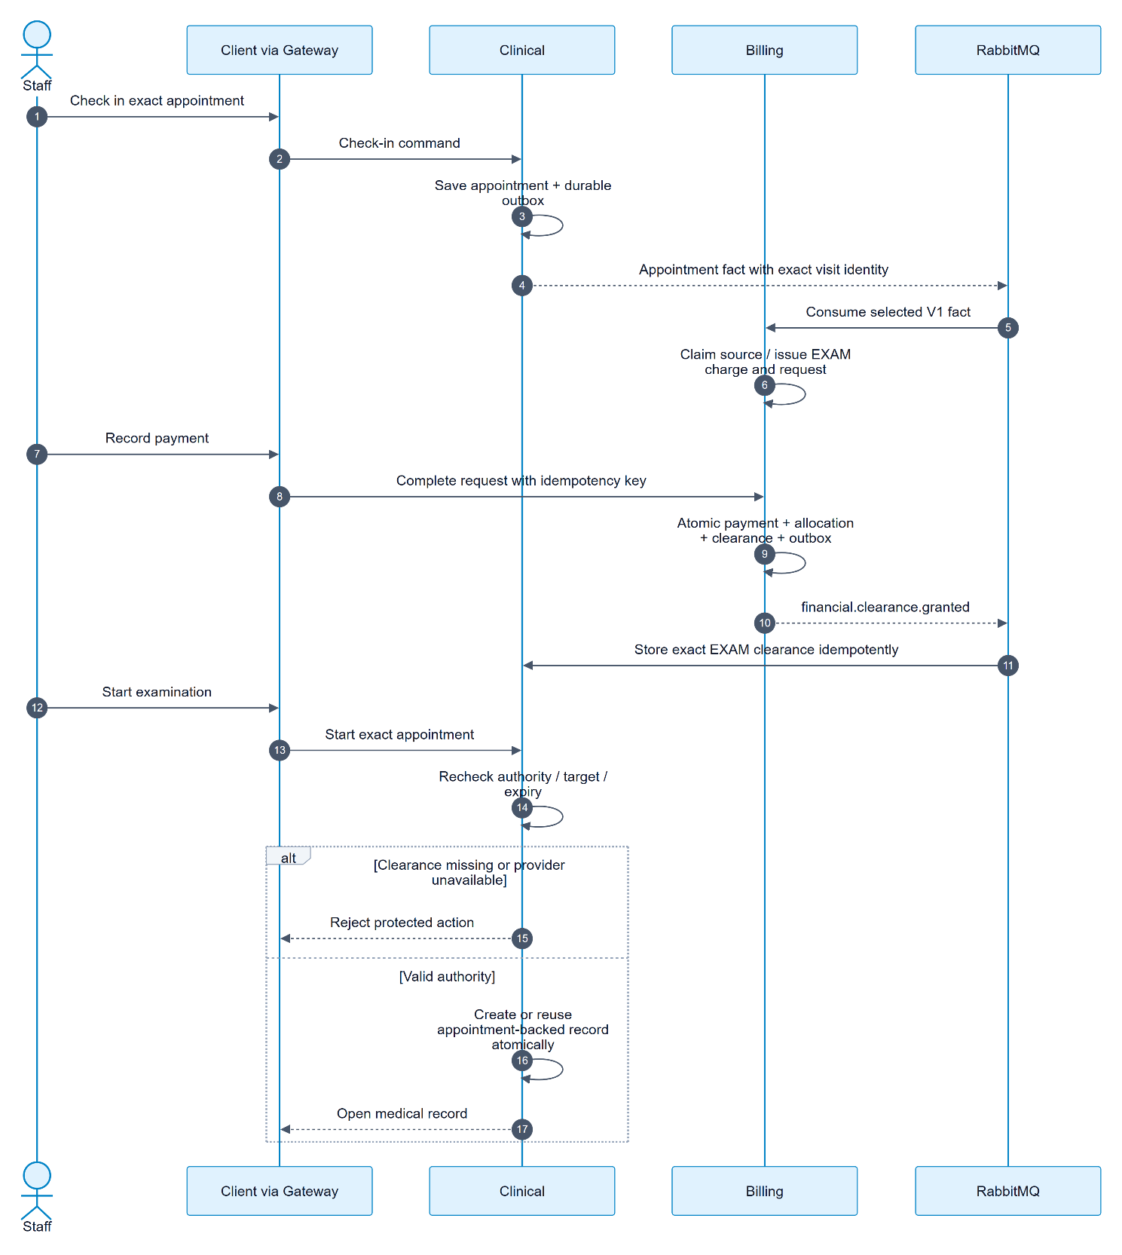

Laboratory order and result attachment
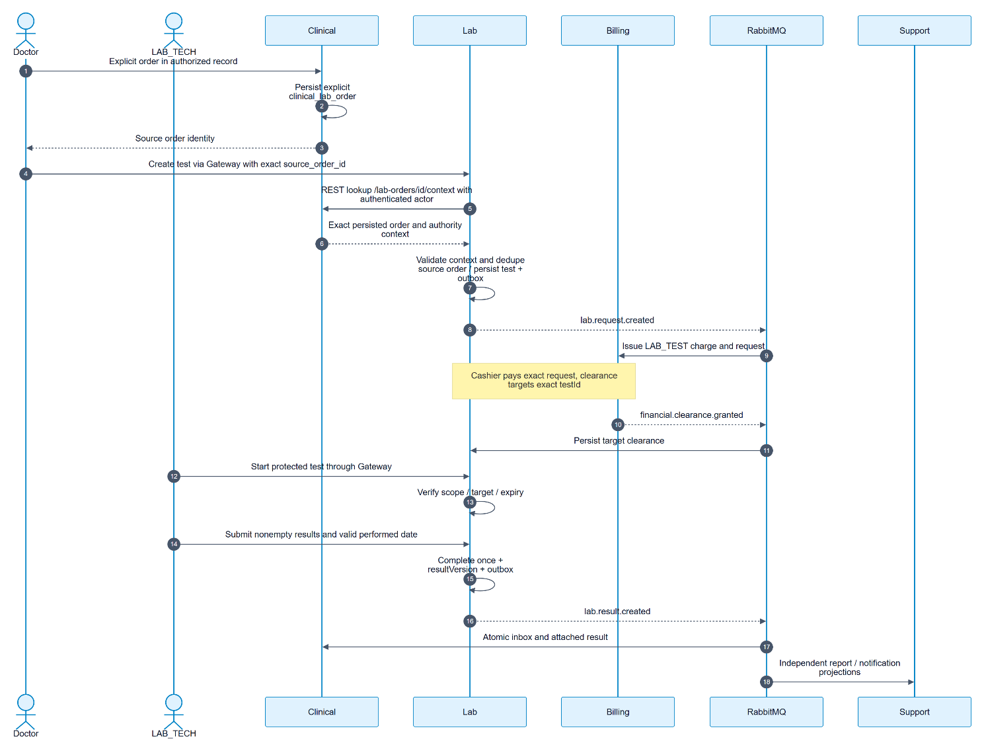

Payment and dispensing
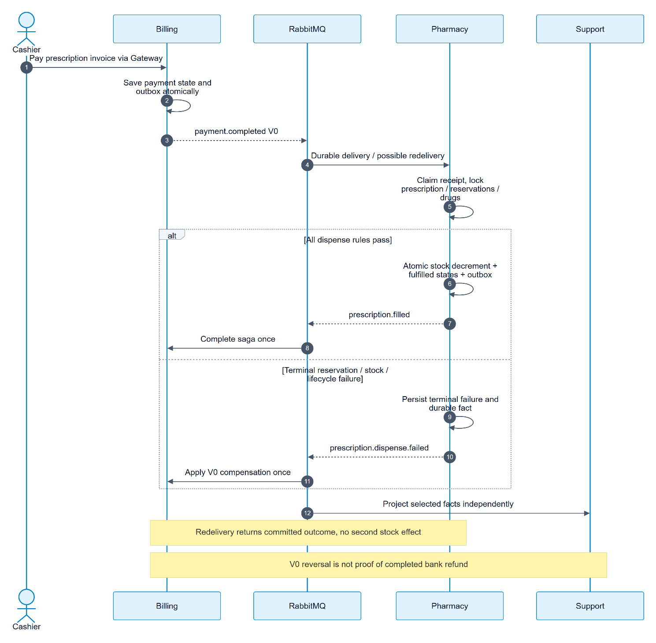

Class Diagrams

Clinical and Lab
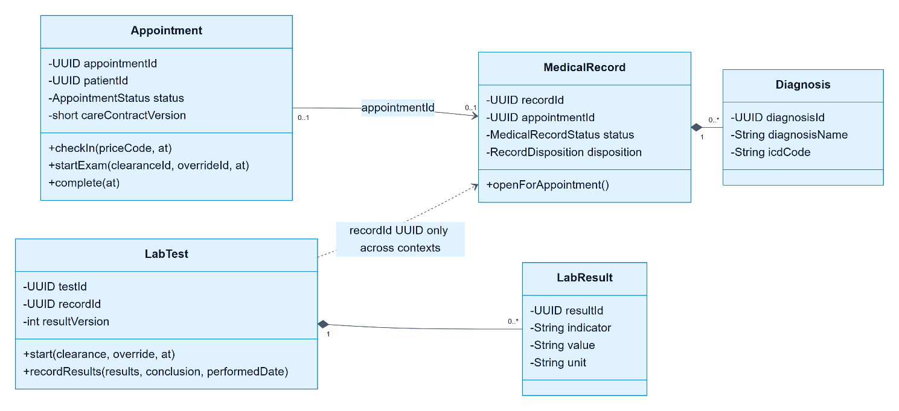

Pharmacy and Billing
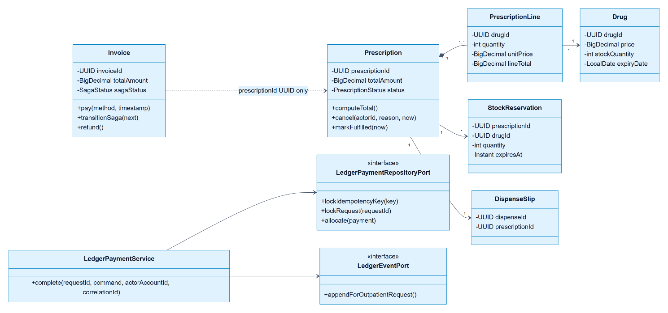

Data Flow Diagram

DFD Level 0 — system boundary
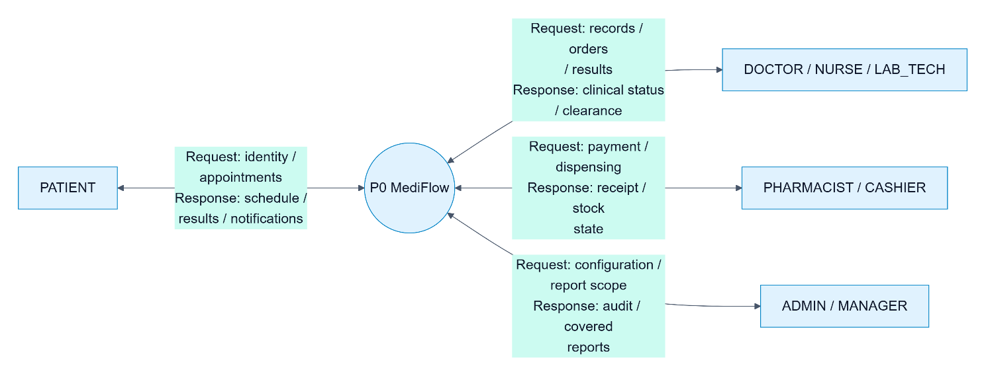

DFD Level 1 — six processes and eight stores
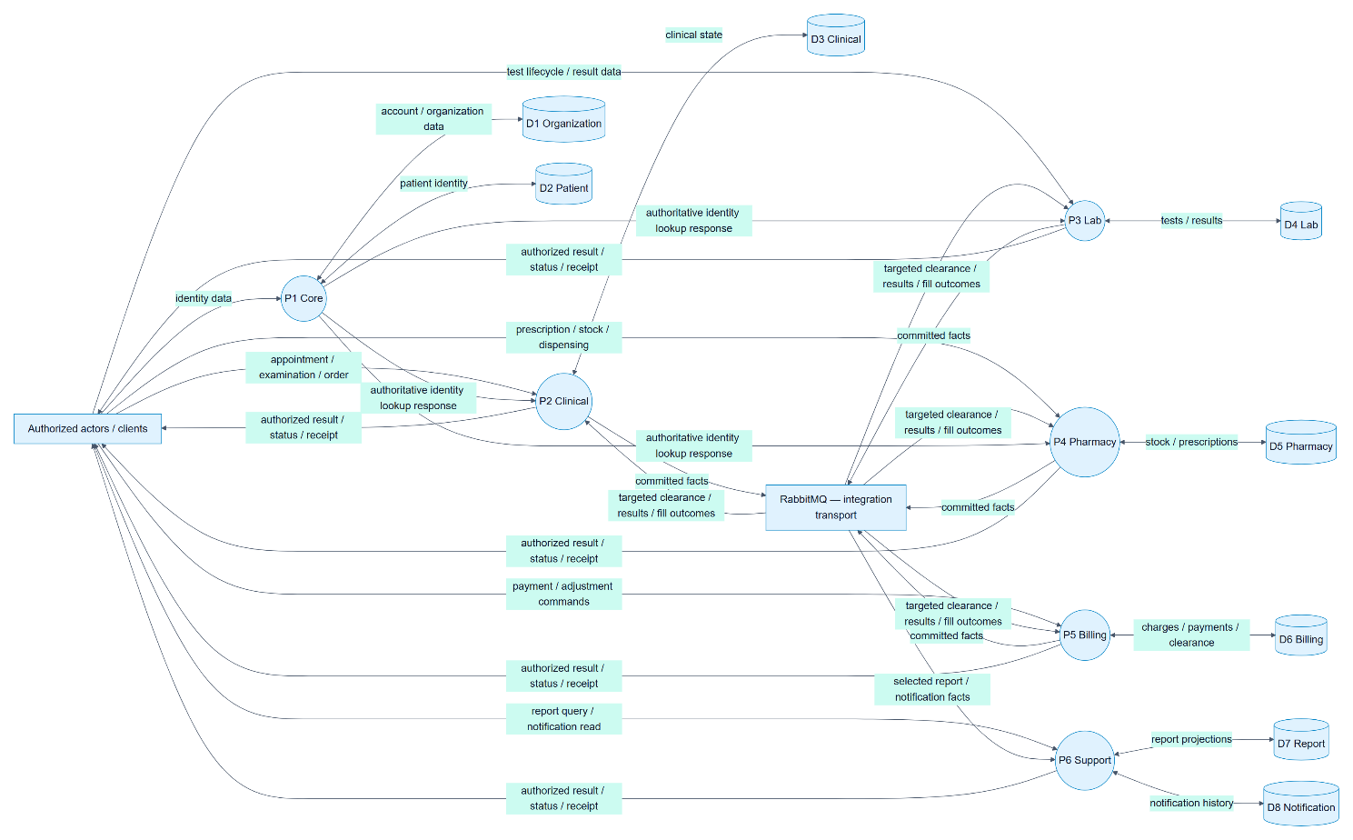

DFD Level 2 — V1 payment and service authorization
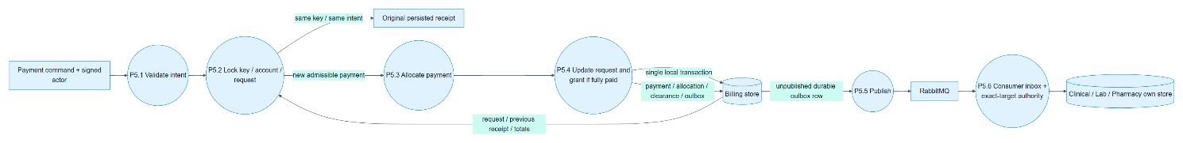

Entity Relationship Diagram

Organization
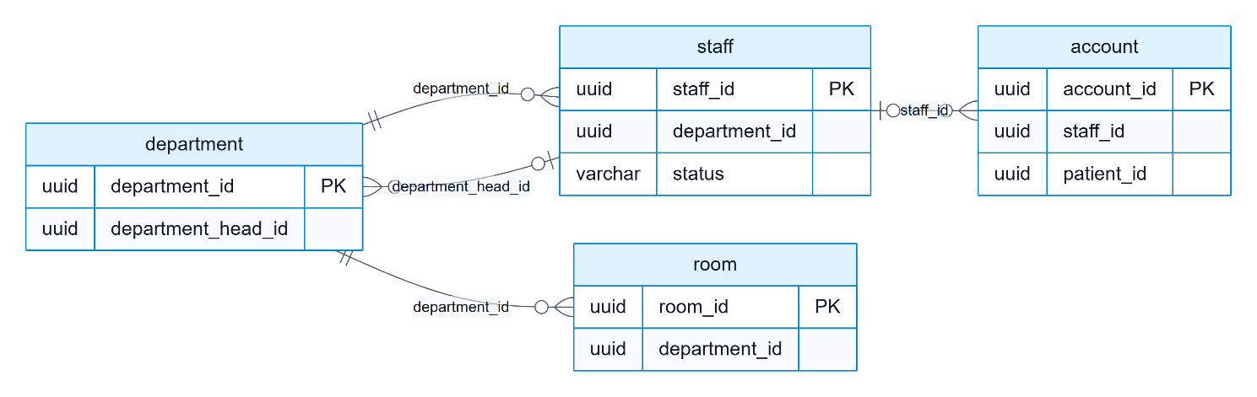

Patient
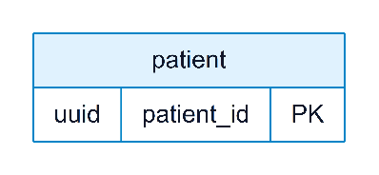

Clinical
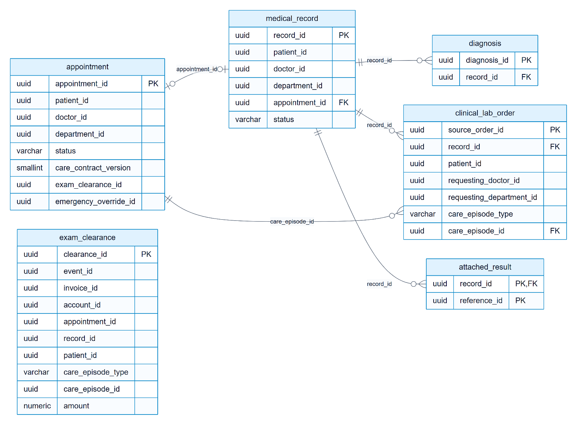

Lab
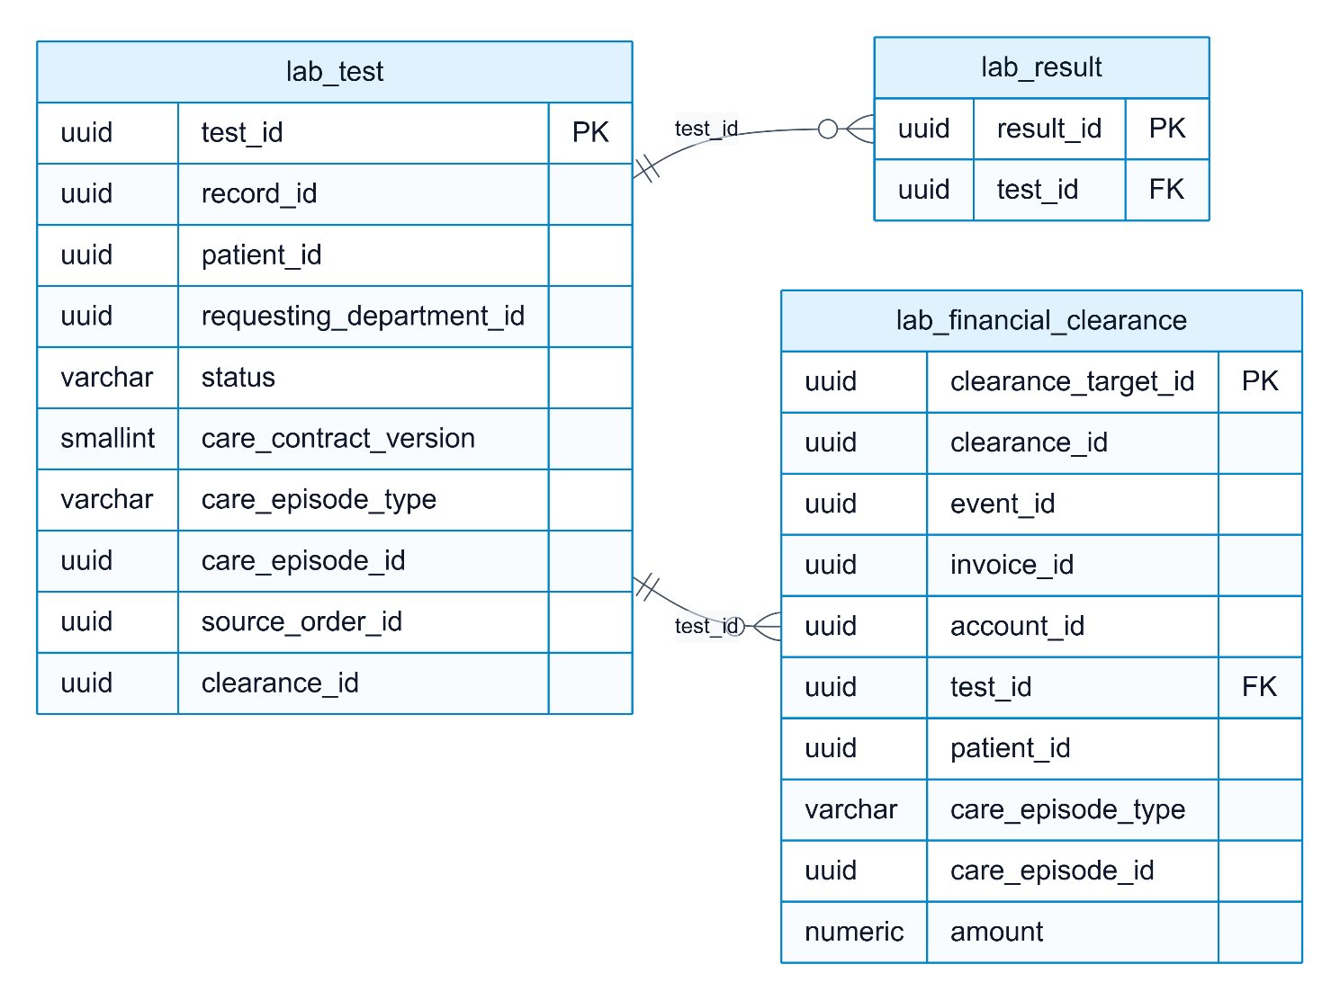

Pharmacy
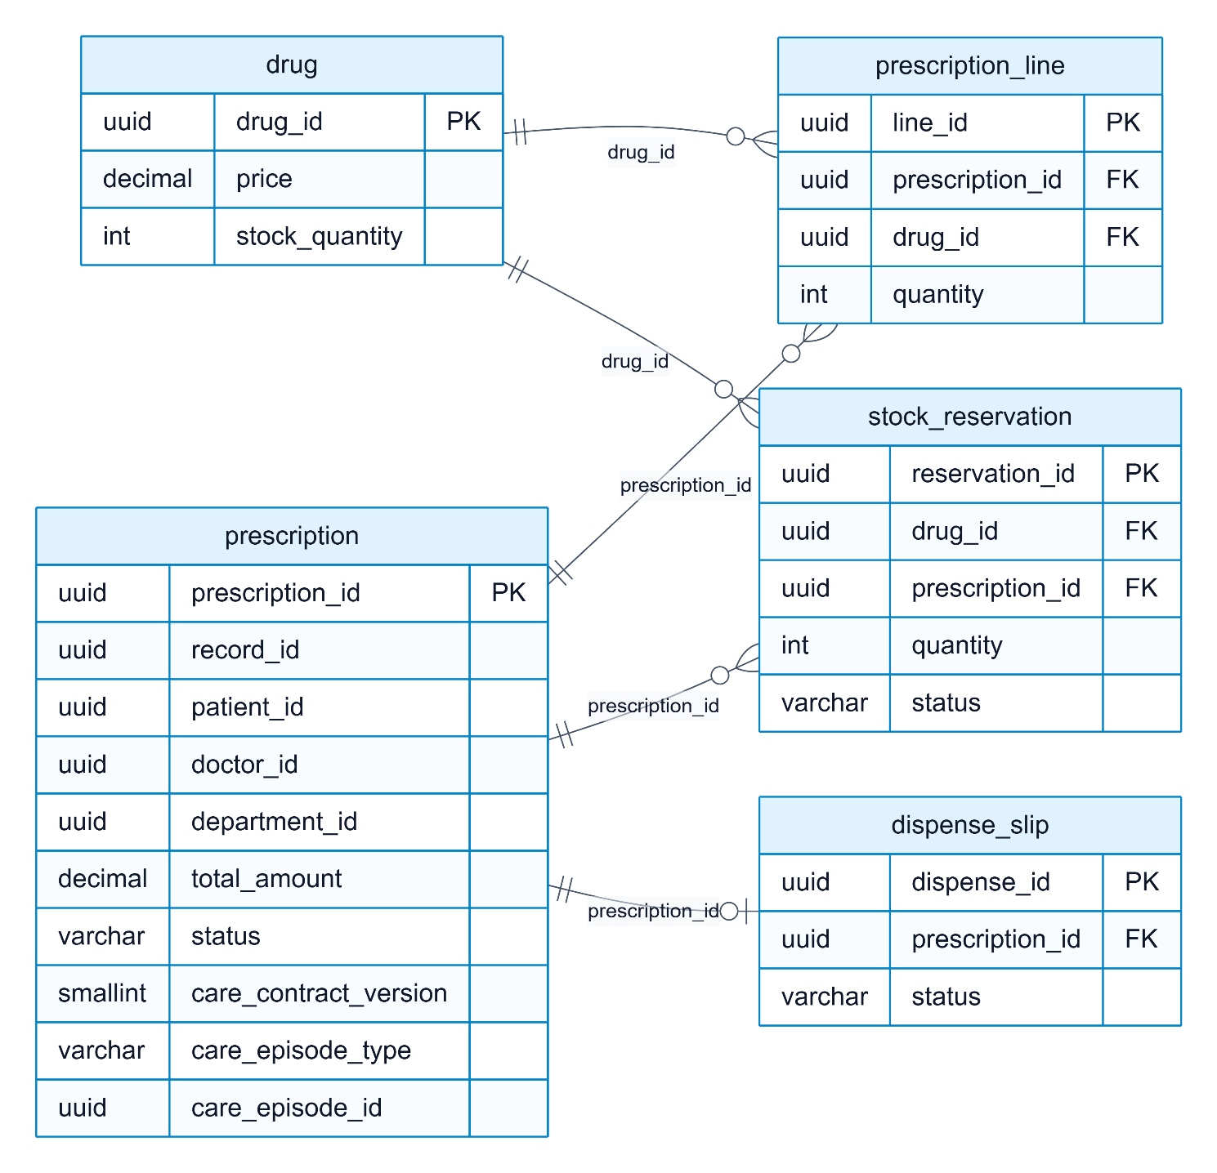

Billing
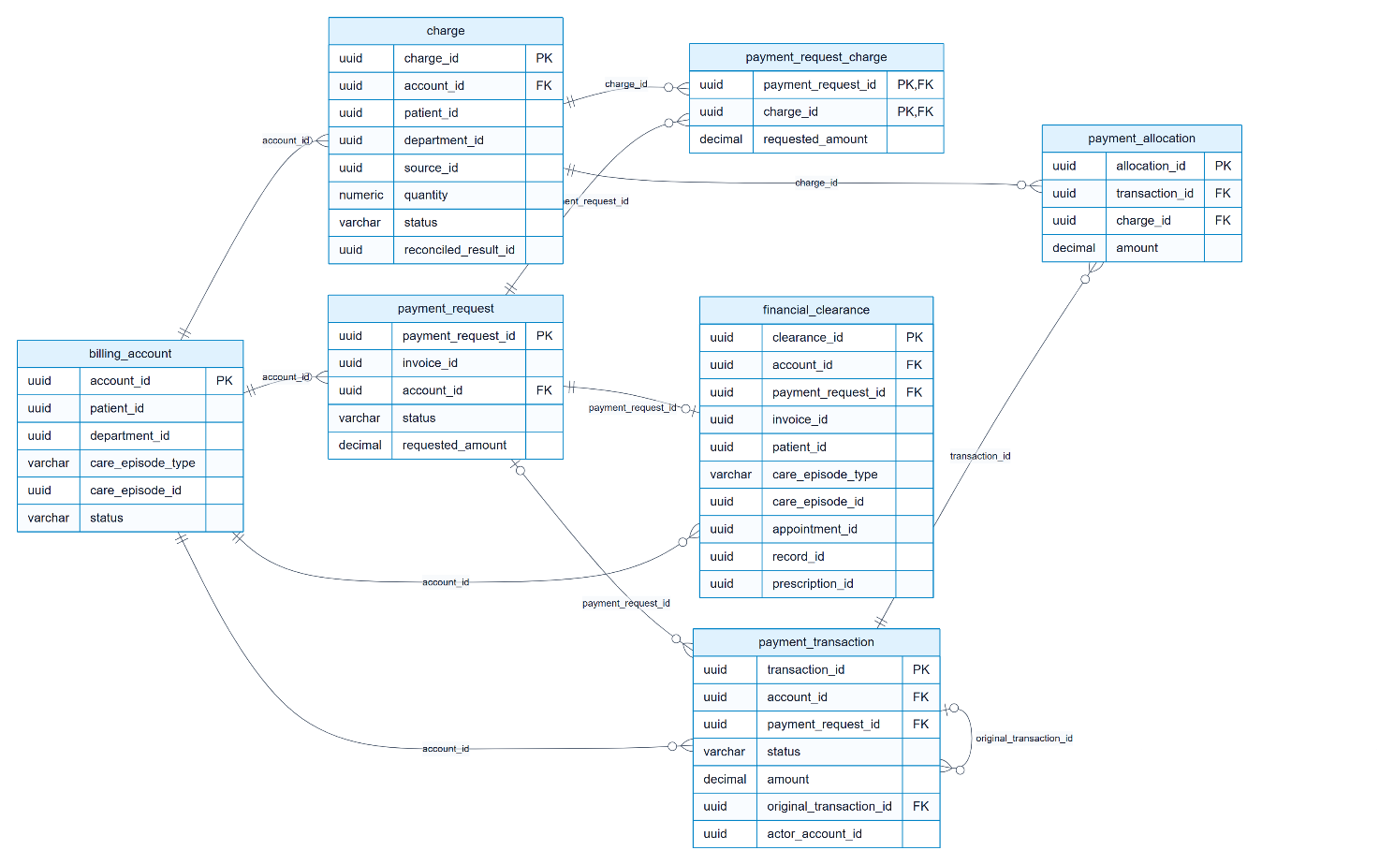

Notification
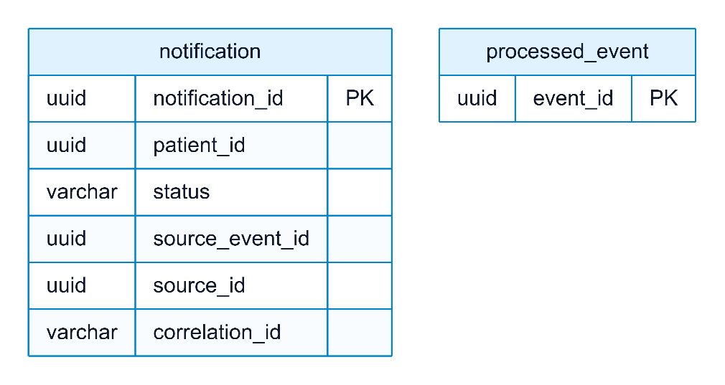

Report
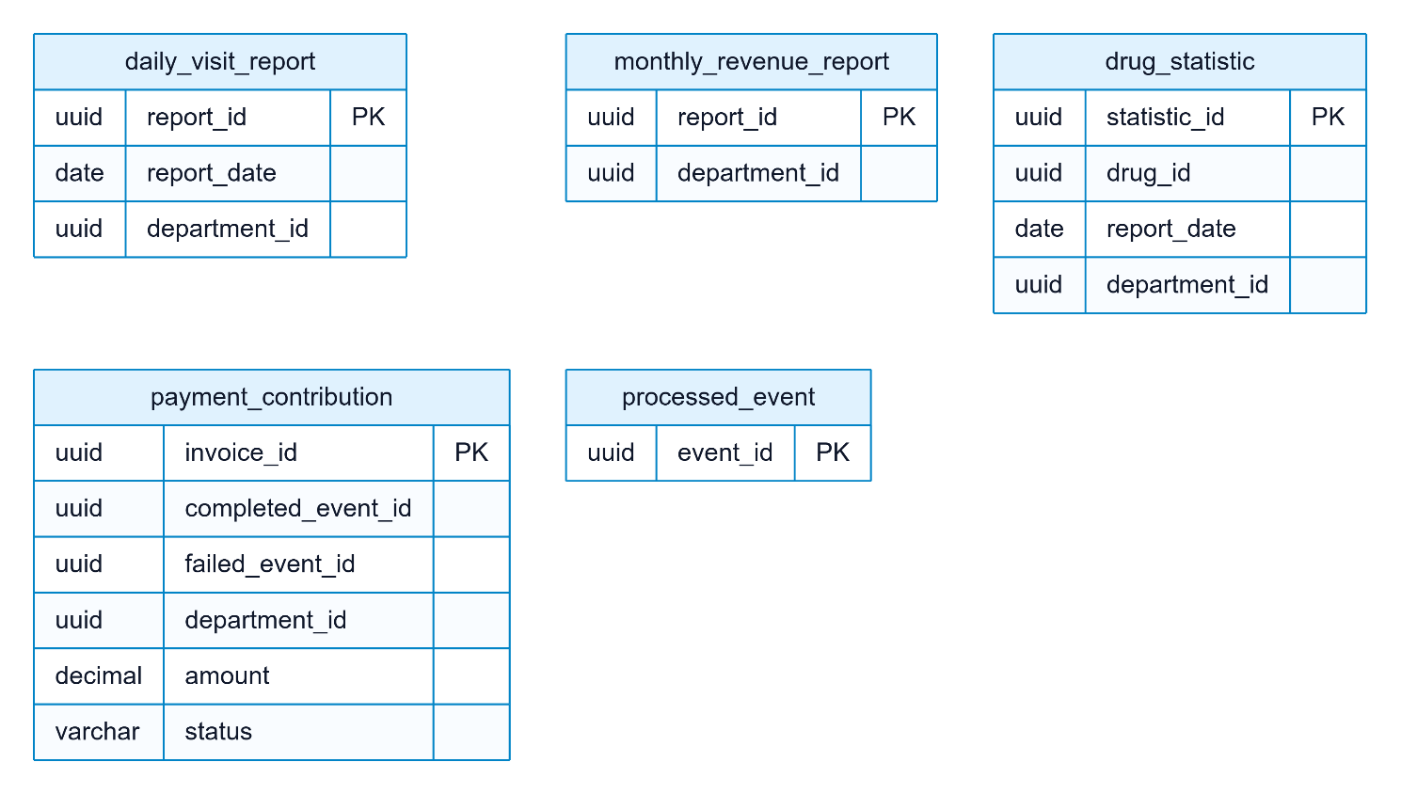

Table Design

Database Tables
Unquoted PostgreSQL identifiers fold to lowercase even when migrations use uppercase. This inventory reads migrations by V number and records each table’s creation and ALTER TABLE migrations. It inventories source, not a live DB: unapplied tables and inactive features may appear. Flyway’s automatically created flyway_schema_history is excluded from business table counts.
Service Context | Database | Declared tables | Migrations
Organization | mediflow_organization | 7 | 4
Patient | mediflow_patient | 1 | 1
Clinical | mediflow_clinical | 12 | 7
Lab | mediflow_lab | 8 | 3
Pharmacy | mediflow_pharmacy | 17 | 20
Billing | mediflow_billing | 42 | 23
Notification | mediflow_notification | 7 | 4
Report | mediflow_report | 58 | 24

Organization
Table | PK / identity
department | department_id
staff | staff_id
account | account_id
room | room_id
operating_room | room_id
surgical_capability | staff_id, team_role
surgery_authority_outbox | event_id

Patient
Table | PK / identity
patient | patient_id

Clinical
Table | PK / identity
appointment | appointment_id
medical_record | record_id
diagnosis | diagnosis_id
attached_result | record_id, type, reference_id
processed_event | event_id
exam_clearance | clearance_id
clinical_emergency_override | override_id
admission_referral | admission_request_id
clinical_outbox_event | event_id
clinical_lab_order | source_order_id
consumer_inbox_delivery | consumer_name, event_id
consumer_inbox_operation | consumer_name, operation_key

Lab
Table | PK / identity
lab_test | test_id
lab_result | result_id
processed_event | event_id
lab_financial_clearance | clearance_target_id
lab_emergency_override | override_id
lab_outbox_event | event_id
consumer_inbox_delivery | consumer_name, event_id
consumer_inbox_operation | consumer_name, operation_key

Pharmacy
Table | PK / identity
drug | drug_id
prescription | prescription_id
prescription_line | line_id
dispense_slip | dispense_id
processed_event | event_id
stock_reservation | reservation_id
pharmacy_event_outbox | event_id
payment_receipt | receipt_id
stock_adjustment | adjustment_id
pharmacy_scheduler_lease | job_name
admission_medication_context | admission_id
admission_medication_event | event_id
prescription_clearance_target | prescription_id
prescription_clearance | clearance_id
prescription_clearance_event | event_id
care_prescription_creation | command_id
pharmacy_outpatient_delivery_cohort | prescription_id

Billing
Table | PK / identity
fee | fee_id
invoice | invoice_id
processed_event | event_id
lab_test_type | lab_id
billing_event_outbox | event_id
billing_account | account_id
charge | charge_id
payment_request | payment_request_id
payment_request_charge | payment_request_id, charge_id
payment_transaction | transaction_id
payment_allocation | allocation_id
financial_clearance | clearance_id
insurance_adjustment | adjustment_id
settlement | settlement_id
payment_request_target | payment_request_id
ledger_refund_evidence | refund_transaction_id
surgery_charge_delivery | event_id
surgery_charge_source | surgery_case_id
surgery_charge_item | surgery_case_id,item_code
surgery_cancellation_source | surgery_case_id
surgery_cancellation_delivery | event_id
surgery_cancellation_refund_due | cancellation_id,original_transaction_id,charge_id
lab_test_charge_delivery | event_id
lab_test_charge_source | lab_id
admission_deposit_delivery | event_id
admission_deposit_source | admission_id
admission_reconciliation | settlement_id
admission_charge_close | admission_id
admission_charge_close_delivery | event_id
deposit_allocation_operation | allocation_operation_id
surgery_completion_source | surgery_case_id
surgery_completion_delivery | event_id
final_admission_settlement_operation | recognition_operation_id
prescription_charge_source | prescription_id
prescription_charge_item | prescription_id,drug_id
prescription_charge_delivery | event_id
prescription_terminal_source | prescription_id
prescription_terminal_delivery | event_id
prescription_terminal_refund_due | prescription_id, original_transaction_id, charge_id
exam_charge_delivery | event_id
exam_charge_source | appointment_id
billing_outpatient_publication_cohort | payment_request_id

Notification
Table | PK / identity
notification | notification_id
processed_event | event_id
notification_event_outbox | event_id
surgery_notice_case | surgery_case_id
surgery_notice_source | event_type,source_id
surgery_notice_snapshot | snapshot_id
care_notification_source | event_type,source_id

Report
Table | PK / identity
daily_visit_report | report_id
monthly_revenue_report | report_id
drug_statistic | statistic_id
processed_event | event_id
payment_contribution | invoice_id
financial_contribution | contribution_id
daily_financial_report | report_id
operational_contribution | contribution_id
daily_operational_report | report_id
operational_event_journal | event_id
operational_delivery | event_id, metric_type
operational_replay_generation | generation_id
operational_replay_input | generation_id, event_id
operational_replay_contribution | generation_id, source_type, source_id, source_revision, metric_type
operational_replay_scope | see DDL
report_admission_target | admission_id
report_admission_delivery | event_id
report_admission_fact | admission_id, fact_type
operational_report_publication | report_kind
operational_source_snapshot | source_type,source_id,source_revision,event_type
report_cash_receipt | transaction_id
report_cash_delivery | event_id
report_gross_cash_daily | scope_id
cash_replay_generation | generation_id
cash_replay_input | generation_id,transaction_id
cash_replay_receipt | generation_id,transaction_id
cash_replay_scope | see DDL
report_cash_refund | refund_transaction_id
report_cash_refund_delivery | event_id
report_refund_cash_daily | scope_id
prescription_fill_receipt | prescription_id
refund_replay_generation | generation_id
refund_replay_input | generation_id,refund_transaction_id
refund_replay_fact | generation_id,refund_transaction_id
refund_replay_scope | see DDL
report_settlement_snapshot | settlement_id
report_settlement_delivery | event_id
report_receivable_current | account_id
report_receivable_stock | see DDL
financial_report_generation | generation_id
financial_report_day | see DDL
financial_report_publication | currency,report_zone
report_medical_discharge | admission_id
report_medical_discharge_delivery | event_id
report_final_recognition | recognition_operation_id
report_final_recognition_delivery | event_id
report_final_recognition_contribution | see DDL
report_final_deposit_release | recognition_operation_id,original_transaction_id
report_final_recognition_daily | see DDL
financial_source_rebuild | generation_id
financial_source_rebuild_input | generation_id,source_kind,source_id
financial_source_rebuild_day | see DDL
financial_archive_restore | archive_fingerprint
financial_generation_acceptance | generation_id
financial_publication_audit | command_id
operational_generation_acceptance | generation_id
operational_publication_audit | command_id
report_outpatient_coverage | coverage_id

Core table column dictionary
The following tables represent the outpatient journey. Column definitions are extracted from CREATE and ADD COLUMN; dropped columns are removed. This is not a full SQL execution engine: ALTER TYPE/DEFAULT, constraints/indexes and conditional SQL must also be read in linked migrations; do not reconstruct production DDL from this summary. Removed fields such as invoice.dispense_id are excluded.

Organization

Organization.account
Column | Declared type and column constraints
account_id | UUID PRIMARY KEY
username | VARCHAR(50) NOT NULL
password_hash | VARCHAR(255) NOT NULL
staff_id | UUID
role | VARCHAR(20) NOT NULL
is_active | BOOLEAN NOT NULL DEFAULT TRUE
last_login_at | TIMESTAMPTZ
created_at | TIMESTAMPTZ NOT NULL DEFAULT now()
updated_at | TIMESTAMPTZ
patient_id | UUID

Organization.staff
Column | Declared type and column constraints
staff_id | UUID PRIMARY KEY
full_name | VARCHAR(100) NOT NULL
department_id | UUID NOT NULL
job_title | VARCHAR(20) NOT NULL
specialization | VARCHAR(100)
license_number | VARCHAR(50)
phone_number | VARCHAR(15)
email | VARCHAR(100)
status | VARCHAR(20) NOT NULL DEFAULT 'ACTIVE'
created_at | TIMESTAMPTZ NOT NULL DEFAULT now()
updated_at | TIMESTAMPTZ

Organization.department
Column | Declared type and column constraints
department_id | UUID PRIMARY KEY
department_name | VARCHAR(100) NOT NULL
abbreviation | VARCHAR(20) NOT NULL
department_type | VARCHAR(20) NOT NULL
department_head_id | UUID
location | VARCHAR(255)
is_active | BOOLEAN NOT NULL DEFAULT TRUE
created_at | TIMESTAMPTZ NOT NULL DEFAULT now()
updated_at | TIMESTAMPTZ

Patient

Patient.patient
Column | Declared type and column constraints
patient_id | UUID PRIMARY KEY
full_name | VARCHAR(100) NOT NULL
date_of_birth | DATE NOT NULL
gender | VARCHAR(1) NOT NULL
identity_number | VARCHAR(20) NOT NULL
address | VARCHAR(255)
phone_number | VARCHAR(15)
email | VARCHAR(100)
health_insurance_number | VARCHAR(20)
created_at | TIMESTAMPTZ NOT NULL DEFAULT now()
updated_at | TIMESTAMPTZ

Clinical

Clinical.appointment
Column | Declared type and column constraints
appointment_id | UUID PRIMARY KEY
patient_id | UUID NOT NULL
doctor_id | UUID NOT NULL
department_id | UUID NOT NULL
appointment_date | DATE NOT NULL
appointment_time | TIME NOT NULL
status | VARCHAR(20) NOT NULL DEFAULT 'PENDING'
reason | TEXT
created_at | TIMESTAMPTZ NOT NULL DEFAULT now()
updated_at | TIMESTAMPTZ
care_contract_version | SMALLINT NOT NULL DEFAULT 0
exam_clearance_id | UUID
exam_clearance_at | TIMESTAMPTZ
emergency_override_id | UUID
exam_price_code | VARCHAR(64)
checked_in_at | TIMESTAMPTZ
examination_started_at | TIMESTAMPTZ
completed_at | TIMESTAMPTZ

Clinical.medical_record
Column | Declared type and column constraints
record_id | UUID PRIMARY KEY
patient_id | UUID NOT NULL
doctor_id | UUID NOT NULL
department_id | UUID NOT NULL
examination_date | DATE NOT NULL
symptoms | TEXT
appointment_id | UUID REFERENCES appointment(appointment_id)
created_at | TIMESTAMPTZ NOT NULL DEFAULT now()
updated_at | TIMESTAMPTZ
status | VARCHAR(20) NOT NULL DEFAULT 'OPEN'
disposition | VARCHAR(32)
disposition_note | TEXT
completed_at | TIMESTAMPTZ

Clinical.diagnosis
Column | Declared type and column constraints
diagnosis_id | UUID PRIMARY KEY
record_id | UUID NOT NULL REFERENCES medical_record(record_id) ON DELETE CASCADE
diagnosis_name | VARCHAR(255) NOT NULL
description | TEXT
icd_code | VARCHAR(10)
created_at | TIMESTAMPTZ NOT NULL DEFAULT now()

Clinical.clinical_lab_order
Column | Declared type and column constraints
source_order_id | UUID PRIMARY KEY
record_id | UUID NOT NULL REFERENCES medical_record(record_id)
patient_id | UUID NOT NULL
requesting_doctor_id | UUID NOT NULL
requesting_department_id | UUID NOT NULL
care_episode_type | VARCHAR(32) NOT NULL CHECK (care_episode_type = 'OUTPATIENT_VISIT')
care_episode_id | UUID NOT NULL REFERENCES appointment(appointment_id)
lab_type | VARCHAR(50) NOT NULL CHECK (length(btrim(lab_type)) > 0)
requested_date | DATE NOT NULL
price_code | VARCHAR(64) NOT NULL CHECK (length(btrim(price_code)) > 0)
ordered_at | TIMESTAMPTZ NOT NULL

Lab

Lab.lab_test
Column | Declared type and column constraints
test_id | UUID PRIMARY KEY
record_id | UUID NOT NULL
patient_id | UUID NOT NULL
requesting_department_id | UUID NOT NULL
test_type | VARCHAR(50) NOT NULL
requested_date | DATE NOT NULL
performed_date | DATE
status | VARCHAR(20) NOT NULL DEFAULT 'PENDING'
conclusion | TEXT
is_paid | BOOLEAN NOT NULL DEFAULT false
created_at | TIMESTAMPTZ NOT NULL DEFAULT now()
updated_at | TIMESTAMPTZ
care_contract_version | SMALLINT NOT NULL DEFAULT 0
care_episode_type | VARCHAR(32)
care_episode_id | UUID
source_order_id | UUID
price_code | VARCHAR(64)
clearance_id | UUID
clearance_granted_at | TIMESTAMPTZ
emergency_override_id | UUID
result_version | INTEGER NOT NULL DEFAULT 0

Lab.lab_result
Column | Declared type and column constraints
result_id | UUID PRIMARY KEY
test_id | UUID NOT NULL REFERENCES lab_test(test_id) ON DELETE CASCADE
indicator | VARCHAR(100) NOT NULL
value | VARCHAR(50) NOT NULL
unit | VARCHAR(20)
reference_range | VARCHAR(50)
created_at | TIMESTAMPTZ NOT NULL DEFAULT now()

Pharmacy

Pharmacy.drug
Column | Declared type and column constraints
drug_id | UUID PRIMARY KEY
drug_name | VARCHAR(150) NOT NULL
active_ingredient | VARCHAR(150)
unit | VARCHAR(20) NOT NULL
price | DECIMAL(15,2) NOT NULL
stock_quantity | INT NOT NULL DEFAULT 0
expiry_date | DATE NOT NULL
manufacturer | VARCHAR(150)
low_stock_threshold | INT NOT NULL DEFAULT 10
created_at | TIMESTAMPTZ NOT NULL DEFAULT now()
updated_at | TIMESTAMPTZ

Pharmacy.prescription
Column | Declared type and column constraints
prescription_id | UUID PRIMARY KEY
record_id | UUID
patient_id | UUID NOT NULL
doctor_id | UUID NOT NULL
department_id | UUID NOT NULL
prescribed_date | DATE NOT NULL
total_amount | DECIMAL(15,2) NOT NULL DEFAULT 0
created_at | TIMESTAMPTZ NOT NULL DEFAULT now()
updated_at | TIMESTAMPTZ
status | VARCHAR(30) NOT NULL DEFAULT 'ACTIVE'
cancelled_at | TIMESTAMPTZ
cancelled_by | UUID
cancellation_reason | VARCHAR(500)
care_contract_version | SMALLINT NOT NULL DEFAULT 0
care_context | VARCHAR(20) NOT NULL DEFAULT 'OUTPATIENT'
care_episode_type | VARCHAR(32)
care_episode_id | UUID
admission_id | UUID
price_code | VARCHAR(64)
lifecycle_at_iso | VARCHAR(35)

Pharmacy.prescription_line
Column | Declared type and column constraints
line_id | UUID PRIMARY KEY
prescription_id | UUID NOT NULL REFERENCES PRESCRIPTION(prescription_id) ON DELETE CASCADE
drug_id | UUID NOT NULL REFERENCES DRUG(drug_id)
quantity | INT NOT NULL
unit_price | DECIMAL(15,2) NOT NULL
dosage | VARCHAR(255)
line_total | DECIMAL(15,2) NOT NULL
drug_name_snapshot | VARCHAR(150)

Pharmacy.stock_reservation
Column | Declared type and column constraints
reservation_id | UUID PRIMARY KEY
drug_id | UUID NOT NULL REFERENCES DRUG(drug_id)
prescription_id | UUID NOT NULL REFERENCES PRESCRIPTION(prescription_id)
quantity | INT NOT NULL
status | VARCHAR(20) NOT NULL DEFAULT 'RESERVED'
expires_at | TIMESTAMPTZ NOT NULL
created_at | TIMESTAMPTZ NOT NULL DEFAULT now()
updated_at | TIMESTAMPTZ
release_reason | VARCHAR(50)
released_at | TIMESTAMPTZ
released_by | UUID

Pharmacy.dispense_slip
Column | Declared type and column constraints
dispense_id | UUID PRIMARY KEY
prescription_id | UUID NOT NULL UNIQUE REFERENCES PRESCRIPTION(prescription_id)
status | VARCHAR(20) NOT NULL DEFAULT 'PENDING'
dispensed_at | TIMESTAMPTZ
dispensed_by | UUID
failure_reason | VARCHAR(500)
created_at | TIMESTAMPTZ NOT NULL DEFAULT now()
updated_at | TIMESTAMPTZ
dispensed_actor_type | VARCHAR(30)
lifecycle_at_iso | VARCHAR(35)

Billing

Billing.invoice
Column | Declared type and column constraints
invoice_id | UUID PRIMARY KEY
patient_id | UUID NOT NULL
created_date | DATE NOT NULL
total_amount | DECIMAL(15,2) NOT NULL
is_paid | BOOLEAN NOT NULL DEFAULT false
payment_method | VARCHAR(20)
prescription_id | UUID
saga_status | VARCHAR(20) NOT NULL DEFAULT 'NONE'
paid_at | TIMESTAMPTZ
created_at | TIMESTAMPTZ NOT NULL DEFAULT now()
updated_at | TIMESTAMPTZ

Billing.billing_account
Column | Declared type and column constraints
account_id | UUID PRIMARY KEY
patient_id | UUID NOT NULL
department_id | UUID NOT NULL
care_episode_type | VARCHAR(32) NOT NULL
care_episode_id | UUID NOT NULL
status | VARCHAR(32) NOT NULL DEFAULT 'OPEN'
currency | CHAR(3) NOT NULL DEFAULT 'VND'
version | BIGINT NOT NULL DEFAULT 0
opened_at | TIMESTAMPTZ NOT NULL
charge_closed_at | TIMESTAMPTZ
closed_at | TIMESTAMPTZ
created_at | TIMESTAMPTZ NOT NULL DEFAULT now()
updated_at | TIMESTAMPTZ NOT NULL DEFAULT now()

Billing.charge
Column | Declared type and column constraints
charge_id | UUID PRIMARY KEY
account_id | UUID NOT NULL REFERENCES BILLING_ACCOUNT(account_id)
patient_id | UUID NOT NULL
department_id | UUID NOT NULL
source_type | VARCHAR(32) NOT NULL
source_id | UUID NOT NULL
price_code | VARCHAR(64) NOT NULL
description | VARCHAR(255) NOT NULL
quantity | NUMERIC(19,4) NOT NULL DEFAULT 1 CHECK (quantity > 0)
unit_amount | DECIMAL(19,2) NOT NULL CHECK (unit_amount >= 0)
gross_amount | DECIMAL(19,2) NOT NULL CHECK (gross_amount >= 0)
status | VARCHAR(20) NOT NULL DEFAULT 'POSTED'
void_reason | VARCHAR(500)
incurred_at | TIMESTAMPTZ NOT NULL
created_at | TIMESTAMPTZ NOT NULL DEFAULT now()
reconciled_result_id | UUID

Billing.payment_request
Column | Declared type and column constraints
payment_request_id | UUID PRIMARY KEY
invoice_id | UUID NOT NULL UNIQUE
account_id | UUID NOT NULL REFERENCES BILLING_ACCOUNT(account_id)
purpose | VARCHAR(32) NOT NULL
status | VARCHAR(24) NOT NULL DEFAULT 'PENDING'
requested_amount | DECIMAL(19,2) NOT NULL CHECK (requested_amount >= 0)
currency | CHAR(3) NOT NULL DEFAULT 'VND'
expires_at | TIMESTAMPTZ
created_by | UUID
created_at | TIMESTAMPTZ NOT NULL DEFAULT now()
completed_at | TIMESTAMPTZ

Billing.payment_transaction
Column | Declared type and column constraints
transaction_id | UUID PRIMARY KEY
account_id | UUID NOT NULL REFERENCES BILLING_ACCOUNT(account_id)
payment_request_id | UUID REFERENCES PAYMENT_REQUEST(payment_request_id)
transaction_type | VARCHAR(20) NOT NULL
classification | VARCHAR(24) NOT NULL
status | VARCHAR(20) NOT NULL
amount | DECIMAL(19,2) NOT NULL CHECK (amount > 0)
currency | CHAR(3) NOT NULL DEFAULT 'VND'
payment_method | VARCHAR(20) NOT NULL
provider_reference | VARCHAR(120)
idempotency_key | VARCHAR(120) NOT NULL UNIQUE
original_transaction_id | UUID REFERENCES PAYMENT_TRANSACTION(transaction_id)
completed_at | TIMESTAMPTZ
created_at | TIMESTAMPTZ NOT NULL DEFAULT now()
actor_account_id | UUID

Billing.payment_allocation
Column | Declared type and column constraints
allocation_id | UUID PRIMARY KEY
transaction_id | UUID NOT NULL REFERENCES PAYMENT_TRANSACTION(transaction_id)
charge_id | UUID NOT NULL REFERENCES CHARGE(charge_id)
amount | DECIMAL(19,2) NOT NULL CHECK (amount > 0)
created_at | TIMESTAMPTZ NOT NULL DEFAULT now()

Billing.financial_clearance
Column | Declared type and column constraints
clearance_id | UUID PRIMARY KEY
account_id | UUID NOT NULL REFERENCES BILLING_ACCOUNT(account_id)
payment_request_id | UUID NOT NULL REFERENCES PAYMENT_REQUEST(payment_request_id)
invoice_id | UUID NOT NULL
patient_id | UUID NOT NULL
purpose | VARCHAR(32) NOT NULL
care_episode_type | VARCHAR(32) NOT NULL
care_episode_id | UUID NOT NULL
appointment_id | UUID
record_id | UUID
lab_test_ids | UUID[] NOT NULL DEFAULT '{}'
prescription_id | UUID
admission_id | UUID
surgery_case_id | UUID
amount | DECIMAL(19,2) NOT NULL CHECK (amount >= 0)
currency | CHAR(3) NOT NULL DEFAULT 'VND'
payment_method | VARCHAR(20) NOT NULL
emergency_override | BOOLEAN NOT NULL DEFAULT FALSE
expires_at | TIMESTAMPTZ
granted_at | TIMESTAMPTZ NOT NULL
revoked_at | TIMESTAMPTZ

Notification.notification
Column | Declared type and column constraints
notification_id | UUID PRIMARY KEY
patient_id | UUID NOT NULL
title | VARCHAR(255) NOT NULL
content | TEXT NOT NULL
channel | VARCHAR(10) NOT NULL
recipient_address | VARCHAR(150)
status | VARCHAR(10) NOT NULL DEFAULT 'PENDING'
failure_reason | VARCHAR(255)
retry_count | INT NOT NULL DEFAULT 0
created_at | TIMESTAMPTZ NOT NULL DEFAULT now()
sent_at | TIMESTAMPTZ
template_key | VARCHAR(64)
source_event_id | UUID
source_event_type | VARCHAR(100)
source_id | UUID
correlation_id | VARCHAR(120)
sensitivity | VARCHAR(32) NOT NULL DEFAULT 'STANDARD'

Report

Report.daily_visit_report
Column | Declared type and column constraints
report_id | UUID PRIMARY KEY
report_date | DATE NOT NULL
department_id | UUID
visit_count | INT NOT NULL DEFAULT 0
lab_count | INT NOT NULL DEFAULT 0
prescription_count | INT NOT NULL DEFAULT 0
revenue | DECIMAL(15,2) NOT NULL DEFAULT 0
created_at | TIMESTAMPTZ NOT NULL DEFAULT now()
updated_at | TIMESTAMPTZ

Report.monthly_revenue_report
Column | Declared type and column constraints
report_id | UUID PRIMARY KEY
month | INT NOT NULL
year | INT NOT NULL
department_id | UUID
total_revenue | DECIMAL(15,2) NOT NULL DEFAULT 0
invoice_count | INT NOT NULL DEFAULT 0
created_at | TIMESTAMPTZ NOT NULL DEFAULT now()
updated_at | TIMESTAMPTZ

Report.drug_statistic
Column | Declared type and column constraints
statistic_id | UUID PRIMARY KEY
drug_id | UUID NOT NULL
drug_name | VARCHAR(150) NOT NULL
report_date | DATE NOT NULL
department_id | UUID
dispensed_quantity | INT NOT NULL DEFAULT 0
updated_at | TIMESTAMPTZ

Constraints and persistence strategy

UUIDs are business identifiers; cross-context references have no JPA relationship/FK. Organization.account.patient_id remains a logical Patient reference even inside the Core JVM.

Money uses BigDecimal and DDL-specific NUMERIC/DECIMAL: V0 commonly (15,2), ledger (19,2). This report does not normalize all precision to one type.

Appointment has a patient/date PENDING uniqueness guard; medical_record has a unique appointment; prescription_line quantity > 0; stock/price are nonnegative; reservation has prescription/drug uniqueness.

Billing has unique charge (source_type, source_id, price_code) and payment_transaction.idempotency_key; FKs/allocations stay within Billing.

Business timestamps use TIMESTAMPTZ/Instant, dates use DATE/LocalDate. Lab result.value is VARCHAR, preserving textual results and reference_range.

Outbox commits with state; inbox/receipt commits with effects. Retries preserve eventId/bytes; poison messages reach DLQ after bounded retry; HELD rows are not automatically released.

Released Flyway migrations are append-only. Indexes and multi-column CHECKs live in the linked DDL, beyond the column summaries above.

Database Diagram

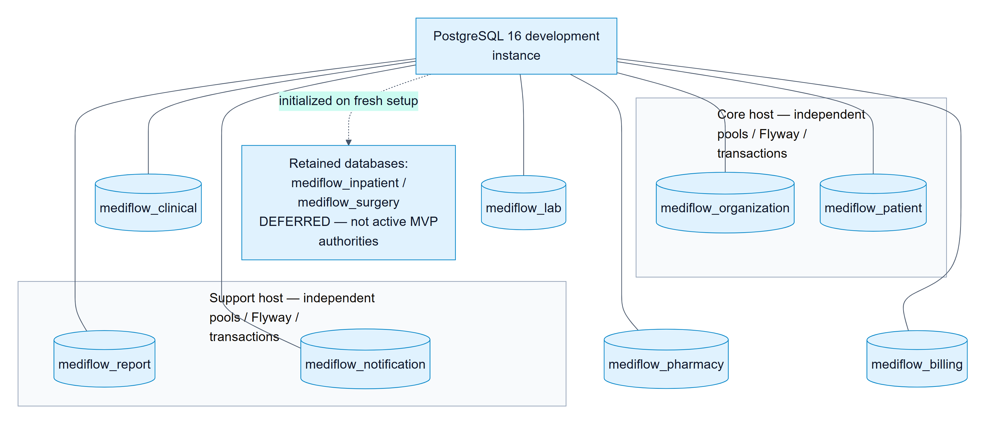

SiteMap

Web sitemap by route group
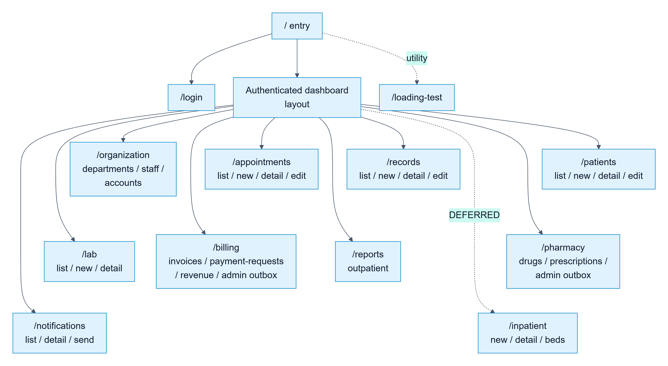

Mobile sitemap and implementation level
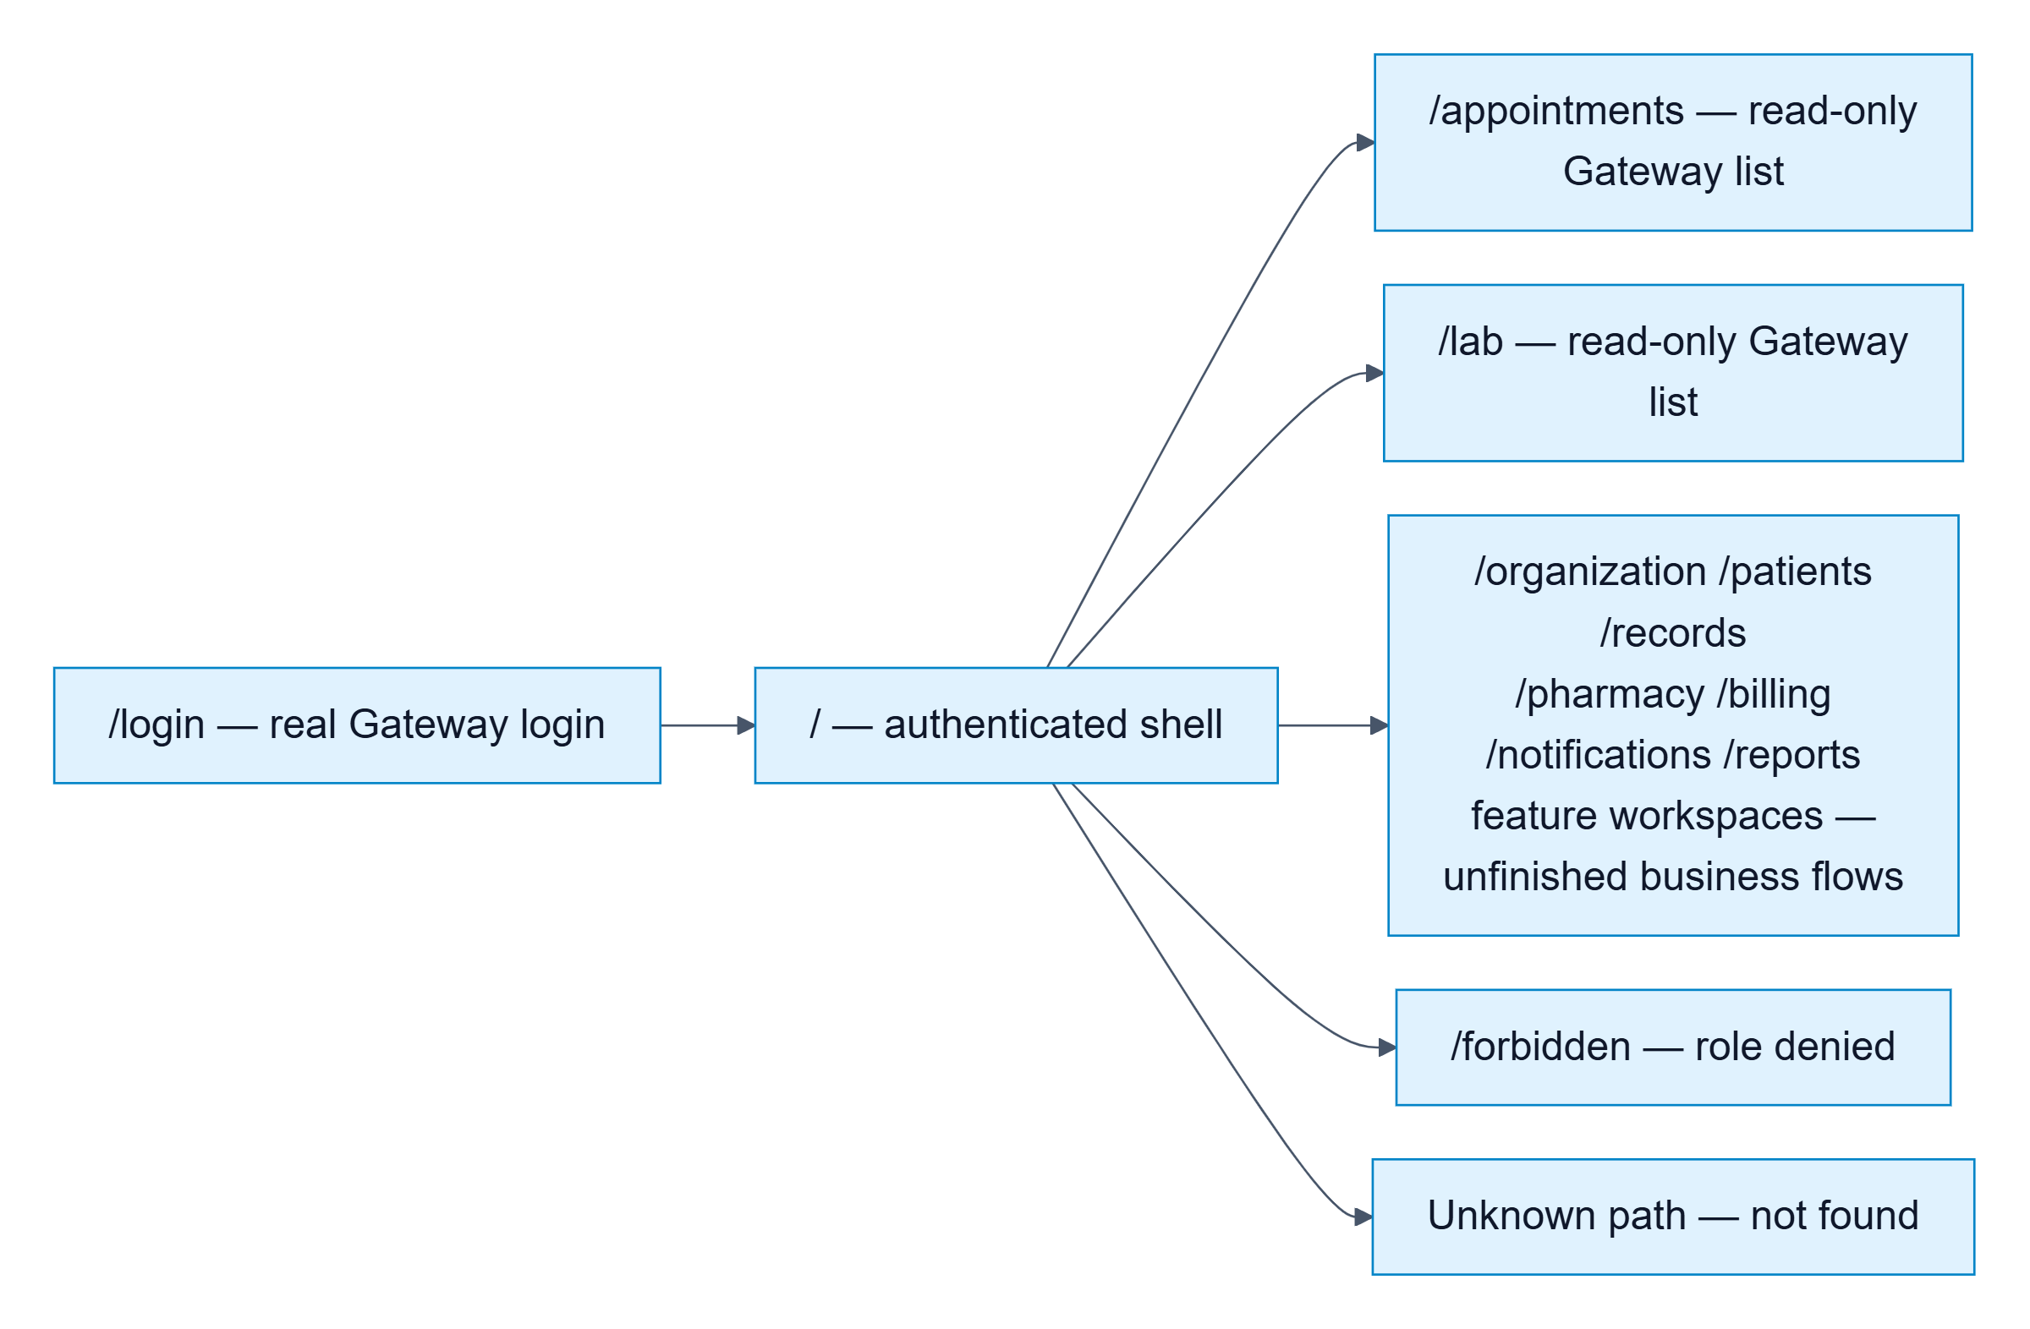

Algorithm

Prescription creation and stock reservation
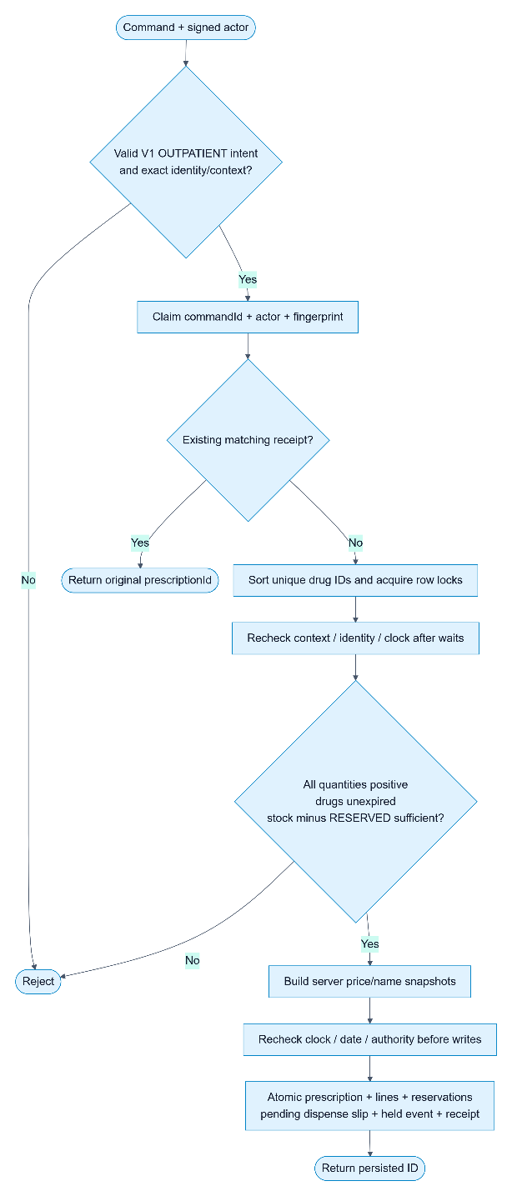

Idempotent payment recording

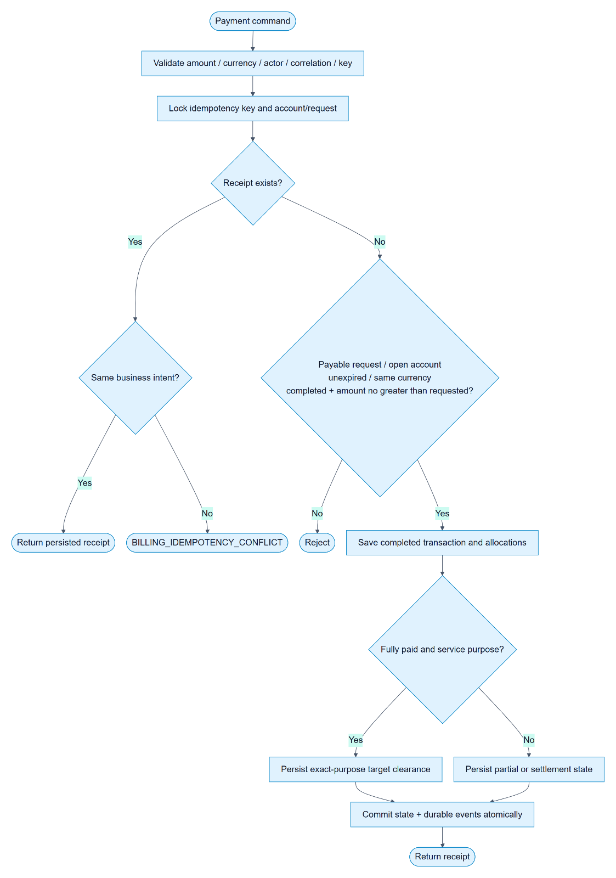

Event delivery, deduplication and recovery
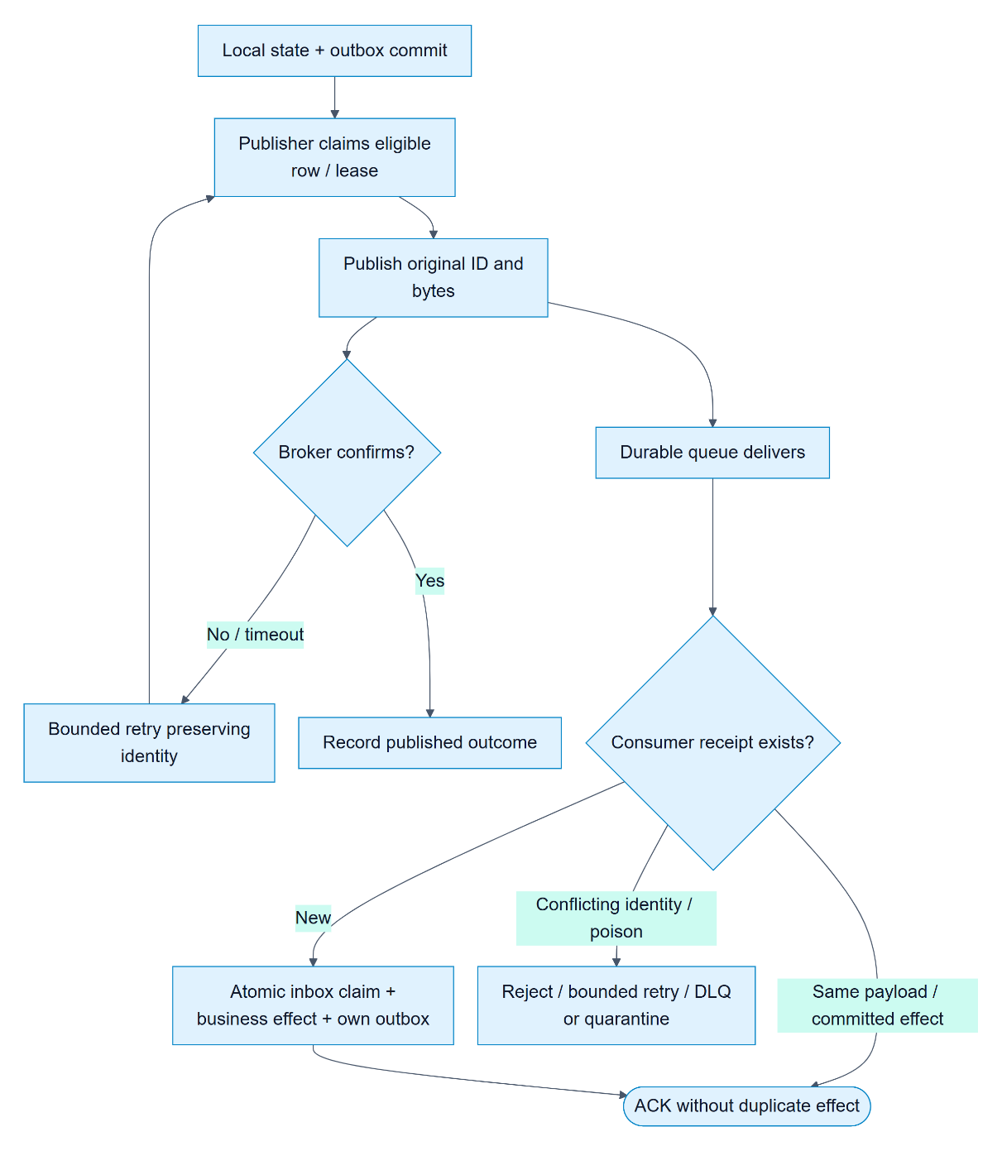

Review 03

Screen shots

User Interface Introduction
Before diving into the Website Structure Overview, this section provides an overview of the visual identity, design principles, and tools used in the Maverick Dresses project. These elements ensure consistency, brand recognition, and an optimized user experience across all pages.

Brand Identity & Design Concept

Brand Recognition
Maverick Dresses is a leading uniform manufacturer, and the website is designed to reflect its professional, modern, and trustworthy identity. The UI/UX approach follows a minimalist yet elegant aesthetic, ensuring clarity and ease of navigation for users.

Color Palette
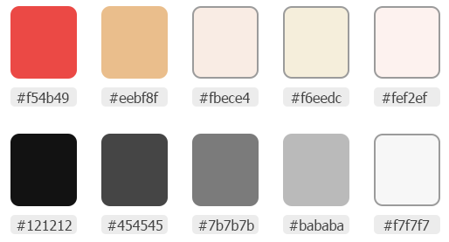
The color scheme is carefully chosen to balance brand representation, readability, and visual appeal. The primary and secondary colors used in the interface include:
- Primary Colors:
  - #f54b49 (Main Accent - Product labels, price highlights)
  - #eebf8f, #fbece4, #f6eedc (Supporting Accent - Banners)
  - #fef2ef (Top-nav Background & Light Theme Areas)
- Neutral & Supporting Colors:
  - #121212 (Text & Primary Dark UI Elements or Call-to-action button backgrounds)
  - #454545 (Secondary Text, Menu, Footer)
  - #7b7b7b (Disabled Elements, Tertiary Text)
  - #bababa (Borders & Subtle Dividers)
  - #f7f7f7 (Card Backgrounds, Light Mode Sections)
These colors ensure strong contrast, readability, and brand consistency across different devices and screen sizes.

Typography & Iconography

Font Selection
- Primary Font: Jost (Modern, Clean, and Readable)
This font provides aesthetic consistency while maintaining high readability across desktop and mobile interfaces.

Icon Set
The website uses Lucide Icons & Svg Icon for a modern and scalable icon set. Icons are used for:
- Navigation Menu & Categories
- Cart, Wishlist, and Checkout Steps
- Social Media & Interactive Features
- Product Status (In Stock, Out of Stock, Discounts, etc.)
All icons are used in SVG format to ensure scalability and performance optimization.

UI Components & Design Principles
3.1. Navigation & Layout Structure
- Fixed Header, Scroll to Top button & Tiker to improve accessibility.
- Top Navigation Bar (Top-Nav) Includes:
  - Contact Information (Phone, Email).
  - Free Shipping Information.
- Primary Navigation Includes:
  - Products, About, Media, Support, Activities.
  - Search Bar, Cart, and Vistor counter Shortcuts.
3.2. UI Components & Interactions
- Smooth Hover Effects on buttons and menus.
- Interactive Filters & Sorting on product pages.
- Collapsible Sections in FAQ and Policies.
- Animated Loading Elements for better user engagement.
3.3. Mobile & Responsive Design
- Fully Responsive Grid System (Using CSS Flexbox & Grid Layouts).
- Optimized Navigation Drawer for mobile users.
- Touch-friendly Buttons & UI Elements for smooth user interactions.

Design Tools & Prototyping
4.1. Design & Prototyping Tool
The entire UI/UX design process was carried out in Figma, ensuring a streamlined workflow between designers and developers. The Figma file includes:
- Wireframes & High-Fidelity Mockups.
- Interactive Prototypes for Testing.
- Component Libraries for Consistency.
- Style Guide & Design Tokens.
4.2. Shared Figma Link
Figma Design File:
MediFlow project evidence: source repository, requirements, architecture, event, and progress documents.
(Accessible for developers, stakeholders, and UI/UX teams).
Important Note:
The Figma file serves as a reference only. During development, there may be deviations from the original design due to technical constraints, optimization decisions, or responsive adjustments. The final coded version may not be 100% identical to the Figma design.

Website Structure Overview: Header, Footer, and Layout Sections
Before diving into the detailed layout of each page, it's important to first define and understand the Header and Footer components, as they are crucial parts of the website’s structure. These sections ensure consistent branding, seamless navigation, and accessibility across different pages.
- We strive to optimize the UI/UX as much as possible, ensuring a smooth, intuitive, and enjoyable user experience.

Header Section
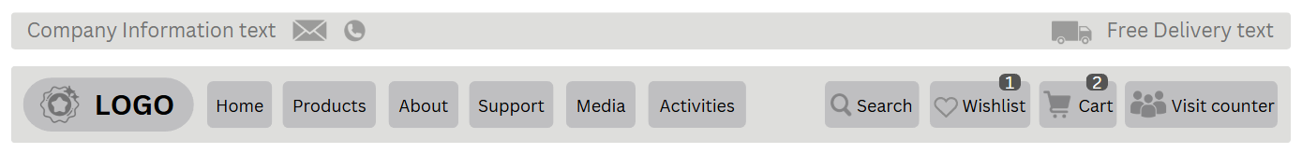
The Header is the topmost part of the website and plays a critical role in user interaction. It serves as the first touchpoint for visitors, providing key navigation and interactive elements.
Top Navigation Bar (Top-Nav)
- Positioned at the very top of the website, above the main navigation menu.

- Left Side: Displays company contact information, including:
  - Phone Number
  - Email Address
- Right Side: Displays free delivery conditions, indicating the minimum purchase amount required to qualify for free shipping.
Company Logo
- Positioned at the top-left of the page.
- Clickable and redirects users to the Homepage when clicked.
Main Navigation Menu & Development Plan
- The Main Navigation Menu is positioned at the top-left of the page and serves as the primary method for users to navigate through the Maverick Dresses website efficiently. It features a horizontal or vertical menu bar that provides quick access to major sections.
    - A horizontal or vertical menu bar that allows users to quickly access major sections:
      - Products (Featured, New, Sale, School Uniforms, Sports Uniforms, Accessories)
      - About (About Us, Careers, Partners, Customer Growth Chart, Awards)
      - Media (Fashion News, Gallery)
      - Support (FAQ, Policies, Feedback, Contact Us)
      - Activities (Wishlist, Coupons, Order Tracking)
- Development Plan (Products & Media Navigation): To ensure a structured and optimized development process, the Products and Media sections in the Main Navigation Menu are being implemented in two phases.
  - Version 1 - Completed Features
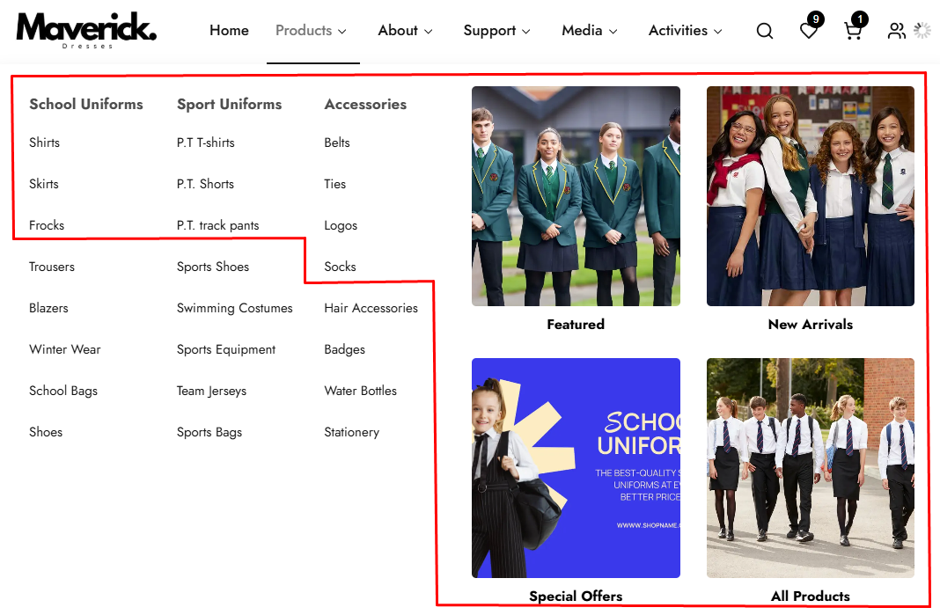
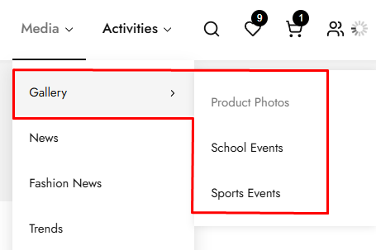
      - In Version 1, the following Products categories and Media sections have been fully implemented, with all links functional:
        - Products -> Featured, New Arrivals, Special Offers, All Products, School Uniforms (Shirts, Skirts, Frocks), Sports Uniforms (P.T. T-Shirts, P.T. Shorts, P.T. Track Pants), Accessories (Belts, Ties, Logos, Socks).
        - Media -> Gallery (Product Photos, School Events, Sports Events), News

  - Version 2 - Upcoming Enhancements (Currently Not Clickable)
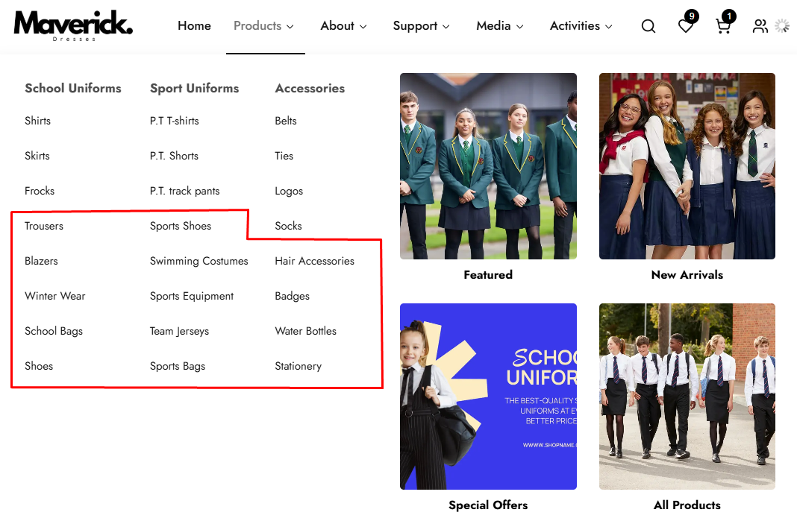
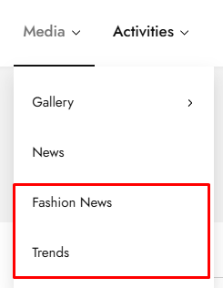
      - The following sections are planned for Version 2, and their links are not yet active:
        - Products -> Advanced Filtering & Sorting Features for better user experience. Expanded Accessories Section with additional product lines. Detailed Subcategories for School Uniforms & Sports Uniforms, including: (More variations for Shirts, Skirts, and Frocks. Additional uniform styles for different school levels. More Sportswear categories such as custom jerseys, sweatpants, and training gear.).
        - Media -> Fashion News and Trends – A dedicated section covering worldwide industry updates, style guides, and the latest collections from Maverick Dresses.
  - Version 2 - Upcoming Enhancements (Currently Not Clickable)
  - By dividing development into two phases, Maverick Dresses ensures:
        - A functional and navigable website in Version 1.
        - A scalable and enriched user experience in Version 2.
        - A seamless transition between current and future updates.
        - With Version 1 successfully implemented, the upcoming enhancements in Version 2 will further elevate the website’s product navigation and media content, making it a fully immersive shopping and branding platform.
        - Stay tuned for Version 2!
- Navbar Highlight for Active Page: The Navigation Bar (Navbar) helps users easily navigate between different sections of the Maverick Dresses website. To improve user experience and usability, the active page should be highlighted dynamically, allowing users to see which section they are currently visiting.
    - Active Page Indication:
      - The currently selected menu item should have a distinct color change and/or an underline to indicate the active state.
      - Example: If a user is on the Products Page, the "Products" menu item should be visually highlighted.
    - Hover Effects:
      - When users hover over menu items, a soft color change or underline animation should appear to indicate interactivity.
    - Dropdown Menu Active State:
      - If a user selects a sub-menu item, both the main menu and the selected sub-menu item should be highlighted.
      - Example: If a user is on the FAQ Page, the “Support” menu (parent category) should also be highlighted.
    - Smooth Transitions:
      - Implement a fade-in or slide-in animation when users switch between pages to enhance UX.
Right Icons Menu
Search Bar Icon: Click to show Search bar.
Wishlist Icon: Displays the number of items in the Wishlist.
Cart Icon: Displays the number of items in the cart.
Visitor Counter
- Positioned near the logo or within the header section.
- A real-time counter displaying the number of active visitors on the site, creating a sense of community and engagement.

Footer Section
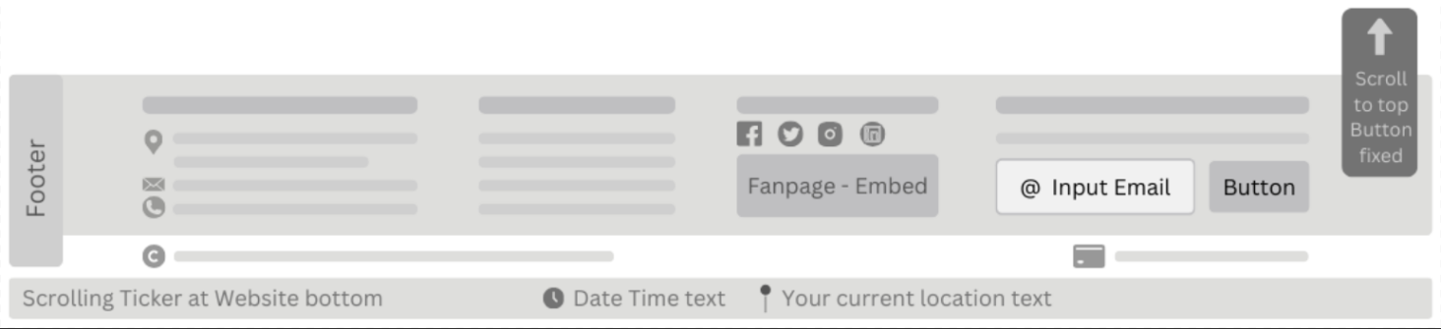
The Footer appears at the bottom of each page and provides additional resources for users, such as company details, policies, and quick navigation.
Company Information
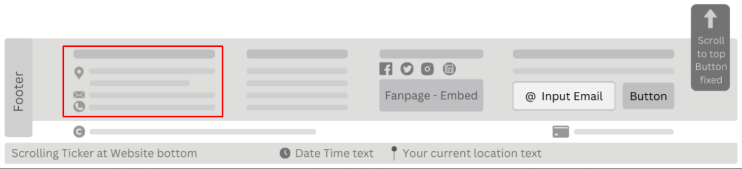
- Displays essential details such as company name, physical address, phone number, and email address.
- May also contain a link to the About Us page or any other relevant company information.
Quick Links
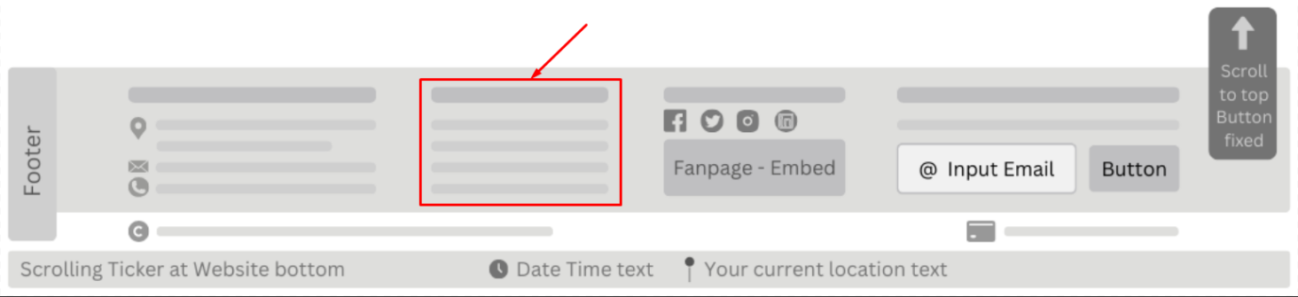
- Provides direct access to commonly accessed pages such as:
  - Policies
  - FAQ
  - Careers
  - Sitemap
  - Partners
  - Contact Us
Social Media Icons and Links
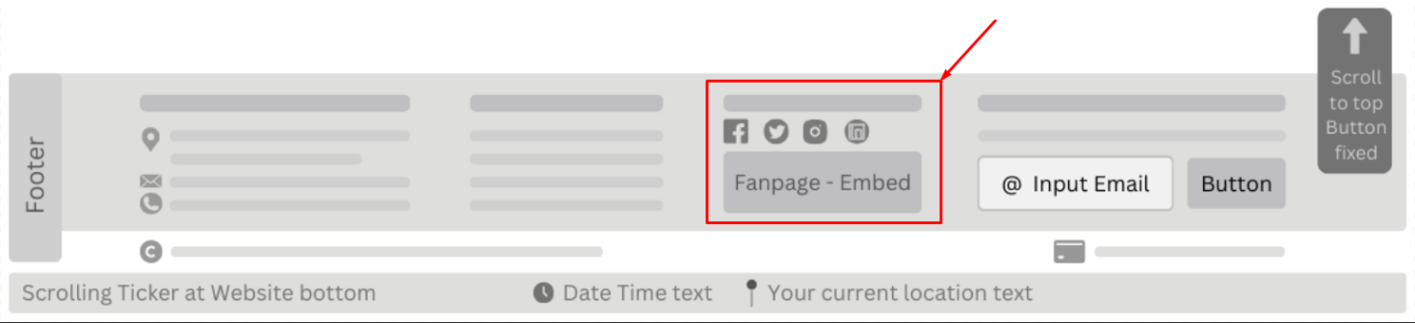
- Allows users to connect with the brand on various platforms, such as:
  - Facebook
  - Instagram
  - Twitter
  - LinkedIn
- The footer includes an embedded Facebook fanpage, allowing users to:
    - View recent posts.
    - Follow Maverick Dresses directly from the site.
    - Engage with brand updates without leaving the page.

Newsletter Signup
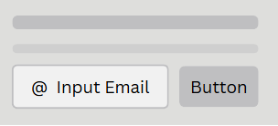
- Includes an email input field where users can subscribe to newsletters and promotional offers.
Payment Methods
- Displays supported payment options for transparency, such as:
  - Visa
  - MasterCard
  - PayPal
  - …
Copyright Notice
- Located at the very bottom of the footer, displaying ownership rights and legal disclaimers.
Scrolling Ticker Section
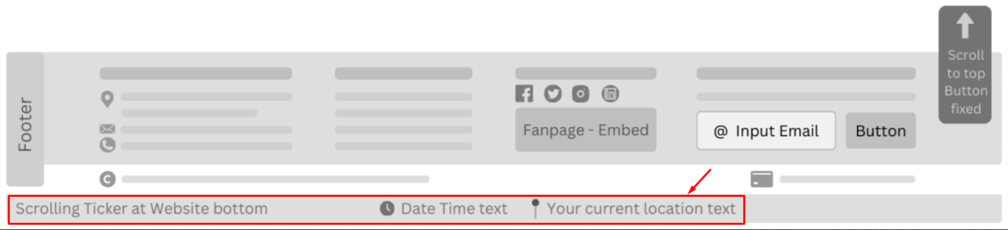
- A persistent ticker located at the very bottom of the page.
- Make sure there is a button that asks the user to give permission for the browser to know the user’s current location. In case the user forgets to give permission when first entering the website, the button will be displayed.
- Displays real-time information, including:
  - Current Date & Time
  - User’s Geolocation (City, Country) (via Geolocation API).
Scroll to Top Button

- Positioned at the bottom-right corner of the page.
- A fixed floating button allowing users to instantly scroll back to the top of the page.
- Enhances usability, especially for pages with long content.

Page Layout Sections Overview
The following sections define the content structure within different pages, helping organize information effectively and improving navigation.
Hero Section (Banner)
- The first section users see on the homepage.
- Contains large images or sliders showcasing:
  - Promotions
  - Best-selling products
  - Limited-time discounts
- Includes call-to-action buttons such as Shop Now or Discover More.
Main Content Section
- Central area of each page containing relevant content.
  - Product pages display product images, descriptions, and filtering options.
  - The About Us page includes the brand’s history, values, and mission.
  - Support pages provide company policies, FAQs, and customer assistance information.

Sidebar (Optional, for Some Pages)
- Typically present on product listing pages or blogs.
- Includes filtering options such as price, size, category, and availability.
- May also display related promotions or featured content.
Interactive Features Section
- Enhances user experience with elements such as dynamic sliders, accordions for FAQs, and live updating product widgets.
Call-to-Action (CTA) Section
- Encourages user interaction through newsletter signups, add-to-cart buttons, and limited-time offer banners.

Important Notes
Product Titles & Breadcrumbs:
- If a product title is too long, it will be automatically truncated with "..." after three lines to prevent layout distortion. To view the full title, users must click on the product for more details.
- Breadcrumbs will also be truncated if they exceed a certain length to maintain a clean and structured navigation flow.

Layout & Responsiveness
The website is fully responsive, ensuring optimal performance across mobile devices, tablets, and all major web browsers as per the project requirements. The design dynamically adjusts to different screen sizes, providing a seamless and user-friendly experience on Chrome, Firefox, Safari, Edge, and other modern browsers.
Next Steps
With the Header, Footer, and Key Layout Sections defined, the next step is to break down the structure of individual pages in more detail, starting with the Homepage Layout.

Testing document

No. |  | Feature Tested | Remarks

Final checklist
No. |  | Review 01 aspect tested | Suggestion / Remarks

Tasksheet
No | Member | Contents | Page Name | Activity Plan | Date of Preparation of Activity Plan
 |  |  |  | Planed Start Date | Actual Start Date | Actual Days | Status
1 | All members; Vinh consolidates | Review outstanding functions, agree API contracts and integration order. Produce a shared list of changes, permissions and test data for web and mobile. | Backend / Frontend / Mobile — scope and API alignment | 2026-10-01 | 2026-10-04 | 5 | In progress  Design and APIs exist; web/mobile integration alignment remains.
2 | Hoàng Anh | Complete Core account, staff, department and patient management. Enforce login and record permissions; keep Organization and Patient data independent. | Backend — Core: Organization, Patient | 2026-10-01 | 2026-10-04 | 10 | Awaiting integration  Core and APIs exist; complete login and cross-service data flows remain unverified.
3 | Hoàng Anh | Complete Gateway routing and caller identity checks. Expose authorized APIs and reject forbidden requests or expired sessions. | Backend — Gateway: authentication, routing, authorization | 2026-10-02 | 2026-10-06 | 9 | In progress  Routing and role checks exist; payment-request discovery routing and prescription cancellation permissions remain open.
4 | Vinh | Complete appointment, check-in, examination start and completion workflows. Enforce valid state transitions and required payment clearance. | Backend — Clinical: appointments and medical records | 2026-10-01 | 2026-10-05 | 12 | Awaiting integration  Business logic and tests exist; acceptance with actual examination payments remains open.
5 | Vinh | Complete lab orders, sample reception and result delivery. Link orders to the correct record, synchronize results and prevent duplicates on retry. | Backend — Lab: orders, samples and results | 2026-10-02 | 2026-10-06 | 12 | Awaiting integration  Orders, results and recovery tests exist; integrated lab payment acceptance remains open.
6 | Huy | Complete drug, inventory, prescription and dispensing workflows. Check stock and payment; enforce cancellation and dispensing permissions and prevent duplicate dispensing. | Backend — Pharmacy: drugs, stock and prescriptions | 2026-10-01 | 2026-10-04 | 12 | Awaiting integration  Drug and dispensing workflows exist; Gateway role checks and the paid prescription journey remain open.
7 | Lộc | Complete charges, invoices and payment recording. Collect the correct examination, lab and prescription charges; ensure accurate amounts and prevent duplicate payments. | Backend — Billing: charges, invoices and payments | 2026-10-01 | 2026-10-05 | 12 | In progress  Charges, payments and tests exist; event publication evidence and consumer acceptance remain incomplete.
8 | Huy | Complete reports and verify data sources. Provide supported filters and reconcilable figures; identify unavailable data clearly. | Backend — Report: reporting | 2026-10-04 | 2026-10-07 | 10 | Awaiting integration  Report APIs exist; source coverage and data completeness await confirmation.
9 | Lộc | Complete in-app notifications and recipient access checks. Deliver to the correct recipient, protect patient information and prevent duplicate delivery on retry. | Backend — Notification: notifications | 2026-10-04 | 2026-10-08 | 10 | Awaiting integration  Notification APIs exist; actual event delivery and recipient permissions await integrated acceptance.
10 | Huy, Lộc; Vinh coordinates; Hoàng Anh supports Gateway | Complete Support packaging and service connections. Start Core, Clinical, Lab, Pharmacy, Billing and Support with correct routing and data connections. | Backend — Support and integration configuration | 2026-10-05 | 2026-10-09 | 10 | Not started  No Support host module exists; Report and Notification remain separate services.
11 | Each business owner | Test backend workflows, permissions and failure recovery. Cover successful requests, forbidden access, invalid states, duplicates, connection failures and retries; fix discovered defects. | Backend — business workflow testing | 2026-10-07 | 2026-10-11 | 11 | In progress  Business and recovery tests exist; system-wide integration testing remains open.
12 | Vinh coordinates; Hoàng Anh supports accounts | Review login, role-based menus, layout and small-screen behavior. Handle session expiry and ensure usable navigation on phones. | Frontend — login, navigation and shared layout | 2026-10-01 | 2026-10-05 | 7 | In progress  Layout, navigation and login exist; real-session and role-based navigation checks remain open.
13 | Hoàng Anh | Complete staff, department and patient screens. Support authorized search, pagination, viewing and updates, with input validation and API error handling. | Frontend — /organization; /patients | 2026-10-03 | 2026-10-06 | 11 | Awaiting integration  Management pages and actions exist; verification against Core through Gateway remains open.
14 | Vinh | Complete appointment, check-in and medical-record screens. Run the examination workflow through Gateway and show correct states and payment conditions. | Frontend — /appointments; /records | 2026-10-03 | 2026-10-07 | 11 | Awaiting integration  Appointment and record screens exist; payment-dependent examination actions await acceptance.
15 | Vinh | Complete lab-order and result screens. Display orders and update states and results for the correct record and authorized roles. | Frontend — /lab; /records | 2026-10-04 | 2026-10-07 | 11 | Awaiting integration  Screens and local tests exist; the paid lab flow through Gateway remains unverified.
16 | Huy | Complete drug, stock and dispensing screens. Search drugs, view stock and process prescriptions according to backend states and server-provided prices. | Frontend — /pharmacy | 2026-10-03 | 2026-10-07 | 11 | Awaiting integration  Drug, stock and prescription screens exist; real-role and paid dispensing checks remain open.
17 | Lộc | Complete invoice and payment screens. Select the correct charges, view invoices and record payments; prevent repeated submissions and show clear errors. | Frontend — /billing | 2026-10-03 | 2026-10-06 | 12 | Awaiting integration  Invoice and payment screens exist; source-based charge discovery through Gateway remains unavailable.
18 | Huy | Complete report screens. Match filters and figures to the backend and handle loading, empty and error states. | Frontend — /reports | 2026-10-05 | 2026-10-08 | 10 | Awaiting integration  Report screens and local tests exist; actual figures and source coverage remain to be reconciled.
19 | Lộc | Complete notification screens. Show lists and details to the correct recipient and expose only backend-supported actions. | Frontend — /notifications | 2026-10-05 | 2026-10-09 | 10 | Awaiting integration  List, detail and send screens exist; recipient checks with real sessions remain open.
20 | Each business owner | Test screens by role and business workflow. Use real APIs, verify permissions and error handling, and record defects. | Frontend — role-based screen testing | 2026-10-07 | 2026-10-11 | 11 | In progress  Local screen tests exist; complete role coverage and real-API journeys remain unverified.
21 | Vinh coordinates; all members review workflows | Review the existing mobile app, agree screens and roles, and configure connections. Confirm the runtime environment and use Gateway for all requests. | Mobile — app configuration and screen scope | 2026-10-01 | 2026-10-04 | 6 | In progress  Folder scaffolding and a loading component exist; app configuration and Gateway connectivity are missing.
22 | Vinh coordinates shared work; Hoàng Anh supports authentication | Complete login, secure session storage and role-based navigation. Handle logout and session expiry and restrict access to authorized screens. | Mobile — login, logout and navigation | 2026-10-02 | 2026-10-06 | 8 | Not started  Mobile login, session storage and navigation have not been implemented.
23 | Hoàng Anh | Complete patient search and information screens. Use authorized APIs and roles and protect personal information. | Mobile — patient information | 2026-10-04 | 2026-10-07 | 10 | Not started  Mobile patient screens and data handling have not been implemented.
24 | Vinh | Complete appointment and examination information screens. Show authorized schedules, states and records; use only supported update APIs. | Mobile — appointments and examination information | 2026-10-04 | 2026-10-08 | 10 | Not started  Mobile appointment and examination screens have not been implemented.
25 | Vinh | Complete lab-result screens. Link results to the correct patient and record and handle refresh, empty and error states. | Mobile — lab results | 2026-10-05 | 2026-10-08 | 10 | Not started  Mobile lab-result screens have not been implemented.
26 | Huy | Complete drug and prescription information screens. Display medicines, instructions and prescription states according to backend data and user permissions. | Mobile — drugs and prescriptions | 2026-10-04 | 2026-10-08 | 10 | Not started  Mobile drug and prescription screens have not been implemented.
27 | Lộc | Complete invoice and payment-status screens. Show correct charges, amounts and states; expose payment actions only when supported by the backend. | Mobile — invoices and payment status | 2026-10-04 | 2026-10-07 | 11 | Not started  Mobile invoice and payment screens have not been implemented.
28 | Lộc | Complete user notification screens. Display notifications for the correct recipient and prevent access to another account’s notifications. | Mobile — notifications | 2026-10-05 | 2026-10-09 | 10 | Not started  Mobile notification screens have not been implemented.
29 | Each business owner tests; Vinh packages the app | Test mobile on devices and prepare an Android installation package. Check screen sizes, keyboards, slow or lost connections and session expiry; verify installation and startup. | Mobile — device testing and Android package | 2026-10-07 | 2026-10-11 | 11 | Not started  No complete app, device testing or Android package is available for acceptance.
30 | All members; Hoàng Anh prepares accounts | Prepare role-based accounts, sample data and shared test scenarios. Use consistent data across backend, web and mobile without real personal information. | Backend / Frontend / Mobile — accounts and test data | 2026-10-06 | 2026-10-09 | 10 | In progress  Backend/web sample data and test fixtures exist; a shared set covering mobile is not ready.
31 | All members; Vinh coordinates | Test the complete check-in, examination, lab, payment and dispensing journey. Run through Gateway on web and agreed mobile screens and reconcile states, amounts and data. | Backend / Frontend / Mobile — examination-to-dispensing workflow | 2026-10-08 | 2026-10-12 | 11 | Awaiting integration  Actual payment journeys depend on pending Gateway work; mobile workflows are not implemented.
32 | All business owners | Verify reports, notifications, permissions and consistency across applications. Reconcile figures and states, protect data and prevent duplicate effects when events are retried. | Backend / Frontend / Mobile — reports, notifications and permissions | 2026-10-08 | 2026-10-12 | 12 | Awaiting integration  Cross-application data, permissions and events have not passed integrated acceptance.
33 | Each business owner | Fix integration defects and retest affected workflows. Resolve login, examination, payment, dispensing and security blockers and record remaining limitations. | Backend / Frontend / Mobile — defect fixes and regression testing | 2026-10-09 | 2026-10-13 | 11 | In progress  Local fixes and regression tests exist; integration issues and dependencies remain to be checked.
34 | All members; Vinh consolidates | Complete installation and user guides, project reports and presentation materials. Document working functions, configuration, demo accounts and presentation scenarios. | Documentation — installation, usage, reports and presentation | 2026-10-09 | 2026-10-12 | 12 | In progress  Design documents and guides exist; handover materials need the final delivery results.
35 | All members | Package, perform final acceptance and hand over the project. Rerun main scenarios, verify the installation package and environment, and deliver source, configuration, documentation and remaining limitations. | Backend / Frontend / Mobile — acceptance and handover | 2026-10-10 | 2026-10-14 | 11 | Not accepted  System-wide acceptance and the complete handover package are not yet available.

Acknowledgments and Declaration
Project Documentation for Mediflow
Completed on 30/10/2025
The documentation for the Mediflow project was completed on November 30, 2026. Our team would like to express our gratitude to our supervisor, Mr. HOÀNG ĐỨC QUANG, for his guidance and valuable feedback throughout the project. We also appreciate the constructive input from our fellow students, which contributed to the refinement of our work.
We also thank Project Aptech for providing us with the opportunity to work on this real-world project, which helped us apply our academic knowledge in a practical scenario.
This document is the result of our team’s efforts, based on the knowledge we have gained during our studies and additional research. We confirm that the content is original and accurate, with no unauthorized copying or plagiarism. Our team is committed to maintaining academic integrity and ensuring the quality of this project.
This is a complete document that reflects the efforts and research of our team as students who are still learning and have not yet entered the professional workforce. We are grateful to our teacher for his support throughout this project. The content is based on the knowledge we have acquired during our studies and reliable sources.

