

MediFlow
A Microservices – Based Distributed Hospital Management System

Supervisor: | LÊ THANH NHÂN
Semester: | 04
Batch No: | T2.2410.E0
Group No: | 04
Order: | Full name | Roll No.
1. | Phạm Đăng Vinh | Student1614910
2. | Lê Quang Huy | Student1394600
3. | Trần Hoàng Anh | Student1614884
4. | Thân Thế Lộc | Student1571994

Month: 10 Year: 2026


This is to certify that
Mr. | PHAM DANG VINH
Mr. | LE QUANG HUY
Mr. | TRAN HOANG ANH
Mr. | THAN THE LOC

Have successfully Designed & Developed
MEDIFLOW
A MICROSERVICES – BASED DISTRIBUTED HOSPITAL MANAGEMENT SYSTEM

Submitted by:
Mr. LE THANH NHAN

Date Of Issue:

Authorized Signature:

Content

Content 3
Acknowledge 4
Synopsis 6
Review 01 7
Problem Definition 8
Customer Requirements Specifications 18
Review 02 36
Architecture Design 37
Data Flow Diagram 38
Entity Relationship Diagram 39
Table Design 40
SiteMap 41
Algorithm 42
Review 03 43
Screen shots 44
Testing document 61
Final checklist 74
Tasksheet 80
Acknowledgments and Declaration 97

Acknowledge

As we approach the completion of our MediFlow – Microservices-Based Distributed Hospital Management System project, we are filled with gratitude, pride, and a sense of accomplishment. This project has been a valuable opportunity to apply our academic knowledge, strengthen our technical skills, and gain practical experience in developing complex software systems.
Heartfelt Gratitude to Our Mentors
First and foremost, we would like to express our sincere gratitude to the Project Team at FPT Aptech for providing us with the knowledge, resources, and opportunity to undertake this meaningful project.
We are especially thankful to our lecturer, Mr. LE THANH NHAN, for his dedicated guidance, patience, and valuable feedback throughout the development process. His mentorship has helped us overcome technical challenges, improve our problem-solving abilities, and develop a more professional approach to software engineering.
Appreciation for Our Team and Families
We extend our heartfelt appreciation to every member of Team 04 for their dedication, teamwork, and perseverance. Through close collaboration, we have explored and developed a distributed healthcare platform encompassing ten business domains: Organization, Patient, Clinical, Laboratory, Pharmacy, Billing, Notification, Reporting, Inpatient, and Surgery.
We are equally grateful to our families, friends, and classmates for their continuous encouragement and understanding throughout this journey.
A Meaningful Learning Experience
The MediFlow Project has provided us with valuable experience in microservices architecture, distributed systems, database design, event-driven communication, and cross-platform application development. By working with technologies such as Spring Boot, Spring Cloud, RabbitMQ, PostgreSQL, Next.js, and Flutter, we have gained a deeper understanding of modern software engineering practices and the challenges of integrating independent healthcare services.
Beyond technical knowledge, this project has strengthened our communication, adaptability, responsibility, and collaborative problem-solving skills.
Looking Forward
As we conclude this important milestone, we believe the knowledge and experience gained from MediFlow will serve as a strong foundation for our future careers in information technology.
Once again, we sincerely thank everyone who has supported and contributed to our journey.
With heartfelt gratitude,
TEAM 04
MediFlow – Microservices-Based Distributed Hospital Management System

Synopsis
MediFlow – Microservices-Based Distributed Hospital Management System is a healthcare management project designed to address the fragmentation of patient information, hospital operations, and medical workflows across different departments. The system aims to improve coordination, streamline administrative processes, and support efficient healthcare service delivery through a distributed software architecture.
Built on a microservices-based and event-driven architecture, MediFlow encompasses ten business domains: Organization, Patient, Clinical, Laboratory, Pharmacy, Billing, Notification, Reporting, Inpatient, and Surgery. These services are designed to manage distinct healthcare responsibilities while enabling coordinated workflows, including patient registration, appointment scheduling, clinical examinations, laboratory testing, prescription management, payment processing, medication dispensing, inpatient care, and surgical procedures.
The project utilizes Java Spring Boot, Spring Cloud Gateway, Netflix Eureka, RabbitMQ, and PostgreSQL for backend development, service discovery, asynchronous communication, and data management. Next.js and Flutter are used to develop web and mobile applications, providing role-based interfaces for healthcare professionals and administrative personnel.
MediFlow follows essential software engineering principles, including Domain-Driven Design, Clean Architecture, database-per-service ownership, RESTful API communication, and event-driven integration. These approaches promote modularity, maintainability, scalability, and separation of responsibilities across independent services.
As an academic project under active development, MediFlow demonstrates the practical application of distributed systems and modern software engineering technologies in the healthcare domain. Beyond its functional scope, the project provides valuable experience in system architecture, collaborative development, integration testing, and solving complex real-world business problems.
Keywords: Hospital Management System, Healthcare Information System, Microservices, Distributed Systems, Event-Driven Architecture, Spring Boot, RabbitMQ, Next.js, Flutter.

Review 01

Problem Definition

Executive Context
Hospitals coordinate information that is simultaneously personal, clinical, operational, and financial. A patient may interact with reception, a doctor, nursing staff, a laboratory, a pharmacy, a cashier, an inpatient ward, and a surgery team during a single episode of care. Each department creates information needed by another department, yet each remains responsible for its own professional decisions and records.
When this information is managed by paper, spreadsheets, isolated applications, or informal messages, the organization loses a reliable end-to-end view. Staff repeat data entry, status changes are communicated late, charges may be missed or duplicated, inventory can become inaccurate, and management reports depend on manual reconciliation. Sensitive data is also harder to protect because access rules are inconsistent across tools.
MediFlow is designed as a hospital workflow platform that connects these areas while preserving clear data ownership. The current repository implements a browser-based frontend and a Spring Boot microservice backend. The final system comprises ten business services supported by an API gateway, Eureka service discovery, PostgreSQL databases, and RabbitMQ messaging.
The central design principle is that each business service is authoritative for its own data. Other services exchange UUID references, use REST only when immediate authoritative information is required, and use events to distribute completed business facts. This structure supports traceability and reduces hidden cross-department coupling.

Problem Identification
Problem | Existing operational impact | Required system response
Fragmented patient information | Staff cannot obtain a complete and timely view of a patient | Maintain a consistent patient identity and connect authorized records by UUID
Manual appointment coordination | Double booking, missed appointments, and slow check-in can occur | Provide appointment registration, status tracking, and encounter handoff
Disconnected clinical documentation | Diagnoses, observations, and orders may not reach the next department reliably | Record clinical encounters and publish controlled downstream requests
Slow laboratory turnaround visibility | Clinicians may not know whether a test is ordered, collected, processed, or completed | Track the laboratory order lifecycle and publish verified results
Prescription and stock separation | Medicines may be prescribed without clear dispensing or inventory status | Authorize prescriptions, validate stock, dispense medicine, and record movements
Inconsistent financial tracking | Charges, invoices, payments, deposits, receipts, and refunds may be reconciled manually | Centralize financial records in the Billing context and expose auditable status
Weak inpatient coordination | Admission, financial clearance, bed allocation, care stay, and discharge may be tracked separately | Provide one stateful inpatient workflow with explicit transitions
Weak surgery coordination | Readiness, clearance, scheduling, execution, and outcomes may be communicated informally | Provide a traceable surgery lifecycle with authorization checkpoints
Delayed communication | Patients and staff may not receive important status changes promptly | Generate notifications from domain events and retain delivery status
Limited management visibility | Managers may depend on manually assembled reports | Build reporting read models from trusted operational events
Insufficient access control | Sensitive medical and financial data may be exposed to unauthorized users | Enforce role-based access at every backend endpoint
Poor auditability | It may be difficult to determine who changed a record and when | Retain identifiers, timestamps, statuses, and event histories suitable for audit

Project Objectives
The primary objective is to provide a coherent, secure, and traceable digital workflow for a patient's journey across hospital departments.
Specific objectives are:
- Establish traceable end-to-end workflows from registration to care, diagnostics, medication, billing, inpatient care, surgery, notification, and reporting.
- Give each bounded context clear ownership of its data and business rules.
- Reduce duplicate entry by exchanging identifiers and authorized information through explicit contracts.
- Enforce role-based authorization at the gateway-facing backend endpoints.
- Record state changes and publish domain events for dependent workflows.
- Support complete financial accountability through charges, invoices, deposits, payments, receipts, refunds, settlement, and service clearance.
- Improve coordination across appointments, encounters, Laboratory, Pharmacy, Billing, Inpatient, and Surgery workflows.
- Provide reliable background processing through outbox publication, idempotent consumers, retry handling, and dead-letter queues.
- Supply managers with consolidated operational information without allowing reporting logic to modify source-of-truth records.
- Maintain a modular architecture that can be developed, tested, and deployed by bounded context.

Project Scope

Included Scope
Scope area | Included capabilities
Organization | Users, staff, departments, roles, facilities, rooms, and organization reference data
Patient | Patient profiles, identifiers, contact information, and demographic records
Clinical | Appointments, encounters, medical records, diagnoses, and admission-referral references; examination requires matching EXAM clearance or an audited emergency override
Laboratory | Tests accepted from explicit Clinical requests, specimens, processing states, results, and publication; protected processing requires matching LAB_TEST clearance or an audited emergency override
Pharmacy | Medicine catalogue, Pharmacy-owned prescription creation, inventory, payment-proof validation, stock movement, and dispensing
Billing | Charges, invoices, deposits, payments, receipts, refunds, settlement, and purpose-specific service clearance
Notification | Event-driven notification requests, templates, delivery attempts, and delivery status
Report | Event-fed read models and management-oriented operational reports
Inpatient | Admission requests, financial clearance, bed ownership/allocation, active stays, treatment, transfers, medical discharge, settlement, and administrative close
Surgery | Surgery requests, readiness review, financial clearance, scheduling, execution, recovery, outcomes, and charge handoff
Shared platform | API gateway, service discovery, per-service databases, messaging, security conventions, and shared contracts
Web client | Role-aware pages that call the platform through same-origin /api/* routes

Excluded or not yet proven complete
- Production integration with national identity, health insurance, banking, payment gateways, or government systems.
- Certified interoperability with external laboratories, medical devices, PACS, or third-party electronic health records.
- Production delivery contracts with SMS, email, or push-notification vendors.
- A complete runnable Flutter mobile application; the repository currently contains only a shared loader package.
- Clinical decision support, automated diagnosis, prescription recommendation, or AI-assisted treatment decisions.
- A finalized production service-level objective, retention policy, disaster-recovery target, or clinical governance process.
- Formal regulatory certification, accessibility certification, penetration-test certification, or medical-device certification.

Users and Functions by Role
Role | Main responsibilities | Representative system functions
ADMIN | Configure and govern the platform | Manage users, roles, departments, facilities, organization reference data, and permitted Inpatient bed records; review administrative status
DOCTOR | Diagnose and direct care | Review patient information; update encounters; enter observations/diagnoses; request tests; prescribe; create admission and surgery requests; follow care outcomes
NURSE | Coordinate permitted patient and ward workflows | Create permitted patient/appointment records; support appointment/check-in/read operations; record permitted Inpatient treatment observations; perform authorized bed operations
PHARMACIST | Validate and dispense medication | Review authorized prescriptions; verify medicines and quantities; manage stock; record dispensing and inventory movement
CASHIER | Process authorized financial transactions | Create and settle invoices; receive deposits and payments; issue receipts; process authorized refunds; confirm settlement and service clearance
LAB_TECH | Process existing diagnostic tests | Start/cancel permitted tests; manage specimens; record status/results; verify and publish results; test creation follows an authorized Clinical request and belongs to Laboratory
MANAGER | Monitor hospital operations | View operational and financial reports, service activity, workloads, trends, and management indicators
PATIENT | Access personal healthcare information and services | Manage permitted profile data; request and review appointments; view authorized results, prescriptions, invoices, receipts, payments, and notifications
SYSTEM | Execute trusted automation | Publish and consume events; retry failed delivery; update read models; initiate notifications; preserve idempotency and traceability

Proposed Solutions
MediFlow proposes a modular hospital platform in which each business capability is implemented as an independent Spring Boot service. The services are accessed through one gateway and registered through Eureka. Each service owns a separate PostgreSQL database, preventing direct cross-service database access. When one service requires authoritative information from another, it uses a defined REST contract. When a completed state change must inform multiple downstream consumers, it publishes an event through RabbitMQ.
Solution element | Purpose | Expected benefit
Next.js web client | Provide role-aware workflows in a consistent user interface | Faster staff access and fewer disconnected screens
API gateway | Expose one controlled entry point | Consistent routing, authentication context, and reduced client coupling
Independent services | Separate business ownership and deployment | Clear boundaries, safer change, and focused testing
Isolated PostgreSQL databases | Keep each service authoritative for its records | Reduced accidental coupling and clearer accountability
REST contracts | Resolve information required immediately for a command | Timely validation using the owning service
RabbitMQ events | Propagate completed business facts | Decoupled notifications, reporting, and cross-department reactions
Transactional outbox | Coordinate database changes with event publication | Lower risk of losing events after a committed state change
Idempotent consumers | Prevent repeated delivery from creating repeated business effects | Safer retries and recovery
Role-based authorization | Restrict every protected operation | Better privacy and separation of duties
Automated tests | Verify rules, contracts, persistence, and integrations | Repeatable evidence that implemented behavior remains stable

Customer Requirements Specifications

Stakeholders and Customer Requirements
Stakeholder | Core requirement | Success indicator
Hospital administration | Govern users, departments, facilities, and access | Authorized configuration is available and changes are traceable
Clinical staff | See relevant patient information and document care efficiently | Encounters, orders, diagnoses, and care states are available to permitted roles
Laboratory staff | Receive complete orders and publish verified results | Each order has an identifiable lifecycle from request to published result
Pharmacy staff | Dispense only valid prescriptions with sufficient stock | Dispensing creates auditable medication and inventory records
Finance staff | Reconcile the complete patient financial lifecycle | Charges, invoices, deposits, payments, receipts, refunds, settlement, and clearance have auditable states
Inpatient staff | Coordinate admission, clearance, bed use, stay, and discharge | No admission proceeds without required state and resource checks
Surgery team | Coordinate readiness, clearance, scheduling, execution, recovery, and outcomes | Every case progresses through an authorized, auditable lifecycle and produces the required care and charge outputs
Managers | Obtain timely operational and financial insight | Reports use trusted source events and do not modify operational data
Patients | Access permitted personal information and services | Authorized self-service exposes only the patient's own profile, appointments, results, prescriptions, invoices, receipts, payments, and notifications
Technical operations | Operate services reliably and recover from transient failures | Health, logs, retries, dead-letter handling, and database isolation are observable

Data-Processing Cycle by User Role
Workflow | Actor | Input information | Processing | Output information | Owning service
User and role administration | ADMIN | User identity, staff details, assigned roles, department | Validate uniqueness and permissions; create or update organization records | User/staff record, role assignment, audit timestamps | Organization
Organization setup | ADMIN | Facility, department, room, and organization attributes | Validate hierarchy and persist organization reference data | Available organization and room references | Organization
Bed catalogue setup | ADMIN,  MANAGER | Department/room references and bed attributes | Validate references and bed state; persist the Inpatient-owned resource | Bed catalogue and availability state | Inpatient
Patient registration | ADMIN,  NURSE | Demographics, contact data, identifiers | Validate required fields and duplicate constraints; assign UUID | Patient profile and registration confirmation | Patient
Appointment scheduling | ADMIN,  NURSE | Patient UUID, department/provider, requested time, reason | Validate request and scheduling rules; create appointment state | Appointment identifier, schedule, and status | Clinical
Appointment/check-in support | ADMIN,  DOCTOR,  NURSE as permitted by route | Appointment and status input | Apply permitted appointment state; ARRIVED alone does not authorize examination | Updated appointment state | Clinical
Clinical examination and record | ADMIN,  DOCTOR | Patient, appointment, findings, matching EXAM clearance or audited emergency override | Validate authority, encounter state, and proof; create/update record and diagnosis | Medical record, diagnosis, disposition/reference | Clinical
Clinical test request and Laboratory creation | ADMIN,  DOCTOR | Patient/record references, department, test code, requested date, order ID | Validate the clinical request; transfer the explicit order; create the Laboratory-owned test | Accepted Laboratory test in initial state | Laboratory
Laboratory processing and result | ADMIN,  LAB_TECH | Existing Lab test, matching LAB_TEST clearance or audited emergency override, specimen/results | Validate proof and lifecycle; start, record, complete, and publish | Published Laboratory result | Laboratory
Prescription creation | ADMIN,  DOCTOR | Clinical record reference, patient, medicine, dose, quantity, instructions | Pharmacy validates lines/prices and creates the Pharmacy-owned prescription plus pending dispense slip | Prescription and medication lines | Pharmacy
Medicine dispensing | ADMIN,  PHARMACIST | Pharmacy prescription, durable payment proof, stock, dispense quantity | Verify proof/prescription/stock; record dispense and inventory movement | Dispense record and remaining stock | Pharmacy
Invoice and payment processing | Authorized Billing staff | Patient/source context, charge, invoice, and payment data | Validate financial state; create invoice; record payment and receipt | Invoice, payment state, and receipt | Billing
Deposit, refund, settlement, and clearance | ADMIN,  CASHIER | Payment request, original transaction, service purpose, and admission/care reference | Apply append-only and idempotent financial rules; authorize refund or service clearance | Deposit, refund, settlement, and clearance records | Billing
Inpatient admission creation | ADMIN, DOCTOR | Patient, clinical need, and admission details | Validate references and create the admission | Pending admission | Inpatient
Bed assignment and transfer | ADMIN, NURSE | Admission and requested/target bed | Validate availability and perform the bed transition | Updated admission and bed occupancy | Inpatient
Inpatient treatment | ADMIN, DOCTOR, NURSE | Active admission and treatment/observation information | Append or correct permitted treatment entries | Updated treatment history | Inpatient
Explicit inpatient admit | ADMIN, DOCTOR, NURSE | Pending admission, active bed assignment, matching deposit clearance or audited emergency override | Invoke the permitted /admit transition after both normal gates | ADMITTED state | Inpatient
Medical discharge | ADMIN, DOCTOR | Active admission and clinical discharge information | Apply medical-discharge transition | Medically discharged admission | Inpatient
Administrative close | ADMIN, CASHIER | Medically discharged admission plus matching settlement.completed or approved debt/emergency override | Validate the close gate and apply administrative close | Closed admission and released resources | Inpatient
Surgery lifecycle | Authorized surgery staff | Request, patient/clinical context, readiness, clearance, schedule, team, procedure, recovery, and outcome data | Validate authority and prerequisites; schedule, execute, record recovery/outcome, and publish charge handoff | Auditable surgery case, outcome, and charge event | Surgery
Notification delivery | SYSTEM | Domain event, recipient reference, template data, channel | Select template; create delivery request; attempt and track delivery | Notification content, delivery status, failure details | Notification
Management reporting | MANAGER, SYSTEM | Trusted domain events and report criteria | Update read models; aggregate permitted measures; filter by criteria | Operational and financial report output | Report

Cross-Department Information Flows
Flow | Trigger | Main processing path | Result
Registration to appointment | Authorized staff register a patient and schedule care | Patient stores identity; Clinical owns and stores the appointment using the patient UUID | Confirmed appointment associated with the correct patient UUID
Appointment to encounter | Appointment reaches check-in/consultation state | Clinical validates the patient/appointment reference and opens an encounter | Traceable clinical encounter
Clinical decision to Laboratory test | ADMIN/DOCTOR decides a test is needed | Clinical sends an explicit test code and producer-generated order ID; Laboratory validates and creates its test | Laboratory-owned test, later processed only with required clearance/override
Laboratory to billing | A billable test reaches the contractually defined state | Laboratory event is consumed idempotently by Billing | One charge for the eligible laboratory activity
Prescription to dispensing | Doctor creates a Pharmacy-owned prescription | Pharmacy later requires durable payment proof and valid stock before dispensing | Medication supplied with inventory movement history
Care to finance | An approved billable care event reaches Billing | Billing records the charge idempotently, updates the account, and returns the required settlement or service-clearance state | Traceable charge, invoice, payment, and clearance result
Admission to active stay | Admission, active bed assignment, and matching deposit clearance or audited emergency override are present | Authorized role invokes the explicit Inpatient admit transition | ADMITTED stay with bed occupancy
Active stay to discharge | Medical discharge plus matching settlement completion or approved close override is present | Authorized roles apply medical discharge, administrative close, and bed release | Closed local admission and reusable bed
Surgery lifecycle | Clinical readiness and financial clearance are approved | Surgery schedules the case, records execution and recovery, publishes the outcome, and sends eligible charges to Billing | Completed or cancelled surgery case with auditable outcome and financial handoff
Domain event to notification/report | An eligible state change is committed | Outbox publishes event; Notification and Report consume idempotently | Delivery record and updated reporting read model

Hardware / Software requirements

Client requirements

Hardware
Client profile | Minimum | Recommended
Staff desktop/laptop | 64-bit dual-core CPU, 4 GB RAM, 1366×768 display, stable network | Modern 4-core CPU, 8 GB RAM, Full HD display, wired or reliable Wi-Fi
Patient browser device | Recent smartphone, tablet, or computer with at least 2 GB available memory | Device receiving current OS/browser security updates, 4 GB or more memory
Development workstation | 64-bit 4-core CPU, 16 GB RAM, 30 GB free storage | 8-core CPU, 32 GB RAM, SSD with 60 GB or more free storage
Shared reception/lab terminal | Keyboard, pointing device, 1366×768 display, reliable network | Full HD display, barcode-capable peripherals where locally required, UPS-backed power

Software
Item | Requirement
Browser | Current Chrome, Edge, Firefox, or Safari with JavaScript, cookies, and HTTPS enabled
Operating system | A vendor-supported Windows, macOS, Linux, Android, or iOS release
Network | Stable access to the deployed HTTPS endpoint through approved firewall/proxy rules
Document tools | Microsoft Word, LibreOffice Writer, or compatible tool for report conversion
Mobile status | Responsive browser access is assumed; a complete native mobile client is not currently delivered

Server requirements

Hardware
Environment | CPU | Memory | Storage | Intended use
Developer demonstration | 8 logical cores | 16 GB RAM | 40 GB free SSD | Local containers, selected services, frontend, and tests
Team integration | 16 logical cores | 32 GB RAM | 150 GB SSD | Concurrent services, shared testing, sample data, and monitoring
Initial production baseline | 24+ logical cores distributed across hosts | 64+ GB RAM distributed | 500+ GB resilient SSD plus backups | Starting point only; must be validated by performance and recovery tests

Software
Item | Source-aligned baseline
Java | 21
Spring Boot | 3.3.5
Spring Cloud | 2023.0.3
Backend build | Maven multi-module
Frontend | Next.js 16.2.11, React 19.2.4, TypeScript 5, Tailwind CSS 4, pnpm
Database | PostgreSQL 16-compatible, isolated logical database per service
Messaging | RabbitMQ 3-compatible with operational management support
Discovery | Eureka Server
Containers | Docker Engine and Docker Compose compatible with repository definitions
Production platform services | HTTPS certificate management, secret management, centralized logs/metrics/alerts, backups, time synchronization

Review 02

Architecture Design
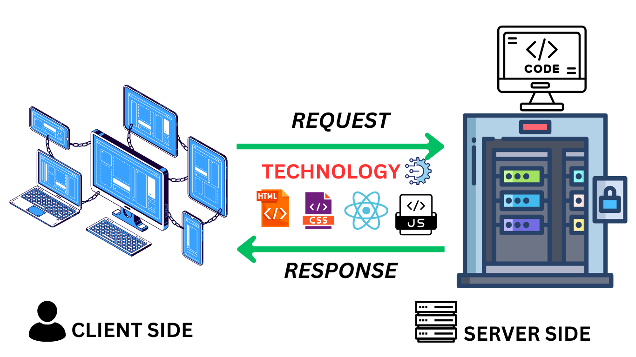

Data Flow Diagram

Entity Relationship Diagram

Table Design

SiteMap
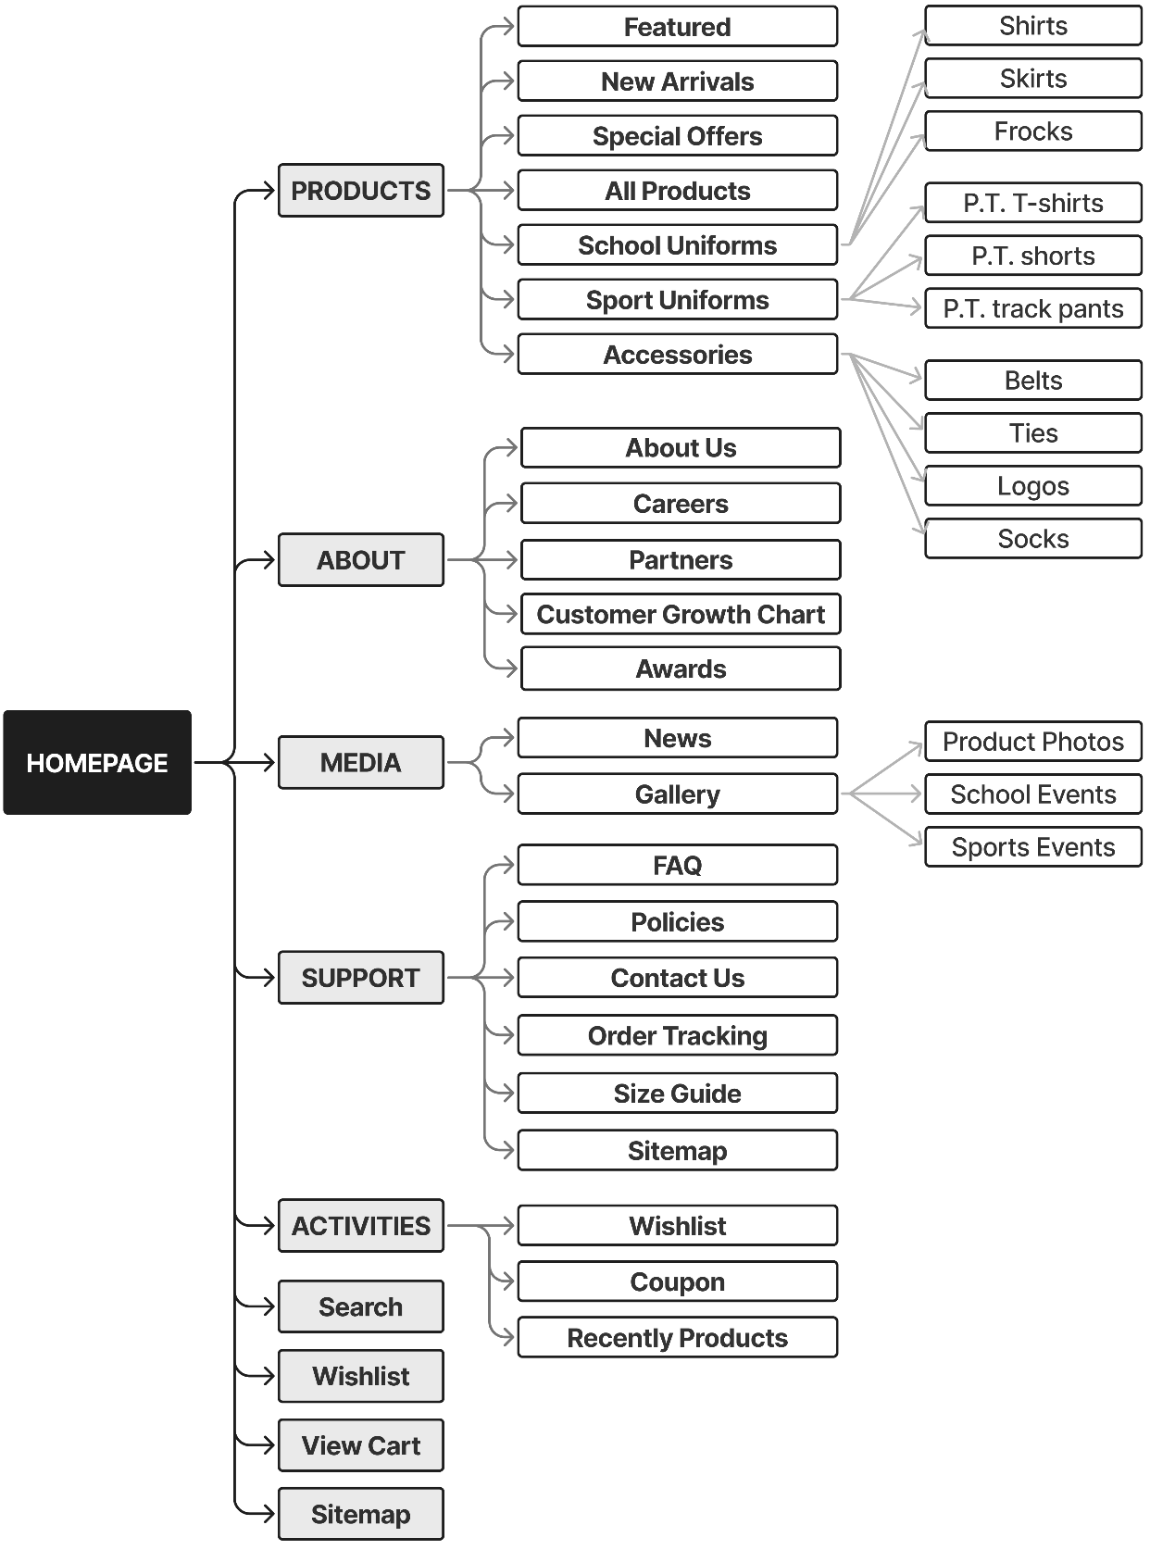

Algorithm

Review 03

Screen shots

User Interface Introduction
Before diving into the Website Structure Overview, this section provides an overview of the visual identity, design principles, and tools used in the Maverick Dresses project. These elements ensure consistency, brand recognition, and an optimized user experience across all pages.

Brand Identity & Design Concept

Brand Recognition
Maverick Dresses is a leading uniform manufacturer, and the website is designed to reflect its professional, modern, and trustworthy identity. The UI/UX approach follows a minimalist yet elegant aesthetic, ensuring clarity and ease of navigation for users.

Color Palette
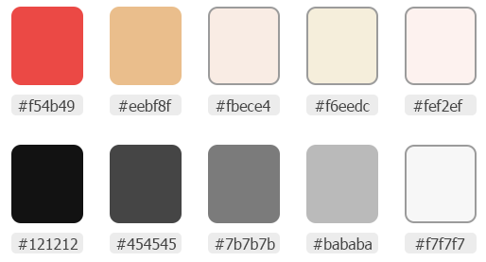
The color scheme is carefully chosen to balance brand representation, readability, and visual appeal. The primary and secondary colors used in the interface include:
- Primary Colors:
  - #f54b49 (Main Accent - Product labels, price highlights)
  - #eebf8f, #fbece4, #f6eedc (Supporting Accent - Banners)
  - #fef2ef (Top-nav Background & Light Theme Areas)
- Neutral & Supporting Colors:
  - #121212 (Text & Primary Dark UI Elements or Call-to-action button backgrounds)
  - #454545 (Secondary Text, Menu, Footer)
  - #7b7b7b (Disabled Elements, Tertiary Text)
  - #bababa (Borders & Subtle Dividers)
  - #f7f7f7 (Card Backgrounds, Light Mode Sections)
These colors ensure strong contrast, readability, and brand consistency across different devices and screen sizes.

Typography & Iconography

Font Selection
- Primary Font: Jost (Modern, Clean, and Readable)
This font provides aesthetic consistency while maintaining high readability across desktop and mobile interfaces.

Icon Set
The website uses Lucide Icons & Svg Icon for a modern and scalable icon set. Icons are used for:
- Navigation Menu & Categories
- Cart, Wishlist, and Checkout Steps
- Social Media & Interactive Features
- Product Status (In Stock, Out of Stock, Discounts, etc.)
All icons are used in SVG format to ensure scalability and performance optimization.

UI Components & Design Principles
3.1. Navigation & Layout Structure
- Fixed Header, Scroll to Top button & Tiker to improve accessibility.
- Top Navigation Bar (Top-Nav) Includes:
  - Contact Information (Phone, Email).
  - Free Shipping Information.
- Primary Navigation Includes:
  - Products, About, Media, Support, Activities.
  - Search Bar, Cart, and Vistor counter Shortcuts.
3.2. UI Components & Interactions
- Smooth Hover Effects on buttons and menus.
- Interactive Filters & Sorting on product pages.
- Collapsible Sections in FAQ and Policies.
- Animated Loading Elements for better user engagement.
3.3. Mobile & Responsive Design
- Fully Responsive Grid System (Using CSS Flexbox & Grid Layouts).
- Optimized Navigation Drawer for mobile users.
- Touch-friendly Buttons & UI Elements for smooth user interactions.

Design Tools & Prototyping
4.1. Design & Prototyping Tool
The entire UI/UX design process was carried out in Figma, ensuring a streamlined workflow between designers and developers. The Figma file includes:
- Wireframes & High-Fidelity Mockups.
- Interactive Prototypes for Testing.
- Component Libraries for Consistency.
- Style Guide & Design Tokens.
4.2. Shared Figma Link
Figma Design File:
MediFlow project evidence: source repository, requirements, architecture, event, and progress documents.
(Accessible for developers, stakeholders, and UI/UX teams).
Important Note:
The Figma file serves as a reference only. During development, there may be deviations from the original design due to technical constraints, optimization decisions, or responsive adjustments. The final coded version may not be 100% identical to the Figma design.

Website Structure Overview: Header, Footer, and Layout Sections
Before diving into the detailed layout of each page, it's important to first define and understand the Header and Footer components, as they are crucial parts of the website’s structure. These sections ensure consistent branding, seamless navigation, and accessibility across different pages.
- We strive to optimize the UI/UX as much as possible, ensuring a smooth, intuitive, and enjoyable user experience.

Header Section
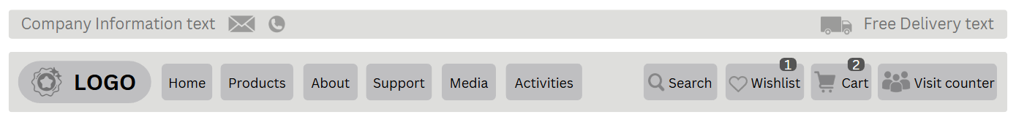
The Header is the topmost part of the website and plays a critical role in user interaction. It serves as the first touchpoint for visitors, providing key navigation and interactive elements.
Top Navigation Bar (Top-Nav)
- Positioned at the very top of the website, above the main navigation menu.

- Left Side: Displays company contact information, including:
  - Phone Number
  - Email Address
- Right Side: Displays free delivery conditions, indicating the minimum purchase amount required to qualify for free shipping.
Company Logo
- Positioned at the top-left of the page.
- Clickable and redirects users to the Homepage when clicked.
Main Navigation Menu & Development Plan
- The Main Navigation Menu is positioned at the top-left of the page and serves as the primary method for users to navigate through the Maverick Dresses website efficiently. It features a horizontal or vertical menu bar that provides quick access to major sections.
    - A horizontal or vertical menu bar that allows users to quickly access major sections:
      - Products (Featured, New, Sale, School Uniforms, Sports Uniforms, Accessories)
      - About (About Us, Careers, Partners, Customer Growth Chart, Awards)
      - Media (Fashion News, Gallery)
      - Support (FAQ, Policies, Feedback, Contact Us)
      - Activities (Wishlist, Coupons, Order Tracking)
- Development Plan (Products & Media Navigation): To ensure a structured and optimized development process, the Products and Media sections in the Main Navigation Menu are being implemented in two phases.
  - Version 1 - Completed Features
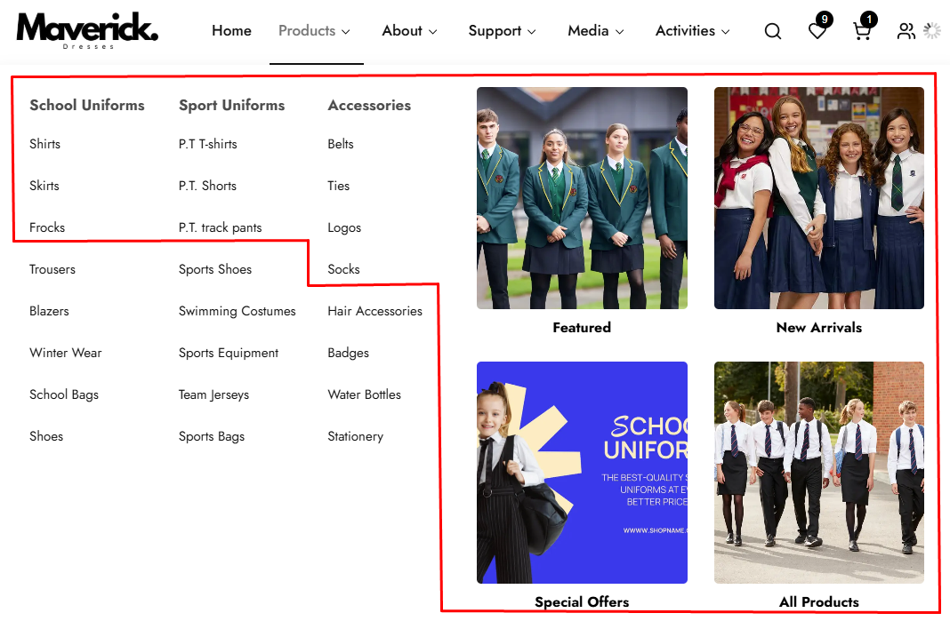
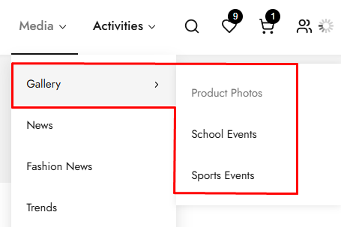
      - In Version 1, the following Products categories and Media sections have been fully implemented, with all links functional:
        - Products -> Featured, New Arrivals, Special Offers, All Products, School Uniforms (Shirts, Skirts, Frocks), Sports Uniforms (P.T. T-Shirts, P.T. Shorts, P.T. Track Pants), Accessories (Belts, Ties, Logos, Socks).
        - Media -> Gallery (Product Photos, School Events, Sports Events), News

  - Version 2 - Upcoming Enhancements (Currently Not Clickable)
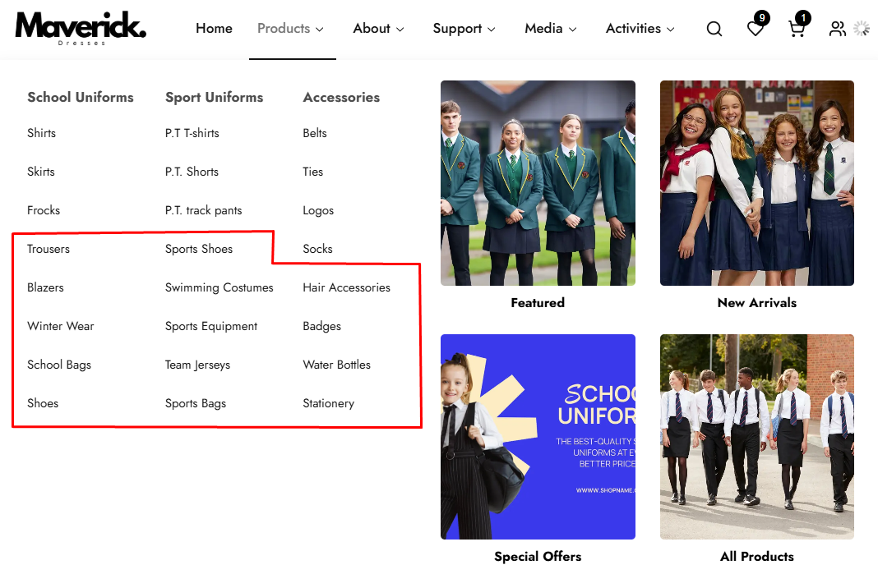
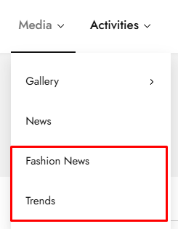
      - The following sections are planned for Version 2, and their links are not yet active:
        - Products -> Advanced Filtering & Sorting Features for better user experience. Expanded Accessories Section with additional product lines. Detailed Subcategories for School Uniforms & Sports Uniforms, including: (More variations for Shirts, Skirts, and Frocks. Additional uniform styles for different school levels. More Sportswear categories such as custom jerseys, sweatpants, and training gear.).
        - Media -> Fashion News and Trends – A dedicated section covering worldwide industry updates, style guides, and the latest collections from Maverick Dresses.
  - Version 2 - Upcoming Enhancements (Currently Not Clickable)
  - By dividing development into two phases, Maverick Dresses ensures:
        - A functional and navigable website in Version 1.
        - A scalable and enriched user experience in Version 2.
        - A seamless transition between current and future updates.
        - With Version 1 successfully implemented, the upcoming enhancements in Version 2 will further elevate the website’s product navigation and media content, making it a fully immersive shopping and branding platform.
        - Stay tuned for Version 2!
- Navbar Highlight for Active Page: The Navigation Bar (Navbar) helps users easily navigate between different sections of the Maverick Dresses website. To improve user experience and usability, the active page should be highlighted dynamically, allowing users to see which section they are currently visiting.
    - Active Page Indication:
      - The currently selected menu item should have a distinct color change and/or an underline to indicate the active state.
      - Example: If a user is on the Products Page, the "Products" menu item should be visually highlighted.
    - Hover Effects:
      - When users hover over menu items, a soft color change or underline animation should appear to indicate interactivity.
    - Dropdown Menu Active State:
      - If a user selects a sub-menu item, both the main menu and the selected sub-menu item should be highlighted.
      - Example: If a user is on the FAQ Page, the “Support” menu (parent category) should also be highlighted.
    - Smooth Transitions:
      - Implement a fade-in or slide-in animation when users switch between pages to enhance UX.
Right Icons Menu
Search Bar Icon: Click to show Search bar.
Wishlist Icon: Displays the number of items in the Wishlist.
Cart Icon: Displays the number of items in the cart.
Visitor Counter
- Positioned near the logo or within the header section.
- A real-time counter displaying the number of active visitors on the site, creating a sense of community and engagement.

Footer Section
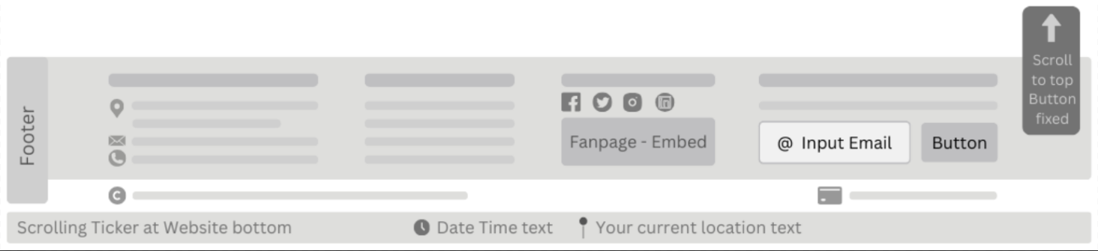
The Footer appears at the bottom of each page and provides additional resources for users, such as company details, policies, and quick navigation.
Company Information
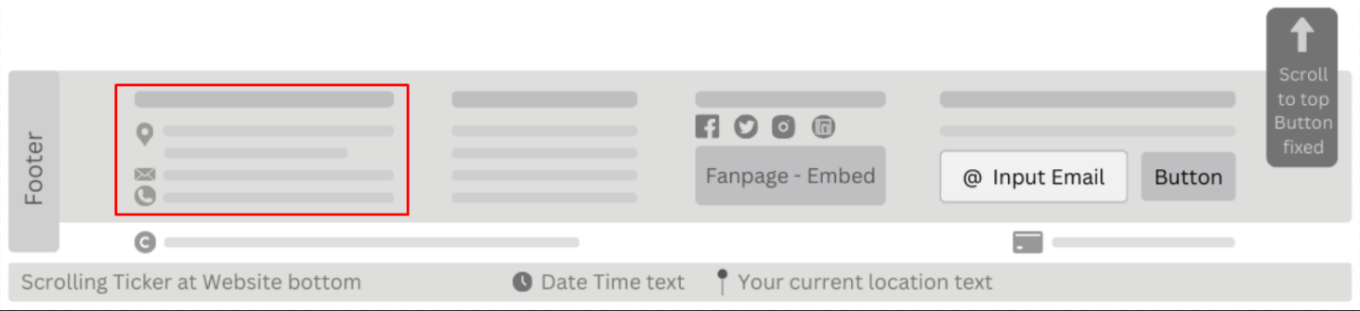
- Displays essential details such as company name, physical address, phone number, and email address.
- May also contain a link to the About Us page or any other relevant company information.
Quick Links
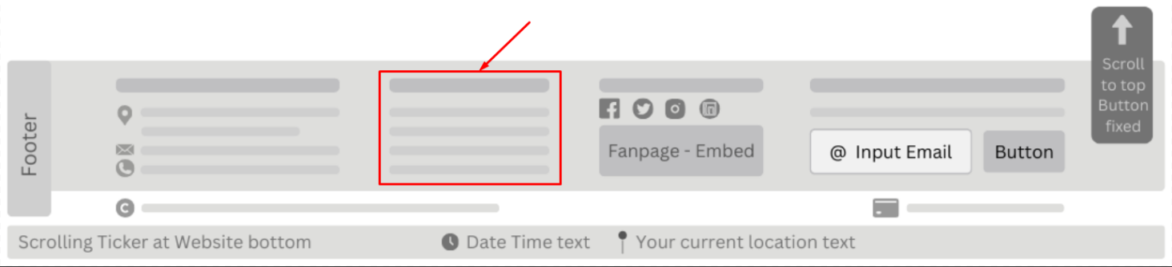
- Provides direct access to commonly accessed pages such as:
  - Policies
  - FAQ
  - Careers
  - Sitemap
  - Partners
  - Contact Us
Social Media Icons and Links
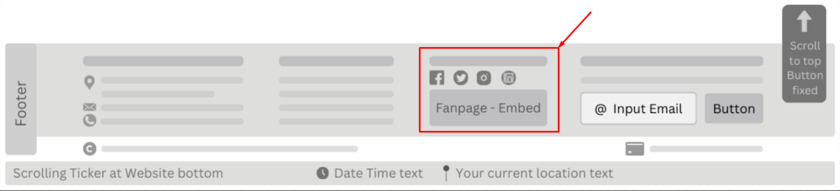
- Allows users to connect with the brand on various platforms, such as:
  - Facebook
  - Instagram
  - Twitter
  - LinkedIn
- The footer includes an embedded Facebook fanpage, allowing users to:
    - View recent posts.
    - Follow Maverick Dresses directly from the site.
    - Engage with brand updates without leaving the page.

Newsletter Signup

- Includes an email input field where users can subscribe to newsletters and promotional offers.
Payment Methods
- Displays supported payment options for transparency, such as:
  - Visa
  - MasterCard
  - PayPal
  - …
Copyright Notice
- Located at the very bottom of the footer, displaying ownership rights and legal disclaimers.
Scrolling Ticker Section
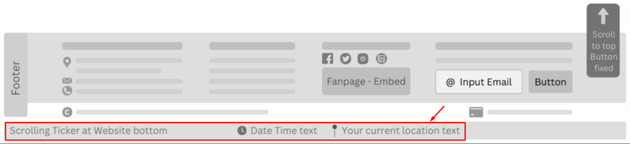
- A persistent ticker located at the very bottom of the page.
- Make sure there is a button that asks the user to give permission for the browser to know the user’s current location. In case the user forgets to give permission when first entering the website, the button will be displayed.
- Displays real-time information, including:
  - Current Date & Time
  - User’s Geolocation (City, Country) (via Geolocation API).
Scroll to Top Button

- Positioned at the bottom-right corner of the page.
- A fixed floating button allowing users to instantly scroll back to the top of the page.
- Enhances usability, especially for pages with long content.

Page Layout Sections Overview
The following sections define the content structure within different pages, helping organize information effectively and improving navigation.
Hero Section (Banner)
- The first section users see on the homepage.
- Contains large images or sliders showcasing:
  - Promotions
  - Best-selling products
  - Limited-time discounts
- Includes call-to-action buttons such as Shop Now or Discover More.
Main Content Section
- Central area of each page containing relevant content.
  - Product pages display product images, descriptions, and filtering options.
  - The About Us page includes the brand’s history, values, and mission.
  - Support pages provide company policies, FAQs, and customer assistance information.

Sidebar (Optional, for Some Pages)
- Typically present on product listing pages or blogs.
- Includes filtering options such as price, size, category, and availability.
- May also display related promotions or featured content.
Interactive Features Section
- Enhances user experience with elements such as dynamic sliders, accordions for FAQs, and live updating product widgets.
Call-to-Action (CTA) Section
- Encourages user interaction through newsletter signups, add-to-cart buttons, and limited-time offer banners.

Important Notes
Product Titles & Breadcrumbs:
- If a product title is too long, it will be automatically truncated with "..." after three lines to prevent layout distortion. To view the full title, users must click on the product for more details.
- Breadcrumbs will also be truncated if they exceed a certain length to maintain a clean and structured navigation flow.

Layout & Responsiveness
The website is fully responsive, ensuring optimal performance across mobile devices, tablets, and all major web browsers as per the project requirements. The design dynamically adjusts to different screen sizes, providing a seamless and user-friendly experience on Chrome, Firefox, Safari, Edge, and other modern browsers.
Next Steps
With the Header, Footer, and Key Layout Sections defined, the next step is to break down the structure of individual pages in more detail, starting with the Homepage Layout.

Testing document

Authentication and Access - User Input Validation
No. |  | Feature Tested | Remarks
1 |  | Username or email | Required; trim whitespace; reject an unknown or disabled account.
2 |  | Password | Required; invalid credentials return a safe error without revealing account state.
3 |  | Role and token | JWT, expiry, and endpoint role are checked before protected access.
4 |  | Refresh session | Refresh is accepted only for a valid session and is rejected after account disablement.

Organization and Account - User Input Validation
No. |  | Feature Tested | Remarks
1 |  | Department name | Required; trim whitespace; reject duplicate names within the organization.
2 |  | Staff and role | Required staff identifier and an allowed role; role changes are traceable.
3 |  | Account status | Only valid active/inactive transitions are accepted.
4 |  | Search and pagination | Filters are bounded and lists use the agreed default and maximum page size.

Patient - User Input Validation
No. |  | Feature Tested | Remarks
1 |  | Patient identifiers | Required fields are validated; duplicate patient identifiers are rejected.
2 |  | Contact and demographic data | Formats and permitted lengths are checked before save.
3 |  | Search result | Only permitted patient fields are returned to the requesting role.

Appointment - User Input Validation
No. |  | Feature Tested | Remarks
1 |  | Patient and clinician | Both identifiers are required and must exist in the approved context.
2 |  | Date and time | Required format; invalid or conflicting appointments are rejected.
3 |  | Status transition | Only an approved lifecycle transition is accepted.
4 |  | Cancel/check-in | Action is role checked and the resulting state is visible to relevant users.

Clinical Record and Diagnosis - User Input Validation
No. |  | Feature Tested | Remarks
1 |  | Clinical episode | Appointment and patient linkage is required before a record is saved.
2 |  | Required clinical fields | Validation covers the fields needed for the current record type.
3 |  | Diagnosis | Diagnosis is linked to the correct episode and authorized clinician.

Laboratory - User Input Validation
No. |  | Feature Tested | Remarks
1 |  | Laboratory request | Test type, patient, episode, and requester are required.
2 |  | Processing status | Only valid request-to-processing transitions are accepted.
3 |  | Result values | Values and required conclusion fields are validated before completion.
4 |  | Result publication | Author, time, permissions, and notification behavior are checked.

Pharmacy and Inventory - User Input Validation
No. |  | Feature Tested | Remarks
1 |  | Medicine and quantity | Required; quantity must be positive and within available stock.
2 |  | Prescription eligibility | Patient, prescription, payment, and status are checked before dispensing.
3 |  | Concurrent stock | No negative stock and no duplicate issue under retry or concurrent requests.
4 |  | Failure event | Insufficient stock and processing failure return a traceable outcome.

Billing, Payment and Dispensing - User Input Validation
No. |  | Feature Tested | Remarks
1 |  | Invoice | Only approved charges and a valid open invoice can be paid.
2 |  | Payment amount | Amount and method are required and validated.
3 |  | Saga correlation | Payment and dispensing share a correlation ID and explicit states.
4 |  | Compensation | Downstream failure produces compensation or a manual-review state.

Notification and Reporting - User Input Validation
No. |  | Feature Tested | Remarks
1 |  | Recipient | Notification is addressed only to the permitted owner.
2 |  | Duplicate event | Repeated event does not create a duplicate business notification.
3 |  | Message retrieval | User sees only messages allowed by role and ownership.
4 |  | Report filters | Date and organization filters return explainable approved totals.

Inpatient and Surgery - User Input Validation
No. |  | Feature Tested | Remarks
1 |  | Admission or case | Patient and responsible clinician are required.
2 |  | Bed or schedule | Conflicts and invalid transitions are rejected.
3 |  | Role and ownership | Extension actions follow the same role and service ownership rules.
4 |  | Outcome trace | State, actor, timestamp, and correlation information remain available.

Web/Mobile Client - User Input Validation
No. |  | Feature Tested | Remarks
1 |  | Client session | Unauthenticated access is redirected or rejected according to route policy.
2 |  | Loading and empty states | The UI communicates progress and no-result conditions clearly.
3 |  | Error handling | Validation and server errors are actionable without exposing sensitive details.

Final checklist
No. |  | Review 01 aspect tested | Suggestion / Remarks
1 |  | Project scope covers organization, patients, appointments, clinical records, laboratory, pharmacy, billing, notifications, and reporting. | Review 01 evidence prepared / To be checked
2 |  | The team roster, supervisor, class, and submission date are confirmed in the project records. | Review 01 evidence prepared / To be checked
3 |  | The problem statement identifies duplicated data, unclear status, manual handover, stock risk, saga risk, and limited visibility. | Review 01 evidence prepared / To be checked
4 |  | Actors and roles are documented: ADMIN, MANAGER, DOCTOR, NURSE, LAB_TECH, PHARMACIST, CASHIER, PATIENT, and SYSTEM. | Review 01 evidence prepared / To be checked
5 |  | The solution identifies the API Gateway, service discovery, bounded services, PostgreSQL ownership, and RabbitMQ messaging. | Review 01 evidence prepared / To be checked
6 |  | Authentication and authorization requirements are written with invalid and unauthorized cases. | Review 01 evidence prepared / To be checked
7 |  | Patient identity and duplicate prevention requirements are written. | Review 01 evidence prepared / To be checked
8 |  | Appointment lifecycle and invalid transition requirements are written. | Review 01 evidence prepared / To be checked
9 |  | Clinical record, diagnosis, laboratory, and result traceability requirements are written. | Review 01 evidence prepared / To be checked
10 |  | Pharmacy stock, concurrency, idempotency, and dispensing requirements are written. | Review 01 evidence prepared / To be checked
11 |  | Billing, payment, dispensing, saga, and compensation requirements are written. | Review 01 evidence prepared / To be checked
12 |  | Notification ownership and duplicate-event behavior are written. | Review 01 evidence prepared / To be checked
13 |  | Reporting dimensions and explainable totals are written. | Review 01 evidence prepared / To be checked
14 |  | Hardware and software requirements identify Java 21, Maven, PostgreSQL, RabbitMQ, Next.js, React, TypeScript, and pnpm. | Review 01 evidence prepared / To be checked
15 |  | Non-functional baselines cover security, data ownership, performance, resilience, consistency, observability, testing, and usability. | Review 01 evidence prepared / To be checked
16 |  | The Review 01 boundary excludes insurance, PACS/DICOM, laboratory devices, production bank integration, and multi-region recovery. | Review 01 evidence prepared / To be checked
17 |  | Repository alignment is recorded for backend contexts, gateway, discovery, Web pages, tests, Mobile readiness, and documentation. | Review 01 evidence prepared / To be checked
18 |  | Review 01 validation tables are completed for the core user inputs and failure paths. | Review 01 evidence prepared / To be checked
19 |  | The team records remaining approval items for production SLA, RTO/RPO, log retention, and accessibility target. | Review 01 evidence prepared / To be checked

Tasksheet
No | Member | Contents | Page Name | Activity Plan | Date of Preparation of Activity Plan
 |  |  |  | Planed Start Date | Actual Start Date | Actual Days | Status
1 | Vinh | Appointment list, filters, detail, create, edit, arrival, cancellation; role and state guards. | /appointments /appointments/new /appointments/[appointmentId] /appointments/[appointmentId]/edit | 2026-07-28 | 2026-07-28 | 7 | DONE
2 | Vinh | Medical-record lookup, detail, create, symptom update, diagnosis entry, disposition, and immutable completed-state presentation. | /records /records/new /records/[recordId] /records/[recordId]/edit | 2026-07-28 | 2026-07-28 | 7 | DONE
3 | Vinh | Laboratory queue, filters, detail, request creation, specimen processing, result entry, and cancellation. | /lab /lab/new /lab/[testId] | 2026-07-28 | 2026-07-28 | 8 | DONE
4 | Vinh | Inpatient admission list/detail, admission creation, and bed list. Only admission-create command slice delivered. | /inpatient /inpatient/new /inpatient/[admissionId] /inpatient/beds | 2026-10-08 | 2026-10-08 | 2 | IN PROGRESS
5 | Vinh | SHARED: Clinical, Laboratory, and Inpatient API/component tests covering permissions, validation, terminal states, retry, and correlation IDs. | Planned: /appointments, /records, /lab, /inpatient test suites | 2026-10-12 | — | — | PLANNED
6 | Vinh | Complete Inpatient bed assignment, transfer, and release after verifying roles, DTOs, transitions, and conflicts. | Planned: /inpatient/[admissionId]/bed | 2026-10-15 | — | — | VERIFY CONTRACT
7 | Vinh | Add admission and pre-admission cancellation controls after verifying bed placement, financial clearance, permissions, and Gateway routing. | Planned: /inpatient/[admissionId]/admission-state | 2026-10-17 | — | — | VERIFY CONTRACT
8 | Vinh | Expose Clinical check-in, examination start, record completion, and admission-referral commands after backend/Gateway activation. | Planned: controls in /appointments/[appointmentId], /records/[recordId] | 2026-10-19 | — | — | BLOCKED
9 | Vinh | Implement Clinical-to-Laboratory test-request handoff using test code and producer-generated order ID. | Planned: /records/[recordId]/lab-orders | 2026-10-22 | — | — | BLOCKED
10 | Vinh | Add Inpatient treatment entries, immutable corrections, order references, bed history, discharge, and administrative-close presentation. | Planned: /inpatient/[admissionId]/care, /inpatient/[admissionId]/order-references | 2026-10-26 | — | — | VERIFY CONTRACT
11 | Vinh | Add bed creation/update controls for administrators and managers; validate bed DTOs, selectors, uniqueness, and occupied-bed restrictions. | Planned: /inpatient/beds/admin | 2026-10-28 | — | — | VERIFY CONTRACT
12 | Vinh | Integrate Inpatient deposit, top-up, settlement, Pharmacy, Surgery, Report, and Notification timeline data after approved handoffs. | Planned: integrated timeline in /inpatient/[admissionId] | 2026-10-29 | — | — | BLOCKED
13 | Huy | Pharmacy drug catalogue/detail/create, stock adjustment, prescription creation/lookup/detail, dispense/cancel, and outbox replay. | /pharmacy /pharmacy/drugs /pharmacy/prescriptions /pharmacy/admin/outbox | 2026-07-28 | 2026-07-28 | 5 | DONE
14 | Huy | Daily metrics, monthly revenue, daily detail, and top-dispensed medicine reports; validation, zero states, errors, and retry. | /reports | 2026-07-28 | 2026-07-28 | 3 | DONE
15 | Huy | SHARED: Pharmacy validation, permission, terminal-state, API-error, and replay tests. | Planned: /pharmacy test suite | 2026-10-12 | — | — | PLANNED
16 | Huy | SHARED: Report formatter, filter, permission, zero-value, error, and retry tests. | Planned: /reports test suite | 2026-10-14 | — | — | PLANNED
17 | Huy | Add Inpatient/Surgery operational snapshots, financial views, and capability indicators after verifying controllers, DTOs, roles, and Gateway routing. | Planned: /reports/operations, /reports/financial | 2026-10-16 | — | — | VERIFY CONTRACT
18 | Huy | Add financial rebuild, progress, publication/rollback, source-archive export/restore after verifying commands, limits, and authorization. | Planned: /reports/financial-operations | 2026-10-19 | — | — | VERIFY CONTRACT
19 | Huy | Create Surgery case list and detail workspace after backend routes, authority, DTOs, roles, and Gateway routing are approved. | Planned: /surgery, /surgery/[caseId] | 2026-10-22 | — | — | BLOCKED
20 | Huy | Add Surgery request, readiness, clearance, schedule, execution, recovery, outcome, cancellation, and charge-handoff controls. | Planned: /surgery/[caseId]/workflow | 2026-10-26 | — | — | BLOCKED
21 | Huy | Add Surgery permission, lifecycle, conflict, retry, and integration tests after workspace and fixtures are available. | Planned: Surgery test suite | 2026-10-29 | — | — | BLOCKED
22 | Hoàng Anh | Organization department/staff list, detail, create, update, staff transfer, and account administration. | /organization /organization/departments/new /organization/departments/[departmentId] /organization/departments/[departmentId]/edit /organization/staff/new /organization/staff/[staffId] /organization/staff/[staffId]/edit /organization/accounts | 2026-07-28 | 2026-07-28 | 3 | DONE
23 | Hoàng Anh | Patient paginated search, detail, create, update, delete, Vietnamese wire mapping, and immutable identity-number behavior. | /patients /patients/new /patients/[patientId] /patients/[patientId]/edit | 2026-07-28 | 2026-07-28 | 6 | DONE
24 | Hoàng Anh | SHARED: Organization partial-failure, pagination, empty-state, role-gate, account, and retry tests. | Planned: /organization test suite | 2026-10-12 | — | — | PLANNED
25 | Hoàng Anh | SHARED: Patient contract, validation, permission, deletion, empty/error, and retry tests. | Planned: /patients test suite | 2026-10-14 | — | — | PLANNED
26 | Hoàng Anh | Provide authorized patient, doctor, and department lookup contracts for Clinical, Laboratory, Billing, and Report selectors. | Planned: shared forms in /appointments, /lab, /billing, /reports | 2026-10-16 | — | — | VERIFY CONTRACT
27 | Hoàng Anh | Integrate stable authenticated staffId, patient identity, and account-to-subject mapping across Gateway and Organization. | Planned: /login and session integration | 2026-10-19 | — | — | VERIFY CONTRACT
28 | Hoàng Anh | Add secure patient self-service profile after Gateway identity and Patient ownership contracts are approved. | Planned: /patients/me | 2026-10-22 | — | — | BLOCKED
29 | Hoàng Anh | Provide identity handoff for patient-owned appointments, results, prescriptions, invoices, receipts, payments, and notifications. | Planned: identity contract for patient portal routes | 2026-10-26 | — | — | BLOCKED
30 | Lộc | Billing patient invoice lookup, detail, creation from server-owned fees, payment state, and fee breakdown. | /billing /billing/new /billing/[invoiceId] | 2026-07-28 | 2026-07-28 | 3 | DONE
31 | Lộc | Notification patient history, privacy-safe secured detail, and administrator manual-send workflow. | /notifications /notifications/[notificationId] /notifications/send | 2026-07-28 | 2026-07-28 | 3 | DONE
32 | Lộc | SHARED: Billing pagination, monetary display, permission, terminal-state, API-error, retry, and payment-flow tests. | Planned: /billing test suite | 2026-10-12 | — | — | PLANNED
33 | Lộc | SHARED: Notification pagination, channel/status, privacy, cross-patient denial, error, and retry tests. | Planned: /notifications test suite | 2026-10-14 | — | — | PLANNED
34 | Lộc | Add ledger payment/refund, deposit allocation, settlement preview, reconciliation, settlement, and final-settlement controls. | Planned: /billing/accounts/[accountId], /billing/transactions/[transactionId] | 2026-10-16 | — | — | VERIFY CONTRACT
35 | Lộc | Add administrator/manager revenue filtering by department/date after validating RevenueByDeptDTO and Gateway routing. | Planned: /billing/revenue | 2026-10-17 | — | — | VERIFY CONTRACT
36 | Lộc | Add prescription-adjustment and Surgery-cancellation refund-due read models, without exposing refund commands. | Planned: /billing/prescription-adjustments/[adjustmentId]/refunds-due, /billing/surgery-cancellations/[cancellationId]/refunds-due | 2026-10-18 | — | — | VERIFY CONTRACT
37 | Lộc | Add Billing administrator outbox replay after verifying event discovery, maintenance settings, correlation IDs, and Gateway routing. | Planned: /billing/admin/outbox | 2026-10-20 | — | — | VERIFY CONTRACT
38 | Lộc | Add Notification read-state and authorized retry commands after endpoint, role, lifecycle, and privacy contracts are available. | Planned: controls in /notifications/[notificationId] | 2026-10-19 | — | — | BLOCKED
39 | Lộc | Add authenticated My Notifications after Gateway/Patient identity mapping and backend ownership checks are enforced. | Planned: /notifications/me | 2026-10-22 | — | — | BLOCKED
40 | Lộc | Define Billing currency semantics in coordination with Report; frontend must not infer currency from locale. | Planned: /billing and shared /reports display contract | 2026-10-26 | — | — | VERIFY CONTRACT
41 | Vinh (Shared Coordinator) | SHARED: Run authenticated browser smoke tests across all delivered dashboard contexts, covering roles, privacy, correlation IDs, and critical workflows. | Planned: all delivered dashboard routes | 2026-11-02 | — | — | PLANNED

Acknowledgments and Declaration
Project Documentation for Maverick Dresses
Completed on 18/02/2025
The documentation for the Maverick Dresses project was completed on February 18, 2025. Our team would like to express our gratitude to our supervisor, Mr. LÊ THANH NHÂN, for his guidance and valuable feedback throughout the project. We also appreciate the constructive input from our fellow students, which contributed to the refinement of our work.
We also thank Project Aptech for providing us with the opportunity to work on this real-world project, which helped us apply our academic knowledge in a practical scenario.
This document is the result of our team’s efforts, based on the knowledge we have gained during our studies and additional research. We confirm that the content is original and accurate, with no unauthorized copying or plagiarism. Our team is committed to maintaining academic integrity and ensuring the quality of this project.
This is a complete document that reflects the efforts and research of our team as students who are still learning and have not yet entered the professional workforce. We are grateful to our teacher for his support throughout this project. The content is based on the knowledge we have acquired during our studies and reliable sources.

