Practical Examination
Subject code: SDN302
Duration: 90 minutes
Exam: Online Shop Order Management System

Requirements
You are tasked with building an online shop order management system. The system will include storing information about products, product stock status, customer information, and handling product order operations. Follow the steps below to complete the task.
- Create a new project directory named <name>_shop and navigate into this directory.
- Create a schema and model for the products: You are provided with a sample dataset below. Create a productModel.js file to define the schema and model for the products. (1 mark)
The product data includes:
- productName: Product name (String).
- category: Product category (String).
- stockStatus: Stock status (in_stock, out_of_stock, discontinued) (String).
- unitPrice: Unit price (Number).
- tags: Product tags (Array).
Sample product document (use this as the basis for your population data — see Population Requirement below):
{ "productName": "Wireless Mouse", "category": "Electronics", "stockStatus": "in_stock", "unitPrice": 250000, "tags": ["bestseller", "wireless", "accessory"] }
- Create a schema and model for product orders: Create an orderModel.js file to define the schema and model for product orders. A sample dataset for an order is as follows: (1 mark)
Order data includes:
- customerName: Customer's name (String).
- productName: Ordered product name (String).
- quantity: Number of units ordered (Number).
- orderDate: Date the order was placed (Date).
- totalPrice: Total price to be paid (Number).
{ "customerName": "Nguyen Thi Lan", "productName": "Wireless Mouse", "quantity": 2, "orderDate": "2024-10-17T00:00:00Z", "totalPrice": 500000 }
- Build EJS pages to manage orders:
Create order.ejs file as shown in figure 1 below to:
- Retrieve the list of product orders. (1.5 mark)
- Delete an order by orderId. (1.5 mark)
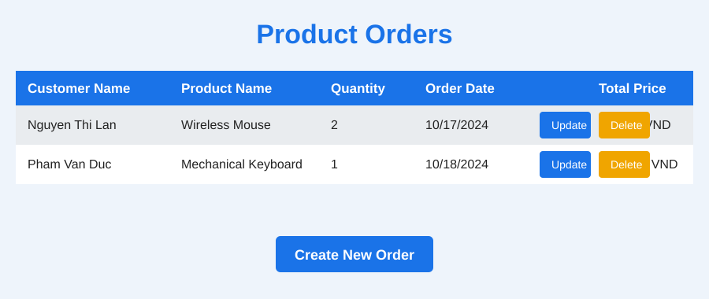
Figure 1. Order list
Create createOrder.ejs file as shown in figure 2 below to:
- Add a new product order. (1.5 mark)
- The constraint is that only products that already exist in the system can be ordered. (0.5 mark)
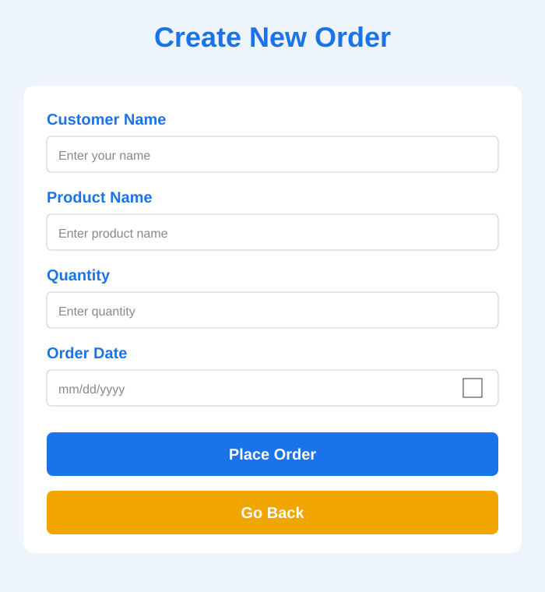
Figure 2. Create new order
Create updateOrder.ejs file as shown in figure 3 to:
- Update order information by orderId. (1.5 mark)
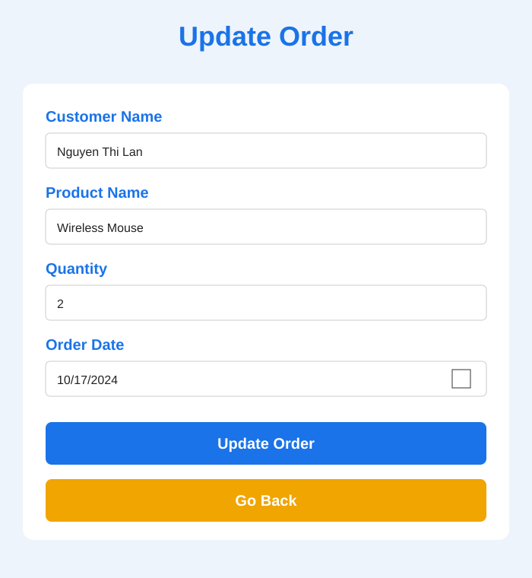
Figure 3. Update order
- The total price (Total Price) should be displayed for each order. The system must automatically calculate the total price based on the quantity ordered and the product's unit price when adding a new order. (0.5 mark)
- Organize the project according to the Model-View-Controller (MVC) structure. (0.5 mark)
- Meets UX/UI standards based on the sample interface figure 1, 2, 3. (0.5 mark)

