EASTERN INTERNATIONAL UNIVERSITY
School of Engineering

LAB REPORT

Course name: Electric Circuits 2
Course code: ECE 202

Group: …

Student Name | Student Code

Ho Chi Minh City
LAB 2. TIME CONSTANTS (Cont’d)

Objectives
By the end of this session, students would be able to:
- Describe the effects of time constants on DC and AC circuits by using calculated and measured values.

Requirements
- FACET base unit
- AC 1 FUNDAMENTALS circuit board
- Oscilloscope, dual trace
- Generator, sine wave
- Two-post connectors
- Terminal posts

Theory
In the previous lab, we studied time constants in RC and RL circuits excited by a DC source. In this lab, we extend that understanding to circuits driven by a square wave source.
A square wave is a non-sinusoidal periodic waveform that alternates abruptly between two fixed voltage levels – typically a positive (high) and a zero or negative (low) value. It can be thought of as an electronic “switch” that repeatedly turns the voltage on and off at a constant frequency.
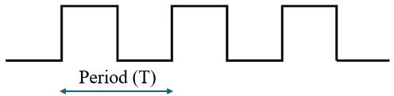
One important parameter of a square wave is its duty cycle, defined as the ratio of the time the waveform stays at its high level to the total period of the wave. The common duty cycle is 50%, which means the waveform spends equal time in the high and low levels.
When a square wave is applied to an RC circuit, the capacitor alternately charges and discharges during each half-cycle.
For the waveform across the capacitor to reach its full charging and discharging limits, each half-period of the square wave should be at least 5 time constants. In contrast, the capacitor will not have enough time to charge or discharge completely, resulting in a distorted waveform.
This is how the voltage and the current on the capacitor looks like when applying the square wave source.
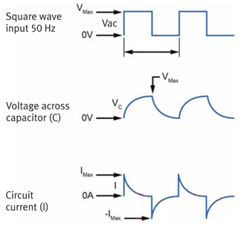
Similarly, this is for the voltage and the current on the inductor
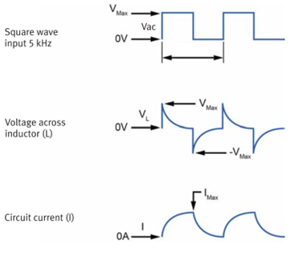

Exercises

Exercise 2. RC and RL Wave Shapes

- Clear the AC 1 FUNDAMENTALS circuit board of all two-post connectors and any other connections.
- Locate the RC/RL WAVE SHAPES circuit block, and connect the circuit shown. Adjust V_{GEN} for an 8 V_{pk-pk}, 100 Hz square wave. Note that pk-pk means peak-to-peak, which is the difference between the high value and the low value of the square wave.
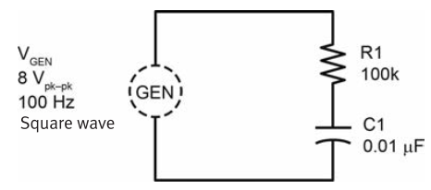
- The circuit shown is a simple RC circuit with a square wave input. As determined by R1 and C1, the time constant (τ) of the circuit is:
τ = ………………… (calculation) = ……………. ms
- Display the capacitor voltage (V_{C1}) on the oscilloscope. Set the time base control to τ/div (τ from step 3). Now each division along the horizontal axis is equal to one time constant of the circuit.
Adjust the oscilloscope controls so that the display resembles the one shown, by selecting the proper trigger slope, probe, volts/div.
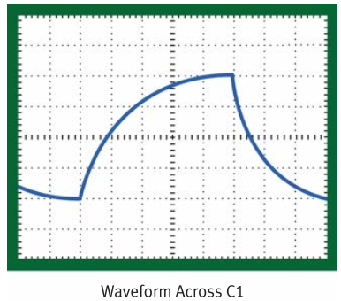
 Insert your photo taken from the oscilloscope
………………………..
- Judging from the waveforms displayed, if each division along the horizontal axis equals one time constant, how many time constants are required for the capacitor to fully charge?
……………………. time constants
- Using the oscilloscope, measure V_{C1} after C1 has charged for two time constants
V_{C1} = ………………… V
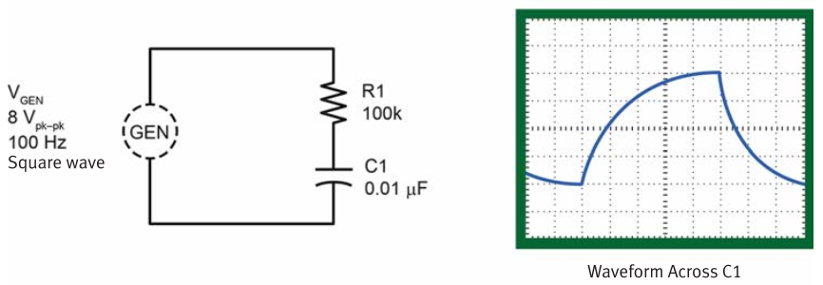
 Insert your photo taken from the oscilloscope
…………………….

Use the universal time constant chart, calculate V_{C1} in theory, then compare it with your above result.
V_{C1 (theory)} = ………………… V
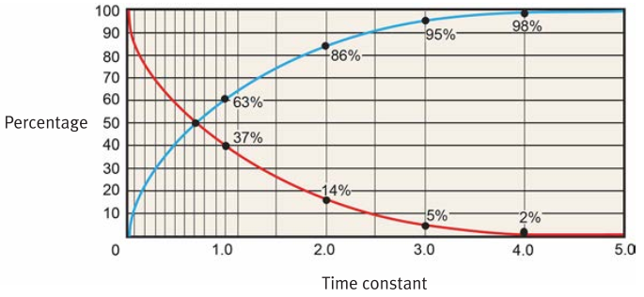
Comment: ……………………………….
- Adjust the oscilloscope controls so that the display resembles the one shown below. The oscilloscope display shows the discharge curve of the capacitor voltage (V_{C1}). You may have to select the proper trigger slope.
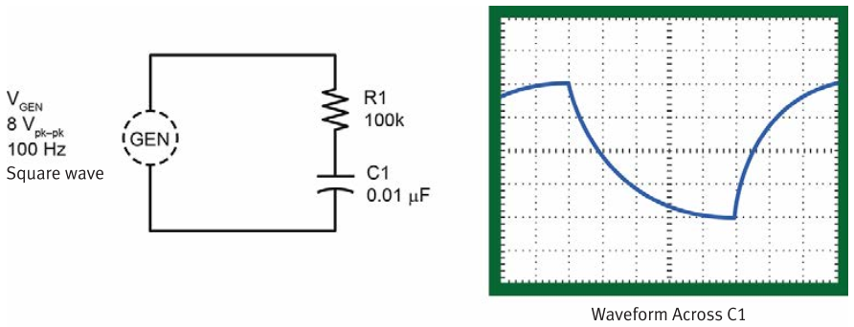
 Insert your photo taken from the oscilloscope
…………………….
- Measure V_{C1} after C1 has discharged for two time constants.
V_{C1} = ………………… V
 Insert your photo taken from the oscilloscope
…………………….

Also use the universal time constant chart, calculate V_{C1} in theory, then compare it with your above result.
V_{C1 (theory)} = ………………… V

Comment: ……………………………….
- Locate the RC/RL WAVE SHAPES circuit block, and connect the circuit shown. The voltage across R2 represents the circuit current.
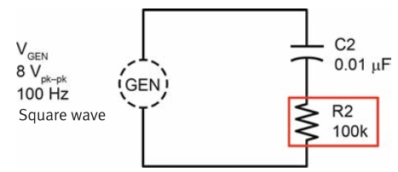
- Connect the oscilloscope probes as shown. Synchronize the oscilloscope on the positive edge of V_{GEN} (trigger slope set to positive, SOURCE set to CH 2). Display V_{GEN} on the upper half of the screen and V_{R2} on the lower half of the screen simultaneously.
V_{R2} represents the circuit current
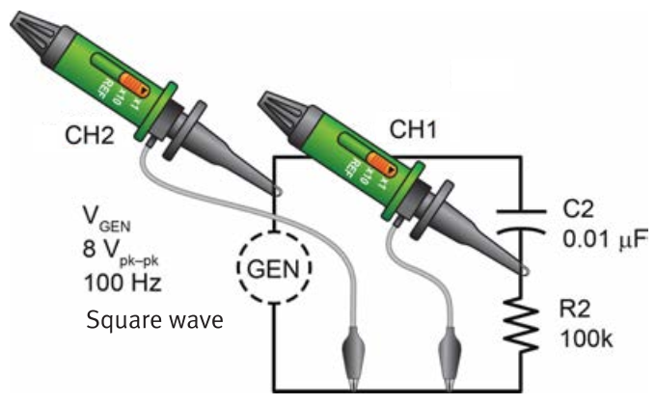
 Insert your photo taken from the oscilloscope
…………………….
- Judging from the waveforms displayed, would you say current flow is maximum at the beginning or at the end of the charge and discharge times?
○ beginning
○ end
- On the RC/RL WAVE SHAPES circuit block, connect the RL circuit shown. Adjust V_{GEN} for an 8 V_{pk-pk}, 5 kHz square wave.
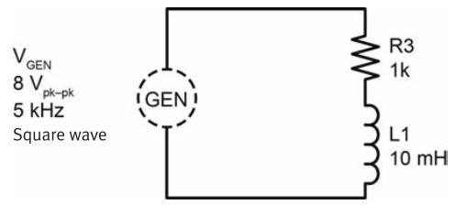
- The circuit shown above is a simple RL circuit with a square wave input. As determined by the R and L component values of the circuit, the time constant (τ) of the circuit is:
τ = …………………… (calculation) = ………………… μs
- Display the inductor voltage (V_{L1}) on the oscilloscope. Set the time base control to τ/div (τ from step 13). Now each division along the horizontal axis is equal to one time constant of the circuit. Adjust the oscilloscope controls so that the display resembles the one shown.
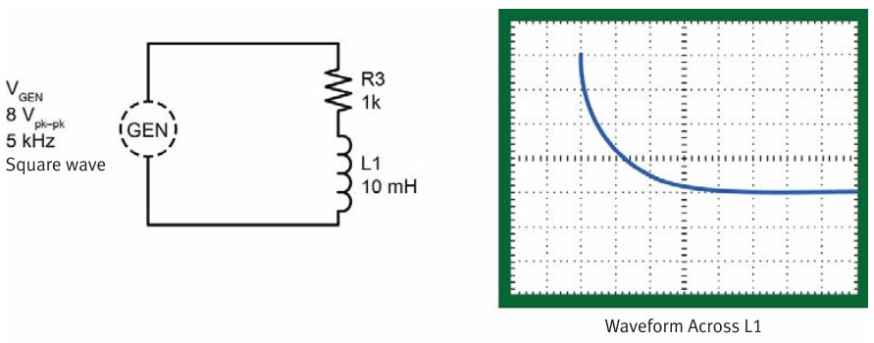
 Insert your photo taken from the oscilloscope
…………………….
- Using the oscilloscope, measure the voltage level across the inductor (V_{L1}) after it has charged for one time constant
V_{L1} = ……………………… V
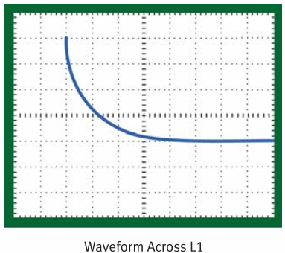
 Insert your photo taken from the oscilloscope
…………………….

Use the universal time constant chart, calculate V_{L1} in theory, then compare it with your above result.
V_{L1 (theory)} = ………………… V

Comment: ……………………………….
- Display several cycles of V_{GEN} by CH 2 and V_{L1} by CH 1 on the same oscilloscope screen simultaneously. Synchronize the oscilloscope on the positive edge of V_{GEN} (SLOPE set to positive, SOURCE set to CH 2).
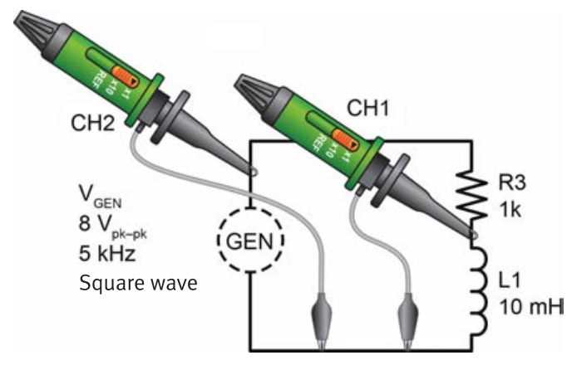
 Insert your photo taken from the oscilloscope
…………………….
- On the RC/RL WAVE SHAPES circuit block, connect the circuit shown. The voltage across R4 represents the circuit current.
- Connect the oscilloscope probes as shown. Synchronize the oscilloscope on the positive edge of V_{GEN} (SLOPE set to positive, SOURCE set to CH 2). Display V_{R4} and V_{GEN} on the same oscilloscope screen simultaneously.
V_{R4} represents circuit current.
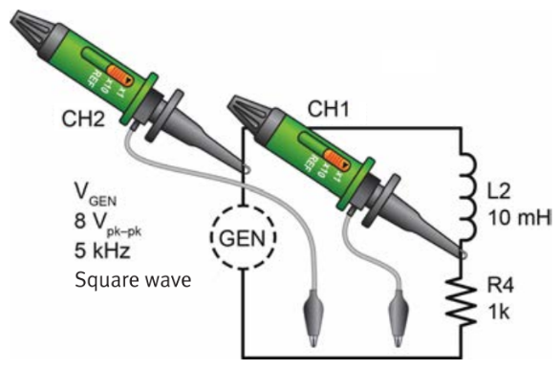
 Insert your photo taken from the oscilloscope
…………………….
- Judging from the displayed waveforms, would you say current flow is maximum at the beginning of a charging cycle or at the end?
○ beginning
○ end
- .

