FILM REVENUE & PROFIT ANALYSIS

PROJECT: PREDICT FILM REVENUE AND PROFIT TO ATTRACT INVESTORS

RESEARCH QUESTION
What factors should an investor consider when deciding whether to invest in the production of a film?

Investment Proposal for a Film

I. ADDING DATA

II. DATA UNDERSTANDING AND CLEANING
- No missing values
- All data types are correctly defined
The “Unnamed: 0” column is essentially an index/row number. It can either be dropped or renamed accordingly.
- 147 duplicate records were identified and removed.
The dataset contains a special value, “-inf,” in the profit_margin column.
The characteristics of these records are:
- Revenue-related values indicate that the films generated no profit and incurred losses.
- ROI (Return on Investment) is negative.
Hypothesis:
Films with this type of data may have been cancelled and never released to the public. As a result, the entire production budget may have been lost, meaning that the profit for these films would be equal to the negative production budget.
There are two possible approaches to handling these records:
1. Remove the records and proceed with the analysis and model development using the remaining data.
2. Retain the records and analyze the negative values to estimate and identify the potential losses associated with these films.
There are 99 -inf values in the profit_margin column.
This suggests that approximately 99 films may have been cancelled or never released.
To analyze these two cases in greater detail, we can create a second dataset from the data cleaned in Step 1, after removing the duplicate records as described above.
Create df_2 by removing all -inf values from df.

III. Variable Analysis
We can see that columns 20 to 38 represent the film genres, which have been encoded as binary values, where 0 = No and 1 = Yes.
Based on this information, we can remove the genre and genre_list columns because the genre information has already been encoded in greater detail across these binary columns.

Univariate Analysis
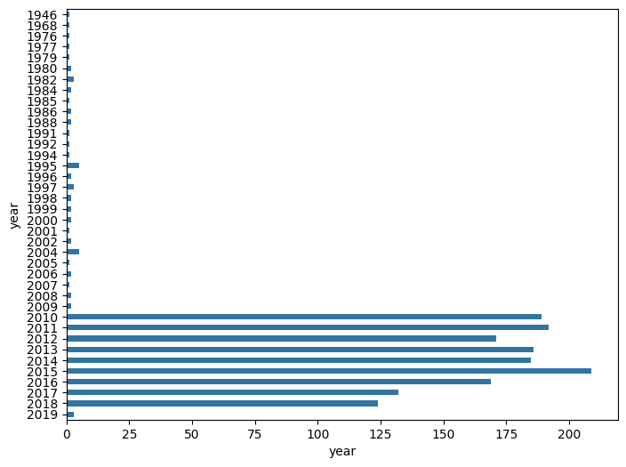
Data overview / variable relationships
Multivariate Analysis
Analyze the relationships between the variables and three key performance indicators: Worldwide Gross Revenue, Profit, and ROI (Return on Investment).
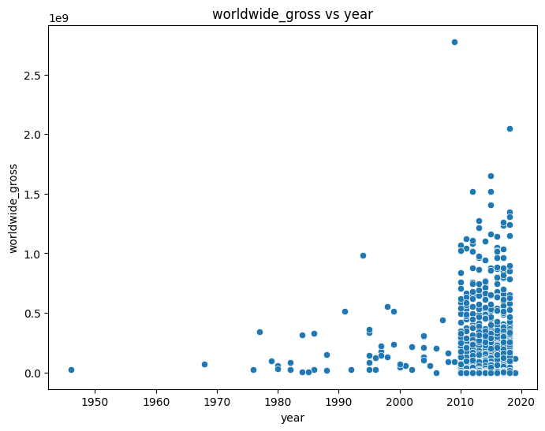
Relationships among key financial variables

After comparing the variables with Profit
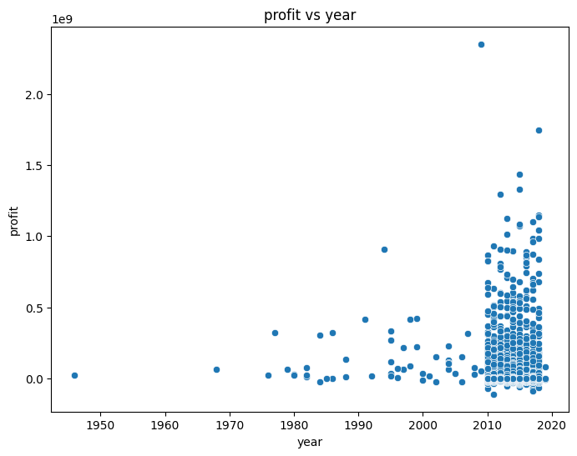
Financial KPI relationships
After analyzing the variables, we can observe that the relationship between revenue and profit is positive, meaning that they tend to increase together.
The relationship between budget and revenue, as well as between budget and profit, is also relatively strong.
Other findings are generally consistent with our initial expectations: when the production budget is higher, the film tends to have higher revenue. When revenue is higher, both profit and ROI also tend to be higher.

Relationship Between Profit, Gross Revenue, and ROI
Gross revenue, represented by the worldwide_gross variable, refers to the total worldwide revenue generated by a film.
Profit is calculated as:

Profit = Total Revenue − Production Budget
ROI (Return on Investment) is calculated as:

ROI = Profit / Production Budget
Based on these relationships, we can see that Profit and ROI are two important indicators for investors and film producers when evaluating whether to invest in a film project.
A higher ROI indicates that the investment generates a greater return relative to the initial production budget, which can make the project more attractive to investors and producers. Profit represents the amount earned after recovering the initial production cost.
Therefore, we can build a prediction model using either profit or ROI as the target variable.
Since our objective is to convince investors to invest in film projects, we need to provide initial estimates of revenue, profit, and ROI based on factors such as film genre and release timing during the year.
To obtain more representative predictions of profit and ROI, we should exclude the -inf values from the dataset. This allows us to build a general prediction model based on films with valid financial outcomes.
As audience preferences and film production trends continue to evolve over time, we will exclude films released before 2010 from the analysis.
This allows us to focus on more recent films and examine how film genres and production budgets are associated with their financial performance, providing more relevant insights to support investment decisions in film projects.

IV. ANALYSIS

The Impact of Budget on Profit, ROI, and Popularity
The production budget is one of the initial factors that can influence investment decisions. Different film segments require different levels of investment, and the amount of initial capital required to attract investors may vary depending on the budget range.
For this analysis, we will use df_2, after removing duplicate records, unnecessary values such as -inf, and films released before 2010.
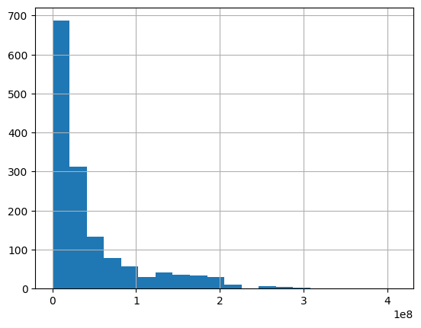
Production-budget distribution
The chart above shows a highly skewed distribution, with most films having a moderate production budget, while a smaller number of films have significantly higher budgets.
In addition, when comparing budget with vote_count and popularity, we can observe a potential positive relationship: as the production budget increases, both vote_count and popularity tend to increase to some extent. This may be partly related to the fact that higher-budget films generally have greater resources available for marketing and promotion, which can increase audience exposure and engagement.
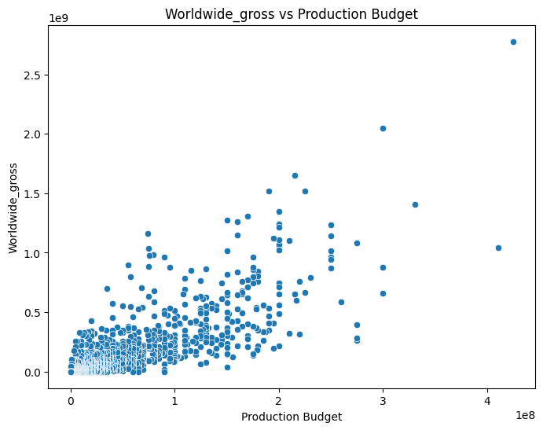
Production budget and related performance measures
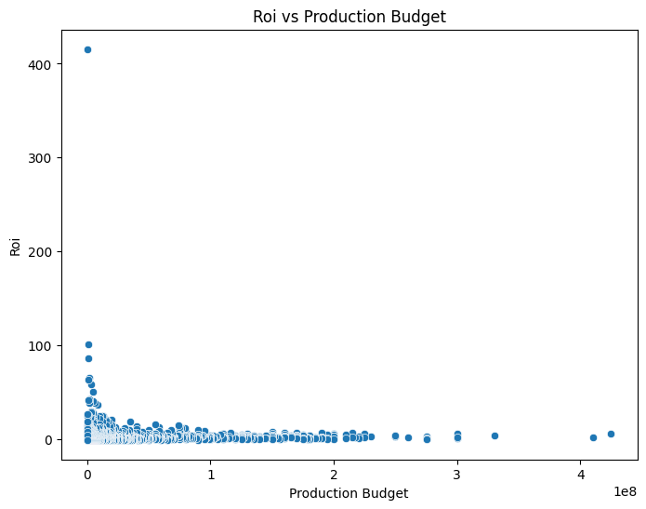
Production budget and related performance measures
Based on the charts above, we can observe that production budget has a positive relationship with several key variables, including popularity, profit, and worldwide gross revenue.
This suggests that films with higher initial production funding tend to have better financial performance and greater audience engagement.
One possible explanation is that a larger production budget provides more resources for factors that can contribute to a film's performance, such as actor salaries, marketing and promotional activities, production quality, and distribution. These additional resources may create greater opportunities to attract audiences and generate stronger awareness and engagement before the film's release.
However, this should be interpreted as a positive association rather than a causal relationship, as other factors may also influence a film's popularity and financial performance.

Analyze revenue by season and month
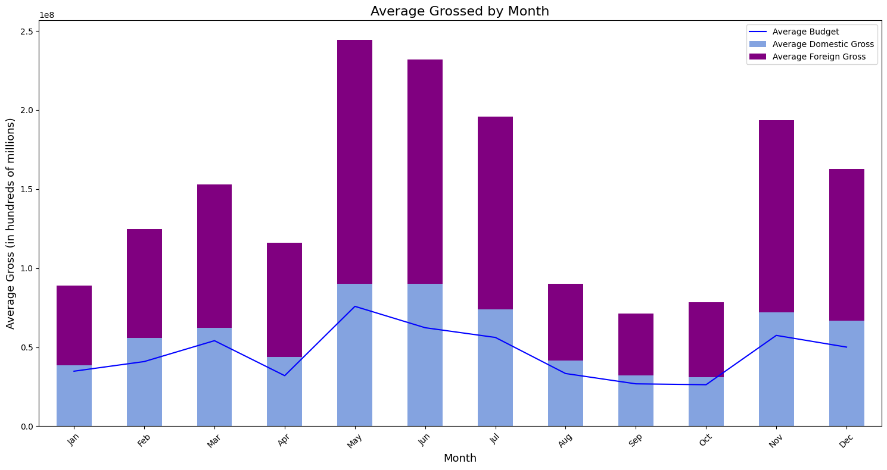
Revenue and return patterns

Analyze ROI by season and month
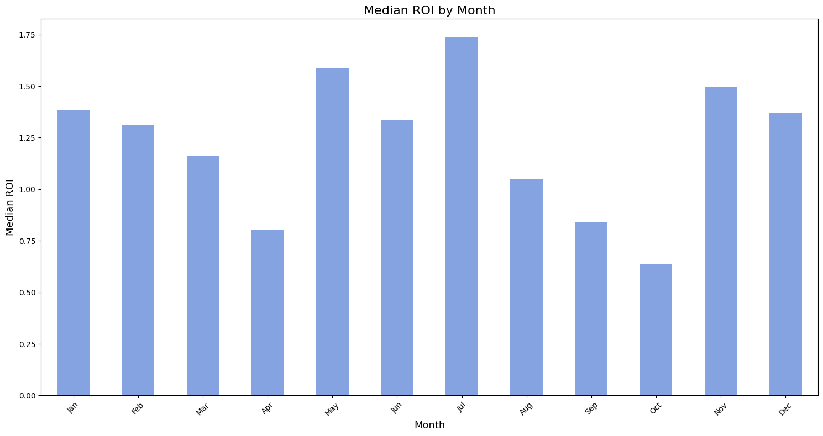
ROI by release period
Consistent with the current film market, high-budget films with extensive marketing campaigns tend to be concentrated around mid-year and year-end release periods.
Higher marketing investment, supported by larger production budgets, may help maintain strong audience awareness and exposure both before and after the film's release.
The average ROI by season also shows relatively similar patterns during these periods.
Therefore, release timing can be considered a factor for investors when evaluating film projects. Investors may consider the expected release period to identify opportunities for higher potential returns while also assessing the level of risk associated with investing in a particular film project.
How Do Film Genres Affect Key Variables?
Try creating a DataFrame summarizing information about film genres, along with the budget, profit, and ROI of each genre.
This can be created using code or Excel.
Use the df_2 dataset to build it.
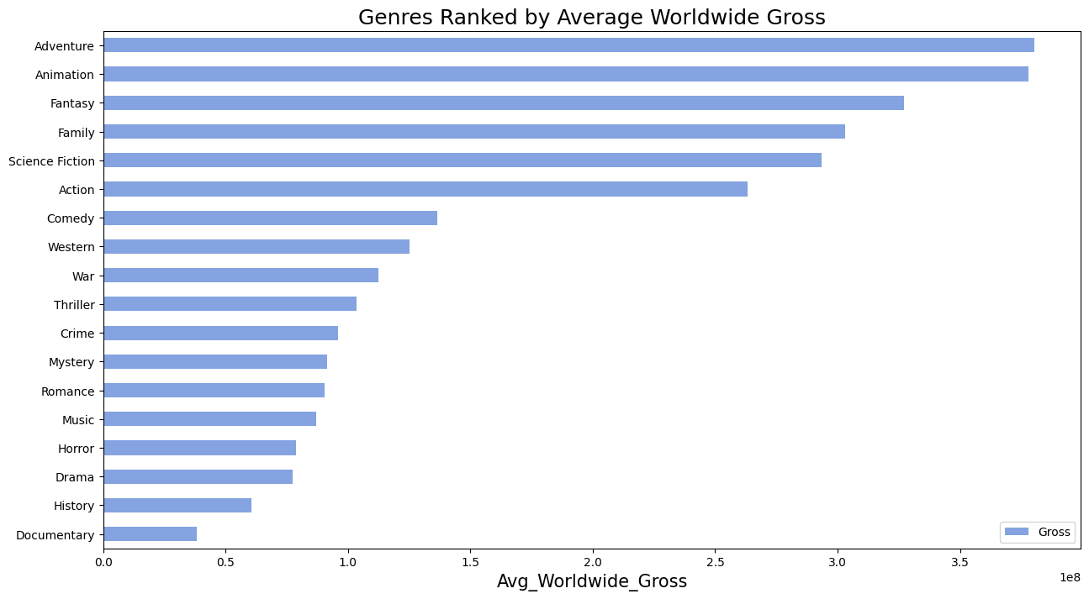
Genre comparisons
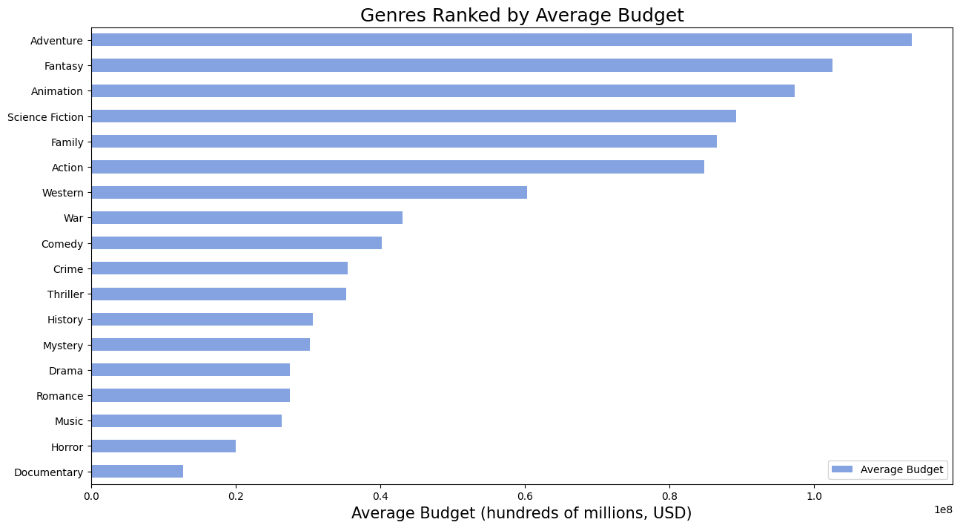
Genre-level financial comparisons

Conclusion on Film Genres
The first important point about film genres is that modern films are not usually classified into only one genre. Instead, a film often belongs to at least two genres.
Based on the charts above, we can understand how film genres are associated with factors such as profit, production budget, and ROI (Return on Investment).
Genres such as Action, Adventure, Fantasy, Animation, Family, and Science Fiction generally have higher production budgets while also generating relatively high profits. The higher production costs can be attributed to expenses such as special effects, post-production, and marketing. These genres also tend to appeal to a broad audience, so higher investment in production and promotion may create greater opportunities to attract viewers and generate higher profits.
However, this pattern does not necessarily apply to genres such as Horror, Thriller, Mystery, Documentary, and Romance. These films often have much lower production costs, sometimes less than one-tenth of the budgets of the genres mentioned above, while still attracting a considerable audience.
For example, in the Horror genre, The Gallows had an initial production budget of approximately $100,000, but generated around $43 million in profit. This represents an exceptionally large return compared with its initial production cost.
Therefore, film genre is associated to some extent with production cost, profit, and ROI. These factors can provide useful information for investors when evaluating which types of film projects may be suitable for investment.

V. OVERALL ANALYSIS SUMMARY
Investing in a film project always involves risks, but it can also generate substantial profits.
The following factors may help investors decide whether to invest in a film project:
1. Production Cost and Potential Profit
As analyzed above, films with higher production budgets tend to have wider popularity and generate higher profits.
The return on investment relative to the initial investment is also relatively stable.
This can be an attractive factor and a significant opportunity for investors with strong financial resources who are seeking higher potential returns.
2. Film Release Timing
The release date is an important factor to consider when investing in a film.
For example, if we invest in a blockbuster film planned for release in July, we need to ensure that there are not too many strong competitors being released around the same time.
It is also important to anticipate unexpected risks or production issues to ensure that the film can be released as scheduled and achieve the expected profit.
If an issue causes the release date to be postponed, careful planning is necessary to avoid unnecessary additional costs.
Investors can consider months with lower levels of competition depending on their initial investment objectives.
3. Return on Investment
If investors are particularly focused on ROI (Return on Investment), they may consider film genres with higher returns.
As analyzed above, some film genres require relatively low initial investment while still generating considerable profits and achieving high returns.
This can be a suitable option for smaller investors or those who prefer a lower-risk investment approach.

VI. MODEL BUILDING

1. Dataset selection

Dataset Selection
Since the objective is to predict profit and ROI (Return on Investment) to support investment decisions for future film projects, cancelled films, as mentioned above, will not be included in the model.
Therefore, we will use the df_2 dataset, which has had the -inf values representing cancelled films removed.

Model comparison / prediction output

2. Data splitting
I selected production_budget, month, and movie genre indicators as the input features (X) to predict worldwide gross revenue (y). I then split the dataset into two parts: 80% for training the machine learning models and 20% for testing their performance. I used random_state=42 to make the split reproducible, so the same split can be obtained when running the code again.

3. Training the Model Based on Worldwide Gross Revenue

Evaluation

Prediction Model Results for Worldwide Gross Revenue
Based on the initial results, the Linear Regression model achieved the best performance:
- Linear Regression – MSE: 2.2680500959706324e+16
- Linear Regression – R-squared: 0.5711261515208788
The Random Forest model achieved the second-best performance:
- Random Forest – MSE: 2.7128846117131052e+16
- Random Forest – R-squared: 0.48701077371606216

4. Training the Model Based on Profit
Based on the initial revenue prediction, we will proceed with a profit prediction model.

Prediction Model Results for Profit
Based on the initial results, the Linear Regression model achieved the best performance for predicting profit:
- Linear Regression (Profit) – MSE: 2.2600466217748244e+16
- Linear Regression (Profit) – R-squared: 0.4045764343215693

5. Hyperparameter Tuning

VII. Comparison of Results
After applying hyperparameter tuning, the MSE and R-squared results for the models are as follows:

Revenue Prediction
Model | MSE (Mean Squared Error) | R² (R-squared)
Linear Regression | 2.260046621774825e+16 | 0.5726395575896677
Random Forest | 2.362938587361107e+16 | 0.5531833412843197

Profit Prediction
Model | MSE (Mean Squared Error) | R² (R-squared)
Linear Regression | 2.2600466217748244e+16 | 0.4045764343215693
Random Forest | 2.238397225186981e+16 | 0.4102801046737312

Other Possible Adjustments
Some additional adjustments could be made to improve the prediction models:
Further filter df_2 by removing films with very low production budgets, such as films with budgets below $9 million.
Add additional information, such as marketing and promotional costs, audience interest in a film, and the actors starring in the film.
These parameters could be adjusted and optimized to potentially improve the performance of the prediction models.

