Dispersal constraints shape the sign and magnitude of biodiversity responses to forest loss and fragmentation

Abstract
Habitat loss and fragmentation are major drivers of biodiversity change in tropical forests, yet their independent effects remain inconsistent across systems. This inconsistency may arise because landscape effects are typically inferred from configuration alone, leaving functional connectivity, and the dispersal processes that generate it, implicit. Here we ask how dispersal limitation modulates the effects of forest loss and fragmentation per se on local tree diversity. We used a spatially explicit neutral model (SENM) calibrated against 105 Atlantic Forest tree inventories, and constructed three experimental landscapes per plot: contemporary fragmented, pristine continuous, and clumped (remaining forest aggregated into a single block). We define vulnerability operationally as the dependence of local richness on external species input (U) required, under SENM assumptions, to sustain observed richness; log(U_{i}/U_{j}) measures how this dependence changes between landscapes. These contrasts isolated the total effect of forest loss and fragmentation, fragmentation per se, and forest cover loss, while making connectivity an emergent property of dispersal across landscape configuration. Model congruence was high under moderate-to-strong dispersal limitation but declined under weak limitation, restricting inference to 66 plots. Forest cover loss dominated vulnerability in low-cover landscapes, with the strongest effects at both extremes of the dispersal range. Fragmentation per se was weaker and more variable, depending on how configuration interacted with dispersal limitation and local community properties rather than on configuration alone. By making the counterfactual contrasts and their underlying demographic mechanisms explicit, the framework treats variation among plots as part of the landscape effect to be explained rather than averaged out. This provides a way to reconcile general landscape heuristics with context-specific mechanistic explanations.

Key-words

Introduction (371 palavras)
Habitat loss and fragmentation are major drivers of biodiversity change in tropical forests (Díaz et al. (2019)). Yet empirical estimates of the independent effect of fragmentation remain highly inconsistent, ranging from negative to neutral or even positive across systems (Fletcher Jr et al. (2018), Fahrig et al. (2019), Miller-Rushing et al. (2019), Valente et al. (2023)). Part of this uncertainty may arise because landscape effects are often inferred from landscape configuration alone, despite connectivity being widely recognized as a fundamental process underlying biodiversity responses (Villard and Metzger (2014); Hanski (2015); Riva et al. (2024a)). Resolving this gap is not only a theoretical challenge but also a practical necessity for conservation planning, in which different traditions (from generalizable heuristics to context-specific mechanistic models) offer contrasting yet potentially complementary paths forward (Arroyo-Rodríguez et al. (2020); Banks-Leite et al. (2021); Arroyo-Rodríguez et al. (2021)).
Functional connectivity is the movement of individuals through remaining habitat and emerges from the interaction between landscape structure and species dispersal ability (Auffret et al. (2017); Hatfield et al. (2018)). By regulating the exchange of individuals among local communities, connectivity modifies the demographic balance between local extinction and recolonization (Kindlmann and Burel (2008); Pardini et al. (2010); May et al. (2012); Baguette et al. (2013); Campos et al. (2013); Chase et al. (2020)). Thus, for a given landscape configuration, different levels of dispersal limitation produce different connectivity regimes and thereby alter colonization, local replacement, and extinction dynamics. Understanding landscape effects therefore requires evaluating how variation in dispersal modifies the demographic consequences of landscape structure.
However, empirical studies typically estimate landscape effects by correlating structural landscape metrics with local biodiversity patterns (Frazier and Kedron (2017)). This leaves the role of connectivity implicit, primarily because species dispersal is rarely known in real landscapes (Baguette et al. (2013); Bullock et al. (2017)). As a result, there is little consensus on which configuration metrics best represent connectivity or which spatial extents are most relevant for estimating biodiversity responses to landscape change (Fletcher Jr et al. (2018); Fahrig et al. (2019); Miller-Rushing et al. (2019); Valente et al. (2023); Fletcher Jr et al. (2023)). Consequently, current approaches often infer ecological responses from landscape structure without explicitly representing the demographic processes through which functional connectivity regulates the maintenance of local biodiversity.
Here we propose a framework to infer plot‑specific landscape effects on local tree diversity using a spatially explicit neutral model calibrated against empirical tree communities. By constructing counterfactual landscapes that experimentally decouple habitat loss from spatial configuration, we estimate the independent and combined effects of forest loss and fragmentation while explicitly accounting for dispersal limitation. Specifically, we ask how variation in dispersal limitation affects the magnitude and direction of these landscape effects along an empirical forest‑cover gradient.

Materials and Methods (971 palavras)

Study system and empirical data
We used the Atlantic Forest as a model system for investigating fragmentation effects in tropical forests. This biome retains less than 30% of its original forest cover, distributed as a mosaic that provides a broad empirical gradient of forest cover and spatial configuration (Vancine et al. (2024)). Tree community data were obtained from the TreeCo database (Lima et al. (2015); Lima et al. (2020)), selecting inventories that: (i) sampled trees with DBH ≥ 4.8 cm; (ii) used single plots ≥ 1 ha; and (iii) had high taxonomic reliability and precise coordinates. Landscape structure was characterized using MapBiomas Collection 6 land cover maps (Souza Jr et al. (2020)), with forest cover defined as native forest formations including secondary stages (Supplementary material Appendix 1). For each plot, we extracted a 16 × 16 km landscape window centered on the plot location, chosen to exceed typical buffers and ensure stabilization of model dynamics (Supplementary material Appendix 2).

Experimental landscape design
To disentangle habitat loss from fragmentation per se, we constructed three experimental landscapes for each plot (Fig. SI1): (i) the contemporary fragmented landscape (observed cover and configuration); (ii) a pristine continuous-forest landscape (no habitat loss); and (iii) a clumped landscape in which all remaining forest was spatially aggregated into a single block centered on the plot, preserving total habitat amount while minimizing fragmentation. Comparing outcomes across these landscapes isolated three effects: FLF, the total effect of forest loss and fragmentation (pristine vs. fragmented); FPS, fragmentation per se (clumped vs. fragmented); and LFC, forest cover loss (pristine vs. clumped). This design resolves a key inferential problem: because habitat removal inevitably alters configuration, complete orthogonality between amount and fragmentation is only achievable through experimental manipulation (Didham et al. (2012); Fahrig et al. (2022)).

Spatially explicit neutral model
We used a Spatially Explicit Neutral Model (SENM; Rosindell et al. (2008)) as a mechanistic framework linking landscape structure to local diversity. The SENM assumes ecological equivalence among individuals, with community dynamics emerging from stochastic birth, death, dispersal, and external species input. Two parameters are central in our design: U, the probability that a lineage originates from a newly introduced species (external input), and k, which quantifies dispersal limitation as the expected proportion of propagules retained near parental individuals. Under this formulation, connectivity emerges from the interaction between demographic dynamics in space and landscape configuration, making the SENM particularly suited for investigating how dispersal limitation modulates biodiversity responses to landscape change (Campos et al. (2012); Azaele et al. (2016); Thompson et al. (2020)).

Calibration, validation, and vulnerability metric
We calibrated the SENM independently for each plot, dispersal scenario and experimental landscape, adjusting U so that simulated richness matched observed richness (semi-analytical method; Rosindell et al. (2008)). Because dispersal is unknown for the communities studied, we explored 20 dispersal scenarios (k = 0.99 to 0.05), where k is the proportion of propagules landing within the distance to the nearest neighbour. For each scenario, the spatial extent was defined in pristine landscapes, where U is affected only by dispersal and extent, as the smallest extent accumulating 75% of the total reduction in U across extents (0.5–16 km); we assumed this extent to be sufficient for the other experimental landscapes (Supplementary material Appendix 2). Calibration, extent selection and validation against observed SADs covered the full range of scenarios, which allowed us to characterise where the model is adequate. Landscape effects, however, were estimated and interpreted only for 0.50 ≤ k ≤ 0.99, scenarios in which at least half of the propagules remain within the immediate neighbourhood of the parent tree [dispersal distance of X–Y m at the observed density], consistent with empirical dispersal kernels of trees (Bullock et al. (2017); Clark et al. (1999); Appendix 1 and 2). Before interpreting effects, we validated the SENM by testing whether simulated communities reproduced empirical species abundance distributions (SADs) using Kolmogorov-Smirnov tests with bootstrap resampling (Dowd (2023)). We retained only simulation batches in which ≥75% of replicate SADs were congruent across all three landscapes, and restricted interpretation to dispersal regimes with consistently high mean congruence (Supplementary material Appendix 3). Within the SENM, U measures the dependence of local diversity on external sources required to maintain richness under drift (Rosindell et al. (2008), Condit et al. (2012)). Differences in U between landscapes therefore provide a mechanistic measure of vulnerability. For each plot and regime, we calculated log-ratios of U:
- FLF (total effect) = log(U_{pristine} / U_{fragmented})
- FPS (fragmentation per se) = log(U_{clumped} / U_{fragmented})
- LFC (forest cover loss) = log(U_{pristine} / U_{clumped})
These contrasts decompose the total effect additively: FLF = FPS + LFC.

Statistical analyses
We analysed variation in SENM congruence (the number of congruent SADs among 100 replicates) with binomial hierarchical generalised additive models (HGAMs; Pedersen et al. (2019)). In this framework (Wood (2017)), s() denotes a smooth, nonlinear function of one variable, estimated with a penalised spline; te() denotes a tensor-product smooth of two variables, which allows the shape of the response to one variable to change with the other (an interaction), in contrast to additive smooths; and plot-level random smooths (written s(k)|Plot in tables) allow the response to k to differ among plots. The most complex congruence model included landscape-specific smooths of k, a plot-level random smooth of k per landscape, and a bivariate smooth of plot coordinates; simpler models removed these terms progressively.
For each landscape effect (FLF, FPS, LFC; log-ratios of U), we fitted Gaussian HGAMs as a function of k and remaining forest cover (%FC). Candidate models comprised (i) plot-level intercepts only, (ii) a smooth of k, (iii) additive smooths of k and %FC, and (iv) a tensor-product smooth of %FC and k, each combined with either a plot-level intercept or a plot-level random smooth of k. Models were fitted by restricted maximum likelihood (REML) with the R package mgcv (Wood (2017)) and compared using AICc, ΔAICc and Akaike weights; we also report deviance explained and effective degrees of freedom (edf) as measures of fit and complexity. For the congruence models, we also tested residual spatial autocorrelation with Moran’s I on plot-mean residuals. Model formulas and diagnostics are provided in the Supporting Information 3.

Results (249+299+433=981)
A total of 107 forest inventories from the TreeCo database met the initial selection criteria (Table SI1). The final dataset comprised 105 plots after excluding two sites where the fragmented landscape configuration prevented reconstruction of the sampled plot as a square (Fig. SI1, Tab. SI1). The dataset spans a broad geographic range across the Atlantic Forest and encompasses substantial variation in abundance (median = 1,528 individuals, IQR = 608, range = [649 ; 12,105], species richness (median = 107 species, IQR = 66, range = [26 ; 458] and forest cover at the landscape level (median = 60.94%, IQR = 63.63%, range = [3.33% ; 100%]. Landscape maps for all study sites are shown in Figures SI3.3.1.1-SI3.3.1.2.
Across dispersal scenarios and plots, U estimates from pristine landscape simulations at the largest spatial scale varied substantially (Figs. SI2.2, SI2.3, SI2.8). Applying a 75% threshold of the total reduction in U yielded more consistent estimates of the sufficient spatial scale (Fig. SI2.7). Under moderate dispersal limitation (k ≈ 0.70), uncertainty increased because differences among spatial scales became smaller than the variation among simulation replicates for a given combination of k and plot (Figs. SI2.4:SI2.6, SI2.9). Linear interpolation within the 75% threshold indicated a sufficient spatial scale of 2 km for scenarios with k ≥ 0.35. For k < 0.30, the sufficient spatial scale increased to 4 km.

Dispersal limitation constrains the empirical validity of a spatially explicit neutral model {Congruencia}
Mean congruence between simulated and observed SADs exceeded 75% across most dispersal scenarios, but declined under very weak dispersal limitation, particularly in clumped and pristine landscapes (Fig. 1). In 103 plots (98.1%), there was at least one parameter setting (dispersal and landscape) in which the 75% congruence criterion was met.
Congruence varied substantially among plots, with non-linear responses to the interaction between dispersal limitation and landscape configuration. Accordingly, the best-supported model included a plot-level interaction between dispersal and landscape configuration, together with a spatial effect accounting for proximity among plots (Appendix S3).
Although the full model received the strongest support, a simpler model excluding spatial coordinates explained the same proportion of deviance (94%), showed no residual spatial autocorrelation (Fig. SI3.1), and had moderately lower support (ΔAICc = 7.16; Table SI3.2). In contrast, models that omitted the plot-level interaction exhibited significant positive spatial autocorrelation and a substantial drop in explained deviance (64% and 59%; Table SI3.2). These results indicate that the plot-level interaction captured the dominant congruence patterns, with spatial proximity providing only a refinement.
Congruence declined as dispersal limitation weakened (Fig. 1), indicating that SENM better reproduces observed SADs under moderate-to-strong dispersal limitation. Subsequent analyses were restricted to scenarios with k ≥ 0.50, where mean congruence consistently exceeded 75% across all experimental landscapes. Applying this criterion together with the predefined requirement of at least 75% congruence across all three landscapes yielded 66 selected plots (62.8%) for the vulnerability analyses. Selected and excluded plots exhibited similar environmental characteristics and showed no evidence of spatial segregation (Appendix SI3).

Forest cover and dispersal jointly shape vulnerability to forest loss and fragmentation
Differences in U between landscapes reflect variation in the external replenishment required to sustain observed diversity patterns. Accordingly, log(U_{i}/U_{j}) quantifies landscape‑induced vulnerability across three experimental contrasts: total effect of forest loss and fragmentation (FLF; pristine vs. fragmented), fragmentation per se (FPS; clumped vs. fragmented), and forest cover loss (LFC; pristine vs. clumped). In fig. 2, plots with greater than or equal 99% forest cover were excluded from the graphical display; only the amplitude (maximum = 0.075; minimum = -0.074) and the central 90% interval (95th quantile = 0.040; 5th quantile = -0.038) of log U_{i}/U_{j} are indicated on the y-axis. This variability reflects the stochasticity inherent to the spatially explicit neutral model simulation.
Model selection indicated that the interaction between remaining forest cover (%FC) and dispersal limitation (k) improved model fit for FLF and LFC, but not for FPS (Tab. 1). For FPS, the best-supported model included only additive effects of %FC and k. Notably, across all three landscape effects, accounting for plot-specific dispersal responses was essential to achieve high explanatory power (>75% deviance explained); removing this component reduced deviance explained by 25 to 40 percentage points (Tab. 1).
The LFC effect became increasingly negative in plots with reduced %FC and was negligible in plots with high %FC (Fig. 2). Across dispersal regimes, LFC exhibited a non-linear response to dispersal limitation (k), with minimum vulnerability at intermediate values (k ≈ 0.70) and stronger effects under both strong and weak dispersal limitations. This pattern indicates that habitat loss exerts its strongest influence when dispersal limitation is either strong or weak, whereas intermediate dispersal partially buffers vulnerability.
The FPS effect was generally weak, with most values clustering around the null reference in landscapes with forest cover above 60%, and becoming weakly negative at low forest cover (<30%) (Fig. 2). Only a few plots showed plot-specific patterns, with some displaying pronounced negative effects under moderate-to-mild dispersal limitation and others showing weak positive effects under severe limitation. Although FPS occasionally increased in plots with reduced %FC, the most pronounced effects occurred in a small number of plots with intermediate %FC. Thus, fragmentation per se acts primarily as a context-dependent modifier of vulnerability rather than a dominant driver.
The FLF effect became more negative as %FC decreased, although a few plots displayed patterns resembling FPS at intermediate-to-high %FC (Fig. 2). Overall, FLF exhibited greater variability, integrating features of both LFC and FPS.
A complementary analysis showed that differences in magnitude between LFC and FPS were generally small and often fell within the null reference range, although LFC tended to dominate in plots with reduced %FC (Fig. SI4.1). Across plots, LFC and FPS frequently differed in sign (41%-65%). The proportion of cases in which LFC and FPS differed in sign increased with %FC. When both effects were negative, the total FLF was correspondingly more negative. In contrast, when the effects differed in sign, positive FPS partially counterbalanced negative LFC.
These contrasting signs were most evident in low-cover landscapes, where LFC dominated, and in a small number of intermediate-cover plots, where FPS effects prevailed (Fig. 2; Fig. S4.1). Together, these patterns indicate that the combined effect of forest loss and fragmentation is predominantly negative in low-cover landscapes, while in higher-cover landscapes it may reflect plot-specific effects of spatial configuration.

Discussion (2373)
Functional connectivity is widely recognized as the mechanism linking landscape structure to biodiversity responses, yet its demographic basis is rarely represented explicitly (Swift and Hannon (2010); Villard and Metzger (2014); Riva et al. (2024a)). In the SENM, connectivity emerges from individual dispersal across a spatially explicit landscape (Rosindell et al. (2008); Campos et al. (2012), Campos et al. (2013); Thompson et al. (2020)). Model congruence was high across a broad range of dispersal regimes and experimental landscapes, although it varied substantially among plots. For plots showing consistently high congruence under moderate-to-severe dispersal limitation, landscape effects could be estimated by contrasting experimental landscapes at the plot level. These analyses revealed that the signal and magnitude of forest loss and fragmentation depend on the landscape-dispersal interplay, a finding that helps explain under which conditions fragmentation per se amplifies the negative effect of forest loss (Haddad et al. (2015); Fletcher Jr et al. (2018); Püttker et al. (2020); Gonçalves-Souza et al. (2025)) or, in rare cases, partially buffers it (Fahrig (2017); Fahrig (2020)).

A mechanistic measure of biodiversity vulnerability
Within our framework, landscape effects are quantified as changes in the species input parameter (U) needed to approximate the observed local species richness under alternative landscape configurations. Because U quantifies the external species input required to maintain observed local richness (Condit et al. (2012); May et al. (2012); Azaele et al. (2016)), differences in U among experimental landscapes provide a mechanistic measure of how landscape structure modifies the demographic dependence of local communities on external biodiversity input. The species input is interpreted as long-distance dispersal, propagule bank replenishment, and speciation (Alonso et al. (2006); Etienne et al. (2007); Jabot et al. (2008)).
This metric provides a direct link between landscape configuration, functional connectivity, and biodiversity persistence. Landscape effects therefore emerge from contrasts among alternative connectivity regimes rather than from correlations between biodiversity patterns and landscape metrics (Marshall and Galea (2014); Frazier and Kedron (2017); Arnold et al. (2018); Manzo (2022)). Because these contrasts are estimated for individual plots, the framework captures heterogeneity in landscape responses that would otherwise be averaged across plots (Feller and Gelman (2015)).

Forest loss dominates, but fragmentation shapes variability in the total forest loss and fragmentation effect
Forest cover loss was consistently associated with increased vulnerability in low-cover landscapes, whereas its effects were negligible in landscapes with high remaining forest cover (Swift and Hannon (2010); Villard and Metzger (2014); Riva et al. (2024a); Haddad et al. (2015); Fletcher Jr et al. (2018); Püttker et al. (2020); Gonçalves-Souza et al. (2025); Fahrig (2017); Fahrig (2020)). The magnitude of this effect was lowest under intermediate dispersal limitation, mirroring the non-linear relationship between dispersal and U observed in pristine landscapes (May et al. (2012)). Under strong dispersal limitation, recruitment is dominated by nearby conspecifics, reducing stochastic species loss and therefore the need for external replenishment. As dispersal increases, heterospecific replacement becomes more frequent, increasing drift-driven species loss and raising U. Under weak dispersal limitation, however, distant populations increasingly contribute propagules to local communities, reducing local extinction and causing U to decline, at the cost of reducing landscape total biodiversity (Mouquet and Loreau (2003)). This mechanism may also explain why vulnerability to habitat loss was minimized under intermediate dispersal limitation. Because U is highest under these conditions, local diversity becomes less dependent on surrounding habitat as a source of biodiversity replenishment, weakening the ecological consequences of landscape structure (Campos et al. (2012), Campos et al. (2013)).
In contrast to forest cover loss, fragmentation per se exhibited weak and highly variable effects across landscapes (Fahrig (2017); Fahrig et al. (2019); Fahrig (2020)). Fragmentation per se (FPS) effects were not organized by a consistent interaction between dispersal limitation and forest cover, unlike the pattern observed for habitat loss. Positive and negative FPS effects occurred across the forest-cover gradient, with a few plots showing positive responses under strong dispersal limitation and others exhibiting strongly negative responses at intermediate to high forest cover. This pattern is broadly consistent with the long-standing inconsistency of fragmentation responses reported across empirical systems, whereas fragmentation per se has been associated with positive, neutral, and negative responses depending on the study (Fahrig (2017); Fahrig (2020)). Our results suggest that this variability emerges because fragmentation effects depend on how particular landscape configurations modify effective connectivity under different dispersal constraints. Under severe dispersal limitation, some spatial configurations may favor local conspecific replacement, reducing stochastic species loss and potentially generating positive fragmentation effects (Campos et al. (2012); Campos et al. (2013)). Conversely, other configurations may further restrict propagule exchange among local communities, amplifying biodiversity loss (Pardini et al. (2010); Villard and Metzger (2014); Campos et al. (2012); Campos et al. (2013)). The scale-sensitivity analysis further indicates that these connectivity dynamics depend not only on dispersal limitation and landscape configuration but also on local community properties (Appendix SI2). Species richness and individual density influence the baseline value of U required to maintain local diversity and therefore affect how landscape configuration alters community dynamics. Consequently, fragmentation effects may emerge from the interplay among spatial configuration, dispersal processes, and local demographic conditions, helping explain why responses remain difficult to generalize across landscapes.
The total effect of forest loss and fragmentation (FLF) mainly reflected the patterns observed for forest cover loss in highly deforested landscapes. Consistent with this result, FLF was best explained by the interaction between dispersal limitation and forest cover, indicating that habitat loss remained the primary determinant of vulnerability across landscapes (Swift and Hannon (2010); Villard and Metzger (2014); Riva et al. (2024a); Haddad et al. (2015); Fletcher Jr et al. (2018); Püttker et al. (2020); Gonçalves-Souza et al. (2025); Fahrig (2017); Fahrig (2020)). However, FLF also inherited the variability associated with fragmentation per se. In most low-cover landscapes, negative FPS effects amplified the vulnerability associated with habitat loss, producing stronger total effects (Haddad et al. (2015); Fletcher Jr et al. (2018); Püttker et al. (2020); Gonçalves-Souza et al. (2025)). In a smaller number of cases, positive FPS effects partially compensated for habitat-loss vulnerability, particularly under severe dispersal limitation (Fahrig (2017); Fahrig (2020)). Together, these results suggest that habitat loss primarily determines the direction of the total landscape effect, whereas fragmentation per se contributes to its variability (Swift and Hannon (2010); Villard and Metzger (2014); Riva et al. (2024a); Haddad et al. (2015); Fletcher Jr et al. (2018); Püttker et al. (2020); Gonçalves-Souza et al. (2025); Fahrig (2017); Fahrig (2020)).

Implications for the fragmentation debate
Our results revealed a general tendency for forest cover loss to dominate landscape effects in highly deforested landscapes, with fragmentation per se contributing additional variability across the gradient of habitat loss. However, the most notable pattern was the variability among plots. Consistent with this result, statistical models that ignored plot-level variation in dispersal responses showed lower explanatory power. In this context, explaining variation among communities may be as important as estimating average landscape effects across a biome.
This distinction reflects a broader tension within landscape ecology regarding how biodiversity responses should be incorporated into conservation planning. One tradition emphasizes generalizable heuristics derived from broad comparative analyses of landscape structure and biodiversity responses, prioritizing scalable recommendations based on relatively simple landscape descriptors (e.g., Fahrig (2013); Watling et al. (2020); Arroyo-Rodríguez et al. (2020); Riva et al. (2024b)). In contrast, more mechanistic approaches seek to represent species responses, dispersal dynamics, and restoration scenarios explicitly through spatially detailed models tailored to particular ecological contexts (Banks-Leite et al. (2021); Fletcher et al. (2026)). More broadly, these traditions reflect different strategies for balancing ecological realism, inferential generality, and data availability in conservation science.
The SENM framework provides a possible integration between these approaches by explicitly incorporating dispersal limitation and landscape configuration while remaining parameterizable from biodiversity and landscape data that are broadly available across fragmented systems. It allows alternative connectivity scenarios to be evaluated explicitly through counterfactual landscape simulations and empirical evaluation.

Limitations

Orthogonality and decomposition of landscape effects
Within our framework, the clumped scenario allows the effects of spatial fragmentation to be evaluated independently from overall forest cover (Fahrig (2003); Fahrig et al. (2022)). This formulation also clarifies an inferential problem underlying the fragmentation debate. Once habitat is spatially distributed across a landscape, habitat removal inevitably alters the spatial configuration of the remaining habitat (Didham et al. (2012); Fletcher Jr et al. (2018); Fahrig et al. (2019); Vancine et al. (2024); Fletcher et al. (2026)). In this sense, the fragmentation debate may be interpreted less as a disagreement about whether fragmentation matters and more as a question about the conditions under which forest loss and fragmentation effect can be meaningfully decomposed into independent ecological components (Fahrig (2003); Didham et al. (2012); Fletcher Jr et al. (2018); Fahrig et al. (2019); Püttker et al. (2020); Watling et al. (2020)). Complete orthogonality between habitat amount and fragmentation therefore represents a limiting inferential case rather than an intrinsic property of empirical landscapes (Pearl et al. (2016)).
Decomposing the effects of forest cover loss and fragmentation per se also requires specifying the spatial scale over which this decomposition is defined (Jackson and Fahrig (2015); Miguet et al. (2016); Fletcher Jr et al. (2023)). In our framework, this scale is determined by the spatial extent from which habitat is redistributed to construct the clumped landscape. By contrast, estimating the combined effect of forest loss and fragmentation only requires a landscape extent sufficiently large to avoid constraining dispersal processes, because SENM simulations are not inherently limited by landscape boundaries (Thompson et al. (2020)). Consequently, decomposing landscape effects requires stronger assumptions than estimating their combined effect. These assumptions become unavoidable when information about ecologically relevant spatial scales is unavailable (Jackson and Fahrig (2015); Miguet et al. (2016); Fletcher Jr et al. (2023)). In such cases, the inferred contributions of forest cover loss and fragmentation per se depend increasingly on how contemporary biodiversity patterns are assumed to relate to landscape structure (Frazier and Kedron (2017)).

Temporal correspondence between biodiversity and landscape patterns
Most observational studies relate contemporary communities to contemporary landscape configuration (Frazier and Kedron (2017)), implicitly assuming that the landscape conditions shaping community assembly have remained sufficiently stable through time or that delayed ecological responses have largely relaxed (Kuussaari et al. (2009); Lira et al. (2019); Figueiredo et al. (2019)). This assumption is common to landscape analyses based on biodiversity and landscape snapshots because historical information on habitat dynamics is often far more limited than the timescales over which ecological responses to habitat change unfold (Lima et al. (2015); Lima et al. (2020); Souza Jr et al. (2020); Chase et al. (2019)).
Within the SENM framework, this assumption is operationalized through ecological equilibrium (Alonso et al. (2006); Rosindell et al. (2012); Azaele et al. (2016)). Under ecological equilibrium, biodiversity patterns are assumed to reflect the long-term interaction between dispersal processes and landscape structure rather than transient responses to recent landscape change. Consequently, violations of this assumption may contribute to deviations between observed and simulated communities. In this context, SENM simulations under pristine and fragmented landscapes can be interpreted as reference scenarios in which the observed community is assumed to be in equilibrium with the pre-loss landscape (no extinction debt paid) or with the contemporary landscape (extinction debt fully paid), respectively (Thompson et al. (2019)). The clumped landscape provides a third reference in which forest area is lost but isolation is minimized, approximating the expectation that local diversity depends on habitat amount rather than arrangement (Etienne (2005); Fahrig (2013)).
Nevertheless, contemporary landscape configuration may retain information about the historical processes that generated present-day habitat patterns. Deforestation trajectories are not spatially random: road expansion, agricultural colonization, and successive cycles of land use and forest regeneration produce characteristic spatial signatures that persist in contemporary landscapes, from the fishbone deforestation pattern of the Amazon to the heterogeneous mosaic created by centuries of disturbance and regeneration in the Atlantic Forest (Filho and Metzger (2006); Lira et al. (2012); Wagner et al. (2020); Jakovac et al. (2021); Alencar et al. (2023); Broggio et al. (2024)). Consequently, contemporary landscape structure may encode part of the historical context relevant to community assembly even when explicit temporal data are unavailable.
Consistent with this interpretation, variation in model congruence among plots was largely explained by the interaction between dispersal limitation and experimental landscape type at the plot level. Moreover, accounting for this interaction eliminated residual spatial autocorrelation among plots, suggesting that contemporary landscape structure and dispersal jointly capture meaningful spatial variation across the Atlantic Forest. This suggests that the simulated connectivity process was sufficient to explain spatial variation in congruence without requiring explicit geographic coordinates. Although these findings do not directly test historical landscape dynamics (Fletcher et al. (2026)), they support the idea that present-day landscapes retain some information relevant to mechanistic inference about biodiversity patterns.

Future directions
Rather than defending neutrality as a description of tropical tree communities, we see the SENM as a first, tractable approximation, to be refined where and when is possible (Rosindell et al. (2012); Leroi et al. (2020)). Earlier assessments led to the expectation that neutral models would rarely reproduce biodiversity patterns in fragmented forests (Gilbert et al. (2006); Laurance (2008); Etienne and Rosindell (2011)). Yet most of our plots showed good SAD congruence under at least one combination of dispersal limitation and landscape, although static patterns cannot address the temporal turnover examined by Gilbert et al. (2006). Because richness and SADs carry little information about competitive hierarchies, this result does not indicate that species are equivalent (Adler et al. (2007); Chisholm and Pacala (2010); Hammal et al. (2015)). It indicates that these patterns cannot, by themselves, discriminate among such hypotheses about species differences, but can elucidate the influence of landscape features in the overall tree demography (Campos et al. (2012); Campos et al. (2013); Claudino et al. (2015); Chisholm et al. (2018); Thompson et al. (2019); the present study). The question then shifts from whether neutrality holds to which auxiliary assumptions matter most for the inferences we want to draw, and how to relax them without losing practical value (Rosindell et al. (2012); Bausman (2019); Leroi et al. (2020); Thompson et al. (2020)). In this approach, plots where the SENM was systematically incongruent are not simply discarded; they are where refinements can be tested.
For landscape effects, the most consequential auxiliary assumption is the matrix (Fletcher Jr et al. (2018); Fahrig et al. (2019); Püttker et al. (2020); Fahrig et al. (2022); Vancine et al. (2024)), which is currently inert: demography does not change near edges, and dispersal through the matrix equals dispersal through habitat. Relaxing it follows the logic applied here to fragmentation. Because habitat is spatially arranged, its loss necessarily alters configuration, so the decomposition of loss and fragmentation per se is defined only relative to an explicit reference landscape (Didham et al. (2012); Fahrig et al. (2022)). The matrix adds a further layer. In a binary map, matrix amount is the complement of habitat amount and cannot vary independently of it, but the functional properties of the converted land can, notably edge effects on mortality and recruitment and resistance to dispersal (Laurance (2008); (bello2015defaunation?); Melito et al. (2018); Schwartz et al. (2019); Willmer et al. (2022)). These properties are also products of the conversion process. Land is converted deliberately to exploit properties of the converted area or to gain access to remaining habitat, and habitat loss, fragmentation and matrix effects are consequences of that process, each acting through different demographic pathways (Didham et al. (2012); Fahrig et al. (2022); Magliocca et al. (2023); Ekström et al. (2024); Fletcher et al. (2026)).
This suggests a design with six types of experimental landscapes (Fig. 3). Two landscapes add a single matrix effect, edge or dispersal friction, and a third combines both, forming a 2 × 2 crossed design within the fragmented configuration. Contrasts with the fragmented give the effects of edge, friction and their interaction, and contrasts between the pristine and each matrix landscape give the total effect of habitat loss and matrix conversion, equal to FLF plus the matrix effect. Edge effects are caused by changes in tree demography near forest edges (Laurance (2008); Melito et al. (2018); Schwartz et al. (2019)), and friction in reduced seed dispersal through degraded matrices ((bello2015defaunation?); Emer et al. (2020); Hatfield et al. (2024)). Neither matrix effects are binary: friction can be varied as dispersal limitation was, and edge effects require an influence function describing how mortality changes with distance to the matrix, in both magnitude and depth. These parameters could be constrained by empirical syntheses and treated as scenarios.
Other auxiliary assumptions rank lower in this sequence because relaxing them is costlier. To relax equilibrium, zero-sum and the static landscape configuration assumptions (Etienne et al. (2007); Aguilar et al. (2019); Martensen et al. (2017)) there will be necessary to explore alternative algorithms to the coalescent approach of the SENM and probability will increase considerably the running time of each individual simulation (Rosindell et al. (2008); Thompson et al. (2020)). They would multiply parameters and computation, and would require information on landscape and community history (Metzger et al. (2017); Pereira et al. (2020); Fletcher et al. (2026)).

Conclusion (254)
Landscape effects on tree communities may be inferred through counterfactuals. We isolated forest loss and fragmentation per se by contrasting experimentally constructed landscapes, and grounded the interpretation of these contrasts in an explicit demographic mechanism: in the SENM, dispersal across landscape configuration generates connectivity and its consequences for local biodiversity. Calibration against observed richness and validation against species abundance distributions delimited the scope of this inference, while retaining the majority of plots, which did not differ environmentally from those excluded.
Variation among plots was a central feature of how landscape structure affected biodiversity. Within the dispersal range retained for interpretation, forest cover loss dominated the total vulnerability effect in low-cover landscapes, with the strongest effects at both ends of the dispersal range. Fragmentation per se was generally weaker and more variable, and our results suggest that it may depend on how a given configuration interacts with dispersal limitation and local community properties (e.g. species richness and individual density), rather than on configuration alone.
These estimates support a situated, mechanism-based counterfactual interpretation. This interpretation is conditional on the SENM assumptions, the dispersal scenarios, and the empirical evidence used to calibrate and evaluate the model. These estimates also remain conditional on an inert matrix and equilibrium, both explicit targets for future refinement. By making the counterfactual contrasts and their underlying demographic mechanisms explicit, the framework treats variation among plots as part of the landscape effect to be explained rather than averaged out. This provides a way to connect general conservation heuristics with context-specific mechanistic evidence.

References
Adler, P. B., HilleRisLambers, J. and Levine, J. M. 2007. A niche for neutrality. - Ecology letters 10: 95–104.
Aguilar, R., Cristóbal-Pérez, E. J., Balvino-Olvera, F. J., Jesús Aguilar-Aguilar, M. de, Aguirre-Acosta, N., Ashworth, L., Lobo, J. A., Martén-Rodrı́guez, S., Fuchs, E. J., Sanchez-Montoya, G. and others 2019. Habitat fragmentation reduces plant progeny quality: A global synthesis. - Ecology letters 22: 1163–1173.
Alencar, L., Escada, M. I. S. and Camargo, J. L. C. 2023. Forest regeneration pathways in contrasting deforestation patterns of amazonia. - Frontiers in Environmental Science 11: 991695.
Alonso, D., ETIENNE, R. and MCKANE, A. 2006. The merits of neutral theory. - Trends in Ecology and Evolution 21: 451–457.
Arnold, K. F., Harrison, W. J., Heppenstall, A. J. and Gilthorpe, M. S. 2018. DAG-informed regression modelling, agent-based modelling and microsimulation modelling: A critical comparison of methods for causal inference. - International Journal of Epidemiology 48: 243–253.
Arroyo-Rodríguez, V., Fahrig, L., Tabarelli, M., Watling, J. I., Tischendorf, L., Benchimol, M., Cazetta, E., Faria, D., Leal, I. R., Melo, F. P. and others 2020. Designing optimal human-modified landscapes for forest biodiversity conservation. - Ecology letters 23: 1404–1420.
Arroyo-Rodríguez, V., Fahrig, L., Watling, J. I., Nowakowski, J., Tabarelli, M., Tischendorf, L., Melo, F. P., Santos, B. A., Benchimol, M., Morante-Filho, J. C. and others 2021. Preserving 40% forest cover is a valuable and well-supported conservation guideline: Reply to Banks-Leite et al. - Ecology Letters 24: 1114–1116.
Auffret, A. G., Rico, Y., Bullock, J. M., Hooftman, D. A., Pakeman, R. J., Soons, M. B., Suárez-Esteban, A., Traveset, A., Wagner, H. H. and Cousins, S. A. 2017. Plant functional connectivity–integrating landscape structure and effective dispersal. - Journal of Ecology 105: 1648–1656.
Azaele, S., Suweis, S., Grilli, J., Volkov, I., Banavar, J. R. and Maritan, A. 2016. Statistical mechanics of ecological systems: Neutral theory and beyond. - Reviews of Modern Physics 88: 035003.
Baguette, M., Blanchet, S., Legrand, D., Stevens, V. M. and Turlure, C. 2013. Individual dispersal, landscape connectivity and ecological networks. - Biological reviews 88: 310–326.
Banks-Leite, C., Larrosa, C., Carrasco, L. R., Tambosi, L. R. and Milner-Gulland, E. 2021. The suggestion that landscapes should contain 40% of forest cover lacks evidence and is problematic. - Ecology Letters 24: 1112–1113.
Bausman, W. 2019. The aims and structures of ecological research programs. - philosophical topics 47: 1–20.
Broggio, I. S., Silva-Junior, C. H. L., Nascimento, M., Villela, D. M. and Aragão, L. E. O. C. 2024. Quantifying landscape fragmentation and forest carbon dynamics over 35 years in the brazilian atlantic forest. - Environmental Research Letters in press.
Bullock, J. M., Mallada González, L., Tamme, R., Götzenberger, L., White, S. M., Pärtel, M. and Hooftman, D. A. 2017. A synthesis of empirical plant dispersal kernels. - Journal of Ecology 105: 6–19.
Campos, P. R., Neto, E. D., Oliveira, V. M. de and Gomes, M. 2012. Neutral communities in fragmented landscapes. - Oikos 121: 1737–1748.
Campos, P. R., Rosas, A., Oliveira, V. M. de and Gomes, M. A. 2013. Effect of landscape structure on species diversity. - PloS one 8: e66495.
Chase, J. M., Liebergesell, M., Sagouis, A., May, F., Blowes, S. A., Berg, Å., Bernard, E., Brosi, B. J., Cadotte, M. W., Cayuela, L. and others 2019. FragSAD: A database of diversity and species abundance distributions from habitat fragments. - Ecology in press.
Chase, J. M., Jeliazkov, A., Ladouceur, E. and Viana, D. S. 2020. Biodiversity conservation through the lens of metacommunity ecology. - Annals of the New York Academy of Sciences 1469: 86–104.
Chisholm, R. A. and Pacala, S. W. 2010. Niche and neutral models predict asymptotically equivalent species abundance distributions in high-diversity ecological communities. - Proceedings of the National Academy of Sciences 107: 15821–15825.
Chisholm, R. A., Lim, F., Yeoh, Y. S., Seah, W. W., Condit, R. and Rosindell, J. 2018. Species–area relationships and biodiversity loss in fragmented landscapes. - Ecology Letters 21: 804–813.
Clark, J. S., Silman, M., Kern, R., Macklin, E. and HilleRisLambers, J. 1999. Seed dispersal near and far: Patterns across temperate and tropical forests. - Ecology 80: 1475–1494.
Claudino, E. S., Gomes, M. A. F. and Campos, P. R. A. 2015. Extinction debt and the role of static and dynamical fragmentation on biodiversity. - Ecological Complexity 21: 150–155.
Condit, R., Chisholm, R. A. and Hubbell, S. P. 2012. Thirty years of forest census at Barro Colorado and the importance of immigration in maintaining diversity. - PloS one 7: e49826.
Díaz, S., Settele, J., Brondízio, E. S., Ngo, H. T., Agard, J., Arneth, A., Balvanera, P., Brauman, K. A., Butchart, S. H., Chan, K. M. and others 2019. Pervasive human-driven decline of life on Earth points to the need for transformative change. - Science 366: eaax3100.
Didham, R. K., Kapos, V. and Ewers, R. M. 2012. Rethinking the conceptual foundations of habitat fragmentation research. - Oikos 121: 161–170.
Dowd, C. 2023. Twosamples: Fast Permutation Based Two Sample Tests.
Ekström, H., Droste, N. and Brady, M. 2024. Modelling forests as social-ecological systems: A systematic comparison of agent-based approaches. - Environmental Modelling & Software 175: 105998.
Emer, C., Jordano, P., Pizo, M. A., Ribeiro, M. C., Silva, F. R. da and Galetti, M. 2020. Seed dispersal networks in tropical forest fragments: Area effects, remnant species, and interaction diversity. - Biotropica 52: 81–89.
Etienne, R. S. 2005. A new sampling formula for neutral biodiversity. - Ecology letters 8: 253–260.
Etienne, R. S. and Rosindell, J. 2011. The spatial limitations of current neutral models of biodiversity. - PloS one 6: e14717.
Etienne, R. S., Alonso, D. and McKane, A. J. 2007. The zero-sum assumption in neutral biodiversity theory. - Journal of theoretical biology 248: 522–536.
Fahrig, L. 2003. Effects of habitat fragmentation on biodiversity. - Annual review of ecology, evolution, and systematics 34: 487–515.
Fahrig, L. 2013. Rethinking patch size and isolation effects: The habitat amount hypothesis. - Journal of Biogeography 40: 1649–1663.
Fahrig, L. 2017. Ecological responses to habitat fragmentation per se. - Annual review of ecology, evolution, and systematics 48: 1–23.
Fahrig, L. 2020. Why do several small patches hold more species than few large patches? - Global Ecology and Biogeography 29: 615–628.
Fahrig, L., Arroyo-Rodrı́guez, V., Bennett, J. R., Boucher-Lalonde, V., Cazetta, E., Currie, D. J., Eigenbrod, F., Ford, A. T., Harrison, S. P., Jaeger, J. A. and others 2019. Is habitat fragmentation bad for biodiversity? - Biological Conservation 230: 179–186.
Fahrig, L., Watling, J. I., Arnillas, C. A., Arroyo-Rodríguez, V., Jörger-Hickfang, T., Müller, J., Pereira, H. M., Riva, F., Rösch, V., Seibold, S. and others 2022. Resolving the SLOSS dilemma for biodiversity conservation: A research agenda. - Biological Reviews 97: 99–114.
Feller, A. and Gelman, A. 2015. Hierarchical models for causal effects. - Emerging Trends in the Social and Behavioral Sciences: 1–16.
Figueiredo, L., Krauss, J., Steffan-Dewenter, I. and Sarmento Cabral, J. 2019. Understanding extinction debts: Spatio–temporal scales, mechanisms and a roadmap for future research. - Ecography 42: 1973–1990.
Filho, F. J. B. O. de and Metzger, J. P. 2006. Thresholds in landscape structure for three common deforestation patterns in the brazilian amazon. - Landscape Ecology 21: 1061–1073.
Fletcher, R. J., Bullock, J. M., Graham, L. J., Kortessis, N. and Watts, K. 2026. Resurrecting habitat fragmentation as a process over time. - Trends in Ecology & Evolution in press.
Fletcher Jr, R. J., Didham, R. K., Banks-Leite, C., Barlow, J., Ewers, R. M., Rosindell, J., Holt, R. D., Gonzalez, A., Pardini, R., Damschen, E. I. and others 2018. Is habitat fragmentation good for biodiversity? - Biological conservation 226: 9–15.
Fletcher Jr, R. J., Betts, M. G., Damschen, E. I., Hefley, T. J., Hightower, J., Smith, T. A., Fortin, M.-J. and Haddad, N. M. 2023. Addressing the problem of scale that emerges with habitat fragmentation. - Global Ecology and Biogeography 32: 828–841.
Frazier, A. E. and Kedron, P. 2017. Landscape metrics: Past progress and future directions. - Current Landscape Ecology Reports 2: 63–72.
Gilbert, B., Laurance, W. F., Leigh Jr., E. G. and Nascimento, H. E. M. 2006. Can neutral theory predict the responses of amazonian tree communities to forest fragmentation? - The American Naturalist 168: 304–317.
Gonçalves-Souza, T., Chase, J. M., Haddad, N. M., Vancine, M. H., Didham, R. K., Melo, F. L., Aizen, M. A., Bernard, E., Chiarello, A. G., Faria, D. and others 2025. Species turnover does not rescue biodiversity in fragmented landscapes. - Nature: 1–5.
Haddad, N. M., Brudvig, L. A., Clobert, J., Davies, K. F., Gonzalez, A., Holt, R. D., Lovejoy, T. E., Sexton, J. O., Austin, M. P., Collins, C. D. and others 2015. Habitat fragmentation and its lasting impact on Earth’s ecosystems. - Science advances 1: e1500052.
Hammal, O. A., Alonso, D., Etienne, R. S. and Cornell, S. J. 2015. When Can Species Abundance Data Reveal Non-neutrality? - PLOS Computational Biology 11: e1004134.
Hanski, I. 2015. Habitat fragmentation and species richness. - Journal of Biogeography 42: 989–993.
Hatfield, J. H., Orme, C. D. L. and Banks-Leite, C. 2018. Using functional connectivity to predict potential meta-population sizes in the brazilian atlantic forest. - Perspectives in Ecology and Conservation 16: 215–220.
Hatfield, J. H., Banks-Leite, C., Barlow, J., Lees, A. C. and Tobias, J. A. 2024. Constraints on avian seed dispersal reduce potential for resilience in degraded tropical forests. - Functional Ecology 38: 315–326.
Jabot, F., Etienne, R. S. and Chave, J. 2008. Reconciling neutral community models and environmental filtering: Theory and an empirical test. - Oikos 117: 1308–1320.
Jackson, H. B. and Fahrig, L. 2015. Are ecologists conducting research at the optimal scale? - Global Ecology and Biogeography 24: 52–63.
Jakovac, C. C., Junqueira, A. B., Crouzeilles, R., Peña-Claros, M., Mesquita, R. and Bongers, F. 2021. The role of land‐use history in driving successional pathways and its implications for the restoration of tropical forests. - Biological Reviews of the Cambridge Philosophical Society 96: 1114–1134.
Kindlmann, P. and Burel, F. 2008. Connectivity measures: A review. - Landscape ecology 23: 879–890.
Kuussaari, M., Bommarco, R., Heikkinen, R. K., Helm, A., Krauss, J., Lindborg, R., Öckinger, E., Pärtel, M., Pino, J., Rodà, F. and others 2009. Extinction debt: A challenge for biodiversity conservation. - Trends in ecology & evolution 24: 564–571.
Laurance, W. F. 2008. Theory meets reality: How habitat fragmentation research has transcended island biogeographic theory. - Biological conservation 141: 1731–1744.
Leroi, A. M., Lambert, B., Rosindell, J., Zhang, X. and Kokkoris, G. D. 2020. Neutral syndrome. - Nature human behaviour 4: 780–790.
Lima, R. A. de, Mori, D. P., Pitta, G., Melito, M. O., Bello, C., Magnago, L. F., Zwiener, V. P., Saraiva, D. D., Marques, M. C., Oliveira, A. A. de and others 2015. How much do we know about the endangered Atlantic Forest? Reviewing nearly 70 years of information on tree community surveys. - Biodiversity and Conservation 24: 2135–2148.
Lima, R. A. de, Oliveira, A. A., Pitta, G. R., Gasper, A. L. de, Vibrans, A. C., Chave, J., Ter Steege, H. and Prado, P. I. 2020. The erosion of biodiversity and biomass in the atlantic forest biodiversity hotspot. - Nature communications 11: 6347.
Lira, P. K., Tambosi, L. R., Ewers, R. M. and Metzger, J. P. 2012. Land-use and land-cover change in atlantic forest landscapes. - Forest Ecology and Management 278: 80–89.
Lira, P. K., Souza Leite, M. de and Metzger, J. P. 2019. Temporal lag in ecological responses to landscape change: Where are we now? - Current Landscape Ecology Reports 4: 70–82.
Magliocca, N. R., Dhungana, P. and Sink, C. D. 2023. Review of counterfactual land change modeling for causal inference in land system science. - Journal of Land Use Science 18: 1–24.
Manzo, G. 2022. Agent-based models and causal inference. - In: Agent‐based models and causal inference. John Wiley & Sons, Ltd, pp. 49–68.
Marshall, B. D. L. and Galea, S. 2014. Formalizing the role of agent-based modeling in causal inference and epidemiology. - American Journal of Epidemiology 181: 92–99.
Martensen, A. C., Saura, S. and Fortin, M.-J. 2017. Spatio-temporal connectivity: Assessing the amount of reachable habitat in dynamic landscapes. - Methods in Ecology and Evolution 8: 1253–1264.
May, F., Giladi, I., Ziv, Y. and Jeltsch, F. 2012. Dispersal and diversity–unifying scale-dependent relationships within the neutral theory. - Oikos 121: 942–951.
Melito, M., Metzger, J. P. and Oliveira, A. A. de 2018. Landscape-level effects on aboveground biomass of tropical forests: A conceptual framework. - Global change biology 24: 597–607.
Metzger, J. P., Esler, K., Krug, C., Arias, M., Tambosi, L., Crouzeilles, R., Acosta, A. L., Brancalion, P. H., D’Albertas, F., Duarte, G. T. and others 2017. Best practice for the use of scenarios for restoration planning. - Current Opinion in Environmental Sustainability 29: 14–25.
Miguet, P., Jackson, H. B., Jackson, N. D., Martin, A. E. and Fahrig, L. 2016. What determines the spatial extent of landscape effects on species? - Landscape ecology 31: 1177–1194.
Miller-Rushing, A. J., Primack, R. B., Devictor, V., Corlett, R. T., Cumming, G. S., Loyola, R., Maas, B. and Pejchar, L. 2019. How does habitat fragmentation affect biodiversity? A controversial question at the core of conservation biology. - Biological Conservation 232: 271–273.
Mouquet, N. and Loreau, M. 2003. Community patterns in source-sink metacommunities. - The American Naturalist 162: 544–557.
Pardini, R., Bueno, A. de A., Gardner, T. A., Prado, P. I. and Metzger, J. P. 2010. Beyond the fragmentation threshold hypothesis: Regime shifts in biodiversity across fragmented landscapes. - PloS one 5: e13666.
Pearl, J., Glymour, M. and Jewell, N. P. 2016. Causal inference in statistics: A primer. - John Wiley & Sons.
Pedersen, E. J., Miller, D. L., Simpson, G. L. and Ross, N. 2019. Hierarchical generalized additive models in ecology: An introduction with mgcv. - PeerJ 7: e6876.
Pereira, L. M., Davies, K. K., Belder, E. den, Ferrier, S., Karlsson-Vinkhuyzen, S., Kim, H., Kuiper, J. J., Okayasu, S., Palomo, M. G., Pereira, H. M. and others 2020. Developing multiscale and integrative nature–people scenarios using the nature futures framework. - People and Nature 2: 1172–1195.
Püttker, T., Crouzeilles, R., Almeida-Gomes, M., Schmoeller, M., Maurenza, D., Alves-Pinto, H., Pardini, R., Vieira, M. V., Banks-Leite, C., Fonseca, C. R. and others 2020. Indirect effects of habitat loss via habitat fragmentation: A cross-taxa analysis of forest-dependent species. - Biological Conservation 241: 108368.
Riva, F., Haddad, N., Fahrig, L. and Banks-Leite, C. 2024a. Principles for area-based biodiversity conservation. - Ecology Letters 27: e14459.
Riva, F., Koper, N. and Fahrig, L. 2024b. Overcoming confusion and stigma in habitat fragmentation research. - Biological Reviews 99: 1411–1424.
Rosindell, J., Wong, Y. and Etienne, R. S. 2008. A coalescence approach to spatial neutral ecology. - Ecological Informatics 3: 259–271.
Rosindell, J., Hubbell, S. P., He, F., Harmon, L. J. and Etienne, R. S. 2012. The case for ecological neutral theory. - Trends in ecology & evolution 27: 203–208.
Schwartz, N. B., Budsock, A. M. and Uriarte, M. 2019. Fragmentation, forest structure, and topography modulate impacts of drought in a tropical forest landscape. - Ecology 100: e02677.
Souza Jr, C. M., Z. Shimbo, J., Rosa, M. R., Parente, L. L., A. Alencar, A., Rudorff, B. F., Hasenack, H., Matsumoto, M., G. Ferreira, L., Souza-Filho, P. W. and others 2020. Reconstructing three decades of land use and land cover changes in brazilian biomes with landsat archive and earth engine. - Remote Sensing 12: 2735.
Swift, T. L. and Hannon, S. J. 2010. Critical thresholds associated with habitat loss: A review of the concepts, evidence, and applications. - Biological reviews 85: 35–53.
Thompson, S. E., Chisholm, R. A. and Rosindell, J. 2019. Characterising extinction debt following habitat fragmentation using neutral theory. - Ecology letters 22: 2087–2096.
Thompson, S. E., Chisholm, R. A. and Rosindell, J. 2020. Pycoalescence and rcoalescence: Packages for simulating spatially explicit neutral models of biodiversity. - Methods in Ecology and Evolution 11: 1237–1246.
Valente, J. J., Gannon, D. G., Hightower, J., Kim, H., Leimberger, K. G., Macedo, R., Rousseau, J. S., Weldy, M. J., Zitomer, R. A., Fahrig, L. and others 2023. Toward conciliation in the habitat fragmentation and biodiversity debate. - Landscape Ecology 38: 2717–2730.
Vancine, M. H., Muylaert, R. L., Niebuhr, B. B., Faria Oshima, J. E. de, Tonetti, V., Bernardo, R., De Angelo, C., Rosa, M. R., Grohmann, C. H. and Ribeiro, M. C. 2024. The atlantic forest of south america: Spatiotemporal dynamics of the vegetation and implications for conservation. - Biological Conservation 291: 110499.
Villard, M.-A. and Metzger, J. P. 2014. Beyond the fragmentation debate: A conceptual model to predict when habitat configuration really matters. - Journal of Applied Ecology 51: 309–318.
Wagner, F., Sánchez, A., Aidar, M., Rochelle, A. L., Tarabalka, Y., Fonseca, M. G., Phillips, O., Gloor, E. and Aragão, L. 2020. Mapping atlantic rainforest degradation and regeneration history with indicator species using convolutional network. - PLoS ONE in press.
Watling, J. I., Arroyo-Rodrı́guez, V., Pfeifer, M., Baeten, L., Banks-Leite, C., Cisneros, L. M., Fang, R., Hamel-Leigue, A. C., Lachat, T., Leal, I. R. and others 2020. Support for the habitat amount hypothesis from a global synthesis of species density studies. - Ecology letters 23: 674–681.
Willmer, J. N. G., Puettker, T. and Prevedello, J. A. 2022. Global impacts of edge effects on species richness. - Biological Conservation 272: 109654.
Wood, S. N. 2017. Generalized additive models: An introduction with r. - Chapman; Hall/CRC.

Table
Table 1: Model comparison among candidate hierarchical generalized additive models (HGAMs). ΔAICc represents the difference in AICc relative to the best-supported model; est. coef. denotes the effective degrees of freedom (model complexity); weight indicates Akaike weight; Dev. Exp. represents deviance explained. Model formulas are expressed using the mgcv package syntax: s() denotes a univariate smooth term, and te() denotes a tensor-product smooth for interactions between continuous variables (here, dispersal limitation, k, and landscape forest cover, p). The notation | Plot indicates plot-specific smooth terms (hierarchical structure), allowing dispersal effects to vary among plots.
HGAM | ΔAICc | est. coef. | weight | Dev. Exp.
Effect: FLF
~ te(p,k) + s(k)|Plot | 0.00 | 202.20 | 1.00 | 88.02
~ s(k) + s(k)|Plot | 29.56 | 230.06 | 0.00 | 89.32
~ s(k) + s(p) + s(k)|Plot | 31.75 | 236.21 | 0.00 | 89.68
~ s(k) + 1|Plot | 473.38 | 66.03 | 0.00 | 59.20
~ 1 + 1|Plot | 497.73 | 62.46 | 0.00 | 57.31
Effect: FPS
~ s(k) + s(p) + s(k)|Plot | 0.00 | 231.46 | 0.99 | 86.42
~ s(k) + s(k)|Plot | 9.79 | 228.67 | 0.01 | 86.01
~ te(p,k) + s(k)|Plot | 44.30 | 230.82 | 0.00 | 85.51
~ s(k) + 1|Plot | 430.58 | 60.95 | 0.00 | 47.75
~ 1 + 1|Plot | 468.98 | 59.54 | 0.00 | 44.66
Effect: LFC
~ te(p,k) + s(k)|Plot | 0.00 | 165.98 | 1.00 | 75.93
~ s(k) + s(p) + s(k)|Plot | 72.82 | 199.81 | 0.00 | 77.48
~ s(k) + s(k)|Plot | 94.32 | 208.45 | 0.00 | 77.85
~ s(k) + 1|Plot | 225.81 | 64.50 | 0.00 | 51.06
~ 1 + 1|Plot | 317.19 | 59.21 | 0.00 | 43.52

Figures
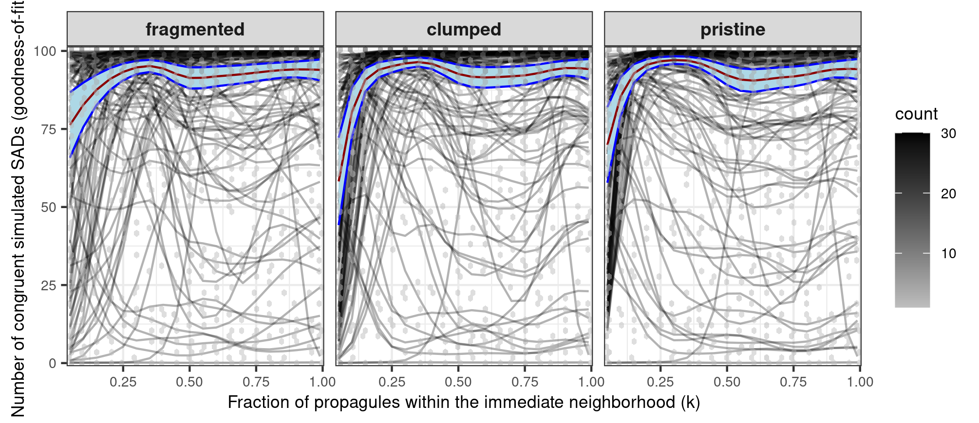
Figure 1: Congruence between simulated and observed SADs (y-axis) across dispersal (x-axis) and landscape combinations (facet labels). Hexagonal bins show the density of plot‑level observations (lighter = fewer points, darker = up to 100 points). Gray lines: plot‑level predictions from the most plausible model with spatial coordinates set to zero. Red line: overall mean prediction; blue shading: 95% pointwise confidence interval. Mean congruence exceeded 75% in most simulations but declined under very weak dispersal limitation, especially in clumped and pristine landscapes.
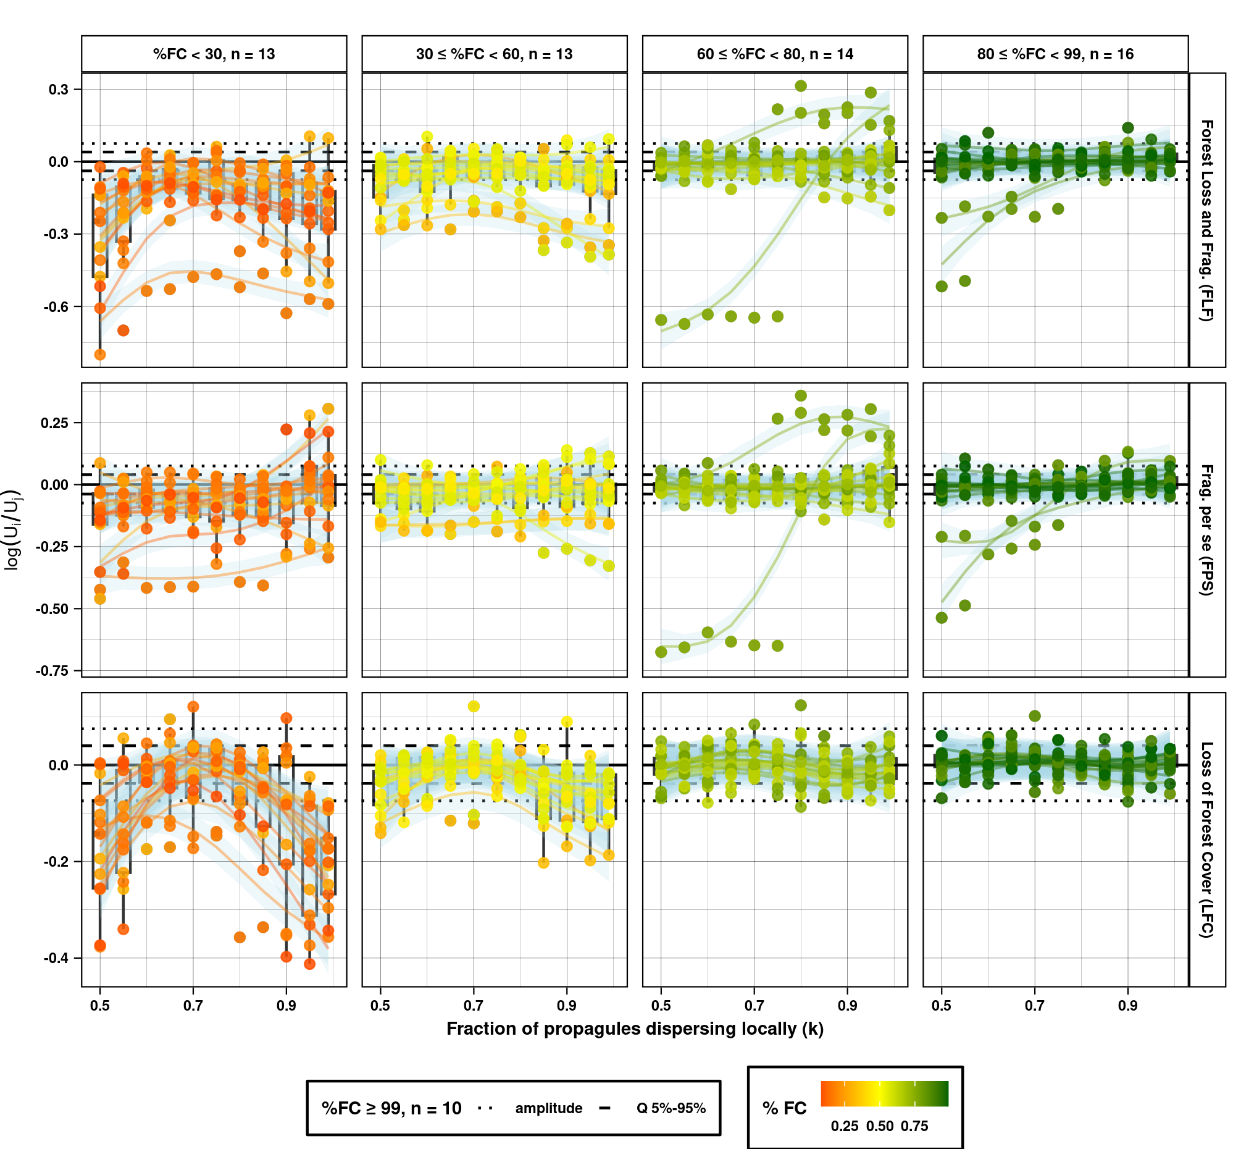
Figure 2: Proposed landscape effects described by the functional metric log U_{i}/U_{j}, shown as observed values and predictions from a hierarchical generalized additive model (HGAM). Differences in U reflect variation in the external replenishment required to sustain observed diversity patterns. The metric log(U_{i}/U_{j}) quantifies the relative change in this requirement and can thus be interpreted as a measure of landscape-induced vulnerability. Each point represents the comparison between two simulations, varying according to the landscape effect under evaluation (row titles). Forest Loss and Fragmentation (FLF): pristine vs fragmented (joint change in forest amount and configuration); Fragmentation per se (FPS): clumped vs fragmented (change in configuration, constant forest amount); Loss of Forest Cover (LFC): pristine vs clumped (change in forest amount, constant aggregation). The x-axis represents dispersal limitation (k), the fraction of propagules dispersed within the immediate neighbourhood of the parent individual. Points are coloured according to the percentage of forest cover (%FC) observed within the 2-km landscape surrounding each focal plot. Columns correspond to classes of observed %FC for each plot (column titles). Plots with greater and equal 99% forest cover were excluded from the graphical display; only the amplitude (maximum = 0.075; minimum = -0.074) and the central 90% interval (95th quantile = 0.040; 5th quantile = -0.038) of log U_{i}/U_{j} are indicated on the y-axis. This variability reflects the stochasticity inherent to the spatially explicit neutral model. Boxplots summarise values for each level of k. The y-axis scale differs among landscape effects. Only plots classified as congruent are shown.
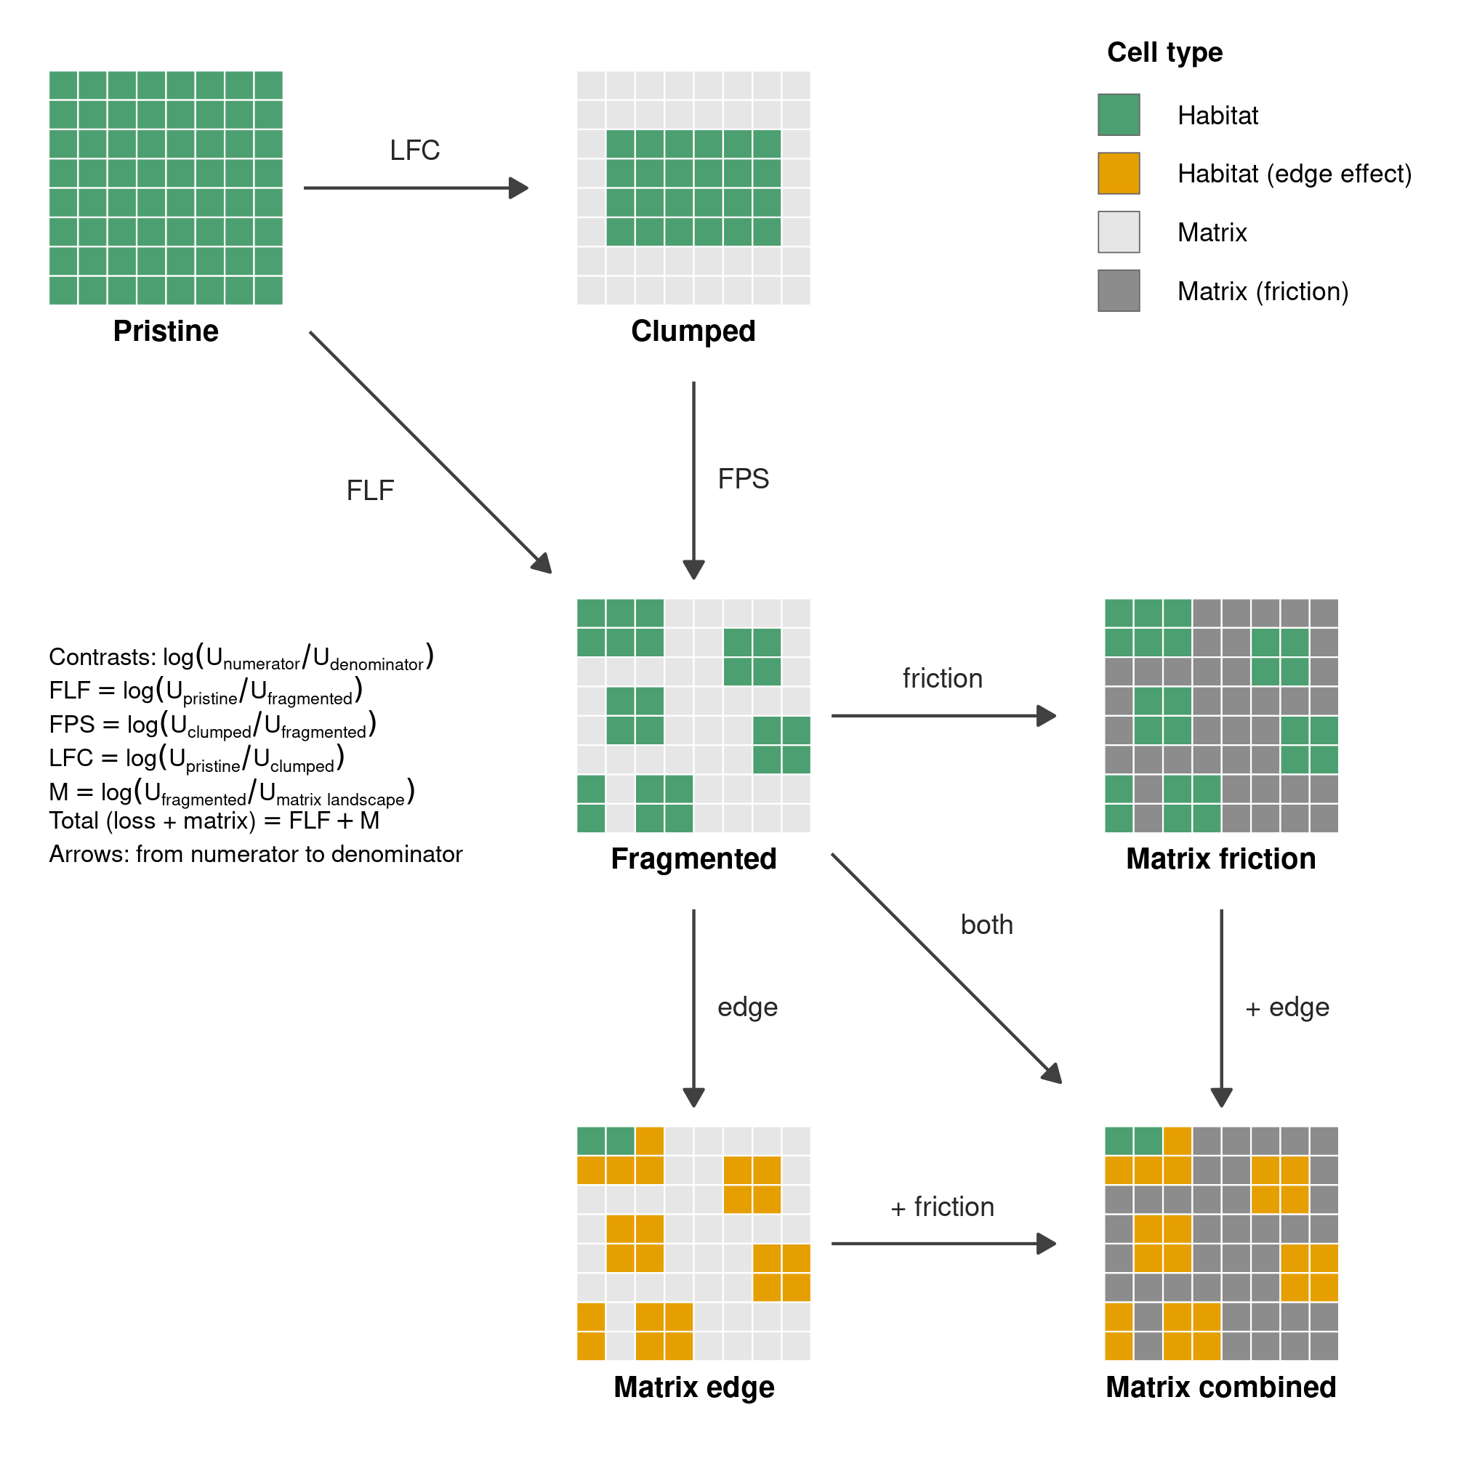
Figure 3: Experimental landscapes used (Pristine, Clumped, Fragmented) and proposed (Matrix friction, Matrix edge, Matrix combined) to estimate effects of forest loss, fragmentation and matrix conversion. Each landscape is a schematic 8 × 8 mosaic of habitat (green) and matrix (grey), not to scale. Clumped, Fragmented and the three matrix landscapes have the same amount of habitat; Pristine has none lost. In the matrix landscapes, edge effects alter demography in habitat cells adjacent to the matrix (orange), and friction reduces dispersal through matrix cells (dark grey); Matrix combined has both. Arrows run from the landscape in the numerator to the landscape in the denominator of each contrast, log(U_{numerator}/U_{denominator}): forest loss and fragmentation (FLF = log[U_{pristine}/U_{fragmented}]), fragmentation per se (FPS = log[U_{clumped}/U_{fragmented}]), forest cover loss (LFC = log[U_{pristine}/U_{clumped}]) and matrix effects (M = log[U_{fragmented}/U_{matrix landscape}]). Because contrasts are log-ratios, they are additive: FLF = FPS + LFC, and the total effect of habitat conversion to matrix is FLF + M; the interaction between edge and friction is M_{combined} − M_{friction} − M_{edge}. Friction and edge are shown at a single intensity, but both may vary continuously.

