Integration of nowcasting, forecasting, and SaTScan techniques for routine spatial-temporal detection of active SARI outbreaks in the State of São Paulo, Brazil

Tatiana P. Portella¹; Audêncio Victor², Raquel Gardini Sanches Palasio¹; Danilo Pereira Mori^{1;} Camila Lorenz¹; Thiago Godoy de Oliveira¹; Guillermo Leonardo Florez Montero¹; Eduardo Koerich Nery¹; Pamella Cristina de Carvalho Lucas¹; Ana Lúcia Frugis Yu¹; Telma Regina Marques Pinto Carvalhanas¹.

- Health Department of the State of São Paulo, Disease Control Coordination, Epidemiological Surveillance Center "Prof. Alexandre Vranjac," Division of Respiratory Disease Transmission, São Paulo, São Paulo, Brazil
- Department of Infectious Disease Epidemiology, Faculty of Epidemiology and Population Health, London School of Hygiene and Tropical Medicine, London, United Kingdom

* Corresponding author: Dr Audencio Victor, Department of Infectious Disease Epidemiology, London School of Hygiene and Tropical Medicine, Keppel Street, London WC1E 7HT, United Kingdom. E-mail: Audenciovictor@gmail.com , ORCID: https://orcid.org/0000-0002-8161-3639

Comite de Etica: CAAE: 83280624.4.0000.0086, SECRETARIA DE ESTADO DA SAUDE
Divisão de métodos: processo SEI 018.00027174/2024-42, Secretaria de Estado da Saúde – SES/SP.

Word count: 2982

Abstract
Introduction: Severe Acute Respiratory Syndrome (SARS) is a severe respiratory condition caused by various pathogens. This study aims to assess the effectiveness of combining nowcasting and forecasting methods with spatial-temporal SaTScan scanning in detecting and forecasting SARS clusters in the state of São Paulo, Brazil.
Methods: This observational and ecological study analyzed SARS patterns across different regions of the state. Data from the SIVEP-Gripe system, collected between May 23, 2022, and December 27, 2023, were used. We applied nowcasting and forecasting models to predict SARS incidence, along with spatial-temporal scanning using SaTScan™ to identify significant case clusters. Statistical comparisons between predicted and observed cases were conducted using t-tests to assess model accuracy.
Results: The models showed an average coverage of 42.7% for Cob50 and 76.8% for Cob95, with a mean WIS of 1.6 and an average MAE of 3.0. Between November 5, 2022, and February 18, 2023, model performance was particularly robust, with Cob95 ranging from 86.9% to 94.0% and Cob50 between 60.7% and 61.1%. In contrast, models underperformed between June and July 2022, with Cob50 below 35% and higher WIS values. Regional analyses revealed that the Extremo Oeste Paulista had the best performance (Cob95 of 92.6%, WIS of 0.5), while São Paulo and the Metropolitan Region of Campinas had significant under-predictions. Comparative t-tests indicated significant differences between consolidated, observed, and superior prediction metrics, with p-values below 0.05.
Conclusion: The integration of nowcasting, forecasting, and spatial-temporal scanning with SaTScan proved effective in real-time detection of SARS outbreaks, offering a valuable tool for epidemiological surveillance and response to respiratory disease outbreaks in the state of São Paulo.
Keywords: Epidemiological surveillance, outbreak prediction, spatial-temporal analysis, SaTScan, nowcasting, forecasting

1. Introduction
Severe Acute Respiratory Infection (SARI) is a severe respiratory condition caused by various pathogens, including viruses such as SARS-CoV-2, Influenza, respiratory syncytial virus, adenovirus, metapneumovirus, parainfluenza, and others [1–3]. Globally, the prevalence of SARI has been a persistent concern for public health systems, emphasizing the need for advanced monitoring and response techniques [4–6]. In Brazil, the prevalence of SARI has been particularly high, especially in the state of São Paulo, which registers a significant burden of hospitalizations and deaths related to the syndrome [7,8].
One of the main objectives of the surveillance for SARI is to detect localized respiratory disease outbreaks quickly. One powerful method to detect emerging geographical disease clusters in real time is through a prospective spatiotemporal cluster analysis with SatScan [9]. However, the reliability of this method is highly dependent on the timeliness of disease case notification [10]. SARI data had a significant reporting delay, and the number of SARI cases in its official database has always been underestimated in recent weeks. This delay can severely compromise the capacity of SatScan to detect a sudden increase in respiratory disease incidence in a geographical area. A statistical method called nowcasting and forecasting can deal with reporting delays and make future incidence projections for disease data that suffer from reporting delays. Nowcasting models estimate the current incidence of cases by accounting for delays in case reporting, providing a more accurate and immediate estimation of incidence [13,14,17]. Forecasting projects future trends of disease cases based on the most recent data, complementing nowcasting estimation [13,16]. Integrating these techniques with the spatial-temporal scanning software SaTScan has great potential to enhance the ability to detect outbreaks of SARI in real time, facilitating quick and effective interventions
Notably, to the best of our knowledge, only one study has tested the association of nowcasting with SaTScan, and it was in the context of dengue surveillance [17]. Additionally, no studies have evaluated the combination of nowcasting, forecasting, and SaTScan for outbreak detection and prediction, which represents the novelty of our work. This study aims to test the effectiveness of combining forecasting and nowcasting techniques with SaTScan’s prospective spatio-temporal analysis to detect active SARI clusters in real-time in the state of São Paulo. A detailed analysis of these techniques will help identify strengths and limitations, contributing to the continuous improvement of epidemiological surveillance strategies and outbreak responses [13,19–21].

2 Methods
2.1 Overview
This study proposes a two-step approach for detecting SARI outbreaks to be used in a real-time early warning surveillance system. The first step involves applying nowcasting and forecasting models to SARI data in order to correct for reporting delays and generate short-term projections of case counts. In the second step, the corrected and estimated data are used in a prospective spatial-temporal analysis using the SaTScan software, which identifies statistically significant clusters of SARI. This approach is expected to enhance the precision and timeliness of outbreak detection. If successful, its implementation could support rapid and effective public health responses.
The data used in this study were collected from the Epidemiological Surveillance Information System for Influenza (SIVEP-Gripe), covering all Regional Interagency Commissions (CIR) in the state of São Paulo.
To assess the effectiveness of this approach in detecting SARI outbreaks in a timely manner, we conduct a validation analysis using different data configurations, including naive uncorrected data and fully consolidated data

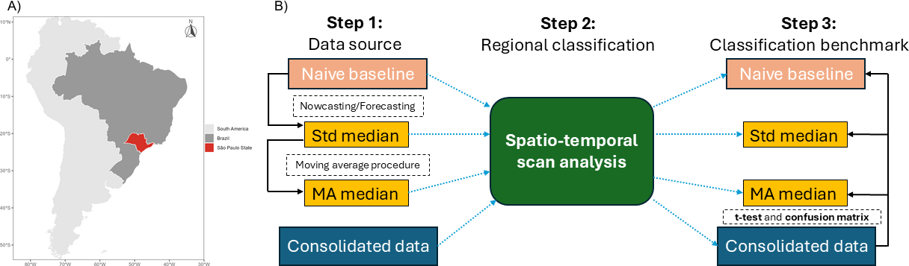
Figure 1. Methodological scheme. (A) Location of the State of São Paulo within South America and Brazil, with the study region highlighted. (B) The analysis comprised three main steps. Step 1 – Data source: four data inputs were used for prospective SaTScan analyses: Naive baseline (raw observed SARI data), Std median (median SARI estimates with eight weeks of nowcasted and one week of forecasted data from Bayesian nowcasting/forecasting models), MA median (three-week moving average of the median estimates), and Consolidated data (reference SARI data used to assess whether detected clusters corresponded to actual active disease clusters). Arrows indicate the nowcasting/forecasting and moving-average procedures. Step 2 – Regional classification: all four data inputs were submitted to a spatial-temporal scan analysis. Step 3 – Classification benchmark: the scan results for each input were compared with the consolidated data using t-tests and confusion matrices to evaluate the early detection of SARI outbreaks in the State of São Paulo.

2.3 Data Source
The data used in this study were extracted from SIVEP-Gripe, managed by the Brazilian Ministry of Health (SIVEP-Gripe, 2024). SIVEP-Gripe is the official system for recording hospitalizations and deaths from SARI in the country, providing a robust dataset that includes sociodemographic information (sex, race/ethnicity, age, place of residence, among others), clinical and epidemiological characterization of cases (symptom onset date, notification date, reported symptoms, outcome), and laboratory results. SARI has been a mandatory reporting disease in Brazil since 2009, and all public and private hospitals should report SARI cases in this notification system. We collected the data for the state of São Paulo, Brazil, which is the most populous and economically important region of Brazil [ ]. The state has 645 municipalities divided into 63 Regional Interagency Commissions (CIRs). The CIRs are groupings of municipalities that share healthcare resources and collaborate in regional health management, allowing for a comprehensive and detailed analysis of SARS incidence across the state [22,23] .
Data were collected between May 23, 2022, and December 27, 2023, and included extraction of information regarding the date of symptom onset and notification . To ensure data quality, consistency, and integrity checks were performed.

2.4 Nowcasting and forecasting modelling
We applied a nowcasting model to SARI data to correct the reporting delay and estimate the recent number of cases count and a forecasting model to make a one week-ahead future predictions of cases count. We used a modified version of the spatio-temporal bayesian nowcasting and forecasting approach proposed by Bastos et al (2019). The formula used in nowcasting and forecasting is demonstrated as follows:
$n_{t,d, s}∼NegBinom\left(λ_{{t,}_{d}, s},ϕ\right)$
$log\left(λ_{{τ,}_{d, s}},\right)=α+βt,s+γd,s+µs+ νs$
This technique fits a negative binomial distribution to case counts (n) in spatial location s, at time t with delay d. The case count time trend ($βt$ ) and delay distribution ($γd)$ for each spatial location (s) were modelled as a random effect using a random walk of second order for the time trend and random walk of first order for delay evolution. We also add a spatially structure $(µs)$ random effect using a Besag ICAR model (Besag, 1974) to account for spatial autocorrelation, and unstructured random effect ($νs)$, using an independent and identically distributed random effect (iid) to account for some spatial variation in each CIR. The two spatial components were modelled together using Besag-York-Mollie (BYM) model (Besag et al. 1991). We assumed a weakly informative loggamma prior distribution with parameters 0.001 and 0.001.
The empirical delay distribution was calculated from the difference in days between the date of symptom onset and the date of data entry for each case. Forecasting operates under the assumption that the temporal trend of the two previous weeks, estimated via nowcasting, will continue into the following week.
The models were fitted using the Integrated Nested Laplace Approximation (INLA) method through the R-INLA package (Rue et al., 2009). We also adapted the code available in the R package of Lopes et al. (2025) to implement the nowcasting and forecasting, adding the spatial structure to their model.

We evaluated the nowcasting and forecasting performance of SARI case estimation using metrics such as , percentage coverage, and the Weighted Interval Score (WIS) [26].
2.5 Prospective spatio-temporal scan analysis
The prospective spatio-temporal scan analysis was performed using the R package rsatscan (Kleinman, 2024), an interface for the SaTScan™ (Information Management Services Inc., Maryland, USA), enabling automated detection of emerging clusters based on scan statistics. Employing the Poisson discrete model with a weekly time scale [17,18,21]. Prior to the prospective spatio-temporal analysis, a purely spatial scan analysis was performed to determine the Gini index and, consequently, the most appropriate spatial window size. In this analysis, a standard maximum spatial window of 50% of the population at risk was used. The unit of analysis was each of the 63 CIRs in the state of São Paulo. The spatial scan centers a circle on the CIR headquarters and expands the radius until it identifies a significantly higher risk of SARS cases within the circle compared to outside. The Gini index obtained from this analysis was then used to define the maximum spatial window for the subsequent prospective spatio-temporal analyses.
The spatio-temporal analysis follows the same principle but adds a time dimension. SaTScan parameters were set to run a maximum of 999 Monte Carlo replications to compute the p-value, considered significant when less than 0.05. The discrete spatial scan procedure in SaTScan begins by defining the centroids for each aggregated area, which represent the location at node 𝑖Circular zones are then applied at each node in spatial space, and a likelihood ratio statistic is calculated depending on the observed and expected values inside and outside the circles. The likelihood function under the null hypothesis is compared to the alternative hypothesis, tested using a Poisson distribution. For a specific scanning window, the likelihood function is proportional to:
$L(c)=\frac{(γ/E(γ))^{γ}(\left(C-γ\right)/(C-E(γ)))^{(C-γ)​} }{C^{c}}$
Where: $γ$ and$E(γ)$ denote the observed and expected number of cases within the specific circular window, respectively, $C$ represents the total number of cases in the study, and I$(γ/E\left(γ\right))$ is the indicator function equal to 1 if the observed number exceeds the expected and 0 otherwise.
Point estimates are generally calculated where the likelihood function is maximized across all locations and circle sizes. In this study, p-values were approximated through Monte Carlo hypothesis testing, comparing the rank of the maximum likelihood among the original and simulated data. Significant hotspots were then identified as all centroids within the significant point estimates of the scan window.
To evaluate whether using nowcasted and forecasted SARI data as input for prospective SaTScan analysis improves the early detection of SARI outbreaks in the State of São Paulo, we performed prospective SaTScan analyses using four different data inputs and compared their detection performance:
Naive baseline: Observed SARI data, representing the uncorrected raw data without nowcasting or forecasting.
Standard Median (Std Median): A time series comprising the median estimates of SARI cases, with eight weeks of nowcasted data and one week of forecasted data, obtained from the Bayesian nowcasting and forecasting models described above.
Moving-average median (MA Median): A smoothed version of the median estimate time series, obtained by applying a three-week moving average to reduce fluctuations and noise in the estimates.
Consolidated data: The consolidated SARI data, used as the reference to assess whether the clusters detected using the estimated data corresponded to actual active disease clusters.
Prospective spatio-temporal visualization was performed in R generating thematic maps to compare the spatial distribution of clusters across indicators and time points. These maps were used to visually assess the geographic patterns and temporal consistency of detected clusters.
For the analysis of each data type, relative risks (RR) were extracted and categorized into risk classes (1.1-2.0, 2.0–3.0, >3.0) for prospective spatio-temporal visualization.
2.6 Outbreak Detection Validation
Differences between the RR values associated with the clusters detected among CIRs/time by the consolidated cases and those detected by each predictive approach (standard median, moving-average median, naive baseline) were first statistically compared using Welch’s t-test (two-sample t-test with unequal variances). Summary statistics (mean and standard deviation of RR) were calculated for each method using the rstatix package. Results were tabulated and complemented with hypothesis testing outputs, including t-statistics and p-values. A significance level of 5% was adopted.

Then, the prospective spatio-temporal Spatial agreement between scenarios was subsequently assessed in QGIS using Boolean overlay analysis, where statistically significant clusters (p < 0.05) were converted into binary layers and intersected to identify coincident high-risk areas.

A second approach to evaluate the ability of the timely data sources to reproduce the outbreak classifications obtained after reporting delays had been resolved, the classifications derived from the consolidated SARI data were treated as the reference standard (ground truth). For the confusion matrix analyses, the relative risk estimates were simplified into a binary classification, with CIRs classified as high risk when RR > 1 and as non-high risk otherwise (RR ≤ 1).

For each epidemiological week and each of the 63 CIRs, the binary classification obtained from each predictive approach was compared with that obtained from the consolidated data. Each CIR-week observation was therefore assigned to one of four categories: true positive (TP), when both the predictive method and the consolidated data classified the CIR as high risk; false positive (FP), when the predictive method classified the CIR as high risk but the consolidated data did not; true negative (TN), when both classifications indicated non-high risk; and false negative (FN), when the predictive method failed to identify a CIR classified as high risk in the consolidated data.

These classifications were summarized at two levels. First, for each epidemiological week and each predictive approach, the numbers of CIRs classified as TP, FP, TN, and FN were counted, providing a week-specific assessment of outbreak detection performance. Second, for each CIR and predictive approach, the number of epidemiological weeks spent in each classification category was calculated to characterize the spatial distribution and persistence of correct and incorrect classifications across the study period.

From the resulting confusion matrices, several complementary performance metrics were calculated. The true positive rate (TPR; sensitivity) was defined as TP/(TP + FN) and represents the proportion of high-risk CIRs identified in the consolidated data that were correctly detected by the predictive approach. The false positive rate (FPR) was defined as FP/(FP + TN) and represents the proportion of CIRs not classified as high risk in the consolidated data that were incorrectly flagged as high risk. Together, TPR and FPR characterize the trade-off between detecting true high-risk clusters and generating false alarms. The Youden index was calculated as TPR − FPR providing a summary measure of the separation between true-positive detection and false-positive alerts, with higher values indicating better discrimination between high-risk and non-high-risk CIRs.

The positive predictive value (PPV), calculated as TP/(TP + FP), represents the probability that a CIR classified as high risk by a timely method was also classified as high risk in the consolidated data, and therefore reflects the reliability of positive alerts. The negative predictive value (NPV), calculated as TN/(TN + FN), represents the probability that a CIR classified as non-high risk by the timely method was also classified as non-high risk in the consolidated data, reflecting the reliability of negative classifications.

The primary comparison of outbreak detection performance focused on TPR and FPR because these measures directly quantify the epidemiologically relevant trade-off between identifying active high-risk clusters and minimizing false alerts. PPV, NPV, and the Youden index were used as complementary measures to characterize each method's reliability and overall discriminatory performance.

All analyses were conducted using the R environment (version 4.1.0, R Foundation for Statistical Computing, Vienna, Austria). Visualization and mapping were done using the 'ggplot2', ‘ggspatial’, and ‘ggsn’ library in R and QGIS (QGIS Development Team, Open Source Geospatial Foundation, Oregon, USA). Validation of the nowcasting and forecasting models was performed as described in the validation script available at: https://github.com/d-resp/05_SRAG_SISTEMA_DE_ALERTA/blob/main/03_script/validacao.
Results
We performed 2,142 nowcasting and forecasting estimates over 34 weeks across the 63 CIRs, covering the period from May 23, 2022, to December 27, 2023 (Figures 2 and S1). The median and moving average of the median of these predictions, along with the naive and consolidated data, were used as inputs to a prospective SatScan analysis to detect emerging spatial SARI outbreaks.

In this section, we first validate the performance of the nowcasting and forecasting estimates across 63 CIRs, utilizing the most recent three weeks of corrected data for nowcasting and one week of forecasted data. Subsequently, we evaluate the performance of SaTScan in detecting active spatio-temporal SARI clusters using the estimates derived from the nowcasted and forecasted data.

Nowcasting and Forecasting model performance

The predictive performance of the last three weeks of nowcasting and the one week of forecasting estimates are shown in Figure 2. Overall, the nowcasting and forecasting estimates showed good predictive performance, with a median 95% and 50% prediction interval (PI) coverages of 76.8% and 42.7%, respectively, and a median WIS of 1.6. Performance remained largely stable over time, with the exception of the initial weeks, where model accuracy was somewhat lower. Among the regions, most DRS (x%) had median 95% and 50% PI coverages higher than XX and XX, respectively. WIS values also varied across regions, ranging from x to y. In the center-south of the state, which is the most populous region, underprediction was the dominant WIS component, whereas in the interior of the state, most CIRs showed spread as the dominant WIS component. All regions had a median underestimation WIS component of 0.
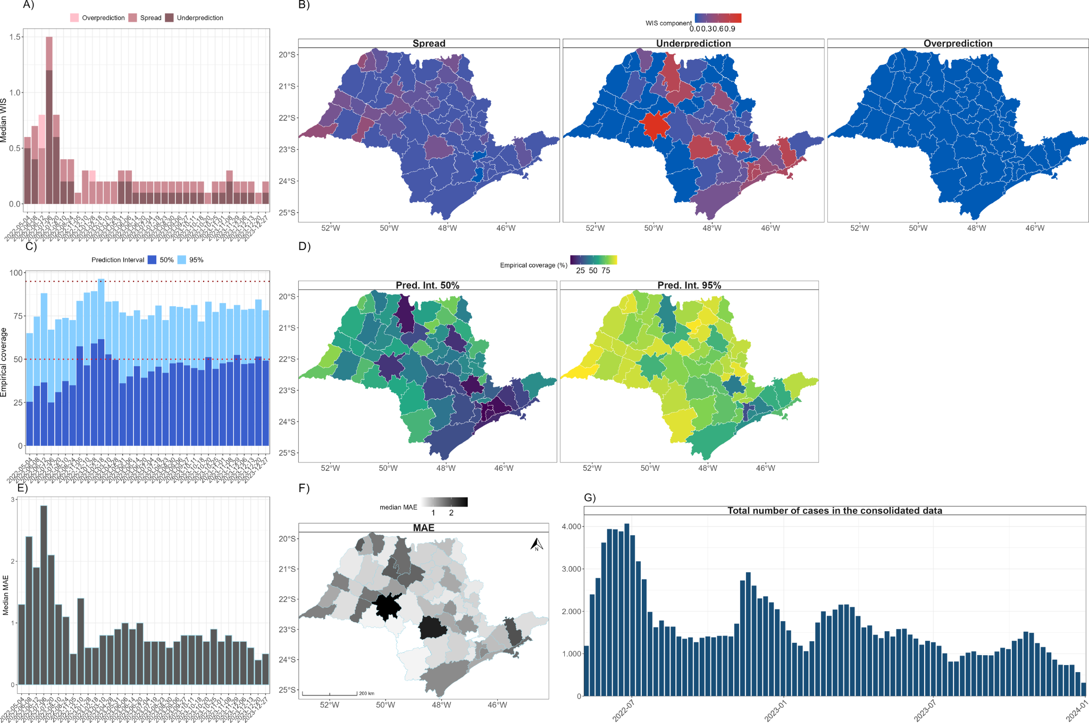
Figure 2. Model performance evaluation. (A) Weekly decomposition of the Weighted Interval Score (WIS) into spread, overprediction, and underprediction components. (B) Spatial decomposition of WIS components by Regional Interagency Commissions (CIR): spread, underprediction, and overprediction. (C) Empirical coverage over epidemiological weeks. (D) Empirical coverage by CIR. (E) Median of MAE over epidemiological weeks. (F) Median of MAE by CIR. (G) Weekly total number of SARI cases in the consolidated dataset.

Outbreak detection Performance

To detect active SARI outbreaks in São Paulo state, we performed spatio-temporal prospective SaTScan analyses using two datasets (1) the median estimates and (2) the moving average of median estimates, from the Bayesian nowcast and forecast model. We evaluated the performance of these approaches by comparing results with those obtained from spatio-temporal prospective SaTScan analyses conducted on (3) naive observed data and (4) consolidated data.

We performed 34 prospective analyses and detected 297 CIRs areas with significant active clusters using median estimates, 324 using the moving average of median estimates, and 9 using observed naive data. The comparison of clusters detected by these models and with those detected using consolidated data is summarised in Table 1.

Figure 3 illustrates the weekly number of CIRs classified as high risk (RR > 1) and low risk (RR ≤ 1) based on consolidated data. Low-risk CIRs consistently outnumbered high-risk ones throughout the study period, with peaks in high-risk classifications occurring around August 2022, January 2023, and November 2023 (Figure 3A). The spatial distribution of the proportion of high-risk weeks per CIR shows that 5 CIRs were persistently classified as high risk (>50% of weeks), whereas 18 CIRs were never classified as high risk (Figure 3B; Tab. S1).

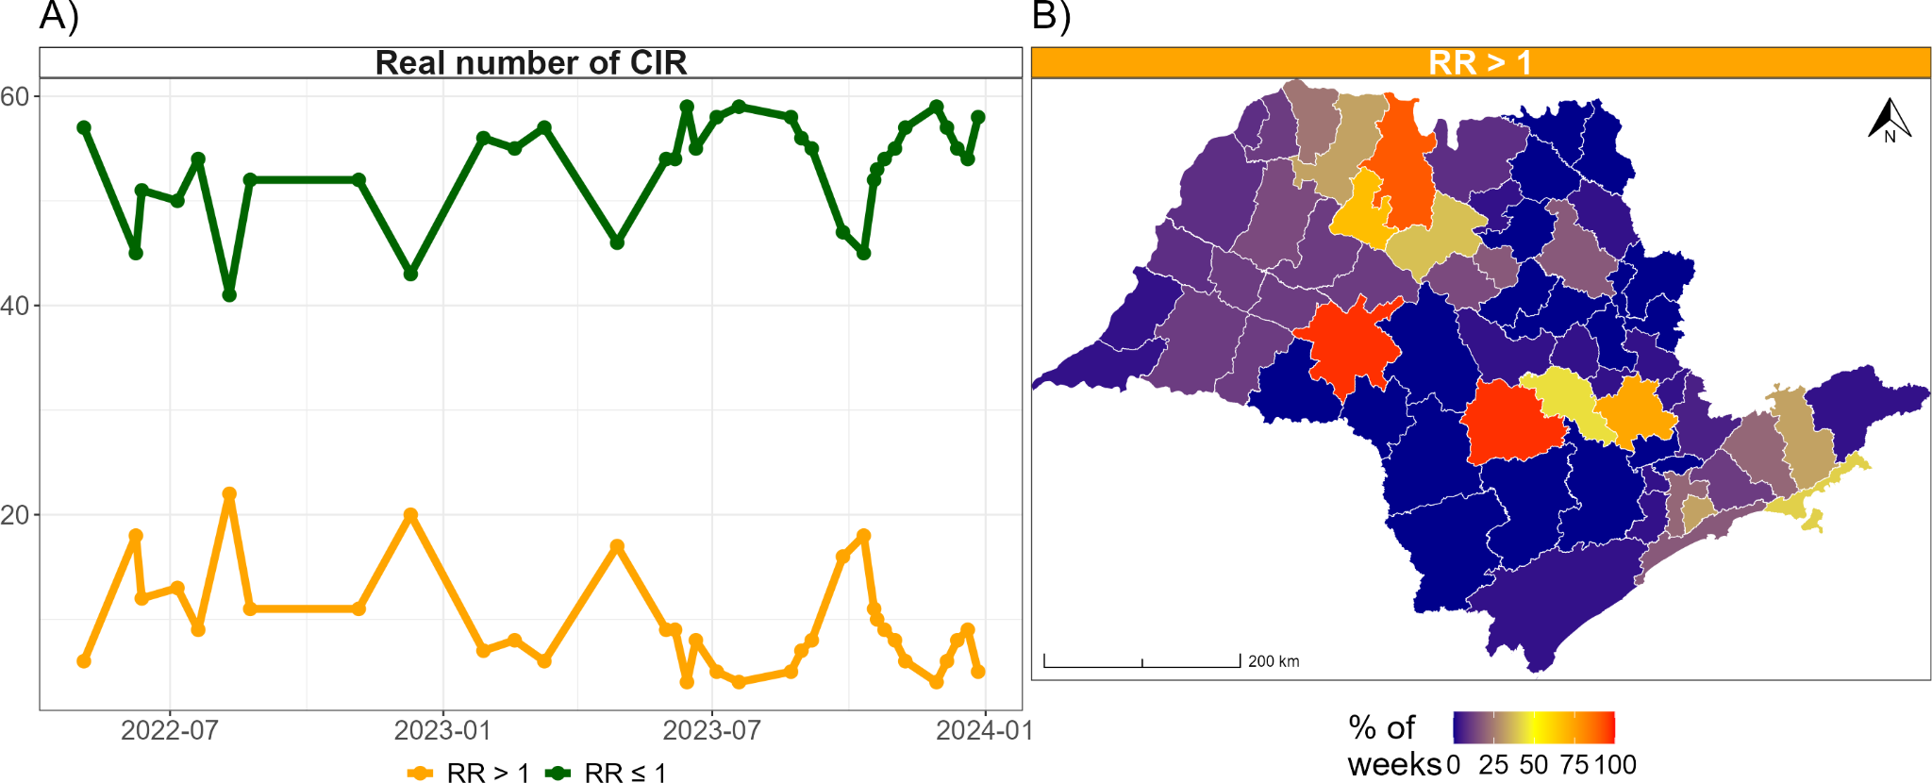
Figure 3. SaTScan-based risk classification of CIRs in the consolidated data. (A) Weekly number of high-risk (RR > 1, orange) and low-risk (RR ≤ 1, green) CIRs in the consolidated (ground truth) dataset. (B) Spatial frequency of high-risk classifications in the consolidated dataset; color intensity reflects the proportion of weeks (n = 34) each CIR was classified as high-risk.

Welch's t-test revealed that the RR values associated with clusters detected by SaTScan using the MA Median data was not significantly different from that detected using the consolidated data (t = 0.85; p = 0.40). In contrast, the number of clusters detected using the Std. Median data (t = 3.13; p = 0.00) and the naive baseline data (t = 2.94; p = 0.02) was significantly smaller than that detected using the consolidated data (Table 1).

The summary of the confusion-matrix-based metrics reinforced this pattern (Table 1). The MA Median achieved the highest sensitivity (TPR = 0.57 ± 0.25) and the best overall discriminatory performance (Youden's index = 0.49 ± 0.24) among the three timely methods, followed by the Std Median (TPR = 0.44 ± 0.25; Youden = 0.36 ± 0.23), while the naive baseline showed a markedly limited ability to detect high-risk CIRs (TPR = 0.03 ± 0.10; Youden = 0.03 ± 0.10). Notably, all three methods maintained comparably low false-alarm rates (FPR ≤ 0.08), indicating that the higher sensitivity achieved by the Bayesian methods was not accompanied by a proportional increase in false positives. The positive predictive value followed the same ranking as TPR — highest for the MA Median (PPV = 0.71 ± 0.25), intermediate for the Std Median (PPV = 0.63 ± 0.30), and lowest for the naive baseline (PPV = 0.12 ± 0.33) — whereas the negative predictive value remained high and comparable across methods (NPV ≥ 0.85), consistent with the relatively low proportion of high-risk CIR-weeks in the consolidated data (Fig. 3, Tab. S1).

<!-- trecho sobre a análise Boolean -->

Figures 5 highlight prospective spatio-temporal variability, with superior performance observed in the Boolean overlay analysis. The best- and worst-performing scenarios were further compared by assessing spatial agreement based on coincident cluster areas, with the former capturing broader clusters in high-risk areas. The moving median adjustment produced cluster patterns more consistent with consolidated cases than those derived from observed data (Figure 5 and Supplementary Figure S3). This approach reduced spatial noise and fragmentation, resulting in more stable and epidemiologically coherent clusters. In contrast, observed naive data showed greater variability and dispersion, suggesting the presence of short-term fluctuations. These findings indicate that smoothing approaches improve the reliability of prospective cluster detection while maintaining sensitivity to high-risk areas. Supplementary Figures S3 and S4 present the remaining scenarios from the prospective spatio-temporal analysis.

Table 1. Summary of performance metrics for SARI outbreak detection using prospective spatio-temporal SaTScan analysis on different datasets. Median and standard deviation of performance metrics are reported separately for the Standard Median data (Std Median), the Moving Average median data (MA Median), both derived from the median of the nowcast and forecast Bayesian predictions, and the naive baseline data. The t-test column reports the mean t-statistic (p-value). Metrics include: True Positive Rate (TPR), False Positive Rate (FPR), Positive Predictive Value (PPV), Negative Predictive Value (NPV), and Youden's Index. Higher values indicate better performance for all metrics except FPR, where lower values are desirable.
Method | t-test | TPR | FPR | PPV | NPV | Youden
Std Median | 3.13 (0.00) | 0.44 (0.25) | 0.08 (0.11) | 0.63 (0.30) | 0.90 (0.07) | 0.36 (0.23)
MA Median | 0.85 (0.40) | 0.57 (0.25) | 0.08 (0.11) | 0.71 (0.25) | 0.92 (0.06) | 0.49 (0.24)
Naive baseline | 2.94 (0.02) | 0.03 (0.10) | 0.00 (0.00) | 0.12 (0.33) | 0.85 (0.08) | 0.03 (0.10)

Figure 4 details the temporal and spatial patterns underlying these aggregate metrics showed in table 1.
Panels D and F show the weekly TPR and FPR, respectively, for the three timely methods. The Std Median and MA Median tracked each other closely for most of the study period (TPR generally between 40% and 90%), with a marked reduction in sensitivity between August and October 2022 (TPR as low as 15–30%) — coinciding with the period of comparatively lower nowcasting/forecasting accuracy identified in Figure 2 — and their best and most stable performance (TPR up to 100%) between November 2022 and February 2023, mirroring the period of highest predictive accuracy reported above. From mid-2023 onward, TPR became more variable for both methods, oscillating between approximately 10% and 65%. FPR remained low (generally below 10%) for all methods across most weeks, with an isolated spike for the Std Median (~40%) around January 2023. The naive baseline showed near-zero TPR and FPR for virtually the entire period, with two isolated TPR peaks (~17% in mid-2022 and ~50% in early 2023) that stand out against its otherwise consistently poor sensitivity.

Panels E and G map the spatial distribution of TPR and FPR for each method. The naive baseline showed uniformly low TPR and FPR across nearly all CIRs, reflecting its near-complete inability to spatially reproduce the consolidated classification. In contrast, the Std Median and MA Median displayed marked spatial heterogeneity in TPR, with the highest sensitivity (TPR ≥ 75%) concentrated in the same cluster of north-central CIRs most frequently classified as high risk in the consolidated data (Panel B), while most CIRs in the southern and coastal portions of the state showed comparatively low TPR; the MA Median showed a somewhat broader spatial extent of moderate-to-high TPR than the Std Median, consistent with its higher aggregate TPR in Table 1. FPR maps for both Bayesian methods were predominantly low across the state, with one notable exception: a single CIR in the central region showed a markedly elevated FPR for both methods.

Resultado análise Danilo

These findings underscore the value of integrating statistical and spatial analyses to enhance outbreak detection and understand SARI transmission dynamics.

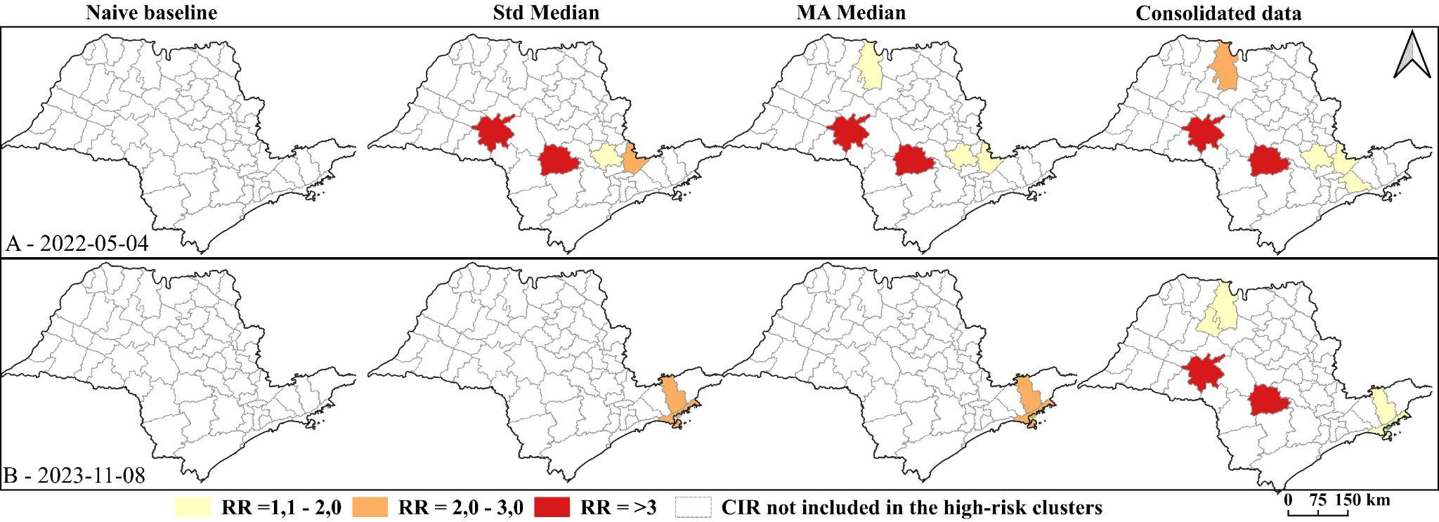
Figura 5. Prospective spatial-temporal distribution of significant clusters (p < 0.05) for the best-performing (A) and worst-performing (B) scenarios identified in the Boolean overlay analysis, with spatial agreement assessed by identifying coincident cluster areas (SARI). Relative risk (RR) clusters were derived from consolidated data, standard Median (Std Median), moving-average median (MA Median), and naive baseline in São Paulo. Supplementary Figures S3 and S4 present the remaining scenarios from the prospective spatial-temporal analysis

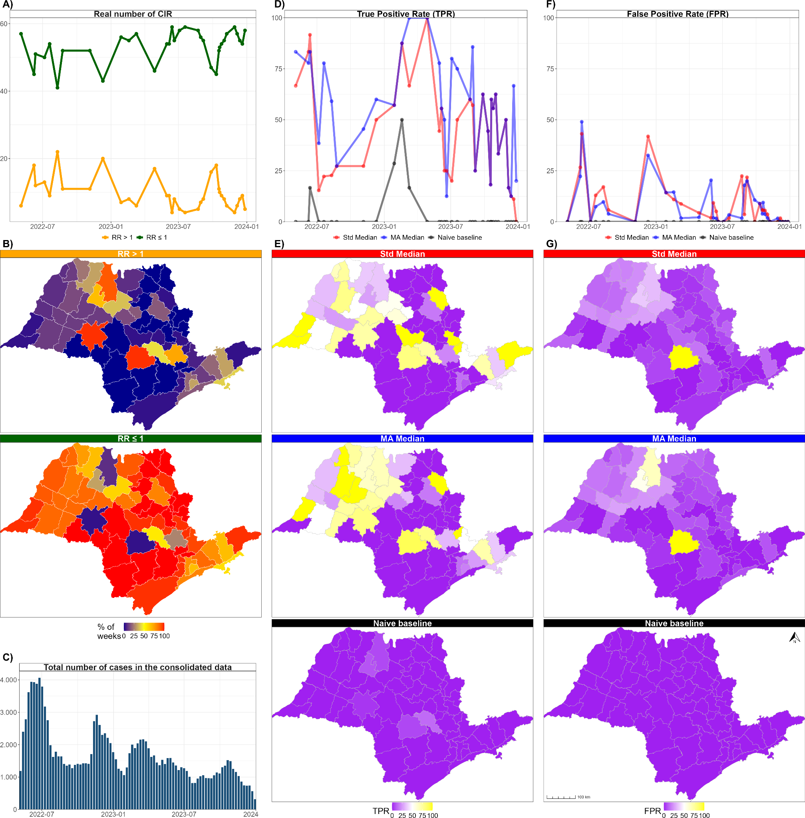
Figure 3. SaTScan-based risk classification of CIRs: comparison of consolidated and predicted data. (A) Weekly number of high-risk (RR > 1, orange) and low-risk (RR ≤ 1, green) CIRs in the consolidated (ground truth) dataset. (B) Spatial frequency of high-risk (top) and low-risk (bottom) classifications in the consolidated dataset; color intensity reflects the proportion of weeks (n = 34) each CIR was classified in each category. (C) Weekly true positive rate (TPR) for the naive baseline (black), standard median Bayesian prediction (red), and moving-average median Bayesian prediction (blue). (D) Spatial distribution of TPR for the standard median, moving-average median, and naive baseline. (E) Weekly false positive rate (FPR) for the same three methods. (F) Spatial distribution of FPR for the standard median, moving-average median, and naive baseline.

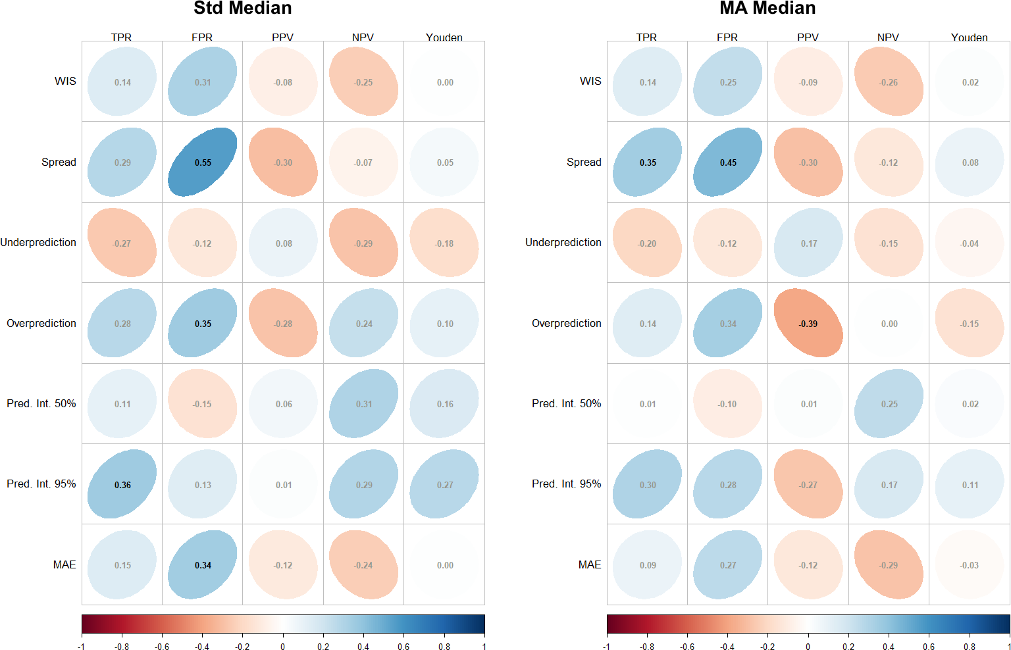
Figure 4. Correlation between model performance metrics and SaTScan-based classification metrics for Standard Median and Moving-Average Median approaches. Spearman correlation coefficients (displayed within ellipses) between prediction quality/uncertainty metrics (y-axis: Weighted Interval Score – WIS, Spread, Underprediction, Overprediction, 50% Prediction Interval Width – Pred. Int. 50%, 95% Prediction Interval Width – Pred. Int. 95%, and Mean Absolute Error – MAE) and risk classification metrics (x-axis: True Positive Rate – TPR, False Positive Rate – FPR, Positive Predictive Value – PPV, Negative Predictive Value – NPV, and Youden’s Index). Results are presented for two median estimation approaches: Std Median (left) and MA Median (right). Ellipse orientation and color indicate correlation sign and magnitude (blue = positive, red/orange = negative). Correlation coefficients displayed in black text are statistically significant (p < 0.05), whereas coefficients in white text are not (p ≥ 0.05). Correlations were calculated across epidemiological weeks, aggregating all CIRs for each week to reflect the spatial structure of the SaTScan classification context.

Discussion
This study proposed an innovative modelling method to predict spatio-temporal clusters of SARI cases in the state of São Paulo. The method integrated nowcasting, forecasting, and spatio-temporal scanning using SaTScan software. The integration of nowcasting to correct reporting delays, along with SaTScan to identify high-risk clusters, proved effective in early outbreak detection. This allowed for actionable data to be provided to public health authorities, enabling faster and more precise interventions. Additionally, the t-test results revealed statistically significant differences among consolidated cases, observed cases, and superior metrics. These findings underscore the pivotal role of statistical validation in calibrating and refining predictive models. They further highlight the necessity of implementing more robust adjustments to enhance predictive accuracy and ensure closer alignment with observed values, particularly in contexts characterized by high variability in the data.

Previous studies, such as Bastos et al. (2019), addressed the application of nowcasting to adjust notification data for diseases like dengue and respiratory infections in Brazil. They used Bayesian methods to adjust for spatial and temporal variability, like our approach, which employed a negative binomial model to account for overdispersion in the data [13]. The flexibility of this model allows it to accommodate variations in case frequency, a crucial aspect in rapidly spreading epidemics like SARS.
Nowcasting is essential in scenarios where reporting is delayed, and real-time data may be incomplete. In our study, we used the negative binomial model to adjust for delays and predict the occurrence of new cases. This model was particularly important for addressing data overdispersion, a common characteristic in epidemiological outbreaks. This approach is supported by the findings of Brooks et al. (2018), who explored predictive models for seasonal influenza, demonstrating that the integration of different models improves short-term forecasting accuracy [16]. The likelihood ratio test is used to determine whether observed cases in a given area are significantly higher than expected. This method proved effective for detecting circular clusters, although it has limitations in identifying irregularly shaped clusters [21].
Comparison with methods such as Generalized Additive Models and Bayesian Disease Mapping, as discussed by Aamodt et al. (2006), reveals that SaTScan has greater specificity in detecting circular clusters, while BYM is better suited for irregularly shaped clusters. However, for real-time applications like SARS outbreak detection, the speed and precision of SaTScan make it the preferred tool [21]. The negative binomial models used in nowcasting offer a flexible way to handle count data with overdispersion. Additionally, the use of the INLA method for Bayesian model fitting, as discussed by Bastos et al. (2019), provides an efficient alternative to traditional Markov Chain Monte Carlo methods, reducing computational complexity and allowing for faster and more accurate adjustments [13].
In terms of cluster detection, the spatio-temporal scan statistic is a robust tool, as demonstrated by Kulldorff's studies on SaTScan for disease outbreaks [18]. However, it is important to note that the circular shape of SaTScan’s scan windows may limit its application in cases where clusters have more complex shapes or where transmission is more diffuse. Future studies could explore the use of hierarchical Bayesian models to accommodate more complex spatial variations.
The real-time nature of our outbreak detection system has significant implications for public health surveillance. The ability to identify clusters as they form and predict future outbreaks allows public health authorities to respond rapidly, allocating resources more efficiently. Our integration of nowcasting and forecasting enables crisis management to be proactive rather than reactive. By identifying SARS clusters in São Paulo, our study contributes to the ongoing management of respiratory diseases in urban areas. This model can be adapted to other infectious diseases, particularly those with high transmission rates and public health impact, such as dengue [17].
Despite the success of our approach, some limitations must be acknowledged. The accuracy of outbreak detection depends on the quality of input data, and reporting delays may introduce uncertainties that affect the precision of cluster detection. Additionally, SaTScan’s reliance on circular clusters limits its effectiveness in identifying irregularly shaped clusters, as noted by Aamodt et al. (2006). Future research should explore the integration of additional data sources, such as environmental and socioeconomic variables, to enhance the model’s predictive power. Advances in machine learning could also be applied to develop more dynamic models that adapt to changing transmission patterns.

Ideias: um paragrado comparando a performance do forecasting e nowcasting com o satscan.
Devemos salientar que o SaTScan não melhora a qualidade dos dados, mas depende da qualidade dos dados de entrada. O nowcasting e o forecasting atuam em etapas diferentes do processo. O nowcasting reduz o viés causado pelo atraso na notificação, fornecendo uma estimativa mais próxima da incidência real no presente. Já o forecasting projeta a incidência futura. O SaTScan utiliza essas informações para identificar aglomerados de maior risco em tempo real. Assim, a combinação dos três métodos é potencialmente superior ao uso isolado do SaTScan, pois melhora tanto a qualidade quanto a disponibilidade temporal dos dados utilizados na análise.
Outro paragrafo discutindo que seria interessante considerar os ICs?? como??

Conclusion
The integration of nowcasting, forecasting,with SaTScan proved effective for real-time detection of SARSI outbreaks. By addressing reporting delays and utilizing advanced cluster detection techniques, we provided a robust framework for improving public health responses to outbreaks. The methodologies discussed, along with insights from related studies, highlight the importance of integrating statistical models with real-time surveillance to optimize responses to public health emergencies.

Data Availability Statement
The data supporting the conclusions of this article will be made available by the authors without undue restriction.
Author Contributions (CRediT)
Conceptualization, formal analysis, and methodology: Tatiana P. Portella, Raquel Gardini Sanches Palasio, Danilo Pereira Mori, Camila Lorenz, Audêncio Victor, Pamella Lucas, Telma Regina Marques Pinto Carvalhanas
Data curation: Tatiana Portella, Thiago Godoy, Audêncio Victor, Danilo Pereira Mori, Guillermo Florez
Funding acquisition and supervision: Telma Regina Marques Pinto Carvalhanas
Investigation: Tatiana P. Portella, Raquel Gardini Sanches Palasio, Camila Lorenz, Danilo Pereira Mori, Eduardo Koerich Nery, Pamella Lucas
Project administration: Telma Regina Marques Pinto Carvalhanas, Pamella Lucas, Ana Lúcia Frugis Yu
Visualization and writing original draft: Audêncio Victor, Tatiana P. Portella, Raquel Gardini Sanches Palasio, Danilo Mori
Writing review and editing: All authors contributed to and approved the final version of the article.
Ethics Statement
This study was submitted to the Research Ethics Committee of the Health Department of the State of São Paulo. Approval was granted through the Plataforma Brasil system under reference No. CAAE 83280624.4.0000.0086 and Opinion No. 7.119.626.
Funding
This research did not receive specific funding from public, commercial, or not-for-profit agencies.
Conflict of Interest
The authors declare no conflict of interest.

References
1. González-Ortiz AM, Bernal-Silva S, Comas-García A, Vega-Morúa M, Garrocho-Rangel ME, Noyola DE. Severe Respiratory Syncytial Virus Infection in Hospitalized Children. Arch Med Res. 2019;50: 377–383. doi:10.1016/j.arcmed.2019.10.005
2. Cillóniz C, Pericàs JM, Rojas JR, Torres A. Severe Infections Due to Respiratory Viruses. Semin Respir Crit Care Med. 2022;43: 60–74. doi:10.1055/s-0041-1740982
3. Ferro Bricks L. REVIEW PREVENTION OF RESPIRATORY SYNCYTIAL VIRUS INFECTIONS. HOSP CLÍN FAC MED S PAULO. 2001.
4. Li ZJ, Zhang HY, Ren LL, Lu Q Bin, Ren X, Zhang CH, et al. Etiological and epidemiological features of acute respiratory infections in China. Nat Commun. 2021;12. doi:10.1038/s41467-021-25120-6
5. Wansaula Z, Olsen SJ, Casal MG, Golenko C, Erhart LM, Kammerer P, et al. Surveillance for severe acute respiratory infections in Southern Arizona, 2010-2014. Influenza Other Respir Viruses. 2016;10: 161–169. doi:10.1111/irv.12360
6. Al-Tawfiq JA, Zumla A, Gautret P, Gray GC, Hui DS, Al-Rabeeah AA, et al. Surveillance for emerging respiratory viruses. The Lancet Infectious Diseases. Lancet Publishing Group; 2014. pp. 992–1000. doi:10.1016/S1473-3099(14)70840-0
7. Durigon GS, Oliveira DBL, Felicio MCC, Finelli C, Pereira MFB, Storni JG, et al. Poor outcome of acute respiratory infection in young children with underlying health condition in Brazil. Int J Infect Dis. 2015;34: 3–7. doi:10.1016/j.ijid.2015.03.003
8. Estofolete CF, Banho CA, Verro AT, Gandolfi FA, dos Santos BF, Sacchetto L, et al. Clinical Characterization of Respiratory Syncytial Virus Infection in Adults: A Neglected Disease? Viruses. 2023;15: 1848. doi:10.3390/v15091848
9. M. Kulldorff, SaTScanTM Manual do Usuário, versão 10.0 Edition, versão Traduzida para o Português por Alec Brian Lacerda, Patricia Marques Moralejo Bermudi, Alessandra Cristina Guedes Pellini, Junho de 2022 (2021). URL http://www.satscan.org/

10. Kulldorff M, Heffernan R, Hartman J, Assunção R, Mostashari F (2005) A Space–Time Permutation Scan Statistic for Disease Outbreak Detection. PLoS Med 2(3): e59. https://doi.org/10.1371/journal.pmed.0020059

9. Buonafine CP, Paiatto BNM, Leal FB, de Matos SF, de Morais CO, Guerra GG, et al. High prevalence of SARS-CoV-2 infection among symptomatic healthcare workers in a large university tertiary hospital in São Paulo, Brazil. BMC Infect Dis. 2020;20. doi:10.1186/s12879-020-05662-8
10. McGough SF, Johansson MA, Lipsitch M, Menzies NA. Nowcasting by Bayesian Smoothing: A flexible, generalizable model for real-time epidemic tracking. Lewis B, editor. PLoS Comput Biol. 2020;16: e1007735. doi:10.1371/journal.pcbi.1007735
11. Nazia N, Butt ZA, Bedard ML, Tang WC, Sehar H, Law J. Methods Used in the Spatial and Spatiotemporal Analysis of COVID-19 Epidemiology: A Systematic Review. Int J Environ Res Public Health. 2022;19. doi:10.3390/ijerph19148267
12. Bailey TC. Spatial statistical methods in health. Cad Saude Publica. 2001;17: 1083–1098. doi:10.1590/S0102-311X2001000500011
13. Bastos LS, Economou T, Gomes MFC, Villela DAM, Coelho FC, Cruz OG, et al. A modelling approach for correcting reporting delays in disease surveillance data. Stat Med. 2019;38: 4363–4377. doi:10.1002/sim.8303
14. Xu B, Gutierrez B, Mekaru S, Sewalk K, Goodwin L, Loskill A, et al. Epidemiological data from the COVID-19 outbreak, real-time case information. Sci Data. 2020;7. doi:10.1038/s41597-020-0448-0
15. Bracher J, Ray EL, Gneiting T, Reich NG. Evaluating epidemic forecasts in an interval format. PLoS Computational Biology. Public Library of Science; 2021. doi:10.1371/JOURNAL.PCBI.1008618
16. Brooks LC, Farrow DC, Hyun S, Tibshirani RJ, Rosenfeld R. Nonmechanistic forecasts of seasonal influenza with iterative one-week-ahead distributions. PLoS Comput Biol. 2018;14. doi:10.1371/journal.pcbi.1006134
17. Rotejanaprasert C, Areechokchai D, Maude RJ. Two-step spatiotemporal anomaly detection corrected for lag reporting time with application to real-time dengue surveillance in Thailand. BMC Med Res Methodol. 2024;24: 10. doi:10.1186/s12874-024-02141-5
18. Kulldorff M. Prospective Time Periodic Geographical Disease Surveillance Using a Scan Statistic. J R Stat Soc Ser A Stat Soc. 2001;164: 61–72. doi:10.1111/1467-985X.00186
19. Xu B, Gutierrez B, Mekaru S, Sewalk K, Goodwin L, Loskill A, et al. Epidemiological data from the COVID-19 outbreak, real-time case information. Sci Data. 2020;7. doi:10.1038/s41597-020-0448-0
20. Lawson AB. Bayesian disease mapping: hierarchical modeling in spatial epidemiology. Chapman and Hall/CRC; 2018.
21. Aamodt G, Samuelsen SO, Skrondal A. A simulation study of three methods for detecting disease clusters. Int J Health Geogr. 2006;5. doi:10.1186/1476-072X-5-15
22. Paschoalotto MAC, Passador JL, de Oliveira LR, Lopes JEF, Dantas MK, Passador CS. The regionalization of the Brazilian national health system: Proposition for performance evaluation of the regional health departments of são paulo state, Brazil. Saude e Sociedade. 2018;27: 80–93. doi:10.1590/s0104-12902018170095
23. Filho RMS, dos Santos AM, Carvalho JA, De Almeida PF. Ações da Comissão Intergestores Regional 853 para gestão compartilhada de serviços especializados no Sistema Único de Saúde. Physis. 2016;26: 853–878. doi:10.1590/S0103-73312016000300008
24. Ranzani OT, Bastos LSL, Gelli JGM, Marchesi JF, Baião F, Hamacher S, et al. Characterisation of the first 250 000 hospital admissions for COVID-19 in Brazil: a retrospective analysis of nationwide data. Lancet Respir Med. 2021;9: 407–418. doi:10.1016/S2213-2600(20)30560-9
25. de Souza FSH, Hojo-Souza NS, de Oliveira Batista BD, da Silva CM, Guidoni DL. On the analysis of mortality risk factors for hospitalized COVID-19 patients: A data-driven study using the major Brazilian database. PLoS One. 2021;16. doi:10.1371/journal.pone.0248580
26. Cramer EY, Ray EL, Lopez VK, Bracher J, Brennen A, Castro Rivadeneira AJ, et al. Evaluation of individual and ensemble probabilistic forecasts of COVID-19 mortality in the United States. Proceedings of the National Academy of Sciences. 2022;119. doi:10.1073/pnas.2113561119

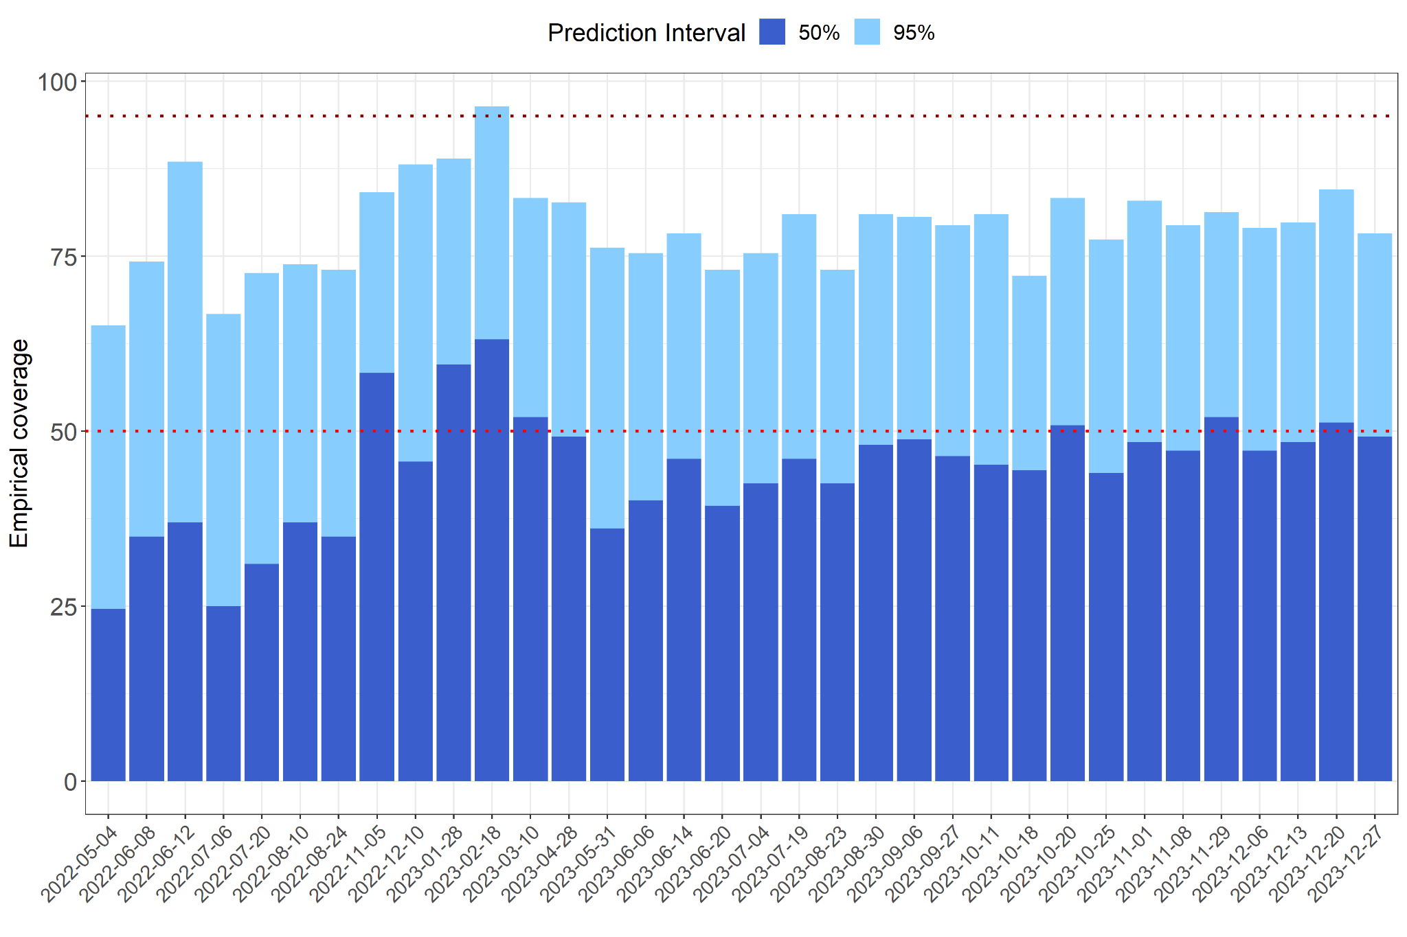
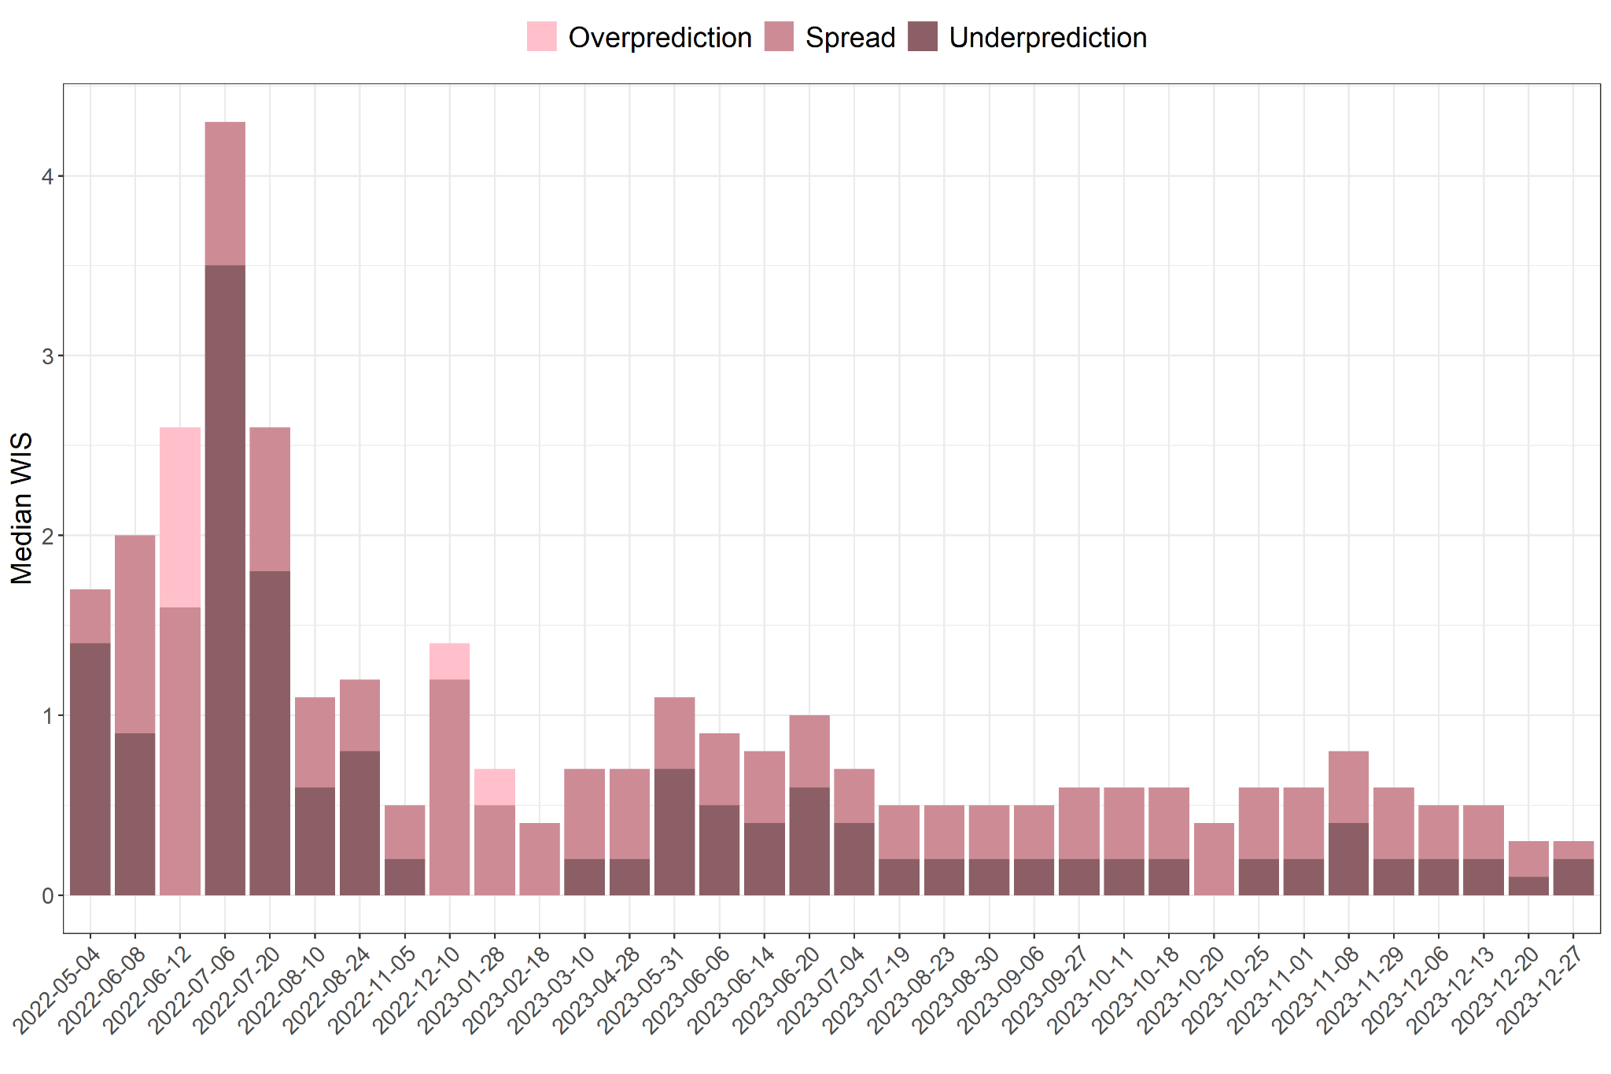
Figure 1: Accuracy and error metrics for the 34 predictive models over time. A) Accuracy of the models according to Cob50 and Cob95 values and B) Model error based on MAE and WIS values.

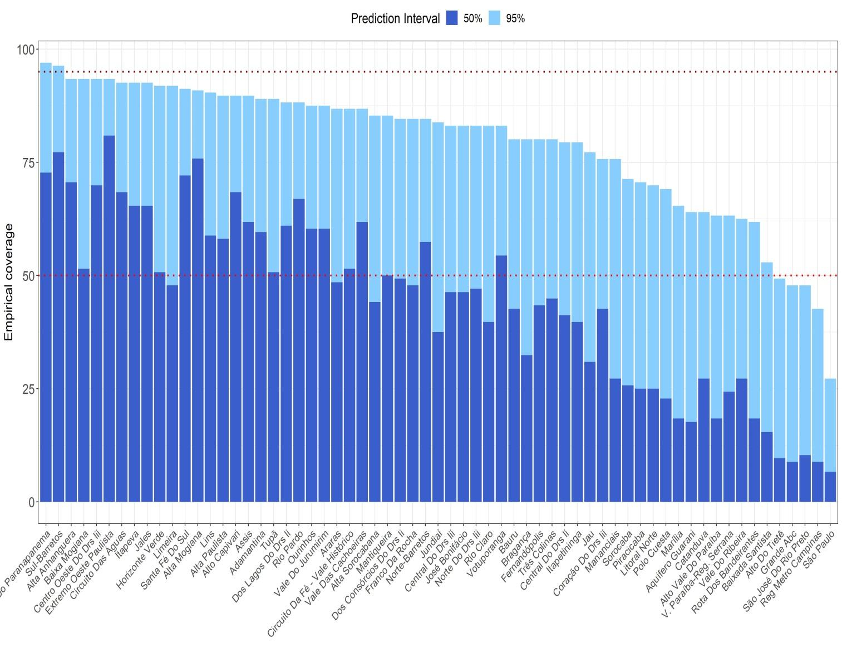

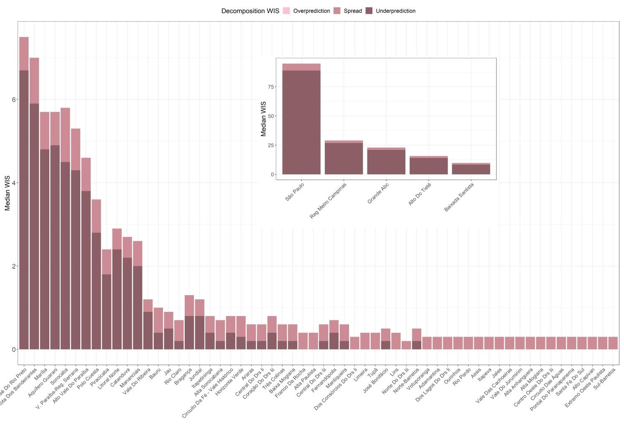

Figure 2. Empirical coverage of the 50% and 95% prediction intervals for the 63 CIRs in the state of São Paulo in predicting SARS outbreaks.

Figure 3: Decomposition of the median WIS for the 63 CIRs in the state of São Paulo, highlighting the components of overprediction, dispersion, and underprediction in the forecasting of SARS outbreaks.

Table S1. CIR frequency of high-risk classifications in the consolidated dataset (fig. 3).

CIR | % of week classified as high-risk
POLO CUESTA | 97.06
MARILIA | 97.06
SAO JOSE DO RIO PRETO | 91.18
REG METRO CAMPINAS | 73.53
JOSE BONIFACIO | 67.65
PIRACICABA | 44.12
LITORAL NORTE | 41.18
CATANDUVA | 38.24
V. PARAIBA-REG. SERRANA | 32.35
VOTUPORANGA | 32.35
GRANDE ABC | 32.35
FERNANDOPOLIS | 23.53
ALTO VALE DO PARAIBA | 20.59
SAO PAULO | 20.59
BAIXADA SANTISTA | 17.65
NORTE DO DRS III | 17.65
AQUIFERO GUARANI | 17.65
CENTRO OESTE DO DRS III | 14.71
CENTRAL DO DRS II | 14.71
TUPA | 11.76
ALTO CAPIVARI | 11.76
ALTA SOROCABANA | 11.76
ALTO DO TIETE | 11.76
LINS | 11.76
DOS CONSORCIOS DO DRS II | 11.76
ADAMANTINA | 11.76
JALES | 11.76
ALTA PAULISTA | 8.82
NORTE-BARRETOS | 8.82
SANTA FE DO SUL | 8.82
DOS LAGOS DO DRS II | 8.82
BRAGANCA | 5.88
RIO CLARO | 2.94
LIMEIRA | 2.94
CIRCUITO DA FE - VALE HISTORICO | 2.94
VALE DO RIBEIRA | 2.94
EXTREMO OESTE PAULISTA | 2.94
MANANCIAIS | 2.94
PONTAL DO PARANAPANEMA | 2.94
ROTA DOS BANDEIRANTES | 2.94
SUL-BARRETOS | 2.94
CIRCUITO DAS AGUAS | 2.94
BAIXA MOGIANA | 2.94
VALE DAS CACHOEIRAS | 2.94
JAU | 2.94
RIO PARDO | 0.00
ARARAS | 0.00
CORACAO DO DRS III | 0.00
CENTRAL DO DRS III | 0.00
ITAPETININGA | 0.00
ITAPEVA | 0.00
SOROCABA | 0.00
VALE DO JURUMIRIM | 0.00
BAURU | 0.00
FRANCO DA ROCHA | 0.00
JUNDIAI | 0.00
MANTIQUEIRA | 0.00
HORIZONTE VERDE | 0.00
OURINHOS | 0.00
ASSIS | 0.00
TRES COLINAS | 0.00
ALTA ANHANGUERA | 0.00
ALTA MOGIANA | 0.00

Table S?? - Comparison of consolidated data among standard Median (Std Median), moving-average median (MA Median), and naive baseline from the scan prospective spatio-temporal analysis, using the t-test for mean comparison between two groups. * Significant p-value < 0.05. N = number of CIR areas.

 | Categorias RR (N) |  |  | RR
 | 1.1-2.0 | 2.0-3.0 | >3 | n | mean | sd | t-test | p.value
Consolidated data | 206 | 85 | 38 | 329 | 2.09 | 0.77 | - | -
Std Median | 134 | 115 | 48 | 297 | 2.49 | 2.04 | 3.1296 | 0.0019*
MA median | 203 | 87 | 34 | 324 | 2.16 | 1.09 | 0.8465 | 0.3976
Naive baseline |  | 8 | 1 | 9 | 2.56 | 0.46 | 2.9432 | 0.0158

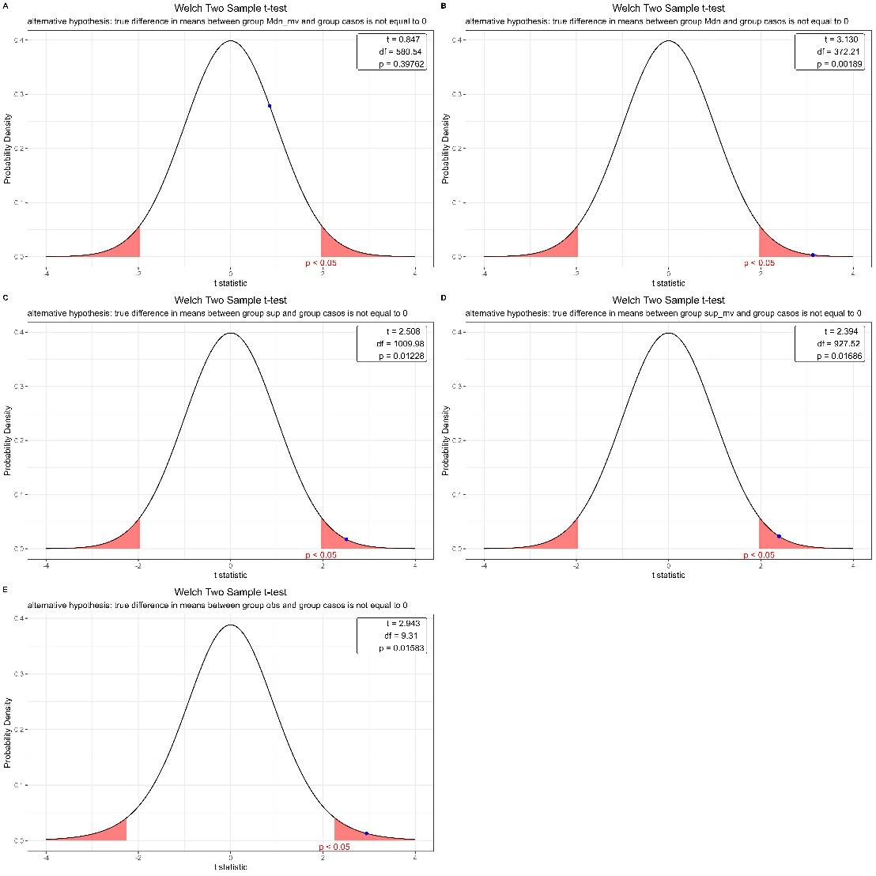
Figure S4: Graph of the t-test distribution for consolidated cases vs. moving average (A), vs. median (B), vs. superior (C), vs. moving superior (D), and vs. observed cases (E) within prospective spatial clusters, based on 34 samples from the state of São Paulo, Brazil, during the period 2022-2023.

Supplementary material
Table-S.1 - Precision metrics for nowcasting and forecasting of the 34 weekly database models from the state of São Paulo.
Model | Data base | N | Cob50 | Cob95 | WIS | Dispersion | Underprediction | Overprediction | MAE
1 | 2022-05-04 | 252 | 29.8 | 68.7 | 2.2 | 0.3 | 1.1 | 0.0 | 4.0
2 | 2022-06-08 | 252 | 34.9 | 75.4 | 4.4 | 1.1 | 0.8 | 0.0 | 7.0
3 | 2022-06-12 | 252 | 31.7 | 86.5 | 4.6 | 1.7 | 0.0 | 1.4 | 7.5
4 | 2022-07-06 | 252 | 25.4 | 70.6 | 4.9 | 0.8 | 3.2 | 0.0 | 8.0
5 | 2022-07-20 | 252 | 30.6 | 72.6 | 3.5 | 0.8 | 1.7 | 0.0 | 6.0
6 | 2022-08-10 | 252 | 36.9 | 75.8 | 2.1 | 0.5 | 0.6 | 0.0 | 4.0
7 | 2022-08-24 | 252 | 38.9 | 76.2 | 2.0 | 0.5 | 0.4 | 0.0 | 3.0
8 | 2022-11-05 | 252 | 60.7 | 86.9 | 0.9 | 0.4 | 0.0 | 0.0 | 1.0
9 | 2022-12-10 | 252 | 50.8 | 88.1 | 2.9 | 1.2 | 0.0 | 0.2 | 4.0
10 | 2023-01-28 | 252 | 57.1 | 88.1 | 1.3 | 0.5 | 0.0 | 0.2 | 2.0
11 | 2023-02-18 | 252 | 61.1 | 94.0 | 1.1 | 0.5 | 0.0 | 0.0 | 2.0
12 | 2023-03-10 | 252 | 56.7 | 86.1 | 1.7 | 0.5 | 0.0 | 0.0 | 3.0
13 | 2023-04-28 | 252 | 53.2 | 86.1 | 1.4 | 0.5 | 0.2 | 0.0 | 2.0
14 | 2023-05-31 | 252 | 33.7 | 70.6 | 1.7 | 0.4 | 0.8 | 0.0 | 3.0
15 | 2023-06-06 | 252 | 36.1 | 71.4 | 1.8 | 0.4 | 1.0 | 0.0 | 3.0
16 | 2023-06-14 | 252 | 42.9 | 75.4 | 1.5 | 0.4 | 0.6 | 0.0 | 3.0
17 | 2023-06-20 | 252 | 36.9 | 69.8 | 1.5 | 0.4 | 0.8 | 0.0 | 3.0
18 | 2023-07-04 | 252 | 38.1 | 72.6 | 1.5 | 0.3 | 0.8 | 0.0 | 3.0
19 | 2023-07-19 | 252 | 39.3 | 69.8 | 1.4 | 0.3 | 0.6 | 0.0 | 2.0
20 | 2023-08-23 | 252 | 38.9 | 70.2 | 1.5 | 0.3 | 0.4 | 0.0 | 2.0
21 | 2023-08-30 | 252 | 39.7 | 72.2 | 1.4 | 0.3 | 0.6 | 0.0 | 2.0
22 | 2023-09-06 | 252 | 44.0 | 72.6 | 1.2 | 0.3 | 0.4 | 0.0 | 2.0
23 | 2023-09-27 | 248 | 41.9 | 73.8 | 1.5 | 0.4 | 0.4 | 0.0 | 3.0
24 | 2023-10-11 | 252 | 42.5 | 73.8 | 1.5 | 0.4 | 0.5 | 0.0 | 3.0
25 | 2023-10-18 | 252 | 40.5 | 69.0 | 1.7 | 0.4 | 0.4 | 0.0 | 3.0
26 | 2023-10-20 | 252 | 48.0 | 79.0 | 1.5 | 0.5 | 0.0 | 0.0 | 3.0
27 | 2023-10-25 | 252 | 39.7 | 74.2 | 1.8 | 0.4 | 0.4 | 0.0 | 3.0
28 | 2023-11-01 | 252 | 44.4 | 75.4 | 1.5 | 0.4 | 0.4 | 0.0 | 2.0
29 | 2023-11-08 | 252 | 44.0 | 73.8 | 1.3 | 0.4 | 0.6 | 0.0 | 2.0
30 | 2023-11-29 | 252 | 48.0 | 81.0 | 1.1 | 0.4 | 0.4 | 0.0 | 2.0
31 | 2023-12-06 | 252 | 43.7 | 78.2 | 1.1 | 0.3 | 0.3 | 0.0 | 2.0
32 | 2023-12-13 | 252 | 45.2 | 78.6 | 0.9 | 0.3 | 0.4 | 0.0 | 1.5
33 | 2023-12-20 | 252 | 48.0 | 79.8 | 0.9 | 0.2 | 0.2 | 0.0 | 1.0
34 | 2023-12-27 | 252 | 47.2 | 76.2 | 0.9 | 0.1 | 0.2 | 0.0 | 1.0
Total | - | 8564 | 42.7 | 76.8 | 1.6 | 0.4 | 0.2 | 0.0 | 3.0

Note: The empirical prediction interval (PI) coverage rates calculate the fraction of times the 50% or 95% PIs covered the eventually observed value. Values with coverage within 10% of nominal rates are highlighted in bold. The columns “Relative WIS” and “Relative MAE” show the average relative WIS and relative MAE, respectively.

Table- S.2 - Precision metrics for nowcasting and forecasting of the 63 models aggregated by CIRs in the state of São Paulo for SARS outbreaks in the 63 CIRs of the state of São Paulo, Brazil, from 2022 to 2023.
Model | Data base by CIR | N | Cob50 | Cob95 | WIS | Dispersion | Underprediction | Overprediction | MAE
1 | Adamantina | 136 | 61.8 | 90.4 | 0.8 | 0.3 | 0.0 | 0 | 1.0
2 | Alta Anhanguera | 136 | 61.0 | 90.4 | 0.7 | 0.3 | 0.0 | 0 | 1.0
3 | Alta Mogiana | 136 | 76.5 | 92.6 | 0.6 | 0.3 | 0.0 | 0 | 1.0
4 | Alta Paulista | 136 | 55.9 | 89.7 | 1.3 | 0.5 | 0.0 | 0 | 2.0
5 | Alta Sorocabana | 136 | 43.4 | 87.5 | 1.5 | 0.5 | 0.3 | 0 | 3.0
6 | Alto Capivari | 136 | 67.6 | 88.2 | 0.5 | 0.3 | 0.0 | 0 | 1.0
7 | Alto Do Tietê | 136 | 14.0 | 47.8 | 18.4 | 1.7 | 15.5 | 0 | 26.5
8 | Alto Vale Do Paraíba | 136 | 16.2 | 65.4 | 6.6 | 0.8 | 4.8 | 0 | 10.0
9 | Aquífero Guarani | 136 | 15.4 | 52.2 | 8.8 | 0.9 | 6.3 | 0 | 12.5
10 | Araras | 136 | 46.3 | 89.0 | 1.5 | 0.4 | 0.4 | 0 | 3.0
11 | Assis | 136 | 61.0 | 87.5 | 0.8 | 0.3 | 0.0 | 0 | 1.0
12 | Baixa Mogiana | 136 | 52.2 | 92.6 | 1.3 | 0.4 | 0.2 | 0 | 2.0
13 | Baixada Santista | 136 | 14.0 | 49.3 | 12.1 | 1.5 | 10.0 | 0 | 20.5
14 | Bauru | 136 | 44.1 | 80.1 | 1.9 | 0.6 | 0.5 | 0 | 3.0
15 | Bragança | 136 | 34.6 | 77.9 | 1.9 | 0.4 | 0.8 | 0 | 3.0
16 | Catanduva | 136 | 21.3 | 61.0 | 3.6 | 0.5 | 2.6 | 0 | 6.0
17 | Central Do Drs Ii | 136 | 39.7 | 78.7 | 1.4 | 0.3 | 0.4 | 0 | 2.0
18 | Central Do Drs Iii | 136 | 46.3 | 83.1 | 1.4 | 0.4 | 0.2 | 0 | 2.0
19 | Centro Oeste Do Drs Iii | 136 | 69.9 | 91.2 | 0.6 | 0.3 | 0.0 | 0 | 1.0
20 | Circuito Da Fé - Vale Histórico | 136 | 49.3 | 87.5 | 1.5 | 0.5 | 0.4 | 0 | 3.0
21 | Circuito Das Águas | 136 | 67.6 | 90.4 | 0.7 | 0.3 | 0.0 | 0 | 1.0
22 | Coração Do Drs Iii | 136 | 37.5 | 77.9 | 1.5 | 0.4 | 0.5 | 0 | 3.0
23 | Dos Consórcios Do Drs Ii | 136 | 47.1 | 84.6 | 1.1 | 0.3 | 0.0 | 0 | 2.0
24 | Dos Lagos Do Drs Ii | 136 | 56.6 | 87.5 | 0.8 | 0.3 | 0.2 | 0 | 1.0
25 | Extremo Oeste Paulista | 136 | 81.6 | 92.6 | 0.5 | 0.3 | 0.0 | 0 | 1.0
26 | Fernandópolis | 136 | 36.8 | 72.8 | 1.5 | 0.3 | 0.6 | 0 | 3.0
27 | Franco Da Rocha | 136 | 44.1 | 83.8 | 1.3 | 0.4 | 0.0 | 0 | 2.0
28 | Grande Abc | 136 | 14.0 | 40.4 | 26.6 | 2.1 | 22.4 | 0 | 38.5
29 | Horizonte Verde | 136 | 50.0 | 90.4 | 1.6 | 0.5 | 0.4 | 0 | 3.0
30 | Itapetininga | 136 | 39.0 | 81.6 | 1.6 | 0.4 | 0.6 | 0 | 3.0
31 | Itapeva | 136 | 65.4 | 92.6 | 0.7 | 0.3 | 0.0 | 0 | 1.0
32 | Jales | 136 | 64.0 | 93.4 | 0.7 | 0.3 | 0.0 | 0 | 1.0
33 | Jau | 136 | 30.9 | 76.5 | 2.0 | 0.4 | 0.6 | 0 | 4.0
34 | José Bonifácio | 136 | 40.4 | 81.6 | 1.2 | 0.3 | 0.6 | 0 | 2.0
35 | Jundiaí | 136 | 32.4 | 86.0 | 2.1 | 0.4 | 0.9 | 0 | 3.0
36 | Limeira | 136 | 47.8 | 89.0 | 1.1 | 0.4 | 0.1 | 0 | 2.0
37 | Lins | 136 | 58.1 | 91.9 | 0.9 | 0.4 | 0.0 | 0 | 2.0
38 | Litoral Norte | 136 | 19.9 | 56.6 | 4.8 | 0.5 | 4.0 | 0 | 8.0
39 | Mananciais | 136 | 22.1 | 71.3 | 3.7 | 0.6 | 2.8 | 0 | 7.0
40 | Mantiqueira | 136 | 45.6 | 82.4 | 1.3 | 0.4 | 0.2 | 0 | 2.0
41 | Marília | 136 | 15.4 | 44.9 | 11.8 | 0.9 | 10.8 | 0 | 16.0
42 | Norte Do Drs Iii | 136 | 46.3 | 80.1 | 0.9 | 0.2 | 0.0 | 0 | 1.0
43 | Norte-Barretos | 136 | 55.1 | 85.3 | 0.9 | 0.3 | 0.2 | 0 | 2.0
44 | Ourinhos | 136 | 58.1 | 86.8 | 0.8 | 0.3 | 0.0 | 0 | 1.0
45 | Piracicaba | 136 | 19.1 | 64.0 | 6.0 | 0.6 | 2.6 | 0 | 9.0
46 | Polo Cuesta | 136 | 15.4 | 43.4 | 10.7 | 0.8 | 9.1 | 0 | 16.0
47 | Pontal Do Paranapanema | 132 | 72.7 | 97.0 | 0.6 | 0.3 | 0.0 | 0 | 1.0
48 | Reg Metro Campinas | 136 | 8.8 | 36.8 | 46.6 | 2.3 | 41.0 | 0 | 60.0
49 | Rio Claro | 136 | 41.2 | 80.9 | 2.1 | 0.5 | 0.2 | 0 | 4.0
50 | Rio Pardo | 136 | 61.8 | 88.2 | 0.7 | 0.3 | 0.0 | 0 | 1.0
51 | Rota Dos Bandeirantes | 136 | 15.4 | 59.6 | 9.0 | 1.2 | 7.1 | 0 | 14.0
52 | Santa Fé Do Sul | 136 | 71.3 | 91.9 | 0.5 | 0.3 | 0.0 | 0 | 1.0
53 | Sorocaba | 136 | 22.8 | 67.6 | 8.0 | 1.4 | 5.3 | 0 | 12.0
54 | Sul-Barretos | 136 | 75.0 | 94.1 | 0.5 | 0.3 | 0.0 | 0 | 1.0
55 | São José Do Rio Preto | 136 | 6.6 | 40.4 | 14.6 | 0.8 | 12.2 | 0 | 20.0
56 | São Paulo | 136 | 5.9 | 24.3 | 134.4 | 6.9 | 121.7 | 0 | 168.5
57 | Três Colinas | 136 | 41.2 | 77.9 | 1.4 | 0.4 | 0.2 | 0 | 2.0
58 | Tupã | 136 | 50.0 | 86.0 | 1.1 | 0.4 | 0.2 | 0 | 2.0
59 | V. Paraíba-Reg. Serrana | 136 | 27.2 | 64.0 | 6.4 | 1.0 | 4.3 | 0 | 12.0
60 | Vale Das Cachoeiras | 136 | 59.6 | 87.5 | 0.8 | 0.3 | 0.0 | 0 | 1.0
61 | Vale Do Jurumirim | 136 | 48.5 | 88.2 | 0.9 | 0.3 | 0.2 | 0 | 1.0
62 | Vale Do Ribeira | 136 | 30.1 | 63.2 | 3.0 | 0.3 | 1.4 | 0 | 4.5
63 | Votuporanga | 136 | 50.0 | 83.8 | 0.9 | 0.3 | 0.0 | 0 | 1.0

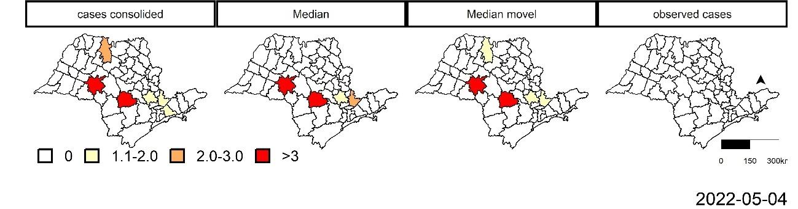
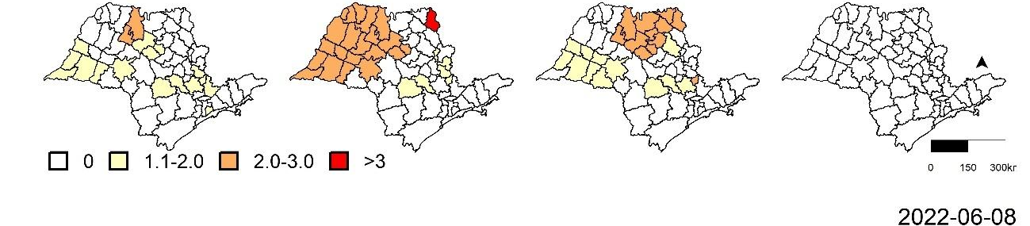
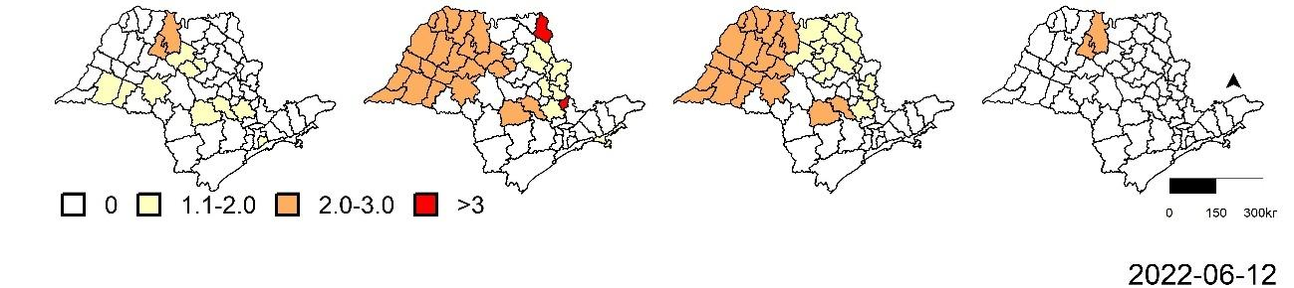
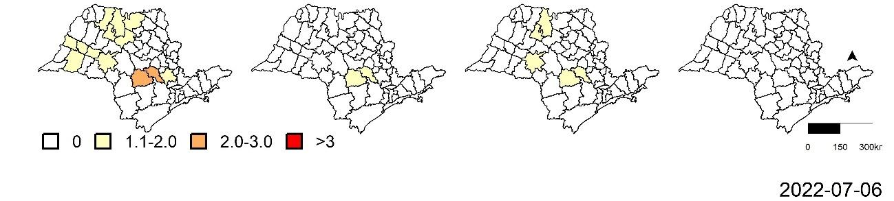
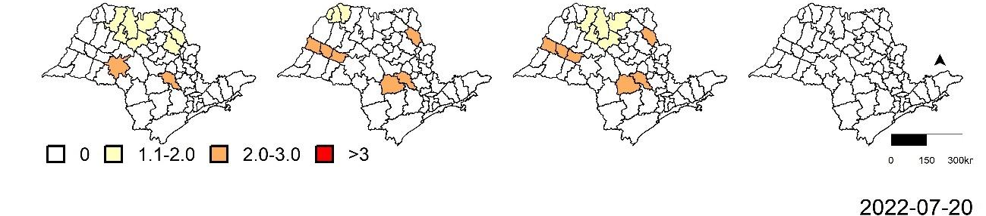
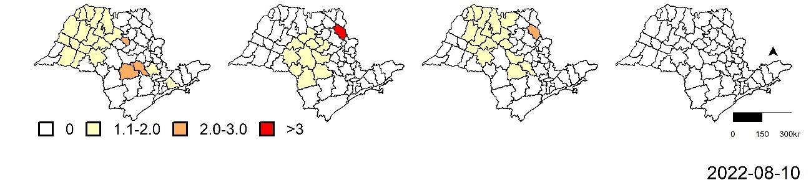
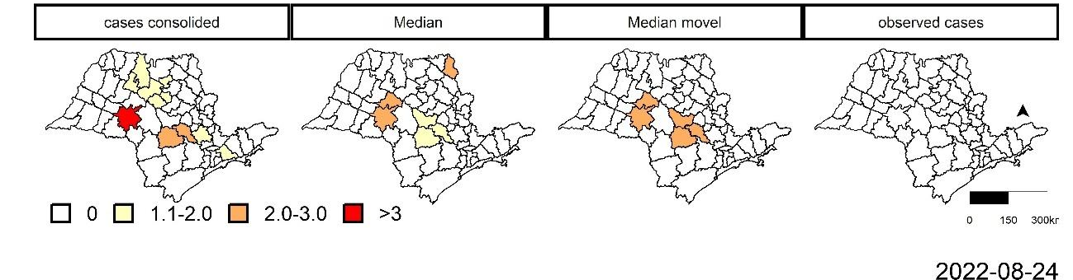
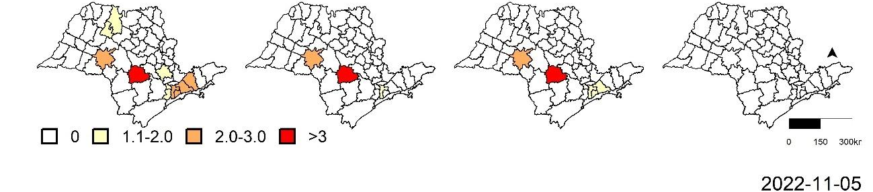
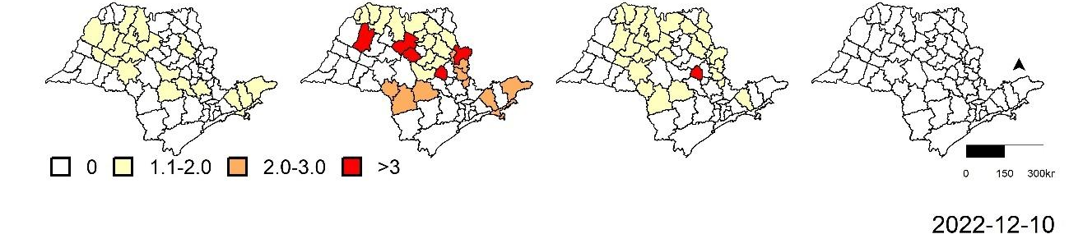
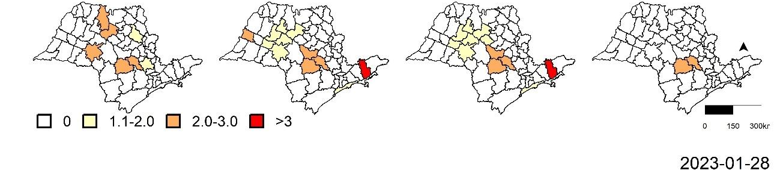
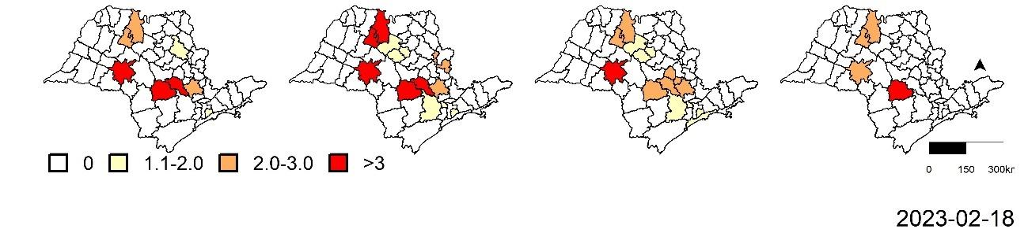
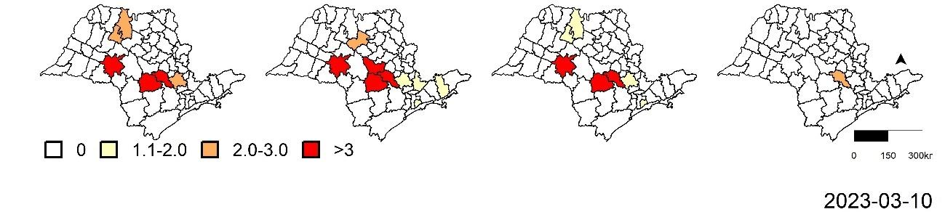
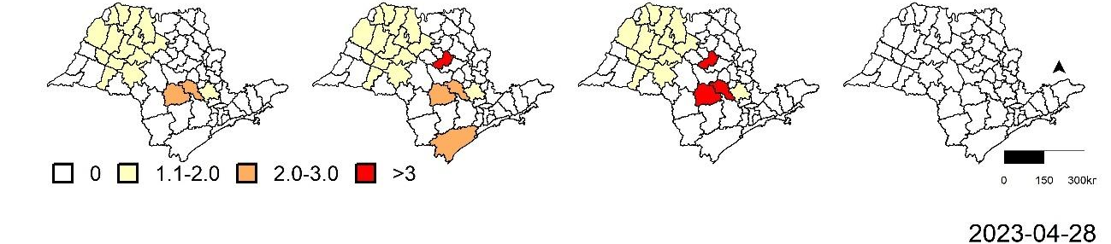
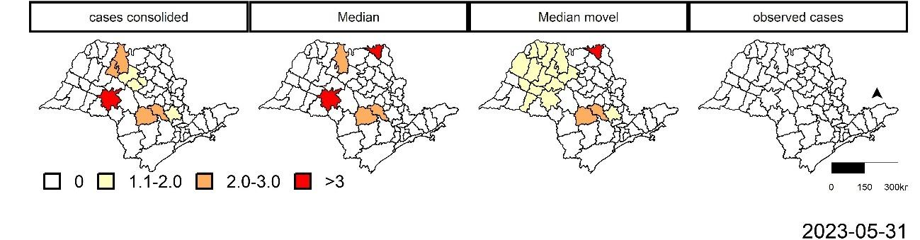
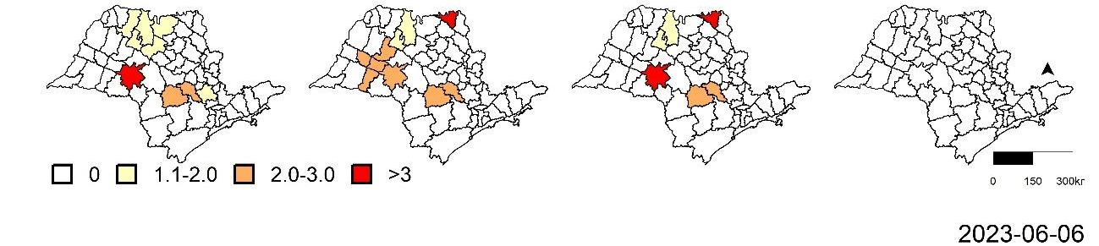
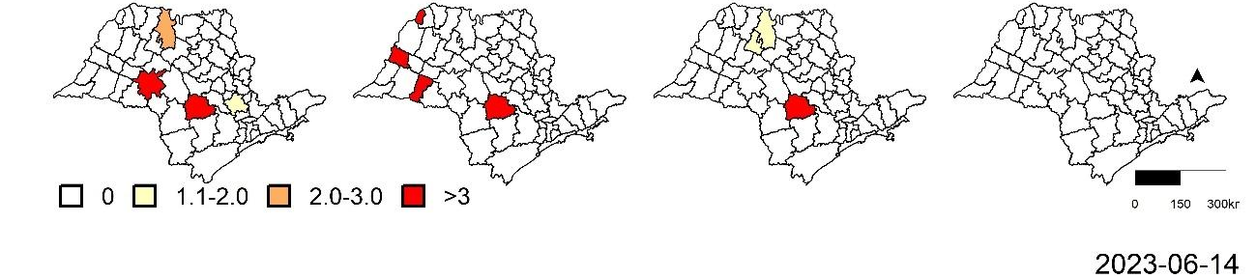
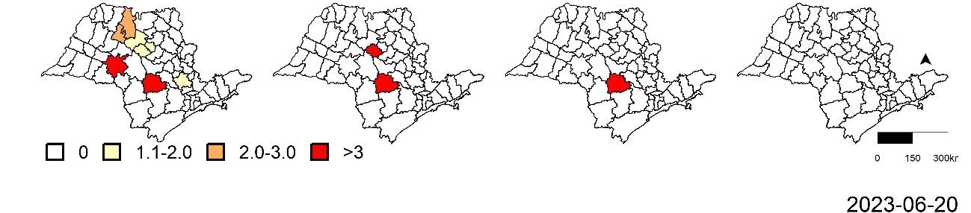
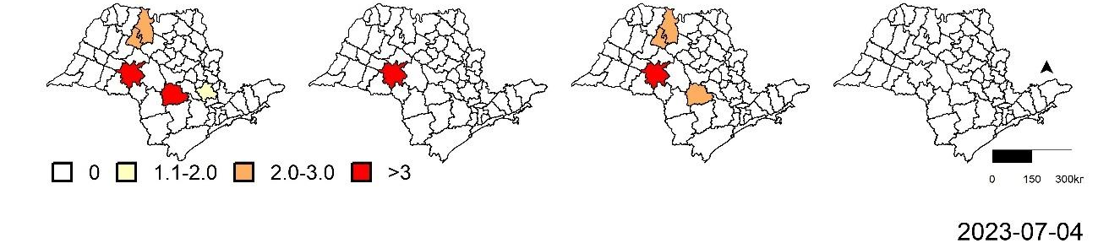
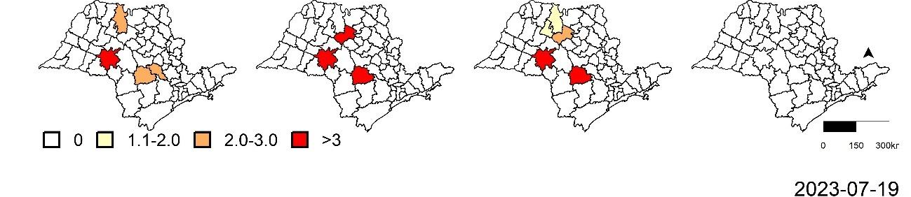
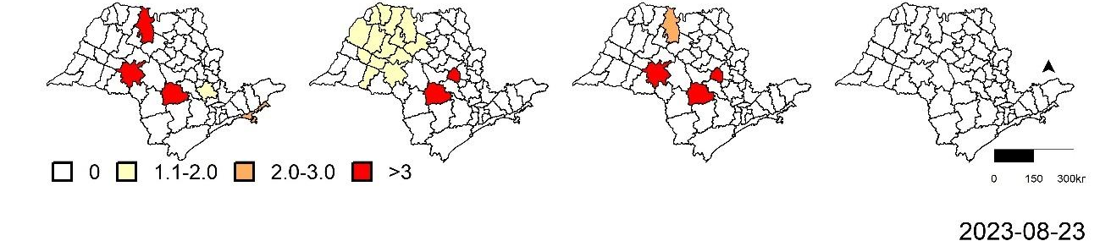
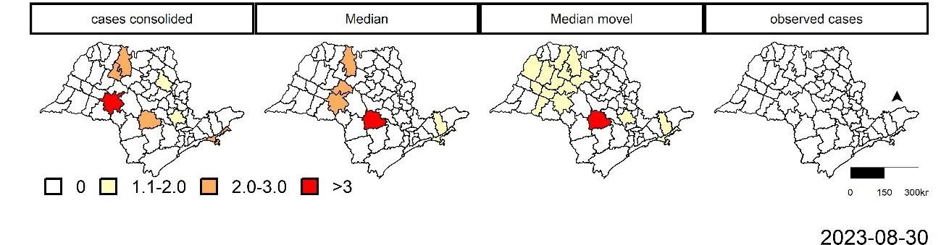
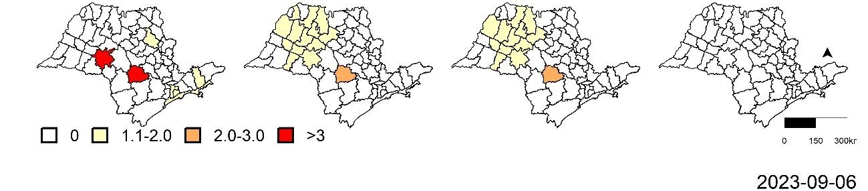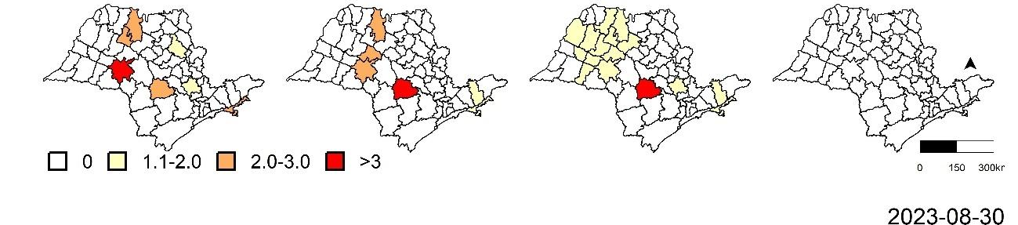
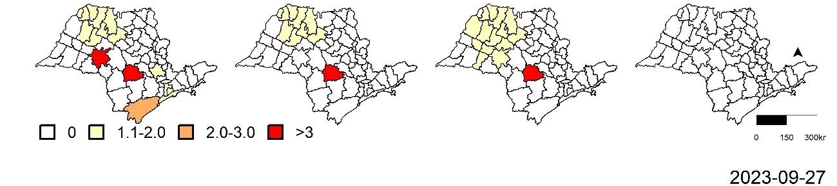
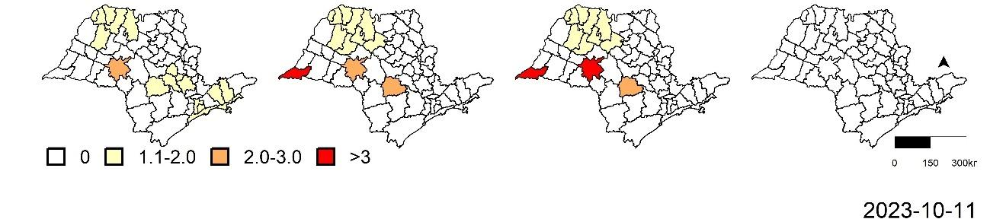
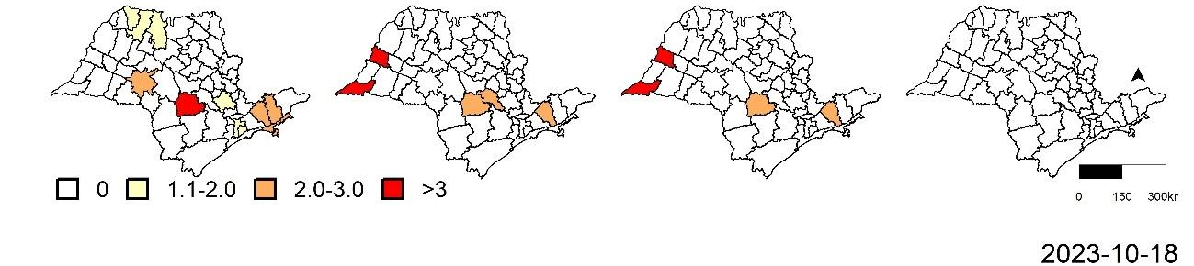
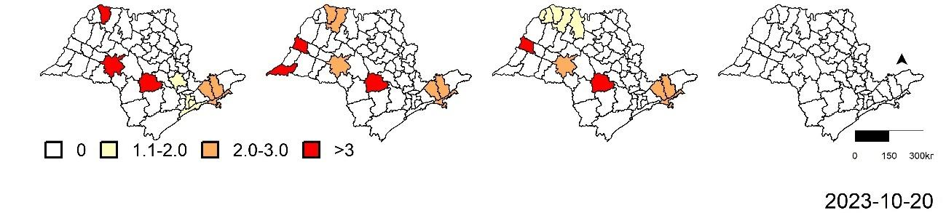
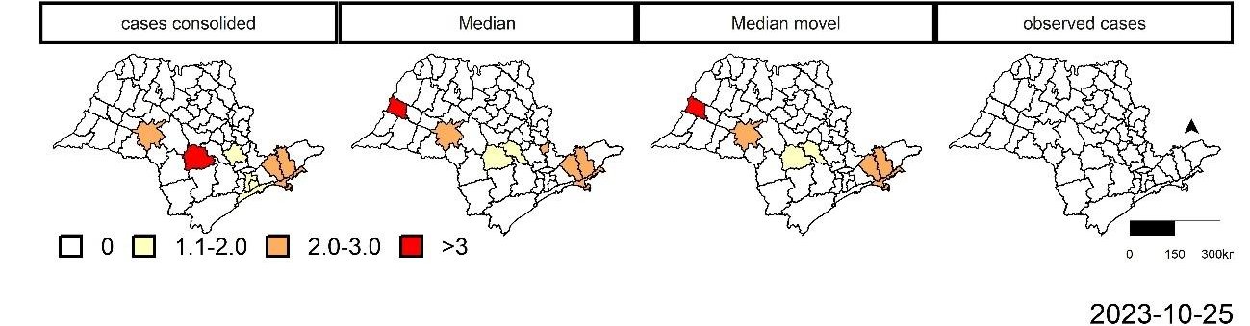
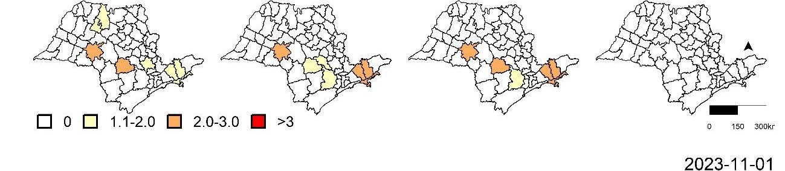
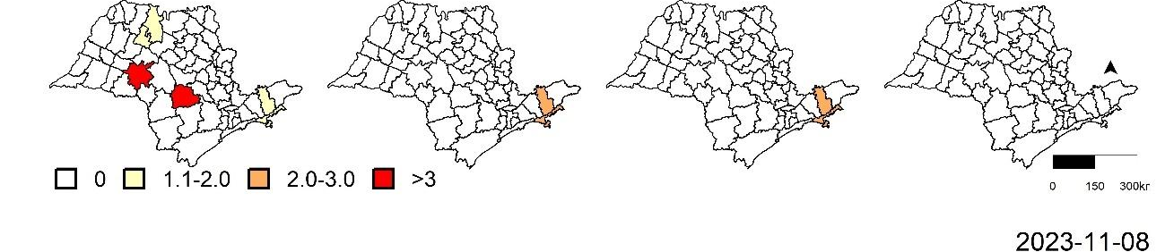
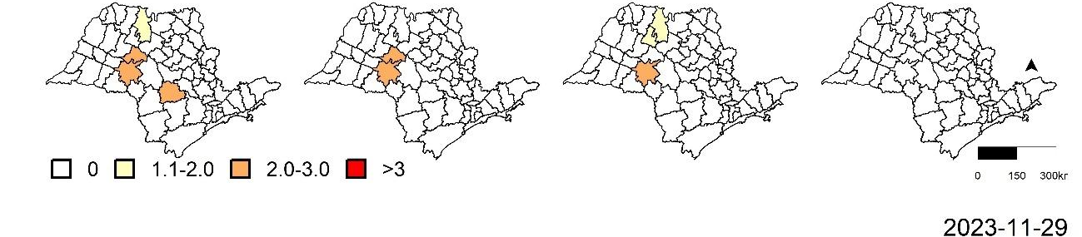
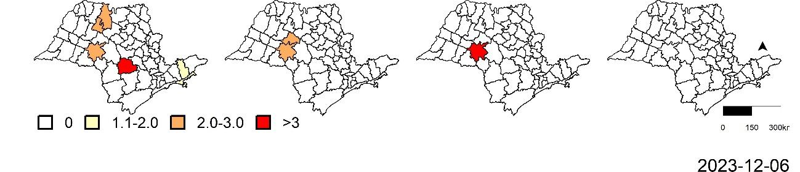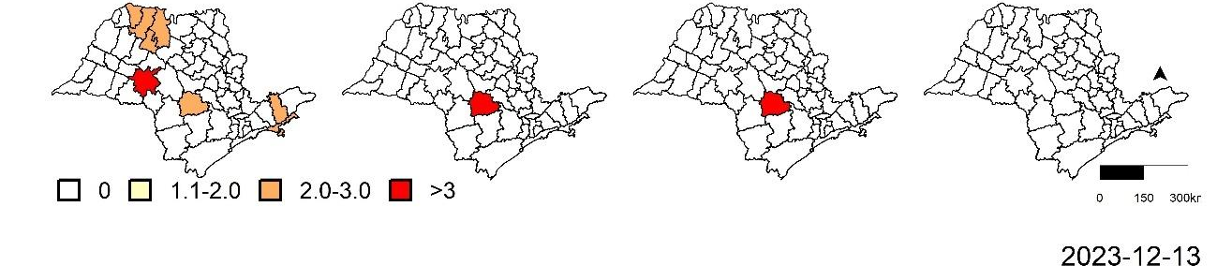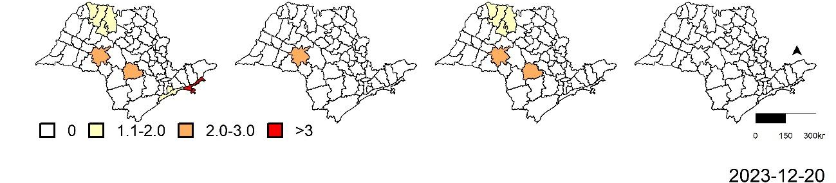
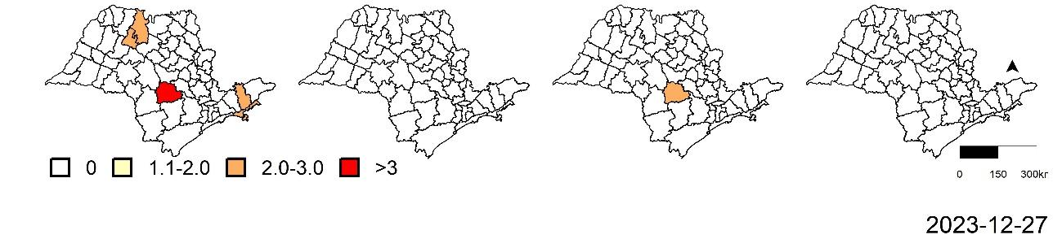
Fig-S3 -Maps of 34 samples with RR clusters classified in the prospective spatio-temporal analysis of consolidated data, standard Median (Std Median), moving-average median (MA Median), and naive baseline in São Paulo, 2022–2023.

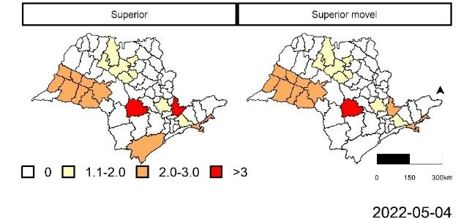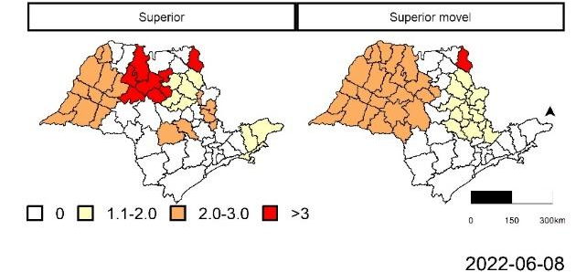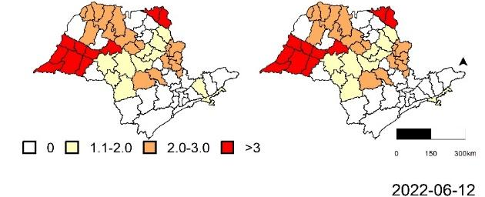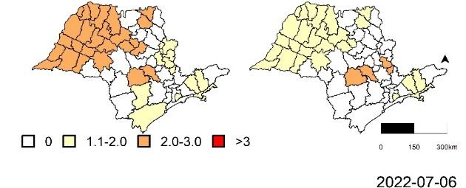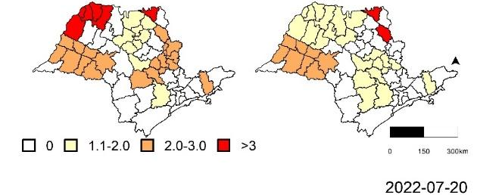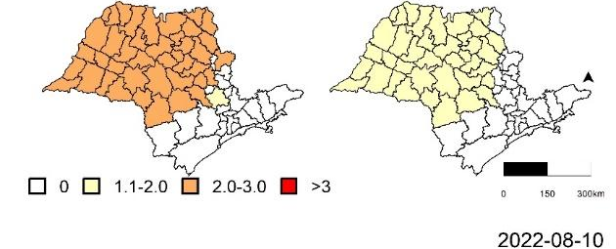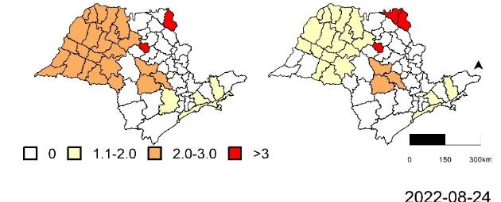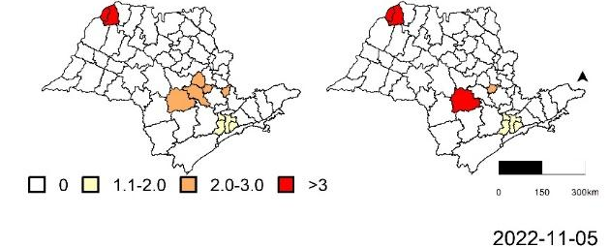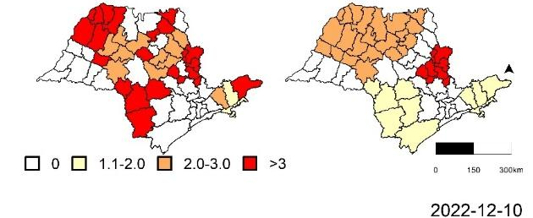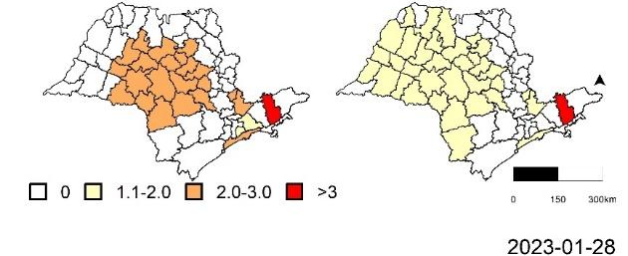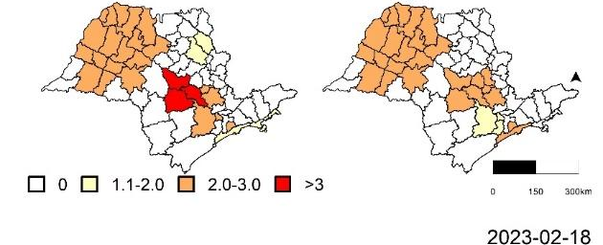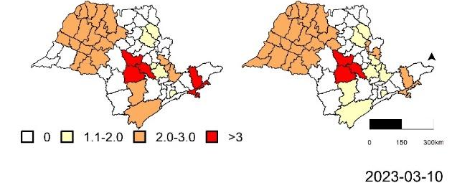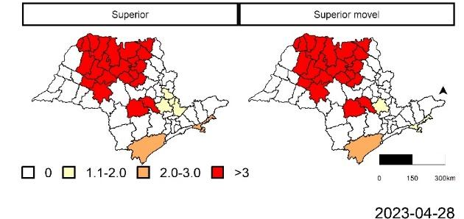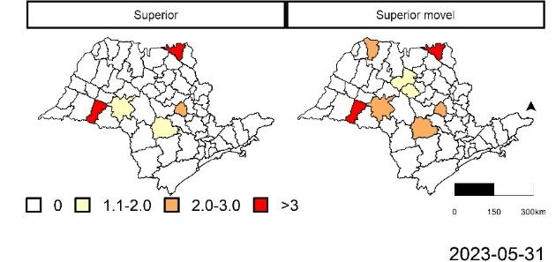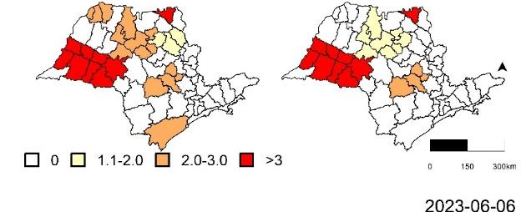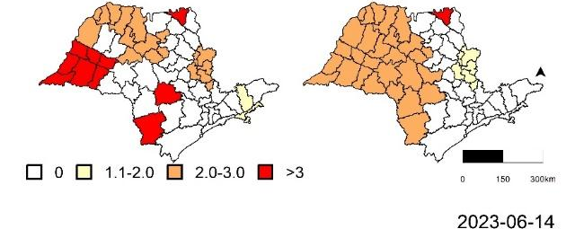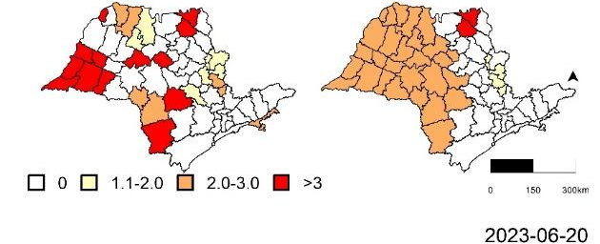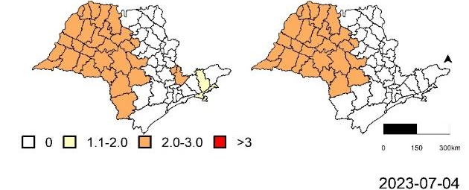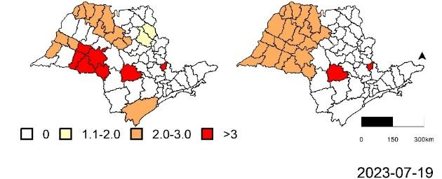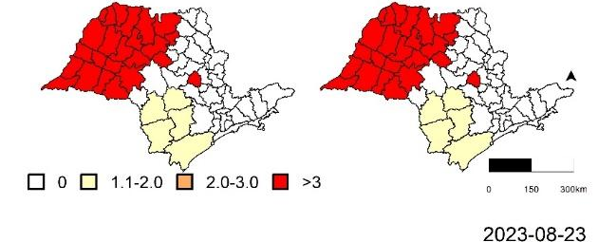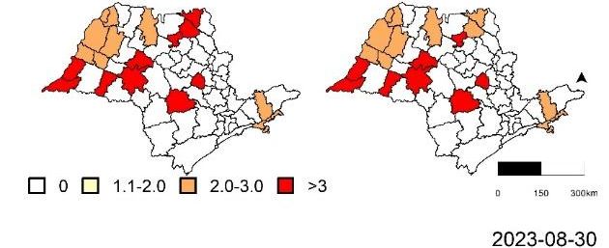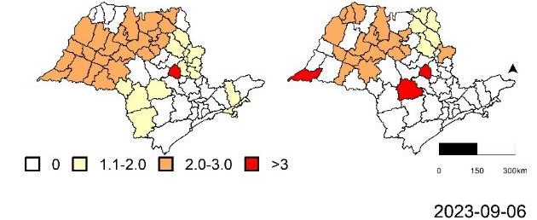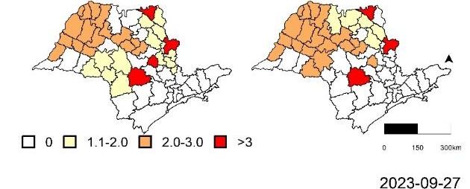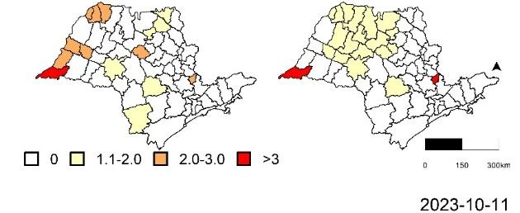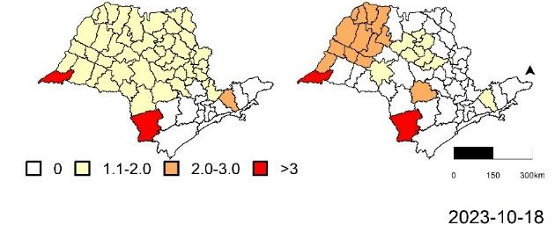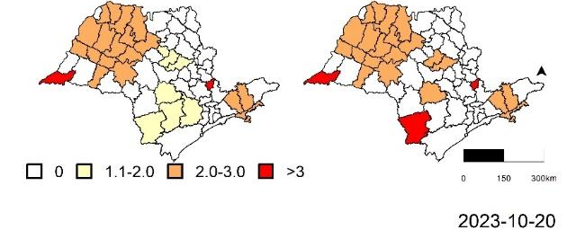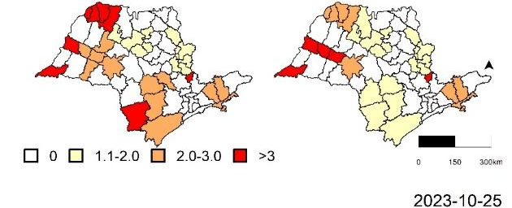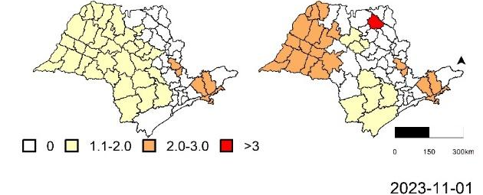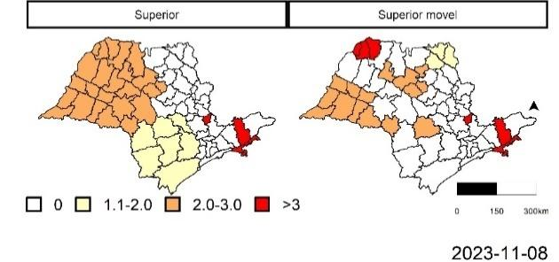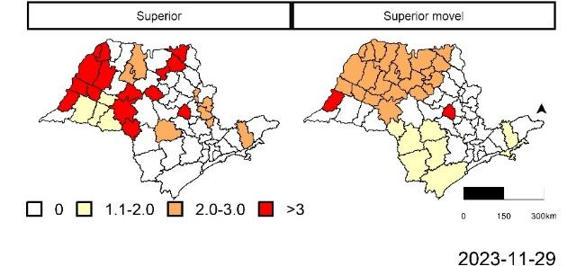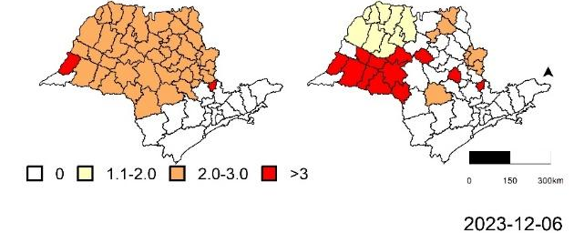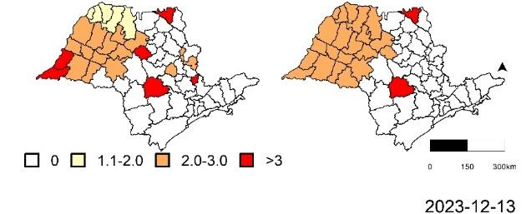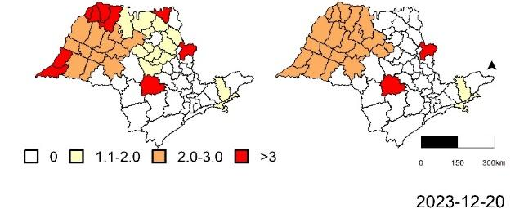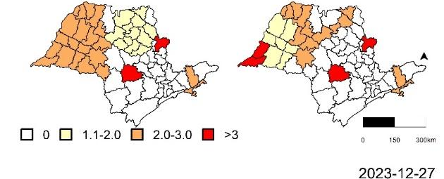
Fig-S4 -Maps of 34 samples with RR clusters classified in the prospective spatio-temporal analysis of superior and moving superior in São Paulo, 2022–2023.

Confusion matrix analysis

In our analysis, the area unit corresponds to the CIR and the region to São Paulo State, Brazil. SaTScan was applied to the consolidated ground-truth data, the naive observations, and two Bayesian predictions (the standard median and the moving average of the median). Details in the main text.

Results were aggregated by epidemiological week and method, yielding four potential prediction outcomes:
- True Positive (TP): The method correctly identifies a significant RR>1.
- True Negative (TN): The method correctly identifies a significant RR≤1.
- False Positive (FP): The method incorrectly identifies an RR>1.
- False Negative (FN): The method incorrectly identifies an RR≤1.

To evaluate the predictive performance of each method, we calculated standard classification metrics based on the confusion matrix elements (TP, TN, FP, and FN). The classification analysis focuses on six metrics (table S3).

Table S3. Confusion matrix metrics description.
Metric | Formula | Description | Interpretation
True Positive Rate (TPR) | TP / (TP + FN) | Proportion of real positives correctly identified. | Ability of the method to detect RR > 1.
False Positive Rate (FPR) | FP / (FP + TN) | Proportion of real negatives incorrectly identified. | Tendency of the method to falsely signal RR > 1.
Specificity | TN / (TN + FP) | Proportion of real negatives correctly identified. | Ability of the method to detect RR ≤ 1.
Positive Predictive Value (PPV) | TP / (TP + FP) | Probability that a positive classification corresponds to a true positive. | Reliability of positive classifications generated by the method.
Negative Predictive Value (NPV) | TN / (TN + FN) | Probability that a negative classification corresponds to a true negative. | Reliability of negative classifications generated by the method.
Youden's index | TPR − FPR | Difference between true alarms and false alarms. | Values close to 1 indicate excellent discriminatory performance.

Table S4. Confusion matrix metrics by data input type (Method) and by data date (Data base) by epidemiological week.
Data base | Method | FN | TN | TP | FP | TPR | FPR | PPV | NPV | Youden
2022-05-04 | Std Median | 2 | 57 | 4 | 0 | 0.67 | 0.00 | 1.00 | 0.97 | 0.67
2022-05-04 | MA Median | 1 | 57 | 5 | 0 | 0.83 | 0.00 | 1.00 | 0.98 | 0.83
2022-05-04 | Naive baseline | 6 | 57 | 0 | 0 | 0.00 | 0.00 | 0.00 | 0.90 | 0.00
2022-06-08 | Std Median | 3 | 33 | 15 | 12 | 0.83 | 0.27 | 0.56 | 0.92 | 0.57
2022-06-08 | MA Median | 4 | 35 | 14 | 10 | 0.78 | 0.22 | 0.58 | 0.90 | 0.56
2022-06-08 | Naive baseline | 18 | 45 | 0 | 0 | 0.00 | 0.00 | 0.00 | 0.71 | 0.00
2022-06-12 | Std Median | 1 | 29 | 11 | 22 | 0.92 | 0.43 | 0.33 | 0.97 | 0.49
2022-06-12 | MA Median | 2 | 26 | 10 | 25 | 0.83 | 0.49 | 0.29 | 0.93 | 0.34
2022-06-12 | Naive baseline | 10 | 51 | 2 | 0 | 0.17 | 0.00 | 1.00 | 0.84 | 0.17
2022-07-06 | Std Median | 11 | 50 | 2 | 0 | 0.15 | 0.00 | 1.00 | 0.82 | 0.15
2022-07-06 | MA Median | 8 | 50 | 5 | 0 | 0.38 | 0.00 | 1.00 | 0.86 | 0.38
2022-07-06 | Naive baseline | 13 | 50 | 0 | 0 | 0.00 | 0.00 | 0.00 | 0.79 | 0.00
2022-07-20 | Std Median | 7 | 47 | 2 | 7 | 0.22 | 0.13 | 0.22 | 0.87 | 0.09
2022-07-20 | MA Median | 2 | 50 | 7 | 4 | 0.78 | 0.07 | 0.64 | 0.96 | 0.70
2022-07-20 | Naive baseline | 9 | 54 | 0 | 0 | 0.00 | 0.00 | 0.00 | 0.86 | 0.00
2022-08-10 | Std Median | 17 | 34 | 5 | 7 | 0.23 | 0.17 | 0.42 | 0.67 | 0.06
2022-08-10 | MA Median | 9 | 37 | 13 | 4 | 0.59 | 0.10 | 0.76 | 0.80 | 0.49
2022-08-10 | Naive baseline | 22 | 41 | 0 | 0 | 0.00 | 0.00 | 0.00 | 0.65 | 0.00
2022-08-24 | Std Median | 8 | 49 | 3 | 3 | 0.27 | 0.06 | 0.50 | 0.86 | 0.22
2022-08-24 | MA Median | 8 | 50 | 3 | 2 | 0.27 | 0.04 | 0.60 | 0.86 | 0.23
2022-08-24 | Naive baseline | 11 | 52 | 0 | 0 | 0.00 | 0.00 | 0.00 | 0.83 | 0.00
2022-11-05 | Std Median | 8 | 52 | 3 | 0 | 0.27 | 0.00 | 1.00 | 0.87 | 0.27
2022-11-05 | MA Median | 6 | 52 | 5 | 0 | 0.45 | 0.00 | 1.00 | 0.90 | 0.45
2022-11-05 | Naive baseline | 11 | 52 | 0 | 0 | 0.00 | 0.00 | 0.00 | 0.83 | 0.00
2022-12-10 | Std Median | 10 | 25 | 10 | 18 | 0.50 | 0.42 | 0.36 | 0.71 | 0.08
2022-12-10 | MA Median | 8 | 29 | 12 | 14 | 0.60 | 0.33 | 0.46 | 0.78 | 0.27
2022-12-10 | Naive baseline | 20 | 43 | 0 | 0 | 0.00 | 0.00 | 0.00 | 0.68 | 0.00
2023-01-28 | Std Median | 3 | 48 | 4 | 8 | 0.57 | 0.14 | 0.33 | 0.94 | 0.43
2023-01-28 | MA Median | 3 | 48 | 4 | 8 | 0.57 | 0.14 | 0.33 | 0.94 | 0.43
2023-01-28 | Naive baseline | 5 | 56 | 2 | 0 | 0.29 | 0.00 | 1.00 | 0.92 | 0.29
2023-02-18 | Std Median | 1 | 49 | 7 | 6 | 0.88 | 0.11 | 0.54 | 0.98 | 0.77
2023-02-18 | MA Median | 1 | 47 | 7 | 8 | 0.88 | 0.15 | 0.47 | 0.98 | 0.73
2023-02-18 | Naive baseline | 4 | 55 | 4 | 0 | 0.50 | 0.00 | 1.00 | 0.93 | 0.50
2023-03-10 | Std Median | 2 | 52 | 4 | 5 | 0.67 | 0.09 | 0.44 | 0.96 | 0.58
2023-03-10 | MA Median | 0 | 56 | 6 | 1 | 1.00 | 0.02 | 0.86 | 1.00 | 0.98
2023-03-10 | Naive baseline | 5 | 57 | 1 | 0 | 0.17 | 0.00 | 1.00 | 0.92 | 0.17
2023-04-28 | Std Median | 0 | 44 | 17 | 2 | 1.00 | 0.04 | 0.89 | 1.00 | 0.96
2023-04-28 | MA Median | 0 | 45 | 17 | 1 | 1.00 | 0.02 | 0.94 | 1.00 | 0.98
2023-04-28 | Naive baseline | 17 | 46 | 0 | 0 | 0.00 | 0.00 | 0.00 | 0.73 | 0.00
2023-05-31 | Std Median | 5 | 53 | 4 | 1 | 0.44 | 0.02 | 0.80 | 0.91 | 0.43
2023-05-31 | MA Median | 2 | 43 | 7 | 11 | 0.78 | 0.20 | 0.39 | 0.96 | 0.57
2023-05-31 | Naive baseline | 9 | 54 | 0 | 0 | 0.00 | 0.00 | 0.00 | 0.86 | 0.00
2023-06-06 | Std Median | 4 | 49 | 5 | 5 | 0.56 | 0.09 | 0.50 | 0.92 | 0.46
2023-06-06 | MA Median | 4 | 53 | 5 | 1 | 0.56 | 0.02 | 0.83 | 0.93 | 0.54
2023-06-06 | Naive baseline | 9 | 54 | 0 | 0 | 0.00 | 0.00 | 0.00 | 0.86 | 0.00
2023-06-14 | Std Median | 3 | 56 | 1 | 3 | 0.25 | 0.05 | 0.25 | 0.95 | 0.20
2023-06-14 | MA Median | 2 | 58 | 2 | 1 | 0.50 | 0.02 | 0.67 | 0.97 | 0.48
2023-06-14 | Naive baseline | 4 | 59 | 0 | 0 | 0.00 | 0.00 | 0.00 | 0.94 | 0.00
2023-06-20 | Std Median | 6 | 55 | 2 | 0 | 0.25 | 0.00 | 1.00 | 0.90 | 0.25
2023-06-20 | MA Median | 7 | 55 | 1 | 0 | 0.12 | 0.00 | 1.00 | 0.89 | 0.12
2023-06-20 | Naive baseline | 8 | 55 | 0 | 0 | 0.00 | 0.00 | 0.00 | 0.87 | 0.00
2023-07-04 | Std Median | 4 | 58 | 1 | 0 | 0.20 | 0.00 | 1.00 | 0.94 | 0.20
2023-07-04 | MA Median | 1 | 58 | 4 | 0 | 0.80 | 0.00 | 1.00 | 0.98 | 0.80
2023-07-04 | Naive baseline | 5 | 58 | 0 | 0 | 0.00 | 0.00 | 0.00 | 0.92 | 0.00
2023-07-19 | Std Median | 2 | 58 | 2 | 1 | 0.50 | 0.02 | 0.67 | 0.97 | 0.48
2023-07-19 | MA Median | 1 | 57 | 3 | 2 | 0.75 | 0.03 | 0.60 | 0.98 | 0.72
2023-07-19 | Naive baseline | 4 | 59 | 0 | 0 | 0.00 | 0.00 | 0.00 | 0.94 | 0.00
2023-08-23 | Std Median | 2 | 45 | 3 | 13 | 0.60 | 0.22 | 0.19 | 0.96 | 0.38
2023-08-23 | MA Median | 2 | 57 | 3 | 1 | 0.60 | 0.02 | 0.75 | 0.97 | 0.58
2023-08-23 | Naive baseline | 5 | 58 | 0 | 0 | 0.00 | 0.00 | 0.00 | 0.92 | 0.00
2023-08-30 | Std Median | 3 | 54 | 4 | 2 | 0.57 | 0.04 | 0.67 | 0.95 | 0.54
2023-08-30 | MA Median | 1 | 46 | 6 | 10 | 0.86 | 0.18 | 0.38 | 0.98 | 0.68
2023-08-30 | Naive baseline | 7 | 56 | 0 | 0 | 0.00 | 0.00 | 0.00 | 0.89 | 0.00
2023-09-06 | Std Median | 6 | 43 | 2 | 12 | 0.25 | 0.22 | 0.14 | 0.88 | 0.03
2023-09-06 | MA Median | 6 | 44 | 2 | 11 | 0.25 | 0.20 | 0.15 | 0.88 | 0.05
2023-09-06 | Naive baseline | 8 | 55 | 0 | 0 | 0.00 | 0.00 | 0.00 | 0.87 | 0.00
2023-09-27 | Std Median | 6 | 47 | 10 | 0 | 0.62 | 0.00 | 1.00 | 0.89 | 0.62
2023-09-27 | MA Median | 6 | 42 | 10 | 5 | 0.62 | 0.11 | 0.67 | 0.88 | 0.52
2023-09-27 | Naive baseline | 16 | 47 | 0 | 0 | 0.00 | 0.00 | 0.00 | 0.75 | 0.00
2023-10-11 | Std Median | 10 | 41 | 8 | 4 | 0.44 | 0.09 | 0.67 | 0.80 | 0.36
2023-10-11 | MA Median | 10 | 41 | 8 | 4 | 0.44 | 0.09 | 0.67 | 0.80 | 0.36
2023-10-11 | Naive baseline | 18 | 45 | 0 | 0 | 0.00 | 0.00 | 0.00 | 0.71 | 0.00
2023-10-18 | Std Median | 9 | 49 | 2 | 3 | 0.18 | 0.06 | 0.40 | 0.84 | 0.12
2023-10-18 | MA Median | 9 | 50 | 2 | 2 | 0.18 | 0.04 | 0.50 | 0.85 | 0.14
2023-10-18 | Naive baseline | 11 | 52 | 0 | 0 | 0.00 | 0.00 | 0.00 | 0.83 | 0.00
2023-10-20 | Std Median | 4 | 50 | 6 | 3 | 0.60 | 0.06 | 0.67 | 0.93 | 0.54
2023-10-20 | MA Median | 4 | 48 | 6 | 5 | 0.60 | 0.09 | 0.55 | 0.92 | 0.51
2023-10-20 | Naive baseline | 10 | 53 | 0 | 0 | 0.00 | 0.00 | 0.00 | 0.84 | 0.00
2023-10-25 | Std Median | 4 | 51 | 5 | 3 | 0.56 | 0.06 | 0.62 | 0.93 | 0.50
2023-10-25 | MA Median | 4 | 52 | 5 | 2 | 0.56 | 0.04 | 0.71 | 0.93 | 0.52
2023-10-25 | Naive baseline | 9 | 54 | 0 | 0 | 0.00 | 0.00 | 0.00 | 0.86 | 0.00
2023-11-01 | Std Median | 3 | 53 | 5 | 2 | 0.62 | 0.04 | 0.71 | 0.95 | 0.59
2023-11-01 | MA Median | 3 | 54 | 5 | 1 | 0.62 | 0.02 | 0.83 | 0.95 | 0.61
2023-11-01 | Naive baseline | 8 | 55 | 0 | 0 | 0.00 | 0.00 | 0.00 | 0.87 | 0.00
2023-11-08 | Std Median | 4 | 57 | 2 | 0 | 0.33 | 0.00 | 1.00 | 0.93 | 0.33
2023-11-08 | MA Median | 4 | 57 | 2 | 0 | 0.33 | 0.00 | 1.00 | 0.93 | 0.33
2023-11-08 | Naive baseline | 6 | 57 | 0 | 0 | 0.00 | 0.00 | 0.00 | 0.90 | 0.00
2023-11-29 | Std Median | 2 | 59 | 2 | 0 | 0.50 | 0.00 | 1.00 | 0.97 | 0.50
2023-11-29 | MA Median | 2 | 58 | 2 | 1 | 0.50 | 0.02 | 0.67 | 0.97 | 0.48
2023-11-29 | Naive baseline | 4 | 59 | 0 | 0 | 0.00 | 0.00 | 0.00 | 0.94 | 0.00
2023-12-06 | Std Median | 5 | 56 | 1 | 1 | 0.17 | 0.02 | 0.50 | 0.92 | 0.15
2023-12-06 | MA Median | 5 | 57 | 1 | 0 | 0.17 | 0.00 | 1.00 | 0.92 | 0.17
2023-12-06 | Naive baseline | 6 | 57 | 0 | 0 | 0.00 | 0.00 | 0.00 | 0.90 | 0.00
2023-12-13 | Std Median | 7 | 55 | 1 | 0 | 0.12 | 0.00 | 1.00 | 0.89 | 0.12
2023-12-13 | MA Median | 7 | 55 | 1 | 0 | 0.12 | 0.00 | 1.00 | 0.89 | 0.12
2023-12-13 | Naive baseline | 8 | 55 | 0 | 0 | 0.00 | 0.00 | 0.00 | 0.87 | 0.00
2023-12-20 | Std Median | 8 | 54 | 1 | 0 | 0.11 | 0.00 | 1.00 | 0.87 | 0.11
2023-12-20 | MA Median | 3 | 54 | 6 | 0 | 0.67 | 0.00 | 1.00 | 0.95 | 0.67
2023-12-20 | Naive baseline | 9 | 54 | 0 | 0 | 0.00 | 0.00 | 0.00 | 0.86 | 0.00
2023-12-27 | Std Median | 5 | 58 | 0 | 0 | 0.00 | 0.00 | 0.00 | 0.92 | 0.00
2023-12-27 | MA Median | 4 | 58 | 1 | 0 | 0.20 | 0.00 | 1.00 | 0.94 | 0.20
2023-12-27 | Naive baseline | 5 | 58 | 0 | 0 | 0.00 | 0.00 | 0.00 | 0.92 | 0.00

CIR | Method | FN | TN | TP | FP | TPR | FPR | PPV | NPV | Youden
ADAMANTINA | Std Median | 3 | 24 | 1 | 6 | 0.25 | 0.20 | 0.14 | 0.89 | 0.05
ADAMANTINA | MA Median | 3 | 23 | 1 | 7 | 0.25 | 0.23 | 0.12 | 0.88 | 0.02
ADAMANTINA | Naive baseline | 4 | 30 | 0 | 0 | 0.00 | 0.00 | 0.00 | 0.88 | 0.00
ALTA ANHANGUERA | Std Median | 0 | 33 | 0 | 1 | 0.00 | 0.03 | 0.00 | 1.00 | -0.03
ALTA ANHANGUERA | MA Median | 0 | 31 | 0 | 3 | 0.00 | 0.09 | 0.00 | 1.00 | -0.09
ALTA ANHANGUERA | Naive baseline | 0 | 34 | 0 | 0 | 0.00 | 0.00 | 0.00 | 1.00 | 0.00
ALTA MOGIANA | Std Median | 0 | 32 | 0 | 2 | 0.00 | 0.06 | 0.00 | 1.00 | -0.06
ALTA MOGIANA | MA Median | 0 | 30 | 0 | 4 | 0.00 | 0.12 | 0.00 | 1.00 | -0.12
ALTA MOGIANA | Naive baseline | 0 | 34 | 0 | 0 | 0.00 | 0.00 | 0.00 | 1.00 | 0.00
ALTA PAULISTA | Std Median | 2 | 24 | 1 | 7 | 0.33 | 0.23 | 0.12 | 0.92 | 0.11
ALTA PAULISTA | MA Median | 2 | 26 | 1 | 5 | 0.33 | 0.16 | 0.17 | 0.93 | 0.17
ALTA PAULISTA | Naive baseline | 3 | 31 | 0 | 0 | 0.00 | 0.00 | 0.00 | 0.91 | 0.00
ALTA SOROCABANA | Std Median | 2 | 30 | 2 | 0 | 0.50 | 0.00 | 1.00 | 0.94 | 0.50
ALTA SOROCABANA | MA Median | 2 | 30 | 2 | 0 | 0.50 | 0.00 | 1.00 | 0.94 | 0.50
ALTA SOROCABANA | Naive baseline | 4 | 30 | 0 | 0 | 0.00 | 0.00 | 0.00 | 0.88 | 0.00
ALTO CAPIVARI | Std Median | 1 | 26 | 3 | 4 | 0.75 | 0.13 | 0.43 | 0.96 | 0.62
ALTO CAPIVARI | MA Median | 1 | 26 | 3 | 4 | 0.75 | 0.13 | 0.43 | 0.96 | 0.62
ALTO CAPIVARI | Naive baseline | 4 | 30 | 0 | 0 | 0.00 | 0.00 | 0.00 | 0.88 | 0.00
ALTO DO TIETE | Std Median | 4 | 30 | 0 | 0 | 0.00 | 0.00 | 0.00 | 0.88 | 0.00
ALTO DO TIETE | MA Median | 3 | 30 | 1 | 0 | 0.25 | 0.00 | 1.00 | 0.91 | 0.25
ALTO DO TIETE | Naive baseline | 4 | 30 | 0 | 0 | 0.00 | 0.00 | 0.00 | 0.88 | 0.00
ALTO VALE DO PARAIBA | Std Median | 2 | 27 | 5 | 0 | 0.71 | 0.00 | 1.00 | 0.93 | 0.71
ALTO VALE DO PARAIBA | MA Median | 2 | 27 | 5 | 0 | 0.71 | 0.00 | 1.00 | 0.93 | 0.71
ALTO VALE DO PARAIBA | Naive baseline | 7 | 27 | 0 | 0 | 0.00 | 0.00 | 0.00 | 0.79 | 0.00
AQUIFERO GUARANI | Std Median | 5 | 27 | 1 | 1 | 0.17 | 0.04 | 0.50 | 0.84 | 0.13
AQUIFERO GUARANI | MA Median | 5 | 26 | 1 | 2 | 0.17 | 0.07 | 0.33 | 0.84 | 0.10
AQUIFERO GUARANI | Naive baseline | 6 | 28 | 0 | 0 | 0.00 | 0.00 | 0.00 | 0.82 | 0.00
ARARAS | Std Median | 0 | 33 | 0 | 1 | 0.00 | 0.03 | 0.00 | 1.00 | -0.03
ARARAS | MA Median | 0 | 34 | 0 | 0 | 0.00 | 0.00 | 0.00 | 1.00 | 0.00
ARARAS | Naive baseline | 0 | 34 | 0 | 0 | 0.00 | 0.00 | 0.00 | 1.00 | 0.00
ASSIS | Std Median | 0 | 34 | 0 | 0 | 0.00 | 0.00 | 0.00 | 1.00 | 0.00
ASSIS | MA Median | 0 | 33 | 0 | 1 | 0.00 | 0.03 | 0.00 | 1.00 | -0.03
ASSIS | Naive baseline | 0 | 34 | 0 | 0 | 0.00 | 0.00 | 0.00 | 1.00 | 0.00
BAIXA MOGIANA | Std Median | 0 | 31 | 1 | 2 | 1.00 | 0.06 | 0.33 | 1.00 | 0.94
BAIXA MOGIANA | MA Median | 1 | 31 | 0 | 2 | 0.00 | 0.06 | 0.00 | 0.97 | -0.06
BAIXA MOGIANA | Naive baseline | 1 | 33 | 0 | 0 | 0.00 | 0.00 | 0.00 | 0.97 | 0.00
BAIXADA SANTISTA | Std Median | 6 | 27 | 0 | 1 | 0.00 | 0.04 | 0.00 | 0.82 | -0.04
BAIXADA SANTISTA | MA Median | 6 | 26 | 0 | 2 | 0.00 | 0.07 | 0.00 | 0.81 | -0.07
BAIXADA SANTISTA | Naive baseline | 6 | 28 | 0 | 0 | 0.00 | 0.00 | 0.00 | 0.82 | 0.00
BAURU | Std Median | 0 | 33 | 0 | 1 | 0.00 | 0.03 | 0.00 | 1.00 | -0.03
BAURU | MA Median | 0 | 34 | 0 | 0 | 0.00 | 0.00 | 0.00 | 1.00 | 0.00
BAURU | Naive baseline | 0 | 34 | 0 | 0 | 0.00 | 0.00 | 0.00 | 1.00 | 0.00
BRAGANCA | Std Median | 1 | 31 | 1 | 1 | 0.50 | 0.03 | 0.50 | 0.97 | 0.47
BRAGANCA | MA Median | 1 | 32 | 1 | 0 | 0.50 | 0.00 | 1.00 | 0.97 | 0.50
BRAGANCA | Naive baseline | 2 | 32 | 0 | 0 | 0.00 | 0.00 | 0.00 | 0.94 | 0.00
CATANDUVA | Std Median | 6 | 15 | 7 | 6 | 0.54 | 0.29 | 0.54 | 0.71 | 0.25
CATANDUVA | MA Median | 4 | 16 | 9 | 5 | 0.69 | 0.24 | 0.64 | 0.80 | 0.45
CATANDUVA | Naive baseline | 13 | 21 | 0 | 0 | 0.00 | 0.00 | 0.00 | 0.62 | 0.00
CENTRAL DO DRS II | Std Median | 1 | 25 | 4 | 4 | 0.80 | 0.14 | 0.50 | 0.96 | 0.66
CENTRAL DO DRS II | MA Median | 0 | 25 | 5 | 4 | 1.00 | 0.14 | 0.56 | 1.00 | 0.86
CENTRAL DO DRS II | Naive baseline | 5 | 29 | 0 | 0 | 0.00 | 0.00 | 0.00 | 0.85 | 0.00
CENTRAL DO DRS III | Std Median | 0 | 31 | 0 | 3 | 0.00 | 0.09 | 0.00 | 1.00 | -0.09
CENTRAL DO DRS III | MA Median | 0 | 32 | 0 | 2 | 0.00 | 0.06 | 0.00 | 1.00 | -0.06
CENTRAL DO DRS III | Naive baseline | 0 | 34 | 0 | 0 | 0.00 | 0.00 | 0.00 | 1.00 | 0.00
CENTRO OESTE DO DRS III | Std Median | 2 | 26 | 3 | 3 | 0.60 | 0.10 | 0.50 | 0.93 | 0.50
CENTRO OESTE DO DRS III | MA Median | 4 | 25 | 1 | 4 | 0.20 | 0.14 | 0.20 | 0.86 | 0.06
CENTRO OESTE DO DRS III | Naive baseline | 5 | 29 | 0 | 0 | 0.00 | 0.00 | 0.00 | 0.85 | 0.00
CIRCUITO DA FE - VALE HISTORICO | Std Median | 0 | 33 | 1 | 0 | 1.00 | 0.00 | 1.00 | 1.00 | 1.00
CIRCUITO DA FE - VALE HISTORICO | MA Median | 1 | 33 | 0 | 0 | 0.00 | 0.00 | 0.00 | 0.97 | 0.00
CIRCUITO DA FE - VALE HISTORICO | Naive baseline | 1 | 33 | 0 | 0 | 0.00 | 0.00 | 0.00 | 0.97 | 0.00
CIRCUITO DAS AGUAS | Std Median | 0 | 30 | 1 | 3 | 1.00 | 0.09 | 0.25 | 1.00 | 0.91
CIRCUITO DAS AGUAS | MA Median | 0 | 31 | 1 | 2 | 1.00 | 0.06 | 0.33 | 1.00 | 0.94
CIRCUITO DAS AGUAS | Naive baseline | 1 | 33 | 0 | 0 | 0.00 | 0.00 | 0.00 | 0.97 | 0.00
CORACAO DO DRS III | Std Median | 0 | 33 | 0 | 1 | 0.00 | 0.03 | 0.00 | 1.00 | -0.03
CORACAO DO DRS III | MA Median | 0 | 34 | 0 | 0 | 0.00 | 0.00 | 0.00 | 1.00 | 0.00
CORACAO DO DRS III | Naive baseline | 0 | 34 | 0 | 0 | 0.00 | 0.00 | 0.00 | 1.00 | 0.00
DOS CONSORCIOS DO DRS II | Std Median | 2 | 23 | 2 | 7 | 0.50 | 0.23 | 0.22 | 0.92 | 0.27
DOS CONSORCIOS DO DRS II | MA Median | 0 | 24 | 4 | 6 | 1.00 | 0.20 | 0.40 | 1.00 | 0.80
DOS CONSORCIOS DO DRS II | Naive baseline | 4 | 30 | 0 | 0 | 0.00 | 0.00 | 0.00 | 0.88 | 0.00
DOS LAGOS DO DRS II | Std Median | 2 | 27 | 1 | 4 | 0.33 | 0.13 | 0.20 | 0.93 | 0.20
DOS LAGOS DO DRS II | MA Median | 2 | 26 | 1 | 5 | 0.33 | 0.16 | 0.17 | 0.93 | 0.17
DOS LAGOS DO DRS II | Naive baseline | 3 | 31 | 0 | 0 | 0.00 | 0.00 | 0.00 | 0.91 | 0.00
EXTREMO OESTE PAULISTA | Std Median | 0 | 32 | 1 | 1 | 1.00 | 0.03 | 0.50 | 1.00 | 0.97
EXTREMO OESTE PAULISTA | MA Median | 0 | 32 | 1 | 1 | 1.00 | 0.03 | 0.50 | 1.00 | 0.97
EXTREMO OESTE PAULISTA | Naive baseline | 1 | 33 | 0 | 0 | 0.00 | 0.00 | 0.00 | 0.97 | 0.00
FERNANDOPOLIS | Std Median | 4 | 21 | 4 | 5 | 0.50 | 0.19 | 0.44 | 0.84 | 0.31
FERNANDOPOLIS | MA Median | 2 | 23 | 6 | 3 | 0.75 | 0.12 | 0.67 | 0.92 | 0.63
FERNANDOPOLIS | Naive baseline | 8 | 26 | 0 | 0 | 0.00 | 0.00 | 0.00 | 0.76 | 0.00
FRANCO DA ROCHA | Std Median | 0 | 34 | 0 | 0 | 0.00 | 0.00 | 0.00 | 1.00 | 0.00
FRANCO DA ROCHA | MA Median | 0 | 34 | 0 | 0 | 0.00 | 0.00 | 0.00 | 1.00 | 0.00
FRANCO DA ROCHA | Naive baseline | 0 | 34 | 0 | 0 | 0.00 | 0.00 | 0.00 | 1.00 | 0.00
GRANDE ABC | Std Median | 10 | 22 | 1 | 1 | 0.09 | 0.04 | 0.50 | 0.69 | 0.05
GRANDE ABC | MA Median | 9 | 22 | 2 | 1 | 0.18 | 0.04 | 0.67 | 0.71 | 0.14
GRANDE ABC | Naive baseline | 11 | 23 | 0 | 0 | 0.00 | 0.00 | 0.00 | 0.68 | 0.00
HORIZONTE VERDE | Std Median | 0 | 33 | 0 | 1 | 0.00 | 0.03 | 0.00 | 1.00 | -0.03
HORIZONTE VERDE | MA Median | 0 | 32 | 0 | 2 | 0.00 | 0.06 | 0.00 | 1.00 | -0.06
HORIZONTE VERDE | Naive baseline | 0 | 34 | 0 | 0 | 0.00 | 0.00 | 0.00 | 1.00 | 0.00
ITAPETININGA | Std Median | 0 | 34 | 0 | 0 | 0.00 | 0.00 | 0.00 | 1.00 | 0.00
ITAPETININGA | MA Median | 0 | 34 | 0 | 0 | 0.00 | 0.00 | 0.00 | 1.00 | 0.00
ITAPETININGA | Naive baseline | 0 | 34 | 0 | 0 | 0.00 | 0.00 | 0.00 | 1.00 | 0.00
ITAPEVA | Std Median | 0 | 34 | 0 | 0 | 0.00 | 0.00 | 0.00 | 1.00 | 0.00
ITAPEVA | MA Median | 0 | 34 | 0 | 0 | 0.00 | 0.00 | 0.00 | 1.00 | 0.00
ITAPEVA | Naive baseline | 0 | 34 | 0 | 0 | 0.00 | 0.00 | 0.00 | 1.00 | 0.00
JALES | Std Median | 1 | 24 | 3 | 6 | 0.75 | 0.20 | 0.33 | 0.96 | 0.55
JALES | MA Median | 0 | 26 | 4 | 4 | 1.00 | 0.13 | 0.50 | 1.00 | 0.87
JALES | Naive baseline | 4 | 30 | 0 | 0 | 0.00 | 0.00 | 0.00 | 0.88 | 0.00
JAU | Std Median | 0 | 29 | 1 | 4 | 1.00 | 0.12 | 0.20 | 1.00 | 0.88
JAU | MA Median | 1 | 30 | 0 | 3 | 0.00 | 0.09 | 0.00 | 0.97 | -0.09
JAU | Naive baseline | 1 | 33 | 0 | 0 | 0.00 | 0.00 | 0.00 | 0.97 | 0.00
JOSE BONIFACIO | Std Median | 17 | 7 | 6 | 4 | 0.26 | 0.36 | 0.60 | 0.29 | -0.10
JOSE BONIFACIO | MA Median | 8 | 5 | 15 | 6 | 0.65 | 0.55 | 0.71 | 0.38 | 0.11
JOSE BONIFACIO | Naive baseline | 21 | 11 | 2 | 0 | 0.09 | 0.00 | 1.00 | 0.34 | 0.09
JUNDIAI | Std Median | 0 | 34 | 0 | 0 | 0.00 | 0.00 | 0.00 | 1.00 | 0.00
JUNDIAI | MA Median | 0 | 34 | 0 | 0 | 0.00 | 0.00 | 0.00 | 1.00 | 0.00
JUNDIAI | Naive baseline | 0 | 34 | 0 | 0 | 0.00 | 0.00 | 0.00 | 1.00 | 0.00
LIMEIRA | Std Median | 1 | 33 | 0 | 0 | 0.00 | 0.00 | 0.00 | 0.97 | 0.00
LIMEIRA | MA Median | 1 | 32 | 0 | 1 | 0.00 | 0.03 | 0.00 | 0.97 | -0.03
LIMEIRA | Naive baseline | 1 | 33 | 0 | 0 | 0.00 | 0.00 | 0.00 | 0.97 | 0.00
LINS | Std Median | 1 | 22 | 3 | 8 | 0.75 | 0.27 | 0.27 | 0.96 | 0.48
LINS | MA Median | 1 | 23 | 3 | 7 | 0.75 | 0.23 | 0.30 | 0.96 | 0.52
LINS | Naive baseline | 4 | 30 | 0 | 0 | 0.00 | 0.00 | 0.00 | 0.88 | 0.00
LITORAL NORTE | Std Median | 8 | 19 | 6 | 1 | 0.43 | 0.05 | 0.86 | 0.70 | 0.38
LITORAL NORTE | MA Median | 9 | 20 | 5 | 0 | 0.36 | 0.00 | 1.00 | 0.69 | 0.36
LITORAL NORTE | Naive baseline | 14 | 20 | 0 | 0 | 0.00 | 0.00 | 0.00 | 0.59 | 0.00
MANANCIAIS | Std Median | 1 | 33 | 0 | 0 | 0.00 | 0.00 | 0.00 | 0.97 | 0.00
MANANCIAIS | MA Median | 1 | 33 | 0 | 0 | 0.00 | 0.00 | 0.00 | 0.97 | 0.00
MANANCIAIS | Naive baseline | 1 | 33 | 0 | 0 | 0.00 | 0.00 | 0.00 | 0.97 | 0.00
MANTIQUEIRA | Std Median | 0 | 30 | 0 | 4 | 0.00 | 0.12 | 0.00 | 1.00 | -0.12
MANTIQUEIRA | MA Median | 0 | 32 | 0 | 2 | 0.00 | 0.06 | 0.00 | 1.00 | -0.06
MANTIQUEIRA | Naive baseline | 0 | 34 | 0 | 0 | 0.00 | 0.00 | 0.00 | 1.00 | 0.00
MARILIA | Std Median | 9 | 1 | 24 | 0 | 0.73 | 0.00 | 1.00 | 0.10 | 0.73
MARILIA | MA Median | 6 | 1 | 27 | 0 | 0.82 | 0.00 | 1.00 | 0.14 | 0.82
MARILIA | Naive baseline | 32 | 1 | 1 | 0 | 0.03 | 0.00 | 1.00 | 0.03 | 0.03
NORTE DO DRS III | Std Median | 3 | 27 | 3 | 1 | 0.50 | 0.04 | 0.75 | 0.90 | 0.46
NORTE DO DRS III | MA Median | 4 | 27 | 2 | 1 | 0.33 | 0.04 | 0.67 | 0.87 | 0.30
NORTE DO DRS III | Naive baseline | 6 | 28 | 0 | 0 | 0.00 | 0.00 | 0.00 | 0.82 | 0.00
NORTE-BARRETOS | Std Median | 3 | 30 | 0 | 1 | 0.00 | 0.03 | 0.00 | 0.91 | -0.03
NORTE-BARRETOS | MA Median | 2 | 27 | 1 | 4 | 0.33 | 0.13 | 0.20 | 0.93 | 0.20
NORTE-BARRETOS | Naive baseline | 3 | 31 | 0 | 0 | 0.00 | 0.00 | 0.00 | 0.91 | 0.00
OURINHOS | Std Median | 0 | 32 | 0 | 2 | 0.00 | 0.06 | 0.00 | 1.00 | -0.06
OURINHOS | MA Median | 0 | 33 | 0 | 1 | 0.00 | 0.03 | 0.00 | 1.00 | -0.03
OURINHOS | Naive baseline | 0 | 34 | 0 | 0 | 0.00 | 0.00 | 0.00 | 1.00 | 0.00
PIRACICABA | Std Median | 4 | 16 | 11 | 3 | 0.73 | 0.16 | 0.79 | 0.80 | 0.58
PIRACICABA | MA Median | 3 | 18 | 12 | 1 | 0.80 | 0.05 | 0.92 | 0.86 | 0.75
PIRACICABA | Naive baseline | 13 | 19 | 2 | 0 | 0.13 | 0.00 | 1.00 | 0.59 | 0.13
POLO CUESTA | Std Median | 6 | 0 | 27 | 1 | 0.82 | 1.00 | 0.96 | 0.00 | -0.18
POLO CUESTA | MA Median | 3 | 0 | 30 | 1 | 0.91 | 1.00 | 0.97 | 0.00 | -0.09
POLO CUESTA | Naive baseline | 31 | 1 | 2 | 0 | 0.06 | 0.00 | 1.00 | 0.03 | 0.06
PONTAL DO PARANAPANEMA | Std Median | 0 | 29 | 1 | 4 | 1.00 | 0.12 | 0.20 | 1.00 | 0.88
PONTAL DO PARANAPANEMA | MA Median | 1 | 30 | 0 | 3 | 0.00 | 0.09 | 0.00 | 0.97 | -0.09
PONTAL DO PARANAPANEMA | Naive baseline | 1 | 33 | 0 | 0 | 0.00 | 0.00 | 0.00 | 0.97 | 0.00
REG METRO CAMPINAS | Std Median | 20 | 9 | 5 | 0 | 0.20 | 0.00 | 1.00 | 0.31 | 0.20
REG METRO CAMPINAS | MA Median | 17 | 9 | 8 | 0 | 0.32 | 0.00 | 1.00 | 0.35 | 0.32
REG METRO CAMPINAS | Naive baseline | 25 | 9 | 0 | 0 | 0.00 | 0.00 | 0.00 | 0.26 | 0.00
RIO CLARO | Std Median | 1 | 31 | 0 | 2 | 0.00 | 0.06 | 0.00 | 0.97 | -0.06
RIO CLARO | MA Median | 1 | 30 | 0 | 3 | 0.00 | 0.09 | 0.00 | 0.97 | -0.09
RIO CLARO | Naive baseline | 1 | 33 | 0 | 0 | 0.00 | 0.00 | 0.00 | 0.97 | 0.00
RIO PARDO | Std Median | 0 | 32 | 0 | 2 | 0.00 | 0.06 | 0.00 | 1.00 | -0.06
RIO PARDO | MA Median | 0 | 33 | 0 | 1 | 0.00 | 0.03 | 0.00 | 1.00 | -0.03
RIO PARDO | Naive baseline | 0 | 34 | 0 | 0 | 0.00 | 0.00 | 0.00 | 1.00 | 0.00
ROTA DOS BANDEIRANTES | Std Median | 1 | 32 | 0 | 1 | 0.00 | 0.03 | 0.00 | 0.97 | -0.03
ROTA DOS BANDEIRANTES | MA Median | 1 | 32 | 0 | 1 | 0.00 | 0.03 | 0.00 | 0.97 | -0.03
ROTA DOS BANDEIRANTES | Naive baseline | 1 | 33 | 0 | 0 | 0.00 | 0.00 | 0.00 | 0.97 | 0.00
SANTA FE DO SUL | Std Median | 1 | 26 | 2 | 5 | 0.67 | 0.16 | 0.29 | 0.96 | 0.51
SANTA FE DO SUL | MA Median | 2 | 29 | 1 | 2 | 0.33 | 0.06 | 0.33 | 0.94 | 0.27
SANTA FE DO SUL | Naive baseline | 3 | 31 | 0 | 0 | 0.00 | 0.00 | 0.00 | 0.91 | 0.00
SAO JOSE DO RIO PRETO | Std Median | 20 | 2 | 11 | 1 | 0.35 | 0.33 | 0.92 | 0.09 | 0.02
SAO JOSE DO RIO PRETO | MA Median | 10 | 1 | 21 | 2 | 0.68 | 0.67 | 0.91 | 0.09 | 0.01
SAO JOSE DO RIO PRETO | Naive baseline | 29 | 3 | 2 | 0 | 0.06 | 0.00 | 1.00 | 0.09 | 0.06
SAO PAULO | Std Median | 6 | 27 | 1 | 0 | 0.14 | 0.00 | 1.00 | 0.82 | 0.14
SAO PAULO | MA Median | 6 | 27 | 1 | 0 | 0.14 | 0.00 | 1.00 | 0.82 | 0.14
SAO PAULO | Naive baseline | 7 | 27 | 0 | 0 | 0.00 | 0.00 | 0.00 | 0.79 | 0.00
SOROCABA | Std Median | 0 | 32 | 0 | 2 | 0.00 | 0.06 | 0.00 | 1.00 | -0.06
SOROCABA | MA Median | 0 | 32 | 0 | 2 | 0.00 | 0.06 | 0.00 | 1.00 | -0.06
SOROCABA | Naive baseline | 0 | 34 | 0 | 0 | 0.00 | 0.00 | 0.00 | 1.00 | 0.00
SUL-BARRETOS | Std Median | 1 | 32 | 0 | 1 | 0.00 | 0.03 | 0.00 | 0.97 | -0.03
SUL-BARRETOS | MA Median | 1 | 31 | 0 | 2 | 0.00 | 0.06 | 0.00 | 0.97 | -0.06
SUL-BARRETOS | Naive baseline | 1 | 33 | 0 | 0 | 0.00 | 0.00 | 0.00 | 0.97 | 0.00
TRES COLINAS | Std Median | 0 | 31 | 0 | 3 | 0.00 | 0.09 | 0.00 | 1.00 | -0.09
TRES COLINAS | MA Median | 0 | 31 | 0 | 3 | 0.00 | 0.09 | 0.00 | 1.00 | -0.09
TRES COLINAS | Naive baseline | 0 | 34 | 0 | 0 | 0.00 | 0.00 | 0.00 | 1.00 | 0.00
TUPA | Std Median | 3 | 23 | 1 | 7 | 0.25 | 0.23 | 0.12 | 0.88 | 0.02
TUPA | MA Median | 1 | 22 | 3 | 8 | 0.75 | 0.27 | 0.27 | 0.96 | 0.48
TUPA | Naive baseline | 4 | 30 | 0 | 0 | 0.00 | 0.00 | 0.00 | 0.88 | 0.00
V. PARAIBA-REG. SERRANA | Std Median | 7 | 20 | 4 | 3 | 0.36 | 0.13 | 0.57 | 0.74 | 0.23
V. PARAIBA-REG. SERRANA | MA Median | 7 | 21 | 4 | 2 | 0.36 | 0.09 | 0.67 | 0.75 | 0.28
V. PARAIBA-REG. SERRANA | Naive baseline | 11 | 23 | 0 | 0 | 0.00 | 0.00 | 0.00 | 0.68 | 0.00
VALE DAS CACHOEIRAS | Std Median | 0 | 30 | 1 | 3 | 1.00 | 0.09 | 0.25 | 1.00 | 0.91
VALE DAS CACHOEIRAS | MA Median | 0 | 30 | 1 | 3 | 1.00 | 0.09 | 0.25 | 1.00 | 0.91
VALE DAS CACHOEIRAS | Naive baseline | 1 | 33 | 0 | 0 | 0.00 | 0.00 | 0.00 | 0.97 | 0.00
VALE DO JURUMIRIM | Std Median | 0 | 32 | 0 | 2 | 0.00 | 0.06 | 0.00 | 1.00 | -0.06
VALE DO JURUMIRIM | MA Median | 0 | 33 | 0 | 1 | 0.00 | 0.03 | 0.00 | 1.00 | -0.03
VALE DO JURUMIRIM | Naive baseline | 0 | 34 | 0 | 0 | 0.00 | 0.00 | 0.00 | 1.00 | 0.00
VALE DO RIBEIRA | Std Median | 1 | 32 | 0 | 1 | 0.00 | 0.03 | 0.00 | 0.97 | -0.03
VALE DO RIBEIRA | MA Median | 1 | 33 | 0 | 0 | 0.00 | 0.00 | 0.00 | 0.97 | 0.00
VALE DO RIBEIRA | Naive baseline | 1 | 33 | 0 | 0 | 0.00 | 0.00 | 0.00 | 0.97 | 0.00
VOTUPORANGA | Std Median | 7 | 18 | 4 | 5 | 0.36 | 0.22 | 0.44 | 0.72 | 0.15
VOTUPORANGA | MA Median | 4 | 18 | 7 | 5 | 0.64 | 0.22 | 0.58 | 0.82 | 0.42
VOTUPORANGA | Naive baseline | 11 | 23 | 0 | 0 | 0.00 | 0.00 | 0.00 | 0.68 | 0.00

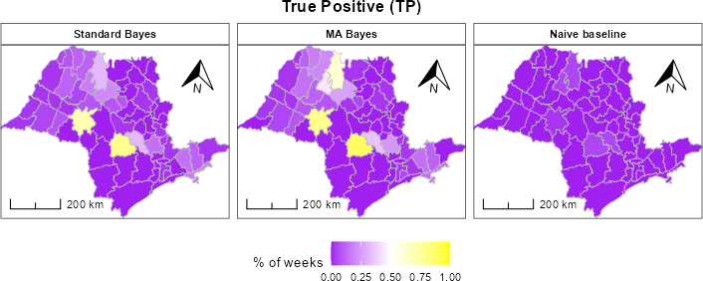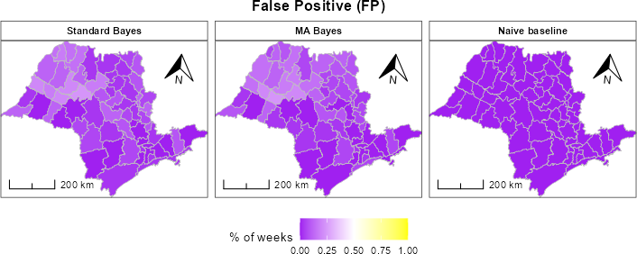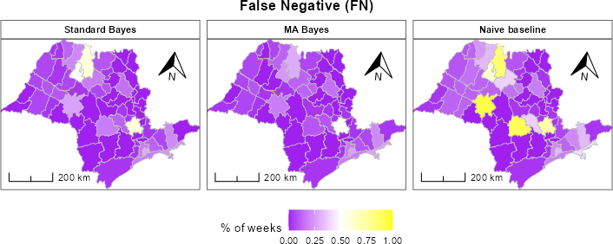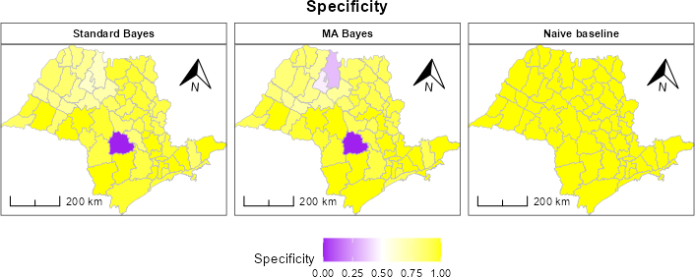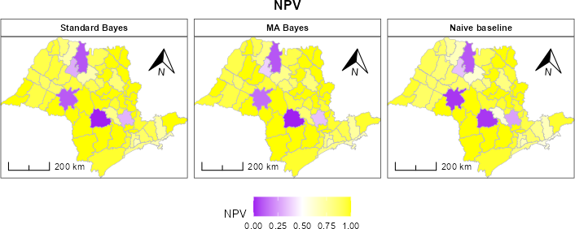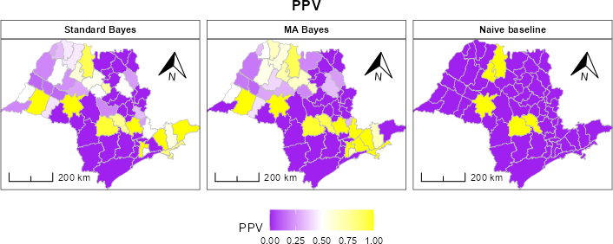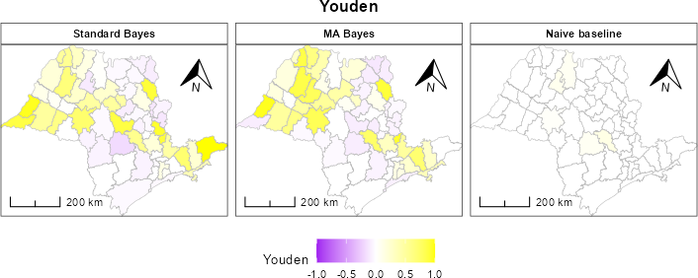-
Fig-S5 Maps of confusion metrics. For details see table S3. And for TPR and FPR maps see fig. 2.

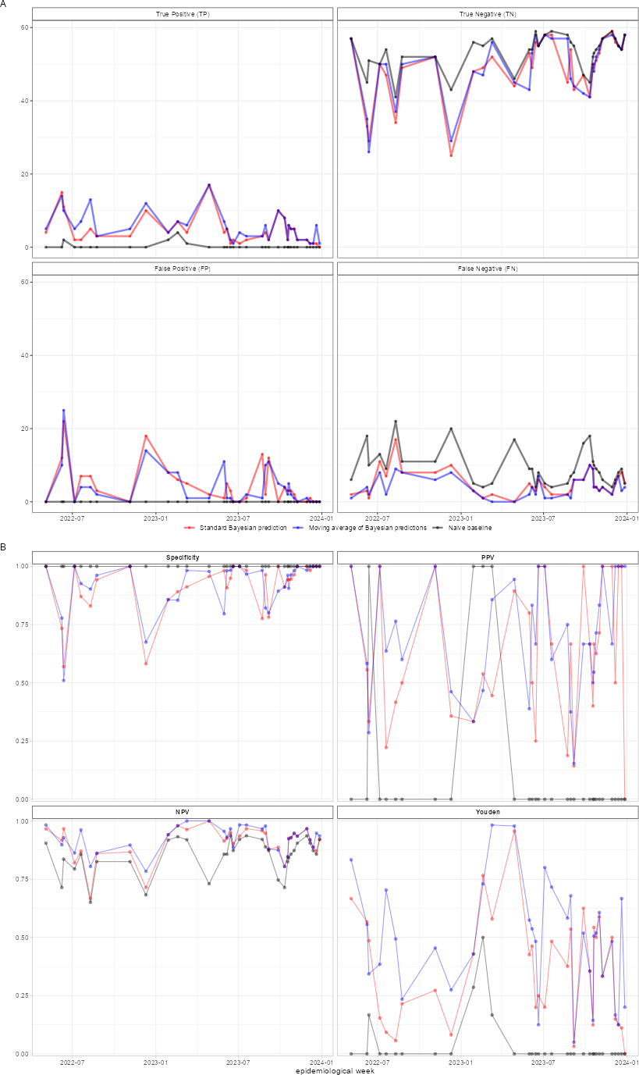
Fig-S6 Confusion metrics.

