# Título

- Disentangling Forest Loss and Fragmentation through a Spatially Explicit Neutral Model

- Estimating functional landscape effects trough a spatially explicit demography neutral model

- Dispersal constraints shape the sign and magnitude of biodiversity responses to forest loss and fragmentation

Revista pretendida: Ecography

# Resumo {-}

REFAZER

# Abstract {-}

REFAZER

# Introduction

Habitat loss and fragmentation are major drivers of biodiversity change in tropical forests (@diaz_pervasive_2019). Yet empirical estimates of the independent effect of fragmentation remain highly inconsistent, ranging from negative to neutral or even positive across systems (@fletcher2018habitat, @fahrig2019habitatA, @miller2019does, @valente2023toward). Part of this uncertainty may arise because landscape effects are often inferred from landscape configuration alone, despite connectivity being widely recognized as a fundamental process underlying biodiversity responses (@villard_beyond_2014; @hanski_2015; @rivaEbanskleite2024). Resolving this gap is not only a theoretical challenge but also a practical necessity for conservation planning, in which different traditions (from generalizable heuristics to context-specific mechanistic models) offer contrasting yet potentially complementary paths forward (@rodriguez_designing_2020; @banks-leite_suggestion_2021; @rodriguez_preserving_2021).

Functional connectivity is the movement of individuals through remaining habitat and emerges from the interaction between landscape structure and species dispersal ability (@auffret2017plant; @hatfield2018using). By regulating the exchange of individuals among local communities, connectivity modifies the demographic balance between local extinction and recolonization (@kindlmann2008connectivity; @pardini_beyond_2010; @may_dispersal_2012 @baguette2013individual; @campos2013; @chase_biodiversity_2020). Thus, for a given landscape configuration, different levels of dispersal limitation produce different connectivity regimes and thereby alter colonization, local replacement, and extinction dynamics. Understanding landscape effects therefore requires evaluating how variation in dispersal modifies the demographic consequences of landscape structure.

However, empirical studies typically estimate landscape effects by correlating structural landscape metrics with local biodiversity patterns (@frazier2017). This leaves the role of connectivity implicit, primarily because species dispersal is rarely known in real landscapes (@baguette2013individual; @bullock_synthesis_2017). As a result, there is little consensus on which configuration metrics best represent connectivity or which spatial extents are most relevant for estimating biodiversity responses to landscape change (@fletcher2018habitat; @fahrig2019habitatA; @miller2019does; @valente2023toward; @fletcher_jr_addressing_2023). Consequently, current approaches often infer ecological responses from landscape structure without explicitly representing the demographic processes through which functional connectivity regulates the maintenance of local biodiversity.

Here we propose a framework to infer plot‑specific landscape effects on local tree diversity using a spatially explicit neutral model calibrated against empirical tree communities. By constructing counterfactual landscapes that experimentally decouple habitat loss from spatial configuration, we estimate the independent and combined effects of forest loss and fragmentation while explicitly accounting for dispersal limitation. Specifically, we ask how variation in dispersal limitation affects the magnitude and direction of these landscape effects along an empirical forest‑cover gradient.

# Materials and Methods

## Study system and empirical data

We used the Atlantic Forest as a model system for investigating fragmentation effects in tropical forests. This biome retains less than 30% of its original forest cover, distributed as a mosaic that provides a broad empirical gradient of forest cover while naturally coupling habitat loss with configuration change (@vancine2024atlantic). Tree community data were obtained from the TreeCo database (@de_lima_how_2015; @de2020erosion), selecting inventories that: (i) sampled trees with DBH ≥ 4.8 cm; (ii) used single plots ≥ 1 ha; and (iii) had high taxonomic reliability and precise coordinates. Landscape structure was characterized using MapBiomas Collection 6 land cover maps (@mapbiomas), with forest cover defined as native forest formations including secondary stages (Supplementary material Appendix 1). For each plot, we extracted a 16 × 16 km landscape window centered on the plot location, chosen to exceed typical buffers and ensure stabilization of model dynamics (Supplementary material Appendix 2).

## Counterfactual landscape design
To disentangle habitat loss from fragmentation per se, we constructed three experimental landscapes for each plot (Fig. S1): (i) the **contemporary fragmented landscape** (observed cover and configuration); (ii) a **pristine continuous-forest landscape** (no habitat loss); and (iii) a **clumped landscape** in which all remaining forest was spatially aggregated into a single block centered on the plot, preserving total habitat amount while minimizing fragmentation. Comparing outcomes across these landscapes isolated three effects: FLF, the total effect of forest loss and fragmentation (pristine vs. fragmented); FPS, fragmentation per se (clumped vs. fragmented); and LFC, forest cover loss (pristine vs. clumped). This design resolves a key inferential problem: because habitat removal inevitably alters configuration, complete orthogonality between amount and fragmentation is only achievable through experimental manipulation (@didham_rethinking_2012; @fahrig_resolving_2022).

## Spatially explicit neutral model
We used a Spatially Explicit Neutral Model (SENM; @rosindell2008) as a mechanistic framework linking landscape structure to local diversity. The SENM assumes ecological equivalence among individuals, with community dynamics emerging from stochastic birth, death, dispersal, and external species input. Two parameters are central in our design: **U**, the probability that a lineage originates from a newly introduced species (external input), and **k**, which quantifies dispersal limitation as the expected proportion of propagules retained near parental individuals. Under this formulation, connectivity emerges from the interaction between demographic dynamics in space and landscape configuration, making the SENM particularly suited for investigating how dispersal limitation modulates biodiversity responses to landscape change (@campos2012; @azaele2016; @thompsonPycoalescence2020).

## Calibration, validation, and vulnerability metric

We calibrated the SENM independently for each plot, dispersal regime (20 values of k, from 0.99 to 0.05), and experimental landscape by adjusting U to match observed richness (semi-analytical method; @rosindell2008). For each regime, we determined the minimum spatial extent for U to stabilize in pristine landscapes, then used that extent for all simulations under that regime (Supplementary material Appendix 2).

Before interpreting effects, we validated the SENM by testing whether simulated communities reproduced empirical species abundance distributions (SADs) using Kolmogorov-Smirnov tests with bootstrap resampling (REF). We retained only simulation batches in which ≥75% of replicate SADs were congruent across all three landscapes, and restricted interpretation to dispersal regimes with consistently high mean congruence (Supplementary material Appendix 3).
Within the SENM, U measures the dependence of local diversity on external sources required to maintain richness under drift (@condit2012; ). Differences in U between landscapes therefore provide a mechanistic measure of vulnerability. For each plot and regime, we calculated log-ratios of U:
- **FLF** (total effect) = log(U_pristine / U_fragmented)
- **FPS** (fragmentation per se) = log(U_clumped / U_fragmented)
- **LFC** (forest cover loss) = log(U_pristine / U_clumped)

These contrasts decompose the total effect additively: FLF = FPS + LFC.
## Statistical analyses

We analyzed variation in SENM congruence (proportion of congruent SADs) using Hierarchical Generalized Additive Models (HGAMs) with binomial errors. The most complex model included smooth terms for k with landscape-specific smoothers, a plot-level random smooth for k, and a bivariate smoother for plot coordinates. For each vulnerability metric (FLF, FPS, LFC), we fitted Gaussian HGAMs evaluating the influence of remaining forest cover (%FC) and k, with models ranging from simple intercepts to tensor-product interactions between k and %FC. Model fitting used restricted maximum likelihood (REML; R package mgcv; @wood2017). Detailed procedures are provided in the Supporting Information.

# Results

<p> <!--Resultados auxiliares: exposição e citação do SI -->
A total of 107 forest inventories from the TreeCo database met the initial selection criteria (Table SI1). The final dataset comprised 105 plots after excluding two sites where the fragmented landscape configuration prevented reconstruction of the sampled plot as a square (Fig. S1). The dataset spans a broad geographic range across the Atlantic Forest and encompasses substantial variation in plot area (median = 1 ha, IQR = 0 ha, range = 1 - 102 ha), abundance (median = 1,528 individuals, IQR = 608, range = 649 - 12,105), and species richness (median = 107 species, IQR = 66, range = 26 - 458). Landscape maps for all study sites are shown in Figures SI1.X–SI1.X.
</p>

<p> <!--Calibração e sensibilidade: escala suficiente -->
Across dispersal scenarios and plots, U estimates from pristine landscape simulations at the largest spatial scale varied substantially (Fig. S2.X). Applying a 75% threshold of the total reduction in U yielded more consistent estimates of the sufficient spatial scale (Fig. S2.XX). Under moderate dispersal limitation (k ≈ 0.70), uncertainty increased because differences among spatial scales became smaller than the variation among simulation replicates for a given combination of k and plot (Fig. S2.XXX and S2.XXXX). Linear interpolation within the 75% threshold indicated a sufficient spatial scale of 2 km for scenarios with k ≥ 0.35. For k < 0.30, the sufficient spatial scale increased to 4 km.
</p>

## Dispersal limitation constrains the empirical validity of a spatially explicit neutral model {Congruencia}

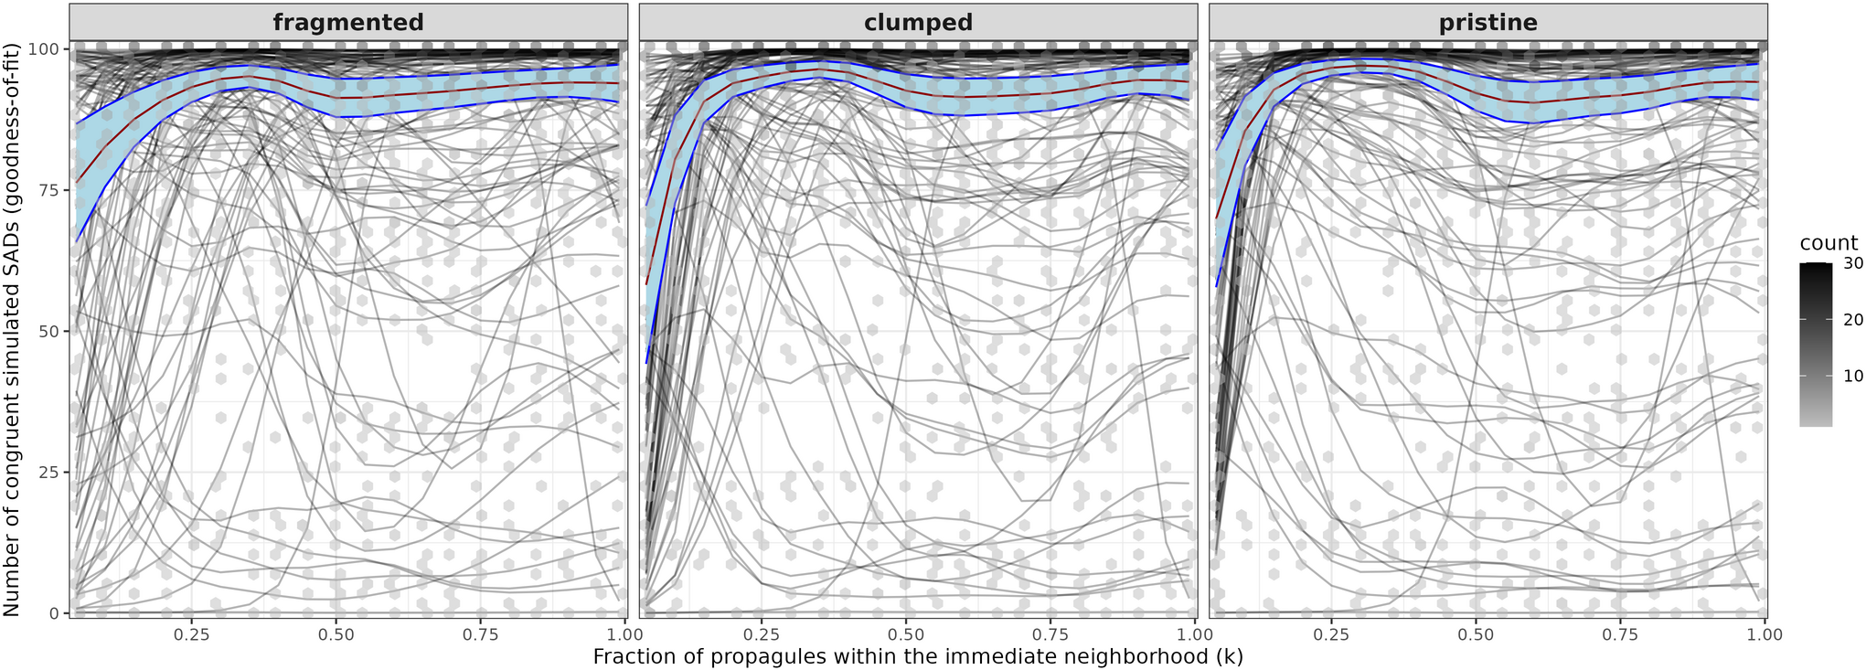
Figure 1. Congruence between simulated and observed SADs (y-axis) across dispersal (x-axis) and landscape combinations (facet labels). Hexagonal bins show the density of plot‑level observations (lighter = fewer points, darker = up to 100 points). Gray lines: plot‑level predictions from the most plausible model with spatial coordinates set to zero. Red line: overall mean prediction; blue shading: 95% pointwise confidence interval. Mean congruence exceeded 75% in most simulations but declined under very weak dispersal limitation, especially in clumped and pristine landscapes.

<p> <!--Descrição do padrão empírico chave para o critério post-hoc -->
Mean congruence between simulated and observed SADs exceeded 75% across most dispersal scenarios but declined under very weak dispersal limitation, particularly in clumped and pristine landscapes (Fig. 1). Congruence varied substantially among plots, with non-linear responses to the interaction between dispersal limitation and landscape configuration. Accordingly, the best-supported model included a plot-level interaction between dispersal and landscape configuration, together with a spatial effect accounting for proximity among plots (Appendix S3).
</p>

<p> <!--a importância da interação entre k e landscape-->
Although the full model received the strongest support, a simpler model excluding spatial coordinates explained the same proportion of deviance (94%), showed no residual spatial autocorrelation (Fig. S3.1), and had moderately lower support (ΔAICc = 8.79; Table S3.2). In contrast, models that omitted the plot-level interaction exhibited significant positive spatial autocorrelation and a substantial drop in explained deviance (64% and 59%; Table S3.2). These results indicate that the plot-level interaction captured the dominant congruence patterns, with spatial proximity providing only a refinement.
</p>

<p> <!--Critério post-hoc-->
Congruence declined as dispersal limitation weakened (Fig. 1), indicating that SENM better reproduces observed SADs under moderate-to-strong dispersal limitation. Subsequent analyses were therefore restricted to scenarios with k ≥ 0.50, where mean congruence consistently exceeded 75% across all experimental landscapes. Applying this post-hoc criterion together with the predefined requirement of at least 75% congruence across all three landscapes yielded 66 selected plots (62.8%) for the vulnerability analyses. Selected and excluded plots exhibited similar environmental characteristics and showed no evidence of spatial segregation (Fig. S3.2; Appendix S3).
</p>

## Forest cover and dispersal jointly shape vulnerability to forest loss and fragmentation

Table 1. figure
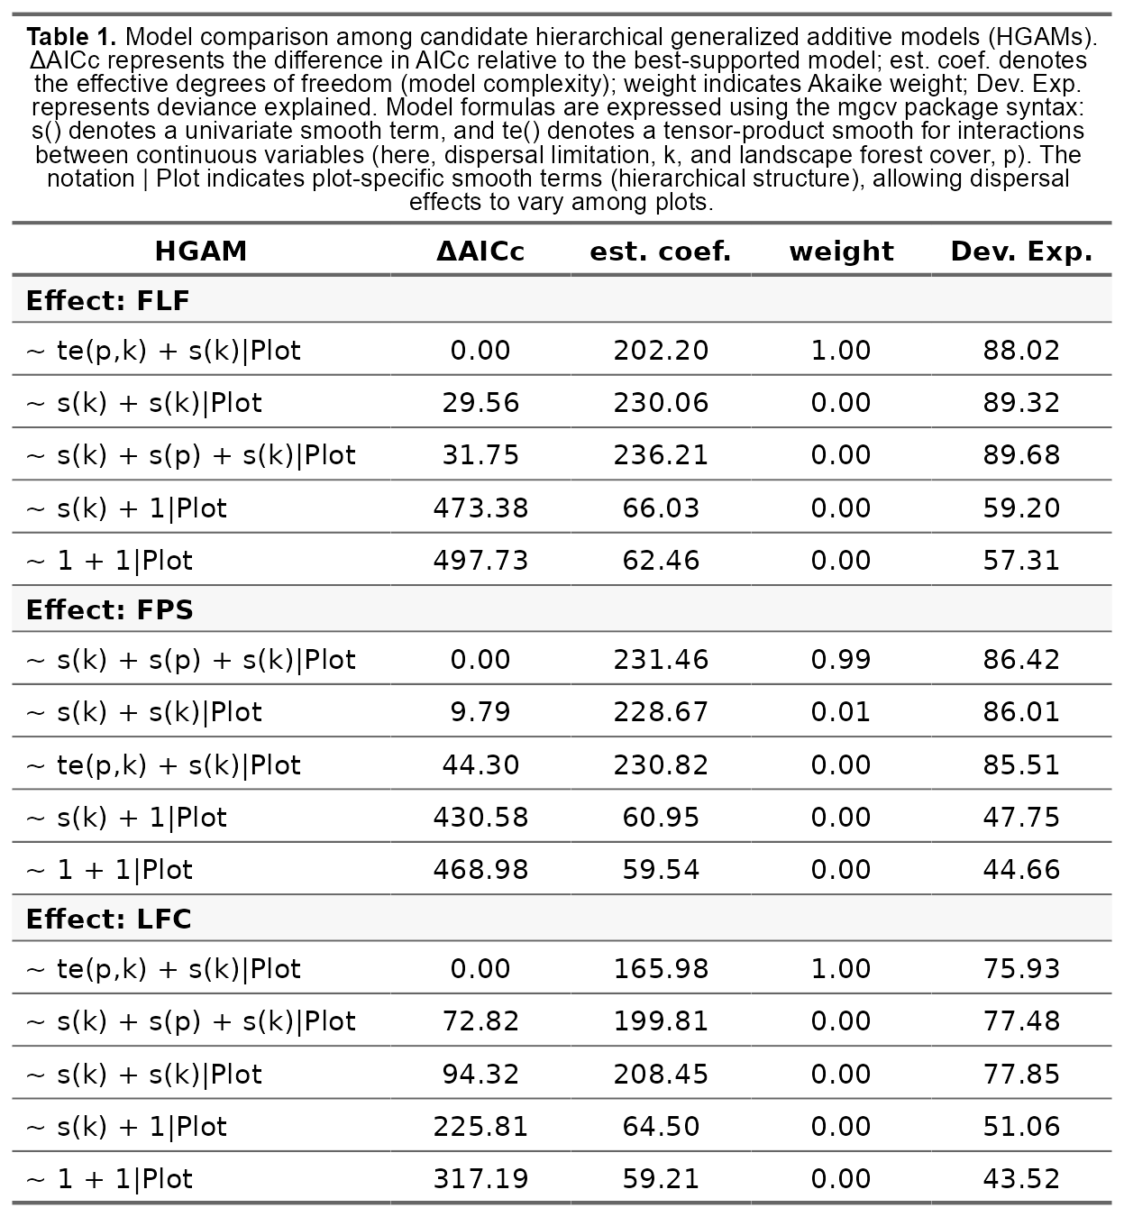

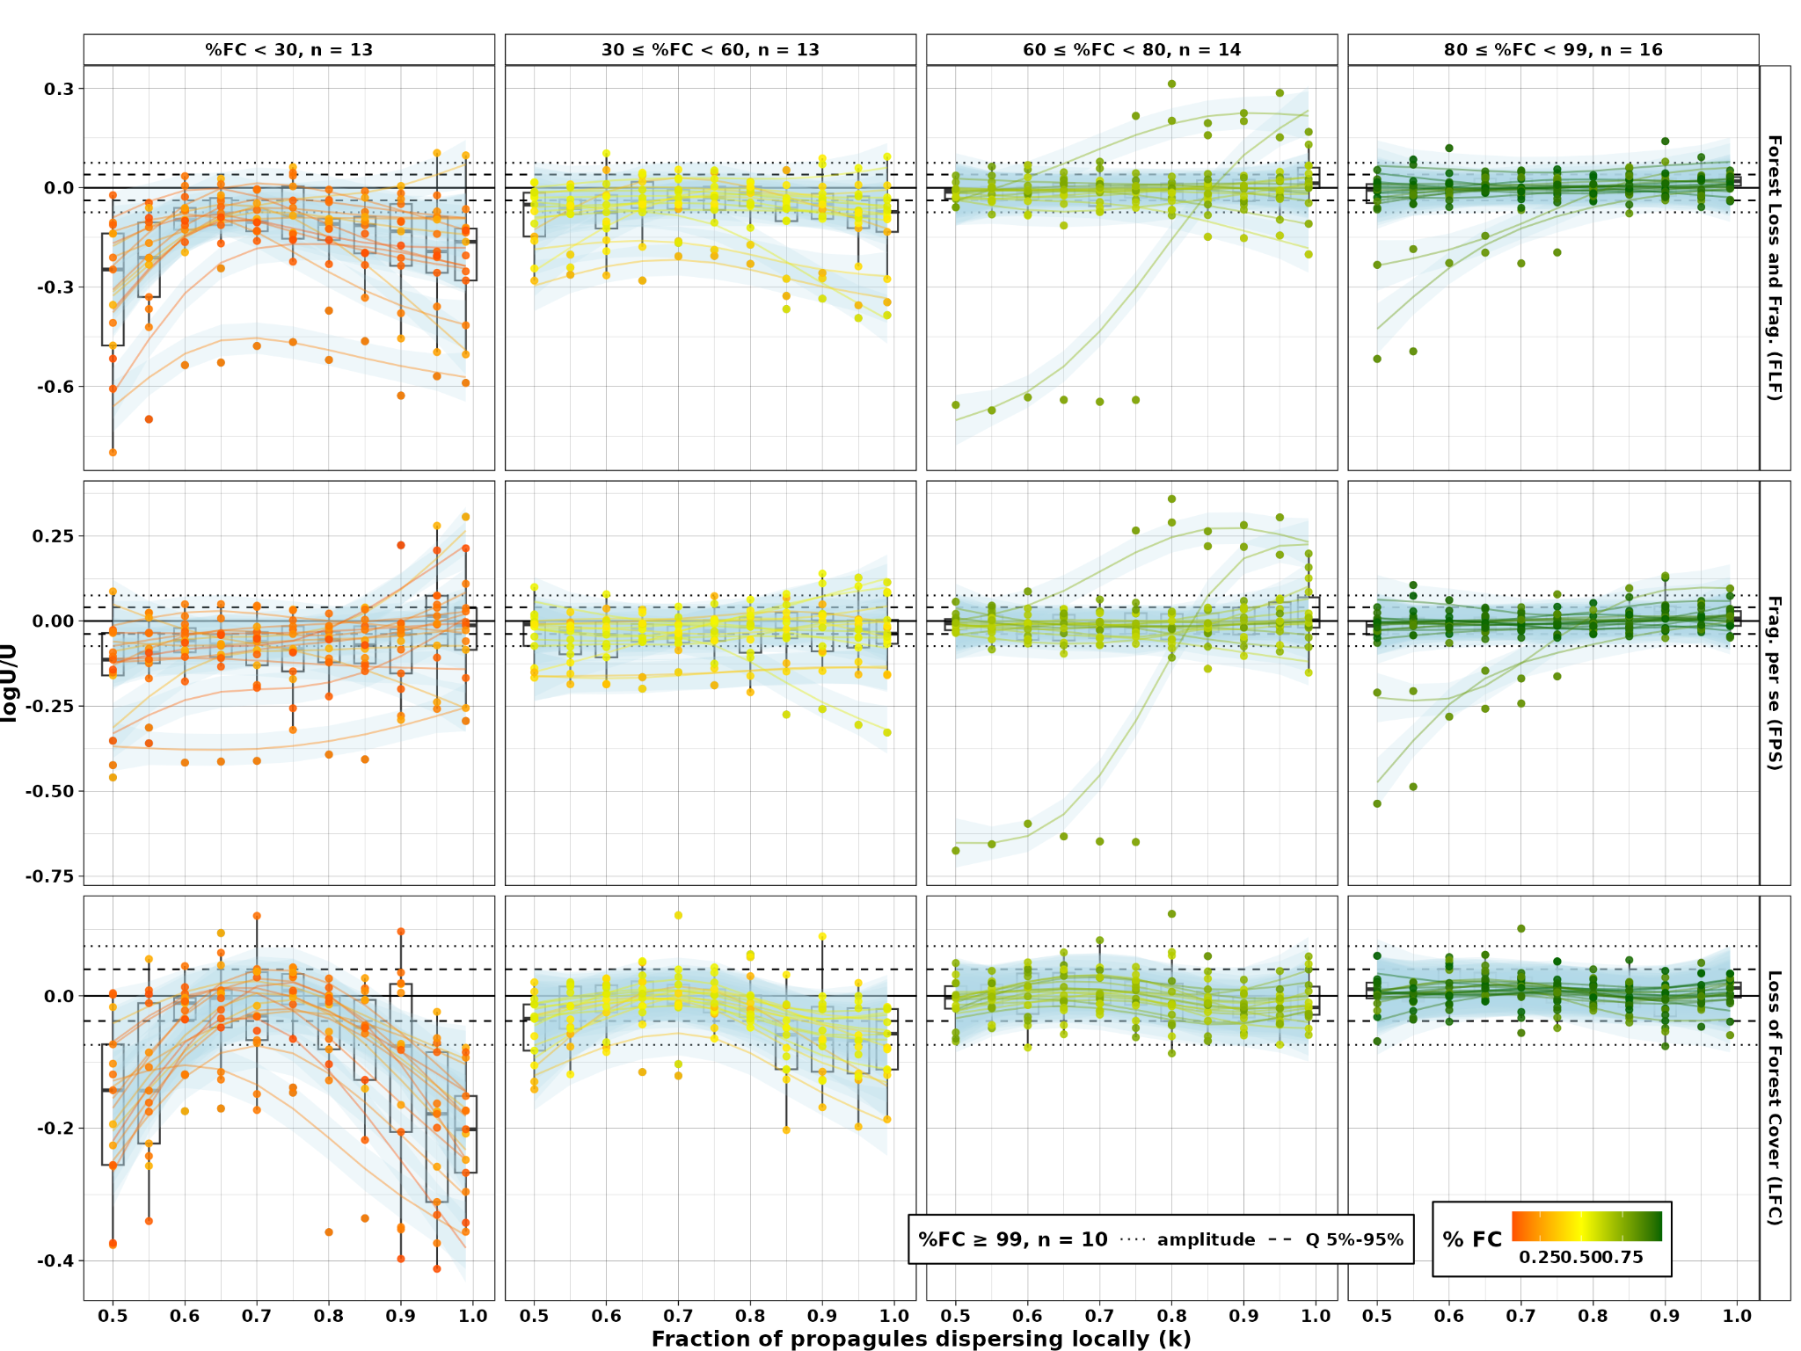

Figure 2. Vulnerability to landscape change measured as log(Uᵢ/Uⱼ) from a hierarchical generalized additive model (larger values indicate greater dependence on external sources). Rows show three experimental contrasts: **FLF** (pristine vs. fragmented: total effect), **FPS** (clumped vs. fragmented: fragmentation per se), and **LFC** (pristine vs. clumped: forest cover loss). x‑axis: dispersal limitation (k). Points are coloured by observed forest cover (%FC) within 2 km of each plot; columns group plots by %FC classes. Boxplots summarize values for each k level. Only SAD‑congruent plots are shown; plots with ≥99% forest cover are excluded for clarity (see text for amplitude and quantile ranges).

Differences in U between landscapes reflect variation in the external replenishment required to sustain observed diversity patterns. Accordingly, log(Ui/Uj) quantifies landscape‑induced vulnerability across three experimental contrasts: total effect of forest loss and fragmentation (FLF; pristine vs. fragmented), fragmentation per se (FPS; clumped vs. fragmented), and forest cover loss (LFC; pristine vs. clumped). In figure 2, plots with greater than or equal 99% forest cover were excluded from the graphical display; only the amplitude (maximum = 0.075; minimum = -0.074) and the central 90% interval (95th quantile = 0.04; 5th quantile = -0.038 ) of log Ui/Uj are indicated on the y-axis. This variability reflects the stochasticity inherent to the spatially explicit neutral model simulation.

Model selection indicated that the interaction between remaining forest cover (%FC) and dispersal limitation (k) improved model fit for FLF and LFC, but not for FPS (Table 1). For FPS, the best-supported model included only additive effects of %FC and k (plus plot-level random dispersal effects). Notably, across all three landscape effects, accounting for plot-specific dispersal responses was essential to achieve high explanatory power (>75% deviance explained); removing this component reduced deviance explained by 25 to 40 percentage points (Table 1).

The LFC effect became increasingly negative in plots with reduced %FC and was negligible in plots with high %FC (Fig. 2). Across dispersal regimes, LFC exhibited a non-linear response to dispersal limitation (k), with minimum vulnerability at intermediate values (k ≈ 0.70) and stronger effects under both strong and weak dispersal limitation. This pattern indicates that habitat loss exerts its strongest influence when dispersal limitation is either strong or weak, whereas intermediate dispersal partially buffers vulnerability.

The FPS effect was generally weak, with most values clustering around the null reference in landscapes with forest cover above 60%, and becoming weakly negative at low forest cover (<30%) (Fig. 2). Only a few plots showed plot-specific patterns, with some displaying pronounced negative effects under moderate-to-mild dispersal limitation and others showing weak positive effects under severe limitation. Although the magnitude of FPS occasionally increased in plots with reduced %FC, the most pronounced effects were observed in a small number of plots with intermediate %FC. Thus, fragmentation per se acts primarily as a context-dependent modifier of vulnerability rather than a dominant driver.

The FLF effect became more negative as %FC decreased, although a few plots displayed patterns resembling FPS at intermediate-to-high %FC (Fig. 2). Overall, FLF exhibited greater variability, integrating features of both LFC and FPS.

A complementary analysis showed that differences in magnitude between LFC and FPS were generally small and often fell within the null reference range, although LFC tended to dominate in plots with reduced %FC (Fig. S4.1). Across plots, LFC and FPS frequently differed in sign (41-65%). The proportion of cases in which LFC and FPS differed in sign increased with %FC. When both effects were negative, the total FLF was correspondingly more negative. In contrast, when the effects differed in sign, positive FPS partially counterbalanced negative LFC.

These contrasting signs were most evident in low-cover landscapes, where LFC dominated, and in a small number of intermediate-cover plots, where FPS effects prevailed (Fig. 2; Fig. S4.1). Together, these patterns indicate that the combined effect of forest loss and fragmentation is predominantly negative in low-cover landscapes, while in higher-cover landscapes it may reflect plot-specific effects of spatial configuration.

# Discussion

Functional connectivity is widely recognized as the mechanism linking landscape structure to biodiversity responses, yet its demographic basis is rarely represented explicitly (\cite{swift2010critical}; \cite{villard_beyond_2014}; \cite{rivaEbanskleite2024} REF). In the SENM, connectivity emerges from individual dispersal across a spatially explicit landscape (Rosindell et al. 2008; Campos et al. 2012, 2013; Thompson et al. 2020). Model congruence was high across a broad range of dispersal regimes and experimental landscapes, although it varied substantially among plots. For plots showing consistently high congruence under moderate-to-severe dispersal limitation, landscape effects could be estimated by contrasting experimental landscapes at the plot level. These analyses revealed that the signal and magnitude of forest loss and fragmentation depend on the landscape-dispersal interplay, a finding that helps explain under which conditions fragmentation per se amplifies the negative effect of forest loss (REF) or, in rare cases, partially buffers it (REF).

## A mechanistic measure of biodiversity vulnerability

Within our framework, landscape effects are quantified as changes in the species input parameter (U) needed to reproduce the observed local species richness under alternative landscape configurations (REF). Because U quantifies the external species input required to maintain observed local richness, differences in U among experimental landscapes provide a mechanistic measure of how landscape structure modifies the demographic dependence of local communities on external biodiversity input. The species input is interpreted as long-distance dispersal, propagule bank replenishment, and speciation (REF).

This interpretation provides a direct link between landscape configuration, functional connectivity, and biodiversity persistence. Landscape effects therefore emerge from contrasts among alternative connectivity regimes rather than from correlations between biodiversity patterns and landscape metrics (REF). Because these contrasts are estimated for individual plots, the framework captures heterogeneity in landscape responses that would otherwise be averaged across plots (REF).

## Forest loss dominates, but fragmentation shapes variability in the total forest loss and fragmentation effect

Forest cover loss was consistently associated with increased vulnerability in low-cover landscapes, whereas its effects were negligible in landscapes with high remaining forest cover (REF galera dos efeitos). The magnitude of this effect was lowest under intermediate dispersal limitation, mirroring the non-linear relationship between dispersal and U observed in pristine landscapes (May et al. 2012). Under strong dispersal limitation, recruitment is dominated by nearby conspecifics, reducing stochastic species loss and therefore the need for external replenishment. As dispersal increases, heterospecific replacement becomes more frequent, increasing drift-driven species loss and raising U. Under weak dispersal limitation, however, distant populations increasingly contribute propagules to local communities, reducing local extinction and causing U to decline. This mechanism may also explain why vulnerability to habitat loss was minimized under intermediate dispersal limitation. Because U is highest under these conditions, local diversity becomes less dependent on surrounding habitat as a source of biodiversity replenishment, weakening the ecological consequences of habitat loss (Campos et al. 2012, 2013).

In contrast to forest cover loss, fragmentation per se exhibited weak and highly variable effects across landscapes (REF galera da fahrig). Fragmentation per se (FPS) effects were not organized by a consistent interaction between dispersal limitation and forest cover, unlike the pattern observed for habitat loss. Positive and negative FPS effects occurred across the forest-cover gradient, with a few plots showing positive responses under strong dispersal limitation and others exhibiting strongly negative responses at intermediate to high forest cover. This pattern is broadly consistent with the long-standing inconsistency of fragmentation responses reported across empirical systems (REFs). Fragmentation per se has been associated with positive, neutral, and negative responses depending on the study (REFs). Our results suggest that this variability emerges because fragmentation effects depend on how particular landscape configurations modify effective connectivity under different dispersal constraints. Under severe dispersal limitation, some spatial configurations may favor local conspecific replacement, reducing stochastic species loss and potentially generating positive fragmentation effects (Campos et al. 2012, 2013). Conversely, other configurations may further restrict propagule exchange among local communities, amplifying biodiversity loss (REF). The scale-sensitivity analysis further suggests that these connectivity dynamics depend not only on dispersal limitation and landscape configuration but also on local community properties. Species richness and individual density influence the baseline value of U required to maintain local diversity and therefore affect how strongly changes in landscape configuration alter community dynamics. Consequently, fragmentation effects may emerge from the interplay among spatial configuration, dispersal processes, and local demographic conditions, helping explain why responses remain difficult to generalize across landscapes.

The total effect of forest loss and fragmentation (FLF) partially reflected the patterns observed for forest cover loss in highly deforested landscapes. Consistent with this result, FLF was best explained by the interaction between dispersal limitation and forest cover, indicating that habitat loss remained the primary determinant of vulnerability across landscapes (REF). However, FLF also inherited the variability associated with fragmentation _per se_. In most low-cover landscapes, negative FPS effects amplified the vulnerability associated with habitat loss, producing stronger total effects (REF). In a smaller number of cases, positive FPS effects partially compensated for habitat-loss vulnerability, particularly under severe dispersal limitation. At intermediate and high forest cover, where LFC effects were weak, variation in FLF reflected the contingent responses associated with fragmentation per se. Together, these results suggest that habitat loss primarily determines the direction of the total landscape effect, whereas fragmentation per se contributes to its variability (REF).

## Implications for the fragmentation debate

Our results revealed a general tendency for forest cover loss to dominate landscape effects in highly deforested landscapes, with fragmentation per se contributing with additional variability. However, the most notable pattern was the substantial variability among plots. Consistent with this result, statistical models that ignored plot-level variation in dispersal responses showed substantially lower explanatory power. Although the SENM did not provide an equally good description of all communities, the framework nevertheless allowed landscape effects to be estimated at the plot level (REF). This contrasts with many observational approaches, where inference is typically restricted to average effects across plots (REF). From this perspective, explaining variation among communities may be as important as estimating average landscape effects.

This distinction reflects a broader tension within landscape ecology regarding how biodiversity responses should be incorporated into conservation planning. One tradition emphasizes generalizable heuristics derived from broad comparative analyses of landscape structure and biodiversity responses, prioritizing scalable recommendations based on relatively simple landscape descriptors (e.g., Fahrig 2017; Watling et al. 2020; Arroyo-Rodríguez et al. 2020). In contrast, more mechanistic approaches seek to represent species responses, dispersal dynamics, and restoration scenarios explicitly through spatially detailed models tailored to particular ecological contexts (Banks-Leite et al. 2021). More broadly, these traditions reflect different strategies for balancing ecological realism, inferential generality, and data availability in conservation science.

The SENM framework provides a possible integration between these approaches by explicitly incorporating dispersal limitation and landscape configuration while remaining parameterizable from biodiversity and landscape data that are broadly available across fragmented systems. In contrast to spatially implicit approaches based primarily on habitat amount or species–area relationships (e.g., Fahrig 2013; Strassburg et al. 2019), it allows alternative connectivity scenarios to be evaluated explicitly through counterfactual landscape simulations

## Limitations

## Broad empirical congruence supports an explicit demographic representation of connectivity

1) The ability of the SENM to reproduce observed species abundance distributions (SADs) in fragmented tropical forests supports the use of simple spatially explicit demographic models to investigate the mechanisms linking landscape configuration to biodiversity (\cite{rosindell2012case}; Metzger & Villard 2013; \cite{Marshall2014}; \cite{DAGinfEPI2019}; \cite{gianluca2022CH5}).
2) Such findings contrast with earlier skepticism regarding the ability of neutral models, including spatially explicit formulations, to reproduce biodiversity patterns in fragmented tropical forests (Gilbert et al. 2006; Laurance 2008; Rosindell & Etienne 2011).
3) These studies questioned different aspects of neutral theory and its application to fragmented forests.

Rosindell & Etienne (2011) compared the SENM with a spatially implicit neutral model (SINM) capable of fitting two free parameters (a metacommunity diversity parameter $\theta$ and a dispersal parameter $I$) directly to the observed SAD, unlike the SENM, where the $U$ parameter is adjusted based on species richness given a dispersal scenario.
In this study, the SINM was taken as the golden standard to reproduce empirical SAD; once the two free parameters are fitted to the empirical SAD, the model has high goodness-of-fit.
They concluded that SENM have

Gilbert et al. (2006) and Laurance (2008) concluded that the functional equivalence assumption was insufficient to explain the temporal dynamics of fragmented forest communities, based on a spatially implicit model fitted to abundance time series. The authors concluded that the spatially implicit neutral model predicted very slow species turnover in comparison with the observed turnover in tropical forest patches. Our results are based solely on static SADs patterns,

Gilbert et al. (2006) and Laurance (2008) argued that functional equivalence was insufficient to explain fragmented forest communities, based on spatially implicitly neutral models fitted to time series abundance data. Whereas Rosindell & Etienne (2011) questioned whether spatially explicit neutral models offered substantial advantages over spatially implicit formulations, based on SAD patterns.

3) One possible explanation for this difference lies in the interpretation of the species-input parameter U.
4) Previous simulation studies typically interpreted U primarily as true speciation (REF), which implies low values of U and consequently slow community dynamics because species persistence times increase as U decreases (REF).
5) In our framework, U represents the aggregate contribution of processes introducing novel lineages into local communities, including long-distance dispersal, propagule-bank replenishment, and speciation (REF).
6) This broader interpretation yields higher values of U and faster turnover, potentially explaining the congruence observed across most simulations.
7) Importantly, this hypothesis derives from matching observed SADs rather than temporal community dynamics (REF).

### Orthogonality and decomposition of landscape effects

Within our framework, the clumped scenario allows the effects of spatial aggregation to be evaluated independently from overall forest cover (REF Fahrig et al. ). This formulation also clarifies an inferential problem underlying the fragmentation debate. Once habitat is spatially distributed across a landscape, habitat removal inevitably alters the spatial configuration of the remaining habitat (REF). In this sense, the fragmentation debate may be interpreted less as a disagreement about whether fragmentation matters and more as a question about the conditions under which total landscape effects can be meaningfully decomposed into independent ecological components (Fahrig 2003, 2019; Didham et al. 2012; Fletcher Jr et al. 2018; Fahrig et al. 2019; Püttker et al. 2020). Complete orthogonality between habitat amount and fragmentation therefore represents a limiting inferential case rather than an intrinsic property of empirical landscapes (Pearl et al. REF).

Decomposing the effects of forest cover loss and fragmentation per se also requires specifying the spatial scale over which this decomposition is defined. In our framework, this scale is determined by the spatial extent from which habitat is redistributed to construct the clumped landscape. By contrast, estimating the combined effect of forest loss and fragmentation only requires a landscape extent sufficiently large to avoid constraining dispersal processes, because SENM simulations are not inherently limited by landscape boundaries (REF). Consequently, decomposing landscape effects requires stronger assumptions than estimating their combined effect. These assumptions become unavoidable when information about ecologically relevant spatial scales is unavailable. In such cases, the inferred contributions of forest cover loss and fragmentation per se depend increasingly on how contemporary biodiversity patterns are assumed to relate to landscape structure (REF).

### Temporal correspondence between biodiversity and landscape patterns

Most observational studies relate contemporary communities to contemporary landscape configuration, implicitly assuming that the landscape characteristics relevant to community assembly have remained sufficiently stable through time or that delayed ecological responses have largely relaxed (Frazier & Kedron 2017; REF). Violations of this assumption may contribute substantially to inferential uncertainty, but historical information on habitat dynamics is often unavailable to assess their magnitude (REF).

Within the SENM framework, this assumption is operationalized through ecological equilibrium (REF). Under this interpretation, biodiversity patterns are assumed to reflect the long-term interaction between dispersal processes and landscape structure rather than transient responses to recent environmental change (REF). Consequently, deviations between observed and simulated communities may partly reflect temporal mismatches between contemporary biodiversity patterns and the landscape conditions used to model them.

Nevertheless, our results suggest that contemporary landscape structure retains ecologically meaningful information about the processes shaping present-day communities. Differences in model congruence among plots were largely explained by the interaction between dispersal limitation and landscape configuration, whereas explicit spatial proximity provided only a modest improvement in model performance. Moreover, accounting for this interaction eliminated residual spatial autocorrelation among plots, indicating that contemporary landscape configuration captures ecologically relevant differences across the Atlantic Forest. Although these findings do not directly evaluate historical landscape dynamics, they suggest that contemporary landscapes retain information relevant to mechanistic inference about present-day biodiversity patterns, even in the absence of explicit historical data.

## Future directions

Incorporating dynamic landscape change represents another important avenue for future research (REF). Explicitly modeling habitat regeneration and landscape transitions could improve the representation of temporal connectivity and delayed ecological responses (REF). However, such extensions would substantially increase both data requirements and computational complexity. The current coalescent implementation reconstructs equilibrium communities directly, allowing large-scale analyses from relatively limited biodiversity and landscape data (REF). Dynamic landscape models would require additional information on landscape trajectories and transient community dynamics, potentially reducing the scalability that constitutes one of the main practical advantages of the present framework.

In contrast, some additional ecological mechanisms may extend the present framework without fundamentally altering its inferential structure. Matrix effects, for example, may influence biodiversity dynamics by modifying dispersal success among habitat patches and demographic processes near habitat edges (REF). Representing these mechanisms explicitly within the same counterfactual framework may help distinguish the relative contributions of forest loss and fragmentation from those associated with matrix. Unlike the decomposition of habitat loss and fragmentation per se, matrix effects can be implemented directly as local dispersal and demographic processes (REF), reducing dependence on a priori definitions of spatial extent.

