Exchange cinema modal from physical to virtual interface

Authors Name/s per 1st Affiliation (Author)
line 1 (of Affiliation): dept. name of organization
line 2-name of organization, acronyms acceptable
line 3-City, Country
line 4-e-mail address if desired
Authors Name/s per 2nd Affiliation (Author)
line 1 (of Affiliation): dept. name of organization
line 2-name of organization, acronyms acceptable
line 3-City, Country
line 4-e-mail address if desired

Abstract: Interactive interface for arranging cinema seats provide a solution for order seat in cinema by web interface. The interface is simple and easy to use. It allow user to create a room with a number of seat that they specify before. They can choose many mode for adding seat very easily. They also can add extra space for more beauty room and preview their room to see how it will look like before save it. The other customer can booking ticket and choose seat easily by click into virtual seat.

Introduction
It is difficult to transform the physical cinema model into a web interface for easy viewing and control. The interface will help manager and cinema customer easily to interact with the system. Manager can easily add and arrange seat for cinema and cinema customer will easily choose seat for booking ticket.
To convert cinema model from physical to virtual we propose to use matrix to store and display. We use 2 dimensional matrix like a template to display seat on it. The size of the matrix will be automatic calculate from the number of seat that user input. The seat object saved will store as a point in matrix. When we load a room, each seat will stand in right position that they has been saved before.
The primary significance of our contribution we feel is in proposing a solution for interact more effectively on website by using matrix to convert physical cinema’s room to virtual.
In Section 2 we formalize the problem and describe our approach to solving it. Section 3 describes the data structures that need to be set up and the subsequent algorithm. We analyze our algorithm in Section 4. Experimental results and the software used are described in the concluding Section 5.

PROBLEM and Solution plan
To start create matrix for cinema room, we will ask user for input the room capacity. Room's capacity will from 80 to 300 seats. Our final goal is create a 2D interface to display a room with all of seats.
First of all, we will calculate size of matrix base on given capacity. The system will auto generate the template for adding seats.
Next, we click on the matrix sell on template to add seat. Each sell will be consider as one seat. User can choose mode to add. If mode is multiple select, user just need to specify the start cell and end cell, all cells in space between the two cells will be selected. If select mode is single select, the node you clicked on will be the node that you select, click it again to deselect.
If user want more space user can click extra space part. User click plus row, one more row will add for the matrix template. Similar that, user click plus column, one column will be added. Note that, the max row and column user can increase is base X-dimension +3 rows and base Y-dimension +3 columns.
Then, we click preview to see how the room will be numbered and then click save. The room information will be save to database. Room information will contain capacity, X-dimension, Y-dimension and the array contain all of seat location data.

plan implementation
3.1 Pre-processing and Data Structures
Each room will be save in room table. The table will contain room Id, room name, room capacity, X-dimension, Y-dimension. Each seat will store in seat table. Every seat will attach with one room Id.
The template matrix will create with given X-dimension and Y-dimension. To create template, we loop for each row and inside that loop we loop into each column and draw a cell for it.
We use two way binding data of angular technology to display each cell. We use ng-repeat to loop through the matrix. If one point in matrix change, the cell on matrix template interface will also change.
When we click onto the cell on template matrix. We will have two mode for selection and one mode for unselect.
If we choose multiple select mode or delete mode. We will be take two node before fill seat to template for this area inside of top-left point and right-bottom point. First of all, system will count the times of click on the template, start by zero. If count click is odd, mean user just click once, we save this point to start point. If count click is even means user click twice, we save clicked point to end point. Base on start point and end point we calculate the top-left point and bottom-right point. If user select top-right or some bottom-left point first we always can convert it in to top-left point and bottom-right point. We do that for select or deselect all cell in the rectangle has the top-left point and bottom-right point that we has calculated.
If we choose single select mode. We no need to count click, just click on the cell, this cell will change from white to orange mean added, click this cell again to unselect.
So, how the seat is added and how we store seat data. When user click on each cell base on each mode. We select a list of point that user has been selected. We actually not change the matrix first, but we will save this list of point into an array we call Seats Data Array. Before we add or remove each point in selected point list to Seats Data Array, we will check if that point already exist in the array for sure no duplicate point. Each point in Seats Data Array will contain data for location and data for seat information. After add all point to Seats Data Array. Base on x, y position of each point in that list to the corresponding cell on interface matrix.
If user want to more extra space. We provide a function to do that. Each time user click plus or minus row. We increase X-dimension or Y-dimension of matrix data, with the help of two-way binding data of angular, the matrix template interface will change for appropriate. Note that, the max row and column user can increase is base X-dimension +3 rows and base Y-dimension +3 columns.
When everything looking good, user may want to save it to database. We will save the Seats Data Array to the database. Each point will corresponding to a record in database.
Once the room has saved. We can load the room to display in 2D matrix template just like how we display it for create. The room now can public to other customer to booking ticket on it.

3.2 Algorithm
Algorithm to determine top-left point and right-bottom point on matrix.
With two given point user has clicked. Assume that, first point is start point and second point is end point.
If location x of start point greater and location x of end point and location y of start point less than location y of end point. It mean that start point now is top-right and end point is bottom-left. We exchange location x of start point and end point for each other.
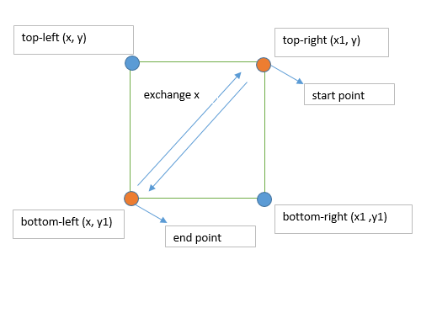
Else if location y of start point greater than location y of end point and location x of start point less than location x of end point. It mean start point now is bottom-left point and end point is top-right point. We exchange location x of start point and end point for each other.
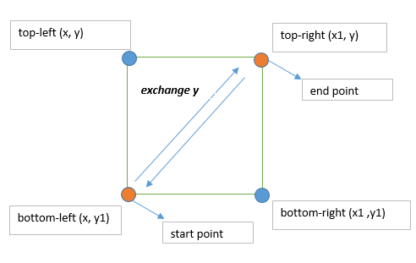
Else if location x of start point greater than location x of end point and location y of start point greater than location y of end point. It mean start point now is bottom-right point and end point is top-left point. We exchange swap two point for each other.
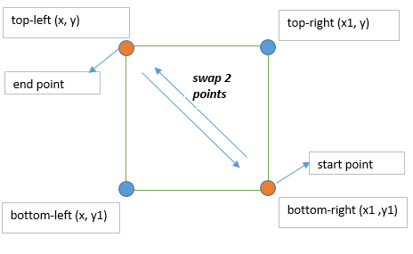
Else if location x of start point equal to location x of end point and location y of start point is greater than location y of end point. In this situation user just select one vertical line so start point now is bottom point and end point now is top point. We swap 2 points to each other.
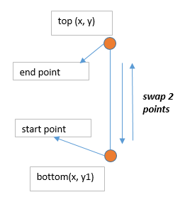
Else if location x of start point greater than location x of end point and location y of start point equal to location y of end point. In this situation user just select one horizontal line so start point now is right point and end point is left point. We swap 2 points to each other.
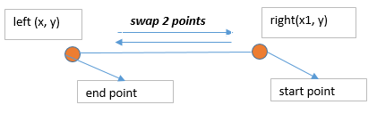

ANalysis
We testing to create a room with 300 seat. We choose multiple select mode.
First we select start point is top-right point and end point is bottom-left point, after run our algorithm start point has been convert to top-left point and end point convert to bottom-right point. Similar to other case, all case is work fine and has no error. After that we choose to extra 2 rows and 2 column the interface corresponded in right way when adding it in matrix interface template. Then we clicked preview to see how the room will display and click save. After save it, we choose to view the room we just created. Everything look the same with the last time we preview it before save.
From now customer can booking ticket on this room easily using virtual cinema interface modal.

EXPERIMENTAL RESults and conclusion
We wrote the data structures, as described in Section 3.1, in Java script [3], using AngularJS framework [2], and using Sql server to store data. In our experiments, with the help of 2 ways data binding of AngularJS framework the code run very fast and response immediately.
Our code, both source and executable, is available online [1]. A set of 80-300 cell on template will display on matrix, depended on what capacity user has choose. User must select all seats before save, suggest that choose multiple select mode for quicker. The seat user select will convert to orange to distinct with other unselected cell.
Our testing will let manager create a room with all seat. The process create room is working good. After create room, we starting booking ticket on that seat. The result of testing is smoothly and has no error.

Acknowledgment (Heading 5)
Expression the supporting from some one ….

References

- Online Cinema Booking System
https://github.com/DanhlcGitHub/CinemaTicket
- Angular Framewok library
https://angularjs.org
- Javascript language
https://www.javascript.com/

