Sơ đồ quan hệ lớp core
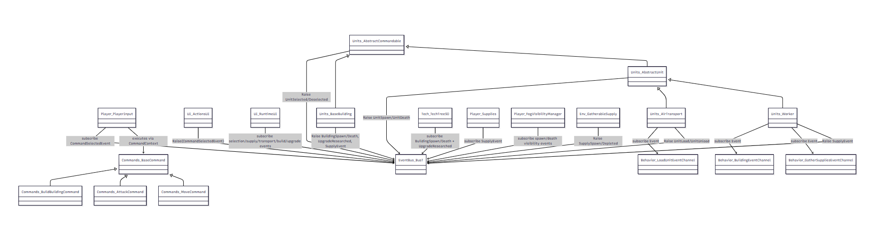
classDiagram
class Player_PlayerInput
class UI_ActionsUI
class UI_RuntimeUI
class Commands_BaseCommand
class Commands_MoveCommand
class Commands_AttackCommand
class Commands_BuildBuildingCommand
class Units_AbstractCommandable
class Units_AbstractUnit
class Units_Worker
class Units_BaseBuilding
class Units_AirTransport
class EventBus_BusT
class Tech_TechTreeSO
class Player_Supplies
class Player_FogVisibilityManager
class Env_GatherableSupply
class Behavior_BuildingEventChannel
class Behavior_GatherSuppliesEventChannel
class Behavior_LoadUnitEventChannel

Commands_BaseCommand <|-- Commands_MoveCommand
Commands_BaseCommand <|-- Commands_AttackCommand
Commands_BaseCommand <|-- Commands_BuildBuildingCommand
Units_AbstractCommandable <|-- Units_AbstractUnit
Units_AbstractCommandable <|-- Units_BaseBuilding
Units_AbstractUnit <|-- Units_Worker
Units_AbstractUnit <|-- Units_AirTransport

Player_PlayerInput --> Commands_BaseCommand : executes via CommandContext
UI_ActionsUI --> EventBus_BusT : Raise(CommandSelectedEvent)
Player_PlayerInput --> EventBus_BusT : subscribe CommandSelectedEvent
Units_AbstractCommandable --> EventBus_BusT : Raise UnitSelected/Deselected
Units_AbstractUnit --> EventBus_BusT : Raise UnitSpawn/UnitDeath
Units_BaseBuilding --> EventBus_BusT : Raise BuildingSpawn/Death, UpgradeResearched, SupplyEvent
Units_Worker --> EventBus_BusT : Raise SupplyEvent
Units_AirTransport --> EventBus_BusT : Raise UnitLoad/UnitUnload
Env_GatherableSupply --> EventBus_BusT : Raise SupplySpawn/Depleted
Player_Supplies --> EventBus_BusT : subscribe SupplyEvent
Player_FogVisibilityManager --> EventBus_BusT : subscribe spawn/death visibility events
UI_RuntimeUI --> EventBus_BusT : subscribe selection/supply/transport/build/upgrade events
Tech_TechTreeSO --> EventBus_BusT : subscribe BuildingSpawn/Death + UpgradeResearched

Units_Worker --> Behavior_GatherSuppliesEventChannel : subscribe Event
Units_Worker --> Behavior_BuildingEventChannel : subscribe Event
Units_AirTransport --> Behavior_LoadUnitEventChannel : subscribe Event

Luồng giao tiếp run time
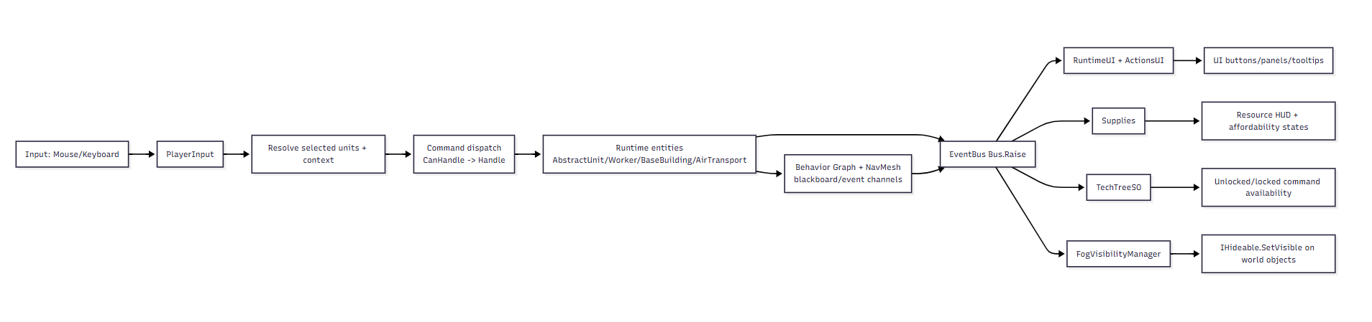
flowchart LR
A[Input: Mouse/Keyboard] --> B[PlayerInput]
B --> C[Resolve selected units + context]
C --> D[Command dispatch<br/>CanHandle -> Handle]
D --> E[Runtime entities<br/>AbstractUnit/Worker/BaseBuilding/AirTransport]
E --> F[Behavior Graph + NavMesh<br/>blackboard/event channels]
E --> G[EventBus Bus<T>.Raise]
F --> G
G --> H[RuntimeUI + ActionsUI]
G --> I[Supplies]
G --> J[TechTreeSO]
G --> K[FogVisibilityManager]
H --> L[UI buttons/panels/tooltips]
I --> M[Resource HUD + affordability states]
J --> N[Unlocked/locked command availability]
K --> O[IHideable.SetVisible on world objects]

