

User Requirement Specification

Contents

Introduction 9

User requirements 9

Non-functional requirements 9

Functional requirements 9

Desktop application 9

Web application 10

Use Cases – Desktop application 10

Use Cases – Web application 15

Sample GUI 19

Desktop Application 19

Web Application 24

Introduction

This document aims to provide insight into the technical aspects of the software developed for DuelSys inc, who want a software solution to allow their customers (sport associations) to manage their sport tournaments.

User requirements

This document uses the MoSCoW user requirement classification system, in which each letter stands for the following:

**M – Must have:** will be implemented mandatorily  
**S – Should have:** should be implemented unless there is a lack of time to do so  
**C – Could have:** nice to have features/ideas that are not essential and are not a priority  
**W – Won’t have:** features that will not be implemented

Non-functional requirements

1. NFR-01(M): Applications are maintainable and extendable
2. NFR-02(M): System is bug free
3. NFR-03(M): Software is secure

Functional requirements

Desktop application

1. FR-01(M): Staff must be able to log in the application
2. FR-02(M): Staff must be able to log out of the application
3. FR-03(M): Staff must be able to create accounts for other staff members
4. FR-04(M): Staff must be able to create tournaments
5. FR-05(S): Staff must be able to specify tournament’s system
6. FR-06(M): Staff must be able to see all pending/ongoing/ended tournaments
7. FR-07(M): Staff must be able to edit the information of non-started tournaments
8. FR-08(M): Staff must be able to delete non-ongoing tournaments
9. FR-09(M): Staff must be able to start any pending tournaments with the click of a button
10. FR-10(M): System must generate tournament schedule related to its type
11. FR-11(S): System should be able to start pending tournaments automatically
12. FR-12(M): Staff must be able to see all games in a tournament
13. FR-13(M): Staff must be able to register the result of a tournament game

Web application

1. FR-14(M): Users must be able to register in the application
2. FR-15(M): Users must be able to log in the application
3. FR-16(M): Users must be able to log out of the application
4. FR-17(M): Users must be able to see all pending/ongoing/ended tournaments
5. FR-18(M): Users must be able to see information and results about a specific tournament
6. FR-19(M): Players must be able to register for a pending tournament
7. FR-20(M): Players must be able to deregister from a pending tournament
8. FR-21(C): Players could be able to see their profile information

Use Cases – Desktop application

UC-01

Use case: Log in the application

Actor: Staff

Main Success Scenario:

1. Staff fills out credentials and confirms
2. System navigates staff to app’s home page

Extensions

1a. Credentials are incorrect

1. System displays wrong credentials message
2. Return to MSS step 1

UC-02

Use case: Log out the application

Actor: Staff

Pre-Condition: Logged in the application

Main Success Scenario:

1. Staff clicks log out button
2. System navigates staff to app’s log in page

UC-03

Use case: Staff creates account in the application

Actor: Staff

Pre-Condition: Logged in the application

On the home screen

Main Success Scenario:

1. Staff clicks button to register user
2. System navigates staff to “Register account” screen
3. Staff fills account information
4. Staff clicks button to confirm
5. System displays success message

Extensions

1a. Details are incorrect

1. System displays error message
2. Return to MSS step 3

UC-04

Use case: Staff adds tournament to the system

Actor: Staff

Pre-Condition: Logged in the application

On the home screen

Main Success Scenario:

1. Staff clicks button to add a new tournament
2. Staff fills in tournament’s information
3. Staff clicks button to confirm
4. System adds tournament to the system
5. System displays success message

Extensions

1a. Details are incorrect

1. System displays error message
2. Return to MSS step 2

UC-05

Use case: Staff sees all tournament in the system

Actor: Staff

Pre-Condition: Logged in the application

On the home screen

Main Success Scenario:

1. Staff member chooses to see all pending tournaments
2. System displays pending tournaments

Extensions

1a. Staff member chooses to see all ongoing tournaments

1. System displays ongoing tournaments

1b. Staff member chooses to see all ended tournaments

1. System displays ended tournaments

UC-06

Use case: Staff edits the information of a tournament

Actor: Staff

Pre-Condition: Logged in the application

On the home screen

Main Success Scenario:

1. Staff selects tournament from list
2. Staff clicks button to edit tournament
3. Staff fills in new information for tournament
4. Staff clicks button to confirm
5. System displays success message

Extensions

1a. Tournament has started

1. System displays error message
2. Return to MSS step 1

1b. Tournament has ended

1. System displays error message
2. Return to MSS step 1

UC-07

Use case: Staff deletes a tournament from the system

Actor: Staff

Pre-Condition: Logged in the application

On the home screen

Main Success Scenario:

1. Staff selects tournament from list
2. Staff clicks button to delete tournament
3. Staff clicks button to confirm
4. System displays success message

Extensions

1a. Tournament is ongoing

1. System displays error message
2. Return to MSS step 1

UC-08

Use case: Staff starts any pending tournaments

Actor: Staff

Pre-Condition: Logged in the application

On the home screen

Main Success Scenario:

1. Staff clicks button to start tournaments
2. System starts tournaments
3. System generates schedules for tournaments
4. System displays success message

Extensions

1a. No tournaments to start

1. System displays information message
2. End of use case

UC-09

Use case: Staff views scheduled games for tournament

Actor: Staff

Pre-Condition: Logged in the application

On the home screen

Main Success Scenario:

1. Staff selects tournament from list
2. Staff clicks button to view tournament games
3. System navigates staff to “View games” screen

UC-10

Use case: Staff registers result of a tournament game

Actor: Staff

Pre-Condition: Logged in the application

On the “View games” screen

Main Success Scenario:

1. Staff selects game from list
2. Staff clicks button to edit game
3. System navigates staff to “Enter results” screen
4. Staff enters game results
5. Staff clicks confirm button
6. System displays success message

Extensions

1a. Invalid score for game

1. System displays error message
2. Return to MSS step 4

Use Cases – Web application

UC-11

Use case: Register in the application

Actor: User

Main Success Scenario:

1. User clicks button to register
2. System navigates user to site’s register page
3. User fills in information
4. User clicks button to register in
5. System displays success message
6. System redirects user to “Log in” page

Extensions

1a. Credentials are incorrect

1. System displays wrong credentials message
2. Return to MSS step 3

UC-12

Use case: Log in the application

Actor: User

Main Success Scenario:

1. User clicks button to log in
2. System navigates user to site’s login page
3. User fills in information
4. User clicks button to log in
5. System displays success message

Extensions

1a. Credentials are incorrect

1. System displays wrong credentials message
2. Return to MSS step 1

UC-13

Use case: Log out of the application

Actor: User

Main Success Scenario:

1. User clicks button to log out
2. System displays success message

UC-14

Use case: User navigates to “Tournaments” page

Actor: User

Main Success Scenario:

1. User clicks on “Tournaments” button
2. System redirects user to “Tournaments” page

UC-15

Use case: User sees all tournaments in the system

Actor: User

Pre-Condition: On “Tournaments” page

Main Success Scenario:

1. User member chooses to see all pending tournaments
2. System displays pending tournaments

Extensions

1a. User member chooses to see all ongoing tournaments

1. System displays ongoing tournaments

1b. User member chooses to see all ended tournaments

1. System displays ended tournaments

UC-16

Use case: User sees information about tournament

Actor: User

Pre-Condition: On “Tournaments” page

Main Success Scenario:

1. Users clicks on info next to a tournament
2. System redirects user to “Tournament details” page

UC-17

Use case: Player registers for a tournament

Actor: Player

Pre-Condition: Logged in as a player

On “Tournament details” page

Main Success Scenario:

1. Player clicks button to register for tournament
2. System displays success message

Extensions

1a. Player is already registered for this tournament

1. System displays error message
2. End of use case

2a. Tournament begins in less than one week

1. System displays error message
2. End of use case

UC-18

Use case: Player deregisters from a tournament

Actor: Player

Pre-Condition: On “Tournament details” page

Main Success Scenario:

1. Player clicks button to deregister from tournament
2. System displays success message

Extensions

1a. Player is not registered for tournament

1. System displays error message
2. End of use case

2a. Tournament begins in less than one week

1. System displays error message
2. End of use case

UC-19

Use case: User sees their profile page

Actor: User

Pre-Condition: Logged in

Main Success Scenario:

1. User clicks button to view their profile
2. System navigates user to “Profile” screen

Sample GUI

Desktop Application

**Note that these screenshots are an early draft of the GUI and are not final**

Login screen

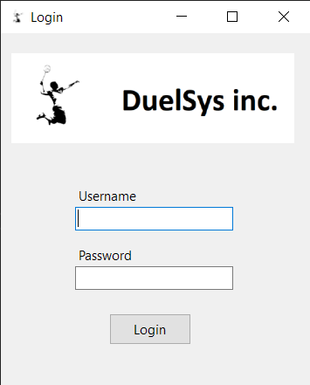

Related to: UC01

Home screen

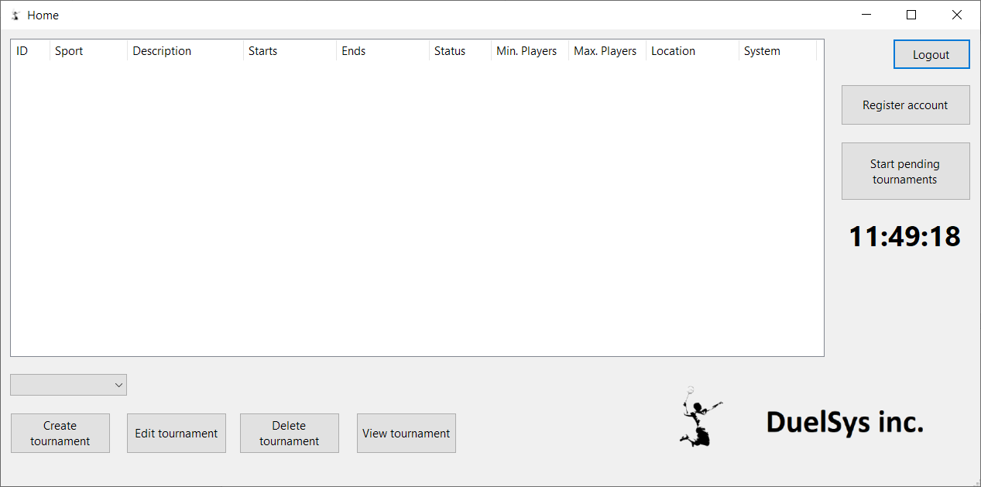

Related to: UC02, UC03, UC04, UC05, UC06, UC07, UC08, UC09

Register account screen

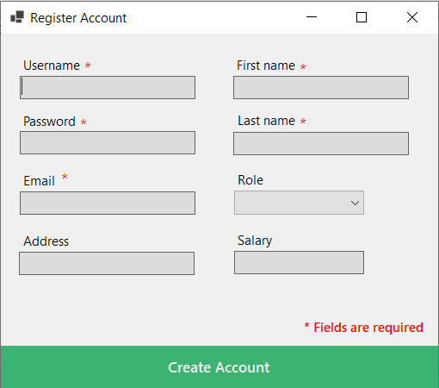

Related to: UC03

Create tournament screen

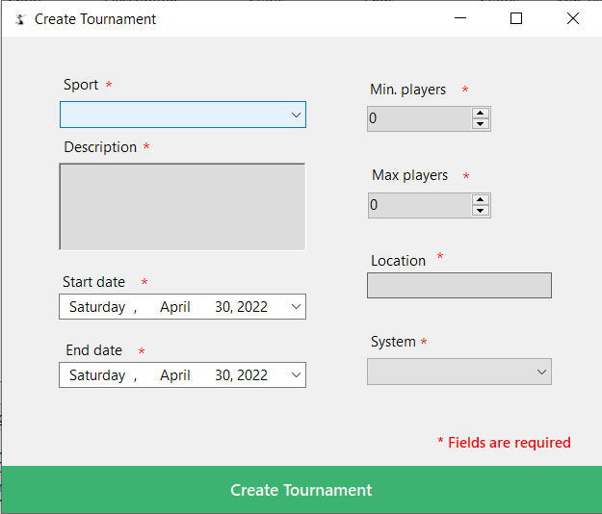

Related to: UC04

Edit tournament screen

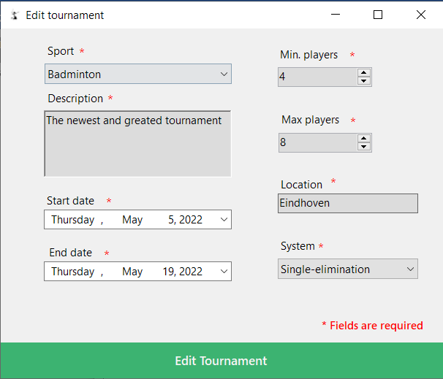

Related to: UC06

View games screen

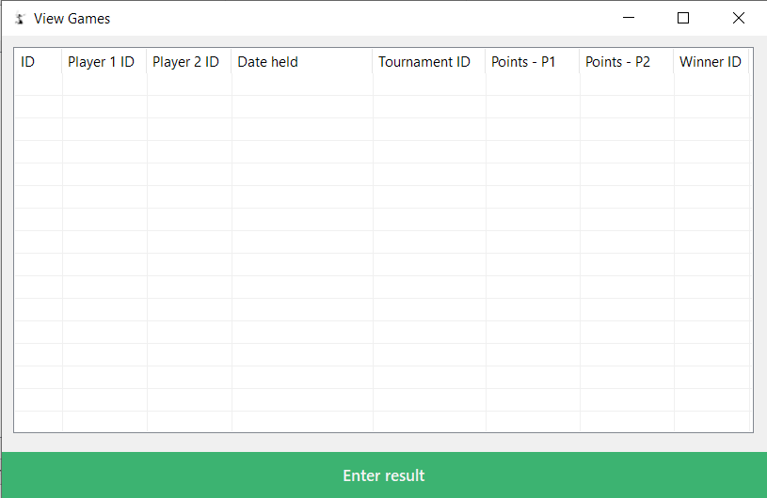

Related to: UC09

Enter result screen

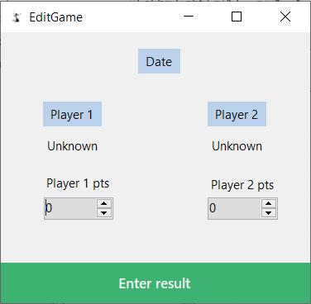

Related to: UC10

Web Application

**Note that these screenshots are an early draft of the GUI and are not final**

Landing page

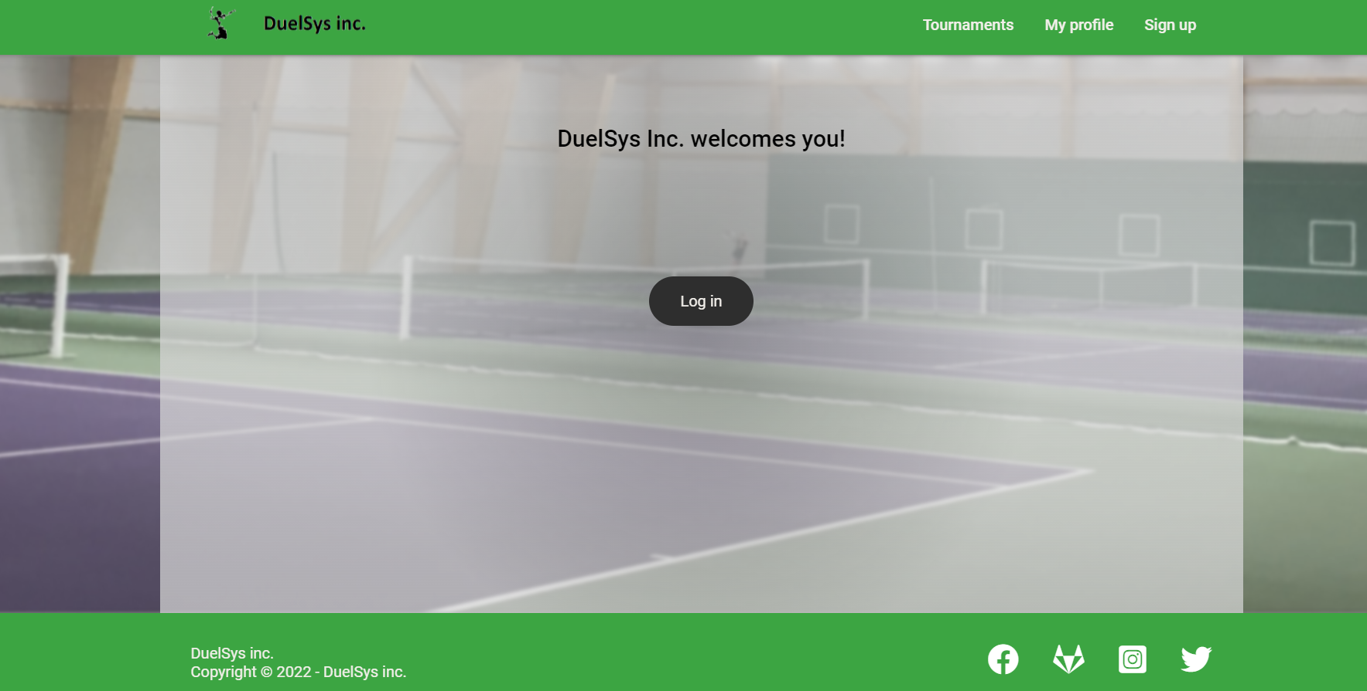

Related to: UC11, UC12, UC13, UC14, UC19

Login page

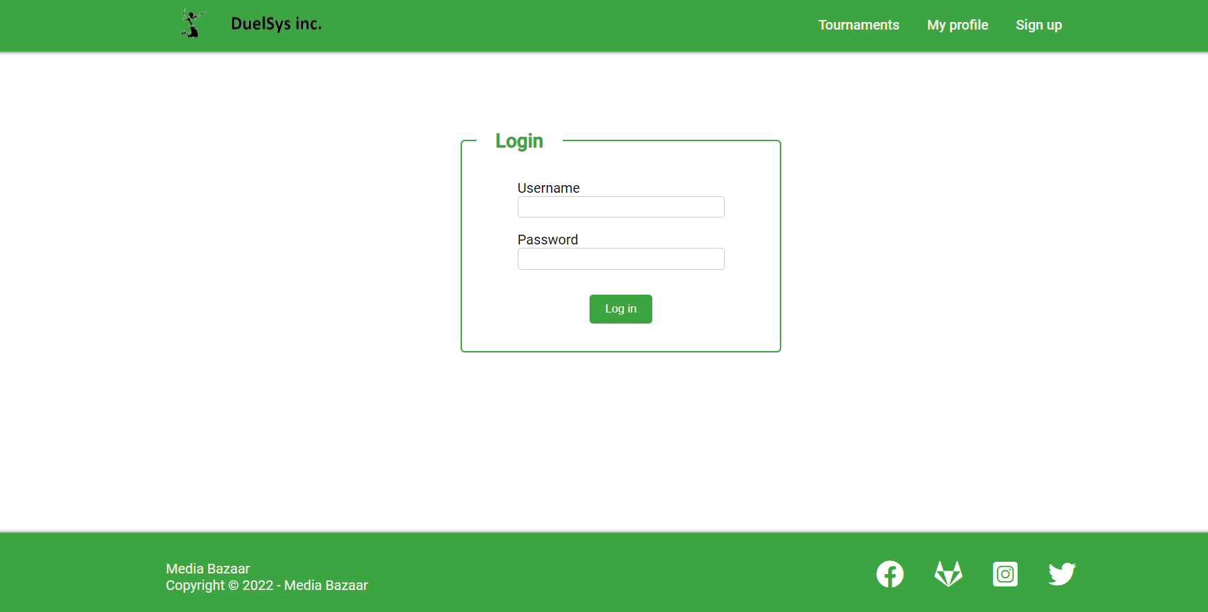

Related to: UC11

Register page

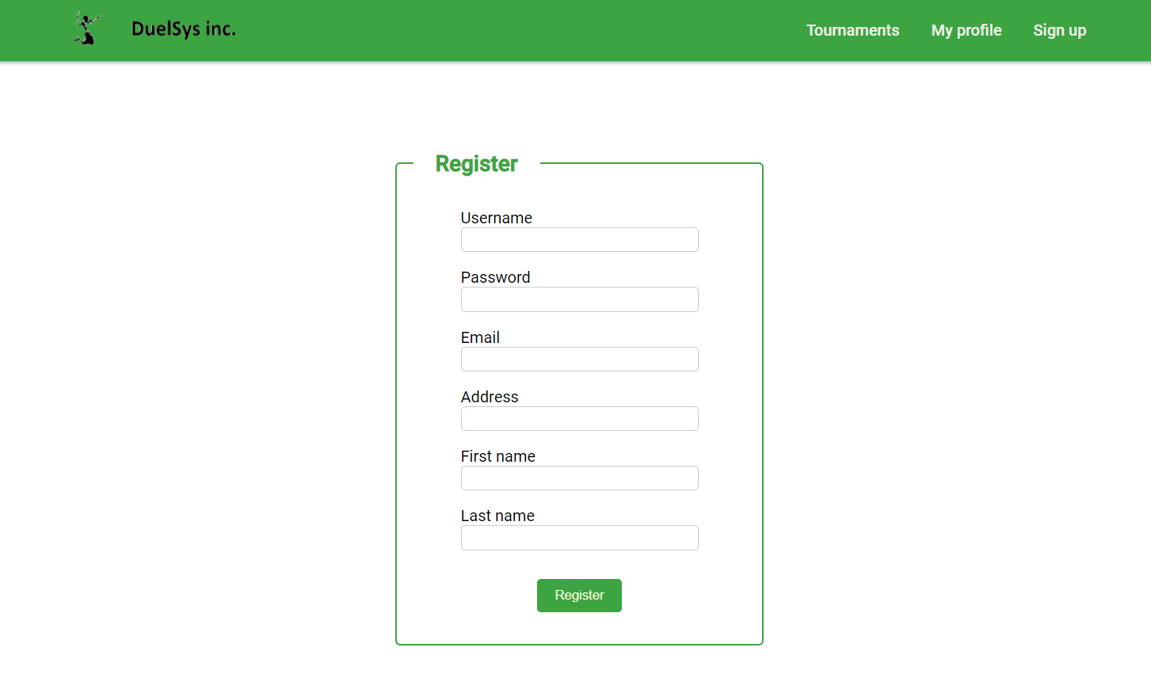

Related to: UC12

Tournaments page

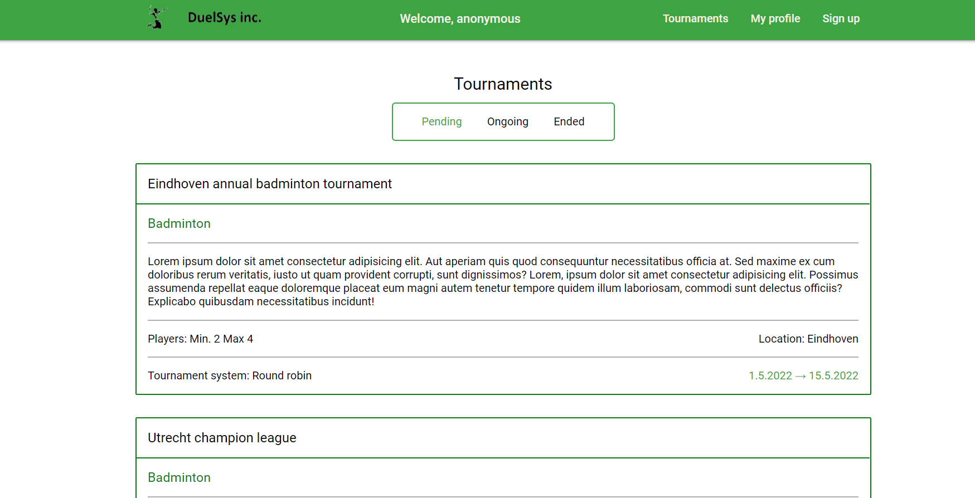

Related to: UC15, UC16

Tournament details page

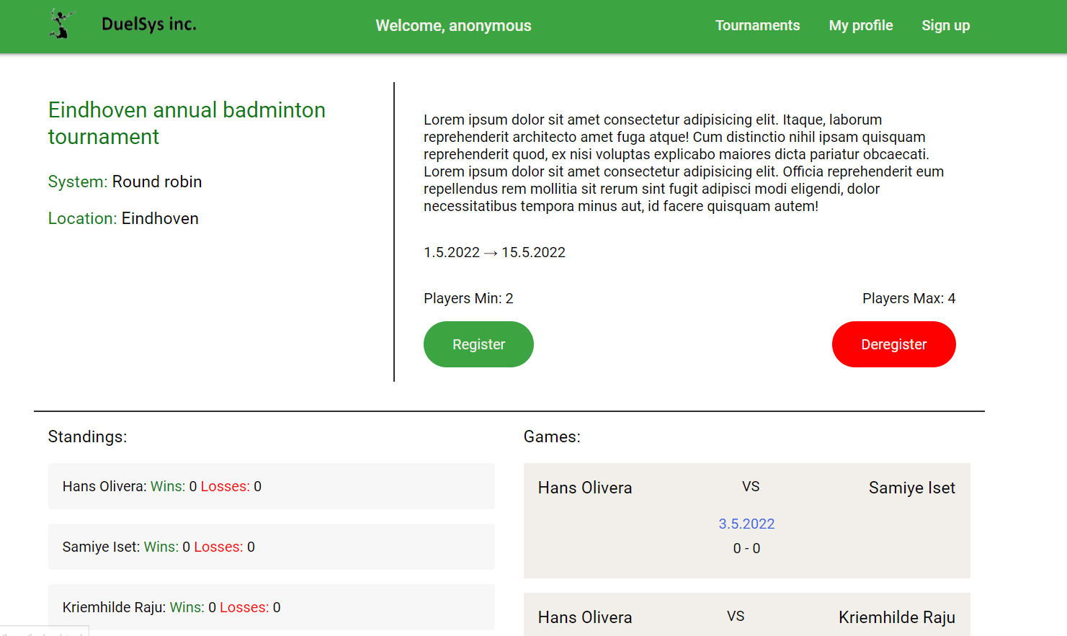

Related to: UC16, UC17, UC18

Profile page

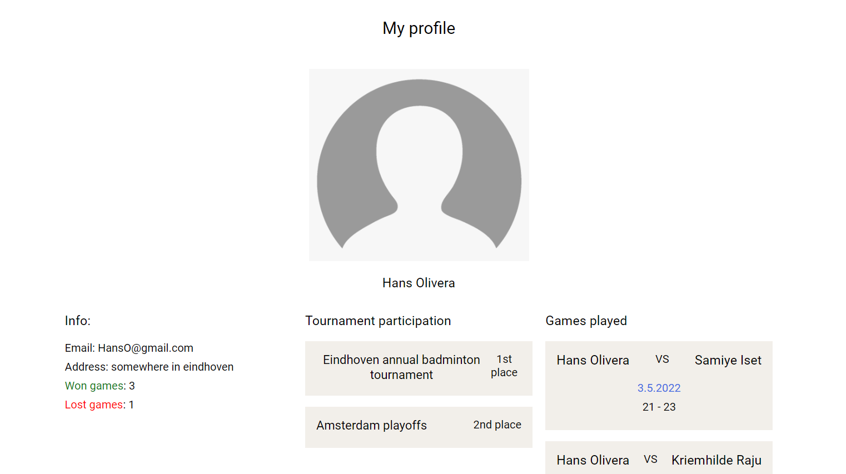

Related to: UC19