# Ideation Document - WatchedIT

Application description – The app is going to be centered around reading reviews for movies (Like IMDb). There are going to be two types of users – regular users and admins. The content is about movies, series, episodes and reviews. A series consists of episodes. A movie is standalone by itself. Admins can add, view, edit and delete movies, series and episodes. Regular users can post a review about an episode or movie and can view all other reviews. They can also edit and delete their own review.

Sitemap of the application

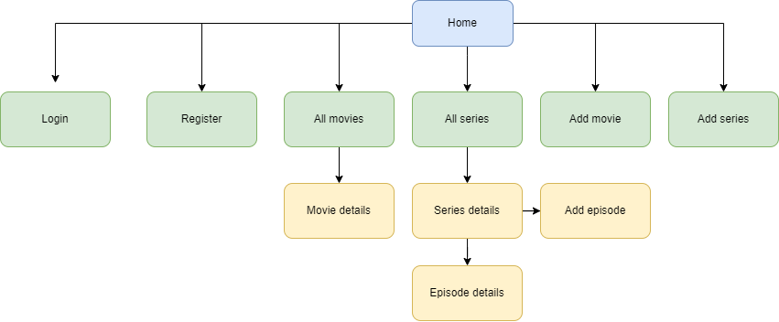

## Wireframes:

Landing page

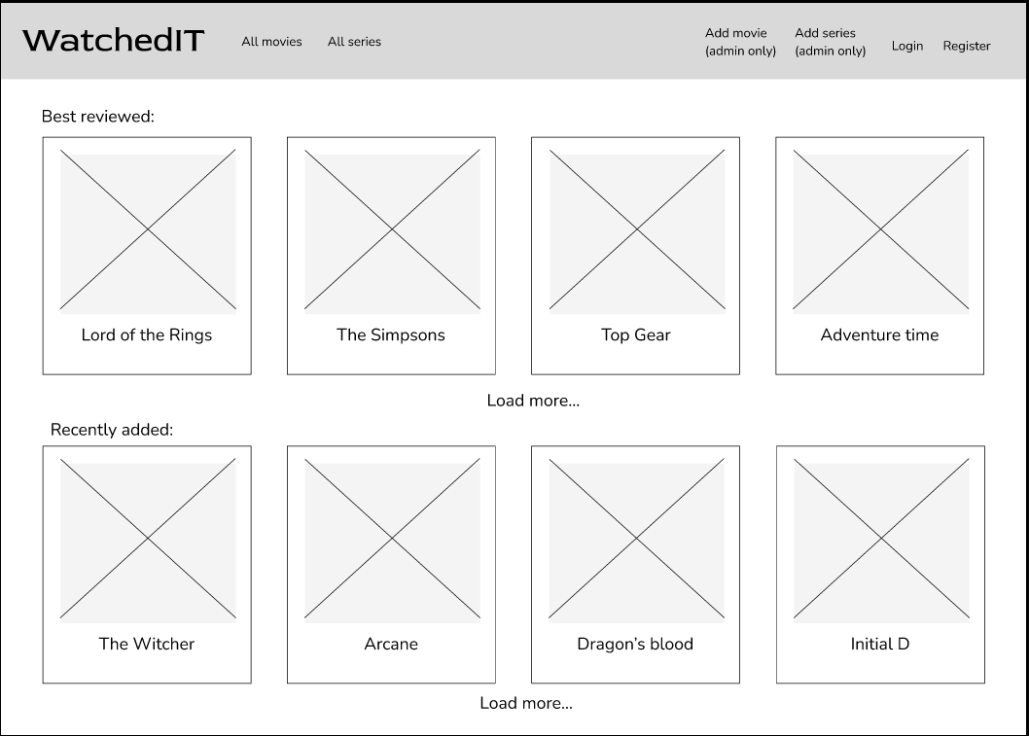

All movies page

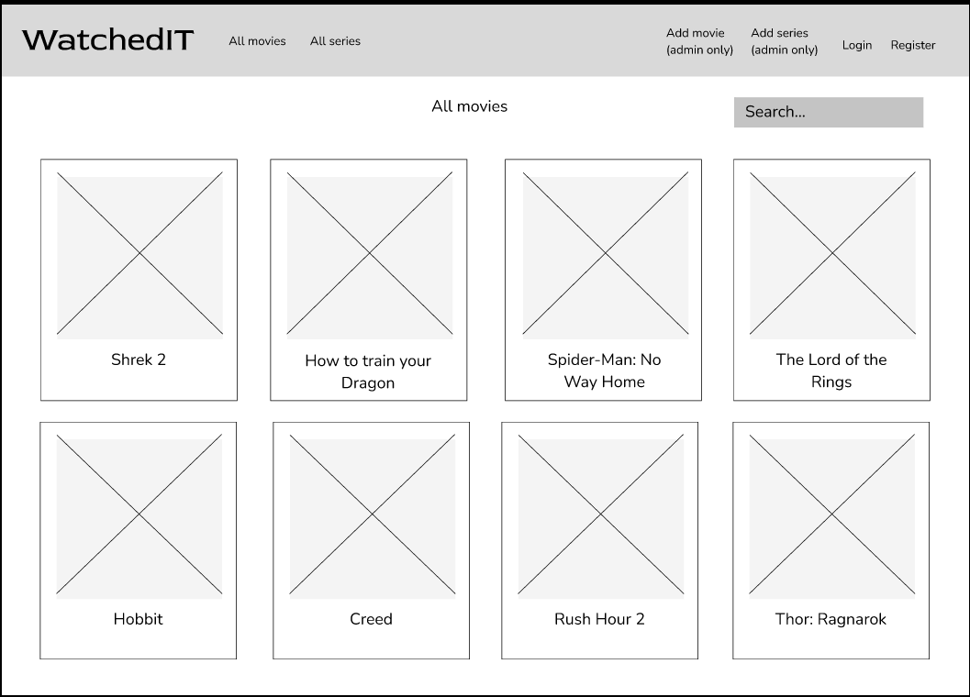

All Series page

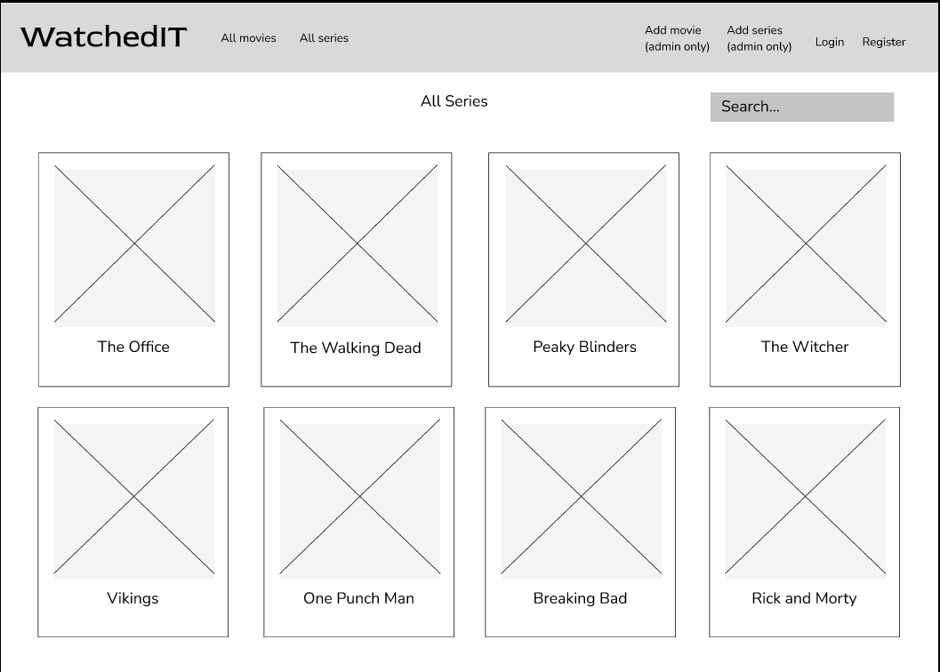

Login page

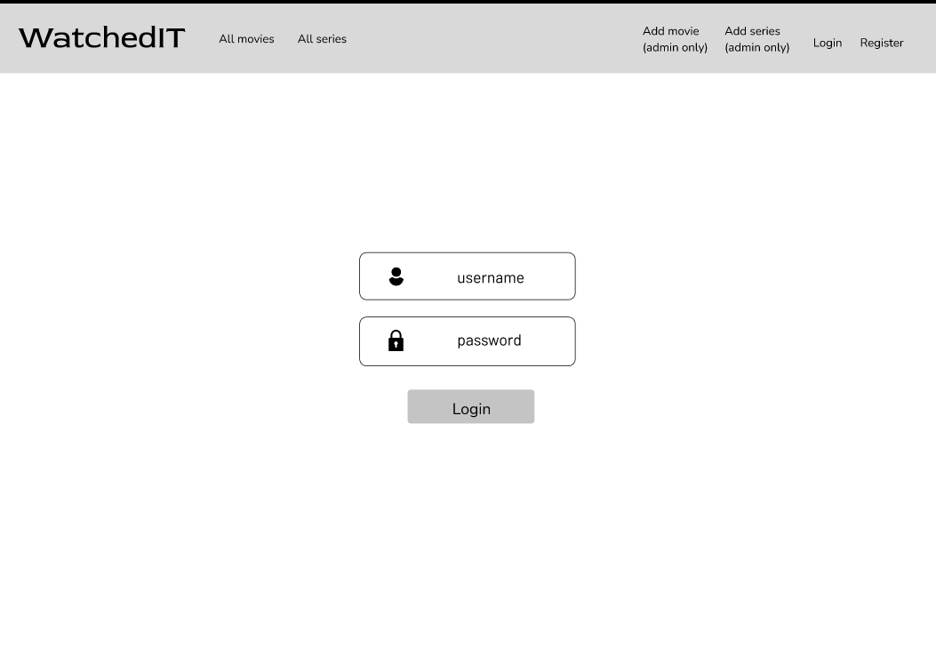

Register page

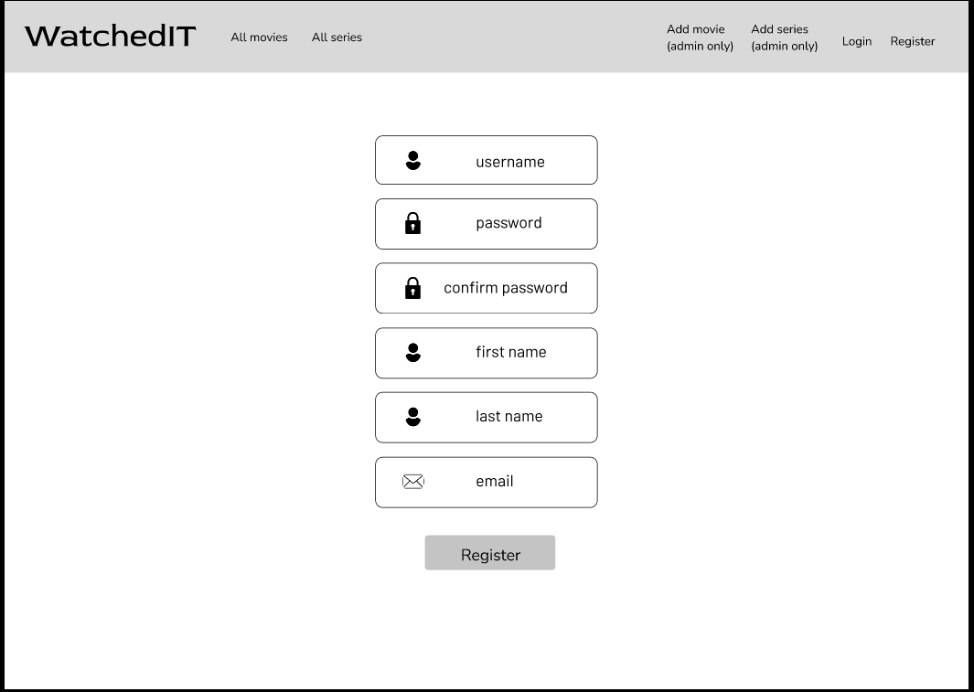

Add movie page

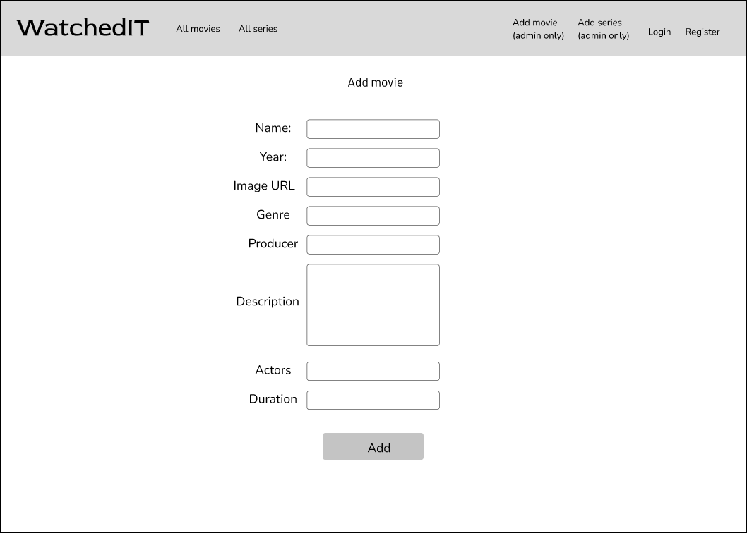

Add episode page

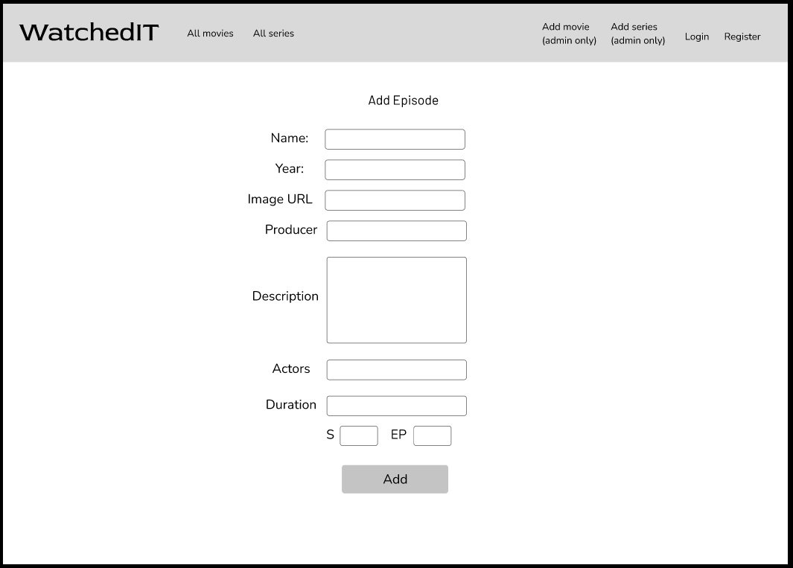

Add series page

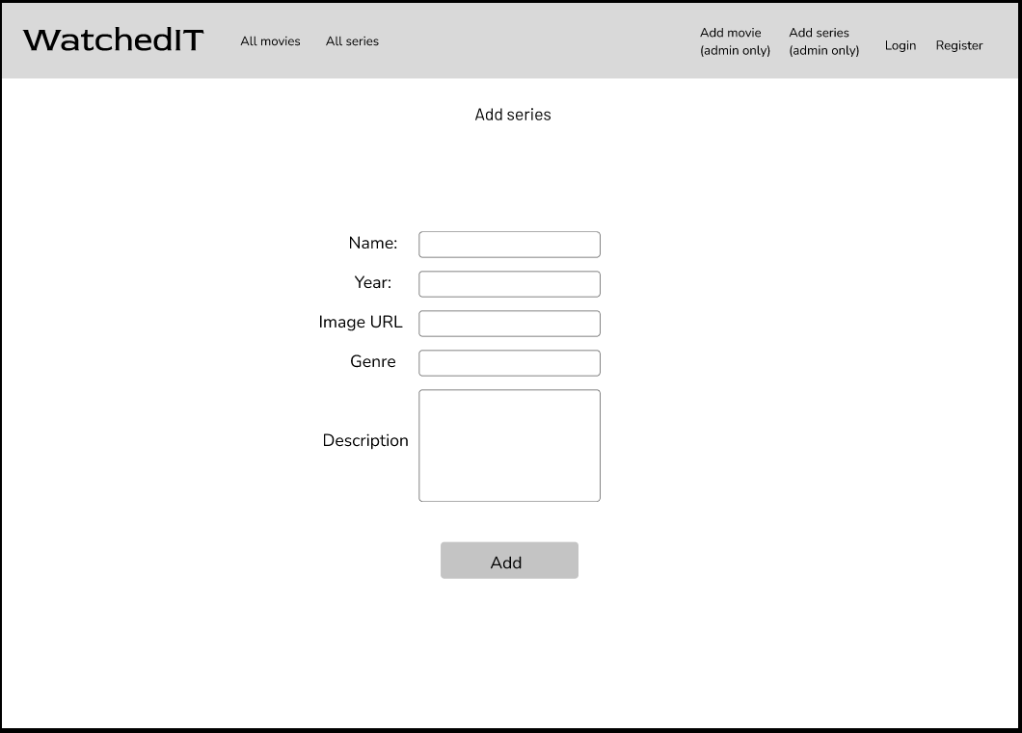

Movie/Episode details page

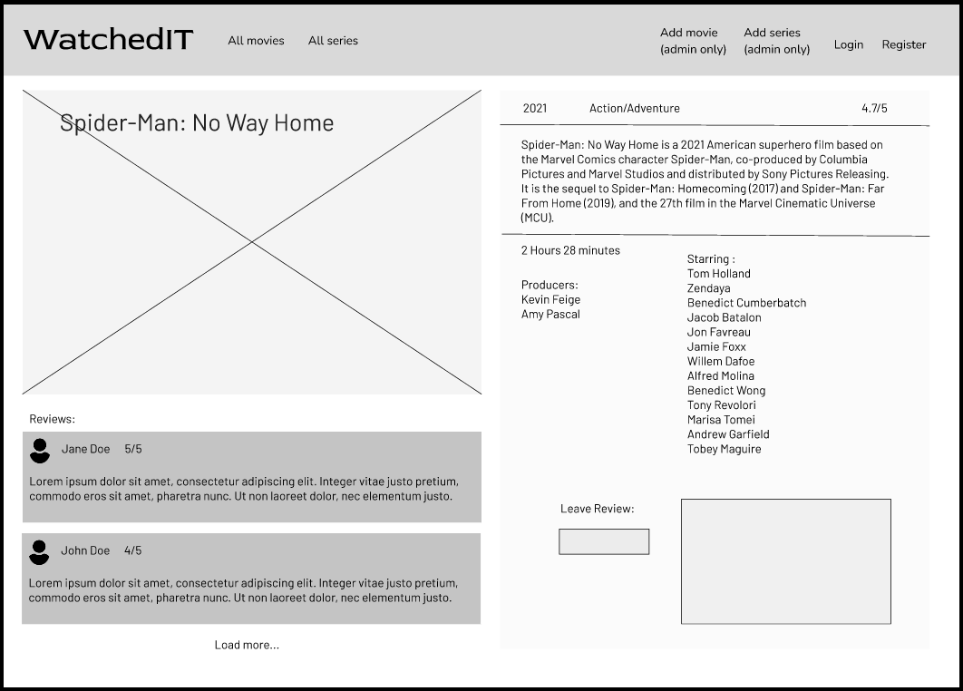

Series details page

