**Temperature affects predator-prey interactions in an African savanna**

D. Rabaiotti1,2, Adam T. Ford3, Ben Chapple2, Sophie Morrill2,

Jacob R. Goheen4 and Rosie Woodroffe1

1Institute of Zoology, Regents Park, London, UK, NW1 4RY

2Department of Genetics, Evolution and Environment, University College London, Gower Street, London, UK, WC1H 0AG

3Departent of Biology, University of British Columbia, 3187 University Way, ASC 413, Kelowna, BC Canada V1V 1V7

4Departent of Zoology and Physiology, University of Wyoming, 1000 E. University Ave., Laramie, USA, WY 82071

# Abbreviated title: Temperature affects pred-prey interactions Key words: Predator-prey interactions, temperature, climate change, habitat use, predation, Lycaon pictus, impala, dik-dik, behaviour, African wild dog

# Article type: Letters

***Number of words:*** Abstract = 149, Main text = 4998

***Number of references:*** 49

***Number of figures, tables and text boxes:*** 6

***Corresponding author:*** D. Rabaiotti, Daniella.Rabaiotti@ioz.ac.uk, +447968018087

# Data Accessibility Statement

Should the article be accepted the data will be deposited on Dryad and the DOI included at the end of the article

# Statement of Authorship

Adam ford, Rosie Woodroffe and D. Rabaiotti designed the research questions. D. Rabaiotti organised the datasets, designed and carried out the final analyses and wrote the paper. Rosie Woodroffe ran the field site from which the African wild dog was collected and contributed to the writing of the paper. Adam Ford and Jacob Goheen collected the dikdik and impala data and contributed to the writing of the paper. Ben Chapple helped design and carry out the analyses on the impala and dikdik data and African wild dog habitat use. Sophie Morrill assisted in designing and carrying out the analyses on wild dog hunt times.

# Abstract

Through changes in the escape speed of prey, attack speed of predators, and the daily activity rhythms or habitat use of both predators and prey, climate warming may alter predator-prey dynamics. In studying a three-species predator-prey system, we predicted that, at high temperatures, African wild dogs (*Lycaon pictus*) would increase predation on impala, (*Aepyceros melampus*) relative to dikdik (*Madoqua guentheri*), due to shifts in habitat use and the greater ability of smaller bodied animals to dissipate body heat. In contrast with these predictions, we found that fewer wild dog scats contained impala when temperatures were high. We found that wild dogs spent less time hunting on hot days and, consistent with the predictions of optimal foraging theory, selected the abundant, lower value dikdik over the rarer, but higher value impala. Our findings contrast with the widely-held assumption that climate change will not affect interactions between endothermic predators and prey.

**Keywords:** African wild dog;antipredator behaviour; climate change; dikdik; habitat selection; impala; predation thermal tolerance

# Introduction

Climate change has far-reaching impacts on both species and ecosystems (Parmesan & Yohe 2003). Meta-analyses suggest that climate impacts on individual species often operate indirectly, through their effects on species interactions such as competition, herbivory, predation, and parasitism (Cahill *et al.* 2012; Ockendon *et al.* 2014). Therefore, understanding how weather affects species interactions may help to make general predictions about which species are most vulnerable to climate change, and therefore in need of conservation interventions.

The effect of climate on species interactions also has impacts beyond individual species. Global Ecosystem Models, such as the Madingley Model, are designed to predict worldwide ecosystem responses to climate change, and thus intended to guide policy decisions about activities such as carbon emissions and land use planning (Harfoot *et al.* 2014). Such models are likely to be sensitive to assumptions about how climate influences species interactions, because interactions between species play a central role in shaping ecosystems.

Shifts in individual behaviour can drive climate impacts on species interactions. For example, rising ambient temperatures may allow ectotherms to move more rapidly, potentially making them more efficient predators and more challenging prey, with cascading consequences for community structure (Dell, Pawar & Savage 2014). It is usually assumed that temperature has no similar impacts on predation involving endotherms (e.g., Dell, Pawar & Savage 2014; Harfoot *et al.* 2014); however, birds and mammals may respond to high ambient temperatures by curtailing their foraging time (Ricklefs & Hainsworth 1968; Quaglietta, Mira & Boitani 2018), switching from diurnal to nocturnal foraging (Levy *et al.* 2018), selecting different habitats (Austin 1976; Pigeon *et al.* 2016), and choosing different foods (Doolan & Macdonald 1996; Garcia-Heras *et al.* 2017), all of which are likely to influence their impacts on the species that they consume, or that consume them. It has been suggested that predator-prey interactions involving large-bodied endotherms might be especially sensitive to temperature, because the low surface-area-to-volume ratios of large animals may make it difficult to dissipate the heat generated by pursuing or avoiding predation (Speakman & Krol 2010; Creel *et al.* 2016). Hence, with respect to the outcome of predator-prey interactions, high ambient temperatures might potentially favour (1) endothermic prey that are smaller than their endothermic predators; and (2) endothermic predators that are smaller than their endothermic prey (Creel *et al.* 2016). Predation by and on large-bodied endotherms can have cascading effects on community structure (e.g., Fortin *et al.* 2005; Johnson, Isaac & Fisher 2007), and these effects might therefore be sensitive to changes in ambient temperature.

These examples demonstrate the multiple ways in which one element of climate change (rising ambient temperature) might alter individual behaviour, and hence predator-prey interactions among endotherms. We quantified the relative importance of these potential mechanisms using a three-species predator-prey system in an African savanna, where two ungulate species, impala (*Aepyceros melampus*) and Guenther’s dikdik (*Madoqua guentheri*), share a common predator, the African wild dog (*Lycaon pictus*). At our study site in Kenya, impala and dikdik are the two most abundant ungulates, and their browsing shapes plant communities (Ford *et al.* 2014; Ford *et al.* 2015). Wild dogs are crepuscular, and hunt by running prey down (Creel & Creel 1995); dikdik and impala together comprise 82% of the prey biomass that wild dogs consume at our study site (Woodroffe et al. 2007).

We evaluated four sets of hypotheses about the impacts of ambient temperature on predation by wild dogs on impala and dikdik, based on predicted behavioural changes by predator and prey (Table 1). First, we explored the potential consequences for predation of a scenario in which animals reduced their activity time during daytime, when solar radiation makes ambient temperatures highest (Table 1, Scenario 1). Previously, we have shown that wild dogs are less active on hot days (Rabaiotti & Woodroffe 2019), which may reflect shorter hunting periods (Woodroffe 2011b). Optimal foraging theory suggests that, when foraging time is limited, individuals should accept lower-value prey when encountered, rather than continuing to search for higher-value prey (Lucas 1983). Therefore, we expected that, if wild dogs had reduced foraging time, they would increase predation on dikdik (which are encountered more frequently but are too small to feed a whole pack) over impala, which are larger but encountered less frequently (Woodroffe *et al.* 2007). We term this, Scenario 1, the ‘reduced foraging time scenario’.

Second, we investigated whether increased nocturnal activity influenced the outcome of interactions between wild dogs and their prey. Following hot days, wild dogs are more active at night, which we have suggested might reflect increased nocturnal hunting (Rabaiotti & Woodroffe 2019). We predicted that this change might increase wild dog predation on impala, which aggregate at night in small clearings (“glades”), apparently as a form of anti-predator behaviour (Augustine 2004; Otieno et al. 2019), and are therefore predictably located. We thus predicted that wild dogs should select areas in and around glades when hunting on nights following hot days (Table 1). We term this, Scenario 2, the ‘nocturnal prey switching scenario’.

Third, we quantified whether habitat selection might be affected by ambient temperatures, with consequences for predation. Many large mammals select shaded habitat in hot weather (Mole *et al.* 2016; Pigeon *et al.* 2016), and we predicted that wild dogs, impala, and dikdik would do the same (Table 1). Further, we predicted that such a change would increase predation by wild dogs on impala, since impala face higher *per capita* predation rates in habitats characterised by higher woody cover (and thus shade; Ford *et al.* 2014). We term this, Scenario 3, the ‘shade-seeking scenario’.

Finally, we explored the potential consequences of both predators and prey overheating during chases. Creel *et al.* (2016) suggested that, during high-speed chases, wild dogs would overheat more slowly than larger-bodied prey, leading to shorter successful chases at high ambient temperatures as a result of larger species of prey having more difficulty dissipating heat due to their lower surface-area-to-volume ratio (Peters 1986). By extension, we predicted that wild dogs (23kg) would overheat less rapidly than impala (40kg) but more rapidly than dikdik (5kg), leading to increased predation on impala relative to dikdik (Table 1). We termed this, Scenario 4, the ‘chase time scenario’.

These four hypothesised behavioural responses to high ambient temperatures generated four different scenarios, comprising contrasting sets of predictions about trophic interactions between wild dogs, impala, and dikdik (summarised in Table 1). By testing these predictions, we explored the behavioural mechanisms underlying whether, and how, ambient temperature influenced interactions between these three endothermic species, in an attempt to evaluate how climate change might affect this ecosystem through predator-prey interactions.

# Methods

## Study area

The focal area for this study was the Mpala Conservancy, a 200 km2 semi-arid savanna in Kenya managed jointly for livestock production and wildlife conservation (0°17’ N, 36°53’ E). Mpala experiences little seasonal variation in temperature; daily maximum temperature ranges from 20-37°C, and mean annual rainfall is 590mm, varying substantially both within and between years (Caylor, Gitonga & Martins 2017).

Mpala hosts 22 species of wild ungulate, of which dikdik and impala are the two most abundant (Ford *et al.* 2015). Mpala also supports six species of large predator: lion (*Panthera leo*), leopard (*P. pardus*), cheetah (*Acinonyx jubatus*), spotted hyaena (*Crocuta crocuta*), striped hyaena (*Hyaena hyaena*) and African wild dog (Frank, Woodroffe & Ogada 2005).

## Data collection

We used Global Positioning System (GPS) collars to measure daytime and night-time activity, movement, and habitat use. GPS-collars (Savannah Tracking Ltd, Nairobi, Kenya) were fitted to 20 adult female impala (each from a different herd) between May and June 2011, as described in Ford *et al.* (2014). Each impala GPS-collar recorded a location every 20 minutes, for an average of 245 days. Likewise, GPS-collars (Savannah Tracking Ltd, Nairobi, Kenya) were fitted to 15 adult female dikdik between July 2010 and September 2011, as described in Ford & Goheen (2015). Each dikdik GPS-collar recorded a location every 10 minutes, for 18 days on average. Additionally, GPS collars (Vectronic Aerospace GmbH, Berlin, Germany) were fitted to 18 wild dogs in 13 packs between 2011 and 2016, using capture methods described in Woodroffe (2011a); all of these packs had home ranges overlapping Mpala, although none remained on Mpala year-round. Data were collected from one collar per pack at any one time. Each wild dog GPS-collar recorded locations at 01:00, 06:30, 07:00, 07:30, 08:00, 13:00, 18:00, 18:30, 19:30, and also recorded average acceleration in two planes (on a scale of 0 to 255) every five minutes, for 218 days on average.

We used faecal analysis to quantify the relative frequency of predation by wild dogs on impala and dikdik. Wild dog scats were collected during 2001-2004 across a 5,700km2 study area which included Mpala Conservancy, and analysed as described in Woodroffe *et al.* (2007). We avoided pseudoreplication by including only one randomly-selected scat collected from each pack on each occasion (Woodroffe *et al.* 2007).

We drew on daily meteorological data collected at Mpala Research Centre, within the study site (Caylor, Gitonga & Martins 2017). We also recorded pack size of wild dogs through visual observation at least once a month. Finally, we used GPS-collar data to identify periods when wild dog packs were denning (raising small pups in a den, recognisable from the movement path which shows a characteristic “starburst” pattern of repeat visits to the same location, Woodroffe, Groom & McNutt 2017).

## Identifying hunting periods of wild dogs

To estimate the time that wild dogs spent hunting, and to compare prey and predator behaviour at times when predation risk was highest, we used accelerometry data to identify wild dog hunting periods. First, we summed the two accelerometer measurements for each 5-minute period, to give an overall measure of activity (from 0 to 510). We then defined hunt periods based on three criteria: (i) activity >0 for >20 minutes; (ii) total activity during the activity bout >500; (iii) followed by three or more consecutive records of 0 activity. These criteria excluded activity bouts which were too short to relate to hunting periods, or which related to less energetic behaviours, such as socialising. Because this method did not allow us to distinguish chases from other parts of the hunt (e.g. seeking prey, feeding from a kill) we could not measure the duration or speed of chases. For each hunting period, we recorded start time, end time, duration (in minutes), and intensity (total activity divided by duration). The distributions of start and stop times are shown in Figure S1. We classified hunting periods as “morning”, “evening”, “night” or “midday”, based on their start and stop times, as detailed in Table S1 and Figure S1. Bouts that spanned multiple time periods were excluded from the analysis. After using accelerometry data to delineate hunting periods, we categorised each wild dog location as falling either inside or outside a hunting period.

We categorised dikdik and impala GPS collar locations into four time periods. We defined “morning” as the time period between sunrise (taken from the *R* package *suncalc*, Agafonkin & Thieurmel 2017) and the third quartile of end times for hunting periods (approximately 3.5h after sunrise; Figure S2). For example, if sunrise was at 0600h (sunrise at the site varied between 0552h and 0623h), any impala or dikdik GPS-collar locations recorded between 0600h and 0930h were categorised to occur within the “morning” period. We likewise classified impala and dikdik “evening” GPS-locations as those recorded between the first quartile of start times for hunting periods (approximately 2hr10min before sunset; Figure S2) and sunset (which fell between 1841h and 1912h). We then categorised impala and dikdik GPS-locations as “midday” if they were recorded between the “morning” and “evening” periods, and “night” if they were recorded between sunset and sunrise.

## Habitat use

We analysed habitat use from a habitat map of Mpala, created from a 2011 Quickbird satellite image (Digital Globe, Longmont, CO, USA) by Ford *et al.* (2014). We estimated the woody cover (a measure of shadiness) associated with each impala, dikdik, and wild dog GPS-collar location as the proportion of woody cover within a circular area of radius 40m, centred on the collar location.

We used the same habitat map to classify each GPS-collar location in relation to glades. For impala and dikdik, we recorded whether each location fell inside or outside a glade. As <1% of wild dog hunting locations fell inside glades, we recorded the distance to the nearest glade for each wild dog location, using the plugin “*NNJoin*” in *QGIS* (QGIS Development Team 2018).

## Statistical analyses

We used multi-model inference to evaluate associations between each outcome variable and a range of explanatory variables (detailed below). For each outcome variable, we built a series of statistical models using explanatory variables and biologically-meaningful interactions between explanatory variables, with individual identity as a random variable. We then used Akaike’s Information Criterion (AIC) to compare models using the *R* package *MuMIn* (Bartoń 2017). We considered all models with AIC scores within 7 units of the best (lowest AIC) model (*i.e.,* ΔAIC<7) to have some level of support (Burnham et al. 2002), referring to this array of models as the “top set”. We used model averaging (Burnham et al. 2002) to estimate the effect on the outcome variable of each explanatory variable in the top set.

In the reduced foraging time scenario (Scenario 1), we predicted that wild dogs would spend less time hunting on hot days. To test this hypothesis, we analysed continuous outcome variables describing hunt duration, start time, and stop time, within the morning, evening, and night-time periods. We also analysed hunt intensity as a continuous outcome variable, as well as a binary outcome variable describing whether or not a hunt was recorded during each period. Only 10% of hunting periods occurred during midday (accounting for 2% of daily activity), so these were not subjected to statistical analyses. For each of these outcome variables, we constructed Generalised Linear Mixed Models (GLMMs) using the package *nlme* (Pinheiro *et al.* 2015) in *R* (R Core Team 2015), with Gaussian error distribution for the continuous outcome variables and binomial error distribution for the binary outcome variable. Each model included the identity of individual animals as a random effect. Temperature was included as an explanatory variable; for morning and evening hunts the temperature variable was maximum temperature (in °C) on the day of the hunt, while the variable for night-time hunts was maximum temperature during the preceding daytime period.

Although our hypotheses concerned the potential effects of temperature, we included three other explanatory variables known to influence activity patterns of wild dogs (Woodroffe, Groom & McNutt 2017; Rabaiotti & Woodroffe 2019). The first of these variables described whether or not the pack was denning. This variable was included because African wild dogs are more active during the denning period, presumably due to the energetic demands of raising a litter (Woodroffe, Groom and McNutt 2017, Rabaiotti and Woodroffe 2019). The second variable was rainfall (in mm) on the day of the hunt, as rainfall appears to mitigate the impact of high temperatures on activity levels (Rabaiotti and Woodroffe 2019). The third variable was moonlight, expressed in full-moon-hour equivalents, calculated from *suncalc* (Agafonkin & Thieurmel 2017) in *R* by multiplying the proportion of the moon that was illuminated, by the number of hours the moon was in the sky between sunset and sunrise. This variable was included as wild dogs are more active on moonlit nights (Cozzi et al. 2012, Rabaiotti and Woodroffe 2019). Models of night-time activity included moonlight on the same night, while models of morning activity included the previous night’s moonlight, and models of evening activity included moonlight the subsequent night. For models of night-time activity, the time of moonrise and moonset were also included as explanatory variables.

In the nocturnal prey-switching scenario (Scenario 2), we predicted that impala would use glades more at night and that wild dogs would also therefore preferentially target glades at night. To test the first hypothesis, we calculated the proportion of each individual impala’s locations falling within glades during the morning, midday, evening, and night periods for each 24-h period. To test the hypothesis that wild dogs hunted in glades more often at night following hot days, we calculated the mean distance to the nearest glade for each night-time hunt period. We analysed these outcome variables using GLMMs with Gaussian error distribution, using time of day, temperature, rainfall, and rainfall phase as candidate explanatory variables. For wild dogs, we also included explanatory variables describing denning and pack size as these have been shown to impact activity levels in the species.

In the shade-seeking scenario (Scenario 3), we hypothesised that wild dogs, impala, and dikdik would increase their use of shaded habitat at high ambient temperatures. To test this hypothesis, we constructed a series of models with use of woody cover as the outcome variable. To avoid pseudoreplication, we averaged the woody cover values for each individual across each morning, midday, evening or night-time period. For wild dogs, only locations from hunting periods were included. We analysed these outcome variables using GLMMs with individual identity as a random effect, building a separate array of models for each time of day, and for all times of day together. Candidate explanatory variables were the same as for the analyses of wild dog activity (i.e., temperature, rainfall, moonlight, and, for wild dogs, denning), but also included a variable describing rainfall phase. Reflecting the unpredictable rainfall at our study site, and following Ford *et al.* (2014), we considered days to fall within “wet phases” if >50mm of rain had fallen in the previous four weeks, and classed all other days as falling in “dry phases”. In constructing the array of models for multi-model inference, this rainfall phase variable was never included in the same model as daily rainfall, because the two were correlated.

In the chase-speed scenario (Scenario 4), we predicted that chase distances of impala would be shorter on hotter days, while chase distances of dikdik would be longer, leading to greater predation on impala on hotter days (Table 1). We could not measure chase distance as our GPS-collar locations were recorded too infrequently, so our evaluation of this scenario relied on testing the hypothesis that wild dogs killed impala more frequently on hot days. This outcome was also predicted under the nocturnal prey-switching and shade-seeking scenarios (Scenarios 2 and 3). We tested this hypothesis by using a GLM with binomial error distribution to analyse whether or not wild dog scats contained impala remains. In this model, candidate explanatory variables were temperature during the previous seven days (to account for delays between a scat being deposited and collected), and land use type (as a previous study showed that impala were consumed less frequently on community land, relative to private land, Woodroffe *et al.* 2007). Pack or individual identity were often unknown for wild dog scats, so these models did not include random effects.

# Results

## Daily movement patterns

African wild dogs showed a strongly crepuscular activity pattern, with the majority of both hunts and daily activity occurring in the morning and evening time periods (Figure 1, Figure 2). Sixteen percent of wild dog hunting periods, and 17% of daily activity, occurred at night (Figure 1).

## Effects of ambient temperature on wild dog hunting patterns

Consistent with the reduced foraging time scenario (Scenario 1), wild dogs’ daytime hunting periods were shorter in both the morning and evening time periods at high ambient temperatures (Table 2). These shorter hunting periods reflected earlier start and stop times in the morning (Table S2) and later start times in the evening (Table S3). In addition to being shorter, both morning and evening hunts entailed less intense activity on hotter days (Table S2, Table S2). Evening hunts were less likely to occur at all on days with higher ambient temperatures (Table S3), though there was no such effect on morning hunts (Table S2). Rainfall may have mitigated the effects of high ambient temperatures, with rainfall:temperature interactions included in some of the top models for hunt duration and intensity (Table S2, Table S3). Packs were consistently more active during daytime when they were denning (Table S2, Table S3).

Similarly, and as predicted under the nocturnal prey-switching scenario (Scenario 2), wild dogs were more likely to hunt at night following daytime periods with high ambient temperatures (Table 2). There was also some evidence that temperature increased the duration and intensity of night-time hunts (Table S3). Nocturnal activity was increased at higher levels of moonlight (Table 2, Table S4), with corresponding reductions in daytime activity on dates with high moonlight indices (Table 2, Table S2, Table S3).

## Habitat selection

The three species differed in their use of woody cover, with impala using the most open areas and wild dogs using the areas with the highest woody cover (Figure 3). Impala were found in areas with the lowest levels of woody cover during the morning and night-time periods, in comparison with wild dogs, which used the highest levels of woody cover during the night (Figure 3). The use of woody cover by dikdik was relatively consistent throughout the day (Figure 3).

As predicted under the shade-seeking scenario (Scenario 3), impala selected areas with denser woody cover on hotter days, during morning, midday, and evening periods (Table 3). In contrast, there was weak and inconsistent evidence for dikdik selecting woody cover based on ambient temperature, and no evidence of such selection by hunting wild dog packs (Table 3).

The three species also varied in their use of glades. On average, we recorded dikdik closest to glades, and wild dogs furthest from glades, irrespective of time period (Figure S4). Consistent with the nocturnal prey-switching scenario (Scenario 2), impala were more likely to be located in glades at night than at other times (Figure 3C), although there was no such pattern for dikdik (Table 4). In contrast with predictions under Scenario 2, wild dogs were not located closer to glades at night than at other times of day, and were no more likely to be found close to glades at night when daytime temperatures had been high (Table 4). Impala were less likely to be located in glades on moonlit nights, and following days with high temperatures, whereas dikdik appeared more likely to use glades on moonlit nights (Table 4). Pack size was the most consistent predictor of wild dog proximity to glades, with larger packs found in closer proximity (Table 4).

## Prey selection

Among 795 wild dog scats, 71 (9%) contained impala remains and 609 (77%) contained dikdik remains. As predicted under the reduced foraging time scenario (Scenario 1) but not the other three scenarios, wild dog scats were less likely to contain impala remains when temperatures had been higher during the previous seven days (Table 5).

# Discussion

Our analyses revealed clear associations between ambient temperature and the behaviour of both predator and prey species, which appeared to influence predation risk. Our findings were most consistent with the reduced foraging time scenario (Scenario 1), under which we predicted that, on hot days, wild dogs would spend less of the daylight period hunting, and would therefore prefer abundant small prey over larger prey which take longer to locate. Consistent with these predictions, we found that wild dogs’ morning hunts ended earlier (Table S2), and evening hunts started later (Table S3): overall, less time was spent hunting during daytime hours. Previously, we posited that dikdik and impala would yield comparable returns, because the greater energy intake achievable by hunting impala was offset by the shorter travel distances associated with hunting dikdik (Woodroffe *et al.* 2007). However, optimal foraging theory predicts that a predator with limited time should select a more abundant but lower-value prey (such as dikdik) rather than waiting to locate rarer, higher value prey (such as impala, Lucas 1983). High ambient temperatures would therefore be expected to favour wild dogs eating dikdik more than impala, and our observations were consistent with this prediction (Table 4).

Under the nocturnal prey-switching scenario (Scenario 2), we predicted that, when ambient temperatures were high, wild dogs would hunt at night, targeting impala which are predictably located in glades. Although wild dogs hunted more often at night in hot weather (Table 2), and impala were usually located in glades at night (Table 4), there was no evidence that wild dogs targeted impala at night. Wild dogs were no closer to glades at night than at other times of day, and were no closer to glades on nights when daytime temperatures had been high (Table 4). Interestingly, impala were less frequently located in glades on moonlit nights, when wild dogs were more active (Table 4). Moonlight is associated with reduced hunting success in lions (Funston, Mills & Biggs 2001), so it is possible that impala relax their antipredator behaviour and abandon glades on moonlit nights. Alternatively, impala may change their antipredator behaviour in response to wild dog hunting on moonlit nights. In contrast with the predictions of the nocturnal prey-switching scenario (Scenario 2), impala remains were less likely to be found in wild dog scats following periods of high ambient temperature (Table 4). Hence, Scenario 2 did not generate the predicted consequences for either predator behaviour or predation risk.

Under the shade-seeking scenario (Scenario 3), we predicted that all three species would increase their daytime use of woody cover at high ambient temperatures. However, we found that only impala did so (Table 3). Of the three species, impala used the most open habitat (Figure 3, Figure 3C), which may have resulted in a greater need to seek shade at high temperatures. Physiological studies suggest that dikdik are dependent upon shade to thermoregulate (Kamau & Maloiy 1985) but, being small-bodied, they may be able to use small patches of shade without moving into denser habitat. There was no evidence that wild dogs hunted in denser cover on hot days (Table 3), perhaps because hunting periods occurred before and after the hottest times of day (Figure 2). The tendency of impala to move into denser cover at high temperatures would be expected to increase their risk of being killed, since wild dogs typically occupied denser cover (Figure 3), and impala are more likely to be killed in denser cover (Ford *et al.* 2014). Nevertheless, we found that impala remains were less likely to be found in wild dog scats following periods of high ambient temperature (Table 4). Hence, although impala behaviour changed in line with the predictions of the shade-seeking scenario (Scenario 3), this change did not generate the predicted impact on predation risk.

Under the chase speed scenario (Scenario 4), we predicted that high ambient temperatures would reduce chase distances for impala and increase them for dikdik, as larger-bodied animals would be slowed down by the heat to a greater extent than smaller-bodied animals (Creel *et al.* 2016). We were not able to test these hypotheses directly because our monitoring methods did not allow us to measure chase distance or speed. However, under this scenario we also predicted that predation upon impala would increase, relative to predation on dikdik, when ambient temperatures were high. Our observations showed the opposite pattern (Table 4); hence, a key prediction of the chase speed scenario was not upheld by our analyses.

Demographic evidence the reduced foraging time scenario (Scenario 1) over the other scenarios. Under Scenario 1, we would expect energy intake by wild dogs to be reduced at high ambient temperatures, due to constrained foraging time and a consequent acceptance of lower-energy prey. This prediction is consistent with our observations that this study population experiences higher mortality and lower reproductive success at high ambient temperatures (Woodroffe, Groom & McNutt 2017; Rabaiotti *et al.* in review). In contrast, under the other three scenarios, wild dogs’ food intake (and potentially survival and reproductive success), would be expected to improve at high temperatures, because impala (a higher-value prey) would be more accessible due to their being predictably located (Scenario 2, nocturnal prey-switching), in dense cover where they are vulnerable to predators (Scenario 3, shade-seeking), or more easily captured due to their tendency to overheat during high speed chases (Scenario 4, chase speed). Hence, while demographic patterns cannot confirm the reduced foraging time scenario (Scenario 1) as the most likely mechanism whereby temperature influences predator-prey interactions in this system, they do contribute to refuting Scenarios 2-4.

Our findings suggest that climate change might have two wider impacts through its effect on predation by wild dogs. First, we have shown previously that wild dogs suppressed dikdik numbers, and dikdik browsing influenced tree abundance (Ford *et al.* 2015). Although we found that wild dog predation on dikdik did not trigger cascading effects on vegetation (Ford *et al.* 2015), rising temperatures would be expected to intensify wild dog predation on dikdik, which might generate wider impacts on community structure.

Second, our findings suggest that wild dog populations’ resilience in the face of climate change might be affected by the abundance of small, abundant prey. Our study site is unusual both in the density of dikdik it supports (Augustine 2010; Ford et al. 2015) and the degree to which wild dogs rely on dikdik as primary prey (Woodroffe *et al.* 2007). Across much of the geographic range of wild dogs, dikdik are altogether absent (Kingdon & Hoffman 2013), and impala comprise the bulk of wild dog diets (Creel, Mills & McNutt 2004; Mbizah, Marino & Groom 2012). Without abundant small prey to hunt on hot days, we would expect wild dogs to more frequently make no kill at all, with potentially greater impacts on energy intake than may occur at our study site. Low reproductive success and high mortality at high ambient temperatures have been reported for wild dogs from two sites where impala are wild dogs’ principal prey (Woodroffe, Groom & McNutt 2017; Rabaiotti *et al.* In Review), although site-specific conditions complicate any comparison of the magnitude of temperature effects at the different sites.

Our results help to explain the negative impacts of high ambient temperatures on the survival and reproductive success of the African wild dog, an endangered species (Woodroffe & Sillero-Zubiri 2013). Our findings suggest that prey diversity may help to buffer wild dog populations against the effects of climate change, because abundant prey are readily located even when hunting time is constrained. This observation suggests that measures which maintain prey densities and diversity (such as limiting offtake by people) may help to conserve wild dogs in a warming climate. However, interventions which artificially raise prey densities (such as installation of waterholes) may risk increasing the densities of wild dogs’ predators (Creel & Creel 1996; Mills & Gorman 1997), and might have harmful consequences for wild dog conservation.

More generally, we have shown that ambient temperature can influence patterns of predation, even when both predator and prey are tropical endotherms. This finding contrasts with the assumptions of several global ecosystem models (e.g., Dell, Pawar & Savage 2014), and suggests that such models may not accurately represent the responses of ecological communities in which endotherms play important roles. However, our findings also highlight the difficulty of accurately predicting exactly how temperature would be expected to influence predation involving endotherms: all four of the scenarios that we investigated were plausible, but they generated conflicting hypotheses about how predation on impala and dikdik might vary in response to weather conditions, and only empirical testing indicated the true direction of the impact. Further investigations of how temperature-induced changes in the behaviour of predator and prey species together influence trophic interactions would help to build a more general picture of the relationship between ambient temperature and endotherm predation within ecological communities.

# Acknowledgements

We thank Mpala Research Centre for hosting our research, Kenya Wildlife Service for collaboration, and the Kenya National Council for Science and Technology (permits NACOSTI/P/14/9920/1659 and NCST/RRI/12/1/MAS86) for research permission. We also thank funders and research assistants too numerous to list individually. Animal handling was approved by the Ethics Committee of the Zoological Society of London and the Animal Care Committee of the University of British Columbia.

# References

Agafonkin, V. & Thieurmel, B. (2017) *suncalc: compute sun position, sunlight phases, moon position and lunar phase*. <https://CRAN.R-project.org/package=suncalc>.

Augustine, D.J. (2004) Influence of cattle management on habitat selection by impala on central Kenyan rangeland. *Journal of Wildlife Management,* **68,** 916-923.

Augustine, D.J., 2010. Response of native ungulates to drought in semi-arid Kenyan rangeland. *African Journal of Ecology*, 48(4), pp.1009–1020. Available at: http://doi.wiley.com/10.1111/j.1365-2028.2010.01207.x [Accessed July 31, 2019].

Austin, G.T. (1976) Behavioral adaptations of verdin to desert. *Auk,* **93,** 245-262.

Bartoń, K. (2017) *MuMIn: Multi-Model Inference*. <https://CRAN.R-project.org/package=MuMIn>.

Burnham, K.P., Anderson, D.R. & Burnham, K.P., 2002. *Model selection and multimodel inference : a practical information-theoretic approach*, Springer.

Cahill, A.E., Aiello-Lammens, M.E., Fisher-Reid, M.C., Hua, X., Karanewsky, C.J., Ryu, H.Y., Sbeglia, G.C., Spagnolo, F., Waldron, J.B., Warsi, O. & Wiens, J.J. (2012) How does climate change cause extinction? *Proceedings of the Royal Society B-Biological Sciences,* **280,** 20121890.

Caylor, K.K., Gitonga, J. & Martins, D.J. (2017) Mpala Research Centre Meteorological and Hydrological Dataset Mpala Research Centre, Kenya.

Cozzi, G. et al., 2012. Fear of the dark or dinner by moonlight ? Reduced temporal partitioning among Africa ’ s large carnivores Author ( s ): Gabriele Cozzi , Femke Broekhuis , John W . McNutt , Lindsay A . Turnbull , David W . Macdonald and Bernhard Schmid Stable URL : http:/. *Ecology*, 93(12), pp.2590–2599.

Creel, S. & Creel, N.M. (1995) Communal hunting and pack size in African wild dogs, *Lycaon pictus*. *Animal Behaviour,* **50,** 1325-1339.

Creel, S., Creel, N.M., Creel, A.M. & Creel, B.M. (2016) Hunting on a hot day: effects of temperature on interactions between African wild dogs and their prey. *Ecology*.

Creel, S., Mills, M.G.L. & McNutt, J.W. (2004) Demography and population dynamics of African wild dogs in three critical populations. *The biology & conservation of wild canids* (eds D.W. Macdonald & C. Sillero-Zubiri), pp. 337-350.Oxford University Press, Oxford.

Creel, S.R. & Creel, N.M. (1996) Limitation of African wild dogs by competition with larger carnivores. *Conservation Biology,* **10,** 1-15.

Dell, A.I., Pawar, S. & Savage, V. (2014) Temperature dependence of trophic interactions are driven by asymmetry of species responses and foraging strategy. *Journal of Animal Ecology,* **83,** 70-84.

Doolan, S.P. & Macdonald, D.W. (1996) Diet and foraging behaviour of group-living meerkats, Suricata suricatta, in the southern Kalahari. *Journal of Zoology,* **239,** 697-716.

Ford, A.T. & Goheen, J.R. (2015) An experimental study on risk effects in a dwarf antelope, Madoqua guentheri. *Journal of Mammalogy,* **96,** 918-926.

Ford, A.T., Goheen, J.R., Augustine, D.J., Kinnaird, M.F., O’Brien, T.G., Palmer, T.M., Pringle, R.M. & Woodroffe, R. (2015) Recovery of African wild dogs suppresses prey but does not trigger a trophic cascade. *Ecology,* **96,** 2705-2714.

Ford, A.T., Goheen, J.R., Otieno, T.O., Bidner, L., Isbell, L.A., Palmer, T.M., Ward, D., Woodroffe, R. & Pringle, R.M. (2014) Large carnivores make savanna tree communities less thorny. *Science,* **346,** 346-349.

Fortin, D., Beyer, H.L., Boyce, M.S., Smith, D.W., Duchesne, T. & Mao, J.S. (2005) Wolves influence elk movements: Behavior shapes a trophic cascade in Yellowstone National Park. *Ecology,* **86,** 1320-1330.

Frank, L.G., Woodroffe, R. & Ogada, M.O. (2005) People and predators in Laikipia District, Kenya. *People and wildlife - Conflict or coexistence?* (eds R. Woodroffe, S. Thirgood & A.R. Rabinowitz), pp. 286-304.Cambridge University Press, Cambridge.

Funston, P.J., Mills, M.G.L. & Biggs, H.C. (2001) Factors affecting the hunting success of male and female lions in the Kruger National Park. *Journal of Zoology,* **253,** 419-431.

Garcia-Heras, M.S., Mougeot, F., Simmons, R.E. & Arroyo, B. (2017) Regional and temporal variation in diet and provisioning rates suggest weather limits prey availability for an endangered raptor. *Ibis,* **159,** 567-579.

Harfoot, M.B.J., Newbold, T., Tittensor, D.P., Emmott, S., Hutton, J., Lyutsarev, V., Smith, M.J., Scharlemann, J.P.W. & Purves, D.W. (2014) Emergent global patterns of ecosystem structure and function from a mechanistic general ecosystem model. *PLOS Biology,* **12,** 24.

Johnson, C.N., Isaac, J.L. & Fisher, D.O. (2007) Rarity of a top predator triggers continent-wide collapse of mammal prey: dingoes and marsupials in Australia. *Proceedings of the Royal Society B-Biological Sciences,* **274,** 341-346.

Kamau, J.M.Z. & Maloiy, G.M.O. (1985) Thermoregulation and heat balance in the dikdik antelope (*Rhynchotragus kirki*) - a field and laboratory study. *Comparative Biochemistry and Physiology a-Physiology,* **81,** 335-340.

Kingdon, J. & Hoffman, M. (2013) *Mammals of Africa: Volume VI, Hippopotamuses, Pigs, Deer, Giraffe and Bovids*. Bloomsbury, London.

Levy, O., Dayan, T., Porter, W.P. & Kronfeld-Schor, N. (2018) Time and ecological resilience: can diurnal animals compensate for climate change by shifting to nocturnal activity? *Ecological Monographs***,** doi:10.1002/ecm.1334.

Lucas, J.R. (1983) The role of foraging time constraints and variable prey encounter in optimal diet choice. *American Naturalist,* **122,** 191-209.

Mbizah, M.M., Marino, J. & Groom, R.J. (2012) Diet of four sympatric carnivores in Savé Valley Conservancy, Zimbabwe: implications for conservation of the African wild dog (*Lycaon pictus*). *South African Journal of Wildlife Research,* **42,** 94-103.

Mills, M.G.L. & Gorman, M.L. (1997) Factors affecting the density and distribution of wild dogs in the Kruger National Park. *Conservation Biology,* **11,** 1397-1406.

Mole, M.A., Rodrigues DÁraujo, S., van Aarde, R.J., Mitchell, D. & Fuller, A. (2016) Coping with heat: behavioural and physiological responses of savanna elephants in their natural habitat. *Conservation Physiology,* **4,** cow044.

Ockendon, N., Baker, D.J., Carr, J.A., White, E.C., Almond, R.E.A., Amano, T., Bertram, E., Bradbury, R.B., Bradley, C., Butchart, S.H.M., Doswald, N., Foden, W., Gill, D.J.C., Green, R.E., Sutherland, W.J., Tanner, E.V.J. & Pearce-Higgins, J.W. (2014) Mechanisms underpinning climatic impacts on natural populations: altered species interactions are more important than direct effects. *Global Change Biology,* **20,** 2221-2229.

Otieno, T.O. et al., 2019. Human- and risk-mediated browsing pressure by sympatric antelope in an African savanna. *Biological Conservation*, 232, pp.59–65. Available at: https://www.sciencedirect.com/science/article/pii/S0006320718312771

Parmesan, C. & Yohe, G. (2003) A globally coherent fingerprint of climate change impacts across natural systems. *Nature,* **421,** 37-42.

Peters, R.H., 1986. *The ecological implications of body size*, Cambridge University Press.

Pigeon, K.E., Cardinal, E., Stenhouse, G.B. & Cote, S.D. (2016) Staying cool in a changing landscape: the influence of maximum daily ambient temperature on grizzly bear habitat selection. *Oecologia,* **181,** 1101-1116.

Pinheiro, J., Bates, D., DebRoy, S., Sarkar, D. & R Core Team (2015) *nlme: Linear and Nonlinear Mixed Effects Models. R package version 3.1-119*. <http://CRAN.R-project.org/package=nlme>.

QGIS Development Team (2018) *QGIS Geographic Information System*. Open Source Geospatial Foundation Project, <http://qgis.osgeo.org>.

Quaglietta, L., Mira, A. & Boitani, L. (2018) Extrinsic and intrinsic factors affecting the daily rhythms of a semiaquatic carnivore in a mediterranean environment. *Hystrix-Italian Journal of Mammalogy,* **29,** 128-136.

R Core Team (2015) *R: A language and environment for statistical computing*. R Foundation for Statistical Computing <http://www.R-project.org>, Vienna, Austria.

Rabaiotti, D., Groom, R., McNutt, J.W., Watermeyer, J. & Woodroffe, R. (In Review) High temperatures and human pressures interact to influence mortality in an African carnivore.

Rabaiotti, D. & Woodroffe, R. (2019) Coping with climate change: limited behavioural responses to hot weather in a tropical carnivore. *Oecologia,* **189,** 587-599.

Ricklefs, R.E. & Hainsworth, F.R. (1968) Temperature dependent behavior of cactus wren. *Ecology,* **49,** 227-233.

Speakman, J.R. & Krol, E. (2010) Maximal heat dissipation capacity and hyperthermia risk: neglected key factors in the ecology of endotherms. *Journal of Animal Ecology,* **79,** 726-746.

Woodroffe, R. (2011a) Demography of a recovering African wild dog (*Lycaon pictus*) population. *Journal of Mammalogy,* **92,** 305-315.

Woodroffe, R. (2011b) Ranging behaviour of African wild dog packs in a human-dominated landscape. *Journal of Zoology,* **283,** 88-97.

Woodroffe, R., Groom, R. & McNutt, J.W. (2017) Hot dogs: high ambient temperatures influence reproductive success in a tropical mammal. *Journal of Animal Ecology,* **86,** 1329-1338.

Woodroffe, R., Lindsey, P.A., Romañach, S.S. & ole Ranah, S.M.K. (2007) African wild dogs (*Lycaon pictus*) can subsist on small prey: implications for conservation. *Journal of Mammalogy,* **88,** 181-193.

Woodroffe, R. & Sillero-Zubiri, C. (2013) *African wild dog Red List Assessment*. IUCN, Gland.

|  |  |  |  |  |  |
| --- | --- | --- | --- | --- | --- |
| **Table 1: Scenarios and the related predicted changes at high ambient temperatures.** | | | | | |
| **Scenario** | **Explanation** | **Predicted behaviour change at high ambient temperature** | | | **Predicted change in predation rate** |
| *wild dog (23kg)* | *impala (40kg)* | *dikdik (5kg)* |
| Scenario 1: Reduced foraging time | Wild dogs are expected to spend less time hunting in daytime when temperatures are high | less time spent hunting during daytime  upheld: yes | unchanged foraging during daytime  not tested | unchanged foraging during daytime  not tested | dikdik>impala  dikdik live at higher densities so are predicted to be selected by a predator with limited time1  upheld: yes |
| Scenario 2: Nocturnal prey-switching | Wild dogs are expected to increase activity at night, because daytime foraging is constrained and impala occur predictably in glades | increased foraging at night  upheld: yes | no change in night-time foraging  not tested | no change in night-time foraging  not tested | impala>dikdik:  at night, impala are predictably located in glades2  upheld: no |
| increased use of glades  upheld: no | no change in glade use  upheld: no | no change in glade use  upheld: yes |
| Scenario 3:  Shade-seeking | All species predicted to seek shade at high temperatures. | increased preference for dense habitat  upheld: no | increased selection for dense habitat    upheld: yes | increased preference for dense habitat  upheld: no | impala>dikdik:  predation on impala is higher in denser habitat3  upheld: no |
| Scenario 4:  Chase speed | All species overheat when running, but largest-bodied species overheat first | intermediate reduction in running speed  not tested | greatest reduction in running speed  not tested | smallest reduction in running speed  not tested | impala>dikdik:  impala are larger and hence predicted to be more affected by overheating4  upheld: no |
| 1(Lucas 1983);2(Augustine 2004); 3(Ford *et al.* 2014);4(Creel *et al.* 2016). | | | | | |

T**able 2** Variables associated with the **duration of hunting periods** of African wild dogs during daytime, and the **occurrence** of night-time hunts. The table presents estimated effects of explanatory variables included in the top model sets (ΔAICc < 5) for the duration of hunting periods in the morning and evening (in minutes), and the occurrence (or not) of hunts at night. The relative importance of each variable is shown along with the number of models in the top model set in which it was included (n). Bold highlighting indicates estimates for which the 95% confidence interval excluded zero.

|  |  |  |  |  |  |  |  |  |  |  |
| --- | --- | --- | --- | --- | --- | --- | --- | --- | --- | --- |
| Outcome variable | Explanatory variable | Estimate | | | Lower  95% CI | | Upper  95% CI | | | Variable  Importance (n) |
| Morning hunt duration (minutes) | Intercept | | | 220.06 | 198.78 | | 241.33 | | | — (4) |
| Denning (Yes) | | | -57.48 | -137.38 | | 22.41 | | | 1.00 (4) |
| Temperature (°C) | | | -1.33 | -2.007 | | -0.66 | | | 0.88 (3) |
| Moonlight night before | | | 0.054 | -0.24 | | 0.35 | | | 0.68 (2) |
| Rainfall (mm) | | | -2.97 | -6.31 | | 0.36 | | | 0.60 (1) |
| Rainfall:Temperature | | | 0.13 | 0.004 | | 0.25 | | | 0.60 (1) |
| Denning:Temperature | | | 5.015 | 2.83 | | 7.19 | | | 0.58 (1) |
| Evening hunt duration (minutes) | Intercept | | | 226.49 | 213.95 | | 239.04 | | | — (2) |
| Temperature (°C) | | | -3.01 | -3.45 | | -2.57 | | | 1.00 (2) |
| Moonlight | | | -1.84 | -2.063 | | -1.62 | | | 1.00 (2) |
| Moonrise | | | -0.006 | -0.12 | | 0.11 | | | 1.00 (2) |
| Denning (Yes) | | | 7.43 | -18.14 | | 33.003 | | | 1.00 (2) |
| Rainfall (mm) | | | -0.14 | -2.30 | | 2.16 | | | 0.20 (1) |
| Rainfall:Temperature | | | 0.013 | -0.071 | | 0.098 | | | 0.20 (1) |
| Denning:Temperature | | | 2.04 | 0.50 | | 3.58 | | | 0.15 (1) |
| Night-time hunt occurrence | Intercept | | -0.41 | | | -0.52 | | -0.30 | — (2) | | |
| Temperature | | 0.019 | | | 0.016 | | 0.023 | 1.00 (2) | | |
| Moonlight | | 0.031 | | | 0.028 | | 0.033 | 1.00 (2) | | |
| Denning | | -0.069 | | | -0.094 | | -0.044 | 0.52 (1) | | |

**Table 3** Variables associated with **selection of woody cover** by African wild dogs, impala, and dikdik. The table presents estimated effects of explanatory variables included in the top model sets (ΔAICc < 5). The relative importance of each variable is shown along with the number of models in the top model set in which it was included (n). Bold highlighting indicates estimates for which the 95% confidence interval excluded zero.

|  |  |  |  |  |  |
| --- | --- | --- | --- | --- | --- |
| Outcome variable | Explanatory variable | Estimate | Lower  95% CI | Upper  95% CI | Variable  importance (n) |
| impala - morning | Intercept | 0.048 | 0.03 | 0.06 | (1) |
| Temperature | 0.002 | 0.001 | 0.002 | 0.98 (1) |
| impala - midday | Intercept | 0.076 | 0.06 | 0.09 | (1) |
| Temperature | 0.001 | 0.001 | 0.002 | 1.00 (1) |
| impala - evening | Intercept | 0.091 | 0.09 | 0.1 | (2) |
| Season (Wet) | -0.002 | -0.004 | -0.0006 | 0.73 (1) |
| Temperature | 0.0005 | 0.0001 | 0.0008 | 0.2 (1) |
| impala - night | Intercept | 0.057 | 0.05 | 0.06 | (1) |
| Rainfall | 0.00024 | -0.0001 | 0.0006 | 0.86 (1) |
| dikdik - crepuscular | Intercept | 0.12 | 0.1 | 0.2 | (2) |
| Season (Wet) | 0.0055 | -0.0004 | 0.01 | 0.78 (1) |
| Temperature | -0.0008 | -0.001 | 0.000003 | 0.11 (1) |
| dikdik - midday | Intercept | 0.12 | 0.1 | 0.2 | (4) |
| Season (Wet) | -0.0002 | -0.006 | 0.006 | 0.59 (1) |
| Moonlight | 0.0009 | 0.0003 | 0.001 | 0.21 (1) |
| Rain (mm) | 0.0005 | 0.0002 | 0.0009 | 0.10 (1) |
| Temperature | 0.0004 | -0.0004 | 0.001 | 0.09 (1) |
| dikdik - night | Intercept | 0.13 | 0.1 | 0.2 | (2) |
| Moonlight | -0.022 | -0.03 | -0.01 | 0.71 (1) |
| Season (Wet) | 0.023 | 0.02 | 0.03 | 0.32 (1) |
| wild dog - crepuscular | Intercept | 0.16 | 0.1 | 0.2 | - (1) |
| denning vs not | -0.036 | -0.05 | -0.02 | 1.00 (1) |
| wild dog - night | Intercept | 0.15 | 0.1 | 0.2 | - (1) |
| denning vs not | -0.12 | -0.14 | -0.09 | 1.00 (1) |

**Table 4** Variables associated with **use of glades** by wild dogs, impala, and dikdik. The table presents Estimated effects of explanatory variables included in the top model sets (ΔAICc < 5. The relative importance of each variable is shown along with the number of models in the top model set in which it was included (n). Bold highlighting indicates estimates for which the 95% confidence interval excluded zero.

|  |  |  |  |  |  |  |
| --- | --- | --- | --- | --- | --- | --- |
| Outcome variable | Explanatory variable | Estimate | | Lower  95% CI | Upper  95% CI | Variable  importance (n) |
| impala in glade – 24h | Intercept | | 0.039 | 0.022 | 0.055 | (1) |
| morning *vs* midday | | 0.06 | 0.06 | 0.07 | 1.00 (1) |
| evening *vs* midday | | -0.009 | -0.01 | -0.005 | 1.00 (1) |
| night *vs* midday | | 0.19 | 0.18 | 0.20 | 1.00 (1) |
| impala in glade - night | Intercept | | 0.26 | -0.007 | 0.03 | (1) |
| Moonlight | | -0.072 | -0.08 | -0.06 | 1.00 (1) |
| Rainfall | | -0.0025 | -0.003 | -0.002 | 0.94 (1) |
| Temperature | | 0.006 | 0.004 | 0.008 | 0.06 (1) |
| dikdik in glade – 24h | Intercept | | 0.030 | 0.02 | 0.04 | — (1) |
| wet *vs* dry phase | | -0.015 | -0.02 | -0.006 | 0.96 (1) |
| dikdik in glade - night | Intercept | | 0.012 | -0.007 | 0.03 | (1) |
| Moonlight | | 0.042 | 0.03 | 0.05 | 0.97(1) |
| wild dog distance to glade – 24h | Intercept | | 0.58 | 0.5 | 0.6 | — (1) |
| Pack size | | -0.012 | -0.01 | -0.02 | 0.90 (1) |
| wild dog distance to glade – night | Intercept | | 0.55 | 0.4 | 0.7 | (5) |
| Pack Size | | -0.020 | -0.03 | -0.01 | 0.67(2) |
| Moonlight | | 0.064 | 0.03 | 0.1 | 0.27 (2) |
| denning *vs* not | | -0.051 | -0.004 | -0.1 | 0.11 (1) |
| wet *vs* dry phase | | -0.039 | -0.08 | -0.001 | 0.08 (1) |

**Table 5** Variables associated with **African wild dog consumption of impala**. The table presents estimated effects of explanatory variables included in the top model sets (ΔAICc<5) for African wild dog consumption of impala. The relative importance of each variable is shown along with the number of models in the top model set in which it was included (n). Bold highlighting indicates estimates for which the 95% confidence interval excluded zero.

|  |  |  |  |  |
| --- | --- | --- | --- | --- |
| Explanatory variable | Estimate | Lower 95% CI | Upper 95% CI | Variable importance (n) |
| Intercept | 0.74 | 0.5 | 1.01 | — (2) |
| Temperature in previous 7 days | -0.021 | -0.03 | -0.01 | 1.00 (1) |
| Community vs private land | -0.63 | -0.1 | -0.02 | 0.10 (1) |

**Figure 3** Glade and woody cover use by African wild dogs impala and dikdik during morning, midday, evening and night time periods. (A) Wild dog mean distance to glades during hunts in each time period, with bars representing the standard error (B) Probability of impala and dikdik locations falling within glades at each time period (C) Mean woody cover use by African wild dogs (when hunting), impala and dikdik during morning, midday, evening and night time periods. Bars denote the standard error.

**Figure 2** Daily movement patterns of African wild dogs (A) activity measured by collar-mounted accelerometers fitted to 18 wild dogs; blue bands denote the start and stop times used to classify morning and evening hunts (B) Mean maximum temperature throughout the day at the study site

**Figure 1** Percentage of hunts and total activity which fall in Morning, Midday, Evening and Night periods. Other denotes bouts of activity that incorporated a number of time periods and were therefore determined not to be hunts.

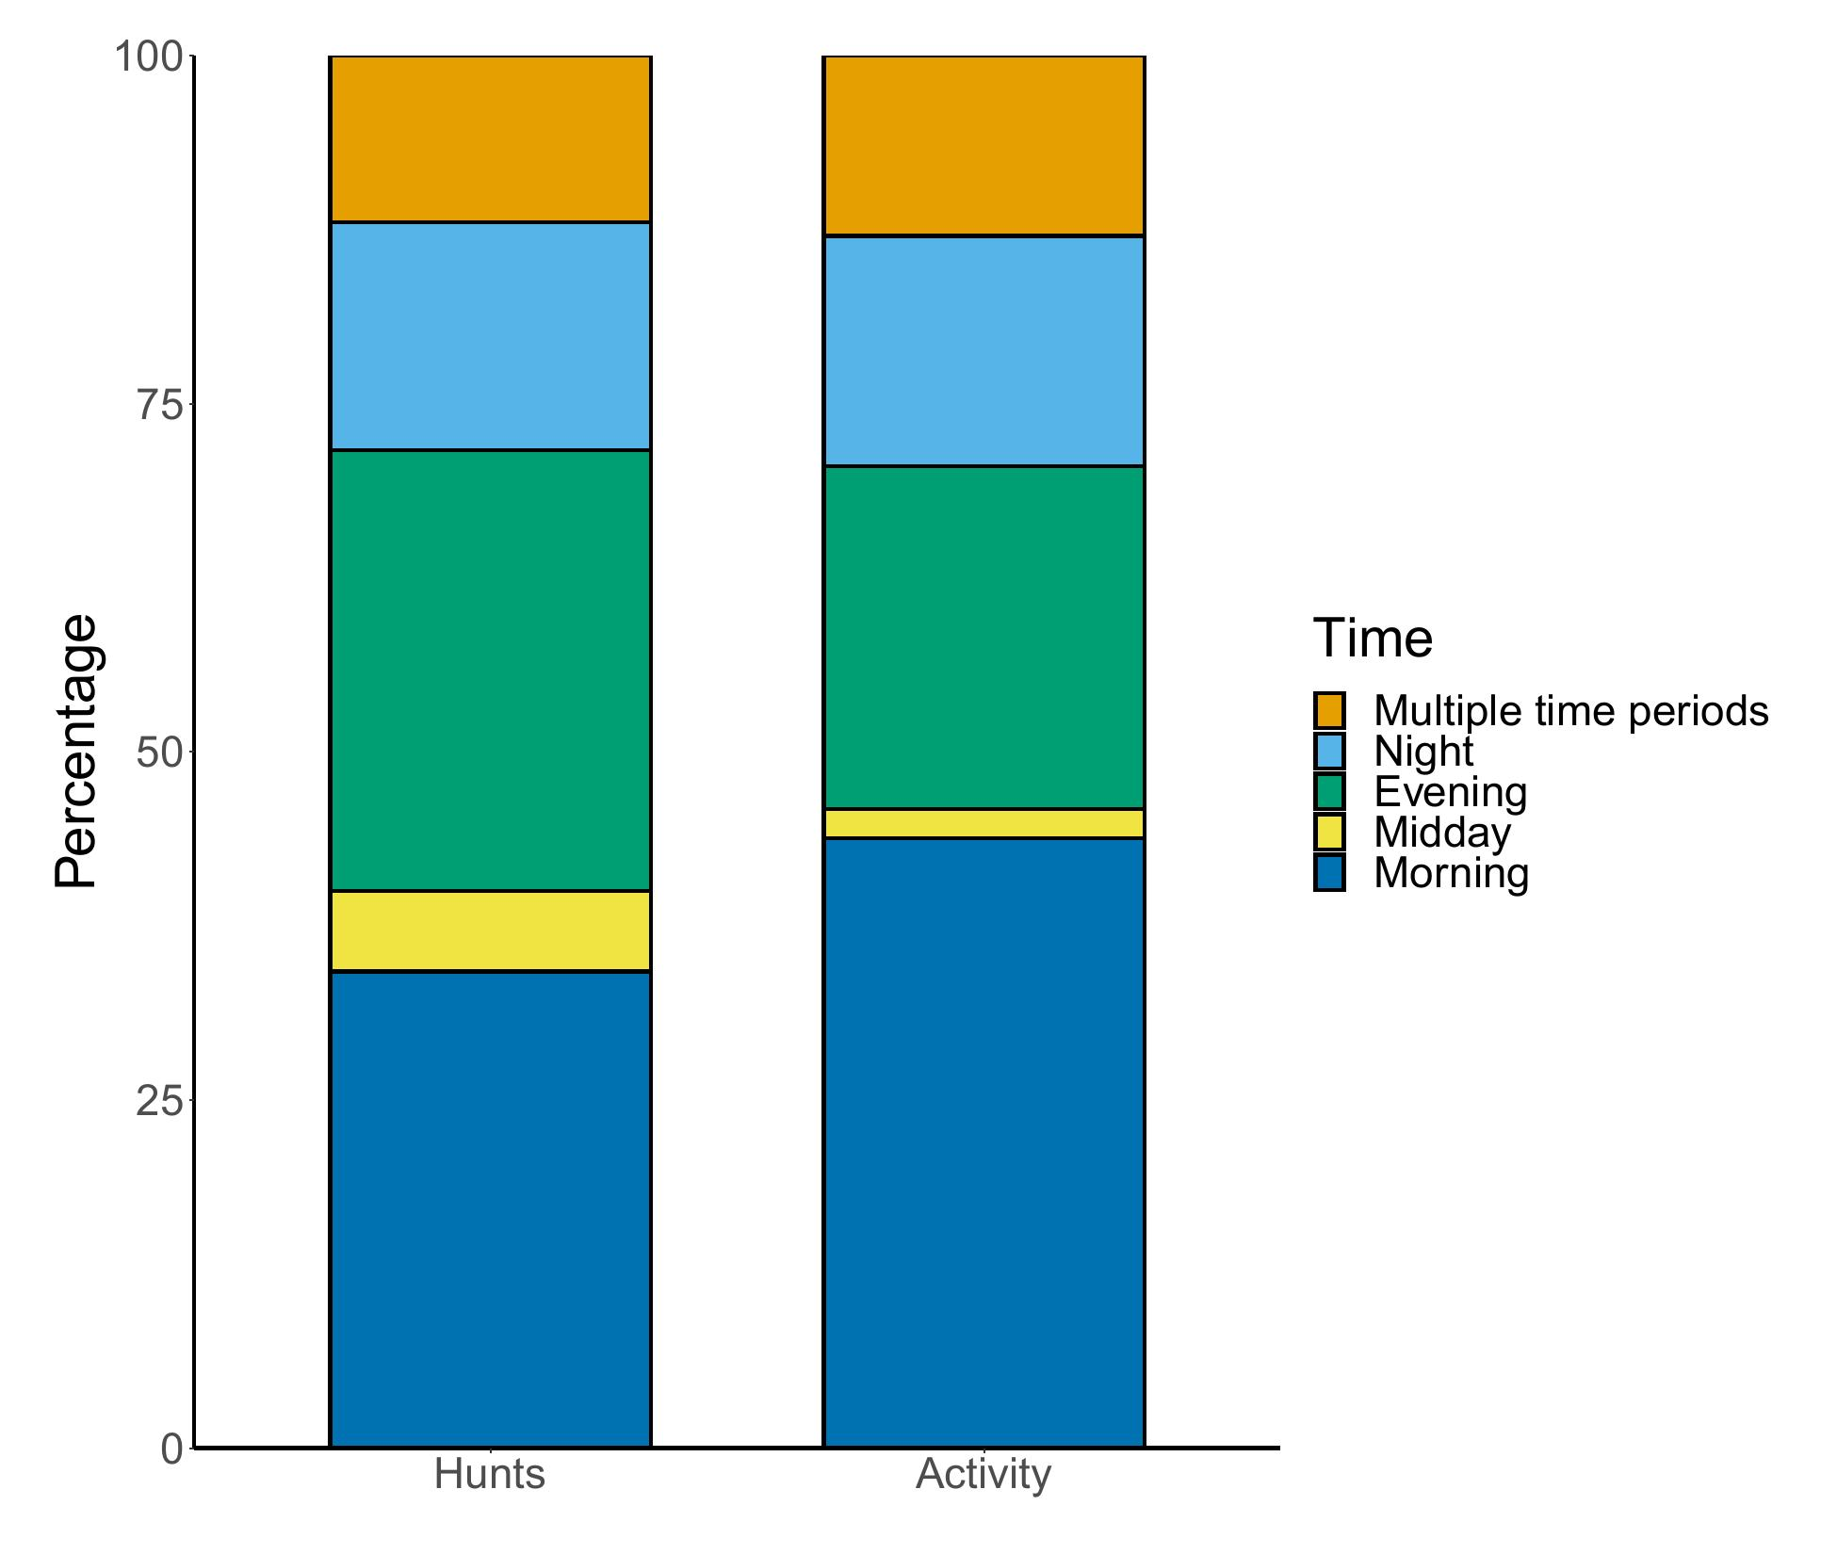

**Figure 1**

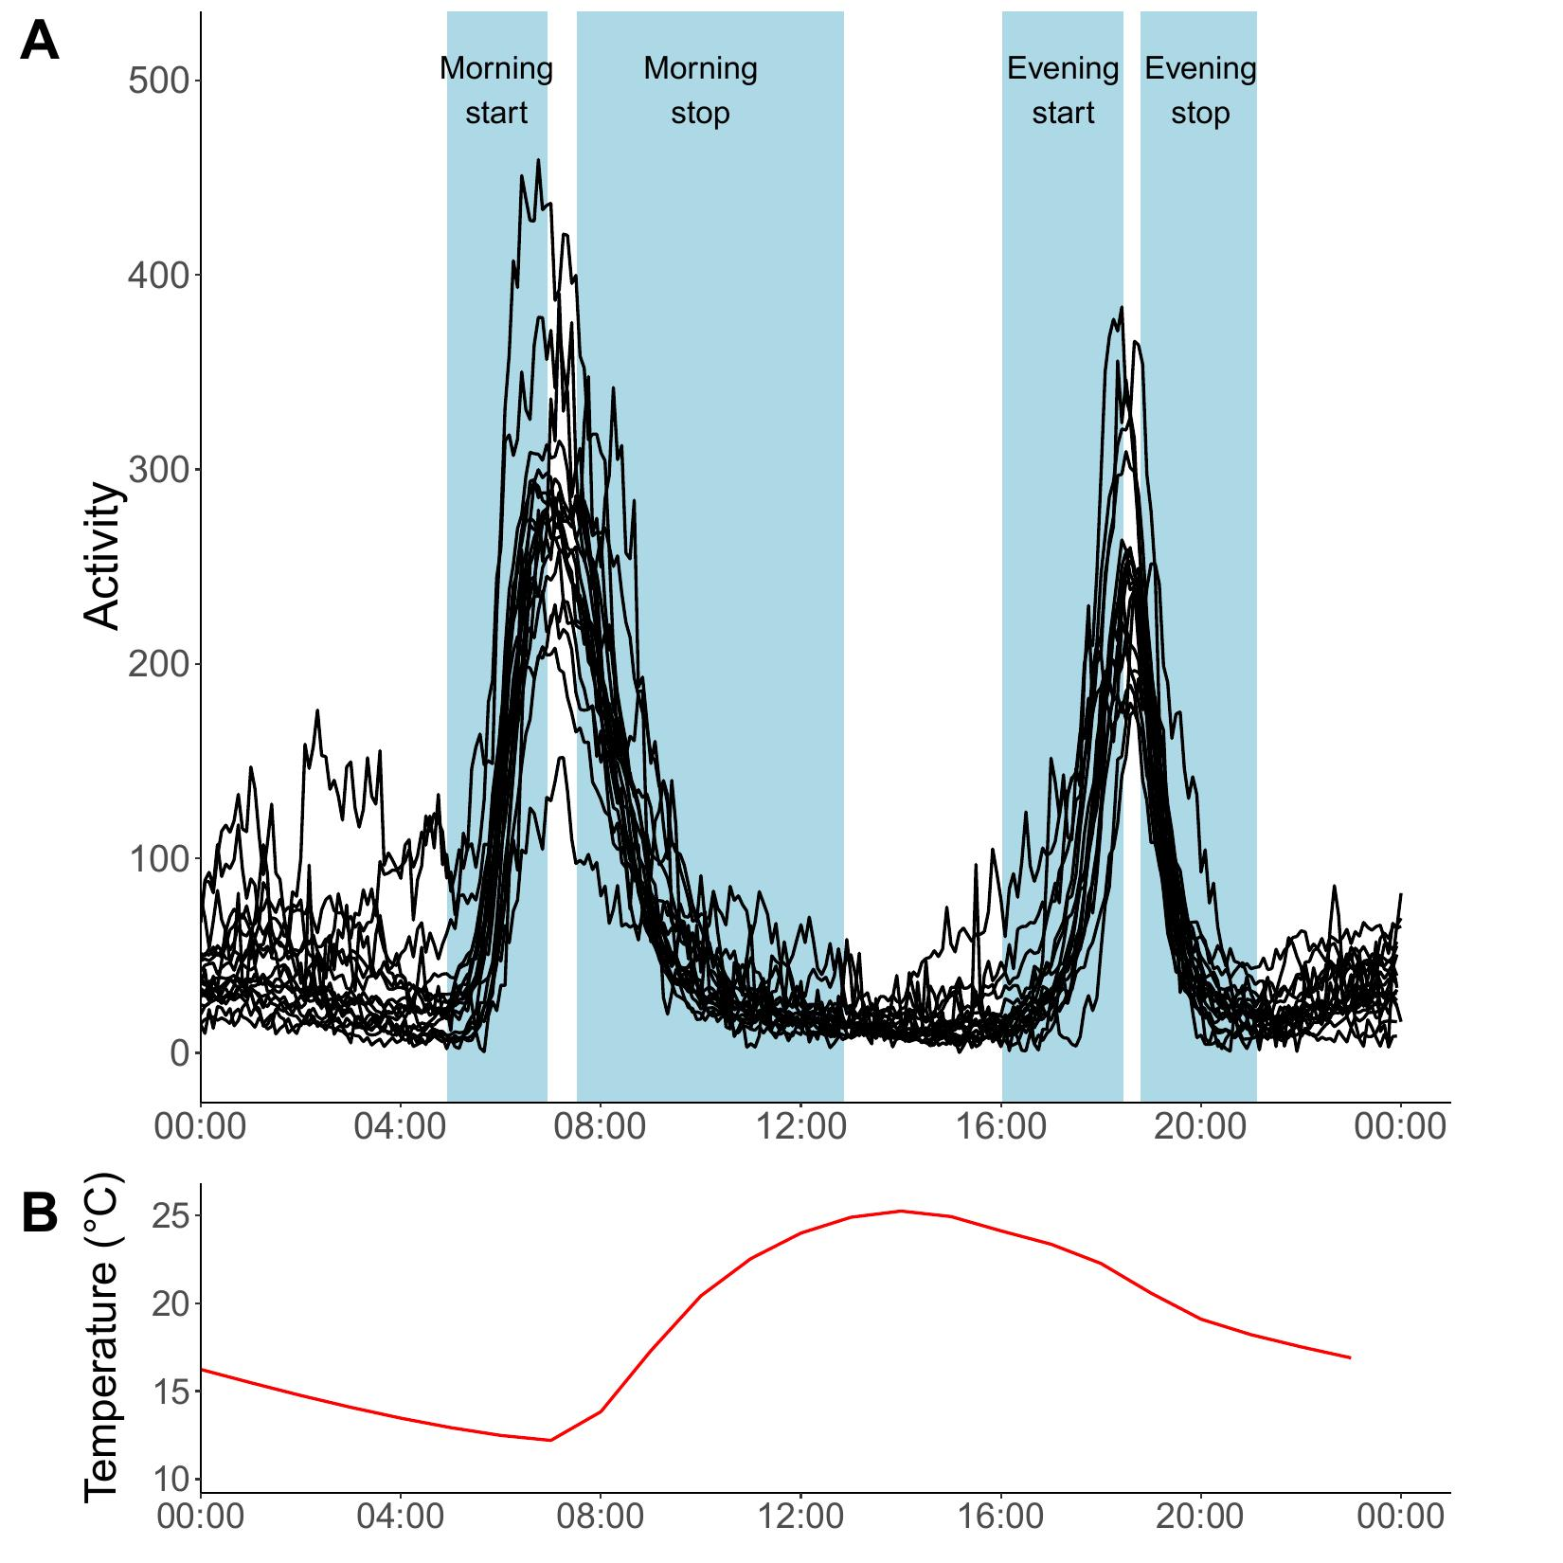

**Figure 2**

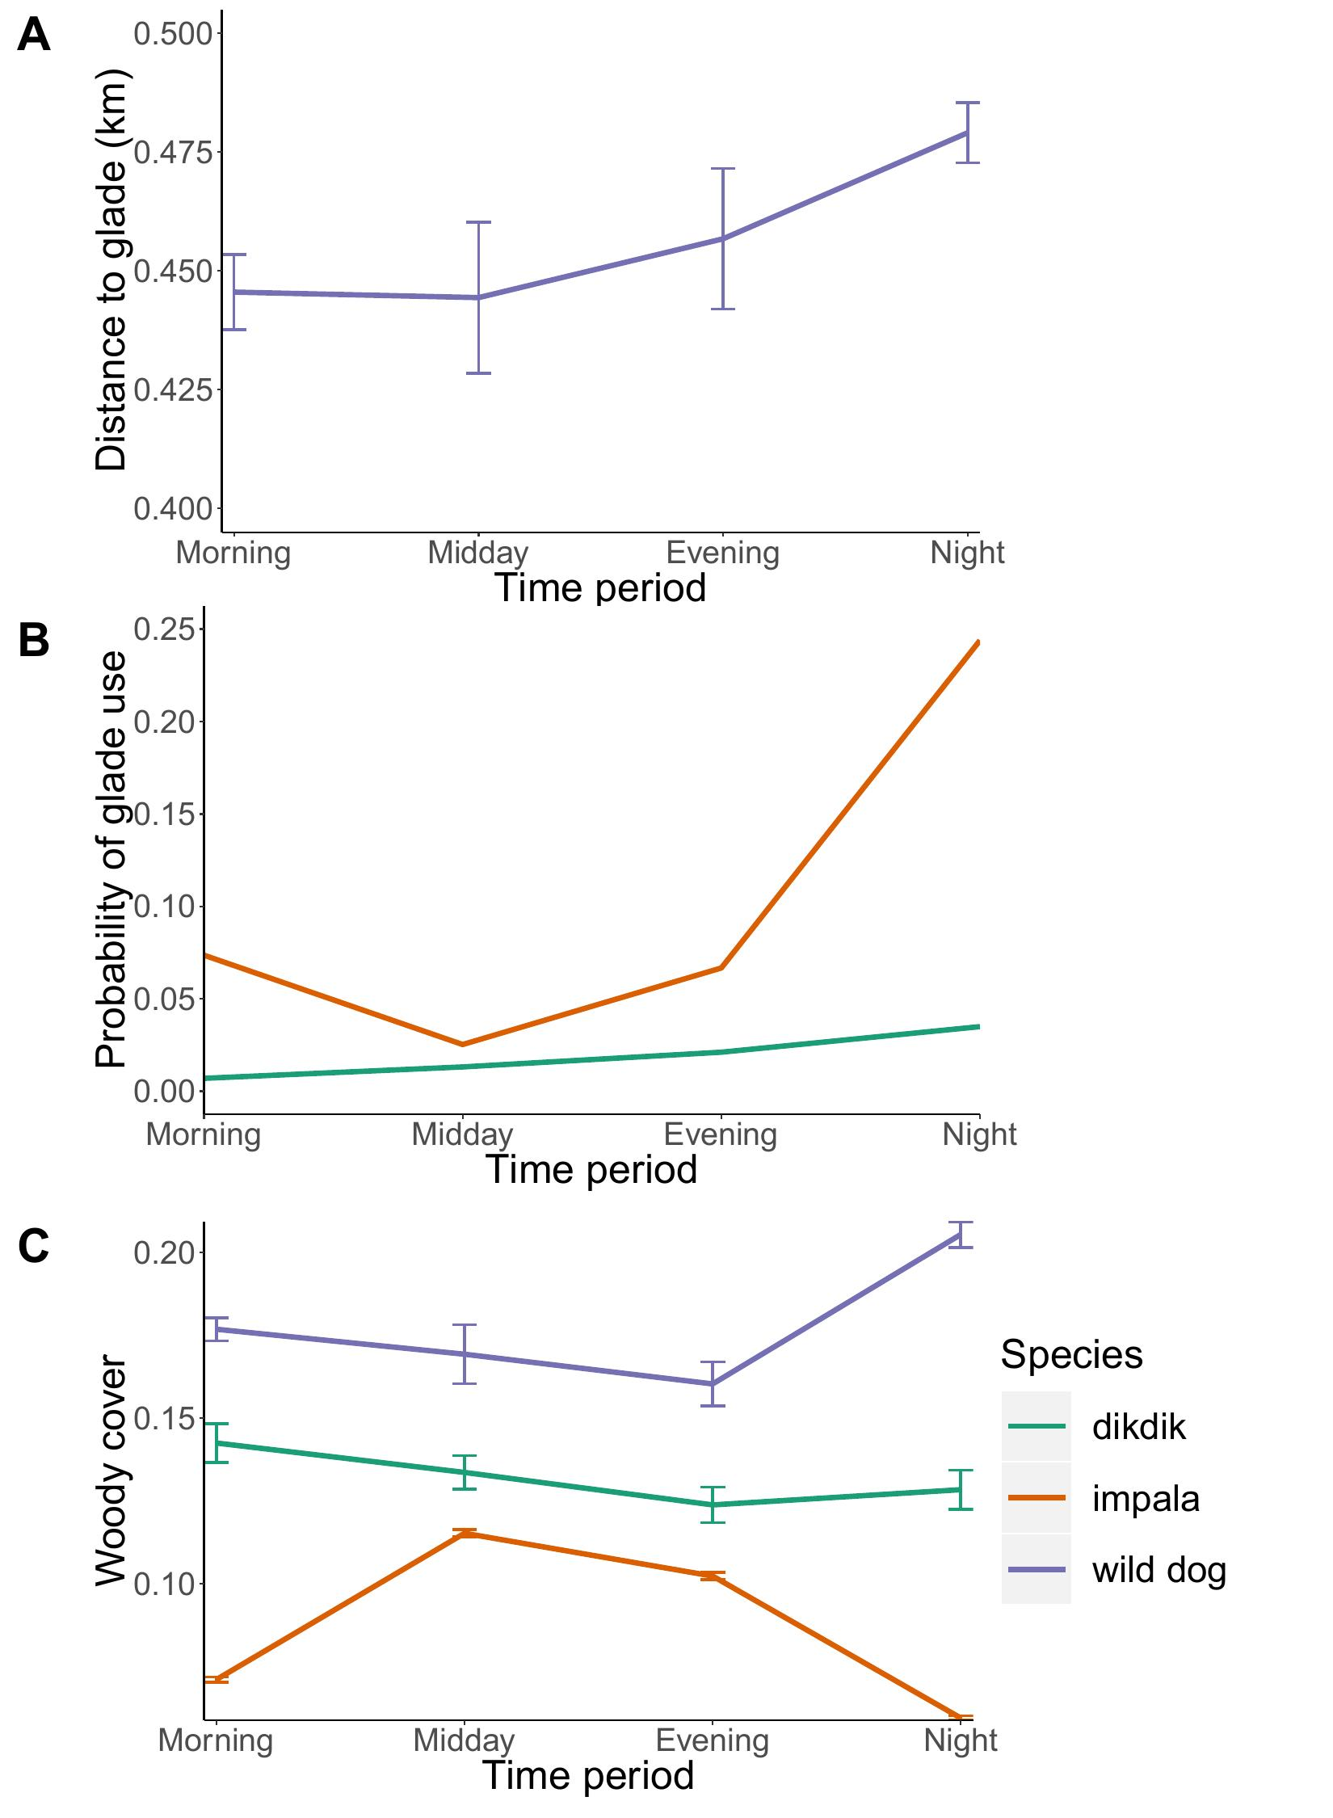

**Figure 3**

**Temperature affects predator-prey interactions in an African savanna**

D. Rabaiotti1,2, Adam T. Ford3, Ben Chapple2, Sophie Morrill2,

Jacob Goheen4 and Rosie Woodroffe1

**Supporting Information**

**Figure S1** Frequency distribution of (A) start times and (B) stop times of African wild dog hunting periods, identified using collar-mounted accelerometers.

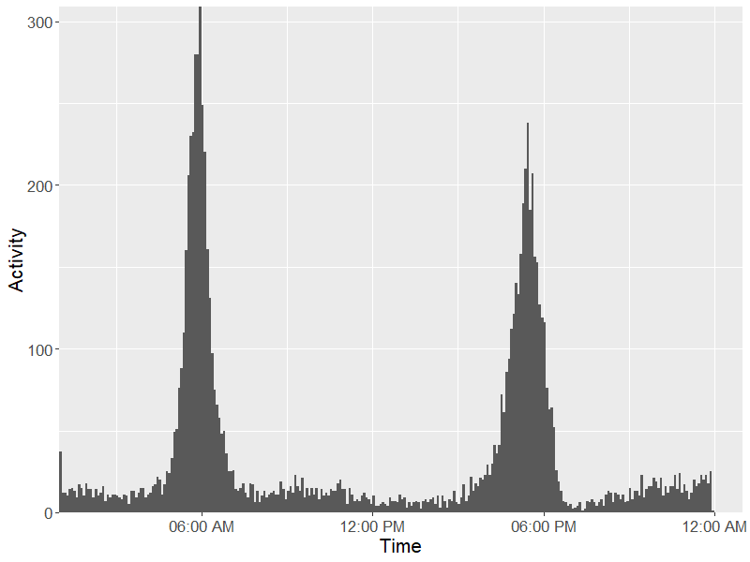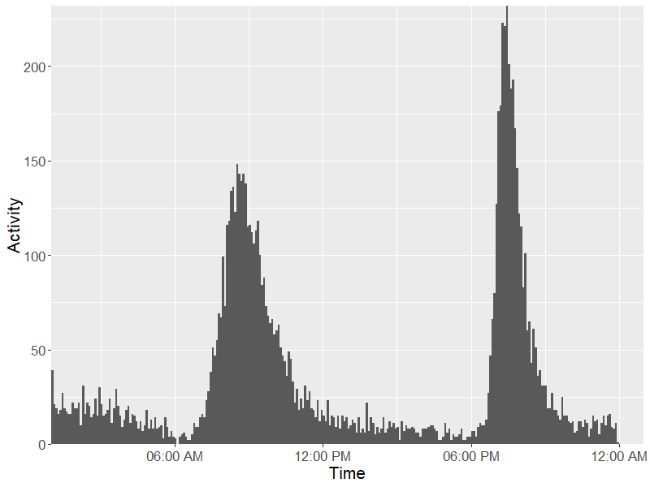

A

B

F**igure S2** Distance to glades for wild dogs, impala and dikdik during morning, day, evening and night time periods.

Time

|  |  |  |  |  |
| --- | --- | --- | --- | --- |
| **Table S1** Start and stop times of hunting periods allocated to each time period within the analysis. | | | | |
| Type of Bout | Earliest start time | Latest start time | Earliest stop time | Latest stop time |
| Morning | 04:55:39 | 06:56:04 | 07:30:41 | 12:51:33 |
| Midday | 06:56:05 | 16:01:54 | 12:51:34 | 18:47:02 |
| Evening | 16:01:55 | 18:26:52 | 18:47:03 | 21:06:56 |
| Night | 18:26:53 | 04:55:38 | 21:06:57 | 07:30:40 |

**Table S2** Variables associated with the characteristics of African wild dog hunting periods in the **morning**. The table presents estimated effects of explanatory variables included in the top model sets (ΔAICc < 5) for each outcome variable. The relative importance of each variable is shown along with the number of models in the top model set in which it was included (n). Bold highlighting indicates estimates for which the 95% confidence interval excluded zero.

|  |  |  |  |  |  |  |  |
| --- | --- | --- | --- | --- | --- | --- | --- |
| Outcome variable | Explanatory variable | | Estimate | Lower  95% CI | Upper  95% CI | Variable  importance (n) | |
| Occurrence | Intercept | | 0.80 | 0.77 | 0.83 | | — (1) |
| Moonlight before | | -0.0097 | -0.011 | -0.0079 | | 1.00 (1) |
| Duration  (minutes) | Intercept | | 220.06 | 198.78 | 241.33 | | — (4) |
| Denning (Yes) | | 57.48 | -137.38 | 22.41 | | 1.00 (4) |
| Temperature (°C) | | -1.33 | -2.007 | -0.66 | | 0.88 (3) |
| Moonlight before | | 0.054 | -0.24 | 0.35 | | 0.68 (2) |
| Rainfall (mm) | | -2.97 | -6.31 | 0.36 | | 0.60 (1) |
| Rainfall:Temperature | | 0.13 | 0.004 | 0.25 | | 0.60 (1) |
| Denning:Temperature | | 5.015 | 2.83 | 7.19 | | 0.58 (1) |
| Intensity | Intercept | | 51.43 | 46.78 | 56.076 | | — (3) |
| Denning (Yes) | | 1.56 | 0.14 | 0.16 | | 0.89 (2) |
| Temperature (°C) | | -0.26 | -0.38 | -0.14 | | 0.57 (2) |
| Start time | Intercept | 06:31:41 | | 06:24:07 | 06:39:14 | | (1) |
| Denning (Yes) | -00:07:46 | | -00:06:14 | -00:09:18 | | 1(1) |
| Temperature (°C) | -00:01:15 | | -00:01:01 | -00:01:29 | | 0.99(1) |
| Stop time | Intercept | | 09:54:52 | 09:20:48 | 10:28:56 | | (3) |
| Temperature (°C) | -00:02:28 | | -00:01:53 | -00:03:03 | | 0.72(2) |
| Denning (Yes) | 00:13:25 | | 00:09:37 | 00:17:14 | | 0.57(2) |

**Table S3** Variables associated with the characteristics of African wild dog hunting periods in the **evening**. The table presents estimated effects of explanatory variables included in the top model sets (ΔAICc < 5) for each outcome variable. The relative importance of each variable is shown along with the number of models in the top model set in which it was included (n). Bold highlighting indicates estimates for which the 95% confidence interval excluded zero.

|  |  |  |  |  |  |  |  |
| --- | --- | --- | --- | --- | --- | --- | --- |
| Outcome variable | Explanatory variable | | Estimate | Lower 95% CI | Upper 95% CI | Variable  importance (n) | |
| Occurrence | Intercept | | 1.21 | 1.08 | 1.35 | | — (2) |
| Moonlight | | -0.010 | -0.012 | -0.008 | | 1.00 (2) |
| Temperature (°C) | | -0.017 | -0.021 | -0.013 | | 0.97 (2) |
|  | Denning (Yes) | | 0.042 | 0.016 | 0.069 | | 0.08 (1) |
| Duration  (minutes) | Intercept | | 226.49 | 213.95 | 239.04 | | — (2) |
| Temperature (°C) | | -3.01 | -3.45 | -2.57 | | 1.00 (2) |
| Moonlight | | -1.84 | -2.06 | -1.62 | | 1.00 (2) |
| Moonrise | | -0.006 | -0.12 | 0.11 | | 1.00 (2) |
| Denning (Yes) | | 7.43 | -18.14 | 33.00 | | 1.00 (2) |
| Rainfall (mm) | | -0.14 | -2.30 | 2.16 | | 0.20 (1) |
| Rainfall:Temperature | | 0.013 | -0.071 | 0.098 | | 0.20 (1) |
| Denning:Temperature | | 2.04 | 0.50 | 3.58 | | 0.15 (1) |
| Intensity | Intercept | | 62.98 | 46.78 | 56.08 | | — (4) |
| Temperature (°C) | | -0.83 | -0.96 | -0.70 | | 1.00 (4) |
| Denning (Yes) | | 7.50 | 2.55 | 12.45 | | 1.00 (4) |
| Moonlight | | -0.21 | -0.27 | -0.15 | | 0.45 (3) |
| Moonrise | | -0.006 | -0.038 | 0.027 | | 0.45 (3) |
| Rainfall (mm) | | -1.14 | -2.04 | -0.78 | | 0.14 (1) |
| Rainfall:Temperature | | 0.058 | 0.034 | 0.082 | | 0.14 (1) |
| Denning:Temperature | | -0.58 | -1.01 | -0.13 | | 0.07 (1) |
| Start time | Intercept | 15:43:55 | | 15:34:49 | 15:53:01 | | (2) |
| Temperature (°C) | 00:03:30 | | 00:03:11 | 00:03:49 | | 1.00 (2) |
| Denning (Yes) | -00:10:49 | | -00:08:52 | -00:09:18 | | 1.00 (2) |
| Moonlight | 00:01:01 | | 00:00:52 | 00:01:10 | | 0.90 (1) |
| Moonrise | -00:00:01 | | -00:00:05 | 00:00:05 | | 0.90 (1) |
| Stop time | Intercept | 19:42:14 | | 19:38:50 | 19:45:39 | | (2) |
| Denning (Yes) | 00:13:25 | | 00:09:37 | 00:17:14 | | 0.55(1) |
| Moonlight | 00:00:52 | | 00:00:43 | 00:01:02 | | 0.44(1) |
| Moonrise | 00:00:01 | | -00:00:04 | 00:00:06 | | 0.44(1) |

**Table S4** Variables associated with the characteristics of African wild dog hunting periods **at night**. The table presents estimated effects of explanatory variables included in the top model sets (ΔAICc < 5) for each outcome variable. The relative importance of each variable is shown along with the number of models in the top model set in which it was included (n). Bold highlighting indicates estimates for which the 95% confidence interval excluded zero.

|  |  |  |  |  |  |  |  |
| --- | --- | --- | --- | --- | --- | --- | --- |
| Outcome variable | Explanatory variable | | Estimate | Lower 95% CI | Upper 95% CI | Variable importance (n) | |
| Occurrence | Intercept | | -0.41 | -0.52 | -0.30 | | — (2) |
| Temperature | | 0.019 | 0.016 | 0.023 | | 1.00 (2) |
| Moonlight | | 0.031 | 0.028 | 0.033 | | 1.00 (2) |
| Denning | | -0.069 | -0.094 | -0.044 | | 0.52 (1) |
| Duration  (minutes) | Intercept | | 80.69 | 47.72 | 113.66 | | — (4) |
| Moonlight | | 5.59 | 5.00 | 6.18 | | 1.00 (4) |
| Moonrise | | 0.83 | 0.42 | 1.25 | | 1.00 (4) |
| Denning (Yes) | | 102.12 | -52.87 | 257.11 | | 0.94 (4) |
| Temperature (°C) | | 0.71 | -0.55 | 1.97 | | 0.79 (3) |
| Rainfall (mm) | | -0.54 | -7.66 | 6.57 | | 0.53 (2) |
| Rainfall:Temperature | | 0.004 | -0.27 | 0.27 | | 0.51 (1) |
| Denning:Temperature | | -7.42 | -13.76 | -1.10 | | 0.47 (2) |
| Intensity | Intercept | | 28.51 | 20.67 | 36.36 | | — (4) |
| Moonlight | | 0.86 | 0.75 | 0.98 | | 1.00 (4) |
| Moonrise | | -0.011 | -0.10 | -0.072 | | 1.00 (4) |
| Denning (Yes) | | 1.82 | -3.17 | 6.84 | | 0.75 (2) |
| Temperature (°C) | | 0.42 | 0.18 | 0.66 | | 0.52 (2) |
| Start time | Intercept | 15:52:55 | | 09:34:32 | 22:11:08 | | (2) |
| Moonrise | 00:24:22 | | 00:20:30 | 00:24:22 | | 1.00 (2) |
| Moonlight | -00:05:15 | | -00:10:38 | 00:00:08 | | 1.00 (2) |
| Temperature (°C) | -00:29:38 | | -00:18:57 | -00:40:20 | | 0.22 (1) |
| Stop time | Intercept | 09:14:33 | | 06:28:31 | 12:00:35 | | (3) |
| Moonlight | -00:24:17 | | -00:20:20 | -00:28:14 | | 1.00 (3) |
| Moonrise | 00:03:22 | | 00:00:31 | 00:06:12 | | 1.00 (3) |
| Denning (Yes) | 02:22:25 | | 01:11:11 | 03:33:39 | | 0.25 (1) |
|  | Temperature | 00:19:04 | | 00:11:10 | 00:26:57 | | 0.08 (1) |