

SCHOOL OF ADVANCED TECHNOLOGIES, ENGINEERING, AND SCIENCE

(SATES)

**PROJECT SYNOPSIS SUBMITTED TO THE ACCRA INSTITUTE OF TECHNOLOGY IN PARTIAL FULFILLMENT OF THE REQUIREMENT OF THE DEGREE IN COMPUTER ENGINEERING**

BY

**ONYINYECHUKWU SYLVIA ILECHUKWU**

***ENG21B00137Y***

**April, 2023**

**TOPIC ONE**

ONLINE REGISTRATION AND IDENTIFICATION SYSTEM FOR VEHICLES IN GHANA

**SYNOPSIS**

This project aims to revolutionize the vehicle registration and identification process in Ghana, making it more efficient, accurate, and secure. The project will help improve the overall transportation system in Ghana and contribute to the country's economic growth. The project involves designing and implementing an online system that will allow individuals and organizations to register their vehicles and obtain unique identification numbers.

The system will offer several benefits, including reducing the time and effort required for vehicle registration, improving the accuracy and security of vehicle data, and facilitating data exchange between government agencies. The system will also help combat vehicle-related crimes such as theft and fraud by making it easier to track and identify registered vehicles.

**B-Diagram:** The system will consist of three main components: the user interface, the database, and the backend processing. The user interface will be a web-based application that allows users to input their vehicle and personal information, upload relevant documents, and make payments. The database will store all the information provided by users and generate unique identification numbers for each registered vehicle. The backend processing will involve verifying user information, generating identification numbers, and integrating with relevant government agencies for data exchange.

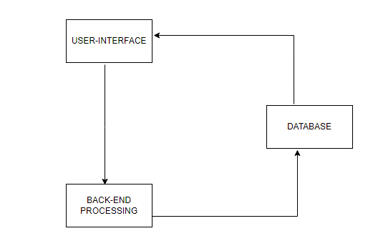

**TOPIC TWO**

ESSENTIAL SERVICE PROVIDER PERMIT SYSTEM

**SYNOPSIS**

It is a user-friendly and efficient solution for managing the issuance and tracking of E-passes during curfews or lockdowns. The system's digitization and automation streamline the process and reduce physical contact between essential service providers and authorized officials, ultimately contributing to overall public health and safety during emergencies. The system aims to streamline the process of obtaining curfew E-passes by digitizing the entire process and eliminating the need for physical paperwork. The system is designed to allow authorized government officials to register essential service providers, such as healthcare workers, law enforcement officers, and other critical workers, who need to travel during curfews. These authorized officials can add, edit, and approve E-pass applications using the web-based interface.

The system has two primary user roles: authorized officials and essential service providers. Authorized officials can register essential service providers and approve E-pass applications. Essential service providers can apply for E-passes by filling out an online form that requires them to provide personal and employment information. The system verifies the information provided by the applicant and notifies the authorized officials for further approval. Once approved, the essential service provider can download and print the E-pass for travel during the curfew.

**B-Diagram:** The system's block diagram includes four primary components: the user interface, the database, the E-pass verification system, and the notification system. The user interface allows authorized officials and essential service providers to interact with the system. The database stores all user data, including registered essential service providers and E-pass application records. The E-pass verification system ensures that only valid E-passes are accepted during the curfew period. The notification system sends alerts to authorized officials and essential service providers on the status of their E-pass applications and approvals.

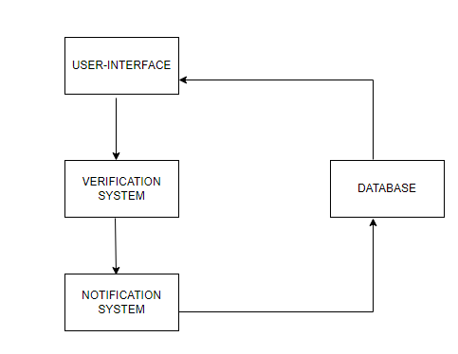

**TOPIC THREE**

DAILY FINANCIAL TRACKER

**SYNOPSIS**

The goal of the project is to provide a user-friendly interface that enables users to input and categorize their expenses easily. The application will allow users to view and analyze their spending patterns over a specified period. It will be a web-based application with a user-friendly interface that can be accessed from any device with an internet connection. The application will have a user-friendly interface and will enable users to input, categorize, and analyze their expenses easily. The project will use modern web technologies and the Agile software development methodology to deliver a high-quality product that meets the customer's needs.

**B-Diagram:** The application will have two main components: the front end and the back end. The front end will consist of a website that users can access through their browser, and the back end will consist of a server that will store and process the user's data. The front end of the application will consist of a dashboard that displays the user's expenses in different categories, such as food, transportation, and entertainment. Users will be able to add new expenses, delete existing ones, and update their expense categories. The server will process the user's data and generate reports and visualizations to help the user analyze their spending patterns.

