**Computer vision – Exercise 2**

* All result images are in folders ordered by question number.

1.

**Courtroom:**

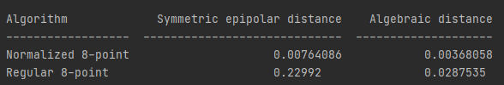

**Family:**

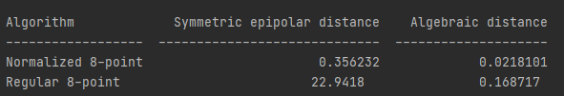

2.