1.1: Getting started with python

Installing Python:  
  


Virtual Enviroment:



Add.py file working:  
  
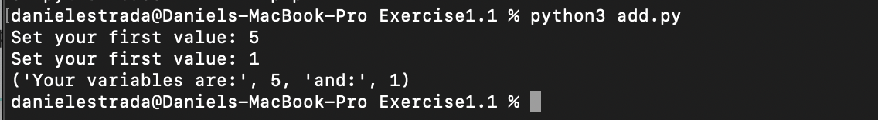

Installing IPython:  
  
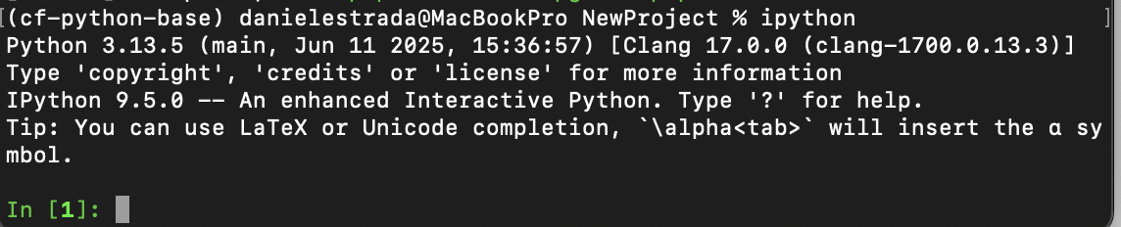

Requirement.txt:  
  
