**Installing R in windows**

1. Go to <https://www.r-project.org/>. This is the main website for R and contains a good amount of information.

2. Click in the link “download R” under the section “Getting Started”.

3. Select your CRAN mirror- a mirror is a distribution site or server that you can access to download exact copies of the original hosting platform, these are created to keep the computational burden of downloading many times all around the world to a minimum. You will always want to pick the geographically closer mirror to minimize network load. For now, we will pick Denmark (although perhaps is more convenient to pick Iceland).

4. In the next window click in “Download R for Windows” and then “base”.

5. Download R 4.x.x for Windows, open the downloaded file and follow the instructions.

**Installing Rstudio in windows**

“RStudio is an integrated development environment (IDE) for R. It includes a console, syntax-highlighting editor that supports direct code execution, as well as tools for plotting, history, debugging and workspace management.” In general, I recommend you to work in Rstudio as this is a more holistic way to work in R than working in the RGui. In Rstudio you will have a view of your files, a history of plots that you have created with your code, console, script editor, etc. Moreover, convenient ways of working in R are available with Rstudio and we will cover these in the course (see the comparison in Fig 1).

1. Go to <https://rstudio.com/>. The Rstudio webpage has more resources available for R work and they are easier to obtain and easier to understand than those in the R webpage. In Resources for example there are several links to blogs and free books for self-training and problem solving.

2. Click on DOWNLOAD located at the top of the webpage.

3. Select RStudio Desktop free for download.

4. On the next window click on the Download Rstudio for Windows button.

5. Open the downloaded file and follow the instructions.

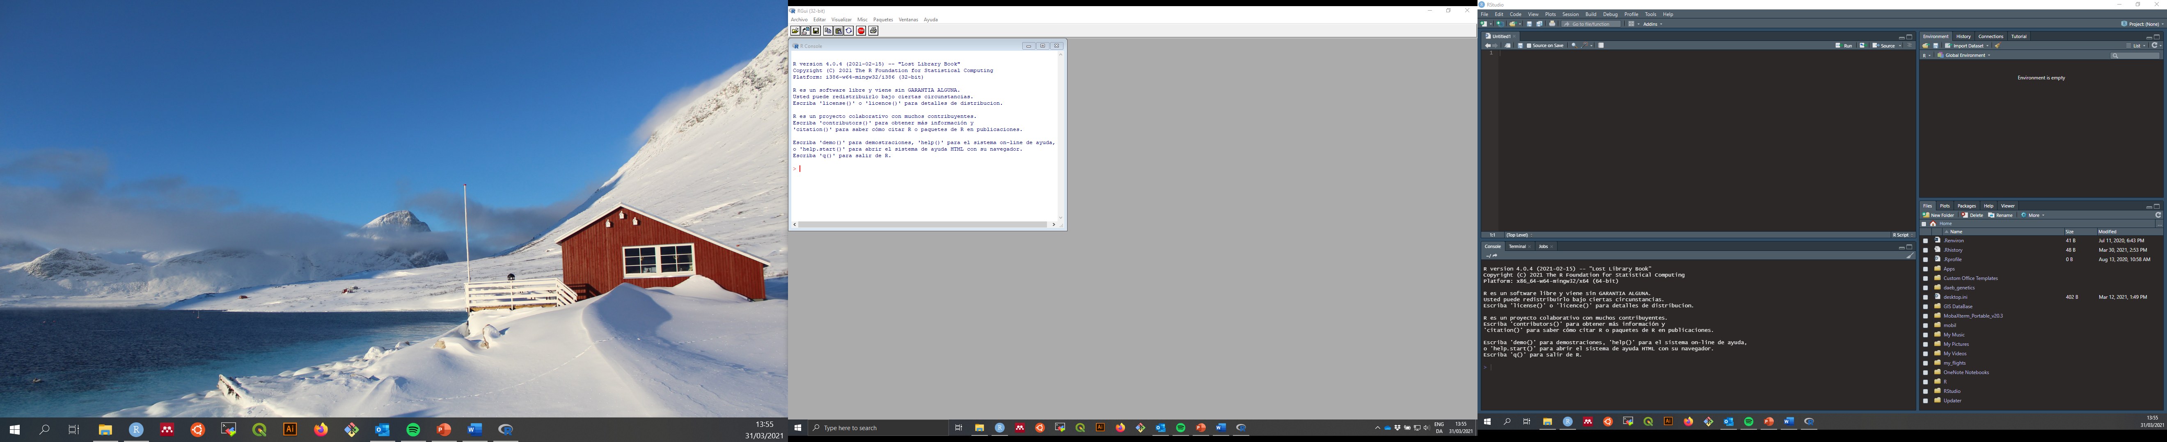

D

C

B

A

**Fig. 1.** R GUI (left) and Rstudio (right). The R GUI is quite succinct in facilities, besides, unless you use a text editor to store your code you do not have the option to do it there. Rstudio on the other hand allows you to set all the work you do with R in a single screen. In the image you can see four panels: A) R script editor, here you can store the commands you use for a given task- this is the only thing you want to save when you are done; B) the console panel corresponds to the R GUI and it is where your commands are run (whether you write them straight away there or pass them from the script), additionally, you can see other two tabs (Terminal and Jobs)- The terminal can be extremely useful for Unix users or in Windows for those who can write C++

**Keep R and Rstudio updated**

R major releases do not occur constantly, some intermediate updates are released however to fix bugs etc. You may think that by updating R, some packages will be useless after, but this is often not the case: those packages that people use constantly will keep in line with major updates in R. It is also important to update the packages themselves every now and then.

*Updating R*

In windows there is a very easy way to update R by using the package “installr”. In the RGui, copy and paste the following code:

# installing/loading the package:

if(!require(installr)) {

install.packages("installr"); require(installr)} #load / install+load installr

# using the package:

updateR() # this will start the updating process of your R installation.

*Updating Rstudio and packages*

You can update Rstudio from the same program going to Help -> Check for Updates, this will re-direct you to the Rstudio webpage to download and install the new version.

In Rstudio, you can also update packages by going to the Packages tab and click Update; a list of available updates for your installed packages will appear and you can select which ones you want to install.

**FAQs and common issues (on development)**

* The package I am using for TASK X only works with version x.x.x, it will stop working with a new version, what should I do? *You can always keep more than one version of R. In Rstudio you can set the version you work with: go to Tools -> Global Options; you will see options there to change the version you are using.* ***Bear in mind that you will have to restart your R session*** ***after this.***
* How do I cite R? *In the R console just write citation() and you will obtain the citation already formated. If you want to cite a particular package- citation(package = “package”).*