**How are participatory Education for Sustainability (ESD) projects influencing sustainability competences of high school students?**

# Introduction

Globally, we as humankind are facing many ecological and social crises at the same time. Despite extensive and continual efforts aimed at transitioning towards a more sustainable society, environmental and social challenges persist or have even exacerbated in various aspects (IPCC, 2023). In transition towards a more sustainable and just society, Education for Sustainable Development (ESD) is seen as one key aspect (REF?). ESD is a holistic educational approach, focusing on the development of sustainability competences which enable the learner to contribute to sustainable development through their competences of knowledge, skills, motivation, attitudes and values (REF Rieckmann & Barth, 2022). Following the Brundtland Report and the Agenda 21 conference in Rio, numerous programs for Education for Sustainable Development (ESD) have been initiated (REF?). However, the impact and effectiveness of ESD is often questioned (Ssossé et al., 2021). When looking at the empirical data on the impact and outcome of ESD interventions within educational settings is very little. Despite the difficulty of attributing the desired outcome to a specific measure and the complexity of many interacting variables, the call for different approaches of measuring and operationalising ESD research, namely shifting form an input to an outcome orientation is becoming more present (Waltner et al). Basing the understanding how education interventions can be designed on empirical data, to foster sustainability competences while considering the complex modes of action, is a key topic on the agenda of educational decision makers all over the world. We currently only have a limited understanding of how participative ESD interventions, as potential enablers towards a more sustainable and just society, are contributing to sustainability competences of students.

Measuring sustainability competences of students and its attribution to ESD is complex. In order to operationalise effectiveness, it is first necessary to define which goals (learner characteristics) should be pursued within the framework of ESD and secondly, which means, methods and procedures can be recommended for the effective promotion of these characteristics (Riess, 2021). There is agreement on the broad tripartite classification of ESD goals in terms of achieving competencies in knowledge, attitudes, and behavioural dimensions (Waltner et al., 2022). In terms of methods to promote those goals, there seems to be scientific agreement. These methods include innovative, participative learning, service-learning, portfolio-work, project work, roll- and plan games, and problem-based learning (Riess, 2021). The little existing empirical data on sustainability competences reveal complex dynamics. Throughout a school year (without having a specific ESD intervention, but ESD being in the local education plans) sustainability knowledge went up, whereas climate attitudes and climate-friendly behaviour did not increase (BUGEN). These results exemplify the knowledge-behaviour gap. However, as these results are based on a school year, it remains interesting to empirically measure the attribution of specific ESD interventions which employ innovative methods. Especially participation can play a key role in fostering motivation of students. Contributing factors include to have an own choice and learning together in a group (Rieß et al, 2021). Assessing changes of sustainability competences of students benefits from measuring precise goal specifications with long-term empirical data of ESD-relevant projects.

Measuring sustainability competences by only looking at knowledge, behavioural and attitude aspects is falling short of different elements. External factors can also influence the sustainability-relevance behaviour. These external factors include behavioural offers, situational conditions, social norms, and lifestyle of the social environment (RIESS, 2021). Therefore, looking at how the educational intervention is supported or hindered by the environment can play an important role. An interesting way of capturing the interdependence of students and their environment could be through the measurement of self-efficacy beliefs of students. Self-efficacy captures the extent to which an actor believes that they can achieve a goal with a certain action (Hammand et al) and thereby also capturing the perceived feedback from the students’ environment. This might be especially relevant when conducting ESD intervention, which according to proposed effective methods, include problem-based real life project learning, where the feedback of what is happening with the input from the student can influence their experience and their learning (REF?). Furthermore, capturing self-efficacy beliefs is a nice way around the debate of whether certain normative behaviours can and should be goals of ESD interventions (REF SINGER). By not capturing whether students are behaving differently according to normative standards set out by experts, self-efficacy beliefs rather capture competences which are an important prerequisite for participation in society. Considering increased self-efficacy as a desired outcome of participatory and experiential ESD interventions brings up the question of operationalising measurement of self-efficacy as well as its relation to pedagogical approaches and which other factors might influence it. Recent theoretical developments have emphasised the importance of differentiating and including agents, actions and aims and their relations when analysing self-efficacy related within ecological and social context. Furthermore, the desirability of the aim and aim content might play a central role, when analysing self-efficacy. Assessing changes of sustainability competences of students can benefit from considering the relation with their structural environment, by for example assessing self-efficacy beliefs.

# Objectives and research questions

My aim is to quantify how ESD interventions influence students’ sustainability competences over time. Existing empirical data of a defined external ESD intervention project of climate attitudes and climate behaviour and the opportunity for continuous data collection allow for long term assessments of sustainability competences over time. Recent theoretical developments on self-efficacy beliefs provide a new possibility to enrich the measurements with these aspects. By integrating previous quantitative research from two schools with current, and theoretically comprehensive data collection, my analysis provides insights into the effectiveness of ESD projects in enabling human agency/ sustainability competences of high school students.

* Do students experience changes in climate attitude and behaviour over time*? // How do sustainability competences (climate attitude and behaviour) among students change over time (through different phases of an ESD intervention)?*
* How do climate attitude and behaviour and self-efficacy beliefs respond to levels of involvement of the students?
  + How does the project evolution influence the magnitude of the changes in climate attitude and behaviour?
  + How do desirability of the aim and group identification influence the magnitude of the self-efficacy beliefs?
* How is climate attitude and behaviour influenced by self-efficacy beliefs?

# Research hypotheses/ predictions?

# Methods

*In my analysis I ask how a participative SDE-intervention influences attitudinal, behavioural and self-efficacy components of sustainability competences over time. I assess variation in the level of involvement of the students. To quantitatively test the impact of SDE-interventions, I will assess long-term effects by using existing data from a before-after self-reported survey on behavioural and attitudinal data and proceeding data collection with the same survey at approximately one year after the last assessment. Furthermore, I will complement data collection with a survey on self-efficacy.*

## Existing data “before-after” survey

The existing data, which I will complement can be described as following. The data was collected within a Master thesis project and in collaboration with the IZT, which is responsible for evaluating the impact of the funding and the project. Based on the theory of planned behaviour, a quantitative before-after survey questionnaire survey was conducted at two participating schools. The surveyed students were divided into three distinctive groups, according to their level of participation (see description of level of involvement in the project description in annex XX). The data collection was conducted between February and Mai 2023 (the later date also marking the official ending of the project from the view of the students) (REF PAULI). Thereby, the next data collection point will be approximately one year after the end of the project.

The survey was designed based on the theory of planned behaviour. It included elements of attitudes, subjective norms, perceived behaviour control, intentions, and behaviour. The results showed that climate awareness and action were increased through active participation (highest level of involvement). There were mixed results regarding the lower level of involvement and the effect on climate attitude and behaviour.

+ confirmation of project as being participative and ESD?

## Project description “KlimaRatSchule” (later in Annex?)

### A blue and green logo Description automatically generatedAims

“The KlimaRatSchule (KRS) project aims to promote and establish an active climate protection culture in schools. To achieve this, KRS combines effective climate protection measures with democracy education. This means that pupils are actively involved in the development of a climate protection concept through a democratic participation process. This sensitizes the students to this topic and develops skills that enable them to act and make decisions in the interests of climate protection beyond the school day. In addition, this process allows thematic priorities and measures to be identified, on the basis of which a climate protection concept is created that is individually adapted to the school.” (KRS Projektbeschreibung, 2024).

### Project stages and resulting students’ level of involvement

*The project can be divided into three phases from the students points of view. In the first phase, a voluntary student team is formed, the so called KRS-expert group. This group receives an introduction about the aims and phases of the project. Additionally, they get informed about general facts about climate change and four relevant areas within their school: energy, mobility, nutrition and procurement. In the first phase, the KRS school group has the task of drawing up a carbon footprint for the school. On the other hand, this group prepares the second phase, which will be explained in more detail later.*

*The second phase includes a micro-citizen report, which was adapted to the school context and is therefore called "Micro-citizen report for schools" (MBGS) (KlimaRatSchule, 2022, p. 1). This is a democratic process in which randomly selected pupils discuss relevant issues and problems and develop solutions.*

*First, 50 pupils are randomly selected and divided into two equal groups on the day of the MBGS. Each of these two groups deals with two areas of activity in parallel in two rounds, so that the four areas of activity mobility, nutrition, procurement and energy are dealt with in total. In each round, the two groups of 25 are divided into five small groups. In these small groups, also known as planning cells, the participants discuss options and finally put three proposals for measures on paper. At the end of each round, the proposals from all planning cells are presented, prioritized and ranked in a plenary session of 25 participants. The process is illustrated graphically in Figure 14.*

*Before each new discussion round, the KRS school group presents its findings on the respective area to the group of 25. The composition of the discussion cells is drawn by lot anew in each round within the group of 25. In the plenary of the groups of 25, the proposals of all small groups are presented and prioritized according to a carefully considered procedure. The entire Climate Council is prepared and carried out by the KRS school group.*

*The participation of pupils from the KRS school group in the MBGS is not excluded. At one of the two schools, not only pupils were involved, but also a total of ten people from the teaching staff and other school personnel, so that a total of only 40 pupils took part in the MBGS.*

*The third phase includes the creation of a roadmap with concrete goals and steps for more climate protection at the school (KlimaRatSchule, 2022, p. 2). After the MBGS, this development is again the responsibility of the KRS school group, which brings together its findings on the climate balance, results from the MBGS and general considerations on implementation options. The completion of this roadmap marks the end of the KRS project, but above all gives the go-ahead for the school to implement the measures set out in it.*

*The levels of involvement are resulting from the different project phases and are summarised in the table below (REF PAULI)*

### Data collection at schools and their description

The impact evaluation is being carried out at two of the participating schools in the Freiburg area, which are supervised by the association Solare Zukunft. The students of the two schools started the project in January 2023, finished the main project phase in July 23.

### Surveys

#### Climate attitude and behaviour

From previous master thesis and conducted at two schools with two points of measurement:

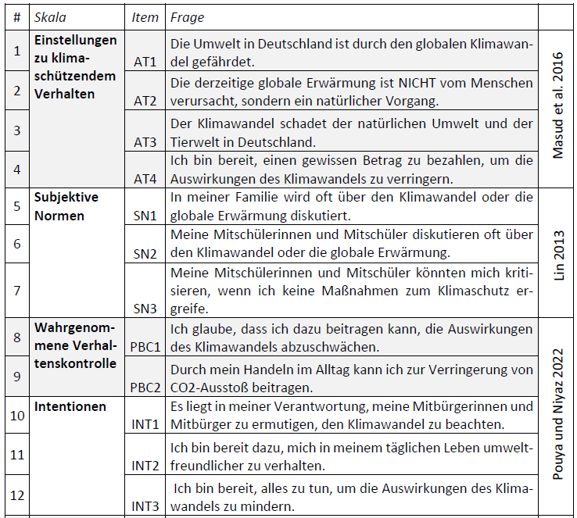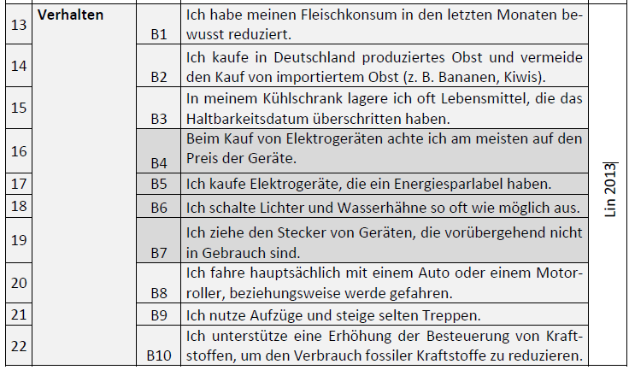

#### Self-efficacy beliefs

**Selbstwirksamkeit nach Triple A Framework (Hamann et al., 2023)**

Nun kommen ein paar Fragen zu deiner persönlichen Meinung. Hier gibt es keine richtigen oder falschen Antworten. Gib bitte ehrlich und spontan an, was du darüber denkst.

1. Ich glaube, dass meine eigenen Handlungen einen Beitrag zum Klimaschutz leisten können. (Agent-aim)
2. Ich glaube, dass ich den Klimaschutz vorantreiben kann, indem ich in meinem Umfeld über den Klimawandel aufkläre. (Agent-action-aim)
3. Ich glaube nicht, dass ich in der Lage bin, mich für den Klimaschutz einzusetzen. (Agent-action) *INVERS*
4. Ich glaube, dass ich dazu in der Lage bin, andere davon zu überzeugen, sich für mehr Klimaschutz einzusetzen. (Agent-action-aim)
5. Ich glaube nicht, dass ich Möglichkeiten habe, einen Einfluss auf den Klimawandel zu nehmen. (Agent-aim) *INVERS*
6. Ich glaube, dass ich beeinflussen kann, wie entscheidungstragende Personen oder Organisationen bezogen auf den Klimaschutz handeln. (Agent-action)
7. Ich glaube, dass ich entscheidungstragende Personen oder Organisationen dabei unterstützen kann, sich für Klimaschutz einzusetzen. (Agent-action-aim)
8. Ich glaube, dass ich mich in Zusammenarbeit mit anderen sinnvoll für den Klimaschutz engagieren kann. (Agent-aim)

Beantwortung auf 7-stufiger Skala:

1 = Stimme gar nicht zu, 4 = Teils/teils, 7 = Stimme voll und ganz zu

## Statistical analysis

All statistical analysis will be conducted in R version 4.0.2.

I will model climate behaviour/ attitude/ self-efficacy beliefs as the response variable. Level of involvement, XXX .The random term in my model will be XXX.

I will apply the same model approach for climate attitude/ self-efficacy beliefs accordingly.

# References

# Proposed timetable