

**THE INFLUENCE OF ACCESSIBILITY TO CITIES ON BIODIVERSITY CHANGE**

*By*

**DANIELA GARGYA**

in partial fulfilment of the requirement for the

Degree of BSc with Honours in

Ecological and Environmental Sciences with Management

May 2020

# Abstract/ Summary

Globally, biodiversity is changing in complex ways in a time of accelerating human impact. We know little about how large-scale anthropogenic activity, as a prominent contemporary global change driver, is influencing the reshuffling of ecological communities. I quantify the influence on ecological assemblages by human activities, such as roads and urbanisation, worldwide and across taxa by analysing change in 181 time series studies. I predict to find higher temporal and spatial turnover with greater exposure to roads and urbanisation. Linking human impact with biodiversity change can provide the needed evidence and predictions for better international policy making in the light of our rapidly changing Anthropocene.

# Table of contents

Contents

Abstract/ Summary 2

Table of contents 3

Acknowledgments 4

List of abbreviations 5

Introduction 6

Objectives and research questions 6

Research hypotheses 7

Predictions 7

Methods 8

Results 8

Discussion 8

Conclusions 8

References 8

Appendices 8

# Acknowledgments

I would like to thank blab la and blab la.

# List of abbreviations

# Introduction

* *Split objectives?*
* *Is last paragraph intro same as objectives and RQ part?*

*The dissertation comprises an introduction discussing the research question, reviewing the relevant literature, and setting out the research questions and hypotheses to be tested. The introduction should introduce the reader to the subject area and clarify the knowledge gap that the dissertation research will fill. The Introduction must set the context for the dissertation by reviewing the relevant literature. The primary research questions and hypotheses should be listed in the final paragraph of the introduction. The introduction should not be just a ‘Literature Review’ but should include relevant references to general (theoretical papers and reviews) and specific (specific to the particular question addressed) literature, to justify the research that has been undertaken and define the question being addressed.*

First paragraph

* Globally, biodiversity is changing in complex ways in a time of accelerating human impact.
* Acceleration of global change
* Abundance, richness and composition of ecological assemblages are changing in complex ways
* Need for understanding the factors driving the change across geography and taxa (or general different levels)
* Importance of biodiversity, link to ecosystem services
* Ecological reshuffling and link to global biodiversity change
* Research gap:
  + Limited understanding global change driver, eg land-use change, that drive those heterogenous patterns of BD change
  + Disentangle sources of heterogeneity across full spectrum of change (across taxa and population etc)
  + Effects of global change driver on ecological changes (but so far only forest loss, warming)
  + Joint anthropogenic activites are influencing (check references prereg 6,7,12)

Middle paragraphs

* Distribution of global change drivers (land-use change, habitat change, pollution, invasion by non-native species, climate change)
* Link global bd change to local bd change
* On top of geographic patterns in exposure to human activities, differentiation at population level/ species vulnerability
  + Certain species traits can moderate/ be more vulnerable
  + Important understanding to focus conservation efforts
* Population dynamics theory, taylor’s power law?
* Threats to species (other than anthropogenic as well)
* So far: space for time and modelling projection approaches (Newbold reference)
  + Don’t account for ecological lags and community self-regualtion
* Controversy about diverse impact of habitat fragmentation on biodiversity (check references from forest loss 18-20)
* Amplification of effects when globacl change drivers are acting together?
* Explanations what anthropogenic activity could cause: land-use change -> cooler habitats, rising temp -> species vulnerability goes up
* Roads and urbanisation, land-use change (effects of human accessibility)
* Conflict development and conservation?
* Human population density

## Objectives and research questions

*This should be a concise statement of the objectives, research questions and hypotheses of the study. You may also include in this section if you wish. Hypotheses should be explicitly and outline the anticipated results should be discussed: “If hypothesis H1 is supported than this will indicate… However, if H2 is supported that this will suggest…”.*

My aim is to quantify how global change drivers influence ecological communities over time. Specifically, I will focus on the effects of urbanisation and roads, captured in the metric accessibility to cities, and human population density on temporal changes on ecological community composition overall and across taxa. These drivers are an indirect representation of large- scale human activity and capture big parts of the alteration of our planet. I will test if these drivers of global change explain heterogenous biodiversity change found across our planet. To achieve this, I investigate the influence of accessibility to cities on ecological assemblages worldwide and across taxa by analysing change in 5078 time series. I assess variation in biodiversity change across blablabla taxa. I will address the following research questions:

1. Do sites with higher accessibility to cities experience more changes in assemblage composition over time (temporal turnover) than locations with lower accessibility?
   1. How does the duration of ecological monitoring influence the magnitude of detected temporal turnover trends?
2. How does temporal turnover of ecological communities respond to levels of accessibility across taxa (birds, mammals, terrestrial invertebrates, terrestrial plants)?
3. How is temporal turnover influenced by an interaction between human population density and accessibility?

## Research hypotheses

I hypothesize that there will be a positive relationship between higher accessibility to cities and greater temporal turnover. The magnitude of temporal turnover increases for sites which have been monitored over longer durations. When looking at individual taxa, I hypothesize that taxa will have different responses to high and low levels of accessibility, with both positive and negative relationships present. The relationship between accessibility to cities and temporal turnover is steeper, when human population density is higher (all positive). Those hypotheses will be tested against the null hypotheses of no relationship (or negative relationship) between level of accessibility and temporal turnover, and human population density and temporal turnover.

* *Sites with higher accessibility to cities correspond with greater temporal turnover*
* *The magnitude of temporal turnover increases for sites which have been monitored over longer durations*
* *Ecological communities of taxa respond differently to high and low levels of accessibility.*
* *The relationship between accessibility to cities and temporal turnover is steeper, when human population density is higher (all positive)*

## Predictions

I predict greater temporal turnover with greater exposure of accessibility to cities, as an alteration of the natural environment benefits some species, while damaging others, influencing community composition. I predict greater temporal turnover in sites which have been monitored over longer durations, as the effect of turnover becomes more apparent over time. I predict both positive and negative trends to be present among taxa, as they have differences in ecological requirements. I predict the relationship between accessibility and temporal turnover to be steeper, when human population density is higher, as high HPD increases the pressures on the natural systems, leading to higher turnover.

If I find support for my null hypotheses, this will indicate that the metric accessibility to cities cannot capture the most relevant human impact on biodiversity, questioning the justification for humanly undisturbed places. If the results are in line with my alternative hypotheses, this will demonstrate the importance of humanly undisturbed places for the conservation of biodiversity.

# Methods

*The methods should explain as concisely as possible where you worked and what you did. Only include the required methods to repeat your study, do not include methods for data you do not present in the dissertation. Standard analyses or techniques need only be given a reference to published accounts or protocols. Use clear subheadings to structure your methods for the reader. Discuss data manipulations, statistical approaches used and the statistical software in a statistical analysis section.*

General intro methods + conceptual diagram of workflow?  
To quantify the influence of accessibility on biodiversity change, this was the workflow: (see figure). No predetermination of sample size, but worked with all available data that met my criteria. Data inclusion criteria? Put table with sample sizes here? Outcomes of sensitivity analysis to justify area etc. Definitions of terms used?

## (Study sites/sample sizes/) Databases

Where to include the diagrams of taxonomic, temporal and spatial distribution of data -> appendix?

***Accessibility to cities 2015 data***

To quantify large scale human impact of roads and urbanisation, I extracted an accessibility to cities metric from the malariaatlas project Accessibility to cities 2015 database. This database calculates least-cost-path land-based travel time to the nearest densely populated area (between 85 degrees north and 60 degrees south) at a 30 arc seconds X and Y resolution. Areas with >1,500 inhabitants/km² or a majority of built-up land cover types coincident with a population centre of at least 50,000 inhabitants are defined as densely populated areas. I bound the scores extracted between zero and one, where zero is very accessible and one is not accessible.

***BioTIME Database – biodiversity time series data***

I analysed 5788 time series from 181 different studies from terrestrial places around the globe that are part of the BioTIME database as of 12/03/2020. Data inclusion criteria? Limitations of the data set?

I will quantify temporal changes in community composition within sites, as the turnover component of beta diversity (species replacement rather than abundance) at the last data point available relative to the first observation data point within the time period outlined above. I will bound the scores of turnovers between zero and one, where zero is no change in community composition and one indicates that all of the original species have been replaced.

From the community composition over time model, I will extract the means for temporal turnover for each time series, which will then become the response variable in the following stage of my analysis where I will test temporal turnover against accessibility.

EQUATION?

***Human population density dataset***

I derived population density data from the Gridded Population of the World, Version 4: Population Density, Revision 11 database (CIESIN, 2018). Human population density was defined as number of persons per square kilometre, based on national censuses counts and population registers. Data is available 2015 at a 30 arc-second resolution.

SWITCH TO WP?

## Data manipulations

## Statistical/data analysis

All statistical analysis was conducted in R v. 3.6.1. Packages used? (ggplot2, MCMCglmm, ggmap, etc?). Bayesian approach and why

**Explanation models response variables and fixed effects**

Response variable:

*Temporal turnover*: changes in species composition due to replacement over time, calculated as the comparison in the final year of each time-series relative to the first.

Explanatory variables:

* The mean accessibility to cities scores for the 100km² grid cells around the location of the biodiversity record
* The interaction term between accessibility and population density
* Taxa
* Duration

Random variables:

* Broad grid cell
* Study ID/plot

temporal turnover ~ accessibility + duration + accessibility:human population density, (accessibility|taxa); random = grid cell, study ID/plot

**Justification inclusion fixed effects, data transformations, random effects**

Scaling accessibility and dissimilarity between 0 and 1.

HPD between 0 and 1.

(Coding scheme for categorical value of human population density)

Grid cell random effect

Partitioning of studies?

**Why not more random effects where included**

**Additional interaction terms, taxa-specific**

**Model predictions. Reference to appendix**

**Model explanation (priors, iterations).**

**Model variables justification**

The models will be based on a zero one inflated beta distribution.

I will run the model first with both random intercepts and slopes but if no model convergence can be achieved, I will run them with only random intercept.

I will initially run models with one chain of 100 000 iterations with a warmup of 10 000 iterations and will increase these metrics if convergence is not achieved. I will assess convergence visually by examining the trace plots.

**Alternatives to measuring variables**

Statistical significance of results explanation

# Results

*The Results Section contains text that summarises the findings of the research referring to all figures, tables and statistical results. Include the primary results, ordered logically (often from most important to least works well). Maintain the order that you present your results through out all parts of the dissertation. Data should only be presented once in either tables or figures in the main text or appendix. Often, it is recommended to write the results section first, so that you can write the methods that are appropriate to describe the results presented, then you can write the discussion next about these results, the introduction to introduce the relevant literature for the scientific story that you are telling and finally the conclusions and abstract – this approach is called writing backwards.*

*Statistical results when reported in the text, tables or figure captions must include the test used (ANOVA, Linear model, Linear mixed effects model, GLM, etc.), sample size (N) or degrees of freedom, effect size and error (e.g., slope and error around the slope), test statistic (t-value, F statistic, etc.), model fit (R2, pseudo R2, etc.) if appropriate and p-value. P-values alone are incomplete statistical reporting (see http://www.nature.com/news/statisticians-issue-warning-overmisuse-of-p-values-1.19503). Full statistical results, additional figures or tables and raw data can be included in an Appendix. For guidelines on how to report specific statistical tests refer to the scientific*

*literature and discuss you're your supervisor. All code for statistical analyses should be included in the appendix for students that are using coding based statistical software such as R.*

*Questions:*

* *How to put sample size*
* *Limitations of results in results section?*
* *Visualising vs modelling*
* *Include sensitivity analysis here?*

**Temporal turnover and accessibility (Research Question 1)**

In line with my predictions (preregistration), I found that temporal turnover has increased across the 5788 time-series surveyed (slope = 0.05, CI = 0.03 to 0.07, Figure 1, see Table 1 for more model outputs). On average, temporal turnover is increasing by 10% as accessibility is increasing by 10%. In line with my predictions (see preregistration), the duration of the observation influenced the magnitude of the detected temporal turnover trends, with higher turnover increases for longer observations of sites.

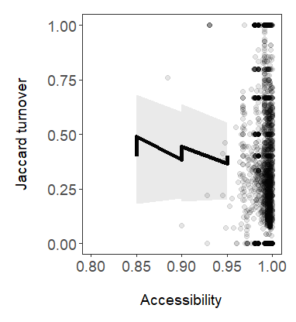

Figure 2. Jaccard turnover has increased for higher levels of accessibility across 5788 time-series globally (slope = 0.05, CI = 0.03 to 0.07, Figure 1, see Table 1 for more model outputs). Grey points represent raw data. Lines and error bands represent model predictions and 95% credible intervals, respectively. Colour coding of lines represent differing duration of monitoring. See trace plots and model Rhat values in appendix confirming model convergence.

The results of the temporal turnover model revealed an increase of temporal turnover across levels of accessibility. Therefore, I found support of my initial prediction of accessibility increasing temporal turnover, and thus accept the alternative hypothesis. Study area had no significant effect on temporal turnover (slope = 0.05, CI = - 0.03 to 0.07). Latitude? Results to be taken with caution? Examining the posterior means of the random terms, study ID, taxa and broad grid cell, revealed among Study ID variation (variance = 0.4, CI 0.3 – 0.5), and little within study ID variation (variance blabla). Same for taxa and broad grid cell. Full model output can be found in Appendix X.

**Taxa-specific responses to different levels of accessibility (Research Question 2)**

Visualising raw temporal turnover data among taxa revealed no clear differences between the temporal turnover of individual taxa on different levels of accessibility (Figure 3). Terrestrial plants’ and birds’ responses, have increased turnover as accessibility is increasing. Among the 4 taxa, terrestrial plants have experiences the greatest temporal turnover increase by 23% for every 10% increase in accessibility. Mammals and terrerstrial invertebrates show no clear pattern. TALK ABOUT DISTRIBUTION OF DATA?

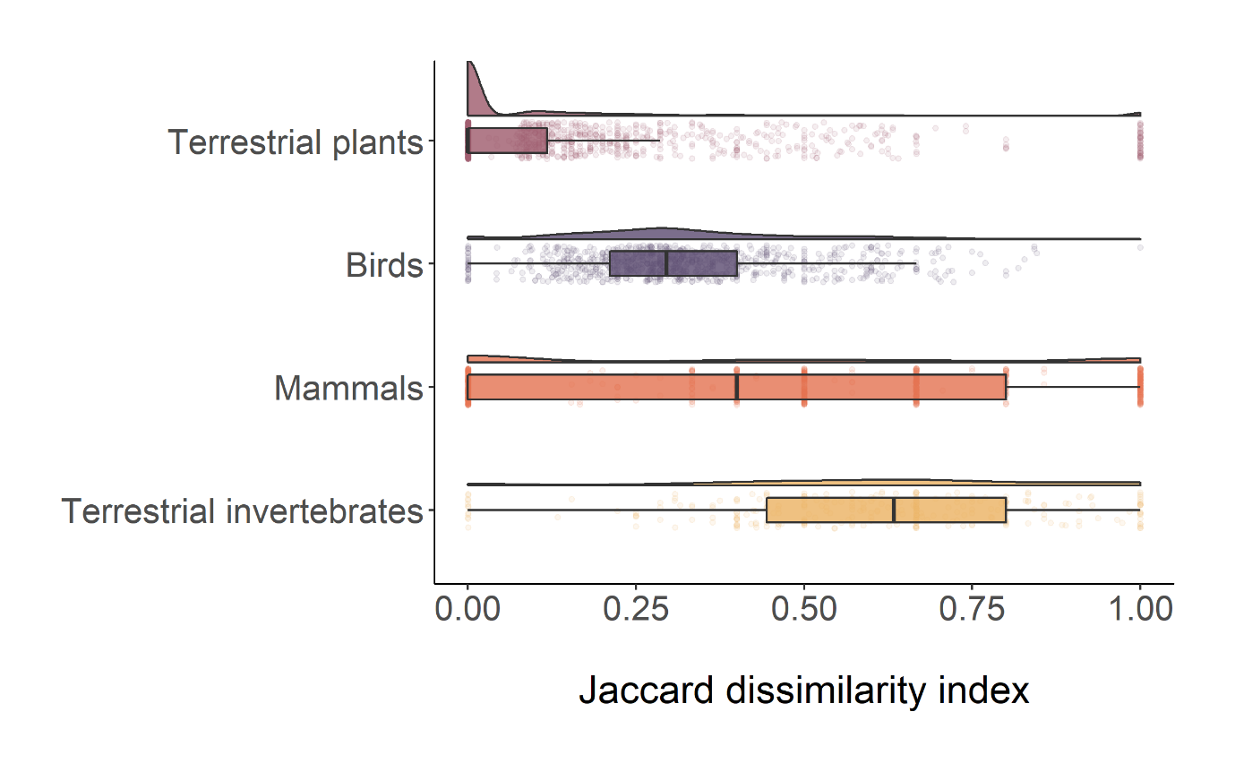

BAR PLOT/ BOX PLOT WITH EFFECT SIZES OF EACH TAXA

SCATTER PLOT FOR EACH TAXA?

The model which compared temporal turnover among taxa revealed that there is no significant difference between taxa’s individual temporal turnover response on accessibility (slope blabla). Interaction taxa:accessibility?. 2 responede, 2 not. Caution with interpretation?

Model predictions confirmed my hypothesis of.. mention other fixed effect response tp that. + random terms

Sensitivity analysis results?

Visual examination trace plots, model convergence, shortcomings of the model

**Relationship between accessibility and human population density on temporal turnover (Research Question 3)**

# Discussion

*The object of the discussion is to summarise your major findings and place your findings in the context of previous studies current state of knowledge in the literature. When you discuss your own work and that of others, back up your opinions with evidence and citations. The first paragraph of the discussion should contain a summary of your major findings (usually 2 – 4 points) and a brief summary of the implications of your findings and should make reference to whether you found support for your hypotheses or how you answered your research questions. The following paragraphs will usually describe each of these findings in greater detail making reference to previous studies. Often the discussion will include a paragraph describing the limitations of your study and the potential for future research.*

# Conclusions

*The conclusion paragraph should put your findings into the broader context of the literature and explain how you have filled the knowledge gap that you have identified in the introduction. This is your chance to present to your reader the major take-home messages of your dissertation research. It should be similar in content to the last sentence of your summary abstract.*

# References

# Appendices