**Questionnaire for Neighbourhood Amenities**

A participant will either answer questions of the social, cultural, or economic category.

**Social** Category

**Open-Ended Recall Question**

“List all the social amenities you remember seeing in the VR environment.

Include as many details as you can.”

**Recognition Question**

Which of the following social elements did you encounter in the VR environment?

* **Community Centre**
* Senior Centre
* **School**
* Youth Club
* **Kindergarten**
* University
* **Library**
* **Food Kitchen**

**Distance Recall Test**

Please mark the following social amenities according to their distance from the main square

with the corresponding colour.

(Community Centre, School, Kindergarten, Library, Food Kitchen)

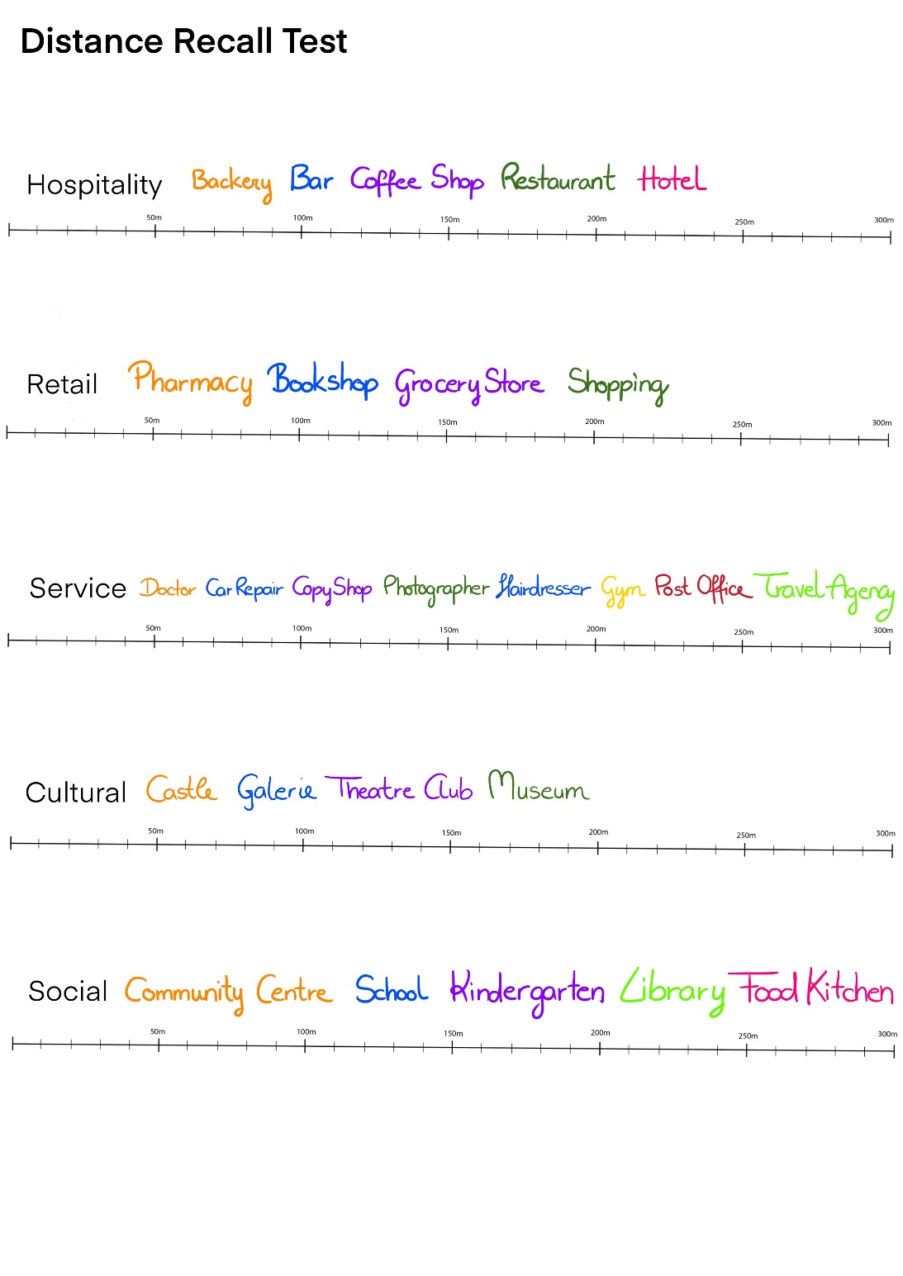

**Cultural** Category

**Open-Ended Recall Question**

“List all the cultural amenities you remember seeing in the VR environment.

Include as many details as you can.”

**Recognition Question**

Which of the following cultural elements did you encounter in the VR environment?

* **Castle**
* Culture Centre
* **Galerie**
* Kino
* **Theatre Club**
* Retirement Home
* **Museum**
* Concert Hall

**Distance Recall Test**

Please mark the following cultural amenities according to their distance from the main square with the corresponding colour.

(Castle, Galerie, Theatre Club, Museum)

Ein Bild, das Text, Screenshot, Schrift, Reihe enthält.

**Economic** Category

Retail

**Open-Ended Recall Question**

“List all the retail amenities you remember seeing in the VR environment.

Include as many details as you can.”

**Recognition Question**

Which of the following retail elements did you encounter in the VR environment?

* **Pharmacy**
* Florist
* **Bookshop**
* Pet Store
* **Grocery Store**
* Stationary Store
* **Shopping**

**Distance Recall Test**

Please mark the following retail amenities according to their distance from the main square with the corresponding colour.

(Pharmacy, Bookshop, Grocery Store, Shopping)

Ein Bild, das Text, Screenshot, Schrift, Reihe enthält.

Hospitality

**Open-Ended Recall Question**

“List all the hospitality amenities you remember seeing in the VR environment.

Include as many details as you can.”

**Recognition Question**

Which of the following hospitality elements did you encounter in the VR environment?

* **Bakery**
* **Bar**
* Nightclub
* **Coffee Shop**
* Spa & Wellness
* **Restaurant**
* Wellness Centre
* **Hotel**
* Motel

**Distance Recall Test**

Please mark the following hospitality amenities according to their distance from the main square with the corresponding colour.

Ein Bild, das Text, Screenshot, Schrift, Reihe enthält.
(Bakery, Bar, Coffee Shop, Restaurant, Hotel)

Service

**Open-Ended Recall Question**

“List all the service amenities you remember seeing in the VR environment.

Include as many details as you can.”

**Recognition Question**

Which of the following service elements did you encounter in the VR environment?

* **Doctor**
* Casino
* **Car Repair**
* Gas station
* **Bike Repair Shop**
* Zoo
* **Copy Shop**
* Pet Grooming
* **Photographer**
* Physiotherapy
* **Hairdresser**
* Taxi
* **Gym**
* Massage Studio
* **Post Office**
* **Travel Agency**
* Lawyer

**Distance Recall Test**

Please mark the following service amenities according to their distance from the main square with the corresponding colour.

Ein Bild, das Text, Screenshot, Schrift, Reihe enthält.
(Doctor, Car Repair, Copy Shop, Photographer, Hairdresser, Gym, Post Office, Travel Agency)

**Correct Distances for Distance Recall Test:**

Social

(Community Centre (303m), School (290m), Kindergarten (89m), Library (87m) , Food Kitchen (120m))

Cultural

(Castle (20m), Galerie (207.5m), Theatre Club (200m), Museum (20m))

Economics - Retail

(Pharmacy (119.5m) , Bookshop (105m) , Grocery Store (263m), Shopping (105m) )

Economics - Hospitality

(Bakery (113m) , Bar (133.5m), Coffee Shop (72.5m), Restaurant (98m), Hotel (187m))

Economics - Service

(Doctor (148.5m), Car Repair (182m), Copy Shop (52m), Photographer (250m), Hairdresser (121m), Gym (164m]), Post Office (267m), Travel Agency (134m))