http

Wireshark:

1. Both are running version 1.1
2. Accept-language: en, pl
3. Source IP: 10.152.200.107  
   Destination IP: 128.119.245.12
4. 200 OK (info)
5. Last modified: Thu, 20 Sep 2018 5:59:01 GTM
6. File data: 126 bytes
7. NO.
8. Yes, I see.
9. The client sends the connection request and the server waits for requests.
10. By the IP address.
11. Because they need a lossless connection.

SMTP/DNS

1. 34.247.62.75 ([www.asiaballetacademy.com](http://www.asiaballetacademy.com))
2. 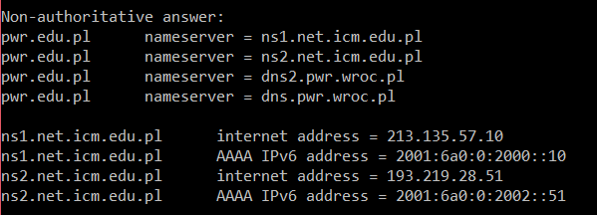  
   (-type=NS)
3. 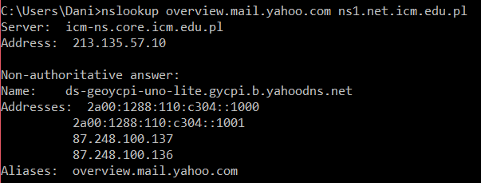
4. UDP  
   