TCP

1. Source IP: 10.152.200.136  
   Port no:62390
2. Dest IP: 128.119.245.12  
   Port no: 80
3. 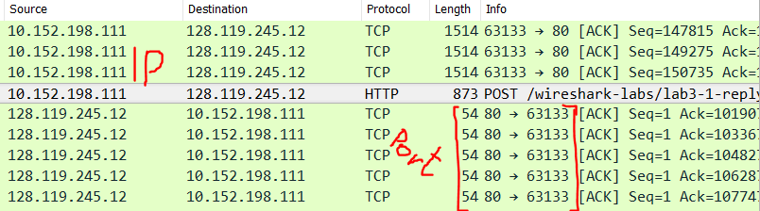
4. Seq=0  
   [SYN], Syn flag set to 1
5. Seq=0  
   Ack=1  
   by adding 1 to the initial seq number  
   [SYN, ACK], Syn and Ack flags are set to 1
6. Seq= 152195
7. 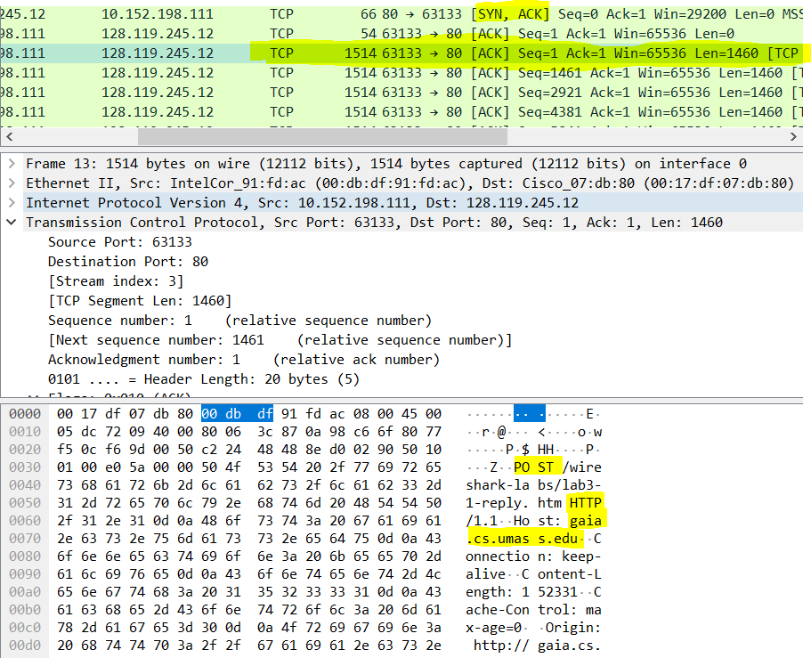  
   seq1=1  
   seq2=1461  
   seq3=2921  
   seq4=4381 Ack=4381(should be 4382) time: 2.394725  
   seq5=5841 RTT= 2. 394725-2.075386= 0.319339s  
   seq6=7301  
   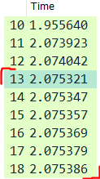  
   //Jeszcze raz wg przykładowego pliku:  
   seq1=1 ack1=566   
   seq2=566 ack2=2026  
   seq3=2026 ack3=3486  
   seq4=3486 ack4=4946  
   seq5=4946 ack5=6406  
   seq6=6406 ack6=7866  
   Times seq:  
   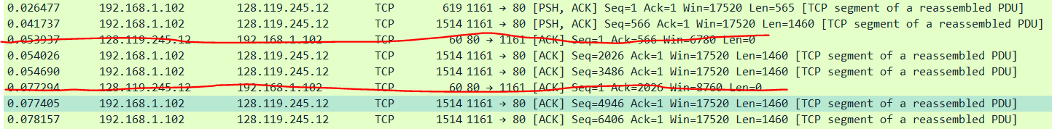  
   Times ack:  
   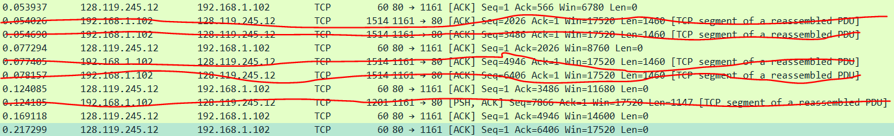  
   RTT1= 0,053937-0,026477=0.02746  
   RTT2= 0,077294-0,041737=0.035557  
   RTT3= 0,124085-0,054026=0.070059  
   RTT4= 0,169118-0,054690=0.114428  
   RTT5= 0,217299-0,077405=0.139894  
   RTT6= 0,267802-0,078157=0.189645  
     
   Estimated RTT=0,875*Estimated RTT+ 0,125*Sample RTT  
   EstminatedRTT1= RTT1= 0.02746  
   EstminatedRTT2= 0,875*0.02746+0,125*0.035557=0,0285  
   EstminatedRTT3= 0.875*0.0285+0.125*0.070059=0.033694875  
   EstminatedRTT4=0.875*0.033694875+0.125*0.070059=0.03824039062  
   EstminatedRTT5=0.875*0.03824039062+0.125*0.139894=0.05094709179  
   EstminatedRTT6=0.875*0.05094709179+0.125*0.189645=0.06828433031
8. 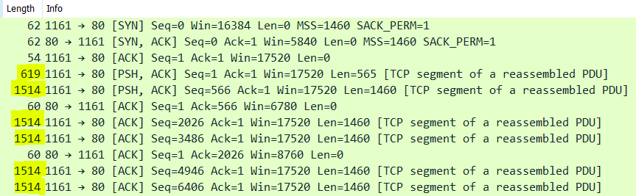
9. Win=5840 and growing (Seq=1). Never throttle
10. There are no. It is seen by no smaller seq numbers than its neighbors seq numbers.
11. Typically: 1460 (len), the first one is 566(len+1)
12. Total amount of data transmitted: **Ack last- seq1=164 091-1=164090**Whole trans time: **Ack last-seq1= 5.455830-0.026477=5.429353**Throughput: **R=I/T= 164090/5.429353=30222.7539819 B/s= 30.222 kB/s**

UDP

1. 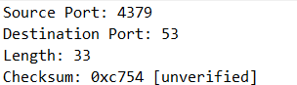
2. Each of them is 2B (bytes) long
3. The sum of the header and the data bytes (header = 8(4*2) + data length =33)
4. Max num: 2^16-1-8(header bytes)
5. Max source port num: 2^16-1
6. UDP protocol num:  
   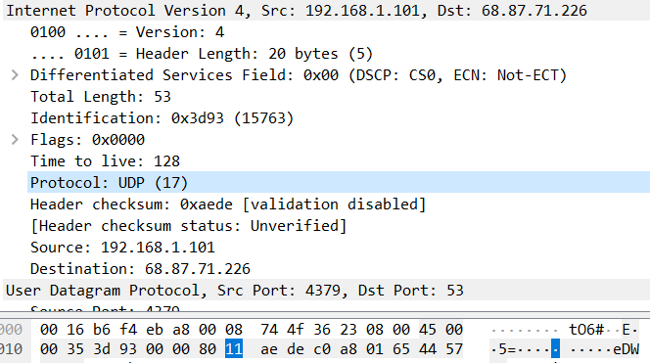  
   hex: 11  
   dec: 17
7. The source port of the second packet has to be the destination for the first packet.