- Test Tasks
  - Task 1 – Add a New Networking Contact and Schedule a Follow-Up
You met a recruiter at a networking event and want to log their information in the app and schedule a follow-up reminder for next week.
  - Task 2 – Complete a Follow-Up
You received a reminder to follow up with a contact. Open the app, review the contact details, and mark the follow-up as completed.
  - Task 3 – View Weekly Follow-Ups
You want to see all of your upcoming follow-ups for the week and identify any overdue contacts.
- Observations and Feedback
  - We tested the wireframes with two undergraduate students who regularly attend networking events.
- Tester #1
  - Task 1 Observations:
    - The tester hesitated on the Dashboard and was unsure where to add a new connection.
    - They clicked “Connections” first instead of using “Quick Add.”
    - They took time to find where to set the follow-up reminder.
Quote: “I thought the add button would be bigger or more obvious.
  - Task 2 Observations:
    - The tester found the reminder on the Dashboard easily.
    - They were unsure what would happen when clicking “Mark Complete.”
Quote: “I don’t know if this deletes the contact or just finishes the reminder.”
  - Task 3 Observations:
    - The tester clicked “Connections” instead of “Calendar.”
    - They expected the Dashboard to show a weekly overview.
Quote:
“I expected to see everything for the week right here.”
- Tester #2
  - Task 1 Observations:
    - The tester successfully added a contact but did not immediately notice the reminder section.
    - They expected reminder setup to be a separate step.
Quote: “I almost forgot to set the reminder.”
  - Task 2 Observations:
    - The tester completed the follow-up successfully.
    - They suggested clearer visual feedback after marking complete.
Quote: “It should show something like ‘Completed’ in green.”
  - Task 3 Observations:
    - The tester found the Calendar view helpful.
    - They suggested overdue items should stand out more visually.
Quote: “Overdue should probably be red.”
- Usability Issues Identified
  - Issue 1 – Add New Connection Is Not Prominent
    - Users did not immediately recognize how to add a new connection from the Dashboard.
  - Improvement:
    - Add a larger and more visually distinct “+ Add New Connection” button at the top of the Dashboard.
  - Issue 2 – Reminder Setup Is Not Clear Enough
    - Some users nearly skipped setting a reminder when adding a new contact.
  - Improvement:
    - Make “Set Reminder” a clearly separated section with stronger labeling and spacing to indicate it is an important step.
  - Issue 3 – Weekly Overview Not Immediately Visible
    - Users expected to see a weekly summary on the Dashboard.
  - Improvement:
    - Add a small weekly preview section on the Dashboard and a clearly labeled “View Full Calendar” button.
  - Issue 4 – Mark Complete Button Is Confusing
    - Users were unsure whether marking complete would delete the contact.
  - Improvement:
    - Add confirmation text or a small explanation under the button stating: “Marks this follow-up as complete. Contact will remain saved.”

- The following wireframes were updated based on usability testing:
  - Updated Wireframe 1 – Dashboard
    - Changes:
      - Larger “+ Add New Connection” button added at the top.
      - Weekly follow-up preview section added.
      - Overdue reminders highlighted more clearly.
      - “View Full Calendar” button added.
  - Updated Wireframe 2 – Connection Detail
    - Changes:
      - Clearer separation of action buttons.
      - Added descriptive text under “Mark Complete.”
      - Improved visual hierarchy of reminder status.

- Updated Wireframe 1 – Dashboard
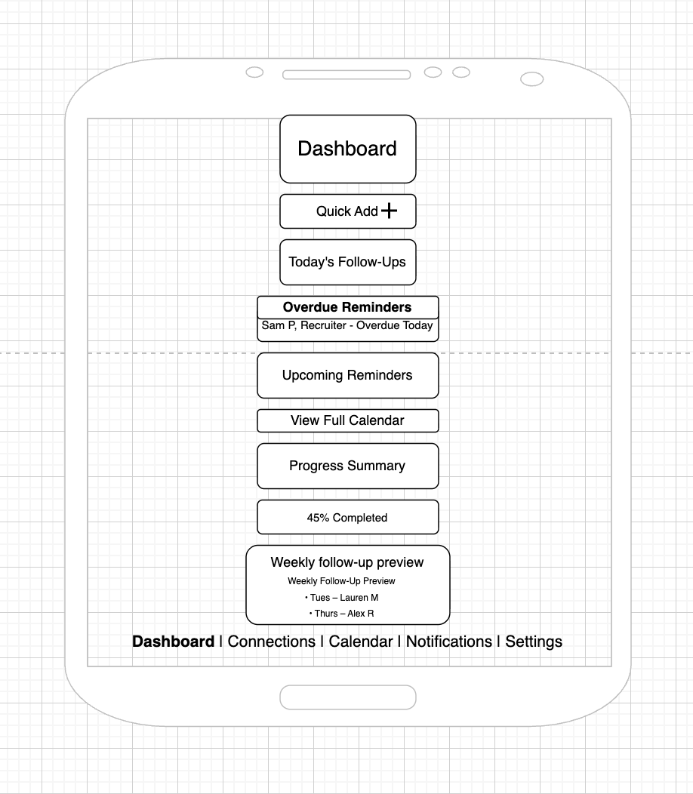

- Updated Wireframe 2 – Connection Detail