Resultados Feature Extraction:

* Borrando **características con prácticamente el mismo valo**r en más de un 90% de los casos

['cSubjectivity', 'cPolarity']

* Borrando **características correlacionadas** (valor de correlación x en los que 0.9<|x|) con Spearman

['sidecarPorcentage', 'varComments', 'varTaggedUsers', 'varWidth', 'cSecondsToRead', 'captionDifficultWords', 'captionSecondsToRead']

* Borrando **características poco importantes** con Lasso (alpha = 0.001)

['HideLikes', 'varLikes', 'avgPhotosInSidecar']

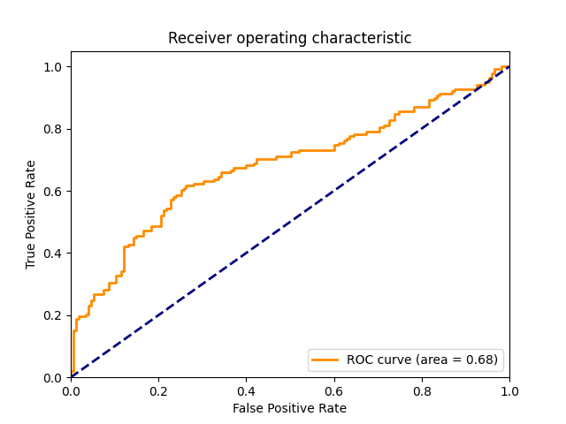Random Forest without Feature Selection: Random Forest with Feature Selection :

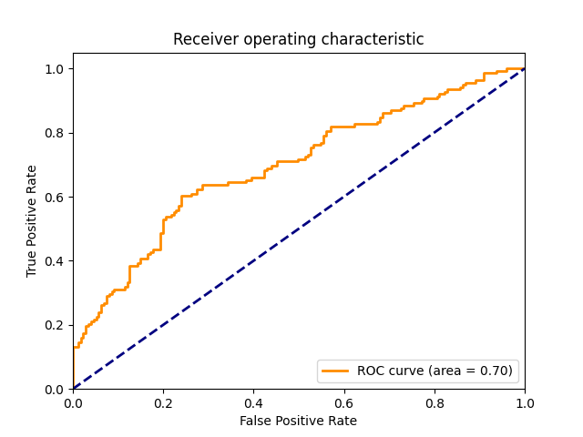

Se observan ligeras mejoras

Resultados Clasificación:

**LogisticRegression**

[[436 143]

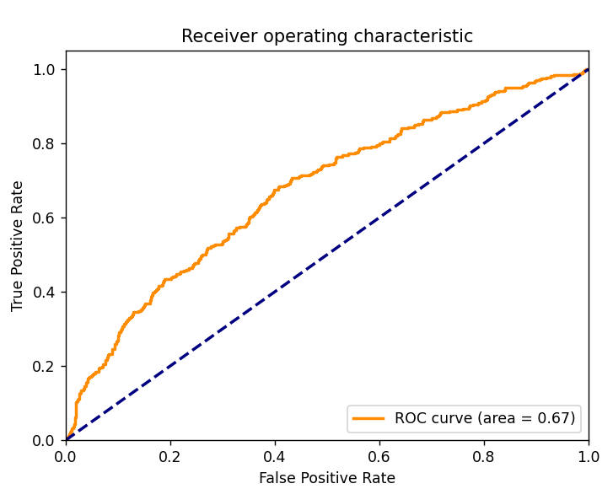 [242 221]]

precision recall f1-score support

0 0.64 0.75 0.69 579

1 0.61 0.48 0.53 463

accuracy 0.63 1042

macro avg 0.63 0.62 0.61 1042

weighted avg 0.63 0.63 0.62 1042

AUC_score: 0.6739

**GradientBoosting**

[[416 163]

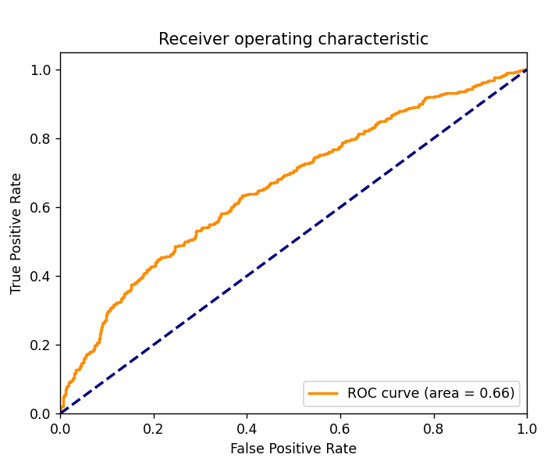 [218 245]]

precision recall f1-score support

0 0.66 0.72 0.69 579

1 0.60 0.53 0.56 463

accuracy 0.63 1042

macro avg 0.63 0.62 0.62 1042

weighted avg 0.63 0.63 0.63 1042

AUC_score: 0.6612

**DecisionTrees**

[[364 215]

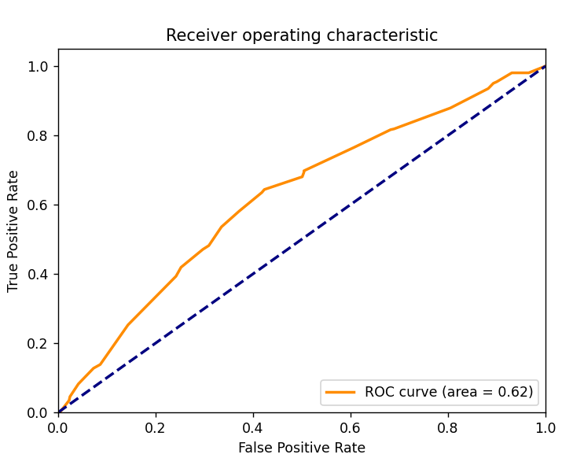 [194 269]]

precision recall f1-score support

0 0.65 0.63 0.64 579

1 0.56 0.58 0.57 463

accuracy 0.61 1042

macro avg 0.60 0.60 0.60 1042

weighted avg 0.61 0.61 0.61 1042

AUC_score: 0.6218

**RandomForest**

[[452 127]

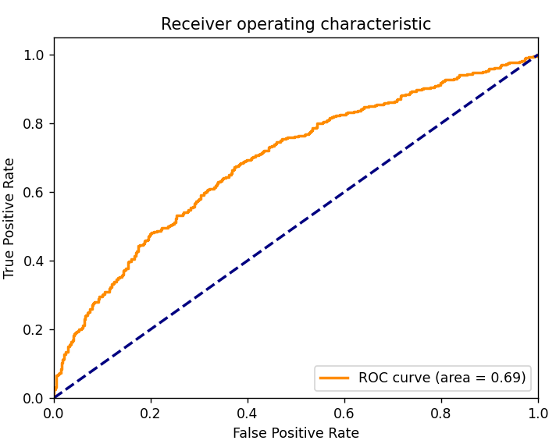 [238 225]]

precision recall f1-score support

0 0.66 0.78 0.71 579

1 0.64 0.49 0.55 463

accuracy 0.65 1042

macro avg 0.65 0.63 0.63 1042

weighted avg 0.65 0.65 0.64 1042

AUC_score: 0.691