**CanSat Critical Design Review**

**– SatPlant –**

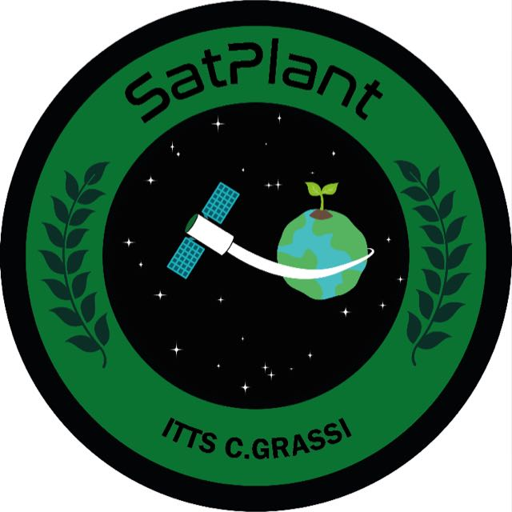

**Team Name: SatPlant**

**School Name: I.T.T.S. Carlo Grassi**

**Torino**

**Italy**

Sommario

1. Introduction 1-3

1.1. Team organization and roles 1-3

1.2. Mission objectives 1-5

First Mission 1-5

Secondary mission – Planting a seed 1-5

2. Cansat description 2-7

2.1. Mission overview 2-7

2.2. Mechanical design 2-7

2.3. Electrical design 2-7

2.4. Software design 2-7

2.5. Recovery system 2-7

2.6. Ground station 2-7

2.7. Tests 2-7

3. Components and Costs Estimation 3-8

4. Outreach Program 4-9

5. Requirements 5-10

6. Appendix 6-11

7. Bibliography 7-12

# Introduction

## Team organization and roles



Prova

* Alex
* Desiée

* Leon
* Stefano
* Mentor

## Mission objectives

### First Mission

The first mission is mandatory and aims to build and program a CanSat in order to measure atmospheric parameters during the descent, such as air temperature and pressure. The parameters will be saved on a microSD card and will be sent in real time to the ground station twice per second.

Additionally, we will measure air humidity, to evaluate environmental conditions, and altitude, to determine the position and the actual rate of descent of the Cansat. The measure of the pressure and, consequently, of the altitude of our Cansat are preparatory for the second mission.

To carry on the first mission our Cansat will be equipped with the following sensors:

* **bmp280:** the sensor measures both air temperature and pressure
* **dht22:** the sensor measures air temperature and humidity. Temperature measure will be used in combination with the bmp280 in order to obtain a more precise measure
* **xbee pro serie 2:** wireless communication module to perform data sent between Cansat and ground station

### Secondary mission – Planting a seed

The objective of our secondary mission is to plant a seed on the ground.

We think that it can be a great alternative reforestation method therefore need to be adopted, taking into account what has happened in the last years, where deforestation started to be a very big problem for our Earth to be concerned about.

During the descent phase, by means of a high-definition camera, the Cansat will scan the ground in order to find the best place to land on and to allow the seed growth. During the descent with the parachute, we will perform field recognition using NDVI and machine learning techniques. The software used for machine learning and NDVI will be trained before the launch, using different images of the ground where the Cansat launch campaign will be carried on (Molinella airfield – BO – Italy).

Even if we know that the Cansat will land on a grass field, we are trying to achieve the ground recognition to generalize the usage of our satellite in places where we don’t know what the ground is made of, in order to rise the chances of planting a plant.

This is the most challenging part of our project because it involves not easy field recognition techniques and both stabilization and driving of our satellite. However, even if the Cansat does not find a right place to permit a seed growth, at a certain point of the descent the seeds will be released nonetheless.

As mentioned above in the presentation of the primary mission, our system needs the conversion of pressure in altitude in order to evaluate the best moment to release the seeds contained in the Cansat. To achieve this goal, the Cansat needs to be calibrated before the launch setting the actual ground pressure via software.

# Cansat description

## Mission overview

As discussed in the previous sections, the primary mission has the aim to build a CanSat that, in the *Ascent Phase*, will be brought at 1.000 m of altitude by a rocket. From this point the CanSat enters in the Descent Phase, where it falls down to the ground using a parachute, recording data about air temperature, pressure and humidity and sending them to a ground station.

We divided the mission in different phases, as showed below:

1. *Ascent phase*. During this phase, the Cansat is brought at 1.000m of altitude by a rocket. For our mission it is an initialization phase, where the CanSat is prepared for the real mission.
2. *Descent phase*. When the CanSat is ejected, the primary mission begins. During the fall the sensors collect data of air parameters, write them in the SD card and send them to the ground station.
3. *Ground phase*. After reaching the ground, the CanSat will plant the seeds in the ground. A dedicated component will get rid of the parachute in order to permit the seed growth. This process will be monitored by a camera, saving images and short videos on the SD card.
4. *Data Elaboration*. After the mission, collected data will be elaborated in order to create graphs to evaluate the variation of atmospheric parameters with the altitude and obtain relative laws.

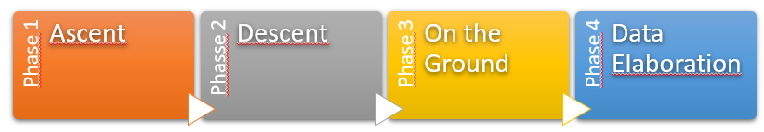

The following schema is referred to the CanSat organization workflow.

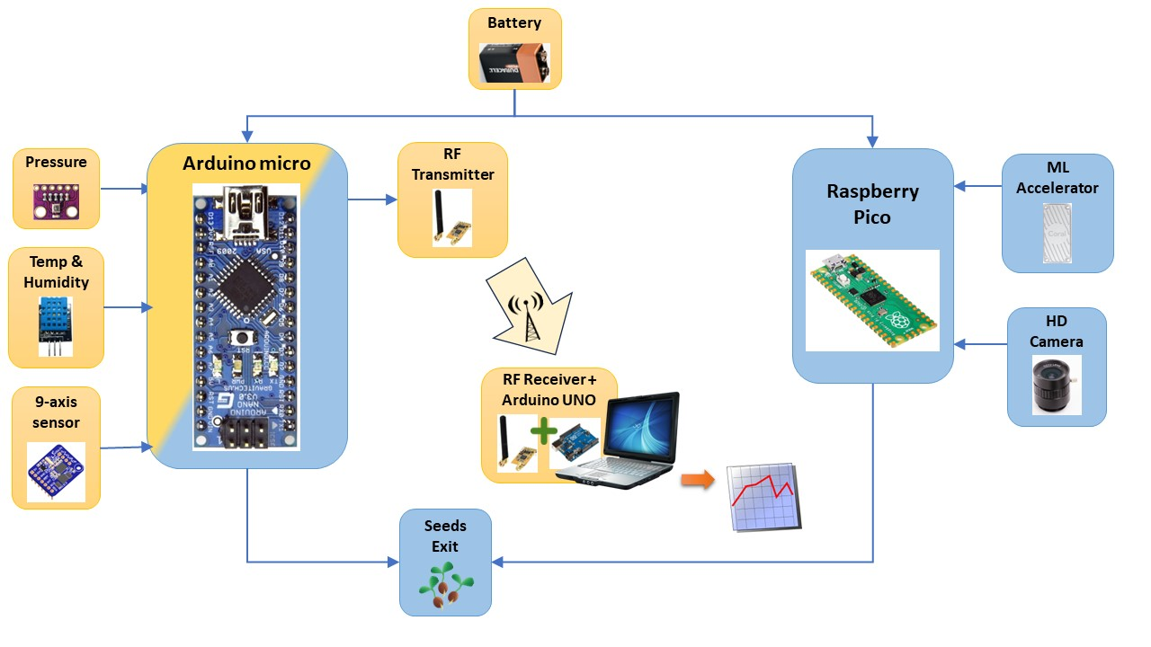

The nylon circular section parachute has a diameter of about 55 cm and will carry a CanSat with a weight in a range of 300 – 350 g, with an average descent ratio of about 6 m/s. These data permit us to estimate the drag coefficient by the following rule:

where:

Compared to the edition of the last year, a big difference in the competition is that the parachute is provided by ESERO.

The CanSat uses two different sensors in order to measure air temperature and pressure, respectively DHT11 and BMP280. Due to the fact that both sensors measure the temperature, we use the average of the two measures to work with for the data plot. Thanks to the DHT sensor, we can also collect humidity data, even if it is not requested for the primary mission, but it will be interesting to analyze the amount of water vapor in different layers of the atmosphere.

We used a professional weather station to calibrate the sensors through the software. This also permitted us to evaluate a possible overheating of the CanSat as function of time that could cause a temperature/pressure/humidity data overestimation.

More details can be found in the following section, Tests.

The data we collected in this phase of test can be found in the Github of the project, as mentioned in the References section.

## Mechanical design

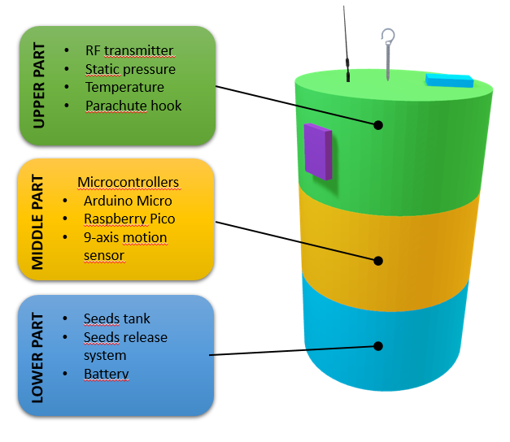The main structure has been 3D printed and PLA material was used for the purpose. The main body of the CanSat consists in a simple tube in which every component founds its place, from the microcontrollers, batteries to wires and different sensors.

The CanSat can be divided by three different main parts, each of them having a specific role, according with the lateral schema.

We calculated the center of gravity of our satellite in order to install the 9-axis motion sensor.

For Bernoulli’s principle, the total pressure of the air is a constant and it is given by two contributions: static and dynamic pressure. It means that if we want to catch information about the static component, we have to act on the parallel air flow with respect to the direction of motion (as done with static ports in airplanes), while if we want to get information about the total, and then the dynamic component, we should act on the orthogonal face with respect to the direction of motion (as done with Pitot’s tube, to measure air speed). Therefore, the bmp280 sensor, mainly used to measure air pressure, is installed on the side of the CanSat, in order to measure the static component of the pressure.

The dht11 sensor, mainly used to measure air temperature and humidity, is placed on the top of the satellite in order to avoid any disturbing effect of the air flow that could cause an over/underestimation in the measure.

The lower part of the CanSat is dedicated to the secondary mission. It contains the little tank with the seeds and the mechanism that will be used to release them.

The following image represents the partial model used to perform 3D printing.

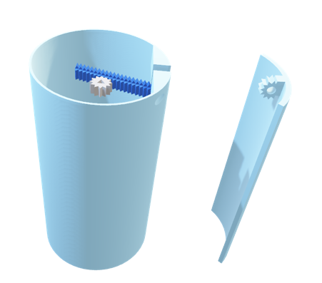

This picture shows an airbrake in the right side of the CanSat. Finally we will have two airbrakes in both side of the structure, for the moment the group was focusing on the single airbrake structure and opening system, in order to perform tests in the wind tunnel.

We don’t expect a sensitive drug increase during the descent phase opening the airbrakes, but working on the connecting mechanism to the main body of the CanSat we can use them for directing the satellite.

## Electrical design

In this section we will provide electrical schemas and designs separately, to give better evidence of the single systems the CanSat is made of. In addition, to make photos and on the ground tests we used Arduino UNO R3 and Raspberry Pi, while we assembly the CanSat with the Arduino Micro and Raspeberry Pi Pico for space and weight optimization.

The first system shown is used for the portable weather station with all the components we used for this purpose.

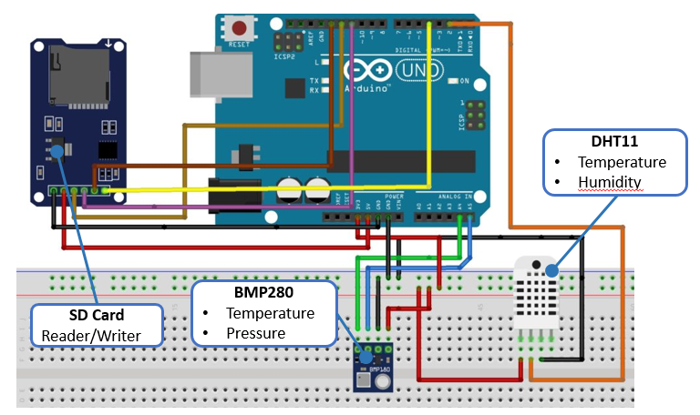

The following images refer to the Raspberry Pico and connections with the 5Mpx HD Camera and the Coral accelerator for Machine Learning.

During the last year part of this team also participated at the AstroPi Mission SpaceLab competition. We want to emphasize on the importance of the resources we found out on the Esero platform in order to learn machine learning technique, and how useful they have been this year with the CanSat competition.

AGGIUGNERE FOTO DEL RASPBERRY CON CORAL E FOTOCAMERA COLLEGATI

## Software design

For what concerns the Arduino microcontroller and sensors measuring part, we used C++ code while in order to use Raspberry Pi, camera and Coral accelerator we had to switch to python code.

Codes can be found in the Github of the project, as mentioned in the References section.

How is famously known that *a picture is worth a thousand words*, we will describe used systems by means of the following schemas.

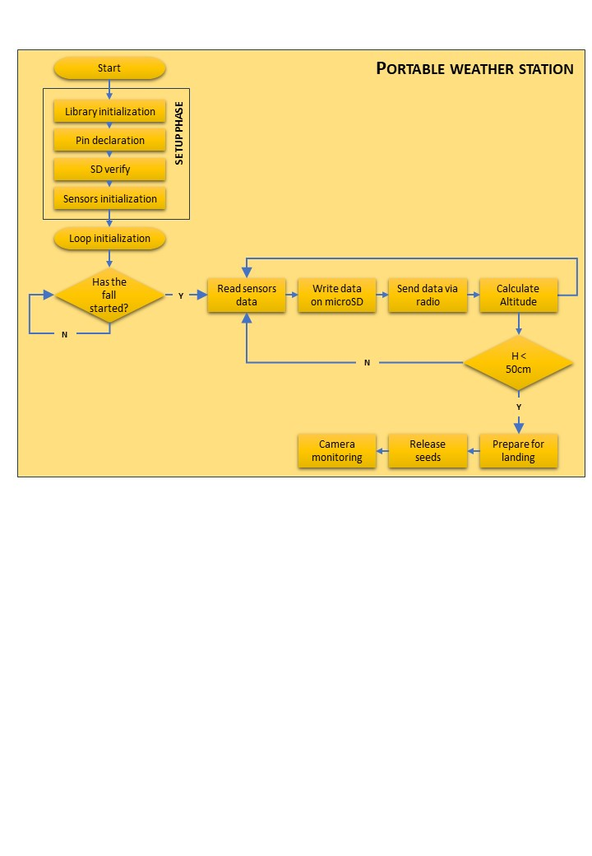

## Recovery system

## Ground station

## Tests

# Components and Costs Estimation

|  |  |  |  |  |
| --- | --- | --- | --- | --- |
| **Component** | **Function** | **Quantity** | **Unitary Cost** | **Total Cost** |
| bmp280 | Temperature and pressure measure | 2 | € 7,90 | € 15,80 |
| dht11 | Temperature and humidity measure | 1 | € 4,90 | € 4,90 |
| Xbee 3 pro | Wifi communication | 1 | ?? | ?? |
| APC220 | Wifi communication | 1 | ~ € 40,00 | ~ € 40,00 |
| SD reader | Arduino SD card reader/writer module | 1 | € 3,90 | € 3,90 |
| SD card | 64 GB microSD card | 1 | ~ €20,00 | ~ €20,00 |
| Arduino nano | Microcontroller | 1 | € 28,00 | € 28,00 |
| LED | LED | 2 | € 0,50 | € 1,00 |
| BNO055 | 9-axis control | 1 | € 40,00 | € 40,00 |
| ICQUANZX GY NEO6MV2 | GPS control module | 1 | € 10,00 | € 10,00 |
| RPI CAM V3 | Raspberry camera | 1 | € 30,00 | € 30,00 |
| USB Accelerator* | Coral USB Accelerator* | 1 | € 60,00* | € 60,00* |
|  | servocomandi |  |  |  |
| PLA | PLA filament for 3D printing | 1 | € 1,00 | € 1,00 |

*In the list we take into account the Coral Machine as contribution for the total budget but with an estimated cost, because we already had it in school thanks to the participation to the AstroPi Mission SpaceLab project during the last year.

# Outreach Program

# Requirements

# References

# Appendix 1 – Sensors calibration

Data collection for sensors calibration.

|  |  |  |  |  |
| --- | --- | --- | --- | --- |
| **Time** | **Pressure**  **(BMP280)** | **Temperature**  **(BMP280)** | **Temperature**  **(DHT11)** | **Humidity**  **(DHT11)** |
|  |  |  |  |  |
|  |  |  |  |  |
|  |  |  |  |  |
|  |  |  |  |  |
|  |  |  |  |  |
|  |  |  |  |  |

# Appendix 2 – Program

Code used during for Arduino and Raspberry Pico.