Room Control System

Dania Farrukh Ghouri | 366013
Sundas Rathore | 366636
Momina Tabassum | 366683

Abstract—The Automatic Room Light &Fan Control System represents an innovative approach to energy-efficient and intelligent room lighting. By integrating Light Dependent Resistors (LDR), PIR motion sensor, Arduino, Timer NE555, and Solar Panel, the project aims to optimize lighting conditions based on ambient light and human presence. This abstract provides a concise overview of the project's components, objectives, and anticipated outcomes.

Introduction

In the contemporary landscape of sustainable living, the demand for innovative solutions extends beyond mere efficiency; it encompasses the seamless integration of technology into our daily lives. The conventional approach to lighting, marked by manual control systems and static responses, has proven inadequate in addressing the dynamic nature of environmental conditions and occupancy. This insufficiency, coupled with the imperative to curtail unnecessary energy consumption, forms the backdrop against which the Automatic Room Light Control System emerges as a transformative solution.
This project is inherently rooted in the recognition of the limitations inherent in traditional lighting systems. By integrating advanced components such as Light Dependent Resistors (LDR), Solar Panel and Timer NE55, the system endeavors to transcend the constraints of conventional lighting. These components collectively form the technological backbone, imbuing the project with the capability to intelligently respond to ambient conditions and human presence. Key factors include:
- Technological Integration:
The project strategically integrates Light Dependent Resistors (LDR), PIR motion sensor, Timer NE555, Arduino and Solar Panel to form a cohesive and intelligent lighting control system.

- Dynamic Nature of Lighting:
Recognizes and addresses the shortcomings of conventional lighting systems in responding to the dynamic nature of environmental conditions and occupancy.

- Objective of Energy Conservation:
The project aligns with the overarching goal of energy conservation by optimizing lighting based on real-time factors.

- Transformation of Manual Control:
Aims to transform the manual control paradigm, allowing for a more adaptive and responsive lighting environment.

- Smart Living Ethos:
Aligns with the ethos of contemporary smart living by seamlessly integrating technology to enhance both efficiency and user experience.

- Bridge to Sustainable Lifestyles:
This project serves as a bridge between technological innovation and sustainable lifestyles, offering a practical solution for energy-efficient room lighting.

Literature Review

It is necessary to explore key aspects essential for developing an Automatic Room Light Control System. From smart lighting's sustainability impact to advancements in technologies like LDR and Timer NE555, each topic provides crucial insights. We also delve into microcontroller integration, human-centric lighting principles, and the role of solar panels. This condensed review serves as a roadmap for our project, guiding us towards effective and sustainable room control solutions.

- Smart Lighting Systems in Sustainable Environments:
Numerous scholarly works delve into the transformative impact of smart lighting systems on sustainability. Studies highlight the pivotal role of these systems in optimizing energy consumption, reducing carbon footprints, and contributing to the creation of environmentally conscious living and working spaces. The literature underscores the need for innovative solutions like the Automatic Room Light Control System to meet the growing demand for sustainable lighting practices.

- Advances in Light Dependent Resistors (LDR) Technology:
In exploring the realm of light-sensing technologies, the literature extensively covers advancements in Light Dependent Resistors (LDR). Research studies and technological reviews delve into the evolution of LDR technology, examining its precision, sensitivity, and applications in intelligent lighting systems. These investigations serve to elucidate the critical role LDR plays in achieving responsive and energy-efficient lighting control.

- Timer NE555 in Timing Control Applications:
The Timer NE555, a venerable integrated circuit known for its versatile timing applications, finds relevance in the context of lighting control. Literature reviews and technical analyses focus on the historical evolution of the Timer NE555, its fundamental principles, and its adaptability in creating customizable time delays. This section explores the various applications of Timer NE555 in timing control, offering a foundation for understanding its role in this project.

- Human-Centric Lighting and Motion Passive Infrared (PIR) Sensors:
The concept of human-centric lighting, which prioritizes lighting solutions that enhance well-being and productivity, has gained prominence in recent literature. Studies explore the integration of Motion Passive Infrared (PIR) Sensors in human-centric lighting systems, emphasizing the role of PIR sensors in adapting lighting conditions to human presence. This section provides insights into the psychological and physiological implications of PIR sensor-based lighting control.

- Microcontroller Integration for Intelligent Lighting:
The integration of microcontrollers, particularly Arduino, stands as a linchpin in the literature discussing intelligent lighting systems. Comprehensive reviews delve into the capabilities of microcontrollers in creating responsive algorithms for real-time lighting control. This section explores the synergies between microcontrollers and various sensors, elucidating the advantages and challenges associated with their integration in smart lighting solutions.

- Solar Panels in Smart Lighting Systems:
Literature highlights the trend of integrating solar panels in smart lighting, offering sustainable power sources for reduced reliance on conventional energy grids. The Automatic Room Light Control System exemplifies the efficacy of this integration, contributing to eco-friendly and energy-efficient lighting solutions.

- Case Studies and Real-World Applications:
A multitude of case studies and real-world applications showcase the practical implementations and successes of smart lighting systems. From residential buildings to commercial spaces, these studies highlight the adaptability and impact of intelligent lighting solutions.

Working

The Automatic Room Light Control System operates as a sophisticated and energy-efficient lighting solution through the seamless integration of Light Dependent Resistor (LDR), Timer NE555, and a relay mechanism. Solar Panel uses solar energy to provide 12V to this circuit. Simultaneously, the system assesses ambient light conditions using the LDR, determining whether artificial lighting is required.

Upon confirming darkness, the Timer NE555 is activated, receiving the signal from Arduino. In turn, the timer initiates a voltage supply to the relay mechanism, crucial for the subsequent switching process. The relay, serving as the gateway for controlling the lighting load, switches in response to the Timer NE555's signal, completing the circuit and allowing power to flow to the lamp. The PIR motion sensor then detects if there is motion. Upon confirmation of motion, the Arduino supplies voltage to the lamp to light up.

In essence, this intricate sequence of events ensures that the Automatic Room Light Control System intelligently activates artificial lighting when motion is detected, all the while considering ambient light levels and harnessing solar power for sustainable and energy-efficient illumination.

- Components
These components collectively form a simple yet effective voltage stabilizer circuit: [2]
Name | Purpose
NE 555 Timer: | The NE 555 Timer facilitates precise timing intervals, contributing to controlled activation within the system.
LDR (Light Dependent Resistor): | The LDR serves as an ambient light sensor, detecting light levels and influencing lighting decisions.
Arduino: | Acts as the central processing unit, coordinating and controlling various components in the system for intelligent operation.
PIR Sensor (Passive Infrared Sensor): | Detects motion within the room, providing input to the system for responsive lighting based on occupancy.
Solar Panel: | The Solar Panel harnesses solar energy to provide a sustainable power source, crucial for system operation.
Relay: | The Relay is a critical switching component, managing the flow of power to the lamp based on system signals.
Transistor BC547: | The Transistor BC547 amplifies and regulates signals within the system, ensuring accurate control.
Potentiometer: | The Potentiometer allows for adjustable resistance, providing a customizable element for system calibration.
Capacitors, Resistors & Diode: | Capacitors and resistors contribute to the system's electrical characteristics, aiding in signal conditioning and stability. Diode prevents any voltage spikes while controlling direction of current flow.
Lamp & Fan: | The Lamp and fan serve as the output, responding to the relay switching mechanism based on environmental conditions.

- Block Diagram

This is a simplified schematic of our project:

Simulation:

There are four case scenarios:

- When the motion sensor detects motion, and it is dark:
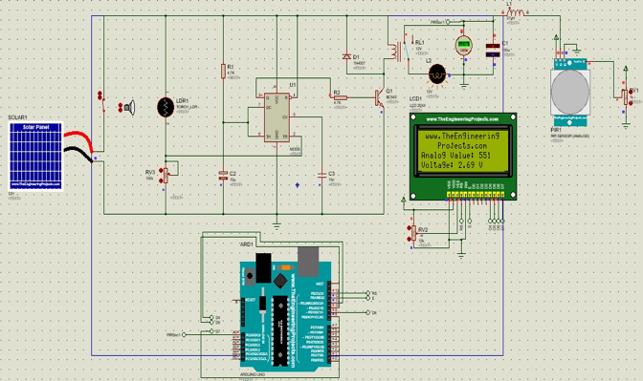
- When the motion sensor detects motion, and it is bright:
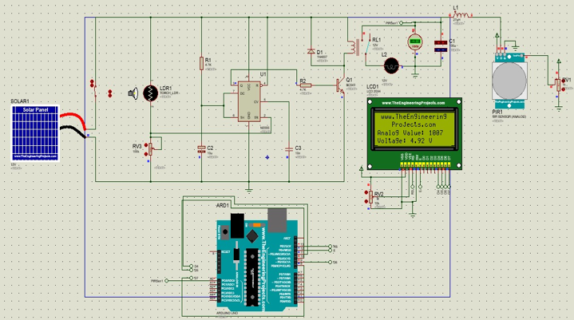
- When the motion sensor does not detect motion, and it is dark:
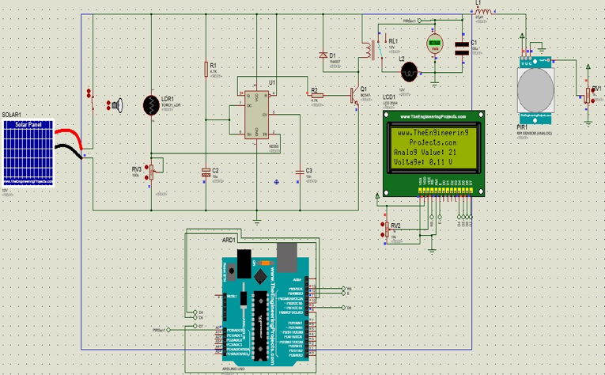
- When the motion sensor does not detect motion, and it is bright:
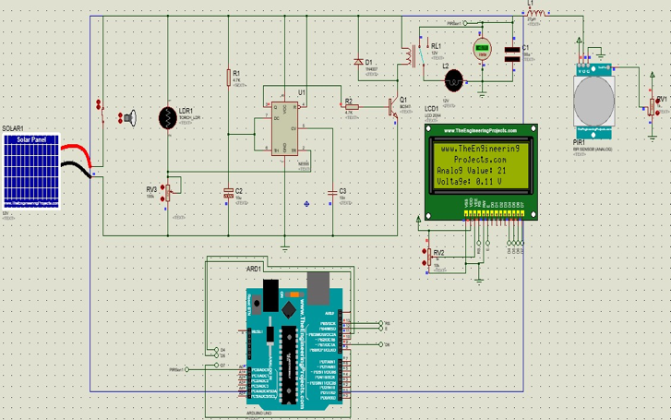

Hardware:

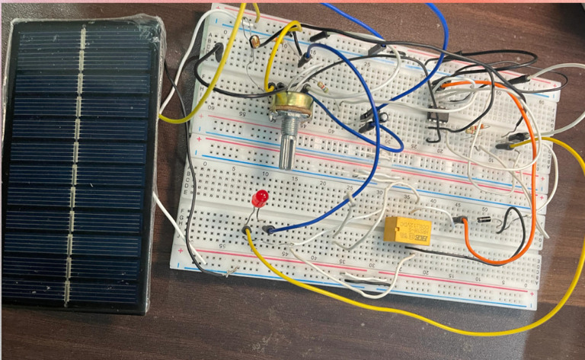

Code for Arduino

#define MOTION_SENSOR_PIN 2
void setup() {
pinMode(MOTION_SENSOR_PIN, INPUT);
Serial.begin(115200);
Serial.println("Motion Sensor Test");
}
void loop() {
int motionValue = digitalRead(MOTION_SENSOR_PIN);
if (motionValue == HIGH) {
Serial.println("Motion detected!");
}
else {
Serial.println("No motion.");
}
delay(1000);
}

Results & Analysis

Hardware and simulation both are running perfectly.
This circuit was designed by us from scratch so we cannot compare it to any given model, nevertheless, the results affirm the Automatic Room Light Control System's efficacy in achieving energy-efficient and responsive room lighting. The incorporation of a solar panel, in conjunction with the precise control offered by Arduino and the responsiveness introduced by the PIR sensor, showcases a holistic and sustainable approach. The system's reliable relay switching mechanism, coupled with its adaptability to environmental changes, positions it as a versatile solution for diverse applications. Further refinements and potential expansions, such as wireless communication and algorithm enhancements, could enhance the system's capabilities and contribute to its broader applicability. Overall, the project presents a promising solution for intelligent and energy-efficient room lighting.

Recommendations

- Algorithm Refinement:
Further refine the control algorithm to enhance adaptive responses and improve energy savings
.
- Wireless Integration:
Explore wireless communication protocols for remote monitoring and control, increasing system flexibility.

- Expand Sensor Capabilities:
Incorporate additional sensors, such as temperature and occupancy sensors, for a more comprehensive environmental control system.

- User Interface Improvement:
Develop an intuitive user interface for convenient customization and control of lighting settings.

Conclusion
The Automatic Room Light Control System successfully achieved its objectives, demonstrating notable improvements in energy efficiency and user experience. The integration of LDR, PIR motion sensor, Arduino, Timer NE555, and Solar Panel showcased a responsive and effective lighting control system. The identified areas for improvement and future considerations suggest promising avenues for further development, solidifying the project's potential as a practical and intelligent solution for automated room lighting.
be set into vehicle’s body where surrounding light can easily be detected by the sensor, such as rear glass side of vehicle.

References
- https://www.circuits-diy.com/automatic-headlight-circuit/
- https://www.electronicsforu.com/electronics-projects/automatic-headlight-switcher
- https://ijret.org/volumes/2014v03/i02/IJRET20140302016.pdf

