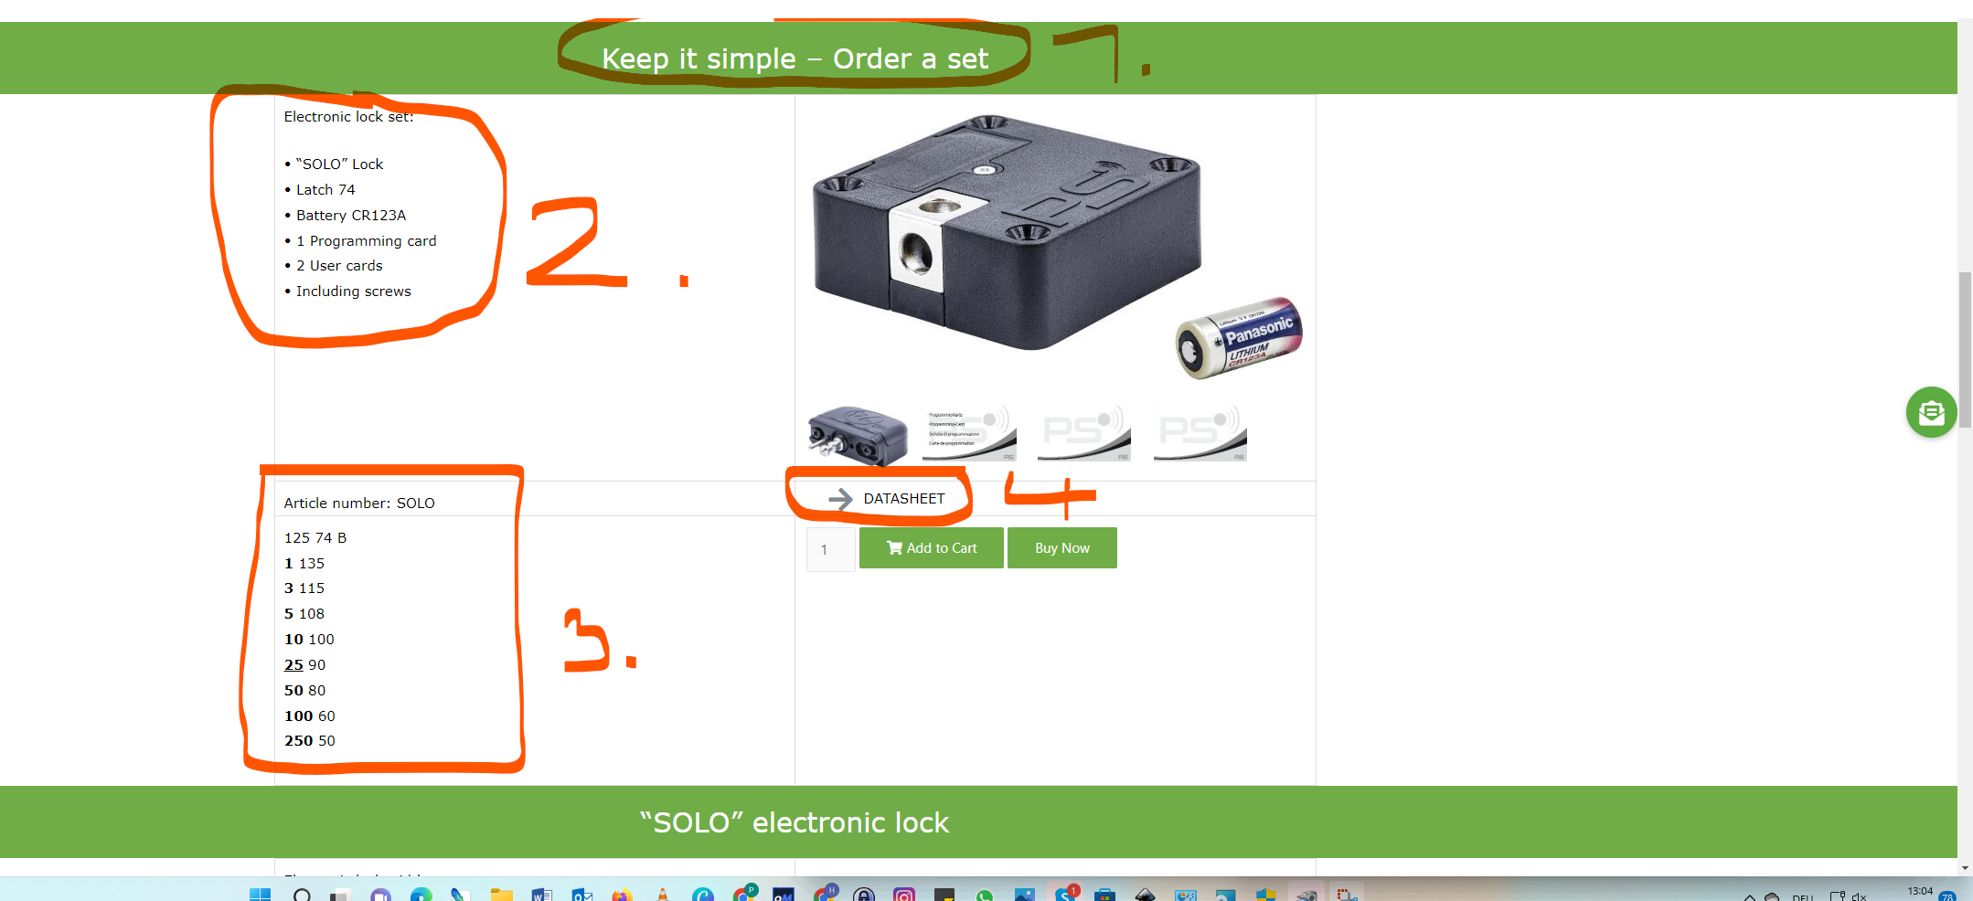

1. Here we need a better title – I think we will have to keep it simpler – something like

“best option for you – order the set”or “choose the SOLO Set instead of ordering the single parts”

1. Here we will have to have more order -that the datas are more obvious:

The Solo Set includes:

* 1x “SOLO 125” Lock
* 1x Latch 74 (Closing Part)
* 1x Battery CR123A
* 1x Programming Card
* 2x User Card (Keycard)
* Screwset

1. Please do take a table here – I really do not like the design – everything has to be clear at the first sight.- We will also need a better name to make this clear. Or better do it with a drop down field – or a table that you are able to open with one click?

Scale prices per piece

|  |  |
| --- | --- |
| 1 | 135 |
| 3 | 115 |
| 5 | 108 |
| 10 | 100 |
| 25 | 90 |
| 50 | 80 |
| 100 | 60 |
| 250 | 50 |

1. Can you find the Datasheet to download here? Or for what is this?

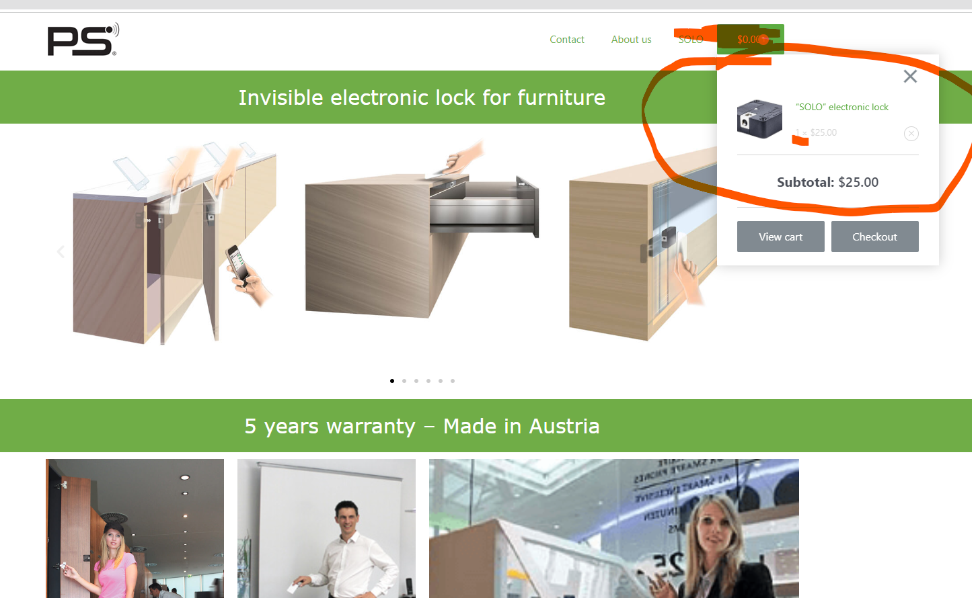

If there is one thing in the shopping cart – the prices should be actualised automatically.

* The prices aren´t right – did you already get them from Günther?

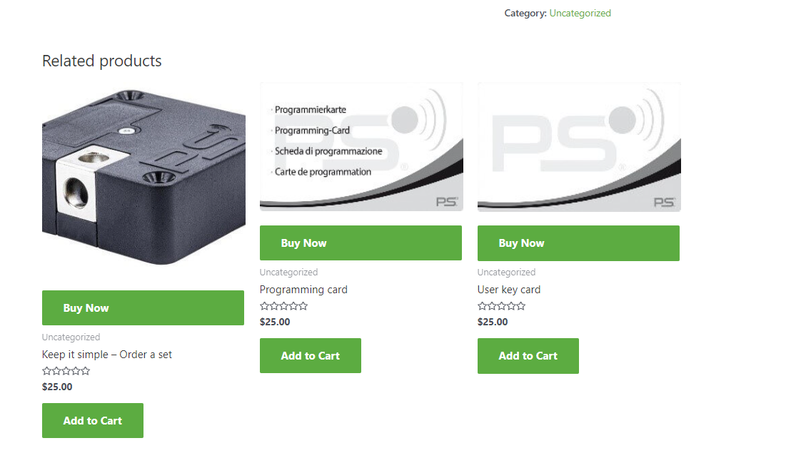

Here would be great – if all are the same size

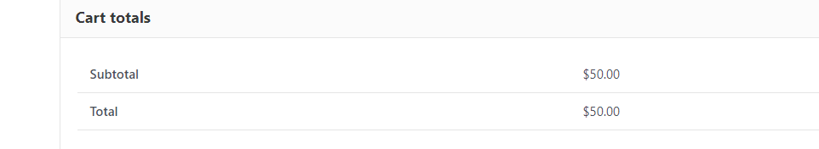

What do you want to say with this? Is this necessary?

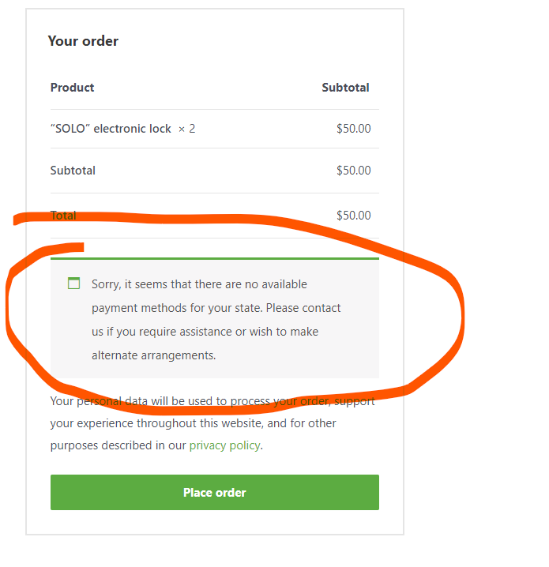Maybe it could be a great option to show this somewhere at the front – not just at the checkout?

This should be everything by now. 😊