

Computer Games Development SE607

Software Functional Specification

Year IV

Danial Nor Azman

C00253517

|  |
| --- |
| [26/04/2023] |

**DECLARATION**

Muhammad Danial Hakim Nor Azman

26/4/2023

Danial Nor Azman

C00253517

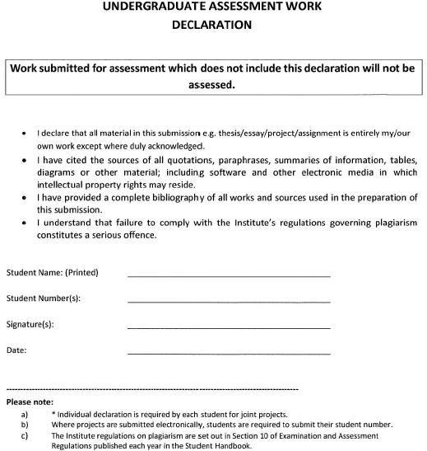

Contents

Introduction 3

Accessibility Features 3

Bullet elements 3

Gun Types 3

Enemy 4

States 4

Decision Making - Fuzzy Logic 4

Adaptive System 4

Procedural Level Generation 4

Playtest Session 4

The questionnaire is as below: 5

# Introduction

LabEscape is a first person rogue like shooter that focuses on testing the accesibility features for people with disabilities. The game features procedural level generation , different types of gun and bullets and adaptive enemy behavior.

# Accessibility Features

The accessibility features included in the game for people with disabilities:

Customizable control: Players can remap controls to fit their individual needs, inluding alternative input devices.

Visual cues: The game includes visual cues to serve an alternate for audio cues for enemy footsteps. Red arrow will show where the enemies is and the opacity will indicate the distance between the enemy and the player.

Magnifier: A magnifier that will make any object or items appear bigger at where the magnifer is placed. Zoom effect and placement of the magnifier can be controlled by the player if an eye tracker is attached. It default to the middle of the screen.

# Bullet elements

LabEscape have 4 different bullet types which help the player in combat.

* Ice: Freezes enemy movement for 2 seconds.
* Fire: Sets enemy on fire, dealing damage over time for 3 seconds.
* Electric: Deals area of effect damage.
* Water: Slows enemy movement for 4 seconds.

Players can change their bullet types by interacting with objects in the game. The game uses an Enum class called "elements" to update the bullet's element, and the effects are applied when the bullet collides with an enemy.

# Gun Types

Three different types of guns:

* Assault: Allows players to hold the fire button and keep firing until it runs out of ammo or needs to reload.
* Burst: Fires 3 bullets with one click at a faster rate but requires the fire button to be clicked again.
* Shotgun: Fires 5 bullets at a shorter range with random spread.

The behaviour of guns is controlled by a custom gun script, which includes settings such as time between shots, bullets per tap, spread, magazine size, and allow button hold. Changing these settings can affect how the guns behave.

# Enemy

## States

LabEscape’s enemies have three main states:

Patrolling: Enemies patrol around the room, avoiding obstacles and moving between multiple points in the room in a loop.

Chasing/Attacking: Enemies chase and attack the player if the player is within their vision cone.

Retreating: Enemies retreat and heal up if their health falls below a certain threshold unless an event occurs.

## Decision Making - Fuzzy Logic

LabEscape's enemies use fuzzy logic in their decision making, with threat levels based on the player's and enemy's health. Threat levels determine the speed at which enemies move, with lower health levels resulting in faster movement. Enemies prioritize attacking or retreating based on threat levels, making their behaviour more passive or aggressive depending on the situation.

## Adaptive System

LabEscape's enemies have an adaptive system that adjusts their behaviour based on the player's bullet element type. If the player consistently uses a particular bullet element, enemies will have more resistance towards that element while the resistance towards other element is reduced. Example: If player keep on using ice bullet where it froze the enemy movement for 2 seconds. The duration will go down to zero at one point, making it just like a normal bullet.

## Procedural Level Generation

LabEscape have different level layout every time and in order to win, player have to clear a number of room depending on the size of the lab. If there are 10 lab rooms, player will need to clear 7 rooms. However, the number of rooms cleared is limited to 12, to avoid player spending most of the game clearing room if the number of lab is big. The obstacle is also randomly generated every time to make the game feels fresh.

# Playtest Session

Player will have a playtest session with questionnaire at the end. As the goal of the research is to study about accessibility in games for disabled gamer, participants with no disabilities will give limitation such as playing with one hand, playing with no sound and sitting further away from the screen.

**The questionnaire is as below**:

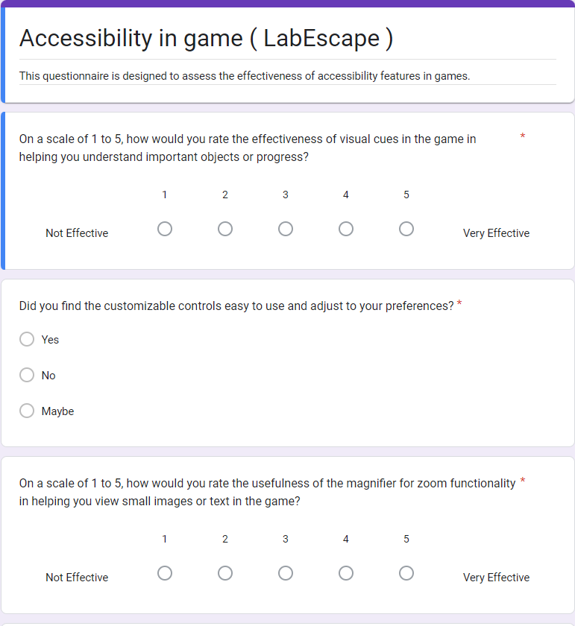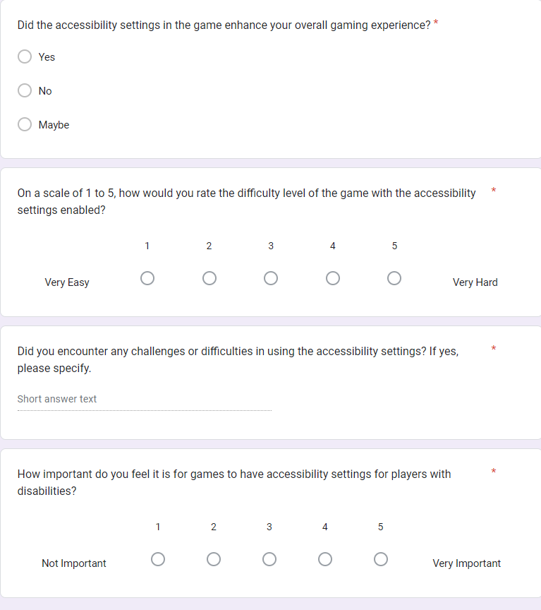

Process when player click into the game:

Main Menu

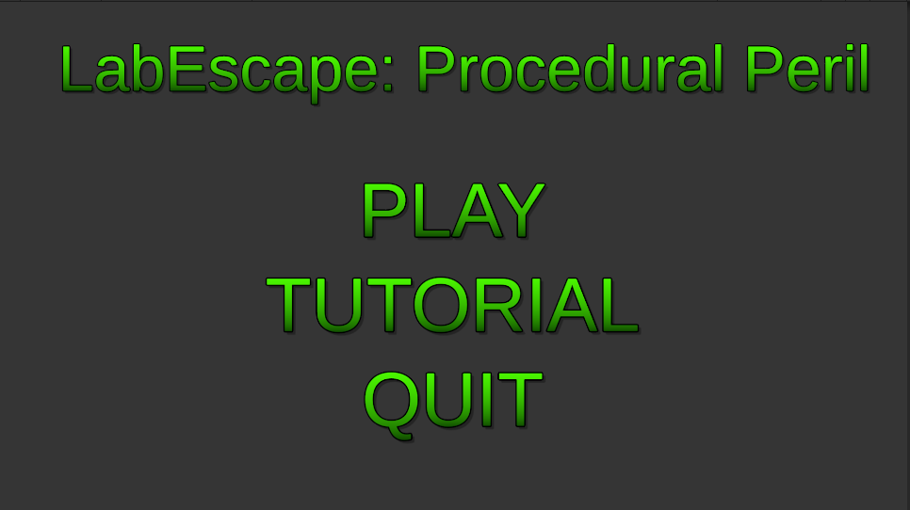

The main menu have 3 options for player which is play , tutorial and quit.

When hover over the options , the outline of the button will appear as visual cue to let the player know which option are they hoving on. The button will become opaque for split second once clicked.

Tutorial page

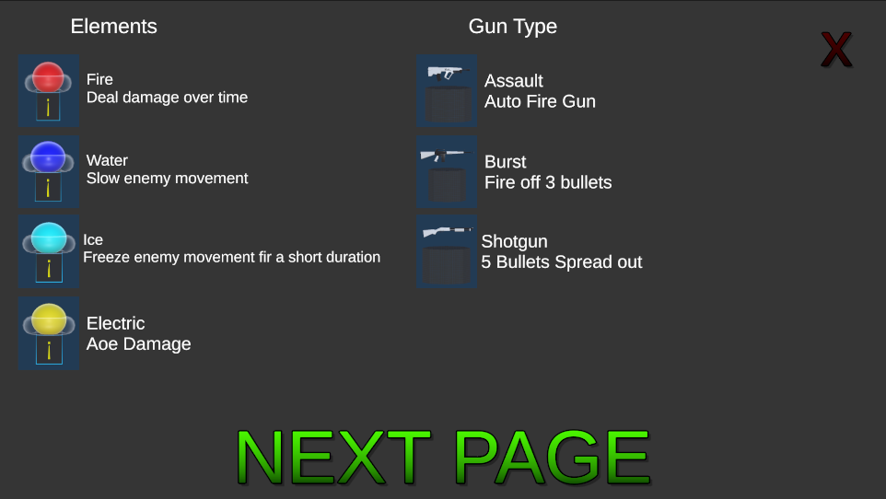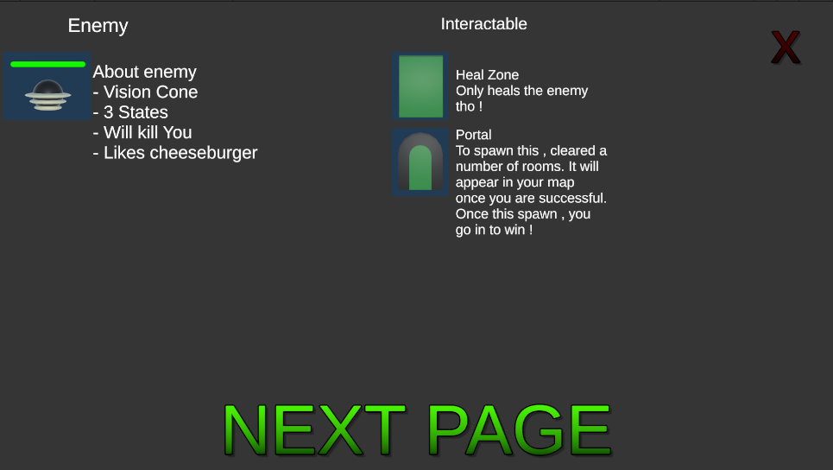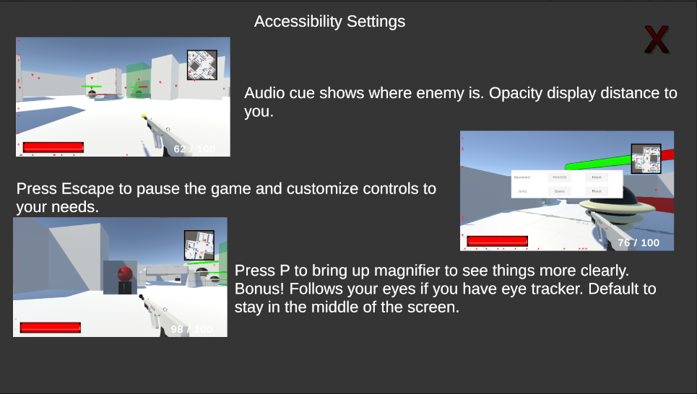

The tutorial page is made up of 3 pages where can be exit at any point by clicking the x button on the top right. It briefly talked about the game and the objective of the game.

Gameplay

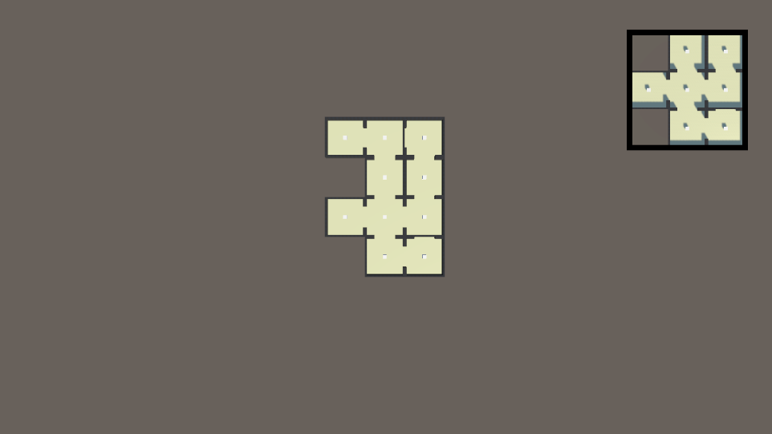

Player will be showing a top-down view of their level. Player can see the layout and how the level is built once they press play.

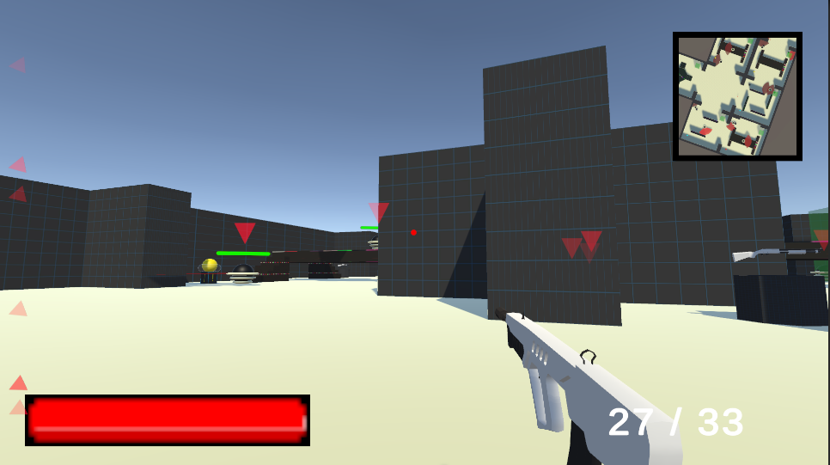

Player can move around with the default bindings unless they already preset their bindings at this point. The bottom left bar represent the health bar of the player and the number on the right represent ammo count for the gun.

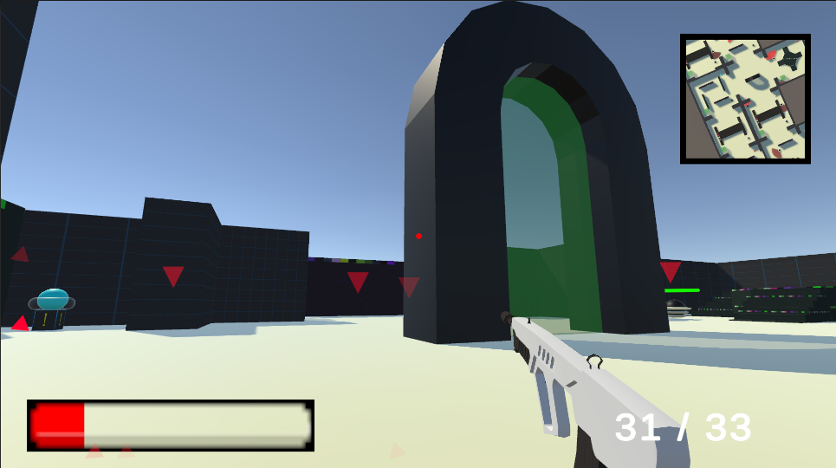

Once the number of room cleared is achieved , a big room will spawn in the starting room for player to enter. Player win the game if they enter the door.

Player can restart the game by pressing M once they enter the door. If the player lose , they can press space to restart the game.

Restarting will give a new level layout.