

Computer Games Development SE607

Software Functional Specification

Year IV

Danial Nor Azman

C00253517

|  |
| --- |
| [Date of Submission] |

[Declaration form to be attached]

Contents

Acknowledgements 2

Functional Specification 2

Audio Cues 2

Remap control 3

Magnifier in game 4

References 4

# Acknowledgements

This section is yet to be completed

Purpose

The purpose of this project is to show the importance of accessibility in games. This will be done by having tester try out the software with and without accessibility to see if it makes a difference.

# Functional Specification

The major functionalities of my software system would be the accessibility for disabled gamer.

## Audio Cues

One of the major functions would be to have visual cues for people who are unable to hear.

Fortnite do this very well by showing logo which indicate what the sounds belong to and from which direction it is coming from.

Here is the example in the game.

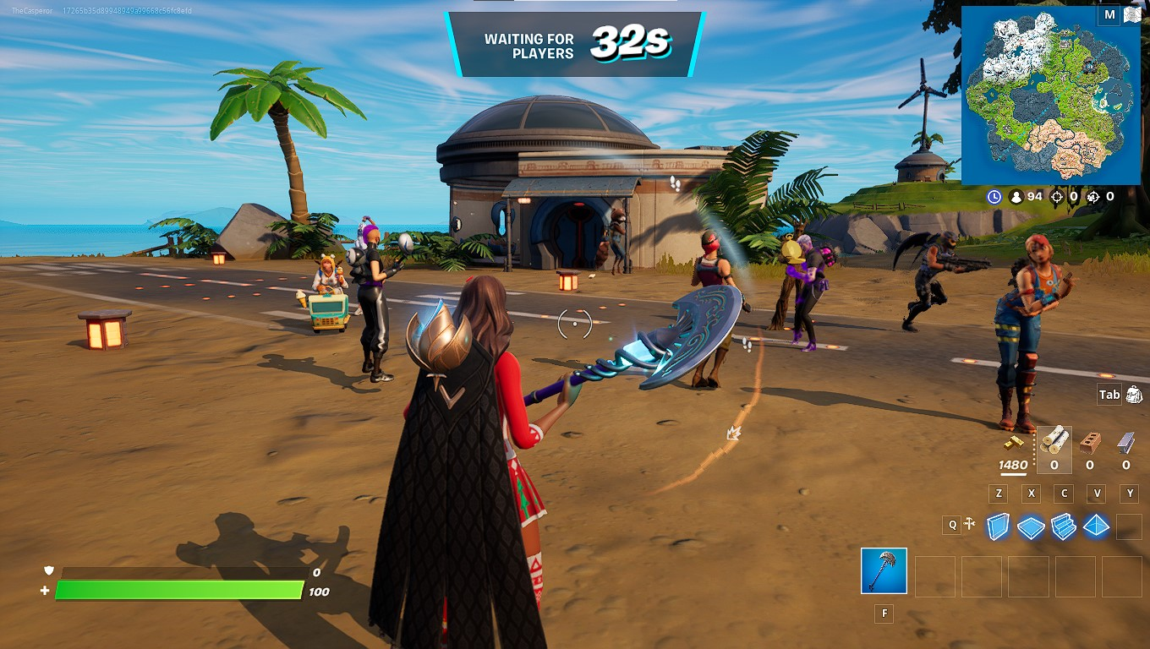

## Remap control

Remapping allows people who are unable to play the game like most players to have the opportunity to play the game in their own way. User should be given the choice to play with controller of their choice.

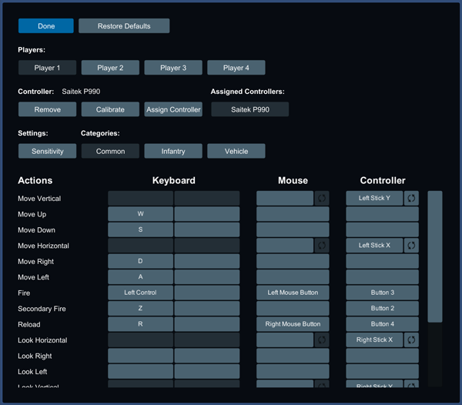

## Magnifier in game

Allow player to zoom in on a location on the screen to magnify what they are looking at. This help with people with visual impairments.

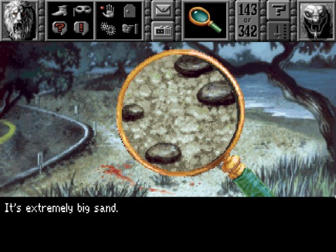

In the software I will be making, this action can also be utilized by eye tracker and if the user focuses their eyes on one point of the screen, that part of the screen will be magnified.

# References

Bei Yuan, E. F. (Apr 2, 2010). *Accessibility in game.* Retrieved from https://link.springer.com/article/10.1007/s10209-010-0189-5

Eyeware Beam . (2022). How Eye Tracking and Head Tracking Help Disabled Gamers Level Up. Retrieved from https://beam.eyeware.tech/disabled-gamers-level-up-head-eye-tracker/

João Antunes, P. S. (2018, May 7). A Study on the Use of Eye Tracking to Adapt Gameplay and Procedural Content Generation in First-Person Shooter Games. Retrieved from https://www.mdpi.com/2414-4088/2/2/23/pdf

Jorge De Greef, V. P. (2018). Evaluating the Benefit of Assistive AR Technology through Eye Tracking in a Surgical Simulation System. Retrieved from https://lirias.kuleuven.be/retrieve/520081

Jovanovic, B. (2022). Gamer Demographics: Facts and Stats About the Most Popular Hobby in the World. Retrieved from https://dataprot.net/statistics/gamer-demographics/

Kate, F. (2022, 3 25). Gamer Born With No Hands Impresses Internet With Setup: 'Such a Boss'. Retrieved from https://www.newsweek.com/tiktok-reddit-86hands-martin-gaming-disability-accessibility-1691729#:~:text=A%20gamer%20has%20been%20praised,scenes%20videos%20of%20his%20gaming.

Sennersten, C. (2004). Eye movements in an Action Game. Retrieved from https://lup.lub.lu.se/student-papers/record/1328850/file/1328851.pdf

Silman, J. (Sep 20, 2021). BrolyLegs on Video Game Accessibility: “We’ve Seen Progress, but Must Continue the Fight”. Retrieved from https://compete.playstation.com/en-ie/all/articles/brolylegs-on-video-game-accessibility-weve-seen-progress-but-must-continue-the-fight?filterNewsO=type.Guides&validatedAge=true

Tara Qadir Kaka Muhammad, H. O. (2022, April 4). Eye Tracking Technique for Controlling Computer Game Objects. Retrieved from http://65.21.159.25/index.php/uhdjst/article/view/903/683

Zalewski, D. (2021, November 4). Eye tracking and video games research. Retrieved from https://tryevidence.com/blog/eye-tracking-and-video-games-research/#:~:text=The%20eye%20tracking%20device%20emits,the%20screen%20player%20was%20looking