Acronym and their full name

RTT = Round Trip Time

MSS = Maximum Segment Size

Q1

In slow start, a sender doubles its window size every RTT if all sent packets were acknowledged

Answer: True

Q2

In steady state, a sender increases its window size by one packet for each acknowledgement

Answer: False as it increases by one MSS for every RTT

Q3

A sender that underestimates the round-trip time of a connection may unnecessarily induce a TCP timeout

Answer: True

Q4

After detecting packet loss through a timeout, TCP halves its window size as a response to the path congestion

Answer: False, TCP reset its window size to one MSS

Q5

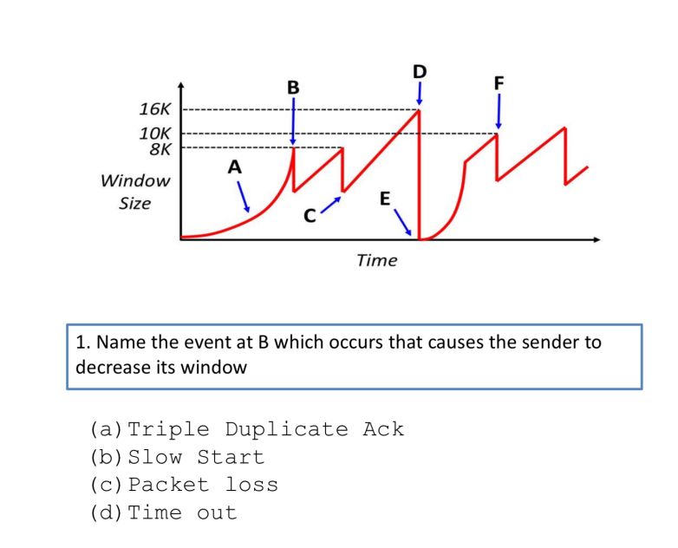

Answer: A

Duplicate ACKs are signs that the receiver received something, just not the right sequence number

Q6

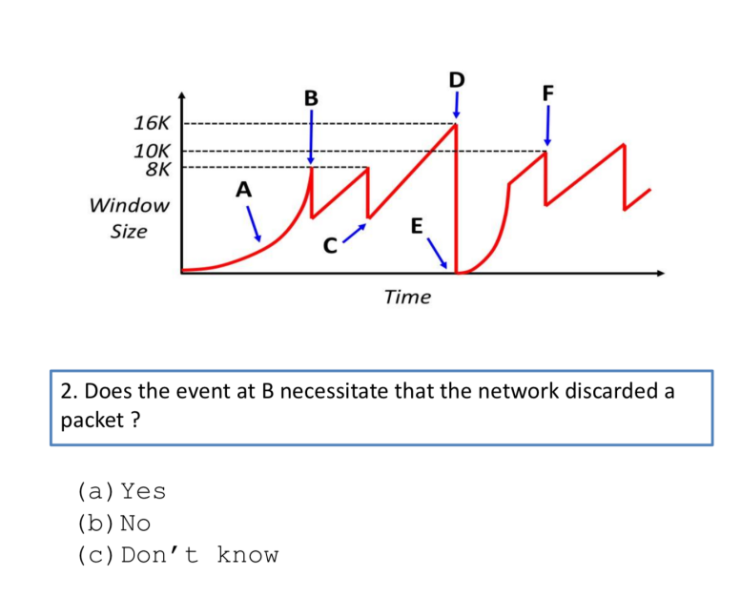

Answer: B

Q7

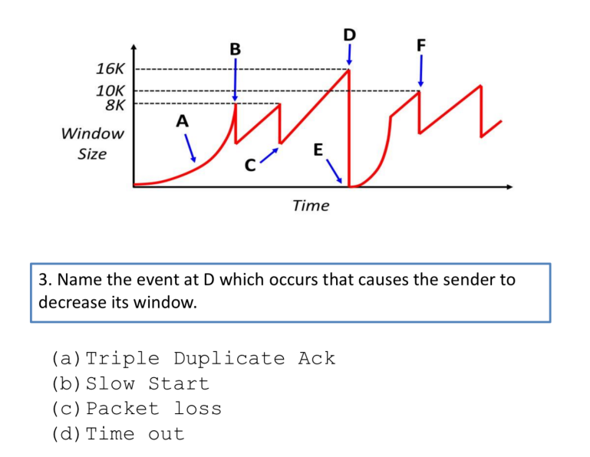

Answer: D

Q8

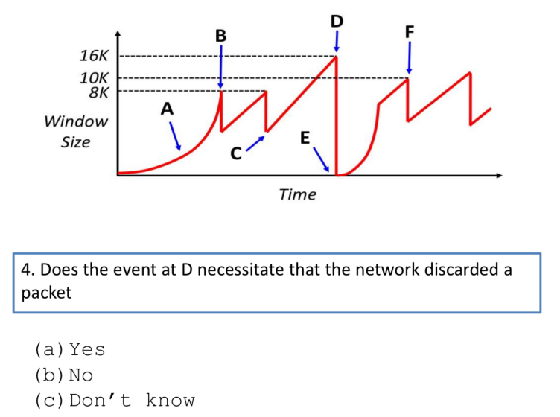

Answer: B

Q9

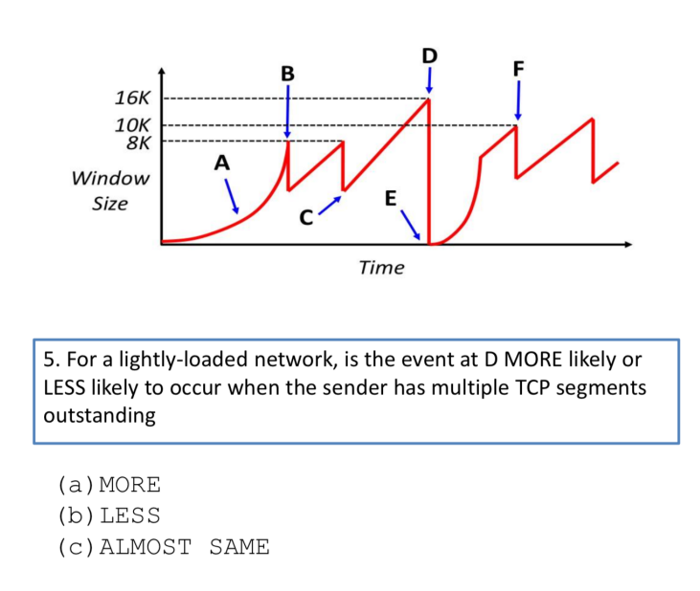

Answer: C

Q10

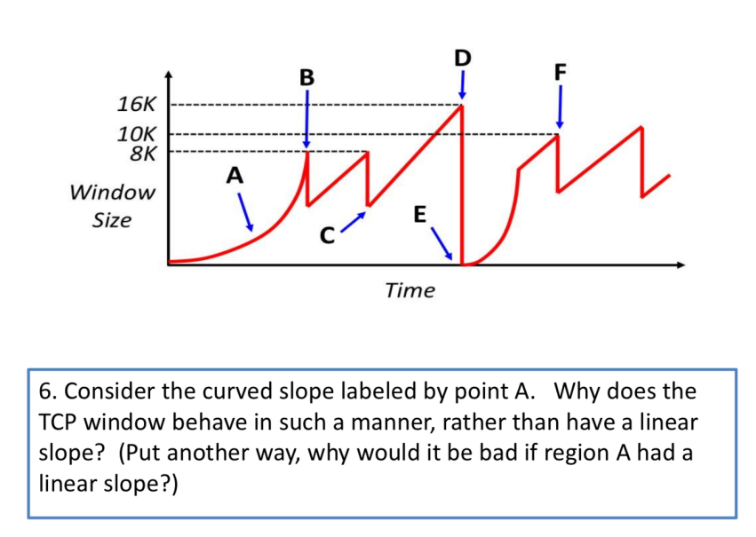

Answer: This “slow-start” period quickly discovers the maximum acceptable throughput that the path supports – otherwise, AI (additive increase) could take too long (each a full RTT).

Q11 – NOT A QUESTION

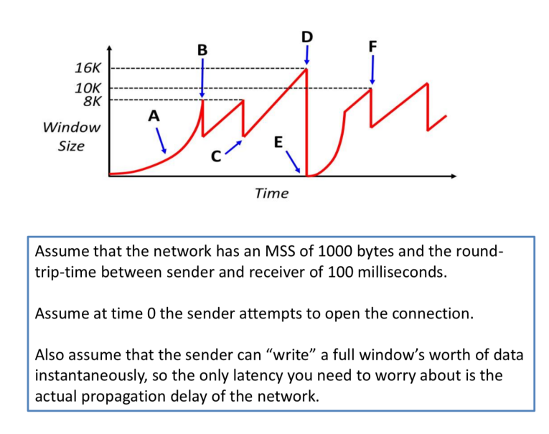

Q12

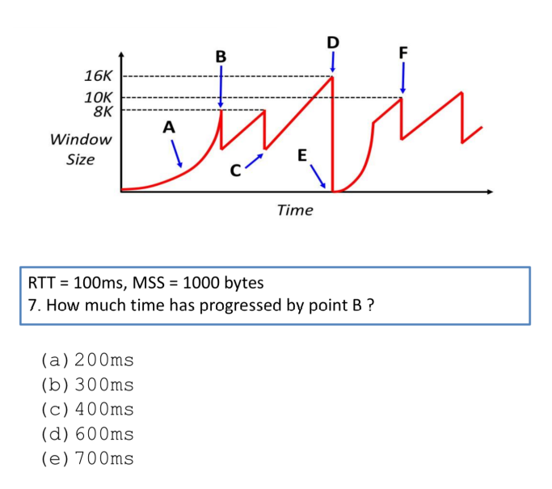

Answer: C

Q13

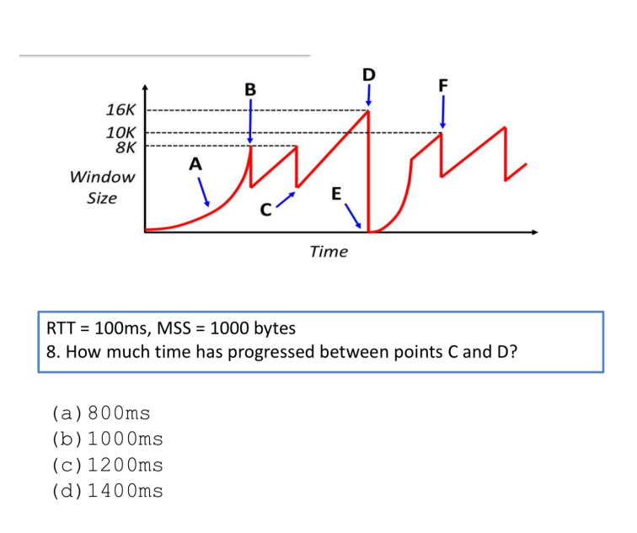

Answer: C

Q14

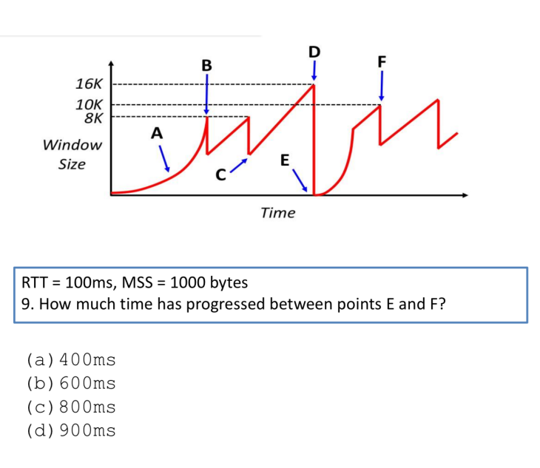

Answer: D

Q15

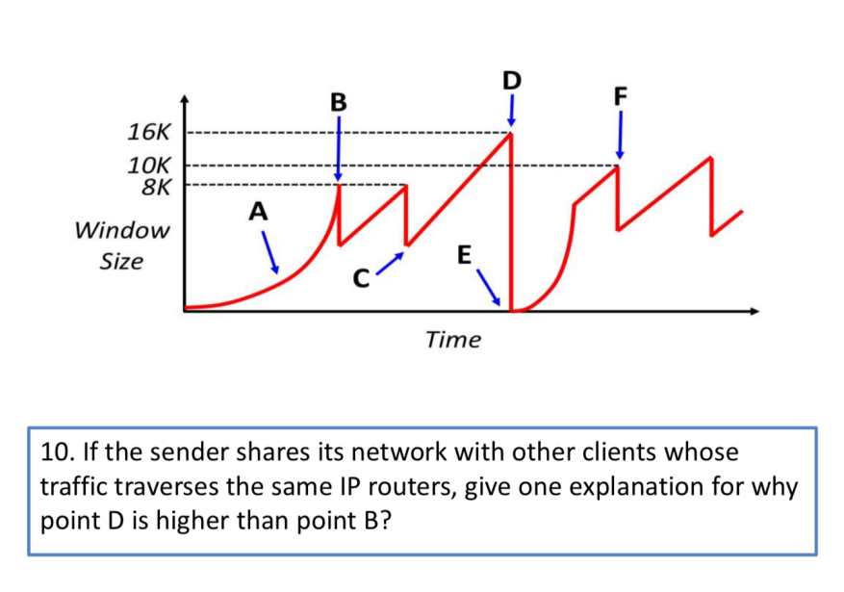

Answer: Changing cross-traffic by other concurrent senders across same routers.