# Silage corn and wheat grain yield prediction for Iran using machine learning techniques

پیش بینی عملکرد ذرت علوفه‌ای و گندم با روش های یادگیری ماشین

Afshin Gomrokchi

Danial Amini Baghbadorani

Fariborz Abbasi

August 2022

# Abstract

# Introduction

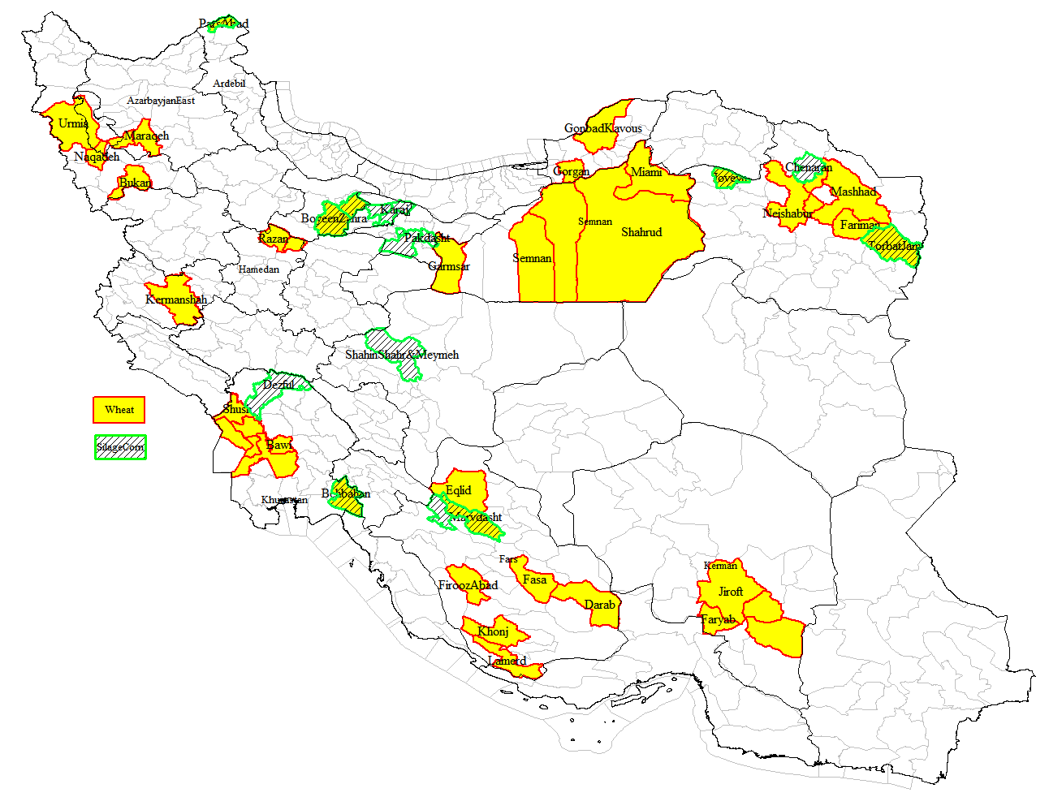

Figure 1. Wheat and silage corn production counties in Iran considered in this study

شهرستان های تولید گندم = خاکستری

شهرستان های تولید ذرت علوفه ای = هاشور

# Error measure

For all of the calculations, data are divided into training (70%) and test (30%) sets. The coefficient of determination is calculated by the following relationship as a metric for evaluating the performance of the proposed formulas:

|  |  |
| --- | --- |
|  | (1) |

Wherein *yi* is the *i*th observation, *y̅* is the average of observations, and *ŷi* is the *i*th prediction, while *N* is the number of data points.

محاسبه دقت با ضریب r2 انجام شده است

# Silage corn yield dataset

The silage corn yield dataset consisted of 105 farms across selected provinces of the country which are among the top producers of silage corn in the national level.. The attributes considered in the study include growth days, irrigation count, irrigation water volume, water salinity (ECwat), potential evapotranspiration (ETO), elevation, latitude, longitude, and yield. Other variables that were also collected at the farm level were water source (well or canal), network type (traditional or modern), crop area, soil texture (heavy, normal or light), soil salinity, cultivar variety, irrigation method (furrow, drip or sprinkler), climate (cold or warm), and literacy level (pre highschool, highschool or above). The yield and irrigation water need as well as some other characteristics are given in Table 1 for the 16 counties located in 8 major silage corn production provinces. Correlation analysis was conducted and many of the variables that had a weak correlation with the yield were eliminated from further analysis.

ذرت علوفه در 16 شهرستان داده داریم و متغیرهای اصلی شامل نوع بافت خاک، روزهای رشد، دفعات آبیاری، حجم آب آبیاری، شوری آب، تبخیر و تعرق و عملکرد است.

# Wheat grain yield dataset

The wheat yield dataset consists of data from 241 farms located in 13 provinces or 41 counties. The database consists of farm address, climate condition (warm or cold, dry or wet), longitude, latitude, water source (well or surface water), network type (traditional or modern), water salinity or ETwat (dS/m), farm area (ha), cropped area (ha), soil texture (1 = light, 2 = normal and 3 = heavy), soil salinity (dS/m), cultivar variety (Chamran, Chamran II, Pishtaz, Sirvan, Mihan and other), growth length or GD (1 : <150 days, 2 : 150-200 days, 3 : >200 days), irrigation type (surface, sprinkler or drip), average irrigation depth (mm), number of irrigation events (IE), irrigation water volume watirrig (m3/ha), effective rain Peff calculated by FAO method for the current year (mm), water need of the crop (mm), ET calculated based on climatic data (mm), 10-year values for effective rain and ET, leeching need (%), and grain yield (kg/ha). The grain yield, irrigation water and other important variables for the wheat dataset are given in Table 2 for 41 counties.

داده های گندم مربوط به 41 شهرستان است. متغیرهای مهم شامل شوری آب، بافت خاک، دوره رشد، دفعات آبیاری، حجم آب آبیاری، بارش موثر، تبخیر و تعرق، نیاز آبشویی و عملکرد است.

Table 1. Silage corn yield dataset for various counties among major national producers

|  |  |  |  |  |  |  |  |  |
| --- | --- | --- | --- | --- | --- | --- | --- | --- |
| **Province** | **County** | **Soil texture (0=heavy, 1=light)** | **GD (days)** | **IE (#)** | **Irrig water (m3/ha)** | **ECwat (dS/m)** | **ETO (mm)** | **Yield (ton/ha)** |
| Alborz | Karaj | 0.8 | 97 | 9 | 8755 | 0.4 | 580 | 49.5 |
| Hashtgerd | 1 | 97 | 15 | 6868 | 0.3 | 555 | 55 |
| Tehran | EslamShahr | 0.3 | 96 | 9 | 6826 | 0.8 | 639 | 51.9 |
| Pakdasht | 0 | 101 | 8 | 5923 | 0.8 | 652 | 55 |
| Shahrerey | 0 | 85 | 6 | 6134 | 1.7 | 593 | 56.9 |
| Gazvin | Abyek | 0.4 | 102 | 9 | 8693 | 2.7 | 582 | 50.4 |
| BoyeenZahra | 0 | 110 | 9 | 7309 | 3.1 | 763 | 47.8 |
| Ardabil | Moghan | 0 | 84 | 5 | 5868 | 1.1 | 422 | 32.8 |
| Esfahan | Shahinshar | 0.6 | 103 | 18 | 8001 | 2.4 | 733 | 58.2 |
| Fars | Sepidan | 0.5 | 95 | 16 | 9089 | 2.3 | 588 | 59.8 |
| Marvdasht | 0.2 | 97 | 11 | 8427 | 0.8 | 636 | 66.4 |
| Khorasan Razavi | Chanaran | 1 | 94 | 24 | 10428 | 1.4 | 826 | 98.8 |
| TorbatJam | 0.7 | 83 | 13 | 11123 | 1.4 | 740 | 75.2 |
| Jovain | 1 | 100 | 13 | 7535 | 0.8 | 782 | 54.2 |
| Khozestan | Behbahan | 0.8 | 102 | 26 | 7738 | 2.5 | 544 | 53.5 |
| Dezful | 0.4 | 99 | 11 | 7088 | 0.8 | 510 | 40.5 |

Table 2. Wheat yield dataset for various counties among major national producers

|  |  |  |  |  |  |  |  |  |  |  |
| --- | --- | --- | --- | --- | --- | --- | --- | --- | --- | --- |
| **Province** | **County** | **ECwat (ds/m)** | **Soil** | **GD** | **IE** | **Watirrig (m3/ha)** | **Peff (mm)** | **ET (mm)** | **Leech (%)** | **Yield (kg/ha)** |
| Ardebil | Parsabad Moqan | 1 | 3 | 3 | 9 | 6107 | 72 | 554 | 3 | 5737 |
| Khuzestan | Behbahan | 2 | 2 | 2 | 8 | 4090 | 127 | 398 | 6 | 3935 |
| Bavi | 2 | 3 | 2 | 6 | 4532 | 70 | 398 | 5 | 3950 |
| Ahvaz | 2 | 1 | 2 | 5 | 4563 | 75 | 398 | 7 | 5850 |
| Hamidieh | 1 | 2 | 2 | 5 | 5415 | 73 | 398 | 4 | 4600 |
| Dasht Azadegan | 2 | 2 | 2 | 5 | 5605 | 75 | 398 | 4 | 4467 |
| Shush | 1 | 2 | 1 | 8 | 5724 | 107 | 427 | 4 | 5000 |
| Kharkheh | 2 | 2 | 1 | 8 | 7328 | 123 | 370 | 5 | 3546 |
| Khorasan Razavi | Jovain | 1 | 2 | 3 | 8 | 5352 | 113 | 709 | 2 | 4300 |
| Neishabur | 2 | 2 | 3 | 7 | 4697 | 207 | 708 | 7 | 4675 |
| Zabarkhan | 1 | 2 | 3 | 8 | 5307 | 207 | 710 | 3 | 5750 |
| TorbatJam | 2 | 2 | 3 | 10 | 7003 | 131 | 709 | 6 | 6250 |
| Fariman | 1 | 2 | 3 | 8 | 7414 | 131 | 709 | 2 | 6736 |
| Mashhad | 1 | 2 | 3 | 8 | 5755 | 185 | 709 | 2 | 4350 |
| Golbahar | 1 | 3 | 3 | 8 | 6619 | 185 | 709 | 3 | 8080 |
| Fars | Marvdasht | 1 | 3 | 3 | 7 | 5332 | 271 | 794 | 2 | 6180 |
| Eghlid | 0 | 3 | 3 | 9 | 5785 | 225 | 866 | 1 | 6923 |
| Lamerd | 8 | 2 | 2 | 5 | 5138 | 255 | 830 | 25 | 3416 |
| Khonj | 5 | 2 | 2 | 5 | 5860 | 264 | 830 | 13 | 6063 |
| Fasa | 7 | 3 | 2 | 7 | 6971 | 324 | 830 | 20 | 5933 |
| Firouz Abad | 1 | 2 | 3 | 6 | 5876 | 343 | 830 | 2 | 6808 |
| Darab | 1 | 2 | 2 | 6 | 5300 | 332 | 830 | 2 | 5240 |
| Kerman | Rudbar Jonub | 3 | 1 | 2 | 12 | 9270 | 111 | 830 | 8 | 4095 |
| Anbarabad | 1 | 3 | 2 | 8 | 6736 | 186 | 830 | 3 | 4588 |
| Faryab | 1 | 1 | 1 | 3 | 3693 | 255 | 830 | 2 | 4150 |
| Kermanshah | Kermanshah | 1 | 3 | 3 | 6 | 4255 | 230 | 338 | 2 | 6663 |
| Hamedan | Razan | 0 | 3 | 3 | 9 | 5430 | 217 | 723 | 1 | 5357 |
| Dargazin | 0 | 3 | 3 | 8 | 4778 | 218 | 707 | 1 | 5800 |
| East Azarbayjan | Bonab | 2 | 2 | 3 | 4 | 4274 | 110 | 451 | 5 | 4010 |
| West Azarbayjan | Urmiah | 1 | 2 | 3 | 4 | 3684 | 210 | 451 | 3 | 4828 |
| Bukan | 1 | 2 | 3 | 5 | 2587 | 224 | 443 | 2 | 3800 |
| Naqadeh | 1 | 2 | 3 | 4 | 4360 | 210 | 455 | 3 | 5030 |
| Semnan | Semnan | 2 | 1 | 3 | 9 | 8500 | 89 | 618 | 5 | 5000 |
| Damqan | 2 | 2 | 3 | 9 | 7395 | 83 | 618 | 5 | 5650 |
| Garmsar | 5 | 2 | 3 | 10 | 6995 | 54 | 618 | 14 | 5750 |
| Shahrud | 2 | 2 | 3 | 10 | 8224 | 118 | 618 | 5 | 4800 |
| Miami | 1 | 3 | 3 | 9 | 7864 | 111 | 618 | 3 | 6000 |
| Qazvin | Abyek | 2 | 3 | 3 | 6 | 6283 | 165 | 664 | 7 | 6417 |
| Boyeen Zahra | 3 | 3 | 3 | 6 | 7000 | 70 | 726 | 8 | 5550 |
| Golestan | Gorgan | 1 | 3 | 2.5 | 7 | 1365 | 125 | 264 | 2 | 4382 |
| Gonbad Kavous | 1 | 3 | 2.5 | 7 | 2077 | 154 | 291 | 4 | 4176 |

# Results for the silage corn yield

The water consumption for silage corn can be determined from Equation 2 as shown in Figure 2. It can be seen that irrigation water consumption increases by increasing the number of irrigation events. Meanwhile, irrigation need is higher for western latitudes, and lower for longer growth days. The inverse influence of growth days on irrigation water need is counter intuitive but it could simply mean that in areas with higher irrigation, growth duration days is shorter than other places. It is obvious from Figure 1 that North West counties have the least amount of irrigation water consumption while the North East counties have the highest amount of irrigation water consumption for silage corn.

|  |  |
| --- | --- |
|  | (2) |

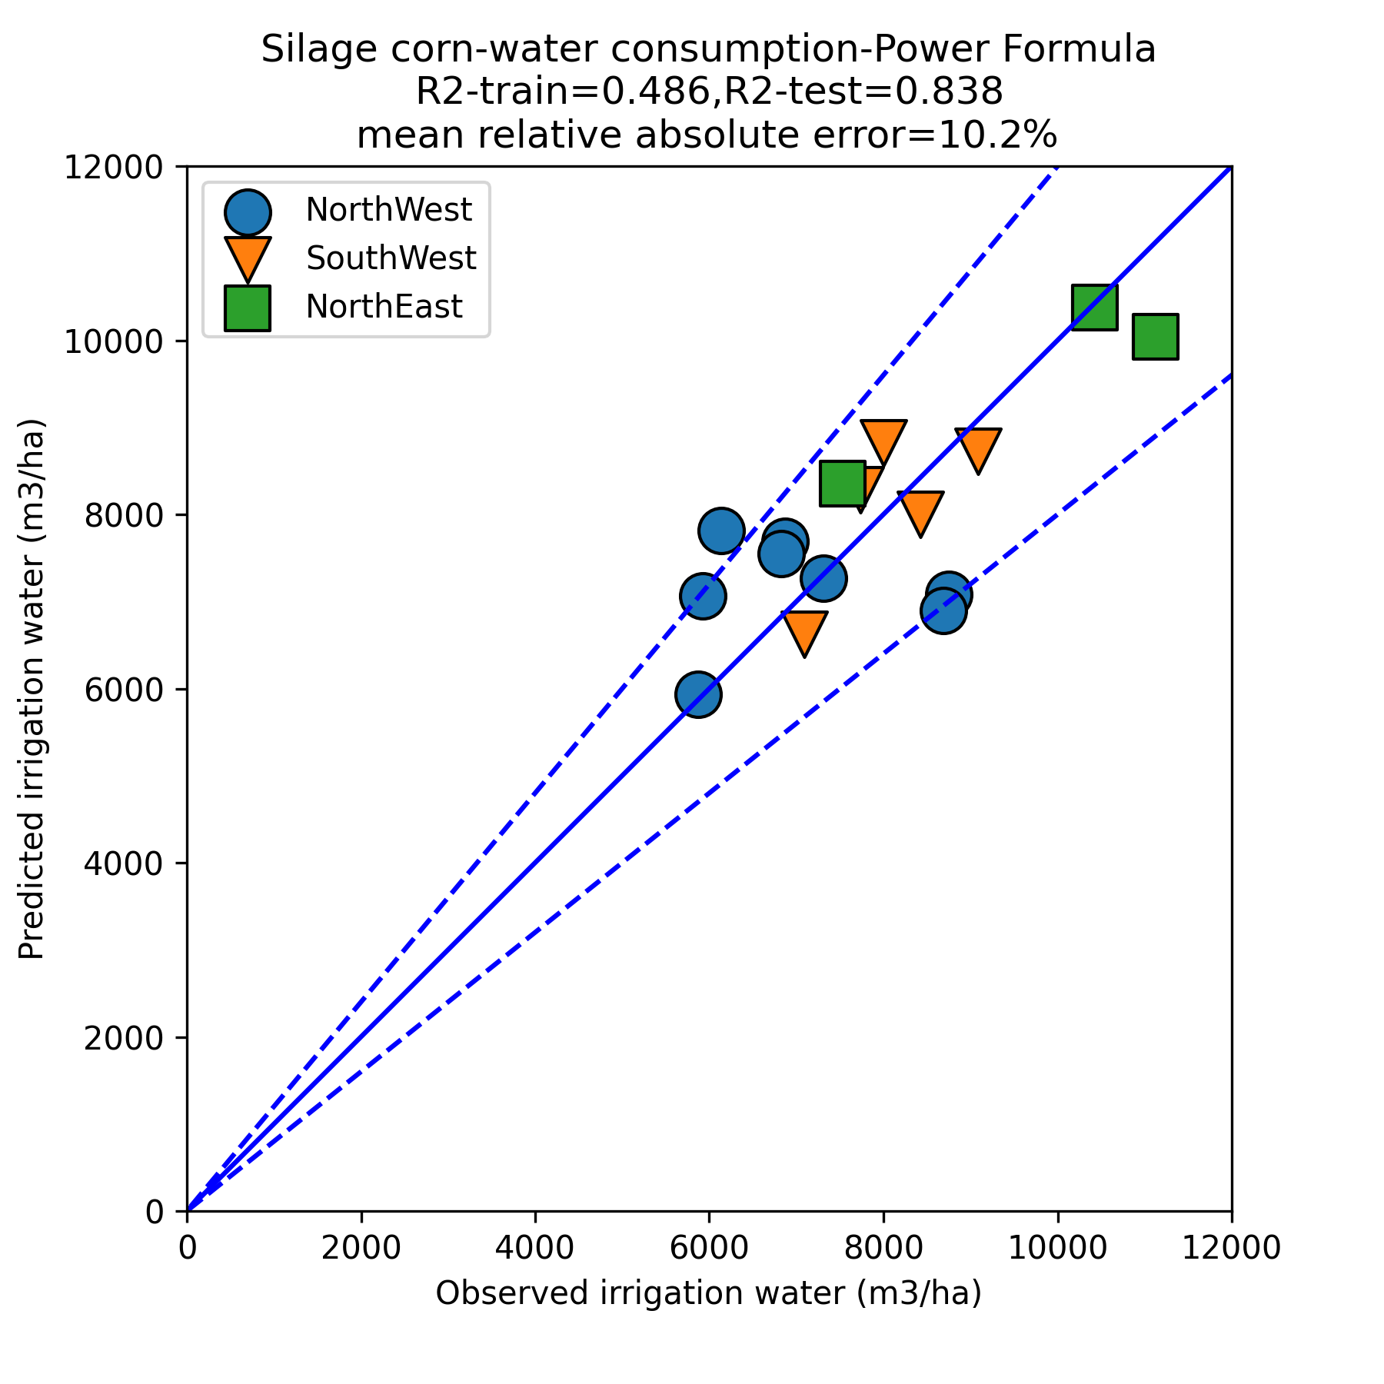

**Figure 2.** Silage corn water consumption per county for the power formula in Equation (2)

رابطه به دست آمده برای حجم آب مصرفی ذرت علوفه ای:

دوره رشد طولانی تر = آب کمتر

تعداد دفعات آبیاری بیشتر = حجم آب بیشتر

عرض جغرافیایی جنوبی = حجم آب بیشتر

For predicting yield of silage corn at the province level, the ensemble regression formula of Equation (3) was used. Since the regression relies on very few data points, each regression was limited to 2 input variables only (except for the last formula). Afterwards, the results of the various formulas were averaged. This method allows us to have a ensemble learning method which considers the effect of both important and less important variables at the same time without overfitting. The results are shown in Figure 3. In the average of 6 regression formulas, 5 of the equations contain irrigation water variable since it is the most important variable in the regression. The sign of coefficients imply that more irrigation events, higher elevation, fewer growth days, higher evapotranspiration, higher irrigation water and heavier soil texture lead to higher yield in the considered provinces. The soil salinity variable has a very small coefficient near zero which means that it does not have an effect on the overall province-level yield data.

|  |  |
| --- | --- |
|  | (3) |

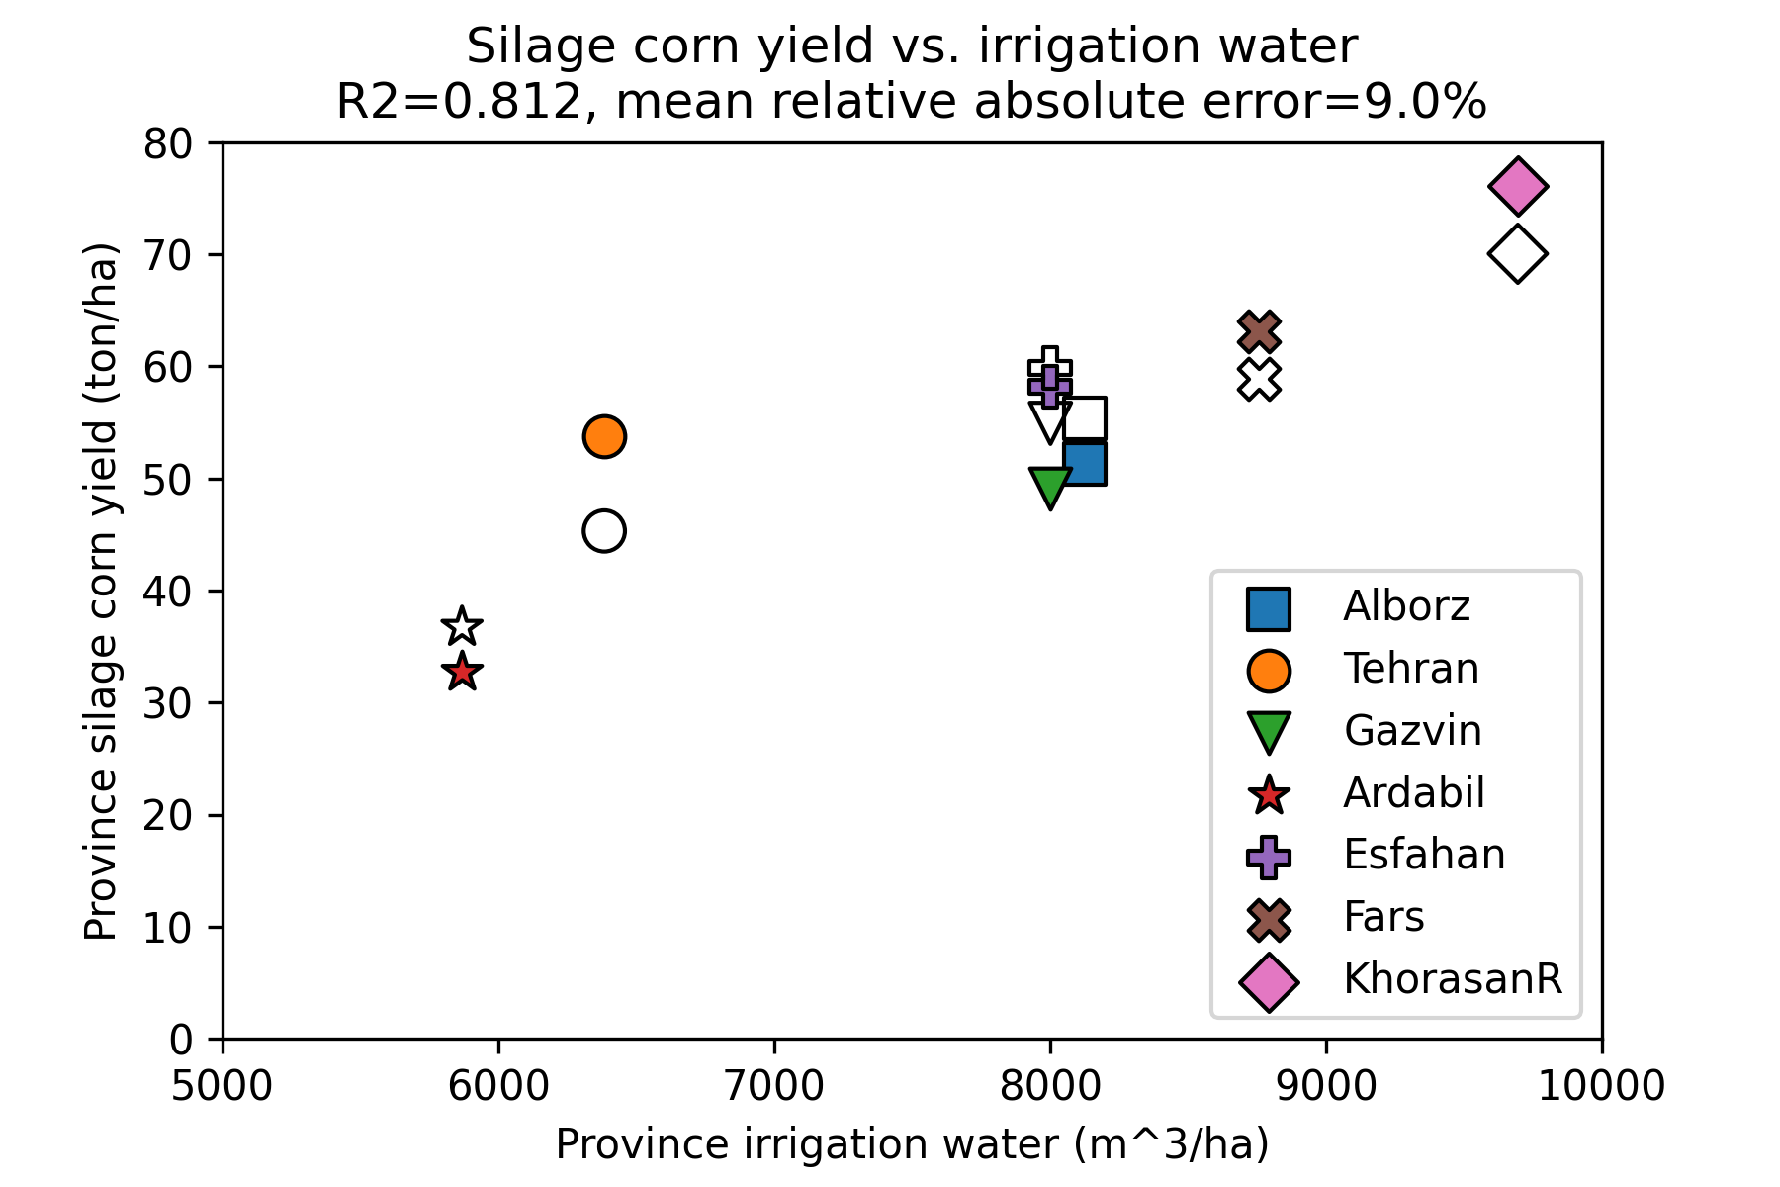

**Figure 3.** Wheat yield in different provinces vs. irrigation water for the ensemble regression equation. Filled and empty markers denote observations and predictions.

رابطه به دست آمده برای عملکرد ذرت علوفه ای

دوره رشد طولانی = عملکرد کمتر (ذرت خشک می شود)، حجم آبیاری بیشتر = عملکرد بیشتر

ارتفاع بیشتر = عملکرد بیشتر، تعداد دفعات آبیاری بیشتر = عملکرد بیشتر

For predicting silage corn yield at the county level, Equation 3 can be used as shown in Figure 3. It can be seen that yield increases by increasing the number of irrigation events and irrigation water volume, while it decreases by increasing water salinity. The yield is higher at higher elevations and it is lower for longer growth durations. The longer the growth duration, the drier the final silage corn becomes, which leads to a lesser amount of yield as the values are not strictly calibrated for moisture content. The yield is slightly higher for areas with a larger evapotranspiration potential. Based on Figure 2, it can be generally observed that higher irrigation water consumption (shown by blue colors) corresponds to higher yields.

|  |  |
| --- | --- |
|  | (4) |

The yield for silage corn can also be determined from Equation 4 which is based on latitude and longitude rather than climatic parameters. It can be seen that yield is higher in the Eastern parts of the country (mainly because of high yield in the Eastern province of Khorasan) while it is higher for lower latitudes (which is due to the high yield in the Southern Khuzestan province). The accuracy of Equation (4) is comparable to Equation (3). Both of the equations have a relative error of less than 9%. The training and test errors are also indicated on the figure.

|  |  |
| --- | --- |
|  | (4) |

رابطه به دست آمده برای عملکرد ذرت علوفه ای: طول جغرافیایی شرقی (مثل خراسان) = عملکرد بیشتر، عرض جغرافیایی جنوبی (مثل خوزستان) = عملکرد بیشتر

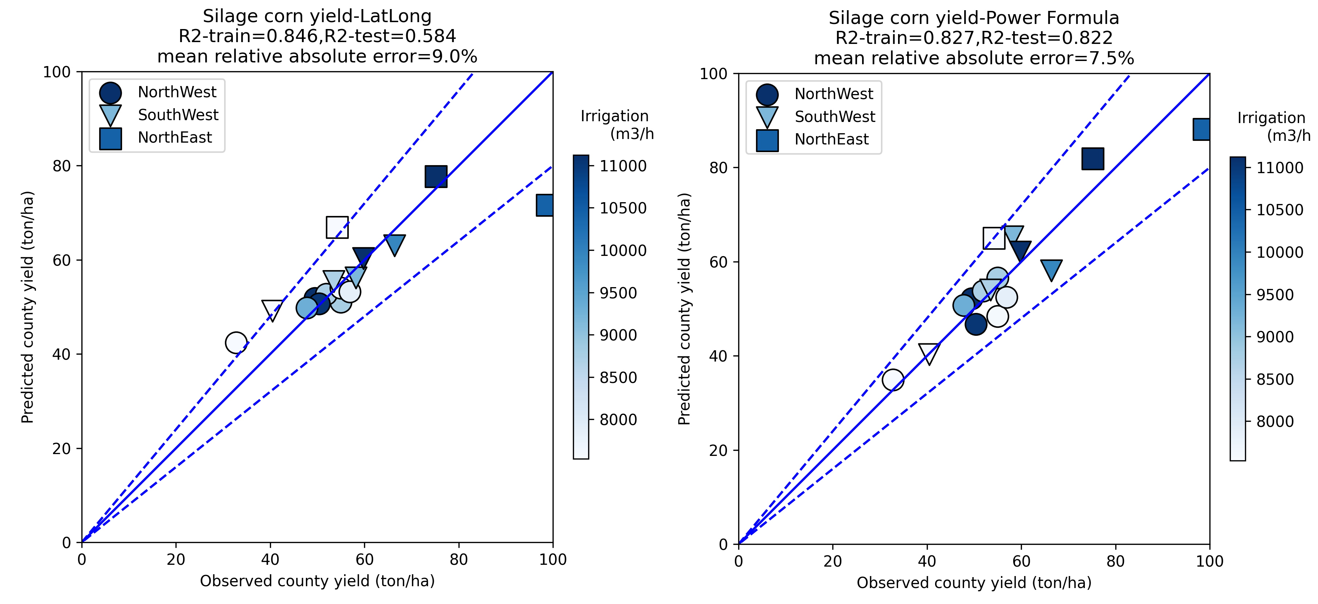**Figure 4.** Silage corn yield per county for the power formula in Equation (3) (right) and the formula based on geographic location in Equation (4) (left) colored by irrigation water

For estimating silage yield at the farm level, a formula was fitted given by Equation (5). In this formula, which takes the power form, it is obvious that higher irrigation water and potential evapotranspiration lead to a higher yield, while longer growth duration days leads to a smaller yield (potentially due to the drying of the biomass). The effect of *IE* variable (number of irrigation events) has a coefficient which is close to zero. Another predictor for farm yield was proposed which is simply assigning the county average value to the farm as given in Equation (6). These two methods had mean relative absolute errors of 23.1% and 18.5%, respectively. The heterogeneity in farming practices over various counties mean that there is a distinctive difference between yield values in different counties, which is the reason that proposing a single equation for the entire country faces major hurdles. Comparison of Equations (5) and (6) are shown in Figure 4.

|  |  |
| --- | --- |
|  | (5) |
|  | (6) |

عملکرد در سطح مزرعه برای ذرت علوفه ای : حجم آبیاری بیشتر = عملکرد بیشتر، تبخیر و تعرق بیشتر = عملکرد بیشتر، تعداد دفعات آبیاری بیشتر = عملکرد بیشتر، دوره رشد طولانی تر = عملکرد کمتر

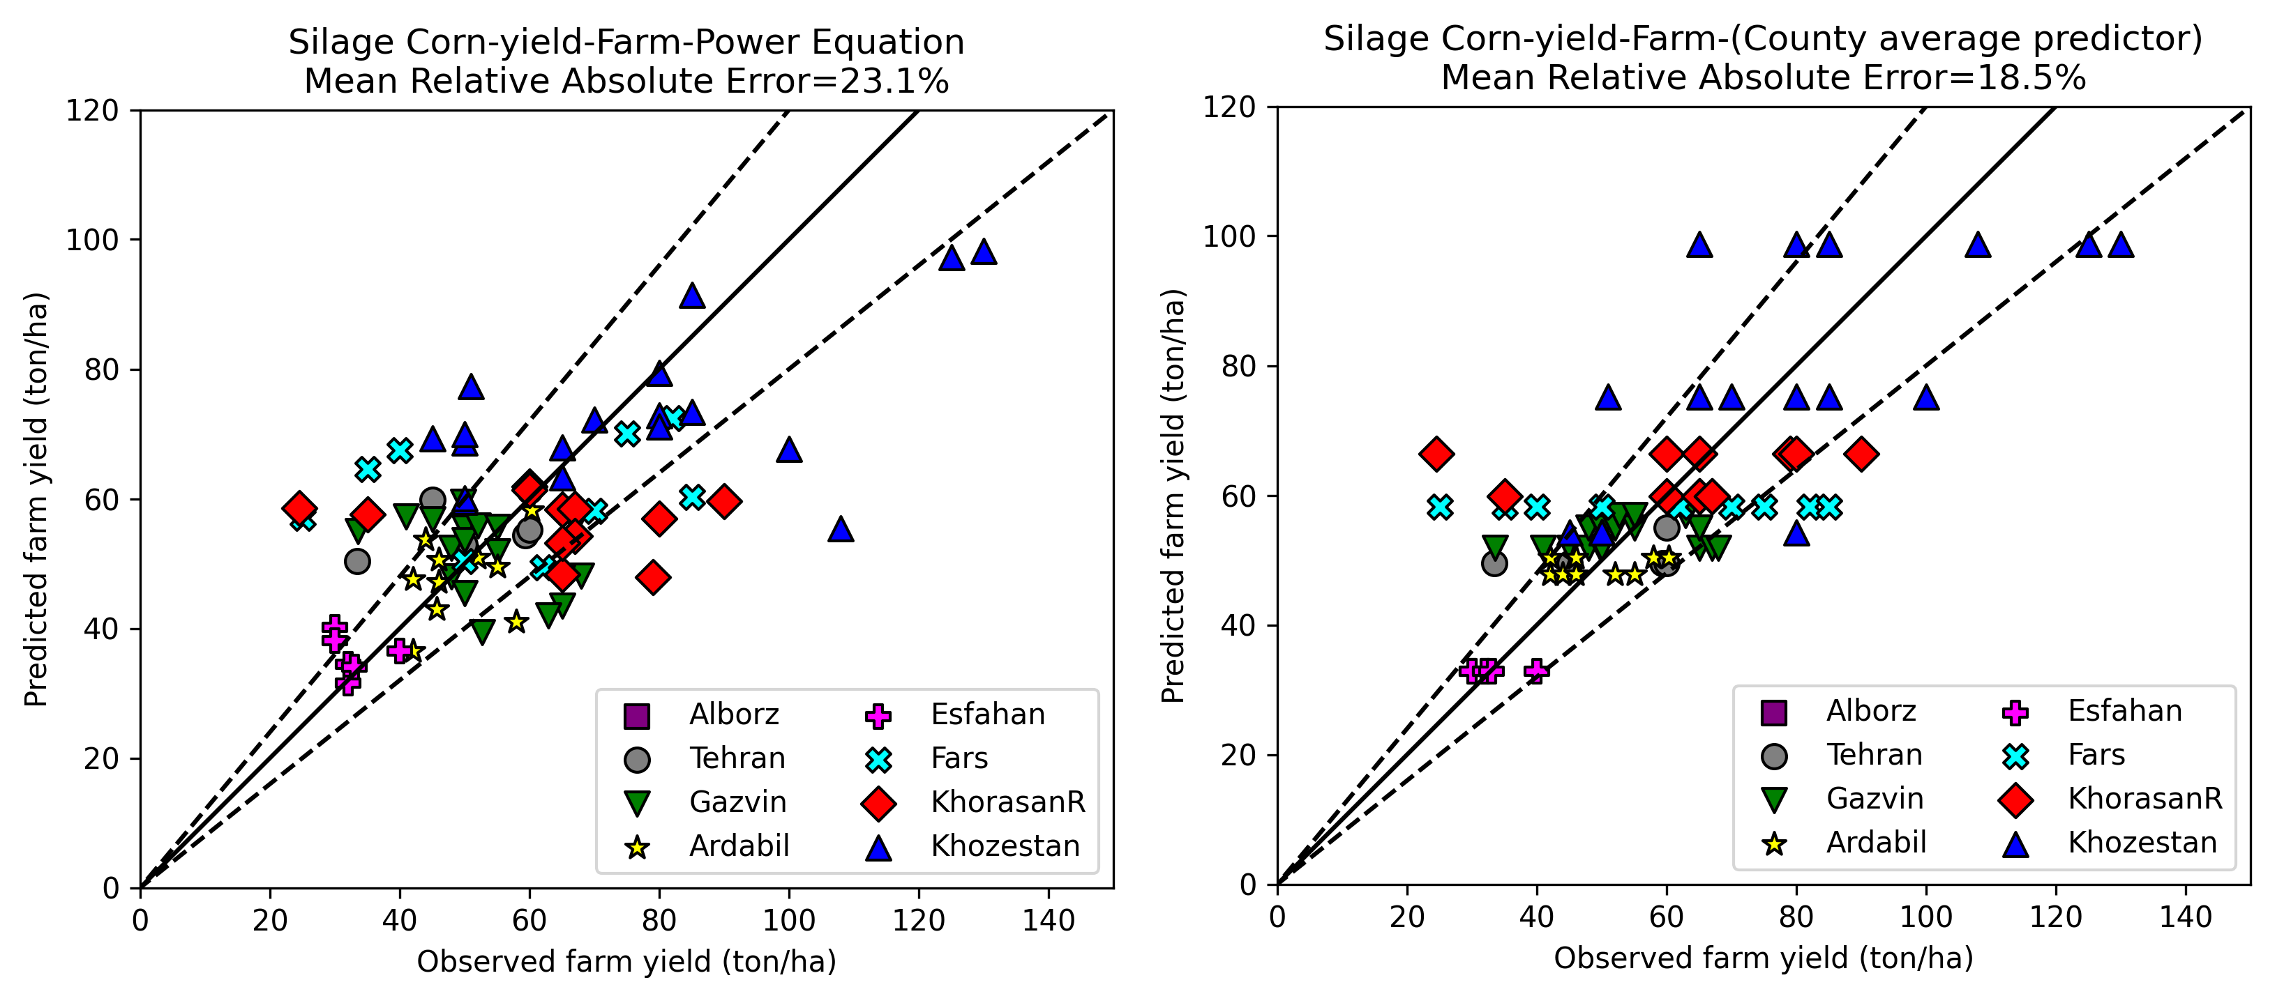**Figure 5.** Silage corn yield for farm level using the power formula in Equation 5 (left) and simple county yield value by using Equation 6 (right)

# Results for the wheat grain yield

The water consumption for wheat grain can be determined from Equation 5 as shown in Figure 5. It can be seen that irrigation water consumption increases by increasing the soil salinity, irrigation need is higher for lighter soils due to lower retention, irrigation need is higher for longer growth durations, irrigation need increases by increasing the number of irrigation events. In addition, irrigation water is higher for lower latitudes due to their hotter climate. It can be seen that the sign of the coefficients in Equation (5) are in line with intuitive understanding of the process of wheat production. From Figure 4, it is obvious that NorthWest counties have the least amount of water consumption, while the NorthEast counties have the highest amount of water consumption for irrigated wheat grain production.

|  |  |
| --- | --- |
|  | (7) |

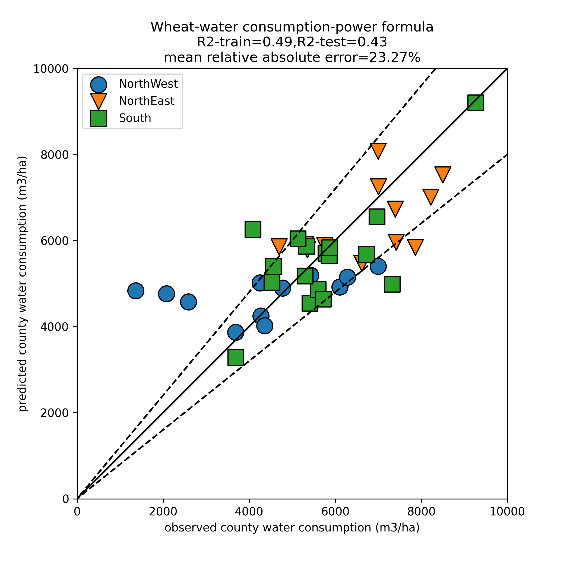

**Figure 6.** Wheat water consumption per county for the power formula in Equation 5 with training and test coefficients of determination of and

حجم آب مصرفی برای گندم

شوری آب بالا = مصرف آب بیشتر

خاک بافت سبک = مصرف آب بیشتر (نگهداشت آب کم است)

طول دوره رشد طولانی = مصرف آب بیشتر

تعداد دفعات آبیاری بیشتر = مصرف آب بیشتر

عرض جغرافیایی جنوبی = مصرف آب بیشتر

For predicting wheat yield at the province level, the ensemble regression formula of Equation (3) was used. Since the regression relies on very few data points, each regression was limited to 3 input variables only. Afterwards, the results of the various formulas were averaged. This method allows us to have an ensemble learning method which considers the effect of both important and less important variables at the same time without overfitting. The results are shown in Figure 3. In all of the ensemble equations, irrigation water volume variable is present since it is the most important variable in the regression. Higher irrigation volume and rain led to a greater yield. Higher water salinity and leeching need had a negative effect on yield. Longer growth duration, more irrigation events and heavier soil texture were also predictors of higher yield. Northern latitudes and western longitudes had a higher yield.

|  |  |
| --- | --- |
|  | (8) |

عملکرد استانی گندم: دفعات آبیاری بیشتر =عملکرد بیشتر، تبخیر تعرق بیشتر = عملکرد بیشتر، بارش بیشتر = عملکرد بیشتر، دوره رشد طولانی = عملکرد بیشتر، نیاز آبشویی بیشتر = عملکرد کمتر، عرض جغرافیایی جنوبی = عملکرد بیشتر، طول جغرافیایی غربی = عملکرد بیشتر، حجم آب آبیاری بیشتر = عملکرد بیشتر

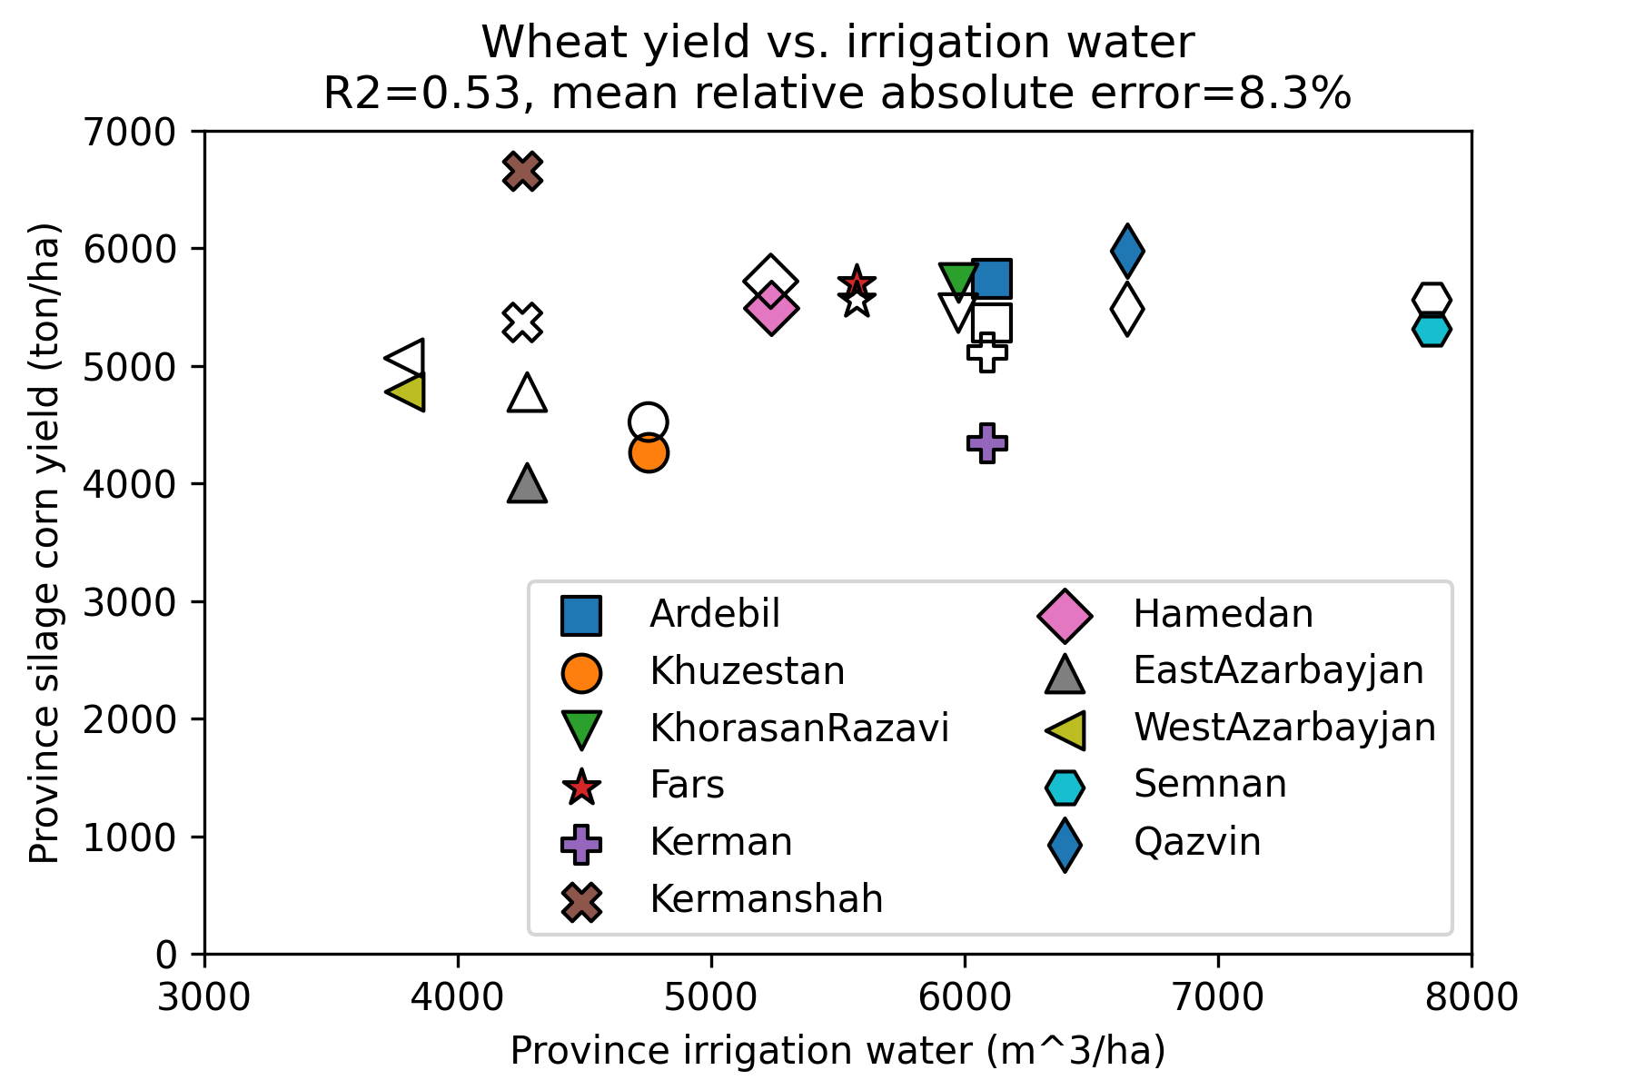

**Figure 7.** Wheat yield in different provinces vs. irrigation water for the ensemble regression equation. Filled and empty markers denote observations and predictions.

The yield for wheat grain can be determined from Equation 6. It can be seen that yield increases by using a lighter soil, a longer growth duration, and increasing the irrigation water volume. After many trials and errors, it was found that using only these three parameters, the yield can be predicted reasonably well without major improvements in accuracy by including other variables.

|  |  |
| --- | --- |
|  | (9) |

The yield for wheat grain can also be determined from Equation (7) as shown in Figure 6 which is based on latitude and longitude as well as climatic parameters. Longitude did not have a sufficiently significant influence to be included in the formula. Here, it can be seen that lower latitudes have a higher yield for grain. Other variables that were not included in Equation 6 are included here. For example, increasing water salinity has an adverse effect on yield, and increasing the number of irrigation events also slightly decreases yield. Either one of Equations (6) and (7) can be used for estimating yield. Both of these formulas have about 13.5% error.

|  |  |
| --- | --- |
|  | (10) |

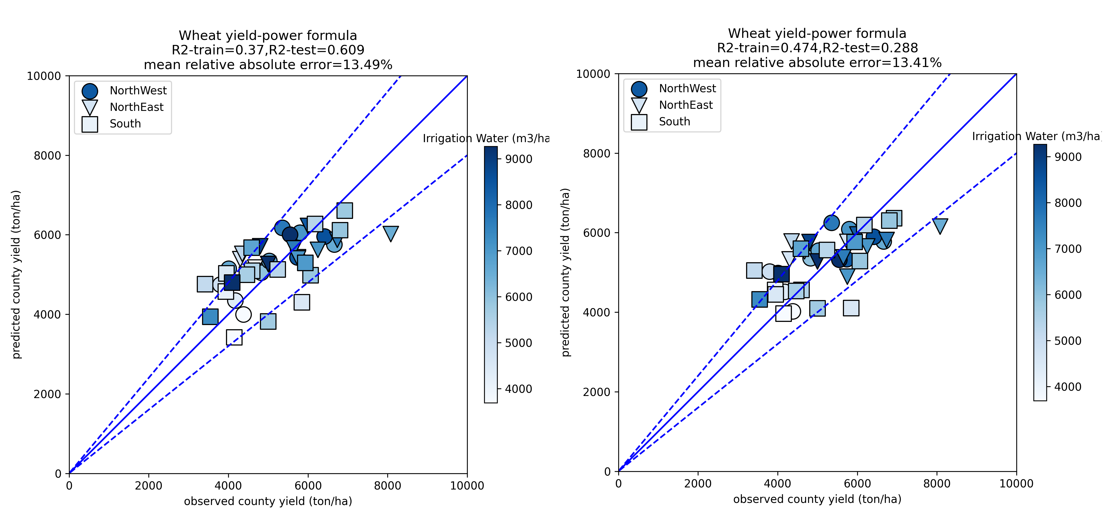

**Figure 8.** Wheat yield per county for the latitude-longitude formula of Equation (7) (left) and power formula of Equation (6) (right)

رابطه مربوط به عملکرد گندم: خاک بافت سبک = عملکرد بهتر، دوره رشد طولانی = عملکرد بهتر، حجم آبیاری بیشتر = عملکرد بالاتر، شوری آب بالاتر = عملکرد کمتر، تعداد دفعات آبیاری بیشتر = عملکرد کمتر

دوره رشد طولانی = عملکرد بهتر، حجم آبیاری بیشتر = عملکرد بهتر، عرض جنوبی = عملکرد بهتر

For estimating wheat yield at the farm level, a formula was fitted given by Equation (8). In this formula, which takes the power form, it is obvious that higher irrigation water and effective rain lead to a higher yield, while longer growth duration days also increases yield (because of grain ripening). Heavier soil has slightly higher yield due to better water retention, while higher leeching need led to smaller yield. The effect of number irrigation events was a positive (albeit small) number. The power (number of irrigation events) has a coefficient which is close to zero. Another predictor for farm yield was proposed which is simply assigning the county average value to the farm as given in Equation (9). These two methods had mean relative absolute errors of 19.5% and 15.6%, respectively. The heterogeneity in farming practices over various counties mean that there is a distinctive difference between yield values in different counties, which is the reason that proposing a single equation for the entire country faces major hurdles. Comparison of Equations (8) and (9) are shown in Figure 7.

|  |  |
| --- | --- |
|  | (11) |
|  | (12) |

عملکرد در سطح مزرعه برای گندم:

حجم آب آبیاری بیشتر = عملکرد بالاتر، بارش بیشتر = عملکرد بیشتر، تعداد دفعات آبیاری بیشتر = عملکرد بیشتر، شوری آب = بدون تاثیر، دوره رشد طولانی = عملکرد بیشتر، نیاز آبشویی بیشتر = عملکرد کمتر، خاک سنگین = عملکرد بهتر

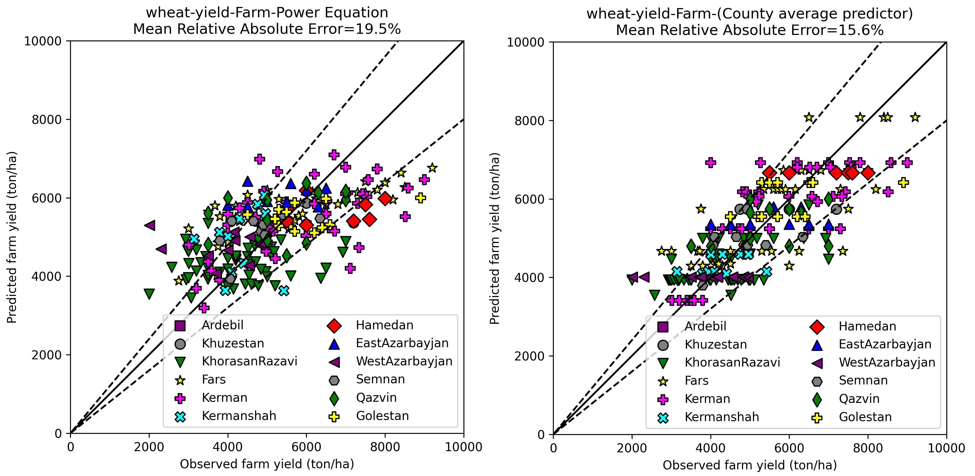**Figure 9.** Wheat yield for farm level using the power formula in Equation 8 (left) and simple county yield value by using Equation 9 (right)

**Conclusion**

**References**