Shrink Quest Game Design Document

-

GameLab2

Danial Azimi

Deltion College

Gam20 & Gam21

# Contents

Contents 2

1. Team Goal 3

2. General Game Overview 3

2.1. Project Name 3

2.2. Genre 3

2.3. Narrative Setting 3

2.4. Game World 3

2.5. Game Character & Visualisation 3

2.6. Game Objective 3

2.7. Gameplay 3

3. Narrative 3

4. Game World 4

4.1. Level Structure 4

4.2. Look & Feel 4

4.3. Visual Representation & Function 4

4.4 Level Interaction 4

Level 4

4.5 Pick ups 5

4.6 Weapons 5

4.6.1 Upgrade 5

4.7 Shop & Item room 6

4.8 NPC 6

4.9 Sounds 6

4.10 Menu flow 7

4.11 Game Flow 8

4.12 HUD 9

4.13 Controls 10

# Team Goal

Our goal in this project is too not make the same mistakes that we made in the previous project. We all hope to make a better project then de last one

# General Game Overview

## Project Name

GameLab2

## Genre

GmeLab2 Is a first person shooter rogue like games.

## Narrative Setting

A marine needs to clear a planet from a “infestation” so that they can colonize on that particular planet. He needs to fight through different rooms as he goes deeper and deeper towards the core of the planet.

## Game World

The dark and grim caves give a feeling off loneliness and solitude, but there is still enough light to give you a challenging feeling. The transition from light giving crystals into corruption that dims the light gives the feeling that you’re going deeper and deeper.

## Game Character & Visualisation

The game perspective is first person because the genre is first person shooter. But another reason is that we want to emerge the player into the action of fighting monsters while navigating through the levels.

## Game Objective

The objective of the game is to navigate through the levels and blocks while not dying. To do this you will need to kill enemies, solve puzzles and get past obstacles.

## Gameplay

The flow of the game is fast, because of the fast movement of the player. The different kind of enemies and level interaction give a strategic feeling too. The different upgrades and weapons that work better on some enemies then others will change the playstyle of the player.

# Narrative

Not sure yet, this is going to be done with cutscenes cinematics or a comic intro.

# Game World

The game world is set in a cave system inside a planet.

## Level Structure

The game world of our game consist out of x levels that each have x blocks. After every block you get a choice of x blocks and once you picked one you can’t go back. Every block has its own difficulty which you can see depending on the lanterns by the door. With every new level you get different obstacles and a different setting.

## Look & Feel

Grim and dark look. Feeling of loneliness and isolation, but still challenging.

## Visual Representation & Function

Every level gets more corrupted and his different kind of obstacles which will give every new level something Unique. The transition from light giving crystals to corruption gives you the feeling you’re going deeper into the planet with every passing level. Things like these crystals and other light sources (lava for example) will give a nice lighting visual effect. Also the further you go the more lava you’ll see

## 4.4 Level Interaction

### Level

|  |  |  |
| --- | --- | --- |
| Asset |  | Gameplay element |
| Lava |  | Dangerous area where you can die |
| Pillars |  | Obstacles where you can get on |
| Bridge | . | With this you’re able to get over rivers of lava. |
| Platforms |  | Spots on the wall were you can have a temp. save spot |
| Light crystals |  | Is a light source that makes the cave lighter. |
| Corruption (eggs) |  | Corruption that dims the light of the crystal |
| Torches |  | Light source and gives an idea of the difficulty for the next room |

## Pick ups

The player is able to pick up ammo, health, shield charge and weapons. Ammo is this case is also the currency for the shop.

## 4.6 Weapons

The player has 3 weapon slots, 1 of them is always melee and the other 2 are shooting weapons.

* Power Fist

A low damage push weapon that can hit more than 1 enemy at once, it has energy and once you’re out of it you can’t use it before it has enough charge again.

* Hand/Revolver Gun

This is the starting shooting weapon, it has 6 shots before you need to reload.

* Assault Rifle

test

* Sub Machine Gun

test

* Grenade/Projectile Launcher

test

## 4.6.1 Upgrade

In the game shop you can upgrade your weapons. You can upgrade your suit, which will affect your maximum health, maximum shield, more damage, faster running and higher jumping.

You can also upgrade your weapons, namely the ammo capacity, damage, fire rate and more reload speed. For the power fist you can upgrade the damage, push power and recharge power. If you upgrade a weapon fully it gains a bonus effect and the this are the effects:

* Power Fist

You can charge up your attack to do a more powerful attack that will push harder and stun enemies.

* Hand/Revolver Gun

test

* Assault Rifle

test

* Sub Machine Gun

test

* Grenade/Projectile Launcher

test

## 4.7 Shop & Item room

There is a change every 3 blocks that you can get a shop were you can buy weapons, upgrade for those weapons and upgrade for your armour (more health, run speed etc.).

Besides the shop there is an item room after the first 2 blocks of a level. Here you get 1 weapon or upgrade for free.

## 4.8 NPC

You have a shop Npc and for the rest its only enemies.

## 4.9 Sounds

-

## Menu flow

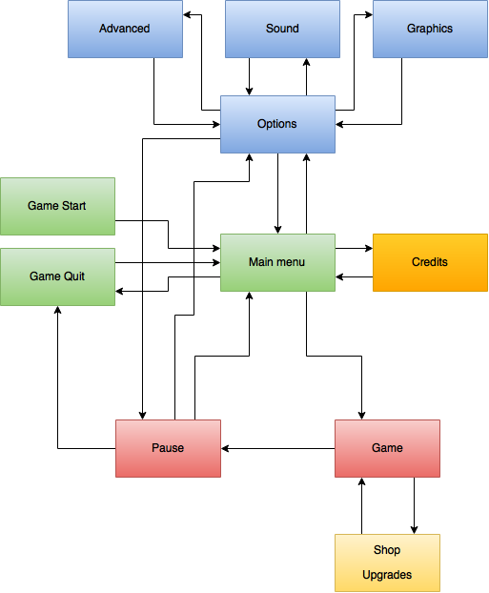

## Game Flow

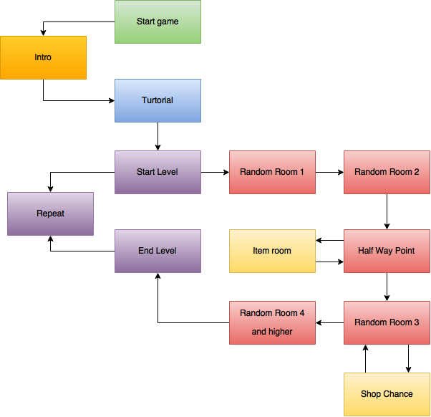

## 4.12 HUD

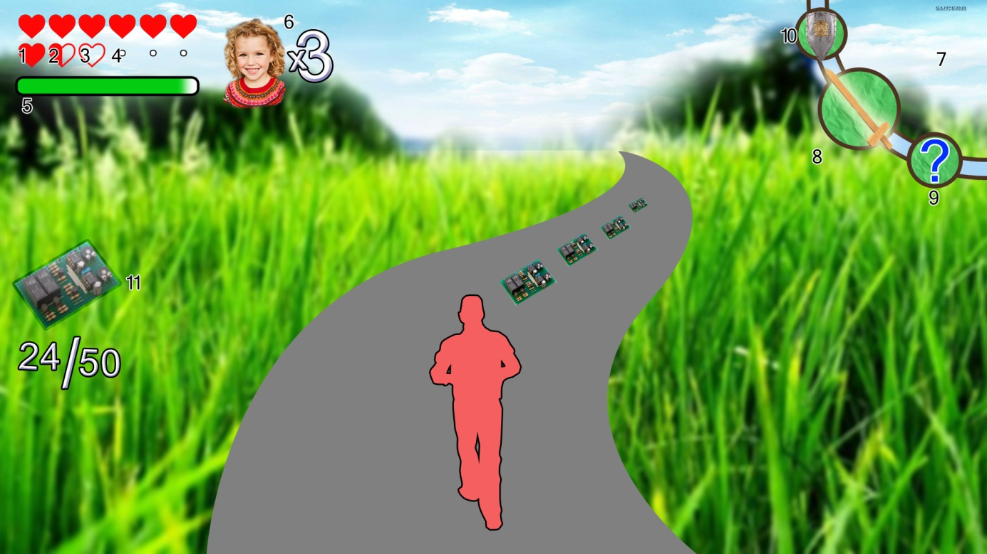

1. **Full heart**

Heart container with full health

1. **Half heart**

Heart container with half health

1. **Empty heart**

Empty heart container

1. **Unlocked heart container**

Designation for an unlockable heart container

1. **Mana bar**

Container for amount of unused mana

1. **Player lives**

Amount of lives

1. **Skill Carousel**

HUD element that displays the currently active, previous selected and following skill.

1. **Active skill**

Highlights the currently active skill

1. **locked skill**

A skill that has not been unlocked is signified by a question mark in the carousel.

1. **Inactive skill**

Shows a skill that came before or comes after the current selected skill

1. **Collectable Counter**

This HUD element is activated when the player gathers a pickup. It will show the player the amount of collectables gathered for that level

## Controls

The game will be with keyboard. x to move around, x to jump, x to shoot and x to switch weapons

We are going for fast feeling controls so you can go play through the levels without getting stuck or feeling to slow.