N!TH21 Game Design Document

-

N!TH21

Harold de Jong

Deltion College

Gam20 & Gam21

# Contents

Contents 2

1. Team Goal 3

2. General Game Overview 3

2.1. Project Name 3

2.2. Genre 3

2.3. Narrative Setting 3

2.4. Game World 3

2.5. Game Character & Visualisation 3

2.6. Game Objective 3

2.7. Gameplay 3

3. Narrative 3

4. Game World 4

4.1. Level Structure 4

4.2. Look & Feel 4

4.3. Visual Representation & Function 4

4.4 Level Interaction 4

Level 4

4.5 Pick ups 5

4.6 Weapons 5

4.6.1 Shop & Item room 5

4.6.2 Upgrade 6

4.6.3 Upgrade Bonus………………………………………………………………………………………………………………………6

4.7 NPC 6

4.8 Sounds 6

4.9 Menu flow 7

4.10 Game Flow 8

4.11 HUD 9

4.12 Controls 10

# Team Goal

Our goal in this project is too make an awesome project where we can later look back upon. We do not want to make the same mistakes that we made in the previous project. We all hope to make a better project then the last one. Some of the mistakes where that we started implementing too late, not everyone was always on the same page, sometimes people were too lax about the project, in some cases there someone in the group that was absent or always late and some people just didn’t do enough work.

# General Game Overview

## Project Name

N!TH21

## Genre

N!TH21 is a first person shooter that shares similarities with the rogue like. Our game is mostly inspired by the game quake and we’re trying to get the same feel as quake.

## Narrative Setting

A marine needs to clear a planet from an “infestation” so that the marines can colonize on that particular planet. He needs to fight through a series blocks as the player will progress through the levels. This infestation is mainly corruption. Corruption is an organic based alien substance. It appears to be living and looks very gooey. The amount off Corruption that will be encounter by the player will increase the further the player progresses through the game.

## 2.4. Game Character & Visualisation

The main character is a male marine in a plated armor suit. This suit has been handed down from generation of captains. This suit has the functions to display the health, shield, mini map and ammo. The main character is from a squad called N!TH21 and he has just achieved the rank of captain. Because of this new achieved rank he gets a dangerous solo mission to proof that he is up to the task of being a captain.

## Level Design

Each level in N!TH21 consists out of different premade rooms that are called blocks. These blocks will be randomly chosen for each new level. Each run of the game will have a different layout. Adding to the replay ability of the game. The player does have some influence in the choosing of the blocks. At the end of every block the player has the choice between 3 doors. Every door has 2 lanterns next to it. The lanterns next to the doors will signify the difficulty of the next block the player is about to choose. This is represented by the colors: purple blue and green.

## Game Objective

The objective of the game is to navigate through the levels and blocks. To progress to the next area the player needs to kill all the enemies that are currently alive. Once al the enemies are killed the player gets the choice between 3 doors and each doorway leading to a different area. The player needs to get as far as possible.

## Gameplay

The flow of the game is fast, because of the fast movement of the player. Level interaction will add a layer of strategic play. A part of this strategic play involves the player interacting with different kind of objects in the scene. The objects are divided into two different kinds, namely destructible and indestructible. Some examples for destructible objects are corrupted eggs and exploding barrels the player can shoot. Examples for indestructible objects are platforms and booster pads. The booster pad is used to get on the platforms to give the players the higher ground. Not all platform are reachable with a normal jump or with a booster pad, but instead the players needs to have the players jump upgraded. The player has different weapons and every weapon is good in a different scenarios. The weapons are also upgradable and will change the playstyle of the player. In these scenarios the player will encounter enemies and every enemy falls into their own category. The categories are: Flying melee, flying shooting, walking melee. Different kind of enemies will attack the player in different ways, so the player has to react to this and change his playstyle according the enemies he will encounter in every scenarios.

# Narrative

Before the tutorial level the player will get to see a log book of the character the player will be playing as, explaining why the player is here. In the tutorial level the player will enter a holographic room training room. In this holographic training room the game will explain to the player the basic controls and give the reason why the player is in this training room. After the player has finished the tutorial level the player will enter a drop pod. This drop pod will launch the player into the first level of the game.

# Game World

The game world is set in a cave system inside a planet. The cave is divided into a series of blocks which are connected through doors. In the game world the player will encounter non hostile and hostile environments. Non hostile environments will contain light emitting crystals, mushrooms and corrupted eggs. In the hostile environments will the player encounter lava and trap pits. Both these environment types will contain enemies that will try to kill the player.

## Level Structure

A series of blocks will create a level, each level will be progressively harder. All these blocks will be premade and will be spawned into the game once the player made the choice of what door to pick. The level is already randomly chosen before the player even made the choice. After the player entered through the door the player will fall down a pit and into the next block, this way the player can’t go back to the previous black

## Look & Feel

The game will give the player a feeling of loneliness. We want to create this feeling by making the game look grim. In the game we also want the player to feel challenged. We want to do this by making the game look hostile, so the player has to be on his toes.

## Visual Representation & Function

In game the player will encounter 4 zones. The player will encounter these zones in no particular order. The zones the player will encounter are: a nature like zone which will contain light emitting crystals and growing mushrooms, the mushrooms in this case can also be big enough to be used as platforms.

A mining zone with scaffolds, pickaxes and construction lights. This will give the player an idea that there used to be entities living here.

A corruption zone with corruption and corruption eggs growing everywhere. These eggs will also be growing over the light emitting crystals the player might have encountered in the previous blocks.

And as last an ancient civilization with mostly old ruins of cities.

Even though each level has its own setting, there will be a certain progress that the player can see through the whole game. The progress the player will see is that the further you go the more lava the player will start to encounter. This way the player will get a feeling that the player is going deeper into the cave system.

## 

## 4.4 Level Interaction

### Level

|  |  |
| --- | --- |
| Asset | Gameplay element |
| Lava | Dangerous area that can damage the player so the player need to be careful not to die here |
| Pillars | Obstacles where the player can jump on. |
| Bridge | With this the player is able to get over rivers of lava. |
| Platforms | Area on the wall were the player can have a temporary spot where the player can avoid some enemies. |
| Light crystals | Is a light source that makes the cave lighter. The player can jump on these. |
| Corruption (eggs) | Corruption (eggs) that dims the light of the crystal and is found all around the later levels. The player can shoot these to break them |
| Lanterns | Light source and gives an idea of the difficulty for the next room Depending on the colour the player can see what difficulty the next room will be. |
| Exploding barrels | Barrels that the player can shoot to make them explode. They can be used to hit a group of enemies. |
| Loot chest | These chest will spawn at random. When opened they will give the player a weapon, a free upgrade, s health pick up, a shield pick up or ammo. |

## Pick ups

The player is able to pick up ammo, health, shield charge and weapons. Ammo is this case is also the currency for the shop. Ammo is divided into bronze, silver and gold tire, Bronze is worth the least amount and gold is worth the most. All of these things are dropped by enemies. The health amount the health drop may vary, but the shield pick up will always give the player a full shield charge. The ammo drop amount may vary depending on what enemy drops it and for what weapon it is.

## 4.6 Weapons

The player has 3 weapon slots, 1 of them is always melee and the other 2 are shooting weapons.

* Power Fist

A low damage weapon that has a knockback effect. Every time the player uses the power fits it will consume energy, once the energy is depleted the player will not be able to use the power. The power fist will recharge over time no matter what.

* Hand/Revolver Gun

This is the starting shooting weapon, it has 6 shots before the players needs to reload.

* Assault Rifle

Weapon used for long and midrange encounters. This weapon works the best against bats.

* Sub Machine Gun

Close range automatic pistol. This weapon works the best against mummies

* Grenade/Projectile Launcher

Shoots projectiles and when fully upgraded also grenades. Good against a large group of enemies.

## 4.6.1 Shop & Item room

There is a chance every 3 blocks that the player can get a shop were the player can buy weapons, upgrade for those weapons and upgrade for the players armour. Upgrades for the players armour includes: Health upgrade, shield upgrade, run speed upgrade and jump height upgrade.

Besides the shop there is an item room after the first 2 blocks of each level. Here the player can get 1 weapon or upgrade for free.

## 4.6.2 Upgrade

In the game shop the player can upgrade the players’ weapons. The player can upgrade the players’ suit, which will affect the players’ maximum health, maximum shield, more damage, faster running and jump height.

The player can also upgrade the players weapons, namely the ammo capacity, damage, fire rate and a faster reload speed. For the power fist the player can upgrade the damage and recharge power.

## 4.6.3. Upgrade Bonus

If the player upgrade a weapon fully it gains a bonus effect and these are the effects:

* Power Fist

The player can charge up an attack to do a more powerful attack that will push harder and stun enemies.

* Hand/Revolver Gun

Power shot,. Will use all 4 bullets at once. This is an alt fire

* Assault Rifle

Does bonus damage to flying enemies. This is always active

* Sub Machine Gun

Rapid fire attack. This is always active

* Grenade/Projectile Launcher

Can now shoot Grenades. This is an alt fire

## NPC

In the game there is only one npc. This npc can be found in the shop where the npc will be selling weapons and upgrades to the player. In the rest of the game you will encounter no npcs

## Sounds

The game sounds we will be using are basic ones. They will get triggered when the player will perform certain actions. Here are the sounds we will be using:

* Move
* Combat
* Interaction
* Shoot
* Reload
* Empty Gun
* Weapon Switching
* Pick up
* Spawn
* Loot Chest Opening

## 4.9 Menu flow

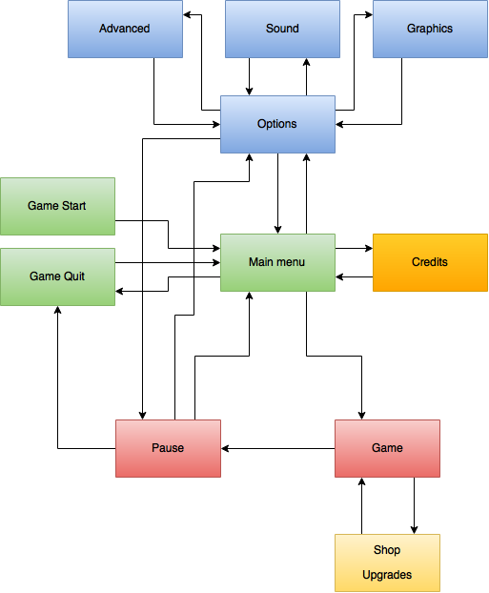

## Game Flow

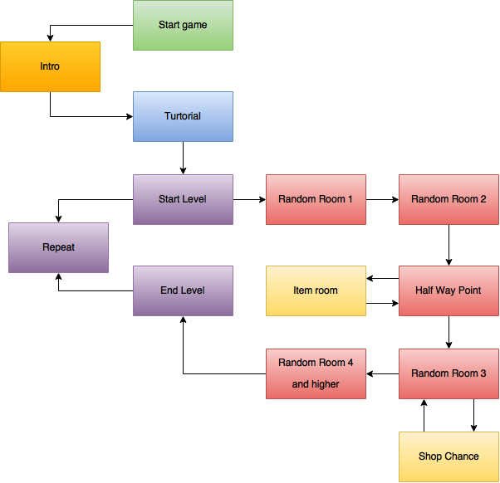

## 4.11 HUD

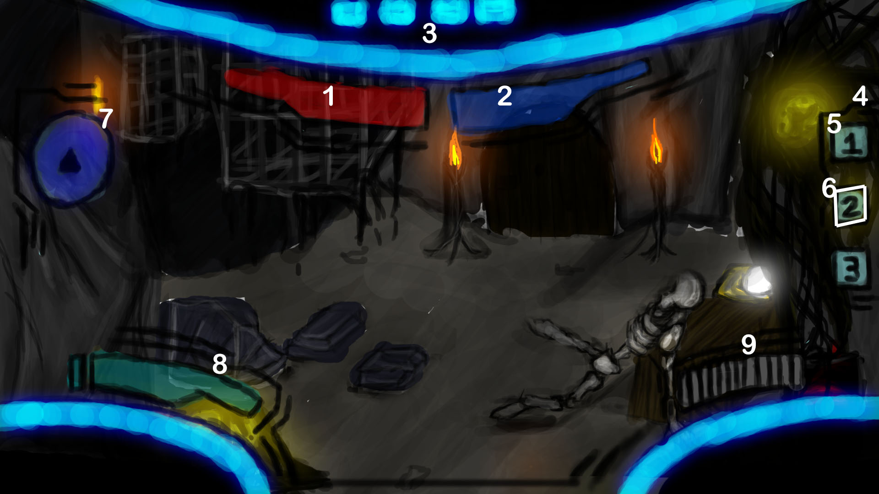

1. **Health Bar**

Health bar displaying Health

1. **Shield Bar**

Shield bar displaying the players shield

1. **Helmet Display**

Inside view from the helmet

1. **Weapon item bar**

Displaying the weapons the player has in the players’ slots

1. **Non selected weapon**

This weapon is currently not selected

1. **Selected weapon**

This weapon is currently selected

1. **Mini Map**

Mini map that shows where enemies are.

1. **Power Fist energy**

This displays how much energy the power fist has.

1. **Ammo & shots display**

Shows the amount of ammo the player has left.

## 4.12 Controls

The game has to be played with the keyboard. The player can use wasd to move around, space to jump, left click to shoot and 1,2 or 3 to switch weapons.

The controls will be explained to the player during the tutorial level. Because the player does not get any new abilities or movement options during the game. this is the only time the controls will be explained via pop ups.