GameLab2 Game Design Document

-

GameLab2

Harold de Jong

Deltion College

Gam20 & Gam21

# Contents

Contents 2

1. Team Goal 3

2. General Game Overview 3

2.1. Project Name 3

2.2. Genre 3

2.3. Narrative Setting 3

2.4. Game World 3

2.5. Game Character & Visualisation 3

2.6. Game Objective 3

2.7. Gameplay 3

3. Narrative 3

4. Game World 4

4.1. Level Structure 4

4.2. Look & Feel 4

4.3. Visual Representation & Function 4

4.4 Level Interaction 4

Level 4

4.5 Pick ups 5

4.6 Weapons 5

4.6.1 Shop & Item room 5

4.6.2 Upgrade 6

4.6.3 Upgrade Bonus………………………………………………………………………………………………………………………6

4.7 NPC 6

4.8 Sounds 6

4.9 Menu flow 7

4.10 Game Flow 8

4.11 HUD 9

4.12 Controls 10

# Team Goal

Our goal in this project is to not make the same mistakes that we made in the previous project. We all hope to make a better project then the last one. Some of the mistakes where that we started implementing to late, not everyone was always on the same page, sometimes people were to lax about the project, in some cases there someone in the group that was absent or always late and some people just didn’t do enough work..

# General Game Overview

## Project Name

Gamelab2

## Genre

Gamelab2 is a first person shooter that shares similarities with the rogue like. Our game is mostly inspired by the game quake and we’re trying to get the same feel as quake.

## Narrative Setting

A marine needs to clear a planet from an “infestation” so that the marines can colonize on that particular planet. He needs to fight through a series blocks as the player will progress through the levels.

## Game Character & Visualisation

The main character is a male marine in a plated armor suit. (explain the armor suit and the character, where it comes from)

## Game World

The setting of Gamelab 2 is set in cave system that features a grim and isolated feeling. The futher the player progresses through the cave the more corruption you encounter.

## Level Design

Each level in Gamelab 2 consists out of different premade rooms that are called blocks. These blocks will be randomly chosen for each new level. Each run of the game will have a different layout. Adding to the replay ability of the game. The player does have some influence in the choosing of the blocks. At the end of every block the player has the choice between 3 doors. Every door has 2 lanterns next to it. The lanterns next to the doors will signify the difficulty of the next block the player is about to choose. This is represented by the colors: purple blue and green.

## Game Objective

The objective of the game is to navigate through the levels and blocks. To progress to the next area the player needs to kill all the enemies that are currently alive. Once al the enemies are killed the player gets the choice between 3 doors and each doorway leading to a different area. The player needs to get as far as possible.

## Gameplay

The flow of the game is fast, because of the fast movement of the player. Level interaction will add a layer of strategic play. (explain how you can interact eggs and exploding barrels is destructible. Platforms and booster pats is indestructible. Some platforms are reaceble with a jump upgrade) A part of this strategic play involves the player interacting with different kind of objects in the scene. The objects are divided into two different kinds, namely destructible and indestructible. Some examples for destructible objects are corrupted eggs and exploding barrels you can shoot. Examples for indestructible objects are platforms and booster pads. The booster pad is used to get on the platforms to give you the higher ground. Not all platform are reachable with a normal jump or with a booster pad, but instead you need to have your jump upgraded. The player has different weapons and every weapon is good in a different scenarios. The weapons are also upgradable and will change the playstyle of the player. (explain that some are walking and others are flying -> shooting and melee) In these scenarios you will encounter enemies and every enemy falls into their own category. The categories are: Flying melee, flying shooting, walking melee. Different kind of enemies will attack the player in different ways, so the player has to react to this and change his playstyle according the enemies he will encounter in every scenarios.

# Narrative

Before the tutorial level you will get to see a log book of the character the player will be playing as, explaining why he is here. (explain turtiorial level hologram and why he is there. The droppod and game start)

# Game World

The game world is set in a cave system inside a planet. The cave is divided into a series of blocks which are connected through doors. (make bigger)

## Level Structure

A series of blocks will create a level, each level will be progressively harder. All these blocks will be premade and will be spawned into the game once the player made the choice of what door to pick.

but you’ll still have a bit choice in this. After every block you get a choice of 3 doors and once you picked a door you can’t go back, because you’ll drop down a far distance making it impossible to get back up. Every block has its own difficulty which you can see depending on the lanterns by the door. With each new level you get different obstacles and a different setting. (explain random, but premade (the prefaps) not so much the lanters)

## Look & Feel

Grim and dark look. Feeling of loneliness and isolation. (bigger)

## Visual Representation & Function

In game you will encounter 4 zones. The player will encounter these zones in no particular order. The zones the player will encounter are: a nature like zone which will contain light emitting crystals and growing mushrooms, the mushrooms in this case can also be big enough to be used as platforms.

A mining zone with scaffolds, pickaxes and construction lights. This will give the player an idea that there used to be entities living here.

A corruption zone with corruption and corruption eggs growing everywhere. These eggs will also be growing over the light emitting crystals the player might have encountered in the previous blocks.

And as last an ancient civilization with mostly old ruins of cities.

Every level has its own setting, but there is a progress from no lava, cracks in the ground and no corruption to lava rivers with corruption all around you.

There are crystal in the first levels will give a more save feeling that transitions into a feeling of danger in the later levels, because most of them will be covered by corruption. The uniqueness of our game comes from the fact you’ll encounter different blocks every time which makes every run unique, even though you are given a choice of difficulty for each now block but it will still give you a random block in that category. (nature(crystals and mushrooms), mining(pickaxe, bouwlampen steiger), corruption, anchient civilisation. Explain platforms and such )

## 

## 4.4 Level Interaction

### Level

|  |  |
| --- | --- |
| Asset | Gameplay element |
| Lava | Dangerous area that can damage you, so you need to be careful not to die here |
| Pillars | Obstacles where you can jump on. |
| Bridge | With this you’re able to get over rivers of lava. |
| Platforms | Area on the wall were you can have a temp. spot where you can avoid some enemies |
| Light crystals | Is a light source that makes the cave lighter. You can jump on these |
| Corruption (eggs) | Corruption (eggs) that dims the light of the crystal and is found all around the later levels. The player can shoot these to break them |
| Lanterns | Light source and gives an idea of the difficulty for the next room Depending on the colour you can see what difficulty the next room will be. |

## Pick ups

The player is able to pick up ammo, health, shield charge and weapons. Ammo is this case is also the currency for the shop. Ammo is divided into bronze, silver and gold tire, Bronze is worth the least amount and gold is worth the most. All of these things are dropped by enemies. The health amount the health drop may vary, but shield pick up will always give you a full shield charge. The ammo drop amount may vary depending on what enemy drops it and for what weapon it is. (hp may vary)

## 4.6 Weapons

The player has 3 weapon slots, 1 of them is always melee and the other 2 are shooting weapons.

* Power Fist

A low damage weapon that has a knockback effect. Every time the player uses the power fits it will consume energy, Once the energy is depleted the player will not be able to use the power. The power fist will recharge over time. (it will always charge, no matter what)

* Hand/Revolver Gun

This is the starting shooting weapon, it has 6 shots before you need to reload.

* Assault Rifle

Weapon used for long and midrange encounters.

* Sub Machine Gun

Close range automatic pistol.

* Grenade/Projectile Launcher

Shoots grenades or shoots projectiles. can hit more enemies at the same time.

## 4.6.1 Shop & Item room

There is a chance every 3 blocks that you can get a shop were you can buy weapons, upgrade for those weapons and upgrade for your armour (more health, run speed etc.).

Besides the shop there is an item room after the first 2 blocks of each level. Here the player can get 1 weapon or upgrade for free.

## 4.6.2 Upgrade

In the game shop you can upgrade your weapons. You can upgrade your suit, which will affect your maximum health, maximum shield, more damage, faster running and jump height.

You can also upgrade your weapons, namely the ammo capacity, damage, fire rate and a faster reload speed. For the power fist you can upgrade the damage and recharge power.

(extra copje voor bonus)

## 4.6.3. Upgrade Bonus

If you upgrade a weapon fully it gains a bonus effect and these are the effects:

* Power Fist

You can charge up your attack to do a more powerful attack that will push harder and stun enemies.

* Hand/Revolver Gun

Power shot, will cost more ammo at once

* Assault Rifle

Ultra-rapid fire, this is an alternative fire

* Sub Machine Gun

Explosive shot, this is an alternative fire.

* Grenade/Projectile Launcher

Shooting 2 projectiles/grenades at once, this is an alternative fire.

## 4.7 NPC

There is a shop npc who sells you items and upgrades. This npc can only be found in the shop that you can encounter. For the rest you will encounter no npcs

## Sounds

The game sounds we will be using are basic ones. They will get triggered when the player will perform certain actions. Here are the sounds we will be using:

* Move
* Combat
* Interaction
* Shoot
* Reload
* Empty Gun
* Weapon Switching
* Pick up
* Spawn
* Loot Chest Opening

## 4.9 Menu flow

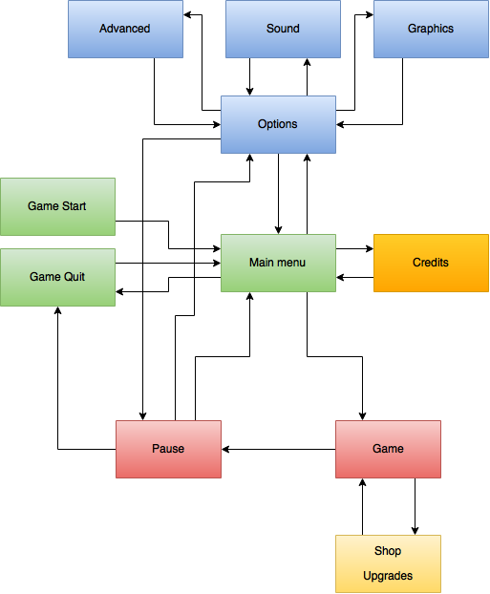

## Game Flow

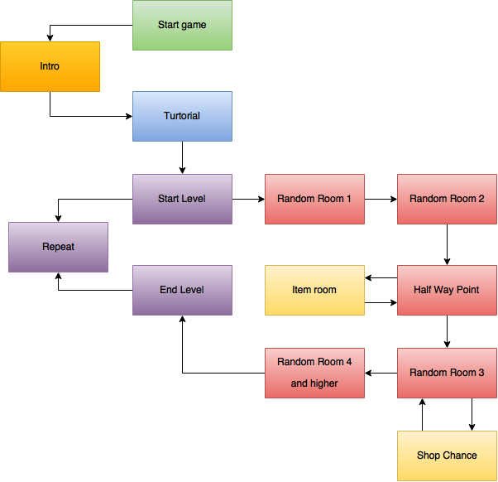

## 4.11 HUD

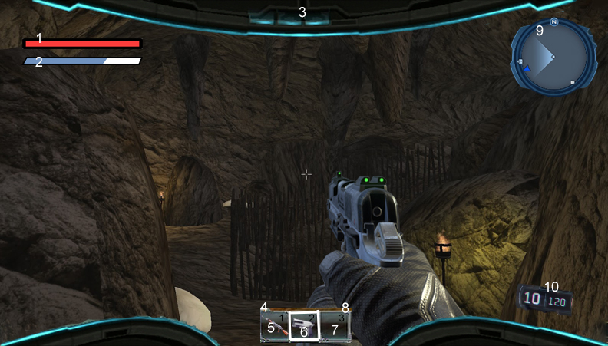

1. **Health Bar**

Health bar displaying Health

1. **Shield Bar**

Shield bar displaying your shield

1. **Helmet Display**

Inside view from the helmet

1. **Weapon item bar**

Displaying the weapons you have in your slots

1. **Non selected weapon**

This weapon is currently not selected

1. **Selected weapon**

This weapon is currently selected

1. **Empty item slot**

There is currently no weapon in this slot

1. **Slot Number**

Displays the number of the slot, this is connected with the 1,2 and 3 key on the keyboard.

1. **Mini Map**

Mini map that shows where enemies are.

1. **Ammo & shots display**

Shows how many shots and how much ammo you have left.

## 4.12 Controls

The game will be with keyboard. wasd to move around, space to jump, left click to shoot and x to switch weapons.

The controls will be explained to the player during the tutorial level. Since the player does not get any new abilities or movement options during the game this is the only time the controls will be explained via pop ups.