

***Arada Developments LLC***

Top of Form

Bottom of Form

**Online Store Transactions**

**(Creating, calculating and posting in D365 finance & operation)**

**Combined TDD & FDD**

**User Guide**

Prepared by

***Danial Dadmohammadi***

***August, 2023***

|  |  |  |  |  |
| --- | --- | --- | --- | --- |
| **DEVELOPMENT DETAILS** | | | | |
| **Task ID** | POS-T121 - D365 Retail APIs development for Manbat & Artal | | | |
| **Task Type** | Y | Functionality | Y | Technicality |
| **Solution Type** |  | Standard Functionality |  | New entitles |

**Objective:**

* Creating the sales transactions for online stores in D365fo without using any P-jobs.
* Posting a related customer payment journal
* Posting an invoice sales order

**REQUIREMENT:**

* Functional:
* Creating an online store in D365fo
* Financial configuration using posting profile
* Triggering and starting the process with or without batch job
* Technical:
* Creating and using the following entities

**SOLUTION:**

* This online store will work with the following entities

|  |  |  |  |  |  |
| --- | --- | --- | --- | --- | --- |
| No. # | Entity Name | Public Collection Name | Sequence | Remarks | Type |
| 1 | ARRetailTransactionAuditableEntity | ARRetailTransactionsAuditable | 1 | Custom entity | Header |
| 2 | RetailTransactionSalesLineV2Entity | RetailTransactionSalesLinesV2 | 2 | Standard entity | Sales lines |
| 3 | ARRetailTransactionPaymentLineEntity | ARRetailTransactionPaymentLines | 3 | Custom entity | Payment lines |

* The sequence of the calling above entities is so vital.
  1. **Functional Steps**
     1. **Online Store Creating**
* There is an important tip for this step that should be considered the channel type as an ‘OnlineStore’ channel type.
* This store unlike the retail stores, does not have any terminal and store ID.

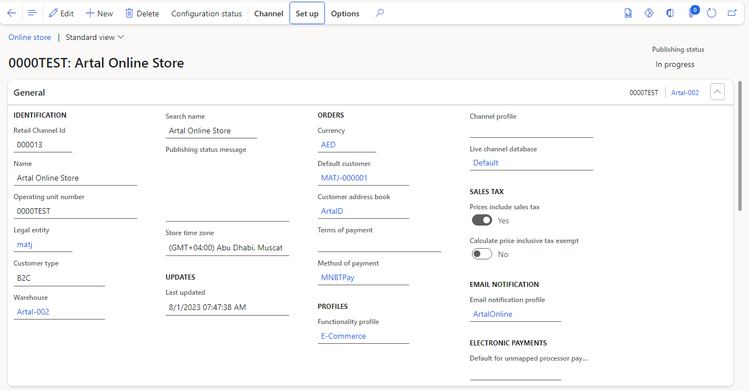

* + 1. **Financial Configurations**
* A valid account number should be considered for posting journals.
* A valid payment method must be defined for this store (Cash, Card …).

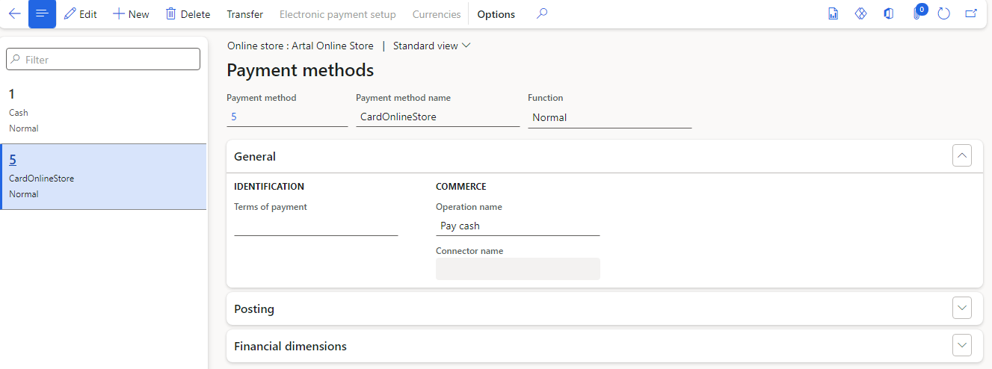

* The mentioned account number must be filled in the payment method form(Crucial step)

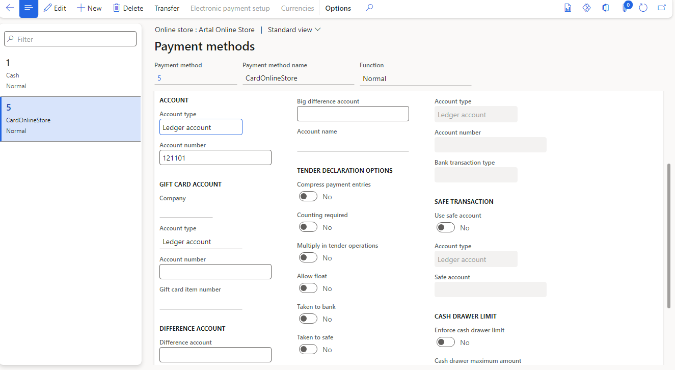

* 1. **Technical Steps**
* For testing and validating of this store, we use Postman for order creating and after that try to create and post the related journals in D365fo.
* Each “TransactionId” in each entity, must be a unique value in the related table.
  + 1. **Header calling : Retail transaction table**
* In this part, we try to create a new unique record in the “RETAILTRANSACTIONTABLE” based on the RetailTransactionId. In the following, you can find the pay load of the calling the first entity:
* **ARRetailTransactionAuditableEntity** <https://arfnodev08e443775586d4552ddevaos.axcloud.dynamics.com/data/ARRetailTransactionsAuditable?cross-company=true>
* **params:**

"cross-company" : "true"

* **method: POST**
* **Body:**

{

    "Company": "matj",

    "OperatingUnitNumber": "0000TEST",

    "AsynchronousOrderStatus": "Editing",

    "LanguageId": "en-US",

    "ChannelType": "OnlineStore",

    "ModeOfDelivery": "OnlineDel",

    "ChannelReferenceId": "120434", [1]

    "GrossAmount": -600,

    "NetPrice": -600,

    "PaymentAmount": 600,

    "NetAmount": -600,

    "StoreNumber": "",

    "RegisterNumber": "",

    "exchRate": 100,

    "toAccount": "Yes",

    "TransactionId": "000013-0000TEST-1030",

    "TimeWhenTransactionClosed": 40871,

    "IsTaxExemptedForPriceInclusive": "No",

    "OperatorID": "2562",

    "DiscountAmount": 0,

    "LastValidationTime": "1900-01-01T00:00:00Z",

    "TotalManualDiscountPercentage": 0,

    "CustomerAccount": "MATJ-000001",

    "BusinessDate": "2023-08-28T12:00:00Z",

    "TransactionOrderType": "SalesOrder",

    "TransactionDate": "2023-08-28T12:00:00Z",

    "RequestedReceiptDate": "1900-01-01T12:00:00Z",

    "SalesOrder": "",

    "NumberOfPaymentLines": 1,

    "Comment": "",

    "Warehouse": "Artal-002",

    "GiftCardActiveFrom": "1900-01-01T00:00:00Z",

    "TransactionType": "AsyncCustomerOrder",

    "RequestedShipDate": "1900-01-01T12:00:00Z",

    "EntryStatus": "None",

    "CreatedAtRegister": "",

    "GiftCardBalance": 0,

    "IsTaxIncludedInPrice": "No",

    "FiscalDocumentId": "",

    "InvoiceComment": "",

    "TaxCalculationType": "Regular",

    "DiscountAmountExcludingTax": 0,

    "GiftCardIdMasked": "",

    "LoyaltyCardNumber": "",

    "FiscalSerialId": "",

    "TransCode": "None",

    "Site": "Artal01",

    "GiftCardExpireDate": "1900-01-01T12:00:00Z",

    "NumberOfProducts": 1,

    "Description": "test from postman for matj",

    "SkipAggregation": "No",

    "CustomerAccountAsync": "",

    "SalesPaymentDifference": 0,

    "SuspendedTransactionId": "",

    "Invoice": "",

    "ExchangeRate": 0,

    "SalesInvoiceAmount": 0,

    "TotalDiscountAmount": 0,

    "NumberOfProductLines": 1,

    "SalesGroup": "",

    "CustomerDiscount": 0,

    "SaleOnAccount": "No",

    "ShiftRegisterID": "",

    "IncomeExpenseAmount": 0,

    "StatementNumber": "",

    "Channel": 5637149826,

    "ReceiptEmail": "",

    "TransactionTime": 40871,

    "CreatedOffline": "No",

    "StatementCode": "",

    "GiftCardIssueAmount": 0,

    "ShiftID": 0,

    "Currency": "AED",

    "SaleIsReturnSale": "No",

    "ReceiptNumber": "",

    "GiftCardHistoryDetails": "",

    "TotalManualDiscountAmount": 0

}

* **Response:**

{

    "@odata.context": "https://arfnodev08e443775586d4552ddevaos.axcloud.dynamics.com/data/$metadata#ARRetailTransactionsAuditable/$entity",

    "@odata.etag": "W/\"JzEsNTYzNzIzODQzMTsxLDU2MzcxNTA1Nzgn\"",

    "OperatingUnitNumber": "0000TEST",

    "StoreNumber": "",

    "RegisterNumber": "",

    "TransactionId": "000013-0000TEST-1030",

    "TimeWhenTransactionClosed": 40871,

    "IsTaxExemptedForPriceInclusive": "No",

    "OperatingUnitRecId": 0,

    "OperatorID": "2562",

    "DiscountAmount": 0,

    "ModeOfDelivery": "OnlineDel",

    "NetPrice": -600,

    "TotalManualDiscountPercentage": 0,

    "LastValidationTime": "1900-01-01T00:00:00Z",

    "CustomerAccount": "MATJ-000001",

    "BusinessDate": "2023-08-28T12:00:00Z",

    "TransactionOrderType": "SalesOrder",

    "AsynchronousOrderStatus": "Editing",

    "ChannelReferenceId": "120434",

    "TransactionDate": "2023-08-28T12:00:00Z",

    "RequestedReceiptDate": "1900-01-01T12:00:00Z",

    "PaymentAmount": 600,

    "SalesOrder": "",

    "NumberOfPaymentLines": 1,

    "Comment": "",

    "Warehouse": "Artal-002",

    "GiftCardActiveFrom": "1900-01-01T00:00:00Z",

    "TransactionType": "AsyncCustomerOrder",

    "RequestedShipDate": "1900-01-01T12:00:00Z",

    "EntryStatus": "None",

    "CreatedAtRegister": "",

    "GiftCardBalance": 0,

    "IsTaxIncludedInPrice": "No",

    "exchRate": 100,

    "FiscalDocumentId": "",

    "InvoiceComment": "",

    "TaxCalculationType": "Regular",

    "DiscountAmountExcludingTax": 0,

    "GiftCardIdMasked": "",

    "ValidationStatus": "None",

    "LoyaltyCardNumber": "",

    "FiscalSerialId": "",

    "TransCode": "None",

    "Site": "Artal01",

    "GiftCardExpireDate": "1900-01-01T12:00:00Z",

    "NetAmount": -600,

    "toAccount": "Yes",

    "NumberOfProducts": 1,

    "Description": "test from postman for matj",

    "SkipAggregation": "No",

    "CustomerAccountAsync": "",

    "SalesPaymentDifference": 0,

    "Invoice": "",

    "SuspendedTransactionId": "",

    "ExchangeRate": 100,

    "SalesInvoiceAmount": 0,

    "TotalDiscountAmount": 0,

    "ChannelType": "OnlineStore",

    "NumberOfProductLines": 1,

    "SalesGroup": "",

    "CustomerDiscount": 0,

    "SaleOnAccount": "No",

    "ShiftRegisterID": "",

    "IncomeExpenseAmount": 0,

    "StatementNumber": "",

    "Channel": 5637149826,

    "GrossAmount": -600,

    "ReceiptEmail": "",

    "TransactionTime": 40871,

    "CreatedOffline": "No",

    "LanguageId": "en-US",

    "StatementCode": "",

    "GiftCardIssueAmount": 0,

    "ShiftID": 0,

    "SaleIsReturnSale": "No",

    "Currency": "AED",

    "ReceiptNumber": "",

    "Company": "matj",

    "GiftCardHistoryDetails": "",

    "TotalManualDiscountAmount": 0

}

* + 1. **Sales line calling : Retail transaction sales table**
* In this section, we try to create a new unique record in the “RETAILTRANSACTIONSALESTRANS” based on the RetailTransactionId. In the following, you can find the pay load of the calling the second entity:
* **RetailTransactionSalesLineV2Entity**

<https://arfnodev08e443775586d4552ddevaos.axcloud.dynamics.com/data/RetailTransactionSalesLinesV2?cross-company=true>

* **params:**

"cross-company" : "true"

* **method: POST**
* **Body:**

{

    "dataAreaId": "matj",

    "Terminal": "",

    "TransactionNumber": "000013-0000TEST-1030",

    "LineNumber": 1,

    "OperatingUnitNumber": "0000TEST",

    "KeyboardProductEntry": "Yes",

    "ItemSalesTaxGroup": "VAT5",

    "IsReturnNoSale": "No",

    "GiftCard": "No",

    "TotalDiscountPercentage": 0,

    "ElectronicDeliveryEmail": "",

    "IsWeightProduct": "No",

    "ReturnLineNumber": 0,

    "LinePercentageDiscount": 0,

    "RetailEmailAddressContent": "",

    "ModeOfDelivery": "OnlineDel",

    "NetPrice": -600,

    "NetAmountInclusiveTax": -600,

    "OriginalPrice": 600,

    "NetAmount": -600,

    "Price": 600,

    "UnitPrice": 0,

    "OfferNumber": "",

    "CustomerAccount": "MATJ-000001",

    "IsLineDiscounted": "No",

    "PeriodicDiscountPercentage": 0,

    "BusinessDate": "2023-08-28T12:00:00Z",

    "CostAmount": 0,

    "PeriodicDiscountGroup": "",

    "ChannelListingID": "",

    "TransactionDate": "2023-08-28T12:00:00Z",

    "ReasonCodeDiscount": 0,

    "RequestedReceiptDate": "2023-08-28T12:00:00Z",

    "TransactionStatus": "None",

    "Warehouse": "Artal-002",

    "IsScaleProduct": "No",

    "PriceGroups": "",

    "CashDiscountAmount": 0,

    "TaxExemptPriceInclusiveOriginalPrice": 0,

    "RequestedShipDate": "2023-08-28T12:00:00Z",

    "ShelfNumber": "",

    "LotID": "",

    "PickupStartTime": 0,

    "SkipReports": "No",

    "SiteId": "Artal01",

    "PeriodicDiscountAmount": 0,

    "LineManualDiscountAmount": 0,

    "TotalDiscount": 0,

    "IsLinkedProductNotOriginal": "No",

    "ItemId": "100000044",

    "ItemConfigId": "Takara",

    "ItemColor": "16",

    "ItemSize": "Size0-L56",

    "ItemStyle": "S51",

    "VariantNumber": "MATJ-00052",

    "Unit": "pcs",

    "SectionNumber": "",

    "PickupEndTime": 0,

    "IsPriceChange": "No",

    "SerialNumber": "",[2]

    "SalesTaxGroup": "VAT5",

    "SalesTaxAmount": 0,

    "ProductScanned": "No",

    "TransactionCode": "ItemOnFile",

    "IsOriginalOfLinkedProductList": "No",

    "ItemRelation": "",

    "ReturnTransactionNumber": "",

    "LogisticLocationId": "",

    "InventoryStatus": "None",

    "DiscountAmountWithoutTax": 0,

    "CustomerDiscount": 0,

    "ReturnTrackingStatus": "None",

    "IsWeightManuallyEntered": "No",

    "CustomerInvoiceDiscountAmount": 0,

    "PriceInBarCode": "No",

    "DiscountAmountForPrinting": 0,

    "BarCode": "100000001BAFS51S17",

    "OriginalItemSalesTaxGroup": "VAT5",

    "StandardNetPrice": 0,

    "TotalDiscountInfoCodeLineNum": 0,

    "ReturnTerminal": "",

    "ReturnQuantity": 0,

    "UnitQuantity": 0,

    "Quantity": -1,

    "RFIDTagId": "",

    "LogisticsPostalAddressValidFrom": "1900-01-01T00:00:00Z",

    "CategoryName": "Abaya",

    "Currency": "AED",

    "ReceiptNumber": "",

    "ReturnOperatingUnitNumber": "",

    "LineDiscount": 0,

    "ItemVersion": "",

    "TaxExemptPriceInclusiveReductionAmount": 0,

    "OriginalSalesTaxGroup": "VAT5",

    "LineManualDiscountPercentage": 0,

    "CategoryHierarchyName": "Artal Retail Hierarchy"

}

* + 1. **Payment line calling : Retail transaction payment table**
* In this step, we try to create a new unique record in the “RETAILTRANSACTIONPAYMENTTRANS” based on the RetailTransactionId. In the following, you can find the pay load of the calling the third entity:
* **ARRetailTransactionPaymentLineEntity**
* <https://arfnodev08e443775586d4552ddevaos.axcloud.dynamics.com/data/ARRetailTransactionPaymentLines?cross-company=true>
* **params:**

"cross-company" : "true"

* **method: POST**
* **Body:**

{

    "dataAreaId": "matj",

    "Channel": 5637149826,

    "OMOperatingUnitNumber": "0000TEST",

    "TransactionId": "000013-0000TEST-1030",

    "transactionStatus": "None",

    "lineNum": 1,

    "amountMST": 600,

    "RefundableAmount": 600,

    "amountCur": 600,

    "amountTendered": 600,

    "isPrepayment": "No",

    "IsCaptureFailed": "No",

    "changeLine": "No",

    "replicated": "No",

    "loyaltyCardId": "",

    "exchRate": 100,

    "LinkedPaymentTransactionId": "",

    "businessDate": "2023-08-28T12:00:00Z",

    "paymentCardToken": "",

    "transTime": 46228,

    "replicationCounterFromOrigin": 1,

    "statementId": "",

    "LinkedPaymentStore": "",

    "CreditCardProcessorStatus": "NA",

    "PaymentCaptureToken": "",

    "statementCode": "",

    "staff": "2498",

    "receiptId": "",

    "LinkedPaymentLineNumber": 0,

    "cardOrAccount": "",

    "exchRateMST": 100,

    "IsCustomerAccountFloorLimitUsed": "No",

    "authenticationCode": "",

    "LinkedPaymentTerminalId": "",

    "AuthorizedAmount": 0,

    "sigCapData": "",

    "IsLinkedRefund": "No",

    "shiftDate": "1900-01-01T12:00:00Z",

    "paymentAuthorization": "",

    "IsPaymentCaptured": "Yes",

    "CardPaymentAccountId": "",

    "cardTypeId": "",

    "tenderType": "5",

    "transDate": "2023-08-28T12:00:00Z",

    "giftCardId": "",

    "VoidStatus": "None",

    "creditVoucherId": "",

    "Origin": "",

    "currency": "AED",

    "LinkedPaymentCurrency": "",

    "qty": 1,

    "IsPaymentDataArchived": "No",

    "shift": ""

}

* **Response:**

{

    "@odata.context": "https://arfnodev08e443775586d4552ddevaos.axcloud.dynamics.com/data/$metadata#ARRetailTransactionPaymentLines/$entity",

    "@odata.etag": "W/\"JzEsNTYzNzIyMTkzOTsxLDU2MzcxNTU4Mjgn\"",

    "dataAreaId": "matj",

    "OMOperatingUnit_PartyNumber": "",

    "Terminal": "",

    "TransactionId": "000013-0000TEST-1030",

    "lineNum": 1,

    "isPrepayment": "No",

    "IsCaptureFailed": "No",

    "OMOperatingUnitNumber": "0000TEST",

    "changeLine": "No",

    "replicated": "No",

    "loyaltyCardId": "",

    "exchRate": 100,

    "LinkedPaymentTransactionId": "",

    "businessDate": "2023-08-28T12:00:00Z",

    "paymentCardToken": "",

    "transTime": 46228,

    "replicationCounterFromOrigin": 1,

    "statementId": "",

    "LinkedPaymentStore": "",

    "CreditCardProcessorStatus": "NA",

    "Store": "",

    "PaymentCaptureToken": "",

    "statementCode": "",

    "RefundableAmount": 600,

    "staff": "2498",

    "amountMST": 600,

    "receiptId": "",

    "LinkedPaymentLineNumber": 0,

    "cardOrAccount": "",

    "RetailChannelId": "",

    "exchRateMST": 100,

    "IsCustomerAccountFloorLimitUsed": "No",

    "authenticationCode": "",

    "transactionStatus": "None",

    "LinkedPaymentTerminalId": "",

    "AuthorizedAmount": 0,

    "sigCapData": "",

    "IsLinkedRefund": "No",

    "shiftDate": "1900-01-01T12:00:00Z",

    "paymentAuthorization": "",

    "IsPaymentCaptured": "Yes",

    "CardPaymentAccountId": "",

    "cardTypeId": "",

    "tenderType": "5",

    "StoreNum": "",

    "amountCur": 600,

    "transDate": "2023-08-28T12:00:00Z",

    "giftCardId": "",

    "VoidStatus": "None",

    "creditVoucherId": "",

    "Origin": "",

    "currency": "AED",

    "LinkedPaymentCurrency": "",

    "qty": 1,

    "IsPaymentDataArchived": "No",

    "amountTendered": 600,

    "shift": "",

    "Channel": 5637149826

}

* 1. **Running the process in D365fo**
* In order to the trigger the process from the beginning, after the doing before steps, the followings stages should be done:
* Running the process can do either using the batch job or not. Bases on your policy, it can be set through the one of the following paths:

1. Retail and commerce 🡪 Inquiries and reports🡪 online store transaction

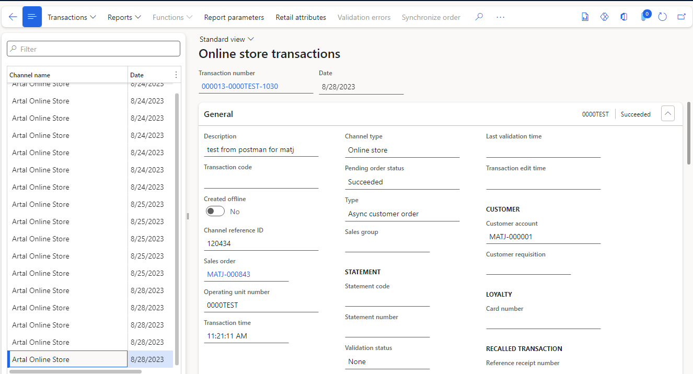

1. Retail and commerce🡪Channel🡪 Store financial

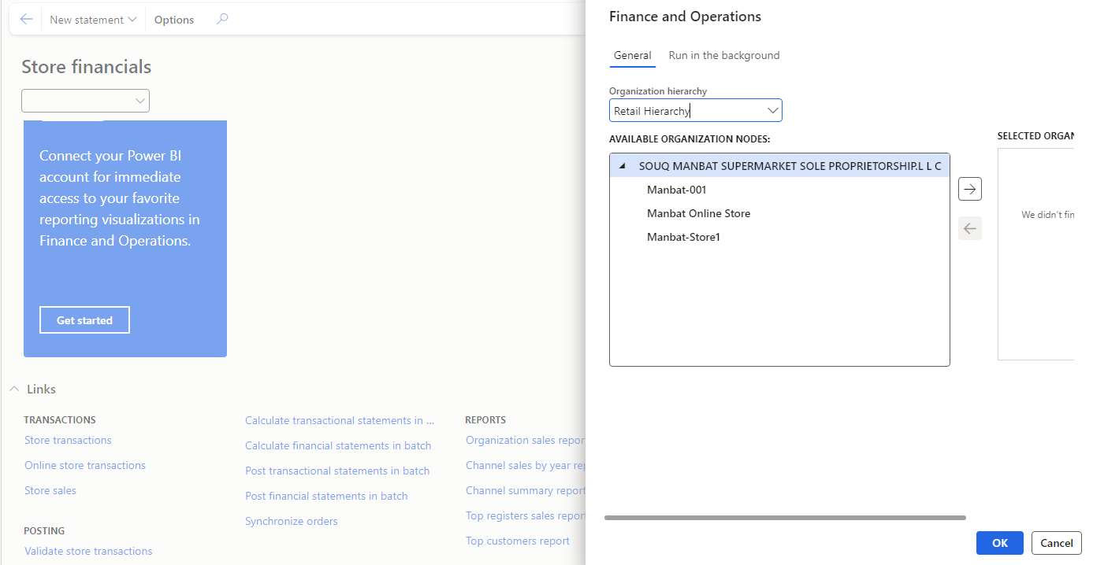

After running the above successfully, a posted customer payment journal and a sales order invoiced would be created in the system.

**Summary:**

* The solution has been developed in such a way that it follows the same as a normal retail store.
* The general flow is:

1. This field is so important and play as receipt id in a normal store. It must be a unique value in each transaction.
2. It would be mandatory on the serial items enabled.