**Artal/Manbat retail API (UAT Server)**

1. **Get Products:**

https://scuv2fb0cle58494738-rs.su.retail.dynamics.com/Commerce/Products/SearchByText(channelId=5637147576,catalogId=0,searchText=@p1)?$top=100&api-version=7.3&@p1=%2710%27  
  
**Header param:**

OUN **=** ArtalStore01

**param:**

@p1 = %2710%27(all products start with ‘10’ and exist in **assortment**.

**method: GET**

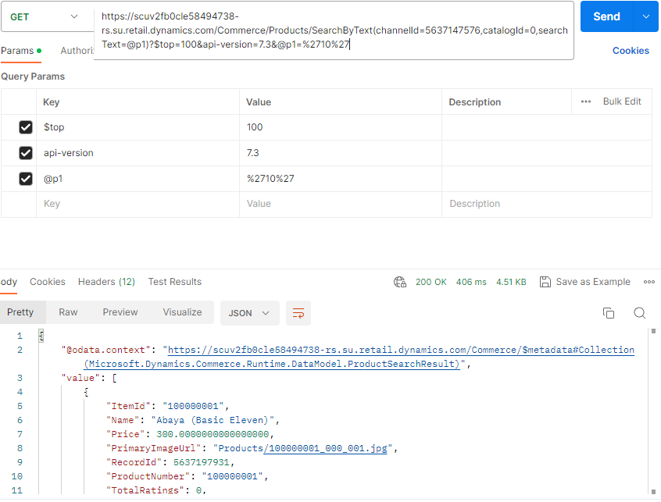

Response:

{

    "@odata.context": "https://scuv2fb0cle58494738-rs.su.retail.dynamics.com/Commerce/$metadata#Collection(Microsoft.Dynamics.Commerce.Runtime.DataModel.ProductSearchResult)",

    "value": [

        {

            "ItemId": "100000001",

            "Name": "Abaya (Basic Eleven)",

            "Price": 300.0000000000000000,

            "PrimaryImageUrl": "Products/100000001_000_001.jpg",

            "RecordId": 5637197931,

            "ProductNumber": "100000001",

            "TotalRatings": 0,

            "AttributeValues": [],

            "ExtensionProperties": []

        },

        {

            "ItemId": "100000002",

            "Name": "Abaya (Basic Fifteen)",

            "Price": 0.0000000000000000,

            "PrimaryImageUrl": "Products/100000002_000_001.jpg",

            "RecordId": 5637197932,

            "ProductNumber": "100000002",

            "TotalRatings": 0,

            "AttributeValues": [],

            "ExtensionProperties": []

        },

        {

            "ItemId": "100000003",

            "Name": "Abaya (Basic Forteen)",

            "Price": 0.0000000000000000,

            "PrimaryImageUrl": "Products/100000003_000_001.jpg",

            "RecordId": 5637197933,

            "ProductNumber": "100000003",

            "TotalRatings": 0,

            "AttributeValues": [],

            "ExtensionProperties": []

        },

        {

            "ItemId": "100000004",

            "Name": "Abaya (Basic One)",

            "Price": 0.0000000000000000,

            "PrimaryImageUrl": "Products/100000004_000_001.jpg",

            "RecordId": 5637197934,

            "ProductNumber": "100000004",

            "TotalRatings": 0,

            "AttributeValues": [],

            "ExtensionProperties": []

        },

        {

            "ItemId": "100000005",

            "Name": "Abaya (Basic Organza)",

            "Price": 0.0000000000000000,

            "PrimaryImageUrl": "Products/100000005_000_001.jpg",

            "RecordId": 5637197935,

            "ProductNumber": "100000005",

            "TotalRatings": 0,

            "AttributeValues": [],

            "ExtensionProperties": []

        },

        {

            "ItemId": "100000006",

            "Name": "Abaya (Basic Sixteen)",

            "Price": 0.0000000000000000,

            "PrimaryImageUrl": "Products/100000006_000_001.jpg",

            "RecordId": 5637197936,

            "ProductNumber": "100000006",

            "TotalRatings": 0,

            "AttributeValues": [],

            "ExtensionProperties": []

        },

        {

            "ItemId": "100000007",

            "Name": "Abaya (Basic Ten)",

            "Price": 0.0000000000000000,

            "PrimaryImageUrl": "Products/100000007_000_001.jpg",

            "RecordId": 5637197937,

            "ProductNumber": "100000007",

            "TotalRatings": 0,

            "AttributeValues": [],

            "ExtensionProperties": []

        },

        {

            "ItemId": "100000008",

            "Name": "Abaya (Basic Twelve)",

            "Price": 0.0000000000000000,

            "PrimaryImageUrl": "Products/100000008_000_001.jpg",

            "RecordId": 5637197938,

            "ProductNumber": "100000008",

            "TotalRatings": 0,

            "AttributeValues": [],

            "ExtensionProperties": []

        },

        {

            "ItemId": "100000009",

            "Name": "Abaya (Basic Two)",

            "Price": 0.0000000000000000,

            "PrimaryImageUrl": "Products/100000009_000_001.jpg",

            "RecordId": 5637197939,

            "ProductNumber": "100000009",

            "TotalRatings": 0,

            "AttributeValues": [],

            "ExtensionProperties": []

        },

        {

            "ItemId": "100000010",

            "Name": "Abaya with Embroidery",

            "Price": 0.0000000000000000,

            "PrimaryImageUrl": "Products/100000010_000_001.jpg",

            "RecordId": 5637197940,

            "ProductNumber": "100000010",

            "TotalRatings": 0,

            "AttributeValues": [],

            "ExtensionProperties": []

        },

        {

            "ItemId": "100000011",

            "Name": "Abaya with Embroidery (Alice)",

            "Price": 0.0000000000000000,

            "PrimaryImageUrl": "Products/100000011_000_001.jpg",

            "RecordId": 5637197941,

            "ProductNumber": "100000011",

            "TotalRatings": 0,

            "AttributeValues": [],

            "ExtensionProperties": []

        },

        {

            "ItemId": "100000012",

            "Name": "Abaya with Embroidery (D901)",

            "Price": 0.0000000000000000,

            "PrimaryImageUrl": "Products/100000012_000_001.jpg",

            "RecordId": 5637197942,

            "ProductNumber": "100000012",

            "TotalRatings": 0,

            "AttributeValues": [],

            "ExtensionProperties": []

        },

        {

            "ItemId": "100000013",

            "Name": "Abaya with Embroidery (D902)",

            "Price": 0.0000000000000000,

            "PrimaryImageUrl": "Products/100000013_000_001.jpg",

            "RecordId": 5637197943,

            "ProductNumber": "100000013",

            "TotalRatings": 0,

            "AttributeValues": [],

            "ExtensionProperties": []

        },

        {

            "ItemId": "100000014",

            "Name": "Abaya with Embroidery (D903)",

            "Price": 0.0000000000000000,

            "PrimaryImageUrl": "Products/100000014_000_001.jpg",

            "RecordId": 5637197944,

            "ProductNumber": "100000014",

            "TotalRatings": 0,

            "AttributeValues": [],

            "ExtensionProperties": []

        },

        {

            "ItemId": "100000015",

            "Name": "Abaya with Embroidery (D904)",

            "Price": 0.0000000000000000,

            "PrimaryImageUrl": "Products/100000015_000_001.jpg",

            "RecordId": 5637197945,

            "ProductNumber": "100000015",

            "TotalRatings": 0,

            "AttributeValues": [],

            "ExtensionProperties": []

        },

        {

            "ItemId": "100000016",

            "Name": "Abaya with Embroidery (D905)",

            "Price": 0.0000000000000000,

            "PrimaryImageUrl": "Products/100000016_000_001.jpg",

            "RecordId": 5637197946,

            "ProductNumber": "100000016",

            "TotalRatings": 0,

            "AttributeValues": [],

            "ExtensionProperties": []

        }

    ]

}

1. **Get Price:**

https://scuv2fb0cle58494738-rs.su.retail.dynamics.com/Commerce/Products/GetActivePrices?$top=250&$count=true&api-version=7.3  
  
**Header param:**

OUN **=** ArtalStore01

**Body:**

* **productIDs get from previous API.**

{

    "projectDomain": {

        "ChannelId": 5637147576,

        "CatalogId": 0

    },

    "productIds": [

        5637197931,

        5637197932,

        5637197933,

        5637197934,

        5637197935,

        5637197936,

        5637197937,

        5637197938,

        5637197939,

        5637197940,

        5637197941,

        5637197942,

        5637197943,

        5637197944,

        5637197945,

        5637197946

    ],

    "activeDate": "2023-06-16T13:15:17.240+04:00",

    "affiliationLoyaltyTiers": [],

    "includeSimpleDiscountsInContextualPrice": **true**,

    "includeVariantPriceRange": **false**,

    "includeAttainablePricesAndDiscounts": **false**

}

**method: POST**

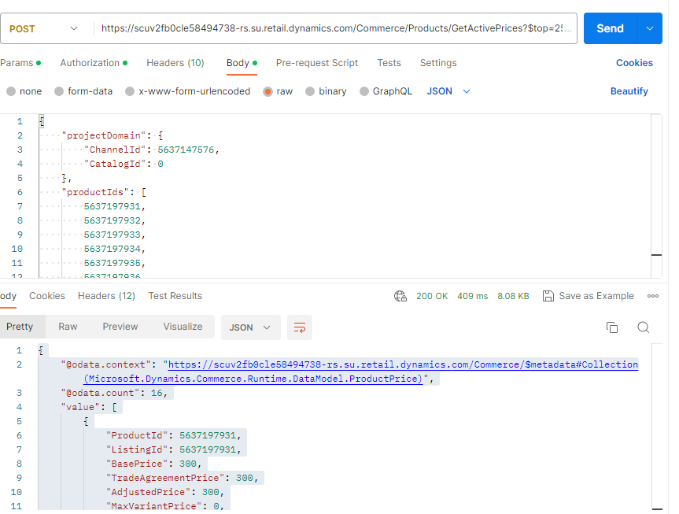

**Response:**

{

    "@odata.context": "https://scuv2fb0cle58494738-rs.su.retail.dynamics.com/Commerce/$metadata#Collection(Microsoft.Dynamics.Commerce.Runtime.DataModel.ProductPrice)",

    "@odata.count": 16,

    "value": [

        {

            "ProductId": 5637197931,

            "ListingId": 5637197931,

            "BasePrice": 300,

            "TradeAgreementPrice": 300,

            "AdjustedPrice": 300,

            "MaxVariantPrice": 0,

            "MinVariantPrice": 0,

            "CustomerContextualPrice": 300,

            "DiscountAmount": 0,

            "CurrencyCode": "AED",

            "ItemId": "100000001",

            "UnitOfMeasure": "pcs",

            "ValidFrom": "2023-06-16T13:15:17.24+04:00",

            "ProductLookupId": 0,

            "ChannelId": 5637147576,

            "CatalogId": 0,

            "SalesAgreementPrice": 0,

            "PriceSourceTypeValue": 1,

            "DiscountLines": [],

            "AttainablePriceLines": [],

            "ExtensionProperties": []

        },

        {

            "ProductId": 5637197932,

            "ListingId": 5637197932,

            "BasePrice": 0,

            "TradeAgreementPrice": 0,

            "AdjustedPrice": 0,

            "MaxVariantPrice": 0,

            "MinVariantPrice": 0,

            "CustomerContextualPrice": 0,

            "DiscountAmount": 0,

            "CurrencyCode": "AED",

            "ItemId": "100000002",

            "UnitOfMeasure": "pcs",

            "ValidFrom": "2023-06-16T13:15:17.24+04:00",

            "ProductLookupId": 0,

            "ChannelId": 5637147576,

            "CatalogId": 0,

            "SalesAgreementPrice": 0,

            "PriceSourceTypeValue": 1,

            "DiscountLines": [],

            "AttainablePriceLines": [],

            "ExtensionProperties": []

        },

        {

            "ProductId": 5637197933,

            "ListingId": 5637197933,

            "BasePrice": 0,

            "TradeAgreementPrice": 0,

            "AdjustedPrice": 0,

            "MaxVariantPrice": 0,

            "MinVariantPrice": 0,

            "CustomerContextualPrice": 0,

            "DiscountAmount": 0,

            "CurrencyCode": "AED",

            "ItemId": "100000003",

            "UnitOfMeasure": "pcs",

            "ValidFrom": "2023-06-16T13:15:17.24+04:00",

            "ProductLookupId": 0,

            "ChannelId": 5637147576,

            "CatalogId": 0,

            "SalesAgreementPrice": 0,

            "PriceSourceTypeValue": 1,

            "DiscountLines": [],

            "AttainablePriceLines": [],

            "ExtensionProperties": []

        },

        {

            "ProductId": 5637197934,

            "ListingId": 5637197934,

            "BasePrice": 0,

            "TradeAgreementPrice": 0,

            "AdjustedPrice": 0,

            "MaxVariantPrice": 0,

            "MinVariantPrice": 0,

            "CustomerContextualPrice": 0,

            "DiscountAmount": 0,

            "CurrencyCode": "AED",

            "ItemId": "100000004",

            "UnitOfMeasure": "pcs",

            "ValidFrom": "2023-06-16T13:15:17.24+04:00",

            "ProductLookupId": 0,

            "ChannelId": 5637147576,

            "CatalogId": 0,

            "SalesAgreementPrice": 0,

            "PriceSourceTypeValue": 1,

            "DiscountLines": [],

            "AttainablePriceLines": [],

            "ExtensionProperties": []

        },

        {

            "ProductId": 5637197935,

            "ListingId": 5637197935,

            "BasePrice": 0,

            "TradeAgreementPrice": 0,

            "AdjustedPrice": 0,

            "MaxVariantPrice": 0,

            "MinVariantPrice": 0,

            "CustomerContextualPrice": 0,

            "DiscountAmount": 0,

            "CurrencyCode": "AED",

            "ItemId": "100000005",

            "UnitOfMeasure": "pcs",

            "ValidFrom": "2023-06-16T13:15:17.24+04:00",

            "ProductLookupId": 0,

            "ChannelId": 5637147576,

            "CatalogId": 0,

            "SalesAgreementPrice": 0,

            "PriceSourceTypeValue": 1,

            "DiscountLines": [],

            "AttainablePriceLines": [],

            "ExtensionProperties": []

        },

        {

            "ProductId": 5637197936,

            "ListingId": 5637197936,

            "BasePrice": 0,

            "TradeAgreementPrice": 0,

            "AdjustedPrice": 0,

            "MaxVariantPrice": 0,

            "MinVariantPrice": 0,

            "CustomerContextualPrice": 0,

            "DiscountAmount": 0,

            "CurrencyCode": "AED",

            "ItemId": "100000006",

            "UnitOfMeasure": "pcs",

            "ValidFrom": "2023-06-16T13:15:17.24+04:00",

            "ProductLookupId": 0,

            "ChannelId": 5637147576,

            "CatalogId": 0,

            "SalesAgreementPrice": 0,

            "PriceSourceTypeValue": 1,

            "DiscountLines": [],

            "AttainablePriceLines": [],

            "ExtensionProperties": []

        },

        {

            "ProductId": 5637197937,

            "ListingId": 5637197937,

            "BasePrice": 0,

            "TradeAgreementPrice": 0,

            "AdjustedPrice": 0,

            "MaxVariantPrice": 0,

            "MinVariantPrice": 0,

            "CustomerContextualPrice": 0,

            "DiscountAmount": 0,

            "CurrencyCode": "AED",

            "ItemId": "100000007",

            "UnitOfMeasure": "pcs",

            "ValidFrom": "2023-06-16T13:15:17.24+04:00",

            "ProductLookupId": 0,

            "ChannelId": 5637147576,

            "CatalogId": 0,

            "SalesAgreementPrice": 0,

            "PriceSourceTypeValue": 1,

            "DiscountLines": [],

            "AttainablePriceLines": [],

            "ExtensionProperties": []

        },

        {

            "ProductId": 5637197938,

            "ListingId": 5637197938,

            "BasePrice": 0,

            "TradeAgreementPrice": 0,

            "AdjustedPrice": 0,

            "MaxVariantPrice": 0,

            "MinVariantPrice": 0,

            "CustomerContextualPrice": 0,

            "DiscountAmount": 0,

            "CurrencyCode": "AED",

            "ItemId": "100000008",

            "UnitOfMeasure": "pcs",

            "ValidFrom": "2023-06-16T13:15:17.24+04:00",

            "ProductLookupId": 0,

            "ChannelId": 5637147576,

            "CatalogId": 0,

            "SalesAgreementPrice": 0,

            "PriceSourceTypeValue": 1,

            "DiscountLines": [],

            "AttainablePriceLines": [],

            "ExtensionProperties": []

        },

        {

            "ProductId": 5637197939,

            "ListingId": 5637197939,

            "BasePrice": 0,

            "TradeAgreementPrice": 0,

            "AdjustedPrice": 0,

            "MaxVariantPrice": 0,

            "MinVariantPrice": 0,

            "CustomerContextualPrice": 0,

            "DiscountAmount": 0,

            "CurrencyCode": "AED",

            "ItemId": "100000009",

            "UnitOfMeasure": "pcs",

            "ValidFrom": "2023-06-16T13:15:17.24+04:00",

            "ProductLookupId": 0,

            "ChannelId": 5637147576,

            "CatalogId": 0,

            "SalesAgreementPrice": 0,

            "PriceSourceTypeValue": 1,

            "DiscountLines": [],

            "AttainablePriceLines": [],

            "ExtensionProperties": []

        },

        {

            "ProductId": 5637197940,

            "ListingId": 5637197940,

            "BasePrice": 0,

            "TradeAgreementPrice": 0,

            "AdjustedPrice": 0,

            "MaxVariantPrice": 0,

            "MinVariantPrice": 0,

            "CustomerContextualPrice": 0,

            "DiscountAmount": 0,

            "CurrencyCode": "AED",

            "ItemId": "100000010",

            "UnitOfMeasure": "pcs",

            "ValidFrom": "2023-06-16T13:15:17.24+04:00",

            "ProductLookupId": 0,

            "ChannelId": 5637147576,

            "CatalogId": 0,

            "SalesAgreementPrice": 0,

            "PriceSourceTypeValue": 1,

            "DiscountLines": [],

            "AttainablePriceLines": [],

            "ExtensionProperties": []

        },

        {

            "ProductId": 5637197941,

            "ListingId": 5637197941,

            "BasePrice": 0,

            "TradeAgreementPrice": 0,

            "AdjustedPrice": 0,

            "MaxVariantPrice": 0,

            "MinVariantPrice": 0,

            "CustomerContextualPrice": 0,

            "DiscountAmount": 0,

            "CurrencyCode": "AED",

            "ItemId": "100000011",

            "UnitOfMeasure": "pcs",

            "ValidFrom": "2023-06-16T13:15:17.24+04:00",

            "ProductLookupId": 0,

            "ChannelId": 5637147576,

            "CatalogId": 0,

            "SalesAgreementPrice": 0,

            "PriceSourceTypeValue": 1,

            "DiscountLines": [],

            "AttainablePriceLines": [],

            "ExtensionProperties": []

        },

        {

            "ProductId": 5637197942,

            "ListingId": 5637197942,

            "BasePrice": 0,

            "TradeAgreementPrice": 0,

            "AdjustedPrice": 0,

            "MaxVariantPrice": 0,

            "MinVariantPrice": 0,

            "CustomerContextualPrice": 0,

            "DiscountAmount": 0,

            "CurrencyCode": "AED",

            "ItemId": "100000012",

            "UnitOfMeasure": "pcs",

            "ValidFrom": "2023-06-16T13:15:17.24+04:00",

            "ProductLookupId": 0,

            "ChannelId": 5637147576,

            "CatalogId": 0,

            "SalesAgreementPrice": 0,

            "PriceSourceTypeValue": 1,

            "DiscountLines": [],

            "AttainablePriceLines": [],

            "ExtensionProperties": []

        },

        {

            "ProductId": 5637197943,

            "ListingId": 5637197943,

            "BasePrice": 0,

            "TradeAgreementPrice": 0,

            "AdjustedPrice": 0,

            "MaxVariantPrice": 0,

            "MinVariantPrice": 0,

            "CustomerContextualPrice": 0,

            "DiscountAmount": 0,

            "CurrencyCode": "AED",

            "ItemId": "100000013",

            "UnitOfMeasure": "pcs",

            "ValidFrom": "2023-06-16T13:15:17.24+04:00",

            "ProductLookupId": 0,

            "ChannelId": 5637147576,

            "CatalogId": 0,

            "SalesAgreementPrice": 0,

            "PriceSourceTypeValue": 1,

            "DiscountLines": [],

            "AttainablePriceLines": [],

            "ExtensionProperties": []

        },

        {

            "ProductId": 5637197944,

            "ListingId": 5637197944,

            "BasePrice": 0,

            "TradeAgreementPrice": 0,

            "AdjustedPrice": 0,

            "MaxVariantPrice": 0,

            "MinVariantPrice": 0,

            "CustomerContextualPrice": 0,

            "DiscountAmount": 0,

            "CurrencyCode": "AED",

            "ItemId": "100000014",

            "UnitOfMeasure": "pcs",

            "ValidFrom": "2023-06-16T13:15:17.24+04:00",

            "ProductLookupId": 0,

            "ChannelId": 5637147576,

            "CatalogId": 0,

            "SalesAgreementPrice": 0,

            "PriceSourceTypeValue": 1,

            "DiscountLines": [],

            "AttainablePriceLines": [],

            "ExtensionProperties": []

        },

        {

            "ProductId": 5637197945,

            "ListingId": 5637197945,

            "BasePrice": 0,

            "TradeAgreementPrice": 0,

            "AdjustedPrice": 0,

            "MaxVariantPrice": 0,

            "MinVariantPrice": 0,

            "CustomerContextualPrice": 0,

            "DiscountAmount": 0,

            "CurrencyCode": "AED",

            "ItemId": "100000015",

            "UnitOfMeasure": "pcs",

            "ValidFrom": "2023-06-16T13:15:17.24+04:00",

            "ProductLookupId": 0,

            "ChannelId": 5637147576,

            "CatalogId": 0,

            "SalesAgreementPrice": 0,

            "PriceSourceTypeValue": 1,

            "DiscountLines": [],

            "AttainablePriceLines": [],

            "ExtensionProperties": []

        },

        {

            "ProductId": 5637197946,

            "ListingId": 5637197946,

            "BasePrice": 0,

            "TradeAgreementPrice": 0,

            "AdjustedPrice": 0,

            "MaxVariantPrice": 0,

            "MinVariantPrice": 0,

            "CustomerContextualPrice": 0,

            "DiscountAmount": 0,

            "CurrencyCode": "AED",

            "ItemId": "100000016",

            "UnitOfMeasure": "pcs",

            "ValidFrom": "2023-06-16T13:15:17.24+04:00",

            "ProductLookupId": 0,

            "ChannelId": 5637147576,

            "CatalogId": 0,

            "SalesAgreementPrice": 0,

            "PriceSourceTypeValue": 1,

            "DiscountLines": [],

            "AttainablePriceLines": [],

            "ExtensionProperties": []

        }

    ]

}

1. **Get Category:**

<https://scuv2fb0cle58494738-rs.su.retail.dynamics.com/Commerce/Categories/GetCategories?$top=250&api-version=7.3>

**Header param:**

OUN **=** ArtalStore01

**Body:**

{

  "channelId": 0,

  "catalogId": 0

}

**Method: POST**

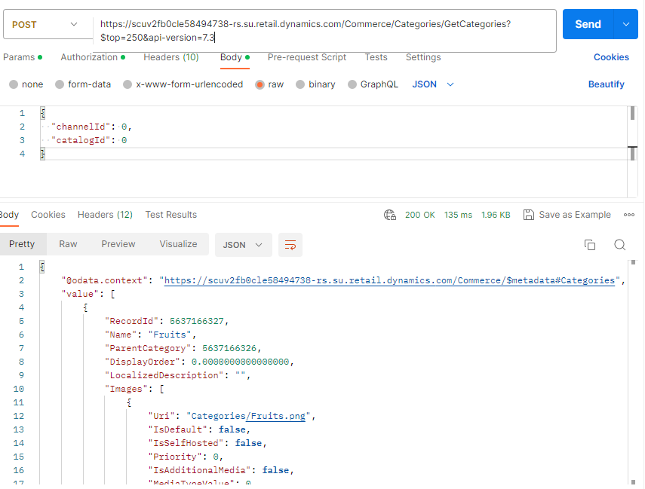

**Response:**

{

    "@odata.context": "https://scuv2fb0cle58494738-rs.su.retail.dynamics.com/Commerce/$metadata#Categories",

    "value": [

        {

            "RecordId": 5637166327,

            "Name": "Fruits",

            "ParentCategory": 5637166326,

            "DisplayOrder": 0.0000000000000000,

            "LocalizedDescription": "",

            "Images": [

                {

                    "Uri": "Categories/Fruits.png",

                    "IsDefault": **false**,

                    "IsSelfHosted": **false**,

                    "Priority": 0,

                    "IsAdditionalMedia": **false**,

                    "MediaTypeValue": 0,

                    "DisplayOrder": 0,

                    "IsApplicableForChildEntities": **false**,

                    "ExtensionProperties": []

                }

            ],

            "NameTranslations": [

                {

                    "Language": "en-us",

                    "Text": "Fruits",

                    "ExtensionProperties": []

                }

            ],

            "ExtensionProperties": []

        },

        {

            "RecordId": 5637166326,

            "Name": "Fruits & Vegetables",

            "ParentCategory": 0,

            "DisplayOrder": 0.0000000000000000,

            "LocalizedDescription": "",

            "Images": [

                {

                    "Uri": "Categories/Fruits & Vegetables.png",

                    "IsDefault": **false**,

                    "IsSelfHosted": **false**,

                    "Priority": 0,

                    "IsAdditionalMedia": **false**,

                    "MediaTypeValue": 0,

                    "DisplayOrder": 0,

                    "IsApplicableForChildEntities": **false**,

                    "ExtensionProperties": []

                }

            ],

            "NameTranslations": [

                {

                    "Language": "en-us",

                    "Text": "Fruits & Vegetables",

                    "ExtensionProperties": []

                }

            ],

            "ExtensionProperties": []

        },

        {

            "RecordId": 5637166328,

            "Name": "Vegetables",

            "ParentCategory": 5637166326,

            "DisplayOrder": 0.0000000000000000,

            "LocalizedDescription": "",

            "Images": [

                {

                    "Uri": "Categories/Vegetables.png",

                    "IsDefault": **false**,

                    "IsSelfHosted": **false**,

                    "Priority": 0,

                    "IsAdditionalMedia": **false**,

                    "MediaTypeValue": 0,

                    "DisplayOrder": 0,

                    "IsApplicableForChildEntities": **false**,

                    "ExtensionProperties": []

                }

            ],

            "NameTranslations": [

                {

                    "Language": "en-us",

                    "Text": "Vegetables",

                    "ExtensionProperties": []

                }

            ],

            "ExtensionProperties": []

        }

    ]

}

1. **Create Order(cart)**

https://scuv2fb0cle58494738-rs.su.retail.dynamics.com/Commerce/Carts?api-version=7.3

**Header param:**

OUN **=** ArtalStore01

**Body:**

{"Id":"000004-000005-184"} 🡪 ?

**Method: POST**

4-1) AddCartLine

<https://scuv2fb0cle58494738-rs.su.retail.dynamics.com/Commerce/Carts('000004-000005-184')/AddCartLines?api-version=7.3>

Body:

{"cartLines":[{"ItemId":"100000001","EntryMethodTypeValue":3,"Description":"Abaya (Basic Eleven)","ProductId":5637203827,"Quantity":1,"UnitOfMeasureSymbol":"pcs","SerialNumber":"777","CommissionSalesGroup":null,"CatalogId":0}],"cartVersion":26284903} 🡪 cartversion ?

1. **Cancel Order(Void)**

https://scuv2fb0cle58494738-rs.su.retail.dynamics.com/Commerce/Carts('000004-000005-185')/Void?api-version=7.3

**Header param:**

OUN **=** ArtalStore01

**Body:**

{"reasonCodeLines":[],"cartVersion":26284934} -- ?

**Response**:

{

"@odata.context": "https://scuv2fb0cle58494738-rs.su.retail.dynamics.com/Commerce/$metadata#SalesOrders/$entity",

"DocumentStatusValue": 0,

"RecordId": 0,

"StatusValue": 4,

"McrOrderStopped": false,

"PaymentStatusValue": 0,

"DetailedOrderStatusValue": 0,

"IsRequiredAmountPaid": false,

"IsDiscountFullyCalculated": false,

"IgnoreDiscountCalculation": false,

"AmountDue": 0,

"AmountPaid": 0.0000000000000000,

"CustomerOrderRemainingBalance": 0,

"AvailableDepositAmount": 0,

"BeginDateTime": "2023-06-16T16:02:53.607+04:00",

"CreatedDateTime": "2023-06-16T12:03:17.513Z",

"BusinessDate": "2023-06-16T00:00:00+04:00",

"CalculatedDepositAmount": 0,

"ChannelId": 5637147576,

"ChannelReferenceId": "",

"ChargeAmount": 0.0000000000000000,

"Comment": "",

"InvoiceComment": "",

"CurrencyCode": "AED",

"CustomerId": "",

"CustomerOrderModeValue": 0,

"CustomerOrderTypeValue": 0,

"DeliveryMode": "",

"DiscountAmount": 0.0000000000000000,

"DiscountAmountWithoutTax": 0,

"NetPrice": 0,

"DiscountCodes": [],

"EntryStatusValue": 1,

"GrossAmount": 315.00000000000000000,

"HasLoyaltyPayment": false,

"Id": "000004-000005-185",

"InternalTransactionId": "402fb169-5f13-4ba6-b065-6770eeab79ee",

"IncomeExpenseTotalAmount": 0.0000000000000000,

"InventoryLocationId": "Artal-001",

"IsCreatedOffline": false,

"IsReturnByReceipt": false,

"IsSuspended": false,

"IsTaxIncludedInPrice": false,

"IsTaxExemptedForPriceInclusive": false,

"LineDiscount": 0.0000000000000000,

"LineDiscountCalculationTypeValue": 0,

"LoyaltyCardId": "",

"LoyaltyDiscountAmount": 0,

"ModifiedDateTime": "1900-01-01T00:00:00Z",

"NetAmount": -300.0000000000000000,

"NetAmountWithoutTax": 300.00000000000000000,

"NetAmountWithNoTax": 0,

"NetAmountWithTax": 0,

"NumberOfItems": 1.0000000000000000,

"PeriodicDiscountAmount": 0.0000000000000000,

"TenderDiscountAmount": 0.0000000000000000,

"PrepaymentAmountAppliedOnPickup": 0,

"PrepaymentAmountInvoiced": 0,

"PrepaymentAmountPaid": 0,

"PrepaymentRoundingDifference": 0,

"ReceiptEmail": "",

"ReceiptId": "",

"RequestedDeliveryDate": "1900-01-01T00:00:00Z",

"RequiredDepositAmount": 0,

"RequiredDepositWithoutCarryoutAmount": 0,

"ReturnTransactionHasLoyaltyPayment": false,

"SalesId": "",

"SalesPaymentDifference": 315.0000000000000000,

"ShiftId": 4,

"ShiftTerminalId": "000005",

"StaffId": "2562",

"StatementCode": "",

"StoreId": "000004",

"SubtotalAmount": 300.00000000000000000,

"SubtotalAmountWithoutTax": 300.00000000000000000,

"SubtotalSalesAmount": 300.00000000000000000,

"TaxAmount": 15.0000000000000000,

"TaxAmountExclusive": 15.0000000000000000,

"TaxAmountInclusive": 0,

"TaxOnCancellationCharge": 0,

"TaxOnShippingCharge": 0,

"TaxOnNonShippingCharges": 0,

"TerminalId": "000005",

"TotalAmount": 315.0000000000000000,

"TotalSalesAmount": 0,

"TotalReturnAmount": 0,

"TotalCarryoutSalesAmount": 0,

"TotalCustomerOrderSalesAmount": 0,

"TotalDiscount": 0.0000000000000000,

"TotalManualDiscountAmount": 0.0000000000000000,

"TotalManualDiscountPercentage": 0.0000000000000000,

"TransactionTypeValue": 2,

"TaxCalculationTypeValue": 0,

"SalesInvoiceAmount": 0,

"GiftCardActiveFrom": "1900-01-01T00:00:00Z",

"GiftCardBalance": 0.0000000000000000,

"GiftCardExpireDate": "1900-01-01T00:00:00Z",

"GiftCardHistoryDetails": "",

"GiftCardIssueAmount": 0.0000000000000000,

"GiftCardIdMasked": "",

"CommissionSalesGroup": "",

"IsCommissionSalesGroupOverriddenByCustomer": false,

"CommissionSalesGroupSetByCashier": "",

"HasTaxCalculationTriggered": false,

"HasChargeCalculationTriggered": false,

"ShippingChargeAmount": 0,

"OtherChargeAmount": 0,

"PeriodicDiscountsCalculateScopeValue": 0,

"CustomerName": "",

"LanguageId": "en-US",

"SalesAgreementRecordId": 0,

"TransactionDate": "2023-06-16T00:00:00+04:00",

"TransactionTime": 57797,

"Shipments": [],

"AffiliationLoyaltyTierLines": [],

"AttributeValues": [],

"ChargeLines": [],

"Coupons": [],

"ContactInformationCollection": [],

"CustomerAccountDepositLines": [],

"IncomeExpenseLines": [],

"LoyaltyRewardPointLines": [],

"ReasonCodeLines": [],

"SalesLines": [

{

"StaffId": "2562",

"TaxOverrideCode": "",

"IsPriceKeyedIn": false,

"IsTaxOverideCodeTaxExempt": false,

"ProductId": 5637203827,

"Barcode": "",

"BarcodeEmbeddedPrice": 0,

"PriceInBarcode": false,

"EntryMethodTypeValue": 0,

"MasterProductId": 5637197931,

"ListingId": 5637203827,

"IsPriceOverridden": false,

"OriginalPrice": 300.0000000000000000,

"TotalAmount": 315.00000000000000000,

"NetAmountWithoutTax": 0,

"DiscountAmount": 0.0000000000000000,

"DiscountAmountWithoutTax": 0.0000000000000000,

"NetPrice": -300.0000000000000000,

"TotalDiscount": 0.0000000000000000,

"TotalPercentageDiscount": 0.0000000000000000,

"LineDiscount": 0.0000000000000000,

"PeriodicDiscount": 0.0000000000000000,

"LineManualDiscountPercentage": 0.0000000000000000,

"LineManualDiscountAmount": 0.0000000000000000,

"DeliveryMode": "",

"Comment": "",

"RequestedDeliveryDate": "2023-06-16T00:00:00+04:00",

"InventoryLocationId": "Artal-001",

"InventoryDimensionId": "#00000001500113B8",

"ItemType": 0,

"ReservationId": "00000000-0000-0000-0000-000000000000",

"LineNumber": 1.0000000000000000,

"ReturnQuantity": 0.00000000000000000,

"StatusValue": 0,

"SalesStatusValue": 0,

"ProductSourceValue": 0,

"IsGiftCardLine": false,

"GiftCardId": "",

"GiftCardCurrencyCode": "",

"GiftCardOperationValue": 0,

"GiftCardTypeValue": 0,

"IsInvoiceLine": false,

"InvoiceId": "",

"InvoiceAmount": 0,

"IsInvoiceSettled": false,

"InvoiceTypeValue": 0,

"IsVoided": false,

"IsPriceLocked": false,

"BasePrice": 0,

"AgreementPrice": 0,

"AdjustedPrice": 0,

"IsWarrantyLine": false,

"WarrantableLineNumber": 0,

"ReturnTransactionId": "",

"ReturnLineNumber": 0.0000000000000000,

"ReturnInventTransId": "",

"ReturnStore": "",

"ReturnTerminalId": "",

"ReturnChannelId": 5637147576,

"FulfillmentStoreId": "",

"SalesDate": "2023-06-16T16:03:17+04:00",

"QuantityCanceled": 0,

"IsSavedDiscount": false,

"RecordId": 0,

"SerialNumber": "1223",

"BatchId": "",

"UnitOfMeasureSymbol": "pcs",

"CatalogId": 0,

"ElectronicDeliveryEmailAddress": "",

"ElectronicDeliveryEmailContent": "",

"LoyaltyDiscountAmount": 0,

"LoyaltyPercentageDiscount": 0,

"TenderDiscountAmount": 0.0000000000000000,

"TenderDiscountPercentage": 0.0000000000000000,

"GiftCardBalance": 0.0000000000000000,

"IsCustomerAccountDeposit": false,

"Blocked": false,

"Found": false,

"DateToActivateItem": "0001-01-01T00:00:00Z",

"LinePercentageDiscount": 0.0000000000000000,

"PeriodicPercentageDiscount": 0.0000000000000000,

"QuantityDiscounted": 0,

"UnitQuantity": 0,

"LineMultilineDiscOnItem": "None",

"RelatedDiscountedLineIds": [],

"LineMultilineDiscOnItemValue": 0,

"WasChanged": false,

"IsLoyaltyDiscountApplied": false,

"CommissionSalesGroup": "",

"IsCommissionSalesGroupOverriddenByCustomer": false,

"CommissionSalesGroupSetByCashier": "",

"FulfillmentStatusValue": 0,

"DetailedLineStatusValue": 0,

"SalesAgreementPrice": 0,

"SalesAgreementLineRecordId": 0,

"IsSalesAgreementSkipped": false,

"ItemId": "100000001",

"Quantity": 1.00000000000000000,

"Price": 300.0000000000000000,

"ItemTaxGroupId": "VAT5",

"SalesTaxGroupId": "VAT5",

"TaxAmount": 15.0000000000000000,

"SalesOrderUnitOfMeasure": "pcs",

"NetAmount": 300.00000000000000000,

"NetAmountPerUnit": 0,

"GrossAmount": 300.00000000000000000,

"TaxAmountExemptInclusive": 0,

"TaxAmountInclusive": 0,

"TaxAmountExclusive": 15.0000000000000000,

"NetAmountWithAllInclusiveTax": 300.00000000000000000,

"BeginDateTime": "1900-01-01T00:00:00Z",

"EndDateTime": "1900-01-01T00:00:00Z",

"TaxRatePercent": 5.0000000000000000,

"IsReturnByReceipt": false,

"ReturnLineTaxAmount": 0,

"TaxExemptPriceInclusiveReductionAmount": 0.0000000000000000,

"TaxExemptPriceInclusiveOriginalPrice": 300.0000000000000000,

"ChargeLines": [],

"UnitOfMeasureConversion": {

"IsBackward": false,

"RecordId": 0,

"ProductRecordId": 0,

"Factor": 1,

"Numerator": 1,

"Denominator": 1,

"InnerOffset": 0,

"OuterOffset": 0,

"ExtensionProperties": []

},

"DiscountLines": [],

"PriceLines": [],

"AttainablePriceLines": [],

"PeriodicDiscountPossibilities": [],

"ReasonCodeLines": [],

"AttributeValues": [],

"ThirdPartyGiftCardInfo": {

"Amount": 0,

"Authorization": "",

"ExtensionProperties": []

},

"LoyaltyRewardPointLines": [],

"ReturnLoyaltyRewardPointLines": [],

"TaxLines": [

{

"TaxGroup": "VAT5",

"Percentage": 5.0000000000000000,

"IsExempt": false,

"TaxBasis": 300.0000000000000000,

"IsIncludedInPrice": false,

"SaleLineNumber": 1.0000000000000000,

"StoreId": "000004",

"TerminalId": "000005",

"TransactionId": "000004-000005-185",

"TaxCode": "VAT5",

"Amount": 15.0000000000000000,

"AmountRefunded": 0,

"IsTaxGroupRounding": false,

"ExtensionProperties": []

}

],

"TaxMeasures": [],

"ReturnTaxLines": [],

"ExtensionProperties": []

}

],

"TaxLines": [

{

"TaxGroup": "VAT5",

"Percentage": 5.0000000000000000,

"IsExempt": false,

"TaxBasis": 300.0000000000000000,

"IsIncludedInPrice": false,

"SaleLineNumber": 1.0000000000000000,

"StoreId": "000004",

"TransactionId": "000004-000005-185",

"TaxCode": "VAT5",

"Amount": 15.0000000000000000,

"AmountRefunded": 0,

"IsTaxGroupRounding": false,

"ExtensionProperties": []

}

],

"TenderLines": [],

"RefundableTenderLines": [],

"FiscalTransactions": [],

"ExtensionProperties": []

}

1. **ReturnOrder**

6-1 ) cart

6-2) Addcartline

6-3) Addreasoncode

https://scuv2fb0cle58494738-rs.su.retail.dynamics.com/Commerce/GetReasonCodesById?$top=250&$count=true&api-version=7.3

**Header param:**

OUN **=** ArtalStore01

**Body:**

{reasonCodeGroupId: "Artal_RC"}

**Method: POST**

**Reponse:**

{

"@odata.context": "https://scuv2fb0cle58494738-rs.su.retail.dynamics.com/Commerce/$metadata#Collection(Microsoft.Dynamics.Commerce.Runtime.DataModel.ReasonCode)",

"@odata.count": 0,

"value": [

{

"InputRequired": true,

"LinkedReasonCodeId": "",

"MaximumLength": 0,

"MaximumValue": 0.0000000000000000,

"MinimumLength": 0,

"MinimumValue": 0.0000000000000000,

"OncePerTransaction": false,

"PrintInputNameOnReceipt": false,

"PrintInputToReceipt": false,

"PrintPromptToReceipt": true,

"Prompt": "Enter the return reason code:",

"RandomFactor": 100.0000000000000000,

"RetailUseReasonCode": false,

"ReasonCodeId": "Artal_RC",

"Description": "Artal return info code",

"InputTypeValue": 0,

"ActivityValue": 0,

"IsMultiLineText": false,

"ReasonSubCodes": [],

"ExtensionProperties": [

{

"Key": "GROUPID",

"Value": {

"StringValue": "Artal_RC"

}

}

]

}

]

}