

***Arada Developments LLC***

Top of Form

Bottom of Form

**Retail Store Advance Transaction (Prepayment Customer Order)**

**FDD User Guide**

Prepared by

***Danial Dadmohammadi***

***November, 2023***

|  |  |  |  |  |
| --- | --- | --- | --- | --- |
| **DEVELOPMENT DETAILS** | | | | |
| **Task ID** | POS-T123 - Advance Transaction | | | |
| **Task Type** | Y | Functionality | N | Technicality |
| **Solution Type** |  | Standard and Custom Functionality both in MPOS and D365f&o |  |  |

**OBJECTIVE:**

**Customer order that has a deposit** – A customer creates a customer order at the POS. The customer can pay a deposit for the order, based on the default deposit percentage that's configured. Commerce (MPOS) processes the deposit payment for the customer order as a prepayment transaction.

**REQUIREMENT:**

* Functional

Commerce (MPOS) performs the following tasks to process a prepayment:

1. **Process a customer account deposit payment** – A deposit payment that a customer makes is transferred to Commerce (MPOS) by using a service that synchronizes data. Commerce (MPOS) creates a retail payment transaction for the payment. When the cashier post the retail transaction, a cash journal or customer payment journal is posted. The **Prepayment journal voucher** checkbox on the **Payment** tab of the **Journal voucher** page in Commerce headquarters is automatically selected for the payment journal. Prepayments can't be processed if the payment amount is negative.
2. **Process a customer order or sales order that has a deposit** – A customer pays a required deposit for a customer. Commerce (MPOS) creates either a customer payment journal or a cash journal, depending on the method of payment that the customer uses. The **Prepayment journal voucher** checkbox on the **Payment** tab of the **Journal voucher** page is automatically selected for the journal in Commerce headquarters. If a customer uses multiple methods of payment to make partial payments, Commerce processes each partial payment, based on the method of payment that was used.
3. If you **cancel a customer order**, the prepayment amount is refunded, and a refund payment journal is posted for the deposit amount. The refund amount is calculated and posted, based on the method of payment that you specified when you posted the refund payment. Commerce might apply a cancellation charge, based on the percentage that you set on the **Commerce parameters** page in Commerce headquarters.
4. If you return a customer order, a return order and a refund payment journal are created. When you post the return order, Commerce creates either a customer payment journal or a cash journal, depending on the method of payment that the customer used for the original transaction.

**Setup and Configuration (AX side)**

Firstly, we need to do some configurations on the headquarter AX d365 f&o.

1. Add the followings in commerce parameters form:

Commerce parameters🡪 customer order

Default deposit percentage and Mode of delivery should be set as the below:

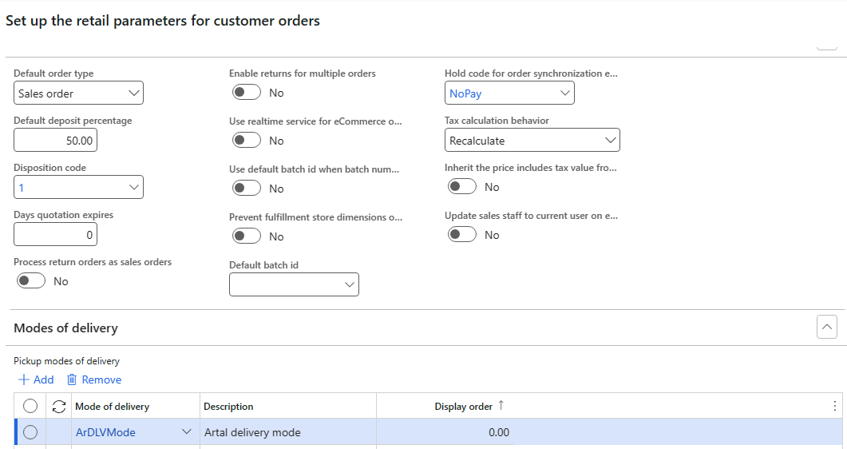

* Assign the delivery mode in the below field as well and define a new charge code if needed.

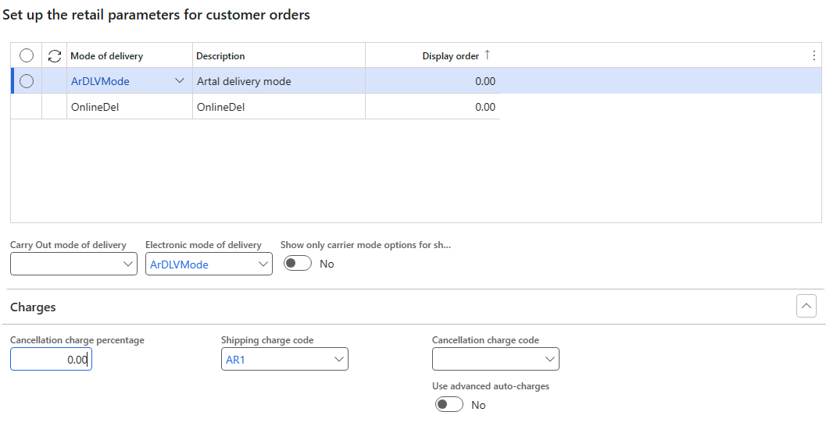

1. We need to count this store as a fulfillment group in the below path:

Retail and commerce🡪Channel setup 🡪 Fulfillment groups

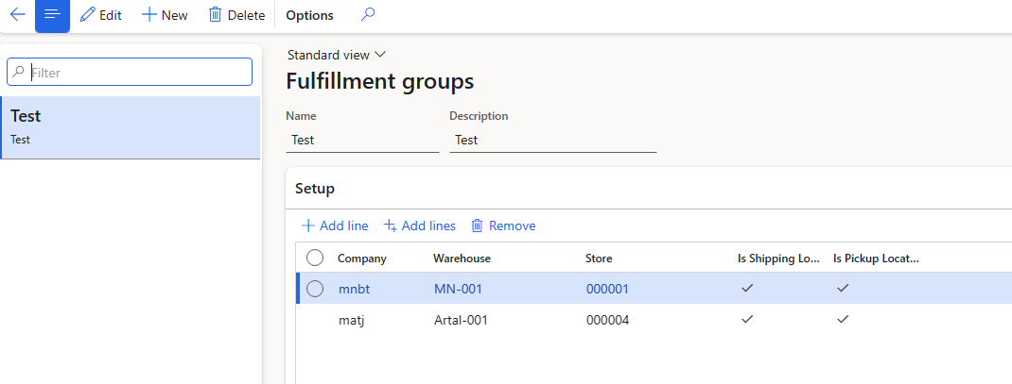

* Do not forget to check the two checkbox in the mentioned path.

1. In order to pick up the order and selected product in the MPOS, we should define the exact address for the current store which customer wants to go back to that. Accordingly, store address should be set in the global address book.

Common 🡪 Global address book

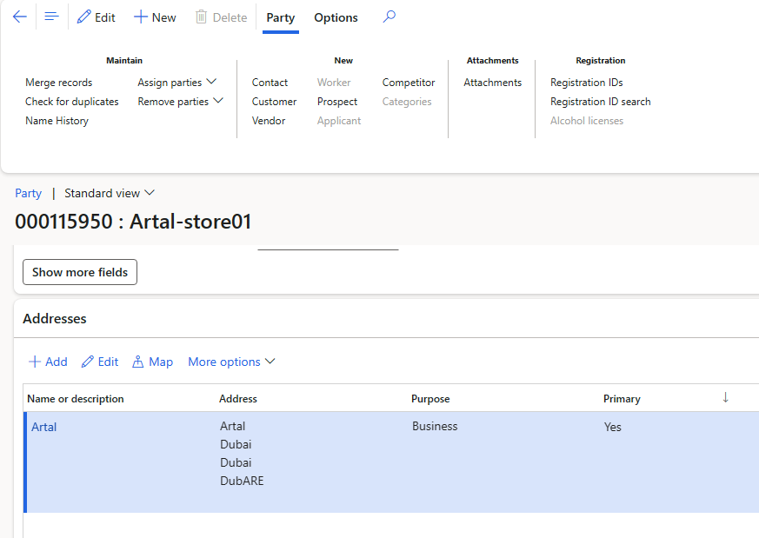

* Noted that, all sections in the address format such as country, county, state and… must be filled carefully.

1. Some steps need to add the proper buttons in the MPOS screen layout. We can od them through the following path:

Retail and commerce 🡪 Channel setup 🡪 POS setup 🡪 POS 🡪 Screen layout

In the button grids, we should add two new buttons on the “Get started” and “Main POS” layout section.

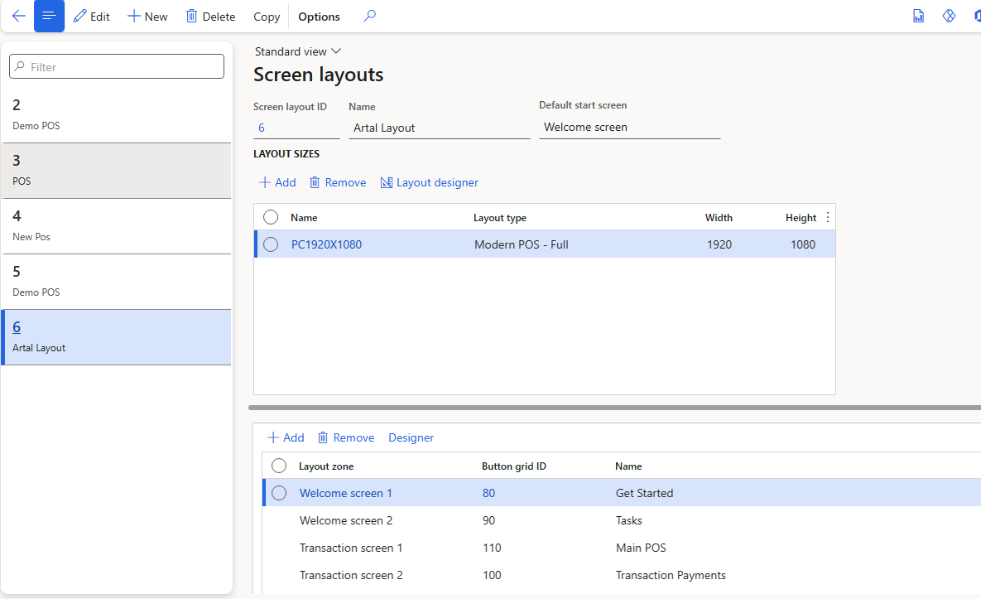

We can add the first button like the below image:

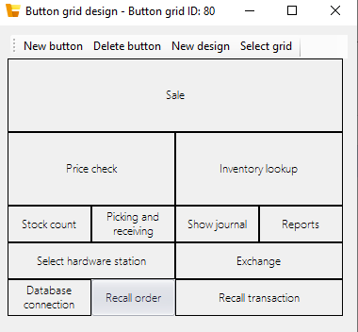

Actually, It can be added wherever of the button grid.

The rest button set should be added in the other button grid. As seen in the figure, the left one is a submenu button and the right one is an expanded. You can find all of the required operations for creating and processing of the one customer order.

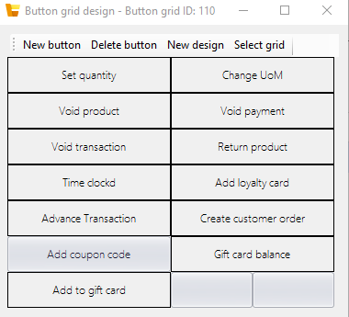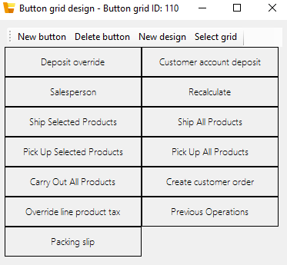

Important Tip: After the doing of the all above changes, the jobs listed must be send sequentially…

1. **1090**
2. **1070**
3. **1110**
4. **1115**
5. **1120**

**Instructions to create a customer order in MPOS**

For creating a customer order in MPOS, the following steps should be done:

1. Select the desired product with proper variant.

*IF the system ask you about the serial number, select the “Add later” button. You should enter the serial number when you want the pick up the product.*

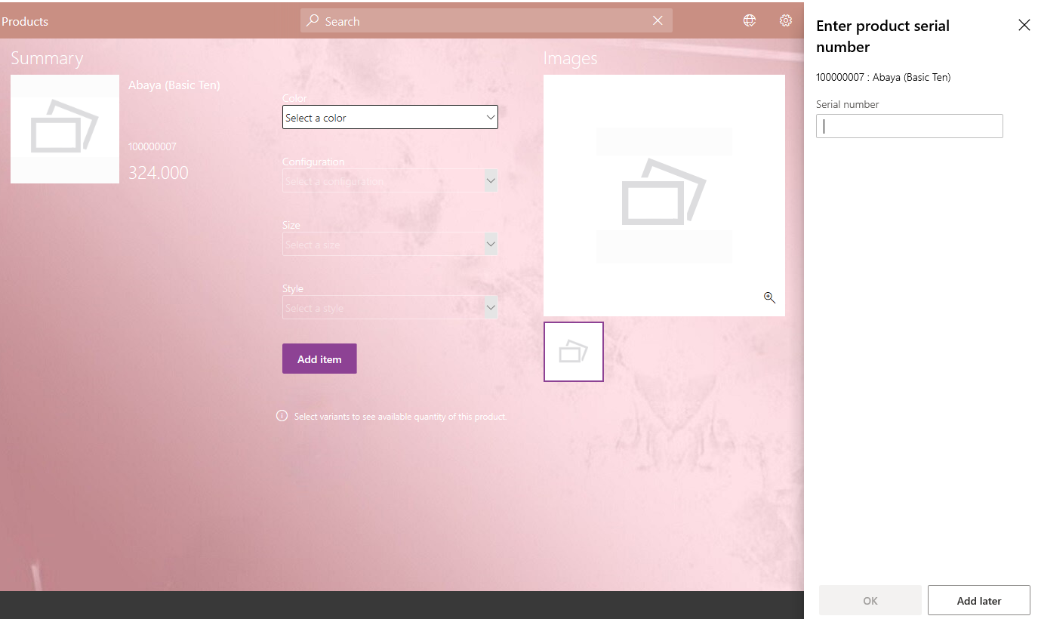

1. Add the desired customer to your order.
2. Click on the “Advance Transaction” button and from the opened button set, select the “Create customer order”. Therefore, in the total section of the current layout, the calculations of the order is done based on the value you have entered in the head quarter in the cart total section.

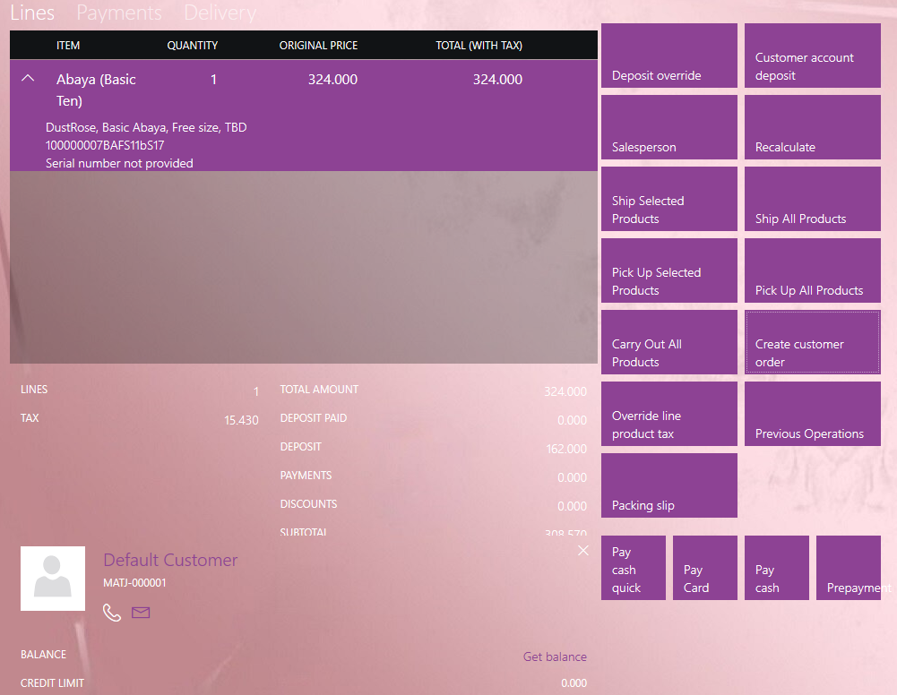

1. Here, you should select the each line in your cart order and select the “Pick up selected products”. Then, a new page will display as shown. Click ok for the next step.

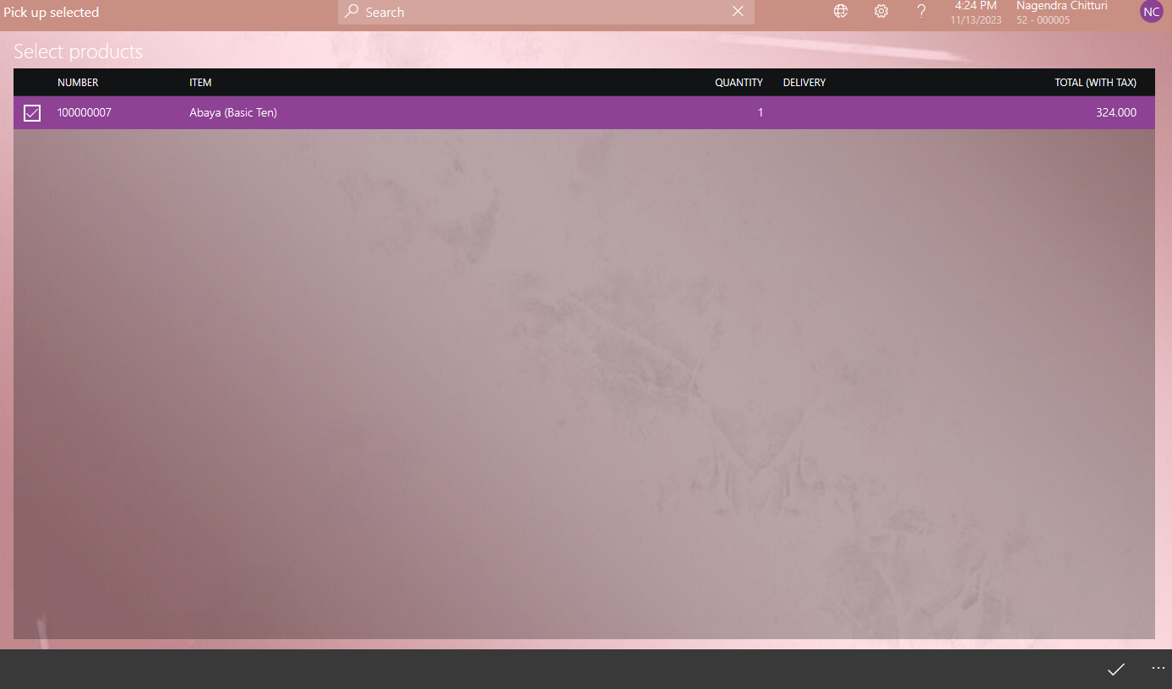

1. In the next, select the current store and desired pick up date using the page displayed.

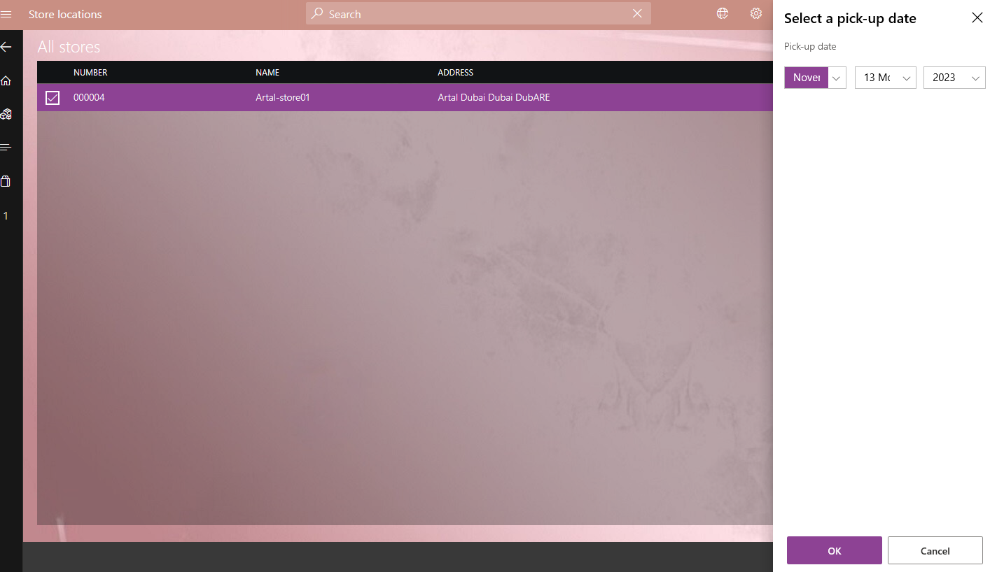

Afterwards, you conduct to the main sales page and you can see the details of the order such as the delivery mode.

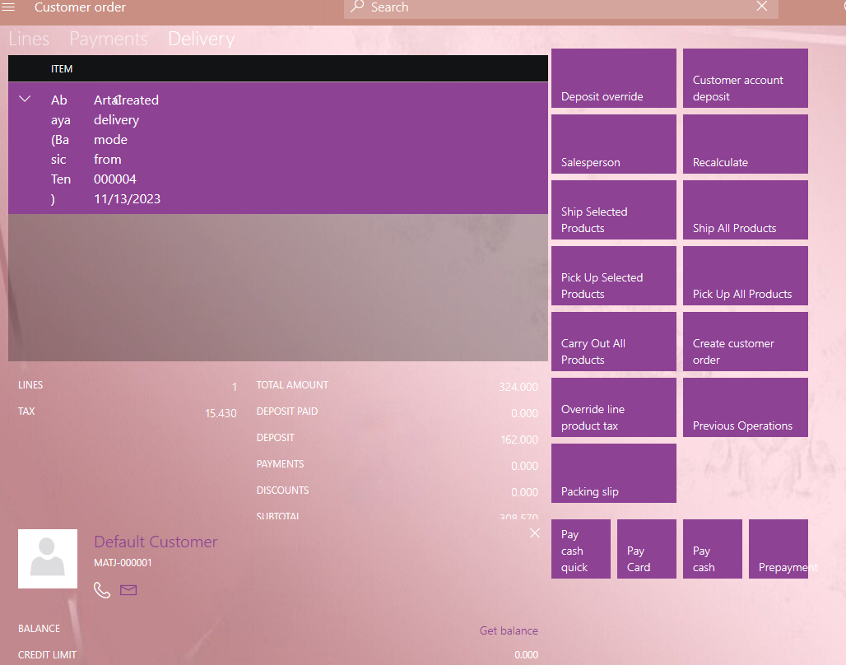

1. As the last step, you should add the payment using one of the payment methods like cash, card and so on.

If everything goes well and your payment is done successfully, the new sales order with the status of the “open order” and a customer payment journal are created in the backend.

You can check the “sales order” receipt in the “Show journal” in the main POS screen for details.

1. For recalling the order, the button “Recall order” in the main POS screen should be clicked. Then, you should select the desired customer order which is created before.

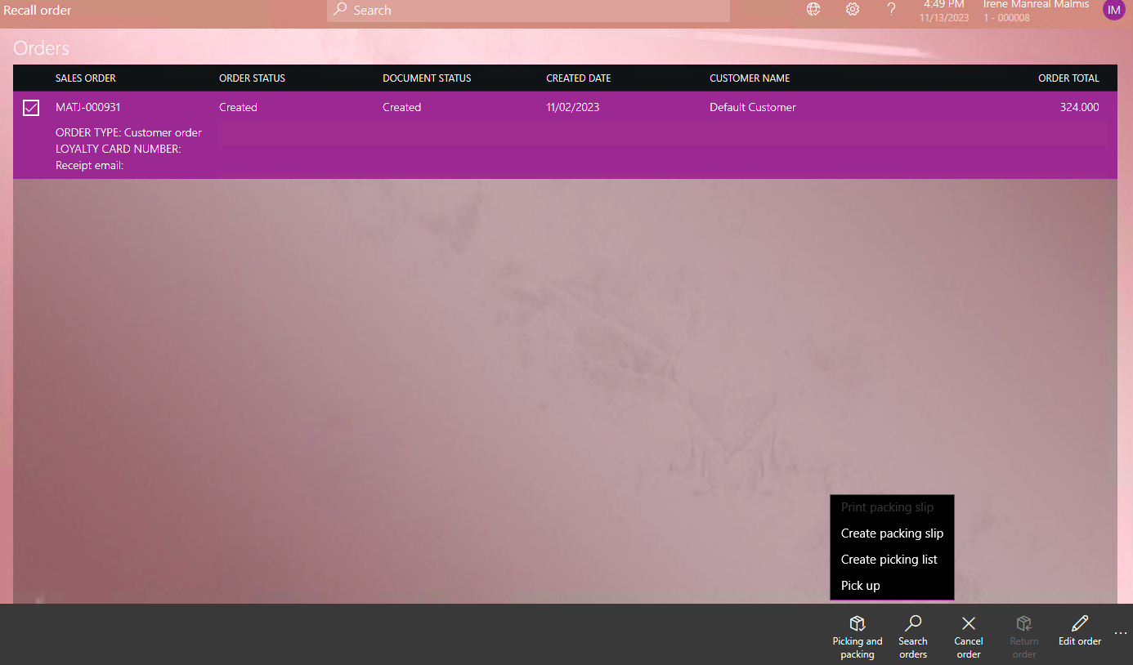

As seen, select the record displayed and then select the pick-up button. You will conduct to the sales screen page and you should complete the order to get the rest money from the customer.

When the order is complete, the mentioned sales order would be “Invoiced” and another customer payment journal is created in the back end.

Moreover that, you can check the “pick up” receipt in the “show journal” for more info.