

***Arada Developments LLC***

Top of Form

Bottom of Form

**Retail Store Sales and On-hand Inventory**

**FDD User Guide**

Prepared by

***Danial Dadmohammadi***

***September, 2023***

|  |  |  |  |  |
| --- | --- | --- | --- | --- |
| **DEVELOPMENT DETAILS** | | | | |
| **Task ID** | POS-T92 - Daily sales report from ERP | | | |
| **Task Type** | Y | Functionality | Y | Technicality |
| **Solution Type** |  | Standard and Custom Functionality |  | New Form, Class and Menu item |

**OBJECTIVE:**

* Calculating the real on-hand inventory level due to the sales transactions (non-posted statements) for retail stores.
* Achieving the Retail sales transactions along with dimension name and related variant ID
* Exporting the two mentioned reports into the excel file

**REQUIREMENT:**

* Functional:
* Adding some changes on the retail sales form
* Setting the export to excel mechanism
* Technical:
* Creating a new form and menu item for on-hand inventory of the retail stores

**SOLUTION:**

* Retail stores sales and on-hand report operate based on the following forms:

|  |  |  |  |
| --- | --- | --- | --- |
| No. | Form Name | Path | Type |
| 1 | **Retail sales Transactions** | **Retail & Commerce🡪 Inquiries & reports🡪 Store sales** | Retail Sales |
| 2 | Retail on-hand inventory level | Retail &Commerce🡪 Inquiries & reports🡪 Store on-hand inventory | Retail on-hand inventory |

1. **Retail sales:**

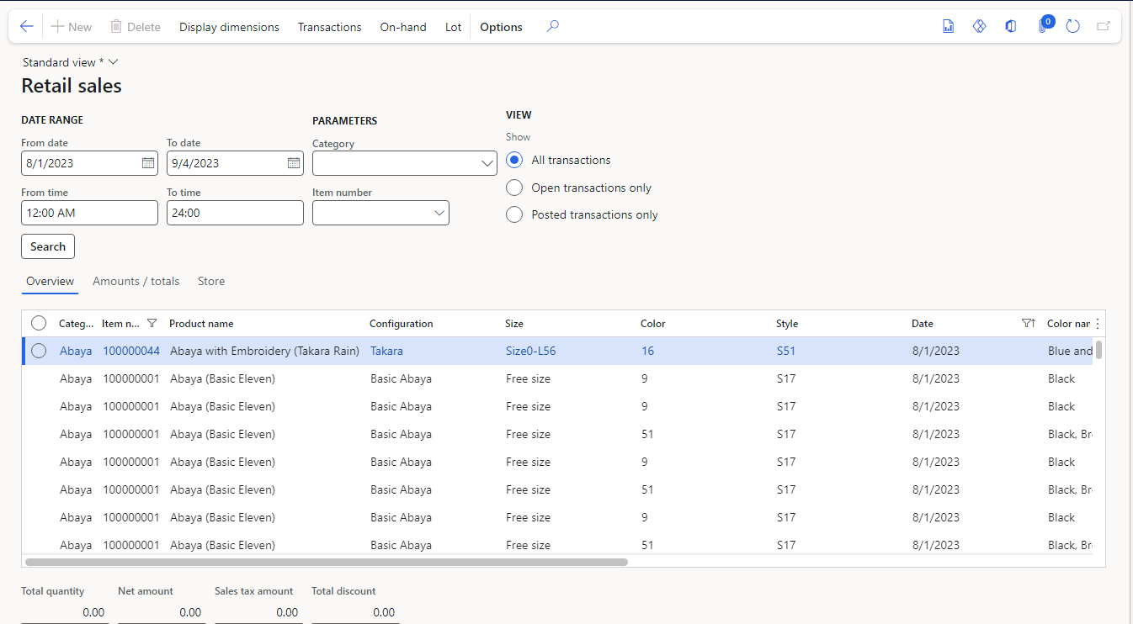This option enables you to get all transferred store transactions. You can get the excel file to add any desired filters.

In the above grid, you can get all detail info for retail store transactions. Dimension name are added to the form as well.

If you need to capture more column about the transactions, you can add them by the “Insert columns” options:

Variant ID, UOM and any other fields you need would be added from there.

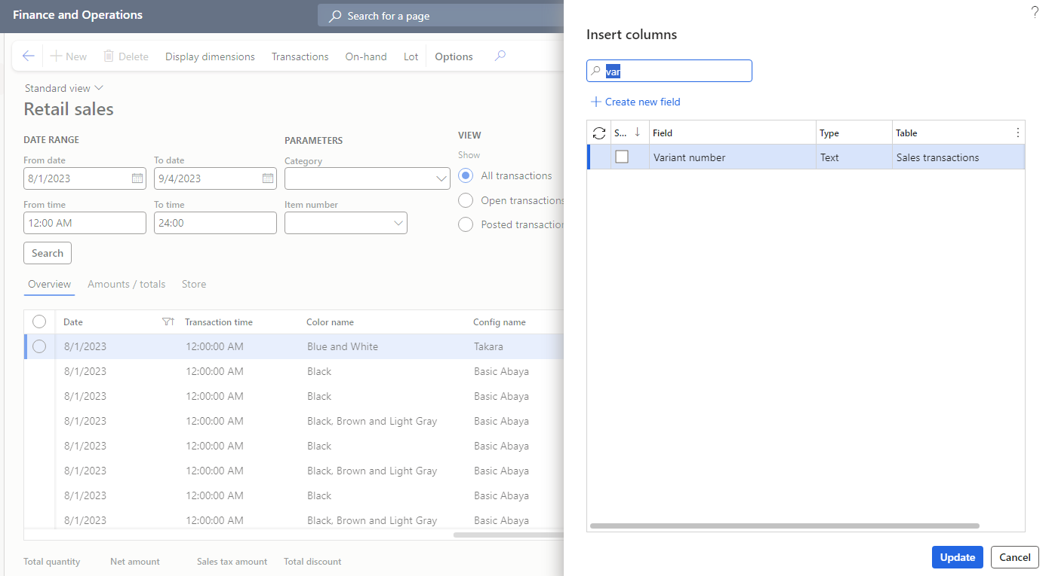

* 1. **Export to excel:**

In order to the export the generated data from the form into a excel file, you can use the following path:

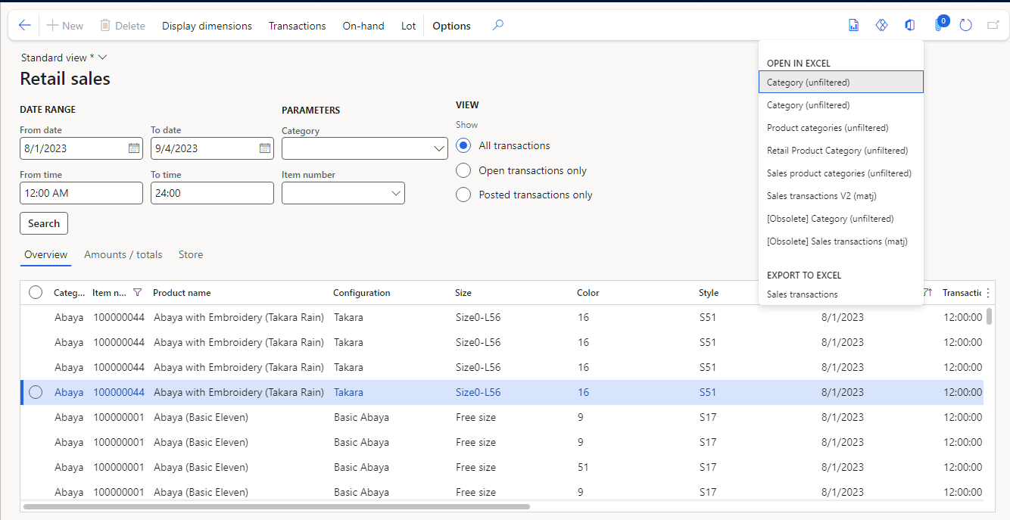

1. **On-hand Inventory:**

In this form, you can fetch the last real on-hand inventory level for each product ID based on its variant and inventory site ID as well. There is an important issue that should be considered about the how to calculate that.

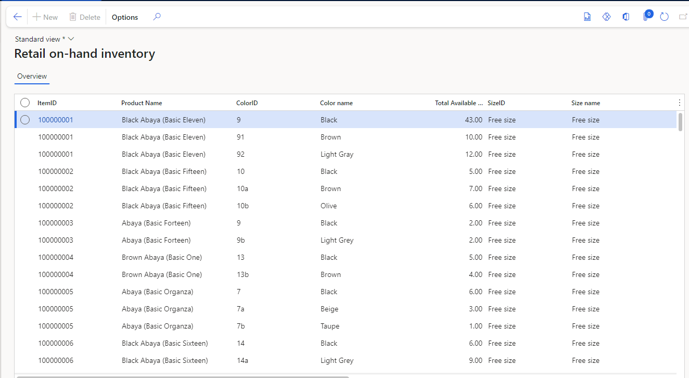

The “TotalAvailableQty” in the mentioned form is the difference between current on-hand inventory minus **non-posted transactions** in the “retailTransactionSalesTrans” table. In the other hand, if you have any non-posted statements, this calculation will consider them to level the inventory amount.

Noted that, calculations take place in terms of the **size, color, configuration, and Inventory site ID** both in current on-hand and retail sales transactions.

* 1. **Export to excel:**

In order to the export the generated data from the form into a excel file, you can use the following path:

