**Arada Stock API**

1. **On-hand inventory based on the Barcode master:**

<https://arfnodev08e443775586d4552ddevaos.axcloud.dynamics.com/data/ProductBarcodesV3>

**Entity Name: EcoResProductBarcodeV3Entity**

**Get Token:**

grant_type : client_credentials

client_id : f07b7d58-6a76-496a-b0f4-3ea560dcb872

client_secret : hAVaw-NR-XtkjtIp6uX_-1Tt7IZHCMp7d1

resource : https://arfnodev08e443775586d4552ddevaos.axcloud.dynamics.com

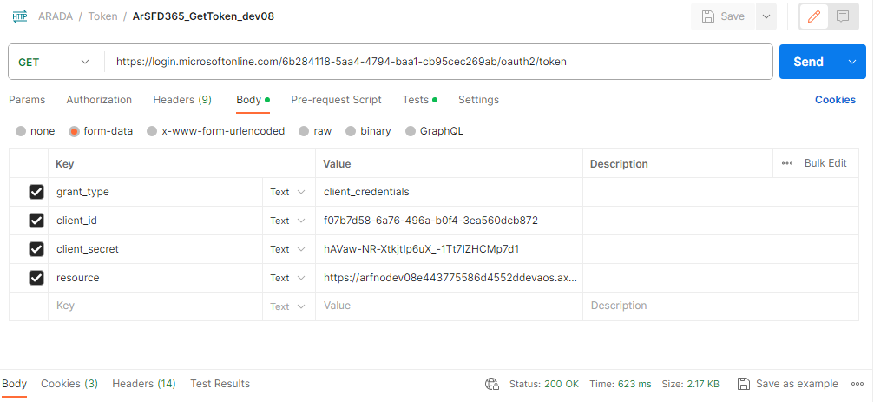

**Method : GET**

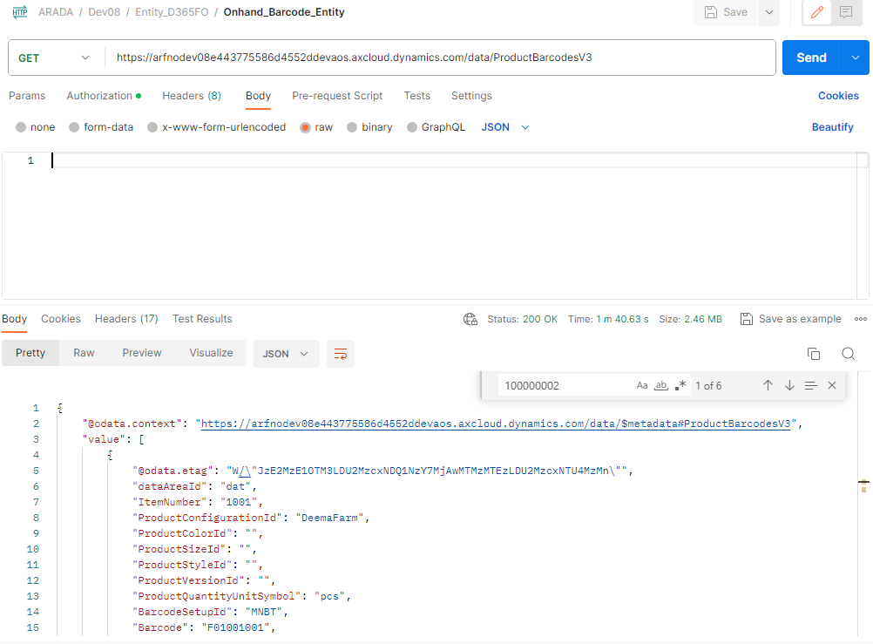

Response:

        {

            "@odata.etag": "W/\"JzEsNTYzNzE3MDA3NjsxLDU2MzcyMDc2NDcn\"",

            "dataAreaId": "dat",

            "ItemNumber": "100000002",

            "ProductConfigurationId": "Basic Abaya",

            "ProductColorId": "10",

            "ProductSizeId": "Free size",

            "ProductStyleId": "S17",

            "ProductVersionId": "",

            "ProductQuantityUnitSymbol": "pcs",

            "BarcodeSetupId": "ARTL",

            "Barcode": "100000002BAFS10S17",

            "ProductDescription": "Abaya (Basic Fifteen)",

            "IsDefaultScannedBarcode": "No",

            "IsDefaultDisplayedBarcode": "No",

            "IsDefaultPrintedBarcode": "No",

            "ProductQuantity": 1,

            "ARColorName": "Black",

            "ARSizeName": "Free size",

            "ARInventorySiteId": "Artal01",

            "ARCompany": "matj",

            "ARTotalAvailableQuantity": 23,

            "ARConfigName": "Basic Abaya",

            "ARRetailVariantId": "MATJ-00001",

            "ARStyleName": "TBD"

        },

1. **On-hand inventory based on the Serial master:**

https://arfnodev08e443775586d4552ddevaos.axcloud.dynamics.com/data/ARInventOnhandSerialNumbers  
  
**Entity Name: ARInventOnhandSerialNumberEntity**

**method: GET**

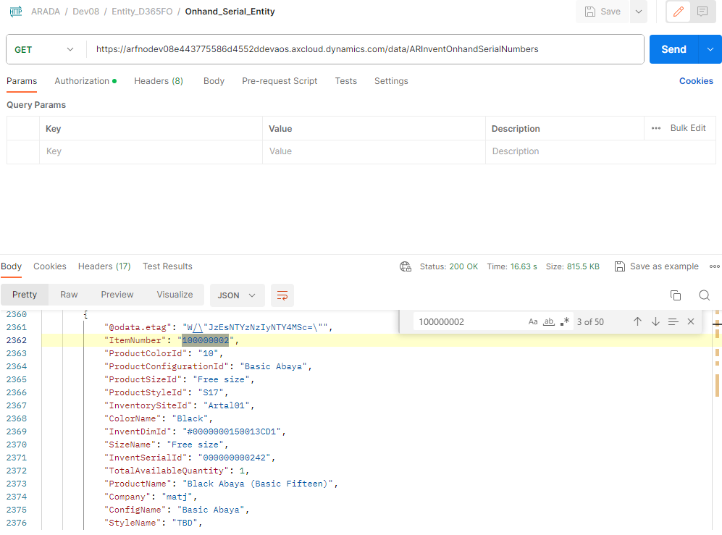

**Response:**

{

            "@odata.etag": "W/\"JzEsNTYzNzIyNTY4MSc=\"",

            "ItemNumber": "100000002",

            "ProductColorId": "10",

            "ProductConfigurationId": "Basic Abaya",

            "ProductSizeId": "Free size",

            "ProductStyleId": "S17",

            "InventorySiteId": "Artal01",

            "ColorName": "Black",

            "InventDimId": "#0000000150013CD1",

            "SizeName": "Free size",

            "InventSerialId": "000000000242",

            "TotalAvailableQuantity": 1,

            "ProductName": "Black Abaya (Basic Fifteen)",

            "Company": "matj",

            "ConfigName": "Basic Abaya",

            "StyleName": "TBD",

            "RetailVariantId": "MATJ-00001"

        },

1. **Counting journal header:**

<https://arfnodev08e443775586d4552ddevaos.axcloud.dynamics.com/data/InventoryCountingJournalHeaders?&cross-company=true>

**Entity Name: InventInventoryCountingJournalHeaderEntity**

**3.1) method: GET**

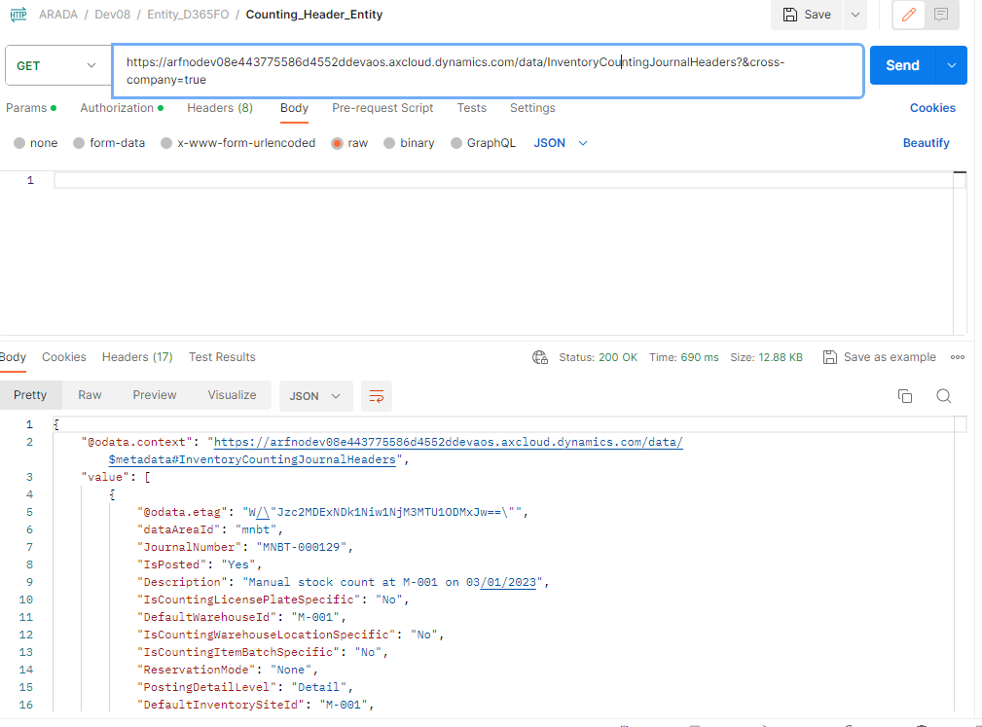

**Response:**

"value": [

        {

            "@odata.etag": "W/\"Jzc2MDExNDk1Niw1NjM3MTU1ODMxJw==\"",

            "dataAreaId": "mnbt",

            "JournalNumber": "MNBT-000129",

            "IsPosted": "Yes",

            "Description": "Manual stock count at M-001 on 03/01/2023",

            "IsCountingLicensePlateSpecific": "No",

            "DefaultWarehouseId": "M-001",

            "IsCountingWarehouseLocationSpecific": "No",

            "IsCountingItemBatchSpecific": "No",

            "ReservationMode": "None",

            "PostingDetailLevel": "Detail",

            "DefaultInventorySiteId": "M-001",

            "JournalNameId": "Counting",

            "VoucherNumberSelectionRule": "DateChange",

            "WorkerPersonnelNumber": "2599",

            "PostedDateTime": "2023-03-02T16:35:09Z",

            "IsCountingItemSerialNumberSpecific": "No",

            "VoucherNumberAllocationRule": "Post",

            "IsCountingWarehouseSpecific": "No",

            "VoucherNumberSequenceCode": "Inve_509",

            "AreLinesDeletedAfterPosting": "No",

            "PostedUserId": "m.shihal",

            "CountingStatusRegistrationPolicy": "EnableCountingStatusRegistration",

            "IsCountingInventoryStatusSpecific": "No"

        },

}

**3.2) method: POST**

**Body:**

{

    "dataAreaId": "matj",

    "Description": "Manual stock count from postman_2",

    "IsCountingLicensePlateSpecific": "No",

    "DefaultWarehouseId": "Artal-001",

    "IsCountingWarehouseLocationSpecific": "No",

    "IsCountingItemBatchSpecific": "No",

    "ReservationMode": "None",

    "PostingDetailLevel": "Detail",

    "DefaultInventorySiteId": "Artal01",

    "JournalNameId": "2",

    "VoucherNumberSelectionRule": "DateChange",

    "WorkerPersonnelNumber": "2599",

    "IsCountingItemSerialNumberSpecific": "No",

    "VoucherNumberAllocationRule": "1",

    "IsCountingWarehouseSpecific": "No",

    "AreLinesDeletedAfterPosting": "No",

    "CountingStatusRegistrationPolicy": "EnableCountingStatusRegistration",

    "IsCountingInventoryStatusSpecific": "No"

}

**Response:**

{

    "@odata.context": "https://arfnodev08e443775586d4552ddevaos.axcloud.dynamics.com/data/$metadata#InventoryCountingJournalHeaders/$entity",

    "@odata.etag": "W/\"JzEsNTYzNzIyNjMyOCc=\"",

    "dataAreaId": "dat",

    "JournalNumber": "MATJ-000030",

    "IsPosted": "No",

    "Description": "Manual stock count from postman_2",

    "IsCountingLicensePlateSpecific": "No",

    "DefaultWarehouseId": "Artal-001",

    "IsCountingWarehouseLocationSpecific": "No",

    "IsCountingItemBatchSpecific": "No",

    "ReservationMode": "None",

    "PostingDetailLevel": "Detail",

    "DefaultInventorySiteId": "Artal01",

    "JournalNameId": "2",

    "VoucherNumberSelectionRule": "DateChange",

    "WorkerPersonnelNumber": "2599",

    "PostedDateTime": "1900-01-01T00:00:00Z",

    "IsCountingItemSerialNumberSpecific": "No",

    "VoucherNumberAllocationRule": "Post",

    "IsCountingWarehouseSpecific": "No",

    "VoucherNumberSequenceCode": "",

    "AreLinesDeletedAfterPosting": "No",

    "PostedUserId": "",

    "CountingStatusRegistrationPolicy": "EnableCountingStatusRegistration",

    "IsCountingInventoryStatusSpecific": "No",

    "Company": ""

}

1. **Counting journal line:**

<https://arfnodev08e443775586d4552ddevaos.axcloud.dynamics.com/data/InventoryCountingJournalLines?&cross-company=true>

**Entity Name: InventInventoryCountingJournalLineEntity**

**4.1) method: GET**

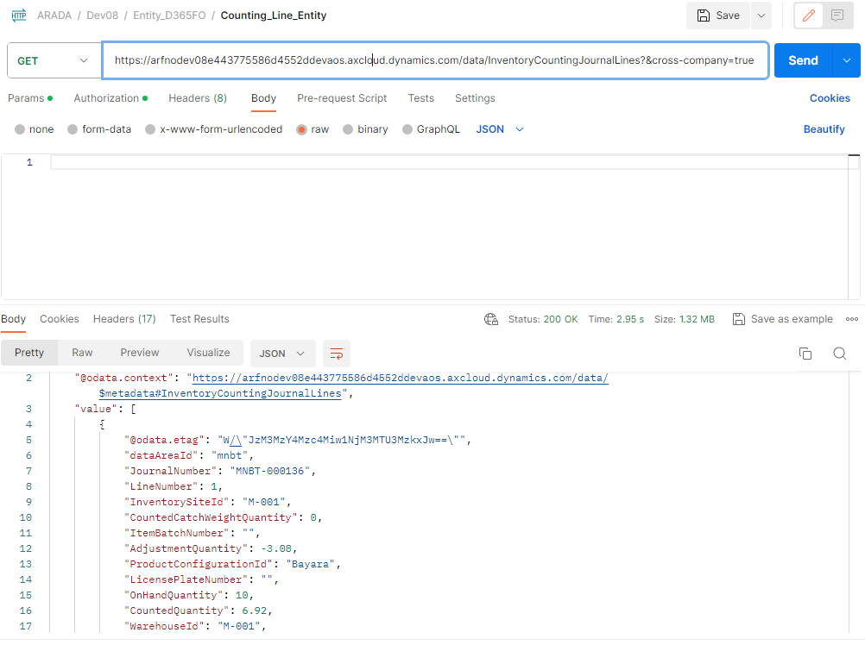

**Response:**

**{**

   "value": [

        {

            "@odata.etag": "W/\"JzM3MzY4Mzc4Miw1NjM3MTU3MzkxJw==\"",

            "dataAreaId": "mnbt",

            "JournalNumber": "MNBT-000136",

            "LineNumber": 1,

            "InventorySiteId": "M-001",

            "CountedCatchWeightQuantity": 0,

            "ItemBatchNumber": "",

            "AdjustmentQuantity": -3.08,

            "ProductConfigurationId": "Bayara",

            "LicensePlateNumber": "",

            "OnHandQuantity": 10,

            "CountedQuantity": 6.92,

            "WarehouseId": "M-001",

            "DefaultLedgerDimensionDisplayValue": "",

            "InventoryOwnerId": "",

            "ProductSizeId": "",

            "AdjustmentCatchWeightQuantity": 0,

            "ItemNumber": "2007",

            "CountingReasonCode": "",

            "CountingDate": "2023-03-01T12:00:00Z",

            "ProductColorId": "",

            "ProductVersionId": "",

            "InventoryStatusId": "",

            "ProductStyleId": "",

            "WorkerPersonnelNumber": "2599",

            "WarehouseLocationId": "",

            "OnHandCatchWeightQuantity": 0,

            "CatchWeightUnitSymbol": "",

            "ItemSerialNumber": "",

            "IsCountedQuantityZero": "No"

        },

}

**4.2) method: POST**

**Body:**

{

    "dataAreaId": "matj",

    "JournalNumber": "MATJ-000030",

    "LineNumber": 1,

    "InventorySiteId": "Artal01",

    "CountedCatchWeightQuantity": 0,

    "ItemBatchNumber": "",

    "ProductConfigurationId": "Basic Abaya",

    "LicensePlateNumber": "",

    "CountedQuantity": 2,

    "WarehouseId": "Artal-001",

    "InventoryOwnerId": "",

    "ProductSizeId": "Free size",

    "ItemNumber": "100000001",

    "CountingReasonCode": "",

    "CountingDate": "2023-12-19T12:00:00Z",

    "ProductColorId": "51",

    "ProductVersionId": "",

    "InventoryStatusId": "",

    "ProductStyleId": "S17",

    "WorkerPersonnelNumber": "2599",

    "WarehouseLocationId": "",

    "ItemSerialNumber": "",

    "IsCountedQuantityZero": "No"

}

Response:

    "@odata.context": "https://arfnodev08e443775586d4552ddevaos.axcloud.dynamics.com/data/$metadata#InventoryCountingJournalLines/$entity",

    "@odata.etag": "W/\"JzEsNTYzNzIzMjMyNyc=\"",

    "dataAreaId": "dat",

    "JournalNumber": "MATJ-000030",

    "LineNumber": 1,

    "InventorySiteId": "Artal01",

    "CountedCatchWeightQuantity": 0,

    "ItemBatchNumber": "",

    "AdjustmentQuantity": -2,

    "ProductConfigurationId": "Basic Abaya",

    "LicensePlateNumber": "",

    "OnHandQuantity": 4,

    "CountedQuantity": 2,

    "WarehouseId": "Artal-001",

    "DefaultLedgerDimensionDisplayValue": "",

    "InventoryOwnerId": "",

    "ProductSizeId": "Free size",

    "AdjustmentCatchWeightQuantity": 0,

    "ItemNumber": "100000001",

    "CountingReasonCode": "",

    "CountingDate": "2023-12-19T12:00:00Z",

    "ProductColorId": "51",

    "ProductVersionId": "",

    "InventoryStatusId": "",

    "ProductStyleId": "S17",

    "WorkerPersonnelNumber": "2599",

    "WarehouseLocationId": "",

    "OnHandCatchWeightQuantity": 0,

    "CatchWeightUnitSymbol": "",

    "ItemSerialNumber": "",

    "IsCountedQuantityZero": "No",

    "Company": ""

}