* 1. **Working time calendars**
  2. **Calendar payload: ARCalendars**

<https://arfnodev08e443775586d4552ddevaos.axcloud.dynamics.com/data/ARCalendars?&cross-company=true>

**Entity:**

ARCalendarEntity

**Entity Key(s):**

ARcalenderRecID

1. **Get PayLoad**

<https://arfnodev08e443775586d4552ddevaos.axcloud.dynamics.com/data/ARCalendars?&cross-company=true>

**Response:**

**{**

    "value": [

        {

            "@odata.etag": "W/\"JzEsNTYzNzE0NDU3NjsxLDU2MzczNTM4MjYn\"",

            " ARcalenderRecID": 5637353826,

            "CompanyID": "aljd",

            "WorkTimeId": "",

            "Name": "FY 2021",

            "StandardWorkDayHours": 0,

            "ClosedForPickup": "Yes",

            "WorkTimeControl": "Closed",

            "TransDate": "2023-01-01T12:00:00Z",

            "CalendarId": "FY2021"

**}**

1. **Post PayLoad**

<https://arfnodev08e443775586d4552ddevaos.axcloud.dynamics.com/data/ARCalendars?&cross-company=true>

**Input:**

**{**

    "CalendarId": "ddm1",

    "CompanyID": "matj",

    "WorkTimeId": "6D",

    "Name": "6DAYS CALENDER",

    "StandardWorkDayHours": 0,

    "ClosedForPickup": "Yes",

    "WorkTimeControl": "Open",

    "TransDate": "2023-08-05T12:00:00Z"

**}**

**Response:**

**{**

    "@odata.context": "https://arfnodev08e443775586d4552ddevaos.axcloud.dynamics.com/data/$metadata#ARCalendars/$entity",

    "@odata.etag": "W/\"JzE1ODAwNjIwNTMsNTYzNzE5NDA3NjsxLDU2Mzc2OTY1NzYn\"",

    "CalendarId": "ddm1",

    "CompanyID": "matj",

    "WorkTimeId": "6D",

    "Name": "6DAYS CALENDER",

    "StandardWorkDayHours": 0,

    "ClosedForPickup": "Yes",

    "WorkTimeControl": "Open",

    "TransDate": "2023-08-05T12:00:00Z",

    " ARcalenderRecID": 5637696576

**}**

1. **Update PayLoad**

<https://arfnodev08e443775586d4552ddevaos.axcloud.dynamics.com/data/ARCalendars(ARcalenderRecID=5637696576)?cross-company=true>

**Input:**

**{**

    "TransDate": "2023-08-06T12:00:00Z"

**}**

**Response:**

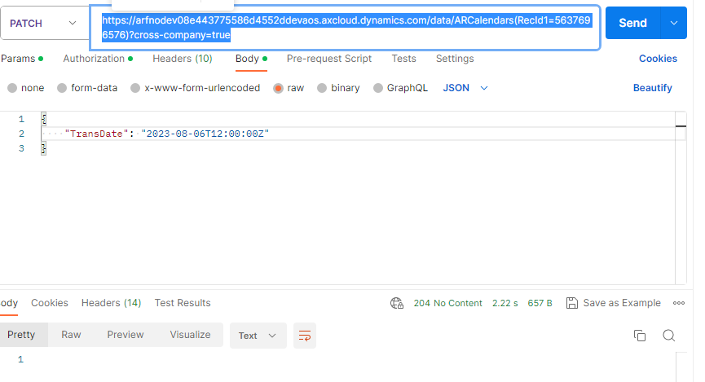

* 1. **Working Time payload**

<https://arfnodev08e443775586d4552ddevaos.axcloud.dynamics.com/data/ARCalendarIntervalsTimes?&cross-company=true>

**Entity:**

ARCalendarIntervalsTimeEntity

**Entity Key(s):**

ARcalenderIntervalRecID

1. **Get PayLoad**

<https://arfnodev08e443775586d4552ddevaos.axcloud.dynamics.com/data/ARCalendarIntervalsTimes?&cross-company=true>

**Response:**

**{**

 "value": [

        {

            "@odata.etag": "W/\"JzEsNTYzNzE0NDU3Nic=\"",

            " ARcalenderIntervalRecID": 5637144576,

            "CompanyID": "ardd",

            "FromTime": 32400,

            "ToTime": 46800,

            "Effectivity": 100,

            "PropertyId": "",

            "Hours": "4 hours",

            "Week": 53,

            "TransDate": "2021-01-03T12:00:00Z",

            "DayFromTime": "09:00:00 am",

            "Month": "January",

            "CalendarId": "Standard",

            "DayToTime": "01:00:00 pm",

            "Day": "Sunday"

**}**

1. **Post PayLoad**

<https://arfnodev08e443775586d4552ddevaos.axcloud.dynamics.com/data/ARCalendarIntervalsTimes?cross-company=true>

**Input:**

**{**

    "CalendarId": "ddm1",

    "TransDate": "2023-08-05T12:00:00Z",

    "FromTime": 28800,

    "CompanyID": "matj",

    "ToTime": 64800,

    "Effectivity": 100,

    "PropertyId": ""

**}**

**Response:**

**{**

    "@odata.context": "https://arfnodev08e443775586d4552ddevaos.axcloud.dynamics.com/data/$metadata#ARCalendarIntervalsTimes/$entity",

    "@odata.etag": "W/\"JzEsNTYzNzU4MzMyNic=\"",

    "CalendarId": "ddm1",

    "TransDate": "2023-08-05T12:00:00Z",

    "FromTime": 28800,

    "CompanyID": "matj",

    "ToTime": 64800,

    "Effectivity": 100,

    "PropertyId": ""

**}**

1. **Update PayLoad**

[https://arfnodev08e443775586d4552ddevaos.axcloud.dynamics.com/data/ARCalendarIntervalsTimes(ARcalenderIntervalRecID =5637583326)?crosscompany=true](https://arfnodev08e443775586d4552ddevaos.axcloud.dynamics.com/data/ARCalendarIntervalsTimes(RecId1=5637583326)?crosscompany=true)

**Input:**

**{**

    "TransDate": "2023-08-06T12:00:00Z"

**}**

**Response:**

