Documentation

Project Group Members:
Danial Ahmad Khadim
Danial Ahmad Anwar
Martaz Ahmad
6th Semester
Artificial Intelligence

1. System Overview
SaveIt is a multi-modal compression platform. It handles image and video compression through a unified interface, directing workloads to specific engines based on the user's requirement for lossless vs. neural compression. Below is the high-level system architecture.
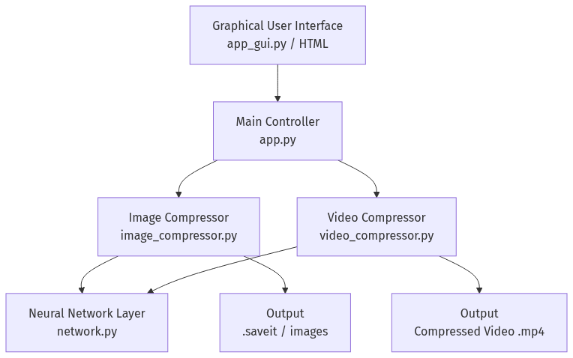

2. Codebase Structure
The application is divided into several modular scripts:
- network.py: Contains the mathematical foundation of the Neural Network (Dense layers, Activations, Forward/Backward propagation, Stochastic Gradient Descent).
- image_compressor.py: Manages the breakdown of images into patches, trains the autoencoder, handles quantization, and builds the .saveit binary.
- video_compressor.py: Manages temporal frame extraction and continuous neural training for video files.
- app_gui.py: Provides the user-facing Tkinter graphical interface.

3. Neural Autoencoder Pipeline (v1)
The core innovation of the neural pipeline is combining a neural bottleneck with integer quantization. An image is split into small patches (e.g., 8x8 pixels), flattened, and passed through the network.
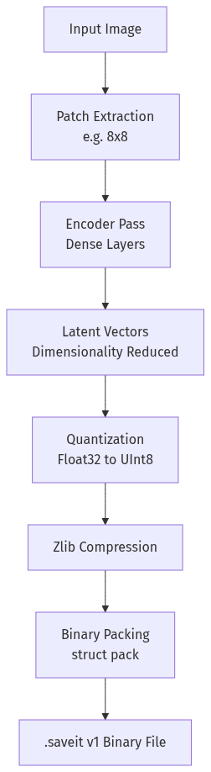

3.1 Network Layers
Input Layer: Size = Patch Width x Patch Height x Channels.
Encoder Hidden Layer: Dense(256 neurons), Activation: ReLU.
Bottleneck Layer: Dense(Encoding Dimension, e.g., 32 neurons).
Decoder Hidden Layer: Dense(256 neurons), Activation: ReLU.
Output Layer: Dense(Original Input Size), Activation: Sigmoid (for pixel scaling 0-1).

3.2 Quantization & Zlib
Once the image is encoded into latent vectors (Float32), storing it directly would consume too much memory. SaveIt normalizes these vectors to a [0, 1] range using their min and max values, and scales them to [0, 255]. They are then cast to UInt8. This process alone reduces size by 4x. The quantized vectors, alongside the quantized decoder weights, are concatenated into a single byte stream and compressed using Zlib at compression level 9.

4. Lossless Pipeline (v2)
For use cases requiring 100% pixel-perfect reconstruction, the neural network introduces too much variance. The lossless pipeline completely bypasses the autoencoder.
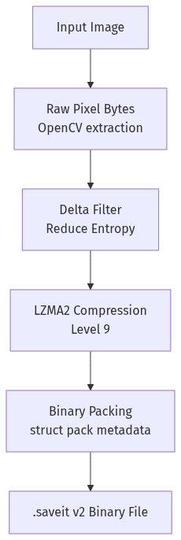
The system extracts the raw bytes of the image directly from memory. It applies a Delta Filter across the color channels. Because adjacent pixels in an image are usually very similar in color, the delta (difference) between them is often near zero. This drastically lowers the entropy of the byte stream, allowing LZMA2 compression to achieve massive reductions (often 60-85%) on raw pixel data.

To ensure the process does not take an excessively long time, SaveIt dynamically adjusts the training epochs. The very first frame requires intense training (e.g., 10 epochs) for the autoencoder to learn the general color palette and shapes of the scene. For all subsequent frames, the autoencoder only fine-tunes its weights using a very low epoch count (e.g., 1 or 2 epochs). This achieves a balance between high reconstruction quality and reasonable processing speeds.

6. The .saveit Proprietary Format
The system packs the compressed data into a custom binary format using Python's 'struct' module. This ensures the file cannot be opened by standard image viewers, securing the proprietary compression methodology.
v1 Header Structure:
Bytes 0-7: Magic String 'SAVEIT01'
Bytes 8-35: Integer Metadata (Patch size, Input dim, Adjustments, Number of patches)
Bytes 36-75: Float Metadata (Quantization mins and maxes for latent vectors and weights)
Bytes 76+: Zlib compressed payload containing quantized data.
v2 Header Structure:
Bytes 0-7: Magic String 'SAVEIT02'
Bytes 8-11: Filename length (Integer)
Bytes 12+: Original Filename (UTF-8 Bytes)
Followed by Dimensions (W, H, Channels) and the LZMA compressed payload.

