SaveIt Compression System
Educational Guide & Architecture Breakdown

1. The Core Philosophy of SaveIt
Compression relies on finding patterns to reduce the amount of data needed to store information. The SaveIt project approaches this using two entirely different strategies:
- The Math Way (Lossless / v2): Looks for exact, predictable patterns in raw pixel data. It guarantees that when you decompress, you get the exact original image back.
- The AI Way (Neural Autoencoder / v1): Teaches an Artificial Intelligence to memorize the essence of an image, keeping only the most important features. This is lossy compression.
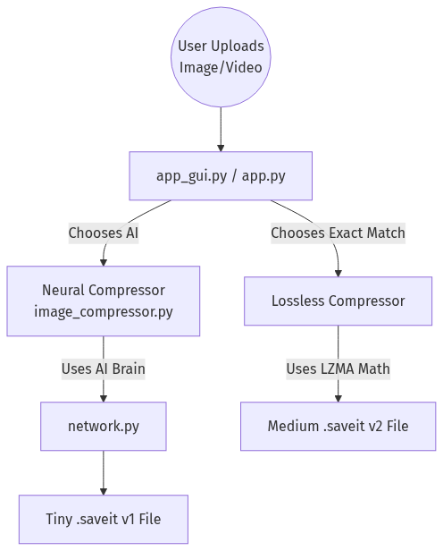

2. The Neural Schema: What is an Autoencoder?
The heart of your AI project is inside network.py. This file contains the math to build an Autoencoder. An Autoencoder is a neural network designed to copy its input to its output, but it forces the data through a tiny bottleneck in the middle.
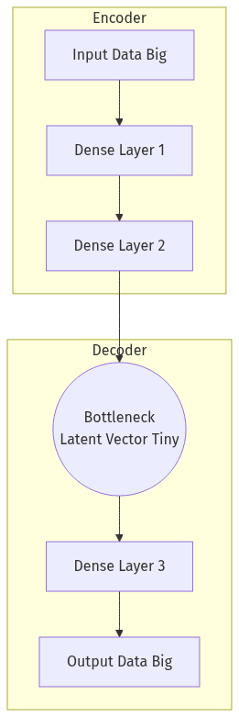
Because the bottleneck is so small, the AI must learn the most important patterns of the image to successfully reconstruct it. If it memorized everything, the data wouldn't fit through the bottleneck.

3. Exact Network Layers & Design
Instead of feeding a giant 4K image into the AI all at once, your code chops the image into tiny squares called Patches (e.g., 8x8 pixels). An 8x8 patch has 64 pixels, and with 3 color channels (RGB), that's 192 numbers. Here is the exact schema:
Step-by-step Breakdown:
- Input (192 Numbers): The raw pixel values of the patch.
- Encoder Layer 1: Expands the 192 numbers into 256 neurons to find complex patterns using ReLU.
- Bottleneck: Squishes those 256 neurons down to just 32 numbers (a massive 6x compression).
- Decoder: Takes those 32 numbers, expands them back to 256, and outputs exactly 192 numbers.
- Output: Uses the Sigmoid activation function, forcing output numbers to be smoothly between 0 and 1, mapping perfectly to pixel colors.

4. The Full Working Pipeline & Quantization
Having the AI squash the data is great, but getting it onto the hard drive efficiently requires a trick called Quantization. A standard computer Float32 number takes up 32 bits (4 bytes) of space. By converting those long decimals into simple integers between 0 and 255 (UInt8), you instantly shrink the data by 4 times in memory.
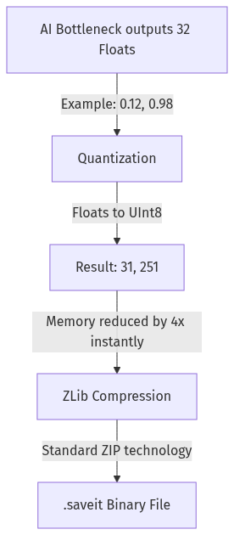

5. Important Code Snippets Explained

Snippet 1: Building the Autoencoder (image_compressor.py)
This function mathematically constructs the layers we discussed above. Notice how the activation functions alternate between ReLU (for learning hidden patterns) and Sigmoid (to finalize the output back to pixel ranges).
def build_autoencoder(input_dim, encoding_dim):
ae = Autoencoder()
ae.add(Dense(input_dim, 256))
ae.add(Activation(relu, relu_prime))
ae.add(Dense(256, encoding_dim)) # BOTTLENECK
ae.add(Activation(relu, relu_prime))
ae.add(Dense(encoding_dim, 256))
ae.add(Activation(relu, relu_prime))
ae.add(Dense(256, input_dim))
ae.add(Activation(sigmoid, sigmoid_prime))
return ae

Snippet 2: Quantization Engine (image_compressor.py)
This is where the Float32 memory footprint is slashed by 4x. We find the min and max values, normalize the data between 0 and 1, multiply by 255, and convert to an 8-bit integer (np.uint8).
def quantize(data):
d_min = data.min()
d_max = data.max()
normalized = (data - d_min) / (d_max - d_min)
quantized = (normalized * 255).astype(np.uint8)
return quantized, d_min, d_max

Snippet 3: Lossless Compression (image_compressor.py)
For lossless compression, the AI is bypassed entirely. OpenCV extracts the raw pixel bytes from memory. LZMA applies a Delta Filter across the RGB channels. Because neighboring pixels are often identical in color, the 'delta' (difference) becomes zero, which compresses phenomenally well.
lzma_filters = [
{'id': lzma.FILTER_DELTA, 'dist': channels},
{'id': lzma.FILTER_LZMA2, 'preset': 9},
]
compressed_data = lzma.compress(
pixel_bytes, format=lzma.FORMAT_RAW, filters=lzma_filters
)

Snippet 4: The Core Dense Layer Math (network.py)
This is the heart of the neural network. During the forward pass, it multiplies the inputs by the weights and adds a bias (Y = W*X + B). During the backward pass (learning), it uses Calculus (derivatives) to adjust the weights via Stochastic Gradient Descent, pushing the network to make fewer mistakes.
class Dense(Layer):
def forward(self, input):
self.input = input
return np.dot(self.input, self.weights) + self.bias
def backward(self, output_error, learning_rate):
input_error = np.dot(output_error, self.weights.T)
weights_error = np.dot(self.input.T, output_error)
self.weights -= learning_rate * weights_error
self.bias -= learning_rate * np.sum(output_error, axis=0)
return input_error

