AI DATASETS MANAGEMENT & INNOVATION SYSTEM
Database Systems (Lab)



Submitted by: DANIAL AMJAD & MUHAMMAD YOUSAF
Submitted to: Sir Ali Hassan

Semester: IV - AI (Group-B)
Session 2024 –2028 (Fall)

Milestone 1 | Date | Version | Remarks
ERD Diagram & Schema | 26/4/2026 | 1.0

ERD DIAGRAM :

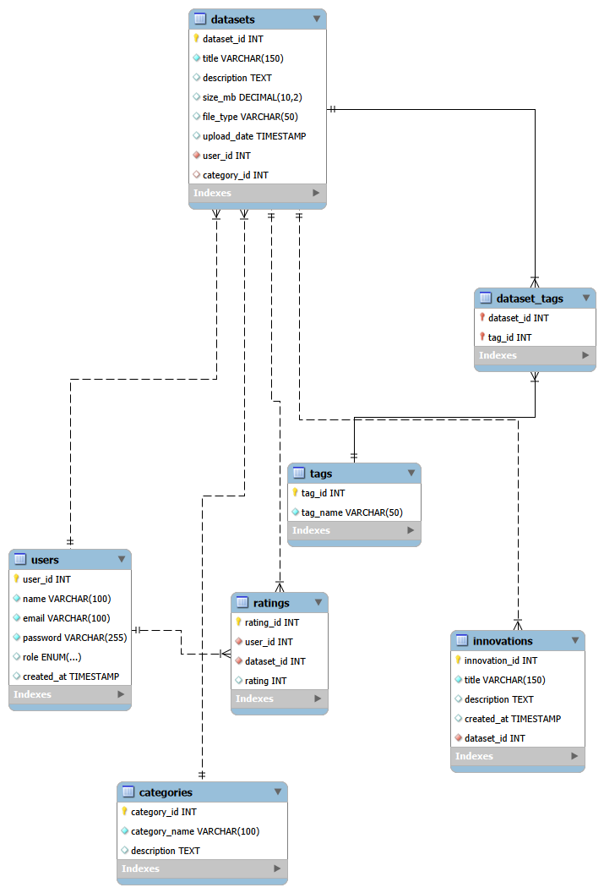

Relational Database Schema Description

USERS Table

Table: USERS
Attribute | Data Type | Key | Description & Constraint
user_id | INT | PK | Auto-incremented primary key. Uniquely identifies every user in the system.
name | VARCHAR(100) |  | Full name of the user. This field cannot be left empty (NOT NULL).
email | VARCHAR(100) | UQ | User's email address. A UNIQUE constraint prevents duplicate registrations.
password | VARCHAR(255) |  | Hashed password string. Cannot be NULL; application layer handles encryption.
role | ENUM |  | Access role: 'admin', 'student', or 'researcher'. Defaults to 'student'.
created_at | TIMESTAMP |  | Automatic timestamp set at the moment the record is first inserted.

CATEGORIES Table

Table: CATEGORIES
Attribute | Data Type | Key | Description & Constraint
category_id | INT | PK | Auto-incremented primary key uniquely identifying each category entry.
category_name | VARCHAR(100) | UQ | Human-readable category label, for example 'Computer Vision' or 'NLP'. UNIQUE and NOT NULL.
description | TEXT |  | Detailed narrative describing the scope of this category and the types of datasets it encompasses.

DATASETS Table

Table: DATASETS
Attribute | Data Type | Key | Description & Constraint
dataset_id | INT | PK | Auto-incremented primary key that uniquely identifies each dataset.
title | VARCHAR(150) |  | Descriptive title of the dataset chosen by the uploader. Cannot be NULL.
description | TEXT |  | Extended notes covering dataset contents, collection methodology, and intended use case.
size_mb | DECIMAL(10,2) |  | File size in megabytes. Allows precise storage estimation and filtering by size.
file_type | VARCHAR(50) |  | Format of the dataset file, such as CSV, JSON, or HDF5.
upload_date | TIMESTAMP |  | Timestamp recorded automatically when the dataset is first added to the system.
user_id | INT | FK | References USERS. Identifies the uploader. Cascades on delete and update.
category_id | INT | FK | References CATEGORIES. Set to NULL if the parent category is deleted.

INNOVATIONS Table

Table: INNOVATIONS
Attribute | Data Type | Key | Description & Constraint
innovation_id | INT | PK | Auto-incremented primary key identifying each innovation entry.
title | VARCHAR(150) |  | Short descriptive title of the innovation or research application. Cannot be NULL.
description | TEXT |  | Detailed explanation of the innovation, its methodology, and its relationship to the linked dataset.
created_at | TIMESTAMP |  | Timestamp set automatically when the innovation record is first inserted.
dataset_id | INT | FK | References DATASETS. Cascades on delete so innovations are removed with their parent dataset.

TAGS Table

Table: TAGS
Attribute | Data Type | Key | Description & Constraint
tag_id | INT | PK | Auto-incremented primary key uniquely identifying each tag.
tag_name | VARCHAR(50) | UQ | Short descriptive label, for example 'image-classification' or 'benchmark'. Must be unique.

DATASET_TAGS Table
.

Table: DATASET_TAGS
Attribute | Data Type | Key | Description & Constraint
dataset_id | INT | PK / FK | References DATASETS. Part of the composite primary key. Cascades on delete and update.
tag_id | INT | PK / FK | References TAGS. Part of the composite primary key. Cascades on delete and update.

RATINGS Table

Table: RATINGS
Attribute | Data Type | Key | Description & Constraint
rating_id | INT | PK | Auto-incremented primary key uniquely identifying each rating record.
user_id | INT | FK | References USERS. Cascades on delete so ratings are removed when the user account is deleted.
dataset_id | INT | FK | References DATASETS. Cascades on delete, removing all ratings when the dataset is removed.
rating | INT |  | Numeric score between 1 and 5 inclusive. Enforced by a CHECK constraint.

Relationship Summary
The system is built on a well-structured relational schema where the datasets table acts as the central entity, connecting multiple components of the system through foreign key relationships. It is linked to the users table to identify dataset ownership and to the categories table for primary classification, ensuring organized and consistent data management.
The inclusion of the dataset_tags junction table establishes a many-to-many relationship between datasets and tags, allowing flexible labeling and advanced search capabilities without redundancy. This design enhances scalability and supports dynamic categorization of datasets.
Furthermore, the ratings table creates a relationship between users and datasets, enabling user feedback while maintaining a constraint that ensures each user can rate a dataset only once. The innovations table is also linked to datasets, representing research or projects derived from specific datasets.
Overall, the schema enforces referential integrity through foreign key constraints and follows normalization principles, ensuring data consistency, reducing redundancy, and supporting efficient querying across the system

